Date 29. 03. 2019

VYSHAK PUTHUSSERI
YEDHU THAMBI

TUTORIAL 1
Xml page

<?xml version="1.0" encoding="utf-8"?>
<android.support.constraint.ConstraintLayout xmlns:android="http://schemas.android.com/apk/res/android"
xmlns:app="http://schemas.android.com/apk/res-auto"
xmlns:tools="http://schemas.android.com/tools"
android:layout_width="match_parent"
android:layout_height="match_parent"
tools:context=".MainActivity">

<LinearLayout
android:id="@+id/linearLayout"
android:layout_width="0dp"
android:layout_height="0dp"
android:layout_marginStart="8dp"
android:layout_marginTop="8dp"
android:layout_marginEnd="8dp"
android:layout_marginBottom="8dp"
android:orientation="vertical"
app:layout_constraintBottom_toBottomOf="parent"
app:layout_constraintEnd_toEndOf="parent"
app:layout_constraintStart_toStartOf="parent"
app:layout_constraintTop_toTopOf="parent">

<TextView
android:id="@+id/textView"
android:layout_width="match_parent"
android:layout_height="wrap_content"
android:text="TextView" />

<Button
android:id="@+id/button"
android:layout_width="match_parent"
android:layout_height="wrap_content"
android:text="Button" />
</LinearLayout>
</android.support.constraint.ConstraintLayout>

Java code

package com.example.tutorial1;

import android.support.v7.app.AppCompatActivity;
import android.os.Bundle;
import android.view.View;
import android.widget.Button;
import android.widget.TextView;

public class MainActivity extends AppCompatActivity {

TextView txt;
Button btn;

@Override
protected void onCreate(Bundle savedInstanceState) {
super.onCreate(savedInstanceState);
setContentView(R.layout.activity_main);
btn = (Button) findViewById(R.id.button);
txt = (TextView) findViewById(R.id.textView);
btn.setOnClickListener(new View.OnClickListener() {
@Override
public void onClick(View v) {
txt.setText("you have clicked the button");

}
});

}
}

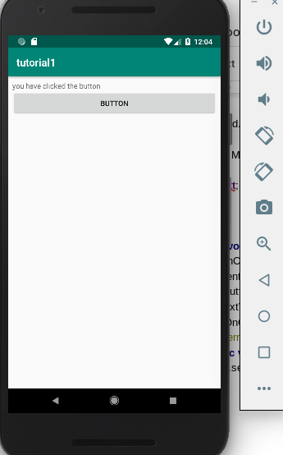

Tutorial 2

Activity file
<?xml version="1.0" encoding="utf-8"?>
<android.support.constraint.ConstraintLayout xmlns:android="http://schemas.android.com/apk/res/android"
xmlns:app="http://schemas.android.com/apk/res-auto"
xmlns:tools="http://schemas.android.com/tools"
android:layout_width="match_parent"
android:layout_height="match_parent"
tools:context=".MainActivity">

<LinearLayout
android:id="@+id/linearLayout"
android:layout_width="0dp"
android:layout_height="0dp"
android:layout_marginStart="8dp"
android:layout_marginTop="8dp"
android:layout_marginEnd="8dp"
android:layout_marginBottom="8dp"
android:orientation="vertical"
app:layout_constraintBottom_toBottomOf="parent"
app:layout_constraintEnd_toEndOf="parent"
app:layout_constraintStart_toStartOf="parent"
app:layout_constraintTop_toTopOf="parent">

<CheckBox
android:layout_width="wrap_content"
android:layout_height="wrap_content"
android:id="@+id/india"
android:text="INDIA"/>
<CheckBox
android:layout_width="wrap_content"
android:layout_height="wrap_content"
android:id="@+id/pak"
android:text="PAKISTHAN"/>
<CheckBox
android:layout_width="wrap_content"
android:layout_height="wrap_content"
android:id="@+id/srilanka"
android:text="SRILANKA"/>
<TextView
android:id="@+id/textView"
android:layout_width="match_parent"
android:layout_height="wrap_content"

android:text="TextView" />
</LinearLayout>
</android.support.constraint.ConstraintLayout>
Java file

package com.example.tutorial2;

import android.support.v7.app.AppCompatActivity;
import android.os.Bundle;
import android.widget.CheckBox;
import android.widget.CompoundButton;
import android.widget.TextView;

public class MainActivity extends AppCompatActivity {

TextView txt;
CheckBox india,sri,pak;
String str = "";

@Override
protected void onCreate(Bundle savedInstanceState) {
super.onCreate(savedInstanceState);
setContentView(R.layout.activity_main);
txt = (TextView)findViewById(R.id.textView);
india = (CheckBox)findViewById(R.id.india);
sri = (CheckBox)findViewById(R.id.srilanka);
pak = (CheckBox)findViewById(R.id.pak);

india.setOnCheckedChangeListener(new CompoundButton.OnCheckedChangeListener() {
@Override
public void onCheckedChanged(CompoundButton buttonView, boolean isChecked) {
if(isChecked) {
str += " INDIA ";
txt.setText(str);
}
else
{
String[] split = str.split("INDIA");
String firstSubString = split[0];
String secondSubString = split[1];
str = firstSubString+" " +secondSubString;
txt.setText(str);
}
}
});

sri.setOnCheckedChangeListener(new CompoundButton.OnCheckedChangeListener() {
@Override
public void onCheckedChanged(CompoundButton buttonView, boolean isChecked) {
if(isChecked) {
str += " SRILANKA ";

txt.setText(str);
}
else
{
String[] split = str.split("SRILANKA");
String firstSubString = split[0];
String secondSubString = split[1];
str = firstSubString+" " +secondSubString;
txt.setText(str);
}
}
});

pak.setOnCheckedChangeListener(new CompoundButton.OnCheckedChangeListener() {
@Override
public void onCheckedChanged(CompoundButton buttonView, boolean isChecked) {
if(isChecked) {

str += " PAKISTAN ";

txt.setText(str);
}
else
{
String[] split = str.split("PAKISTAN");
String firstSubString = split[0];
String secondSubString = split[1];
str = firstSubString+" " +secondSubString;
txt.setText(str);
}
}
});

}
}

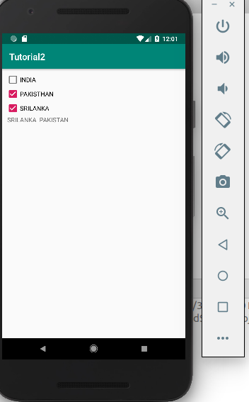

Tutorial 3

Xml page

<?xml version="1.0" encoding="utf-8"?>
<android.support.constraint.ConstraintLayout xmlns:android="http://schemas.android.com/apk/res/android"
xmlns:app="http://schemas.android.com/apk/res-auto"
xmlns:tools="http://schemas.android.com/tools"
android:layout_width="match_parent"
android:layout_height="match_parent"
tools:context=".MainActivity">

<LinearLayout
android:id="@+id/linearLayout"
android:layout_width="0dp"
android:layout_height="0dp"
android:layout_marginStart="8dp"
android:layout_marginTop="8dp"
android:layout_marginEnd="8dp"
android:layout_marginBottom="8dp"
android:orientation="vertical"
app:layout_constraintBottom_toBottomOf="parent"
app:layout_constraintEnd_toEndOf="parent"
app:layout_constraintStart_toStartOf="parent"
app:layout_constraintTop_toTopOf="parent">

<CheckBox
android:layout_width="wrap_content"
android:layout_height="wrap_content"
android:id="@+id/india"
android:text="INDIA"/>
<CheckBox
android:layout_width="wrap_content"
android:layout_height="wrap_content"
android:id="@+id/pak"
android:text="PAKISTHAN"/>
<CheckBox
android:layout_width="wrap_content"
android:layout_height="wrap_content"
android:id="@+id/srilanka"
android:text="SRILANKA"/>
<EditText
android:id="@+id/textView"
android:layout_width="match_parent"
android:layout_height="wrap_content"

android:text="TextView" />
</LinearLayout>
</android.support.constraint.ConstraintLayout>
Java code

package com.example.tutorial3;

import android.support.v7.app.AppCompatActivity;
import android.os.Bundle;
import android.widget.CheckBox;
import android.widget.CompoundButton;
import android.widget.EditText;
import android.widget.TextView;

public class MainActivity extends AppCompatActivity {

EditText txt;
CheckBox india,sri,pak;
String str = "";

@Override
protected void onCreate(Bundle savedInstanceState) {
super.onCreate(savedInstanceState);
setContentView(R.layout.activity_main);
txt = (EditText)findViewById(R.id.textView);
india = (CheckBox)findViewById(R.id.india);
sri = (CheckBox)findViewById(R.id.srilanka);
pak = (CheckBox)findViewById(R.id.pak);

india.setOnCheckedChangeListener(new CompoundButton.OnCheckedChangeListener() {
@Override
public void onCheckedChanged(CompoundButton buttonView, boolean isChecked) {
if(isChecked) {
str += " INDIA ";
txt.setText(str);
}
else
{
String[] split = str.split("INDIA");
String firstSubString = split[0];
String secondSubString = split[1];
str = firstSubString+" " +secondSubString;
txt.setText(str);
}
}
});

sri.setOnCheckedChangeListener(new CompoundButton.OnCheckedChangeListener() {
@Override
public void onCheckedChanged(CompoundButton buttonView, boolean isChecked) {
if(isChecked) {
str += " SRILANKA ";

txt.setText(str);
}
else
{
String[] split = str.split("SRILANKA");
String firstSubString = split[0];
String secondSubString = split[1];
str = firstSubString+" " +secondSubString;
txt.setText(str);
}
}
});

pak.setOnCheckedChangeListener(new CompoundButton.OnCheckedChangeListener() {
@Override
public void onCheckedChanged(CompoundButton buttonView, boolean isChecked) {
if(isChecked) {

str += " PAKISTAN ";

txt.setText(str);
}
else
{
String[] split = str.split("PAKISTAN");
String firstSubString = split[0];
String secondSubString = split[1];
str = firstSubString+" " +secondSubString;
txt.setText(str);
}
}
});
}
}

Screenshort
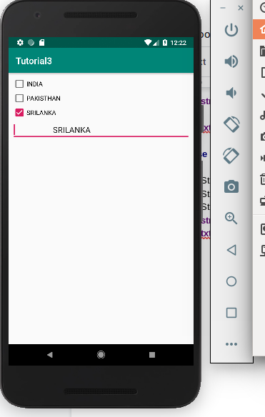

Tutorial 4

Xml

<?xml version="1.0" encoding="utf-8"?>
<android.support.constraint.ConstraintLayout xmlns:android="http://schemas.android.com/apk/res/android"
xmlns:app="http://schemas.android.com/apk/res-auto"
xmlns:tools="http://schemas.android.com/tools"
android:layout_width="match_parent"
android:layout_height="match_parent"
tools:context=".MainActivity">

<LinearLayout
android:id="@+id/linearLayout"
android:layout_width="0dp"
android:layout_height="0dp"
android:layout_marginStart="8dp"
android:layout_marginTop="8dp"
android:layout_marginEnd="8dp"
android:layout_marginBottom="8dp"
android:orientation="vertical"
app:layout_constraintBottom_toBottomOf="parent"
app:layout_constraintEnd_toEndOf="parent"
app:layout_constraintStart_toStartOf="parent"
app:layout_constraintTop_toTopOf="parent">

<ToggleButton
android:id="@+id/toggleButton"
android:layout_width="match_parent"
android:layout_height="wrap_content"
android:text="ToggleButton" />

<ToggleButton
android:id="@+id/toggleButton2"
android:layout_width="match_parent"
android:layout_height="wrap_content"
android:text="ToggleButton" />

<Button
android:id="@+id/button"
android:layout_width="match_parent"
android:layout_height="wrap_content"
android:text="Button" />
</LinearLayout>
</android.support.constraint.ConstraintLayout>

Java code

package com.example.tutorial4;

import android.support.v7.app.AppCompatActivity;
import android.os.Bundle;
import android.view.View;
import android.widget.Button;
import android.widget.Toast;
import android.widget.ToggleButton;

public class MainActivity extends AppCompatActivity {

Button b;
ToggleButton one,two;
@Override
protected void onCreate(Bundle savedInstanceState) {
super.onCreate(savedInstanceState);
setContentView(R.layout.activity_main);
b = (Button)findViewById(R.id.button);
one = (ToggleButton)findViewById(R.id.toggleButton);
two = (ToggleButton)findViewById(R.id.toggleButton2);
b.setOnClickListener(new View.OnClickListener() {
@Override
public void onClick(View v) {
Toast.makeText(getApplicationContext(),"Toggle 1 : "+one.getText()+"\nToggle 2 : "+two.getText(),Toast.LENGTH_LONG).show();

}
});
}
}

