Date 10. 04. 2019 VYSHAK PUTHUSSERI

**ASSIGNMENT 1**

XML: (activity_main.xml)

*<?*xml version="1.0" encoding="utf-8"*?>*<android.support.constraint.ConstraintLayout xmlns:android="http://schemas.android.com/apk/res/android"  
 xmlns:app="http://schemas.android.com/apk/res-auto"  
 xmlns:tools="http://schemas.android.com/tools"  
 android:layout_width="match_parent"  
 android:layout_height="match_parent"  
 tools:context=".MainActivity">  
  
 <TextView  
 android:layout_width="wrap_content"  
 android:layout_height="wrap_content"  
 android:text="Hello World!"  
 android:textColor="@android:color/holo_red_light"  
 app:layout_constraintBottom_toBottomOf="parent"  
 app:layout_constraintLeft_toLeftOf="parent"  
 app:layout_constraintRight_toRightOf="parent"  
 app:layout_constraintTop_toTopOf="parent" />  
  
</android.support.constraint.ConstraintLayout>

JAVA FILE:

package com.example.assignment_1;  
  
import android.support.v7.app.AppCompatActivity;  
import android.os.Bundle;  
  
public class MainActivity extends AppCompatActivity {  
  
 @Override  
 protected void onCreate(Bundle savedInstanceState) {  
 super.onCreate(savedInstanceState);  
 setContentView(R.layout.*activity_main*);  
 }  
}

Screenshot :

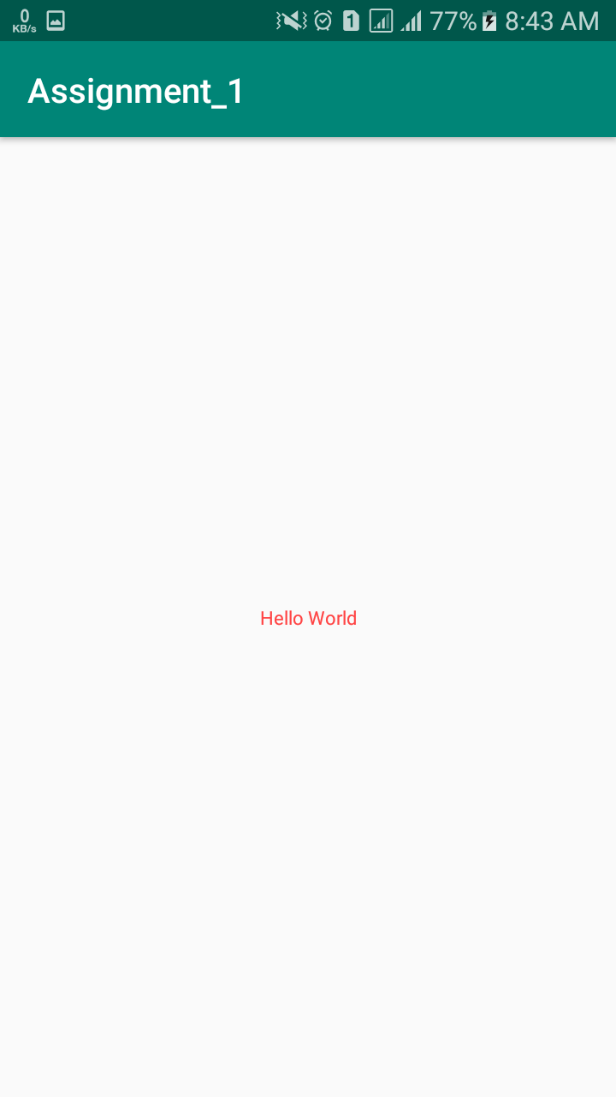

Date 10. 04. 2019 VYSHAK PUTHUSSERI

**ASSIGNMENT 2**

XML: (activity_main.xml)

*<?*xml version="1.0" encoding="utf-8"*?>*<android.support.constraint.ConstraintLayout xmlns:android="http://schemas.android.com/apk/res/android"  
 xmlns:app="http://schemas.android.com/apk/res-auto"  
 xmlns:tools="http://schemas.android.com/tools"  
 android:layout_width="match_parent"  
 android:layout_height="match_parent"  
 tools:context=".MainActivity">  
 <RelativeLayout  
 android:layout_width="match_parent"  
 android:layout_height="match_parent">  
 <TextView  
 android:id="@+id/title"  
 android:layout_width="wrap_content"  
 android:layout_height="wrap_content"  
 android:layout_centerHorizontal="true"  
 android:layout_marginStart="15dp"  
 android:layout_marginTop="15dp"  
 android:layout_marginEnd="15dp"  
 android:layout_marginBottom="15dp"  
 android:padding="5dp"  
 android:text="Login App" />  
 <LinearLayout  
 android:layout_width="match_parent"  
 android:layout_height="match_parent"  
 android:layout_marginTop="65dp"  
 android:orientation="vertical">  
 <LinearLayout  
 android:layout_width="match_parent"  
 android:layout_height="wrap_content"  
 android:orientation="horizontal">  
 <TextView  
 android:id="@+id/textView3"  
 android:layout_width="wrap_content"  
 android:layout_height="wrap_content"  
 android:layout_weight="0"  
 android:text="Username" />  
 <EditText  
 android:id="@+id/username"  
 android:layout_width="wrap_content"  
 android:layout_height="wrap_content"  
 android:layout_marginStart="20dp"  
 android:layout_weight="0"  
 android:ems="10"  
 android:inputType="textPersonName"  
 android:padding="10dp"  
 android:text="" />  
 </LinearLayout>  
 <LinearLayout  
 android:layout_width="match_parent"  
 android:layout_height="wrap_content"  
 android:orientation="horizontal">  
 <TextView  
 android:id="@+id/textView5"  
 android:layout_width="wrap_content"  
 android:layout_height="wrap_content"  
 android:layout_weight="0"  
 android:text="Password" />  
 <EditText  
 android:id="@+id/password"  
 android:layout_width="wrap_content"  
 android:layout_height="wrap_content"  
 android:layout_marginStart="20dp"  
 android:layout_weight="0"  
 android:ems="10"  
 android:inputType="textPassword" />  
 </LinearLayout>  
 <LinearLayout  
 android:layout_width="match_parent"  
 android:layout_height="wrap_content"  
 android:layout_margin="70dp"  
 android:orientation="horizontal"  
 android:padding="25dp">  
 <Button  
 android:id="@+id/button"  
 android:layout_width="0dp"  
 android:layout_height="wrap_content"  
 android:layout_weight="1"  
 android:text="Login" />  
 </LinearLayout>  
 </LinearLayout>  
 </RelativeLayout>  
</android.support.constraint.ConstraintLayout>

XML: (activity_main2.xml)

*<?*xml version="1.0" encoding="utf-8"*?>*<android.support.constraint.ConstraintLayout xmlns:android="http://schemas.android.com/apk/res/android"  
 xmlns:app="http://schemas.android.com/apk/res-auto"  
 xmlns:tools="http://schemas.android.com/tools"  
 android:layout_width="match_parent"  
 android:layout_height="match_parent"  
 tools:context=".Main2Activity">  
 <TextView  
 android:id="@+id/display"  
 android:layout_width="wrap_content"  
 android:layout_height="wrap_content"  
 android:layout_margin="50dp"  
 android:layout_marginStart="176dp"  
 android:layout_marginTop="168dp"  
 android:layout_marginEnd="8dp"  
 android:layout_marginBottom="8dp"  
 android:padding="50dp"  
 android:text=" "  
 app:layout_constraintBottom_toBottomOf="parent"  
 app:layout_constraintEnd_toEndOf="parent"  
 app:layout_constraintHorizontal_bias="0.0"  
 app:layout_constraintStart_toStartOf="parent"  
 app:layout_constraintTop_toTopOf="parent"  
 app:layout_constraintVertical_bias="0.408" />  
</android.support.constraint.ConstraintLayout>

JAVA CODE : (MainActivity.java)

**package** com.example.login;  
**import** android.content.Intent;  
**import** android.support.v7.app.AppCompatActivity;  
**import** android.os.Bundle;  
**import** android.view.View;  
**import** android.widget.Button;  
**import** android.widget.EditText;  
**import** android.widget.Toast;  
**public class** MainActivity **extends** AppCompatActivity {  
 EditText **password**;  
 EditText **username**;  
 Button **button**;  
 String **str**,**str2**;  
 @Override  
 **protected void** onCreate(Bundle savedInstanceState) {  
 **super**.onCreate(savedInstanceState);  
 setContentView(R.layout.***activity_main***);  
 **password** = (EditText)findViewById(R.id.***password***);  
 **username** = (EditText)findViewById(R.id.***username***);  
 **button** = (Button)findViewById(R.id.***button***);  
 **button**.setOnClickListener(**new** View.OnClickListener() {  
 @Override  
 **public void** onClick(View v) {  
 **str** = **username**.getText().toString();  
 **str2** = **password**.getText().toString();  
 **if**(**str**.equals(**"admin"**) && **str2**.equals(**"admin"**)) {  
 Intent i = **new** Intent(MainActivity.**this**, Main2Activity.**class**);  
 i.putExtra(**"username"**, **str**);  
 startActivity(i);  
 } **else** {  
 Toast.*makeText*(getApplicationContext(), **"Invalid credinals ! Try again."**, Toast.***LENGTH_LONG***).show();  
 }  
 }  
 });  
 }  
}

JAVA CODE : (Main2Activity.java)

**package** com.example.login;  
  
**import** android.support.v7.app.AppCompatActivity;  
**import** android.os.Bundle;  
**import** android.widget.TextView;  
**public class** Main2Activity **extends** AppCompatActivity {  
 TextView **textView**;  
 @Override  
 **protected void** onCreate(Bundle savedInstanceState) {  
 **super**.onCreate(savedInstanceState);  
 setContentView(R.layout.***activity_main2***);  
 **textView** = (TextView)findViewById(R.id.***display***);  
 **textView**.setText(**"User : "**+getIntent().getExtras().getString(**"username"**));  
 }  
}

Screenshot :

