Date 29. 03. 2019 VYSHAK PUTHUSSERI  
 YEDHU THAMBI

**TUTORIAL 1**

**AIM:** Create linear layout which contains one button and a text view. In button tag we set the button_id [as@id/button. This](mailto:as@id/button.This) id is used to uniquely identify the view. When we click on button, the text view text will change to ‘you have clicked the button’

XML:

<?**xml version="1.0" encoding="utf-8"**?>

<**android.support.constraint.ConstraintLayout xmlns:android="http://schemas.android.com/apk/res/android"**

**xmlns:app="http://schemas.android.com/apk/res-auto"**

**xmlns:tools="http://schemas.android.com/tools"**

**android:layout_width="match_parent"**

**android:layout_height="match_parent"**

**tools:context=".MainActivity"**>

<**LinearLayout**

**android:id="@+id/linearLayout"**

**android:layout_width="0dp"**

**android:layout_height="0dp"**

**android:layout_marginStart="8dp"**

**android:layout_marginTop="8dp"**

**android:layout_marginEnd="8dp"**

**android:layout_marginBottom="8dp"**

**android:orientation="vertical"**

**app:layout_constraintBottom_toBottomOf="parent"**

**app:layout_constraintEnd_toEndOf="parent"**

**app:layout_constraintStart_toStartOf="parent"**

**app:layout_constraintTop_toTopOf="parent"**>

<**TextView**

**android:id="@+id/textView"**

**android:layout_width="match_parent"**

**android:layout_height="wrap_content"**

**android:text="TextView"** />

<**Button**

**android:id="@+id/button"**

**android:layout_width="match_parent"**

**android:layout_height="wrap_content"**

**android:text="Button"** />

</**LinearLayout**>

</**android.support.constraint.ConstraintLayout**>

JAVA FILE:

**package** com.example.tutorial1;

**import** android.support.v7.app.AppCompatActivity;

**import** android.os.Bundle;

**import** android.view.View;

**import** android.widget.Button;

**import** android.widget.TextView;

**public class** MainActivity **extends** AppCompatActivity {

TextView **txt**;

Button **btn**;

@Override

**protected void** onCreate(Bundle savedInstanceState) {

**super**.onCreate(savedInstanceState);

setContentView(R.layout.**activity_main**);

**btn** = (Button) findViewById(R.id.**button**);

**txt** = (TextView) findViewById(R.id.**textView**);

**btn**.setOnClickListener(**new** View.OnClickListener() {

@Override

**public void** onClick(View v) {

**txt**.setText(**"you have clicked the button"**);

}

});

}

}

Screenshot :

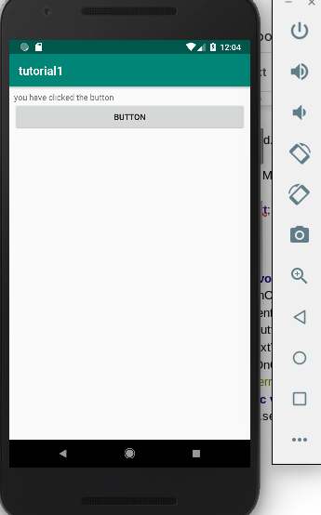

Date 29. 03. 2019 VYSHAK PUTHUSSERI  
 YEDHU THAMBI

**TUTORIAL 2**

**AIM:** Create three check boxes named as INDIA, SRILANKA and PAKISTAN. When we check the specific checkbox,it will display the corresponding text of that checkbox in the textview.

XML:

<?**xml version="1.0" encoding="utf-8"**?>

<**android.support.constraint.ConstraintLayout xmlns:android="http://schemas.android.com/apk/res/android"**

**xmlns:app="http://schemas.android.com/apk/res-auto"**

**xmlns:tools="http://schemas.android.com/tools"**

**android:layout_width="match_parent"**

**android:layout_height="match_parent"**

**tools:context=".MainActivity"**>

<**LinearLayout**

**android:id="@+id/linearLayout"**

**android:layout_width="0dp"**

**android:layout_height="0dp"**

**android:orientation="vertical"**>

<**CheckBox**

**android:layout_width="wrap_content"**

**android:layout_height="wrap_content"**

**android:id="@+id/india"**

**android:text="INDIA"**/>

<**CheckBox**

**android:layout_width="wrap_content"**

**android:layout_height="wrap_content"**

**android:id="@+id/pak"**

**android:text="PAKISTHAN"**/>

<**CheckBox**

**android:layout_width="wrap_content"**

**android:layout_height="wrap_content"**

**android:id="@+id/srilanka"**

**android:text="SRILANKA"**/>

<**TextView**

**android:id="@+id/textView"**

**android:layout_width="match_parent"**

**android:layout_height="wrap_content"**

**android:text="TextView"** />

</**LinearLayout**>

</**android.support.constraint.ConstraintLayout**>

JAVA CODE :

**package** com.example.tutorial2;

**import** android.support.v7.app.AppCompatActivity;

**import** android.os.Bundle;

**import** android.widget.CheckBox;

**import** android.widget.CompoundButton;

**import** android.widget.TextView;

**public class** MainActivity **extends** AppCompatActivity {

TextView **txt**;

CheckBox **india**,**sri**,**pak**;

String **str** = **" "**;

@Override

**protected void** onCreate(Bundle savedInstanceState) {

**super**.onCreate(savedInstanceState);

setContentView(R.layout.**activity_main**);

**txt** = (TextView)findViewById(R.id.**textView**);

**india** = (CheckBox)findViewById(R.id.**india**);

**sri** = (CheckBox)findViewById(R.id.**srilanka**);

**pak** = (CheckBox)findViewById(R.id.**pak**);

**india**.setOnCheckedChangeListener(**new** CompoundButton.OnCheckedChangeListener() {

@Override

**public void** onCheckedChanged(CompoundButton buttonView, **boolean** isChecked) {

**if**(isChecked) {

**str** += **" INDIA "**;

**txt**.setText(**str**);

}

**else** {

String[] split = **str**.split(**"INDIA"**);

String firstSubString = split[0];

String secondSubString = split[1];

**str** = firstSubString+**" "** +secondSubString;

**txt**.setText(**str**);

}

}

});

**sri**.setOnCheckedChangeListener(**new** CompoundButton.OnCheckedChangeListener() {

@Override

**public void** onCheckedChanged(CompoundButton buttonView, **boolean** isChecked) {

**if**(isChecked) {

**str** += **" SRILANKA "**;

**txt**.setText(**str**);

}

**else** {

String[] split = **str**.split(**"SRILANKA"**);

String firstSubString = split[0];

String secondSubString = split[1];

**str** = firstSubString+**" "** +secondSubString;

**txt**.setText(**str**);

}

}

});

**pak**.setOnCheckedChangeListener(**new** CompoundButton.OnCheckedChangeListener() {

@Override

**public void** onCheckedChanged(CompoundButton buttonView, **boolean** isChecked) {

**if**(isChecked) {

**str** += **" PAKISTAN "**;

**txt**.setText(**str**);

}

**else** {

String[] split = **str**.split(**"PAKISTAN"**);

String firstSubString = split[0];

String secondSubString = split[1];

**str** = firstSubString+**" "** +secondSubString;

**txt**.setText(**str**);

}

}

});

}

}

Screenshot :

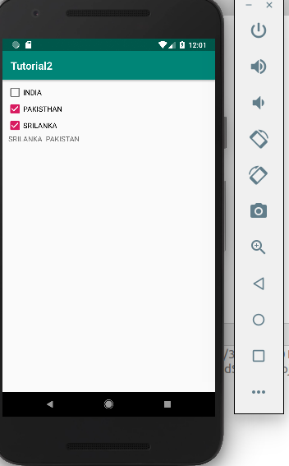

Date 29. 03. 2019 VYSHAK PUTHUSSERI  
 YEDHU THAMBI

**TUTORIAL 3**

**AIM:** Create three check boxes named as INDIA, SRILANKA and PAKISTAN. When we check the specific checkbox,it will display the corresponding text of that checkbox in the edittext.

XML:

<?**xml version="1.0" encoding="utf-8"**?>

<**android.support.constraint.ConstraintLayout xmlns:android="http://schemas.android.com/apk/res/android"**

**xmlns:app="http://schemas.android.com/apk/res-auto"**

**xmlns:tools="http://schemas.android.com/tools"**

**android:layout_width="match_parent"**

**android:layout_height="match_parent"**

**tools:context=".MainActivity"**>

<**LinearLayout**

**android:id="@+id/linearLayout"**

**android:layout_width="0dp"**

**android:layout_height="0dp"**

**android:layout_marginStart="8dp"**

**android:layout_marginTop="8dp"**

**android:layout_marginEnd="8dp"**

**android:layout_marginBottom="8dp"**

**android:orientation="vertical"**

**app:layout_constraintBottom_toBottomOf="parent"**

**app:layout_constraintEnd_toEndOf="parent"**

**app:layout_constraintStart_toStartOf="parent"**

**app:layout_constraintTop_toTopOf="parent"**>

<**CheckBox**

**android:layout_width="wrap_content"**

**android:layout_height="wrap_content"**

**android:id="@+id/india"**

**android:text="INDIA"**/>

<**CheckBox**

**android:layout_width="wrap_content"**

**android:layout_height="wrap_content"**

**android:id="@+id/pak"**

**android:text="PAKISTHAN"**/>

<**CheckBox**

**android:layout_width="wrap_content"**

**android:layout_height="wrap_content"**

**android:id="@+id/srilanka"**

**android:text="SRILANKA"**/>

<**EditText**

**android:id="@+id/textView"**

**android:layout_width="match_parent"**

**android:layout_height="wrap_content"**

**android:text="TextView"** />

</**LinearLayout**>

</**android.support.constraint.ConstraintLayout**>

Java code:

**package** com.example.tutorial3;

**import** android.support.v7.app.AppCompatActivity;

**import** android.os.Bundle;

**import** android.widget.CheckBox;

**import** android.widget.CompoundButton;

**import** android.widget.EditText;

**import** android.widget.TextView;

**public class** MainActivity **extends** AppCompatActivity {

EditText **txt**;

CheckBox **india**,**sri**,**pak**;

String **str** = **""**;

@Override

**protected void** onCreate(Bundle savedInstanceState) {

**super**.onCreate(savedInstanceState);

setContentView(R.layout.**activity_main**);

**txt** = (EditText)findViewById(R.id.**textView**);

**india** = (CheckBox)findViewById(R.id.**india**);

**sri** = (CheckBox)findViewById(R.id.**srilanka**);

**pak** = (CheckBox)findViewById(R.id.**pak**);

**india**.setOnCheckedChangeListener(**new** CompoundButton.OnCheckedChangeListener() {

@Override

**public void** onCheckedChanged(CompoundButton buttonView, **boolean** isChecked) {

**if**(isChecked) {

**str** += **" INDIA "**;

**txt**.setText(**str**);

}

**else** {

String[] split = **str**.split(**"INDIA"**);

String firstSubString = split[0];

String secondSubString = split[1];

**str** = firstSubString+**" "** +secondSubString;

**txt**.setText(**str**);

}

}

});

**sri**.setOnCheckedChangeListener(**new** CompoundButton.OnCheckedChangeListener() {

@Override

**public void** onCheckedChanged(CompoundButton buttonView, **boolean** isChecked) {

**if**(isChecked) {

**str** += **" SRILANKA "**;

**txt**.setText(**str**);

}

**else** {

String[] split = **str**.split(**"SRILANKA"**);

String firstSubString = split[0];

String secondSubString = split[1];

**str** = firstSubString+**" "** +secondSubString;

**txt**.setText(**str**);

}

}

});

**pak**.setOnCheckedChangeListener(**new** CompoundButton.OnCheckedChangeListener() {

@Override

**public void** onCheckedChanged(CompoundButton buttonView, **boolean** isChecked) {

**if**(isChecked) {

**str** += **" PAKISTAN "**;

**txt**.setText(**str**);

}

**else** {

String[] split = **str**.split(**"PAKISTAN"**);

String firstSubString = split[0];

String secondSubString = split[1];

**str** = firstSubString+**" "** +secondSubString;

**txt**.setText(**str**);

}

}

});

}

}

Screenshot :

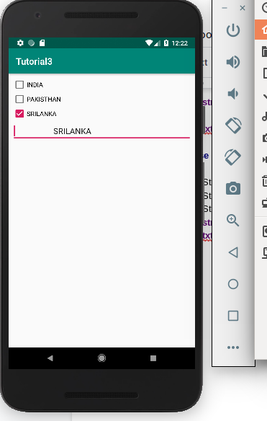

Date 29. 03. 2019 VYSHAK PUTHUSSERI  
 YEDHU THAMBI

**TUTORIAL 4**

**AIM:** Create an application contains two toggle button and one button .When we click on toggle button it will show a toast message.

XML:

<?**xml version="1.0" encoding="utf-8"**?>

<**android.support.constraint.ConstraintLayout xmlns:android="http://schemas.android.com/apk/res/android"**

**xmlns:app="http://schemas.android.com/apk/res-auto"**

**xmlns:tools="http://schemas.android.com/tools"**

**android:layout_width="match_parent"**

**android:layout_height="match_parent"**

**tools:context=".MainActivity"**>

<**LinearLayout**

**android:id="@+id/linearLayout"**

**android:layout_width="0dp"**

**android:layout_height="0dp"**

**android:layout_marginStart="8dp"**

**android:layout_marginTop="8dp"**

**android:layout_marginEnd="8dp"**

**android:layout_marginBottom="8dp"**

**android:orientation="vertical"**

**app:layout_constraintBottom_toBottomOf="parent"**

**app:layout_constraintEnd_toEndOf="parent"**

**app:layout_constraintStart_toStartOf="parent"**

**app:layout_constraintTop_toTopOf="parent"**>

<**ToggleButton**

**android:id="@+id/toggleButton"**

**android:layout_width="match_parent"**

**android:layout_height="wrap_content"**

**android:text="ToggleButton"** />

<**ToggleButton**

**android:id="@+id/toggleButton2"**

**android:layout_width="match_parent"**

**android:layout_height="wrap_content"**

**android:text="ToggleButton"** />

<**Button**

**android:id="@+id/button"**

**android:layout_width="match_parent"**

**android:layout_height="wrap_content"**

**android:text="Button"** />

</**LinearLayout**>

</**android.support.constraint.ConstraintLayout**>

Java code :

**package** com.example.tutorial4;

**import** android.support.v7.app.AppCompatActivity;

**import** android.os.Bundle;

**import** android.view.View;

**import** android.widget.Button;

**import** android.widget.Toast;

**import** android.widget.ToggleButton;

**public class** MainActivity **extends** AppCompatActivity {

Button **b**;

ToggleButton **one**,**two**;

@Override

**protected void** onCreate(Bundle savedInstanceState) {

**super**.onCreate(savedInstanceState);

setContentView(R.layout.**activity_main**);

**b** = (Button)findViewById(R.id.**button**);

**one** = (ToggleButton)findViewById(R.id.**toggleButton**);

**two** = (ToggleButton)findViewById(R.id.**toggleButton2**);

**b**.setOnClickListener(**new** View.OnClickListener() {

@Override

**public void** onClick(View v) {

Toast.makeText(getApplicationContext(),**"Toggle 1 : "**+**one**.getText()+**"\nToggle 2 : "**+**two**.getText(),Toast.**LENGTH_LONG**).show();

}

});

}

}

Screenshot:

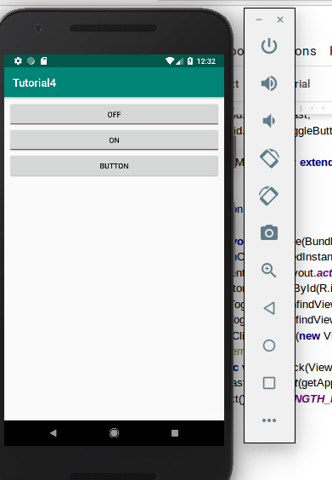

Date 05. 04. 2019 VYSHAK PUTHUSSERI  
 YEDHU THAMBI

**TUTORIAL 5**

**AIM:** Create an application which contains two radio button present in one group. That means at a time one radio button is selected .When we click on button, corresponding text will display in textview. That means, when we click on female radio button, it displays “selected gender:female”

XML:

<?**xml version="1.0" encoding="utf-8"**?>

<**android.support.constraint.ConstraintLayout xmlns:android="http://schemas.android.com/apk/res/android"**

**xmlns:app="http://schemas.android.com/apk/res-auto"**

**xmlns:tools="http://schemas.android.com/tools"**

**android:layout_width="match_parent"**

**android:layout_height="match_parent"**

**tools:context=".MainActivity"**>

<**LinearLayout**

**android:id="@+id/linearLayout"**

**android:layout_width="0dp"**

**android:layout_height="0dp"**

**android:layout_marginStart="8dp"**

**android:layout_marginTop="8dp"**

**android:layout_marginEnd="8dp"**

**android:layout_marginBottom="8dp"**

**android:orientation="vertical"**

**app:layout_constraintBottom_toBottomOf="parent"**

**app:layout_constraintEnd_toEndOf="parent"**

**app:layout_constraintStart_toStartOf="parent"**

**app:layout_constraintTop_toTopOf="parent"**>

<**TextView**

**android:id="@+id/textView"**

**android:layout_width="match_parent"**

**android:layout_height="42dp"**

**android:layout_margin="10dp"**

**android:padding="5dp"**

**android:text="@string/tutorial_5"**

**android:textAlignment="center"** />

<**RadioGroup**

**android:layout_width="318dp"**

**android:layout_height="128dp"**

**android:textAlignment="center"**

**android:id="@+id/sexradiogroup"**>

<**RadioButton**

**android:id="@+id/male"**

**android:layout_width="match_parent"**

**android:layout_height="wrap_content"**

**android:layout_weight="1"**

**android:text="@string/male"** />

<**RadioButton**

**android:id="@+id/female"**

**android:layout_width="match_parent"**

**android:layout_height="wrap_content"**

**android:layout_weight="1"**

**android:text="@string/female"** />

</**RadioGroup**>

<**TextView**

**android:id="@+id/textView2"**

**android:layout_width="match_parent"**

**android:layout_height="wrap_content"**

**android:layout_margin="30dp"**

**android:padding="10dp"**

**android:text="@string/selected_gender"**

**android:textAlignment="center"**

**android:textColorLink="@color/colorAccent"** />

</**LinearLayout**>

</**android.support.constraint.ConstraintLayout**>

JAVA CODE :

**package** com.example.tutorial5;

**import** android.support.v7.app.AppCompatActivity;

**import** android.os.Bundle;

**import** android.view.View;

**import** android.widget.RadioButton;

**import** android.widget.RadioGroup;

**import** android.widget.TextView;

**public class** MainActivity **extends** AppCompatActivity {

RadioGroup **radioGroup**;

RadioButton **male**,**female**;

TextView **textView**;

@Override

**protected void** onCreate(Bundle savedInstanceState) {

**super**.onCreate(savedInstanceState);

setContentView(R.layout.**activity_main**);

**radioGroup** = findViewById(R.id.**sexradiogroup**);

**textView** = findViewById(R.id.**textView2**);

**male** = findViewById(R.id.**male**);

**female** = findViewById(R.id.**female**);

**male**.setOnClickListener(**new** View.OnClickListener() {

@Override

**public void** onClick(View v) {

**textView**.setText(**"SELECTED SEX : MALE"**);

}

});

**female**.setOnClickListener(**new** View.OnClickListener() {

@Override

**public void** onClick(View v) {

**textView**.setText(**"SELECTED SEX : FEMALE"**);

}

});

}

}

**ScreenShot**

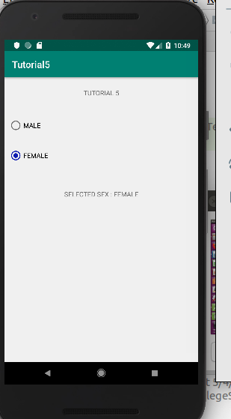

Date 29. 03. 2019 VYSHAK PUTHUSSERI  
 YEDHU THAMBI

**TUTORIAL 6**

**AIM:**Create an example applcation , when we write a letter it suggests the words related to that letter which we write in the edit text.(Auto complete view)

XML:

<?**xml version="1.0" encoding="utf-8"**?>

<**android.support.constraint.ConstraintLayout xmlns:android="http://schemas.android.com/apk/res/android"**

**xmlns:app="http://schemas.android.com/apk/res-auto"**

**xmlns:tools="http://schemas.android.com/tools"**

**android:layout_width="match_parent"**

**android:layout_height="match_parent"**

**tools:context=".MainActivity"**>

<**LinearLayout**

**android:id="@+id/linearLayout"**

**android:layout_width="0dp"**

**android:layout_height="0dp"**

**android:layout_marginStart="8dp"**

**android:layout_marginTop="8dp"**

**android:layout_marginEnd="8dp"**

**android:layout_marginBottom="8dp"**

**android:orientation="vertical"**

**app:layout_constraintBottom_toBottomOf="parent"**

**app:layout_constraintEnd_toEndOf="parent"**

**app:layout_constraintStart_toStartOf="parent"**

**app:layout_constraintTop_toTopOf="parent"**>

<**TextView**

**android:id="@+id/textView"**

**android:layout_width="match_parent"**

**android:layout_height="wrap_content"**

**android:layout_margin="15dp"**

**android:padding="15dp"**

**android:text="TUTORIAL 5"**

**android:textAlignment="center"**

**android:textColor="@color/colorAccent"** />

<**LinearLayout**

**android:layout_width="match_parent"**

**android:layout_height="match_parent"**

**android:orientation="vertical"**>

<**AutoCompleteTextView**

**android:id="@+id/autoCompleteTextView"**

**android:layout_width="match_parent"**

**android:layout_height="wrap_content"**

**android:layout_margin="20dp"**

**android:padding="20dp"**

**android:hint="Enter the names like vyshak puthusseri, yedhu thampi,vishnu prashanth, Tyson"**

**android:textColor="@color/colorAccent"** />

</**LinearLayout**>

</**LinearLayout**>

</**android.support.constraint.ConstraintLayout**>

JAVA CODE :

**package** com.example.tutorial6;

**import** android.support.v7.app.AppCompatActivity;

**import** android.os.Bundle;

**import** android.widget.ArrayAdapter;

**import** android.widget.AutoCompleteTextView;

**public class** MainActivity **extends** AppCompatActivity {

String[] **names** = {**"vyshak puthusseri"**,**"vyshnav"**,**"yeanest"**,**"yedhu thampi"**,**"vimuna"**,**"vishnu prashanth"**,**"Tarson"**,**"Tyson"**};

@Override

**protected void** onCreate(Bundle savedInstanceState) {

**super**.onCreate(savedInstanceState);

setContentView(R.layout.**activity_main**);

ArrayAdapter<String> adapter = **new** ArrayAdapter<String>(**this**, android.R.layout.**select_dialog_item**,**names**);

AutoCompleteTextView txt = (AutoCompleteTextView)findViewById(R.id.**autoCompleteTextView**);

txt.setThreshold(1);//Start prediction from first character

txt.setAdapter(adapter);

}

}

**ScreenShot**

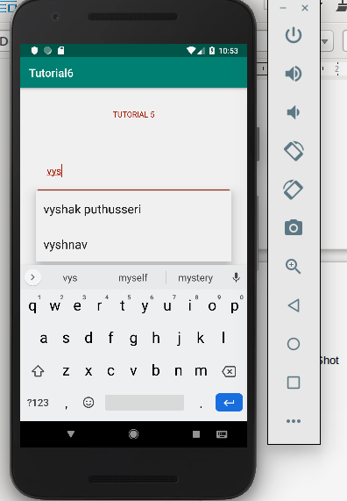

Date 29. 03. 2019 VYSHAK PUTHUSSERI  
 YEDHU THAMBI

**TUTORIAL 7**

**AIM:** Create an example application, where we have to display one image on the screen. Then we have to create two images named android1 and android2,and place it in drawable folder .When we click on change button, the picture of image view will change to android2 (Image view)

XML:

<?**xml version="1.0" encoding="utf-8"**?>

<**android.support.constraint.ConstraintLayout xmlns:android="http://schemas.android.com/apk/res/android"**

**xmlns:app="http://schemas.android.com/apk/res-auto"**

**xmlns:tools="http://schemas.android.com/tools"**

**android:layout_width="match_parent"**

**android:layout_height="match_parent"**

**tools:context=".MainActivity"**>

<**LinearLayout**

**android:id="@+id/linearLayout"**

**android:layout_width="0dp"**

**android:layout_height="0dp"**

**android:layout_marginStart="8dp"**

**android:layout_marginTop="8dp"**

**android:layout_marginEnd="8dp"**

**android:layout_marginBottom="8dp"**

**android:orientation="vertical"**

**app:layout_constraintBottom_toBottomOf="parent"**

**app:layout_constraintEnd_toEndOf="parent"**

**app:layout_constraintStart_toStartOf="parent"**

**app:layout_constraintTop_toTopOf="parent"**>

<**ImageView**

**android:id="@+id/imageView"**

**android:layout_width="match_parent"**

**android:layout_height="426dp"**

**android:contentDescription="TODO"**

**android:src="@drawable/dora"** />

<**Button**

**android:id="@+id/button"**

**android:layout_width="match_parent"**

**android:layout_height="wrap_content"**

**android:text="@string/next"** />

</**LinearLayout**>

</**android.support.constraint.ConstraintLayout**>

JAVA CODE :

**package** com.example.tutorial7;

**import** android.provider.ContactsContract;

**import** android.support.v7.app.AppCompatActivity;

**import** android.os.Bundle;

**import** android.view.View;

**import** android.widget.Button;

**import** android.widget.ImageView;

**public class** MainActivity **extends** AppCompatActivity {

Button **nextButton**;

ImageView **imageView**;

**int count** = 0;

@Override

**protected void** onCreate(Bundle savedInstanceState) {

**super**.onCreate(savedInstanceState);

setContentView(R.layout.**activity_main**);

**nextButton** = (Button)findViewById(R.id.**button**);

**imageView** = (ImageView)findViewById(R.id.**imageView**);

**nextButton**.setOnClickListener(**new** View.OnClickListener() {

@Override

**public void** onClick(View v) {

**if**(**count** == 0 ) {

**imageView**.setImageDrawable(getDrawable(R.drawable.**img1**));

**count** = 1;

} **else if**(**count** == 1){

**imageView**.setImageDrawable(getDrawable(R.drawable.**img2**));

**count** = 2;

} **else if**(**count** == 2){

**imageView**.setImageDrawable(getDrawable(R.drawable.**img3**));

**count** = 3;

}**else if**(**count** == 3){

**imageView**.setImageDrawable(getDrawable(R.drawable.**rose**));

**count** = 4;

}**else** {

**imageView**.setImageDrawable(getDrawable(R.drawable.**dora**));

**count** = 0;

}}

});

}

}

ScreenShot

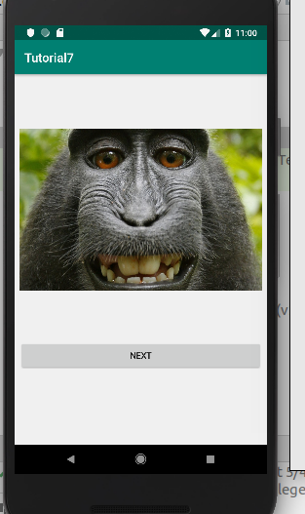

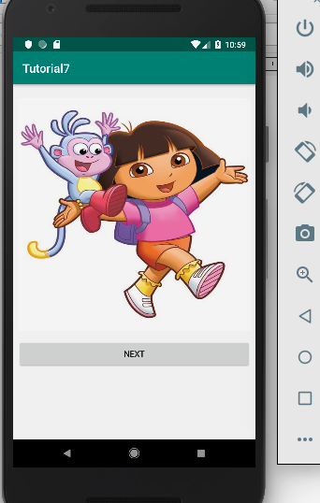

Date 05. 04. 2019 VYSHAK PUTHUSSERI  
 YEDHU THAMBI

**TUTORIAL 8**

**AIM:** Create an example ,where you have a push button for which you can specify a customized background image (Drawable)

XML:

*<?***xml version="1.0" encoding="utf-8"***?>*<**android.support.constraint.ConstraintLayout xmlns:android="http://schemas.android.com/apk/res/android"  
 xmlns:app="http://schemas.android.com/apk/res-auto"  
 xmlns:tools="http://schemas.android.com/tools"  
 android:layout_width="match_parent"  
 android:layout_height="match_parent"  
 tools:context=".MainActivity"**>  
  
 <**LinearLayout  
 android:id="@+id/linearLayout"  
 android:layout_width="0dp"  
 android:layout_height="0dp"  
 android:layout_marginStart="8dp"  
 android:layout_marginTop="8dp"  
 android:layout_marginEnd="8dp"  
 android:layout_marginBottom="8dp"  
 android:orientation="vertical"  
 app:layout_constraintBottom_toBottomOf="parent"  
 app:layout_constraintEnd_toEndOf="parent"  
 app:layout_constraintStart_toStartOf="parent"  
 app:layout_constraintTop_toTopOf="parent"  
 android:background="@drawable/img2"**>  
  
  
 <**ImageButton  
 android:id="@+id/button"  
 android:layout_width="300dp"  
 android:layout_height="150dp"  
 android:src="@drawable/dora"** />  
 </**LinearLayout**>  
  
</**android.support.constraint.ConstraintLayout**>

JAVA CODE :

**package** com.example.tutorial_8;  
  
**import** android.support.v7.app.AppCompatActivity;  
**import** android.os.Bundle;  
**import** android.view.View;  
**import** android.widget.Button;  
**import** android.widget.ImageButton;  
**import** android.widget.LinearLayout;  
  
**public class** MainActivity **extends** AppCompatActivity {  
  
 ImageButton **nextButton**;  
 LinearLayout **background**;  
 @Override  
 **protected void** onCreate(Bundle savedInstanceState) {  
 **super**.onCreate(savedInstanceState);  
 setContentView(R.layout.***activity_main***);  
 **nextButton** = findViewById(R.id.***button***);  
 **background** = (LinearLayout)findViewById(R.id.***linearLayout***);  
 **nextButton**.setOnClickListener(**new** View.OnClickListener() {  
 @Override  
 **public void** onClick(View v) {  
 **background**.setBackground(getDrawable(R.drawable.***dora***));  
 }  
 });  
 }  
}

**ScreenShot**

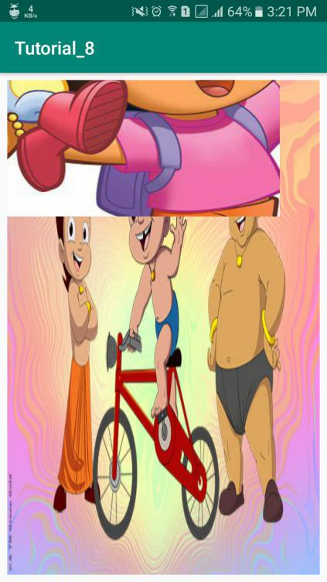 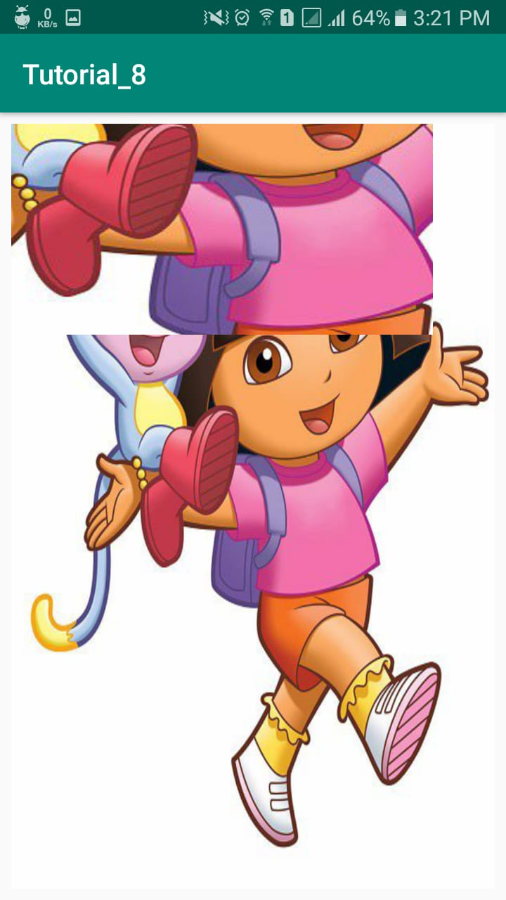

Date 05. 04. 2019 VYSHAK PUTHUSSERI  
 YEDHU THAMBI

**TUTORIAL 9**

**AIM:** Create a timepicker application where we have to pick current time and display it on the screen.

XML:

<?**xml version="1.0" encoding="utf-8"**?>

<**android.support.constraint.ConstraintLayout xmlns:android="http://schemas.android.com/apk/res/android"**

**xmlns:app="http://schemas.android.com/apk/res-auto"**

**xmlns:tools="http://schemas.android.com/tools"**

**android:layout_width="match_parent"**

**android:layout_height="match_parent"**

**tools:context=".MainActivity"**>

<**RelativeLayout**

**android:layout_width="match_parent"**

**android:layout_height="match_parent"**>

<**TimePicker**

**android:layout_width="wrap_content"**

**android:layout_height="wrap_content"**

**android:id="@+id/timePicker"**></**TimePicker**>

<**TextView**

**android:layout_width="wrap_content"**

**android:layout_height="wrap_content"**

**android:id="@+id/display"**

**android:layout_below="@+id/timePicker"**/>

</**RelativeLayout**>

</**android.support.constraint.ConstraintLayout**>

JAVA CODE :

**package** com.example.tutorial;

**import** android.support.v7.app.AppCompatActivity;

**import** android.os.Bundle;

**import** android.widget.TextView;

**import** android.widget.TimePicker;

**public class** MainActivity **extends** AppCompatActivity {

TimePicker **timePicker**;

TextView **textView**;

@Override

**protected void** onCreate(Bundle savedInstanceState) {

**super**.onCreate(savedInstanceState);

setContentView(R.layout.**activity_main**);

**timePicker** =findViewById(R.id.**timePicker**);

**textView** = findViewById(R.id.**display**);

**textView**.setText(**"Current Time : "**+**timePicker**.getHour()+ **" : "**+**timePicker**.getMinute()+**" "**);

**timePicker**.setOnTimeChangedListener(**new** TimePicker.OnTimeChangedListener() {

@Override

**public void** onTimeChanged(TimePicker view, **int** hourOfDay, **int** minute) {

**textView**.setText(**"Time : "**+hourOfDay + **" : "**+minute);

}

});

}

}

**ScreenShot**

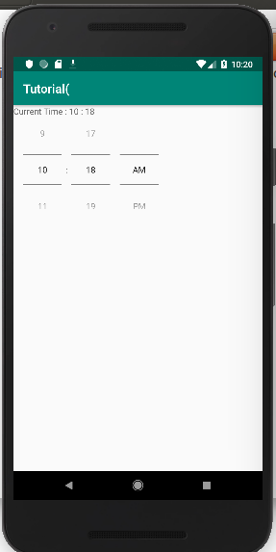

Date 05. 04. 2019 VYSHAK PUTHUSSERI  
 YEDHU THAMBI

**TUTORIAL 10**

**AIM:** Create a datepicker application where we have to pick current date and display it on the screen.

XML:

<?**xml version="1.0" encoding="utf-8"**?>

<**RelativeLayout xmlns:android="http://schemas.android.com/apk/res/android"**

**xmlns:app="http://schemas.android.com/apk/res-auto"**

**xmlns:tools="http://schemas.android.com/tools"**

**android:layout_width="match_parent"**

**android:layout_height="match_parent"**

**tools:context=".MainActivity"**>

<**DatePicker**

**android:layout_width="wrap_content"**

**android:layout_height="wrap_content"**

**android:id="@+id/datePicker"**>

</**DatePicker**>

<**TextView**

**android:layout_width="wrap_content"**

**android:layout_height="wrap_content"**

**android:id="@+id/display"**/>

</**RelativeLayout**>

JAVA CODE :

**package** com.example.tutorial_10;

**import** android.support.v7.app.AppCompatActivity;

**import** android.os.Bundle;

**import** android.widget.DatePicker;

**import** android.widget.TextView;

**import** android.widget.TimePicker;

**import** java.time.Year;

**import** java.util.Calendar;

**public class** MainActivity **extends** AppCompatActivity {

DatePicker **datePicker**;

TextView **textView**;

@Override

**protected void** onCreate(Bundle savedInstanceState) {

**super**.onCreate(savedInstanceState);

setContentView(R.layout.**activity_main**);

**datePicker** =findViewById(R.id.**datePicker**);

**textView** = findViewById(R.id.**display**);

**final** Calendar calendar = Calendar.getInstance();

**textView**.setText(calendar.get(calendar.**DAY_OF_MONTH**)+**" : "**+ calendar.get(Calendar.**MONTH**)+ **" : "** +calendar.get(Calendar.**YEAR**));

**datePicker**.init(calendar.get(Calendar.**YEAR**), calendar.get(Calendar.**MONTH**), calendar.get(Calendar.**DAY_OF_MONTH**), **new** DatePicker.OnDateChangedListener() {

@Override

**public void** onDateChanged(DatePicker view, **int** year, **int** monthOfYear, **int** dayOfMonth) {

**textView**.setText(dayOfMonth +**" : "**+monthOfYear+**" : "**+ year);

}

});

}

}

**ScreenShot**

