- 总结：

每一次做RDM构建，请修改版本，否则就会出现OTA升级失败的问题。

处处是坑，请君小心为上。
- 问题描述：
ID： 50187338
刷回3.5或者3.6版本，ota增量升级失败，安装期间出现："ROM内嵌刷机脚本出错 "提示
【条件】
刷回新蜂9308 v3.5或者 v3.6 版本
【测试机型】
三星I9308
【步骤】
- 刷回9308之前的版本（如： v3.5或者 v3.6）
- 2. 连接wifi后，进入 系统升级，检测最新版本
- 3. 检测到增量包（3M或者5M）下载安装，
- 4. 查看ota增量升级是否成功
【现象】
ota增量升级安装期间出现：ROM内嵌刷机脚本出错 提示
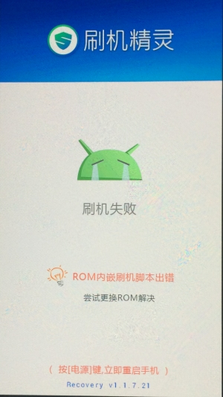
【重现规律】
操作3次，出现3次
【预期结果】
ota增量升级成功并工作正常
- 问题分析
- 从/cache/recovery/目录下面，取last_log，如下为关键log：
I:Update location: /data/media/0/ota_newbee_0f9abc88e24ef6a7bd925a92183d90b8_1422407506163.zip
Opening update package...
Installing update...
Verifying current system...
- file "/system/build.prop" doesn't have any of expected sha1 sums; checking cache
- failed to stat "/cache/saved.file": No such file or directory
- failed to load cache file
script aborted: assert failed: apply_patch_check("/system/build.prop", "d8f7ae6a3a5c9a80ddc2637a3bc851d10758a9f8", "9913fb26c5c9158c9cd772d4cdde5441df8b94c8")
assert failed: apply_patch_check("/system/build.prop", "d8f7ae6a3a5c9a80ddc2637a3bc851d10758a9f8", "9913fb26c5c9158c9cd772d4cdde5441df8b94c8")
E:Error in /data/media/0/ota_newbee_0f9abc88e24ef6a7bd925a92183d90b8_1422407506163.zip
(Status 7)
I:install_package result 6
先来看看这个三个关键log的出处：

// Returns 0 if the contents of the file (argv[2]) or the cached file

// match any of the sha1's on the command line (argv[3:]). Returns

// nonzero otherwise.

int applypatch_check(const char* filename,

int num_patches, char** const patch_sha1_str) {

FileContents file;

file.data = NULL;

// It's okay to specify no sha1s; the check will pass if the LoadFileContents is successful. (Useful for reading

// partitions, where the filename encodes the sha1s; no need to check them twice.)

if (LoadFileContents(filename, &file, RETOUCH_DO_MASK) != 0 ||

(num_patches > 0 &&

FindMatchingPatch(file.sha1, patch_sha1_str, num_patches) < 0)) {

printf("file \"%s\" doesn't have any of expected " "sha1 sums; checking cache\n", filename);

free(file.data);

file.data = NULL;

// If the source file is missing or corrupted, it might be because we were killed in the middle of patching it.

//A copy of it should have been made in CACHE_TEMP_SOURCE.

//If that file exists and matches the sha1 we're looking for, the check still passes.

if (LoadFileContents(CACHE_TEMP_SOURCE, &file, RETOUCH_DO_MASK) != 0) {

printf("failed to load cache file\n");

return 1;

}

if (FindMatchingPatch(file.sha1, patch_sha1_str, num_patches) < 0) {

printf("cache bits don't match any sha1 for \"%s\"\n", filename);

free(file.data);

return 1;

}

}

free(file.data);

return 0;

}

// Read a file into memory; optionally (retouch_flag == RETOUCH_DO_MASK) mask

// the retouched entries back to their original value (such that SHA-1 checks

// don't fail due to randomization); store the file contents and associated

// metadata in *file.

//

// Return 0 on success.

int LoadFileContents(const char* filename, FileContents* file,

int retouch_flag) {

file->data = NULL;

// A special 'filename' beginning with "MTD:" or "EMMC:" means to

// load the contents of a partition.

if (strncmp(filename, "MTD:", 4) == 0 ||

strncmp(filename, "EMMC:", 5) == 0) {

return LoadPartitionContents(filename, file);

}

if (stat(filename, &file->st) != 0) {

printf("failed to stat \"%s\": %s\n", filename, strerror(errno));

return -1;

}

.......

}

关于SHA1加解密的方式，请查看：http://www.siqiboke.com/post/121.html
关于android rom刷机过程，请参考：http://wenku.baidu.com/view/f6e589926bec0975f465e2aa.html?re=view
回到这个问题，总之，在做updater之前，系统会对于ota升级包的有效性做检查。在升级脚本updater-script的语法中，apply_patch_check命令对应的函数实体为：ApplyPatchCheckFn。
在ApplyPatchCheckFn()中检查完参数的有效性之后，实际上是直接调用applypatch_check这个函数来验证patch包的有效性。

@bootable/recovery/updater/install.c

// apply_patch_check(file, [sha1_1, ...])

Value* ApplyPatchCheckFn(const char* name, State* state,

int argc, Expr* argv[]) {

if (argc < 1) {

return ErrorAbort(state, "%s(): expected at least 1 arg, got %d",

name, argc);

}

char* filename;

if (ReadArgs(state, argv, 1, &filename) < 0) {

return NULL;

}

int patchcount = argc-1;

char** sha1s = ReadVarArgs(state, argc-1, argv+1);

int result = applypatch_check(filename, patchcount, sha1s);

int i;

for (i = 0; i < patchcount; ++i) {

free(sha1s[i]);

}

free(sha1s);

return StringValue(strdup(result == 0 ? "t" : ""));

}
整个校验过程如下，这里面以build.prop为例。
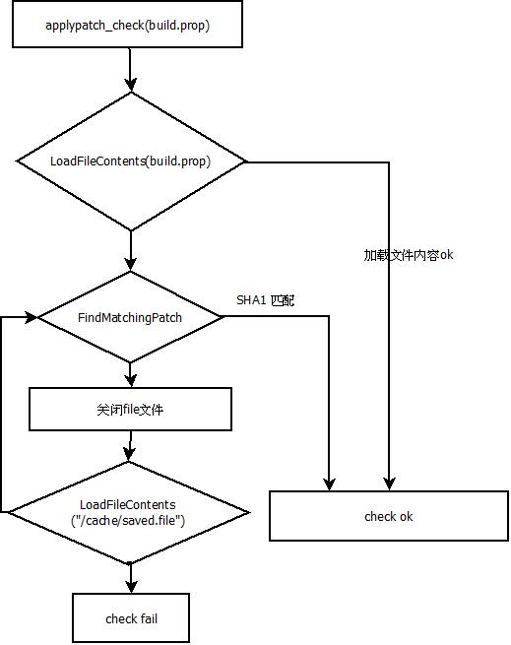
从log来看，很显然，是因为校验不过导致程序没有办法继续执行下去。
那么为什么会校验不过呢？问题先留着，看看ota升级包是如何产生的。
- 生成ota升级包
从我们的build的脚本来看，ota生成包是在RDM构建服务器中的Build_newbee.sh中来完成的。
这部分的脚本如下：
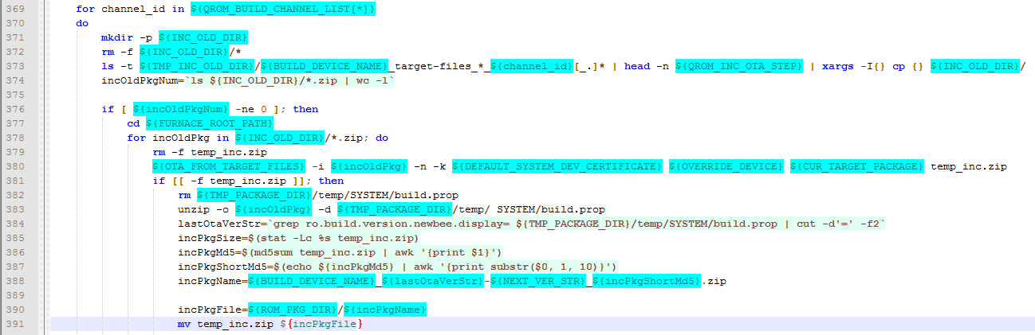

几个关键节点的脚步说明：
Line 378：找到一个之前版本的zip包。---》标注1
Line380: 调用脚本ota_from_target_files来生成ota包，为temp_inc.zip;
Line388&Line391: 生成ota的名字，并将temp_inc.zip重命名。
于是在RDM构建之后的url.txt中就会有类似这样的一些链接：
http://dl.nbrom.cn/17051/1e41f0027ceb822a39ffdf625b9f3150.zip?fsname=I9308_newbee_16.13.01.15_release_V3.7-newbee_5.01.27.21_release_1e41f0027c.zip 1e41f0027ceb822a39ffdf625b9f3150
http://dl.nbrom.cn/17051/1ed0ac15f474a7db1de197afabd4df61.zip?fsname=I9308_newbee_16.13.01.15_release_V3.7-newbee_5.01.27.21_release_1ed0ac15f4.zip 1ed0ac15f474a7db1de197afabd4df61
http://dl.nbrom.cn/17051/dd8bab067e0f231bd139d87ee2495f73.zip?fsname=I9308_newbee_4.10.16.16_release_V3.4-newbee_5.01.27.21_release_dd8bab067e.zip dd8bab067e0f231bd139d87ee2495f73
http://dl.nbrom.cn/17051/e8e01095d9c81139bfe244c3d4f3cd41.zip?fsname=I9308_newbee_4.10.16.16_release_V3.4-newbee_5.01.27.21_release_e8e01095d9.zip e8e01095d9c81139bfe244c3d4f3cd41
http://dl.nbrom.cn/17051/fc8d86feb186eab837476cc3c3bc0fa7.zip?fsname=I9308_newbee_4.10.16.16_release_V3.4-newbee_5.01.27.21_release_fc8d86feb1.zip fc8d86feb186eab837476cc3c3bc0fa7
http://dl.nbrom.cn/17051/52886c14a659575e7b64c829f3013600.zip?fsname=I9308_newbee_4.11.05.15_release_V3.5-newbee_5.01.27.21_release_52886c14a6.zip 52886c14a659575e7b64c829f3013600
http://dl.nbrom.cn/17051/7335c3c668d62e4973813876810cf461.zip?fsname=I9308_newbee_4.11.05.15_release_V3.5-newbee_5.01.27.21_release_7335c3c668.zip 7335c3c668d62e4973813876810cf461
http://dl.nbrom.cn/17051/3fd8035ad67f891335448fed0553eab4.zip?fsname=I9308_newbee_4.11.27.17_release_V3.6-newbee_5.01.27.21_release_3fd8035ad6.zip 3fd8035ad67f891335448fed0553eab4

这些包都是OTA包，我们简化下：

I9308_newbee_16.13.01.15_release_V3.7-newbee_5.01.27.21_release_1e41f0027c.zip

I9308_newbee_16.13.01.15_release_V3.7-newbee_5.01.27.21_release_1ed0ac15f4.zip

I9308_newbee_4.10.16.16_release_V3.4-newbee_5.01.27.21_release_dd8bab067e.zip

I9308_newbee_4.10.16.16_release_V3.4-newbee_5.01.27.21_release_e8e01095d9.zip

I9308_newbee_4.10.16.16_release_V3.4-newbee_5.01.27.21_release_fc8d86feb1.zip

I9308_newbee_4.11.05.15_release_V3.5-newbee_5.01.27.21_release_52886c14a6.zip

I9308_newbee_4.11.05.15_release_V3.5-newbee_5.01.27.21_release_7335c3c668.zip

I9308_newbee_4.11.27.17_release_V3.6-newbee_5.01.27.21_release_3fd8035ad6.zip

也就是如果以4.11.05.15_release_V3.5这个版本构建了3次，那么就会在这次的RDM构建中出现三个ota升级包。
- 发布

在发布的时候，会选择一个当前的版本进行发布，包括OTA包和全量包。比如：I9308_newbee_4.11.27.17_release_V3.6-newbee_5.01.27.21_release_3fd8035ad6.zip

可是，问题来了，对于前一个版本4.11.05.15_release_V3.5的OTA包，会选择哪一个呢。据我的了解，应该是不确定的。那也就是说，如果用户机器上面刷的I9308_newbee_4.11.05.15_release_V3.5-newbee_5.01.27.21_release_7335c3c668.zip对应的4.11.05.15_release_V3.5包，而服务器确实提交却是I9308_newbee_4.11.05.15_release_V3.5-newbee_5.01.27.21_release_52886c14a6.zip，于是就会出现SHA1校验出错。

用个图来表示可能会更加清楚：

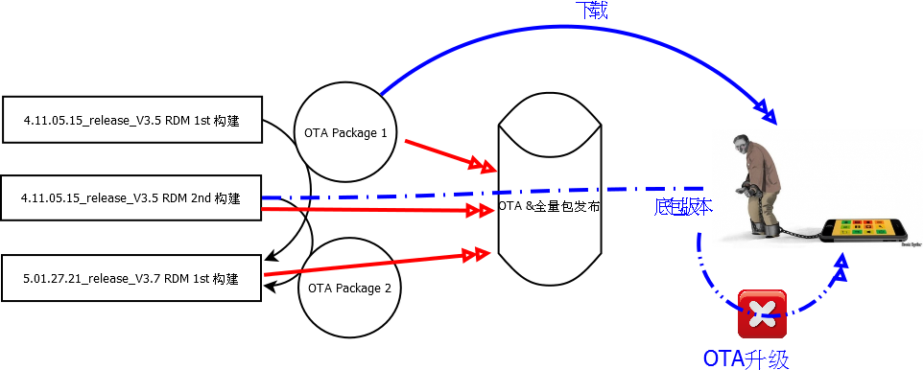
- 解决办法：

将服务器上面同一版本中非发布的zip删掉，重新进行RDM构建。问题解决。

