目前有两种办法来查看帧率，本质都是一样，即都是基于SurfaceFlinger的调用来实现。

1 dumpsys SurfaceFlinger --dispsync
我们先来看看执行命令的结果：
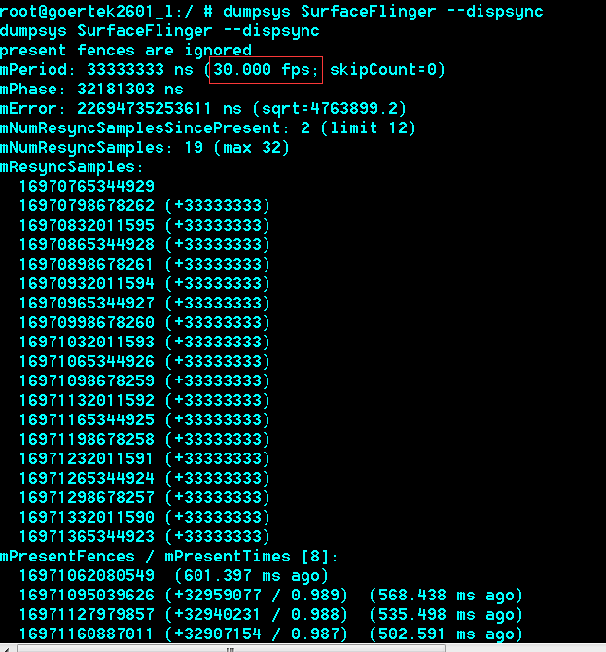
我们可以从这个参数中，清楚地看到当前的实际帧率为30FPS。
接下来，来看看具体的代码实现，本质上就是调用了SurfaceFlinger::dump函数。
status_t SurfaceFlinger::dump(int fd, const Vector<String16>& args)
{
String8 result;

IPCThreadState* ipc = IPCThreadState::self();
const int pid = ipc->getCallingPid();
const int uid = ipc->getCallingUid();
if ((uid != AID_SHELL) &&
!PermissionCache::checkPermission(sDump, pid, uid)) {
result.appendFormat("Permission Denial: "
"can't dump SurfaceFlinger from pid=%d, uid=%d\n", pid, uid);
} else {
// Try to get the main lock, but don't insist if we can't
// (this would indicate SF is stuck, but we want to be able to
// print something in dumpsys).
int retry = 3;
while (mStateLock.tryLock()<0 && --retry>=0) {
usleep(1000000);
}
const bool locked(retry >= 0);
if (!locked) {
result.append(
"SurfaceFlinger appears to be unresponsive, "
"dumping anyways (no locks held)\n");
}

bool dumpAll = true;
size_t index = 0;
size_t numArgs = args.size();
if (numArgs) {
if ((index < numArgs) &&
(args[index] == String16("--list"))) {
index++;
listLayersLocked(args, index, result);
dumpAll = false;
}

if ((index < numArgs) &&
(args[index] == String16("--latency"))) {
index++;
dumpStatsLocked(args, index, result);
dumpAll = false;
}

if ((index < numArgs) &&
(args[index] == String16("--latency-clear"))) {
index++;
clearStatsLocked(args, index, result);
dumpAll = false;
}

if ((index < numArgs) &&
(args[index] == String16("--dispsync"))) {
index++;
mPrimaryDispSync.dump(result);
dumpAll = false;
}
}

if (dumpAll) {
dumpAllLocked(args, index, result);
}

if (locked) {
mStateLock.unlock();
}
}
write(fd, result.string(), result.size());
return NO_ERROR;
}
我们看看mPrimaryDispSync.dump(result);的实现：
void DispSync::dump(String8& result) const {
Mutex::Autolock lock(mMutex);
result.appendFormat("present fences are %s\n",
kIgnorePresentFences ? "ignored" : "used");
result.appendFormat("mPeriod: %" PRId64 " ns (%.3f fps; skipCount=%d)\n",
mPeriod, 1000000000.0 / mPeriod, mRefreshSkipCount);
result.appendFormat("mPhase: %" PRId64 " ns\n", mPhase);
result.appendFormat("mError: %" PRId64 " ns (sqrt=%.1f)\n",
mError, sqrt(mError));
result.appendFormat("mNumResyncSamplesSincePresent: %d (limit %d)\n",
mNumResyncSamplesSincePresent, MAX_RESYNC_SAMPLES_WITHOUT_PRESENT);
result.appendFormat("mNumResyncSamples: %zd (max %d)\n",
mNumResyncSamples, MAX_RESYNC_SAMPLES);

result.appendFormat("mResyncSamples:\n");
nsecs_t previous = -1;
for (size_t i = 0; i < mNumResyncSamples; i++) {
size_t idx = (mFirstResyncSample + i) % MAX_RESYNC_SAMPLES;
nsecs_t sampleTime = mResyncSamples[idx];
if (i == 0) {
result.appendFormat(" %" PRId64 "\n", sampleTime);
} else {
result.appendFormat(" %" PRId64 " (+%" PRId64 ")\n",
sampleTime, sampleTime - previous);
}
previous = sampleTime;
}mNumResyncSamplesSincePresent

result.appendFormat("mPresentFences / mPresentTimes [%d]:\n",
NUM_PRESENT_SAMPLES);
nsecs_t now = systemTime(SYSTEM_TIME_MONOTONIC);
previous = 0;
for (size_t i = 0; i < NUM_PRESENT_SAMPLES; i++) {
size_t idx = (i + mPresentSampleOffset) % NUM_PRESENT_SAMPLES;
bool signaled = mPresentFences[idx] == NULL;
nsecs_t presentTime = mPresentTimes[idx];
if (!signaled) {
result.appendFormat(" [unsignaled fence]\n");
} else if (presentTime == 0) {
result.appendFormat(" 0\n");
} else if (previous == 0) {
result.appendFormat(" %" PRId64 " (%.3f ms ago)\n", presentTime,
(now - presentTime) / 1000000.0);
} else {
result.appendFormat(" %" PRId64 " (+%" PRId64 " / %.3f) (%.3f ms ago)\n",
presentTime, presentTime - previous,
(presentTime - previous) / (double) mPeriod,
(now - presentTime) / 1000000.0);
}
previous = presentTime;
}

result.appendFormat("current monotonic time: %" PRId64 "\n", now);
}
这个mPeriod就是Dispsync同步之后的频率。

2 通过surfaceflinger 1013号来查看
service call SurfaceFlinger 1013
sleep 600
service call SurfaceFlinger 1013
通过时间差来计算具体的帧率。
执行的结果如下：
root@goertek2601_l:/data # sh fps_test.sh
Result: Parcel(00001a26 '&...')
Result: Parcel(00001a6b 'k...')
这个是一个十六进制的显示，需要手动计算差值，然后除以时间，这样就可以算出具体的帧率。
具体的实现是onTransact@SurfaceFlinger.cpp
case 1013: {
Mutex::Autolock _l(mStateLock);
sp<const DisplayDevice> hw(getDefaultDisplayDevice());
reply->writeInt32(hw->getPageFlipCount());
return NO_ERROR;
getPageFlipCount()@DisplayDevice.cpp
uint32_t DisplayDevice::getPageFlipCount() const {
return mPageFlipCount;
}

void DisplayDevice::flip(const Region& dirty) const
{
mFlinger->getRenderEngine().checkErrors();

EGLDisplay dpy = mDisplay;
EGLSurface surface = mSurface;

#ifdef EGL_ANDROID_swap_rectangle
if (mFlags & SWAP_RECTANGLE) {
const Region newDirty(dirty.intersect(bounds()));
const Rect b(newDirty.getBounds());
eglSetSwapRectangleANDROID(dpy, surface,
b.left, b.top, b.width(), b.height());
}
#else
(void) dirty; // Eliminate unused parameter warning
#endif

mPageFlipCount++;
}

从上面的代码可以知道，每做一次flip，就将mPageFlipCount自加1，那么时间段的差值就可以计算出来。这样，也就得到了平均的帧率。

