屏幕：色彩（8mA）、lcd刷新率、vsync的帧率（9.327mA）；

CPU：调频

场景：脱腕，静置，关掉ＴＰ

程序：减少不要的layer

1 屏幕色彩的影响
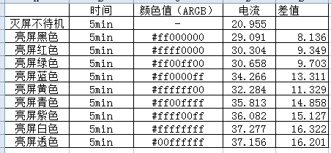

2 降低lcd的刷新频率

3 降低vsync的帧率
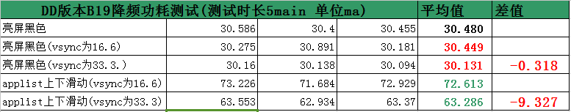
通过手动调整vsync的帧率，来实现CPU & GPU功耗的降低。本质是通过调整Dispsync的刷新频率来实现。
diff --git a/native/services/surfaceflinger/DisplayHardware/HWComposer.cpp b/native/services/surfaceflinger/DisplayHardware/HWComposer.cpp
index 83cfd1b..4c606cf 100644
--- a/native/services/surfaceflinger/DisplayHardware/HWComposer.cpp
+++ b/native/services/surfaceflinger/DisplayHardware/HWComposer.cpp
@@ -523,7 +523,16 @@ float HWComposer::getDpiY(int disp) const {

nsecs_t HWComposer::getRefreshPeriod(int disp) const {
size_t currentConfig = mDisplayData[disp].currentConfig;
- return mDisplayData[disp].configs[currentConfig].refresh;
+ char value1[PROPERTY_VALUE_MAX];
+ int mSWVsyncPeriod;
+ property_get("debug.sf.sw_vsync_period", value1, "0");
+ mSWVsyncPeriod = atoi(value1);
+ if ( mSWVsyncPeriod > 0){
+ ALOGD("junsion modify the mSWVsyncPeriod =%d\n",mSWVsyncPeriod);
+ return mSWVsyncPeriod;
+ }
+ return mDisplayData[disp].configs[currentConfig].refresh;
+
}

const Vector<HWComposer::DisplayConfig>& HWComposer::getConfigs(int disp) const {
diff --git a/native/services/surfaceflinger/SurfaceFlinger.cpp b/native/services/surfaceflinger/SurfaceFlinger.cpp
index 9a2e1dd..e97a550 100644
--- a/native/services/surfaceflinger/SurfaceFlinger.cpp
+++ b/native/services/surfaceflinger/SurfaceFlinger.cpp
@@ -891,18 +891,27 @@ void SurfaceFlinger::disableHardwareVsync(bool makeUnavailable) {

void SurfaceFlinger::onVSyncReceived(int type, nsecs_t timestamp) {
bool needsHwVsync = false;
-
- { // Scope for the lock
- Mutex::Autolock _l(mHWVsyncLock);
- if (type == 0 && mPrimaryHWVsyncEnabled) {
- needsHwVsync = mPrimaryDispSync.addResyncSample(timestamp);
- }
- }
-
- if (needsHwVsync) {
- enableHardwareVsync();
- } else {
- disableHardwareVsync(false);
+ char value1[PROPERTY_VALUE_MAX];
+ int mSWVsyncPeriod;
+ property_get("debug.sf.sw_vsync_period", value1, "0");
+ mSWVsyncPeriod = atoi(value1);
+ if ( mSWVsyncPeriod > 0){
+ ALOGD("junsion modify the mSWVsyncPeriod =%d\n",mSWVsyncPeriod);
+ disableHardwareVsync(false);
+ mPrimaryDispSync.reset();
+ mPrimaryDispSync.setPeriod(mSWVsyncPeriod);
+ }else{
+ {
+ Mutex::Autolock _l(mHWVsyncLock);
+ if (type == 0 && mPrimaryHWVsyncEnabled) {
+ needsHwVsync = mPrimaryDispSync.addResyncSample(timestamp);
+ }
+ }
+ if (needsHwVsync) {
+ enableHardwareVsync();
+ } else {
+ disableHardwareVsync(false);
+ }
}
}

4 脱腕，静置
发现脱腕就降低心率、计步器的采集频率，30分钟之后，就将屏幕（37mA）关掉。

5 关掉TP
关掉触摸屏，大概可以节省2mA/时。

6 Cpu调频
Mtk2601支持3个频率1001000：806000：598000

7 黑白模式（shader）
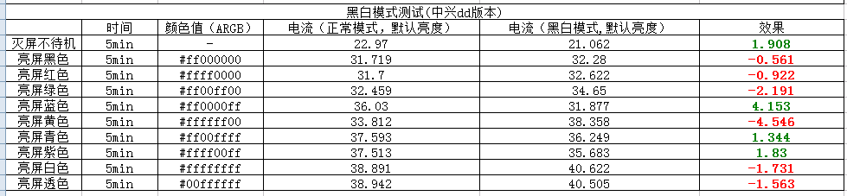

commit f9f8b1af43741c9f95ecd9c9bd98bc97b792a2b3
Author: Daniel <yaocong_52@163.com>
Date: Thu Mar 10 14:35:45 2016 +0800

当hwc关闭时，增加GPU合成时的黑白滤镜效果

diff --git a/services/surfaceflinger/RenderEngine/Program.cpp b/services/surfaceflinger/RenderEngine/Program.cpp
old mode 100644
new mode 100755
index 4a7fb58..7830e0b
--- a/services/surfaceflinger/RenderEngine/Program.cpp
+++ b/services/surfaceflinger/RenderEngine/Program.cpp
@@ -22,6 +22,7 @@
#include "ProgramCache.h"
#include "Description.h"
#include <utils/String8.h>
+#include "cutils/properties.h"

namespace android {

@@ -65,6 +66,10 @@ Program::Program(const ProgramCache::Key& needs, const char* vertex, const char*
mColorLoc = glGetUniformLocation(programId, "color");
mAlphaPlaneLoc = glGetUniformLocation(programId, "alphaPlane");

+ //added by ycD for color2grey
+ mColortogreyUniform = getUniform("colortogrey");
+ //end add
+
// set-up the default values for our uniforms
glUseProgram(programId);
const GLfloat m[16] = {1,0,0,0, 0,1,0,0, 0,0,1,0, 0,0,0,1 };
@@ -143,6 +148,22 @@ void Program::setUniforms(const Description& desc) {
}
// these uniforms are always present
glUniformMatrix4fv(mProjectionMatrixLoc, 1, GL_FALSE, desc.mProjectionMatrix.asArray());
-}

+ //added by ycD for color2grey
+ if(mColortogreyUniform >= 0){
+ char* tmp;
+ float ft[3];
+ char val[PROPERTY_VALUE_MAX];
+ property_get("persist.sys.textutils.Colorgrey", val, "0.0 0.0 0.0");
+// ALOGD(" ycDColor2Grey persist.sys.textutils.Colorgrey = %s", val);
+ tmp = strtok(val, " ");
+ ft[0] = atof(tmp);
+ tmp = strtok(NULL, " ");
+ ft[1] = atof(tmp);
+ tmp = strtok(NULL, " ");
+ ft[2] = atof(tmp);
+ glUniform3f(mColortogreyUniform, ft[0]/100.0f, ft[1]/100.0f, ft[2]/100.0f);
+ }
+ //end add
+}
} /* namespace android */
diff --git a/services/surfaceflinger/RenderEngine/Program.h b/services/surfaceflinger/RenderEngine/Program.h
old mode 100644
new mode 100755
index 36bd120..4466de7
--- a/services/surfaceflinger/RenderEngine/Program.h
+++ b/services/surfaceflinger/RenderEngine/Program.h
@@ -54,7 +54,6 @@ public:
/* set-up uniforms from the description */
void setUniforms(const Description& desc);

-
private:
GLuint buildShader(const char* source, GLenum type);
String8& dumpShader(String8& result, GLenum type);
@@ -84,6 +83,9 @@ private:

/* location of the color uniform */
GLint mColorLoc;
+ //added by ycD for color2grey
+ int mColortogreyUniform;
+ //added end
};

diff --git a/services/surfaceflinger/RenderEngine/ProgramCache.cpp b/services/surfaceflinger/RenderEngine/ProgramCache.cpp
old mode 100644
new mode 100755
index 09b0ddc..196829b
--- a/services/surfaceflinger/RenderEngine/ProgramCache.cpp
+++ b/services/surfaceflinger/RenderEngine/ProgramCache.cpp
@@ -129,6 +129,9 @@ String8 ProgramCache::generateFragmentShader(const Key& needs) {
// default precision is required-ish in fragment shaders
fs << "precision mediump float;";

+ //add by ycD for color2grey
+ fs << " uniform vec3 colortogrey; ";
+ //end add
if (needs.getTextureTarget() == Key::TEXTURE_EXT) {
fs << "uniform samplerExternalOES sampler;"
<< "varying vec2 outTexCoords;";
@@ -177,6 +180,17 @@ String8 ProgramCache::generateFragmentShader(const Key& needs) {
}
}

+ //add by ycD for color2grey
+ fs << "if(colortogrey.x == 1.0 && colortogrey.y == 1.0 && colortogrey.z == 1.0)";
+ fs << "{";
+ fs << "float r = gl_FragColor.r , g = gl_FragColor.g, b = gl_FragColor.b;";
+ fs << "float y = 0.299*r + 0.587*g + 0.114*b;";
+ fs << "gl_FragColor.r = y;";
+ fs << "gl_FragColor.g = y;";
+ fs << "gl_FragColor.b = y;";
+ fs << "} ";
+ //end add
+
fs << dedent << "}";
return fs.getString();
}

8 减少非必要的layers

9 屏幕网格化显示
