##### AGENDA

首先我們會先簡介如何實作，接著再分為Env與Agent介紹，最後講我們訓練的結果

First, we will start by giving an overview of the implementation. Then, we will dive into the introduction of the environment and the agent. Finally, we will discuss the results of our training.

##### 簡介

我們使用DDQN作為主要的演算法

有兩個獨立的ConvNet，分別為Qonline跟Qtarget，這兩者為獨立的optimal action-value function

這兩個獨立的value function會由TD Estimate與TD Target來得到

最後，本篇使用epsilon-greedy action

First, we utilize two Convolutional Neural Networks, called Q_online and Q_target. These networks independently approximate the optimal action-value function, helping our agent make decisions in the environment.

Next, we have two important values in play: the TD Estimate and the TD Target. These values are crucial for training our agent effectively. The TD Estimate is the value predicted by our Q_online network for a given state-action pair, while the TD Target is calculated using the Q_target network and represents the maximum expected future rewards.

As for the action part, we employ an epsilon-greedy action selection strategy. And we will introduce it more detail later.

##### Enviroment

我們使用前面提到的gym_super_mario_bros作為我們的env，接著用JoypadSpace將action space限制在只做往右及往右上跳的動作。

接著因為馬力歐遊戲不會因為背景顏色而影響做的action，我們將其背景轉為灰階，如此，每個state的array會由[240,256,3] →[240,256,1]。接著將其resize成[84,84,1]。

而skipFrame是從gym.Wrapper中繼承而來的，主要是在執行step時，因為連續的Frame並不會差異很多，可以透過skip n個連續的Frame來加速運算，且不會lose過多data。至於reward的部分則會被累加起來。

最後就是用FrameStack將四個state合起來當作一個觀測點，也就是每個state的array會轉成[4,84,84,1]

We use the gym_super_mario_bros environment mentioned earlier as our env. We utilize JoypadSpace to restrict the action to either walking right or jumping right

Since the actions taken by Mario in the game are not affected by the background color, we convert the background to grayscale. This means that each state array, originally in the shape [240, 256, 3], becomes [240, 256, 1]. We then resize it to [84, 84, 1].

The skipFrame functionality is inherited from gym.Wrapper. It is primarily used to speed up computation during the step execution. Consecutive frames do not differ significantly, so we can skip a certain number of frames (n) to accelerate the process without losing too much data. The rewards are accumulated during this skipping process.

Finally, we use FrameStack to combine four consecutive states into a single observation point. Each state array is transformed into [4, 84, 84, 1].

##### Agent

We have created a class named "Mario" that consists of three main components.

1. Act: according to the optimal action policy based on the current state
2. memory: experiences. Experience = (current state, current action, reward, next state), we can use the benefit of Experience Replay to avoid stuck in the local area.
3. Learn: find a better action policy over time

## Act

For any given state, an agent can choose to do the most optimal action (exploit) or a random action (explore).

Mario randomly explores with a chance of self.exploration_rate; when he chooses to exploit, he relies on MarioNet (implemented in Learn section) to provide the most optimal action.

## Memory

Cache and Recall functions serve as Mario’s “memory” process.

cache(): Each time Mario performs an action, he stores the experience to his memory. His experience includes the current state, action performed, reward from the action, the next state, and whether the game is done.

recall(): Mario randomly samples a batch of experiences from his memory, and uses that to learn the game.

## Learn

Mario uses the DDQN algorithm(Double Deep Q-Network)，

DDQN uses two ConvNets -Qonline跟Qtarget, - that independently approximate the optimal action-value function

*"""mini CNN structure*

*input -> (conv2d + relu) x 3 -> flatten -> (dense + relu) x 2 -> output*

*"""*

使用上式中的mini CNN架構，再使用兩種不同的value function, 一種是TD Estimation, 另一種是TD Target。

We utilize a mini CNN architecture, as mentioned in the previous equation, to build our Qonline and Qtarget networks. These networks are used to estimate two different value functions: TD Estimation and TD Target.

TD Estimate - the predicted optimal Q* for a given state s

TD Target - aggregation of current reward and the estimated Q* in the next state s’.

a’ will choose by maximizing Qonline in the next state s’.

Notice we use the @torch.no_grad() decorator on td_target() to disable gradient calculations here (because we don’t need to backpropagate on θtarget

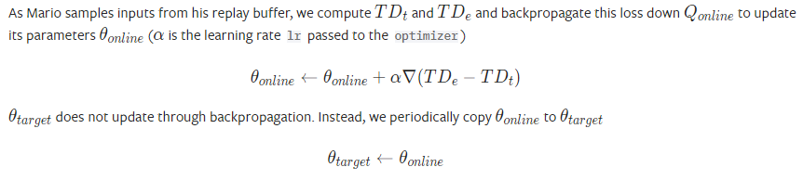

##### Result