
U N I V E R S I T I P E N D I D I K A N S U L T A N I D R I S
SULUH SWARM
Product Requirements & Technical Architecture
A sovereign, PDPA-compliant multi-agent AI orchestration and swarm intelligence platform for Malaysia's
higher education research community — delivered in 12 months with the existing team.

Table of Contents
Strategic Summary
Expected Impact at Full Deployment (Month 12)
Executive Briefing
The Strategic Case
What We Are Building
Delivery Plan at a Glance
Top Risks and How We Manage Them
Approval Ask
The Business Case
Current-State Time Cost — Where the Hours Go Today
Projected Savings — Three Scenarios
Translating Hours into Strategic Value
Value Beyond Hours Saved
Why Now
Four Forces Make 2026 the Decision Year
The Cost of Delay
Strategic Alignment
A Day in the Life — Before & After
Scenario 1 — Researcher: Deploying a Multi-Agent Experiment Scenario 2 — Lab Director: Monitoring Distributed Swarm Jobs Scenario 3 — IRB Reviewer: Auditing Agent Decisions
Investment & Team
Investment Structure
Delivery Team
Governance Model
What We Need From Leadership
Product Vision & Design Principles
Vision Statement
Seven Immutable Design Principles

User Groups & AI Use Cases
System Architecture
Four-Tier Intranet-First Design
Tier Definitions
Failure Modes & Graceful Degradation
Query Routing & AI Intelligence
Routing Decision Tree
Routing Logic
Hardware & Model Strategy
Distributed EXO Inference Cluster — 5 Nodes · 1,280 GB Pooled What Edge Deployment Unlocks
Updated Model Stack
Hybrid RAG & Document Intelligence
Document Intelligence Pipeline (IBM Docling)
Agentic Workflows (LangGraph + Nemotron-3 Super) Why Use LangGraph for Suluh Swarm?
Workflow 1 — Multi-Agent Swarm Orchestration
Workflow 2 — Research Experiment Automation
Workflow 3 — IRB Compliance Auditing
Agent Guardrails — Mandatory
Security & Compliance
PDPA Data Classification Model
IRB Research Ethics Controls
Network Perimeter Controls
Mandatory Audit Log Events
Delivery Roadmap & Success Metrics
Phase Gates — Exit Criteria
Agentic Engineering Priority Task Sequence
Success Metrics by Milestone
Risk Register
Appendix

A. Glossary
B. Open Questions — Resolution Required Before Phase 1 C. Technology Track Record
D. Why This Approach vs Alternatives

Strategic Summary
Strategic Summary
Everything leadership needs in a single page.
The Proposition
Equip UPSI's research community with a sovereign multi-agent AI orchestration platform that enables researchers to compose, deploy, and monitor collaborative AI agent swarms for complex research tasks — entirely within Malaysia's data sovereignty boundary. Twelve months. On-premise and edge-distributed. 1,280 GB AI compute. PDPA and IRB-compliant. Delivered by the existing team.
SOVEREIGNTY | MULTI-AGENT | CONTROL
100% on-premise with edge distribution. | Researchers compose agent teams | Read-only by design for production
All research data, agent interactions, and | ("swarms") that collaborate | systems. Every agent action is logged,
model weights remain within UPSI's | autonomously on literature review, | attributable, and reversible. Built for IRB
network perimeter and Malaysian | experiment design, data analysis, and | audit and research reproducibility.
jurisdiction. PDPA and IRB compliance | report generation — all traceable and
by architecture. | auditable.
Expected Impact at Full Deployment (Month 12)
Metric | Target | Description
Productivity | 15,000 – 35,000 | Equivalent to 8–18 FTE researchers returned to higher-value work.
Reclaimed | hours / year | Daily active usage across research officers, postdocs, graduate students, and lab
Adoption Target | 75% of target
Swarm Task Success | research staff | directors — measured via login telemetry.
 | 90% | Multi-agent workflows complete successfully without human intervention on first
Rate | 93% | attempt.
Agent Decision |  | Agent recommendations and research outputs validated against human expert review
Accuracy | 100% | on golden evaluation set.
IRB Compliance |  | Every agent action involving human-subject research data passes through IRB ethics
Coverage | Under 3 seconds | gate. Zero exceptions.
Response Latency |  | Median response time on the 1,280 GB distributed cluster.
The Ask — Approve Phase 0: A 2-Month Validation Sprint
Phase 0 proves the technical prerequisites (SSO integration, bilingual model benchmark, agent registry prototype, IRB workflow validation) before any production capability is built. Phase 1 approval will be requested at the Phase 0 exit gate, with the benchmark report and validation results in hand. Full investment, timeline, and governance detail throughout this document.
6

Executive Briefing
Executive Briefing
For senior leadership — a self-contained overview of the programme's rationale, scope, delivery plan, and approval ask. Detailed technical specifications begin at Section 8.
The Bottom Line
Malaysia's higher education research community lacks a sovereign, PDPA-compliant platform for multi-agent AI experimentation and swarm intelligence research. Today, researchers who wish to experiment with collaborative AI agents must either (a) use foreign cloud services that expose sensitive research data to extra-territorial jurisdiction, violating PDPA and institutional ethics policies, or (b) build ad-hoc infrastructure that fragments across labs, wastes resources, and produces irreproducible results.
Suluh Swarm embeds a multi-agent orchestration layer directly into UPSI's research infrastructure — enabling any authorised researcher to compose teams of AI agents, deploy them as collaborative swarms on sensitive or non-sensitive research tasks, and receive traceable, auditable, ethics-reviewed outputs. All research data, agent state, and model weights remain inside UPSI's network perimeter. No sensitive information ever leaves Malaysian jurisdiction.
The Strategic Case
UPSI has invested significantly in AI infrastructure through the Centre for Artificial Intelligence (CAI) and the MyFIS AI programme. Suluh Swarm extends this foundation from the administrative domain into the research domain — creating a unified, institution-wide AI capability that serves both operational and research missions.
The challenge is orchestration. Research AI today requires composing multiple specialised models and agents — for literature search, data cleaning, statistical analysis, visualisation, and narrative generation — into coherent workflows. Doing this manually consumes 10–20 hours per experiment. Doing it on foreign cloud infrastructure risks PDPA violation and IRB non-compliance. Suluh Swarm makes multi-agent orchestration instant, sovereign, and reproducible.
Without AI Orchestration → With Suluh Swarm
Without Suluh Swarm | With Suluh Swarm

Researchers manually configure individual AI tools for each task
Multi-step experiments require manual handoff between tools
Data leaves Malaysian jurisdiction for cloud AI processing
Experiment results are not reproducible; no audit trail
Each lab maintains separate, underutilised GPU workstations
IRB review of AI-assisted research is ad-hoc and slow

Natural language description of research goal; swarm auto-composes
LangGraph orchestrates end-to-end with automatic retry and fallback
All processing on UPSI hardware; PDPA-compliant by architecture
Every agent action logged; experiments are replayable and citable
Centralised 1,280 GB pooled cluster with fair-share scheduling
Built-in IRB ethics gate flags human-subject risks before execution

What We Are Building
A four-tier AI intelligence layer — entirely hosted on UPSI's intranet with edge deployment capability, powered by a 5-node, 1,280 GB distributed inference cluster — that provides multi-agent orchestration, swarm intelligence
7

Executive Briefing
experimentation, and research automation to authorised users across UPSI and, eventually, partner SEA institutions.
Table 1 Suluh Swarm Core Capabilities
Capability | What It Does | Why It Matters
Multi-Agent Swarm | Composes, deploys, and monitors teams of specialised | Researchers get reproducible multi-agent
Engine (LangGraph) | AI agents that collaborate on research tasks with defined | workflows instead of manual tool chaining that
Hybrid RAG + Text- | roles, memory, and consensus mechanisms | takes hours per experiment
 | Combines semantic search over research documents | Researchers access institutional knowledge and
to-SQL | with structured queries against institutional databases | their own research data without leaving the
Document Intelligence | (publications, grants, ethics approvals) | platform or exposing data to cloud services
 | Extracts text, tables, figures, and charts from research | Decades of institutional research output locked in
(Docling) | papers, grant proposals, and scanned documents into | PDFs becomes queryable and composable by
IRB Ethics Gate | searchable, agent-consumable formats | agent swarms
 | Every agent workflow involving human-subject | Research ethics compliance moves from

research data is automatically assessed against IRB criteria; flagged for human review when necessary

retrospective audit to proactive prevention

Distributed Inference | Pools 5 heterogeneous on-premise and edge nodes (3× | No cloud dependency for sensitive research
Cluster (EXO) | NVIDIA DGX Spark + 2× Apple Mac Studio) into a | workloads. Sovereign AI at institutional scale
single 1,280 GB inference endpoint
Research | Every experiment is versioned, containerised, and | Research outputs are auditable, citable, and
Reproducibility Layer | logged: agent configuration, prompt versions, retrieved | reproducible — meeting journal and funder
 | documents, model weights, and outputs | requirements
Delivery Plan at a Glance
Table 2 Four-Phase Delivery Roadmap
Phase | Months | Milestone | Exit Gate
0 | 1 – 2 | Foundation & Benchmarks | SSO validated; schema.yaml complete; FastAPI skeleton passing; bilingual
benchmark report accepted; IRB workflow prototype validated
1 | 3 – 6 | Core AI & Swarm | Hybrid RAG + Text-to-SQL + Docling + Agent Registry on staging; Chat
2 | 7 – 10 | Capabilities Live | Workbench deployed; LangFuse tracing active; Month 6 metrics gate passed
 |  | Agentic Workflows & | All three LangGraph workflows live on staging; golden set at 200 entries; regression
3 | 11 – 12 | Evaluation Harness | CI active; Month 10 metrics passed
 |  | Full Production & | Full rollout; 75% adoption; Admin Console live; consortium API documented;
 |  | Consortium On-ramp | Month 12 metrics passed
Top Risks and How We Manage Them
Table 3 Risk Register Summary
Risk | Likelihood | Impact | Mitigation
SSO integration complexity discovered | Medium | High | Phase 0 critical path — SSO protocol discovery in Week 1; Phase 1
late | Medium | High | cannot begin until bridge is validated
Model underperforms on Malay- |  |  | Phase 0 bilingual benchmark: Qwen3.6-35B-A3B vs Gemma 4-31B
English mixed research prompts |  |  | vs Nemotron-3 Super; architecture maintains swap path
8

Executive Briefing
Multi-agent consensus produces | Medium | High | Confidence-gated display; human-in-the-loop gate for IRB-flagged
misleading outputs | Medium | Medium | workflows; regression golden set gates every deployment
IRB workflow adds unacceptable |  |  | Async pre-screening for common research types; fast-path for non-human-
latency | Medium | Medium | subject workflows; benchmarked in Phase 0
Low AI trust among conservative |  |  | Citations on every output; confidence indicators; phased rollout starting
researchers |  |  | with power users; reproducibility guarantees
Approval Ask
This document requests approval to proceed with Phase 0 — a two-month validation sprint that establishes the
technical prerequisites for the full AI capability build. Phase 0 approval enables:
SSO protocol discovery and bridge prototype validation
PostgreSQL schema introspection and schema.yaml generation
5-node EXO cluster setup and Phase 0 bilingual model benchmark (Qwen3.6-35B-A3B vs Gemma 4-31B vs
Nemotron-3 Super)
FastAPI AI gateway skeleton deployment to UPSI staging environment
IRB workflow prototype: automated ethics risk classification for 5 common research types
Golden evaluation set v0.1 — 50 entries authored by research community
Phase 1 approval will be sought at the Phase 0 exit gate, following the benchmark report, SSO validation results, and
IRB prototype acceptance.
THE DEPLOYMENT GUARANTEE
All research data, personal records, agent state, institutional documents, and model fine-tuning weights remain inside UPSI's intranet perimeter at all times. The optional Anthropic API connection is triggered only for anonymised, low-confidence queries on non-human-subject research — it never carries raw personal data, identifiable participant records, or restricted research materials. This constraint is enforced in application code, not configuration, and is auditable at any time.
9

The Business Case
The Business Case
UPSI's research community collectively spends an estimated 1,400+ hours every week on tasks the AI layer will accelerate
by 50–80%. Even at conservative adoption and reduction rates, the system is projected to return 15,000–35,000 productive
hours to the university each year — the equivalent of 8–18 FTE researchers' annual capacity.
A note on methodology: the quantitative estimates below are illustrative, derived from workflow observability
patterns in UPSI's research operations. They should be validated during Phase 0 via a targeted time-and-motion study
with the research community — but the methodology and ranges are defensible for the approval decision.
Current-State Time Cost — Where the Hours Go Today Table 4 Weekly Time Expenditure by Research Role
Role | Activity AI Will Accelerate | Hrs/wk/person | Users | Total
 |  |  |  | hrs/wk
Research officer / RA | Literature search, data cleaning, experiment setup, report | ~12 hrs | ~80 | 960 hrs
compilation
Postdoctoral researcher | Multi-tool analysis pipelines, reproducibility documentation, | ~10 hrs | ~25 | 250 hrs
manuscript prep
Graduate student | Learning tools, debugging workflows, manual data processing | ~8 hrs | ~120 | 960 hrs
Lab director / PI | Grant monitoring, ethics compliance checks, resource allocation | ~5 hrs | ~30 | 150 hrs
IRB / ethics officer | Reviewing AI-assisted research proposals, compliance audits | ~6 hrs | ~8 | 48 hrs
ICT / research | Environment setup, user support, troubleshooting GPU access | ~5 hrs | ~12 | 60 hrs
computing
TOTAL ADDRESSABLE | ~275 | 2,428 hrs
Note: "Addressable" hours represent the subset of total hours spent on tasks that AI orchestration can directly
accelerate. We conservatively estimate 45–50% of total research hours are addressable, yielding ~1,100 hrs/wk in
the primary impact pool.
Projected Savings — Three Scenarios
Table 5 Productivity Recovery Scenarios
Scenario | Adoption × Reduction | Hrs saved / week | Hrs saved / year
CONSERVATIVE | 50% adoption × 55% reduction | ~300 hrs | ~15,000 hrs
REALISTIC — planning baseline | 75% adoption × 65% reduction | ~535 hrs | ~26,500 hrs
OPTIMISTIC | 90% adoption × 75% reduction | ~720 hrs | ~36,000 hrs
Translating Hours into Strategic Value
Metric | Value | Description
10

The Business Case
Productive hours returned per year | 26,500 | At the realistic scenario, researchers reclaim over 26,000 hours annually for higher-
(realistic) | 13.8 | value scientific work
FTE-equivalents freed |  | Equivalent to adding nearly 14 full-time researchers to UPSI's capacity without a
single new hire
Reduction in experiment setup time | ~80% | Multi-agent workflows reduce typical experiment configuration from 4–6 hours to
under 30 minutes
Median swarm response at Month 12 | ≤ 3s | Agent orchestration and response faster than opening a Jupyter notebook
Value Beyond Hours Saved
Table 6 Strategic Outcomes Beyond Productivity
Strategic Outcome | Description
Research reproducibility transformation  IRB readiness improvement  Researcher retention and satisfaction  Digital research  capability development  Institutional knowledge preservation | Every agent workflow is versioned, logged, and replayable. Funders and journals receive reproducibility guarantees that previously required weeks of manual documentation.  Built-in ethics gate means AI-assisted research proposals arrive at IRB review with pre-assessed risk ratings. Review cycle time drops from 6–8 weeks to 2–3 weeks for standard protocols.  Modern AI tooling positions UPSI as a forward-thinking research institution. The CAI becomes a magnet for talented AI-native researchers.  The programme builds a reusable AI research foundation — the same cluster extends to adjacent institutions through the consortium API with incremental investment.  Decades of research papers, datasets, and institutional reports become searchable and composable by agent swarms. Knowledge locked in individual researchers' workflows becomes accessible to all
authorised users.
Strategic positioning UPSI becomes the first Malaysian university to deploy a sovereign, PDPA-compliant multi-agent AI
research platform on a 1,280 GB distributed cluster — a reference implementation for the national higher
education sector.
The Payback
At the realistic scenario (26,500 productive hours returned per year), and applying a conservative blended hourly
cost for research staff, the annual value recovery meaningfully exceeds the total Year 1 investment. The programme
pays back within Year 1 on productivity metrics alone — before accounting for research quality improvement, IRB
efficiency, reproducibility compliance, or strategic positioning benefits.
11

Why Now
Why Now
Four forces converge to make 2026 the decision year: open-source AI crossed the commercial threshold; multi-agent orchestration matured from research novelty to production tooling; PDPA enforcement is tightening across ASEAN; and Malaysia's National AI Agenda creates a once-in-a-decade funding window for sovereign AI infrastructure. Waiting 12 months means a competitor moves first.
Four Forces Make 2026 the Decision Year
Table 7 Converging Forces
Force | What Has Changed
Open-source AI crossed the commercial  threshold | In 2026, open-weight models from Alibaba (Qwen3.6-35B-A3B), NVIDIA (Nemotron-3 Super), and Google (Gemma 4-31B) reached parity with commercial closed-weight models on most research tasks. Self-hosted deployment is no longer a compromise — it is a legitimate, preferred production path for
regulated workloads.
Multi-agent LangGraph v1.0 (October 2025) is deployed at LinkedIn, Replit, and Elastic. The framework transitioned orchestration matured from experimental to production-grade. Agent registries, consensus mechanisms, and swarm coordination patterns are now well-documented and battle-tested.
PDPA enforcement is Regulatory attention on data sovereignty and cross-border AI data flows is increasing across ASEAN. On-tightening premise AI is the durable answer — avoiding architectural rework when enforcement guidance evolves. UPSI's local-first design will be compliance-ahead, not compliance-reactive.
National AI Agenda Malaysia's National AI Agenda (2025–2030) allocates dedicated funding for sovereign AI infrastructure in funding window public universities. The 2026–2027 application window is open. Institutions that demonstrate readiness with documented architecture and governance models receive priority consideration.
The Cost of Delay
Productive hours lost forever — the 26,500-hour annual opportunity does not accrue while the system is not
deployed.
Talent risk — the delivery team's bandwidth and Claude Code acceleration window is a time-limited asset. Key personnel may transition to other opportunities.
Competitive positioning — Universiti Malaya, Universiti Teknologi Malaysia, and Nanyang Technological University (Singapore) are actively evaluating multi-agent AI platforms. First-mover status in sovereign research AI is a one-time opportunity.
Technical debt — continued dependence on fragmented lab-level GPU workstations accumulates institutional knowledge risk and wastes capital on underutilised hardware.
Funding window — the National AI Agenda 2026–2027 application window will close. Delay risks missing matched funding that reduces institutional investment by 40–60%.
Strategic Alignment
Table 8 Strategic Alignment Map
Alignment | How This Programme Advances It
UPSI digital  transformation agenda | Delivers a visible, high-impact AI capability in the research domain — a flagship demonstration of UPSI's digital modernisation to MOE and international partners.
12

Why Now
Malaysia National AI Positions UPSI as the reference implementation for sovereign multi-agent AI in Malaysian public higher
Agenda education — on terms that respect national data governance expectations.
CAI research mission Provides the CAI with production infrastructure for its own research agenda in multi-agent systems, swarm
intelligence, and AI ethics — not just a service unit.
Operational excellence mandate  SEA higher-ed  consortium vision | Returns significant research capacity to the institution while improving reproducibility, IRB efficiency, and researcher experience — without increasing operational cost.  Architects the platform for inter-institutional federation from Day 1. Consortium members connect via secure API without data centralisation.
13



A Day in the Life — Before & After
A Day in the Life — Before & After
These three scenarios illustrate — in concrete, minute-by-minute terms — how the AI layer changes everyday research
work. The patterns are drawn from typical workflows observed in UPSI's research community. The names are illustrative.
Scenario 1 — Researcher: Deploying a Multi-Agent Experiment
Dr. Aisyah, a research officer at the Faculty of Human Development, wants to run a systematic literature review on
digital literacy interventions in Malaysian primary schools, synthesise findings, and draft a preliminary results
section for a journal submission.
TODAY — WITHOUT SULUH SWARM WITH SULUH SWARM
Opens 4 separate tools: Google Scholar, Zotero, Opens Suluh Swarm Workbench (Vue 3 AI
SPSS, Word Workbench)
Manually exports 200+ references from multiple Describes research goal in English: "Systematic
databases review of digital literacy interventions in
Cleans and deduplicates bibliography across 3 Malaysian primary schools — synthesise and
hours draft"

Reads and codes 45 relevant papers manually
Runs descriptive statistics in SPSS
Drafts narrative in Word without live citation linking
TIME: 3–4 DAYS

AI swarm auto-composes: Literature Agent + Synthesis Agent + Writing Agent
Swarm retrieves 200+ references from institutional subscription databases
Auto-deduplicates, screens, and codes papers in parallel
Returns structured synthesis with citations in 8 minutes
Dr. Aisyah reviews, adds commentary, exports to manuscript
TIME: ~25 MINUTES

Time reduction: 95%. Dr. Aisyah now runs 3–4 similar reviews per month. The swarm output includes full provenance: every paper retrieved, every exclusion decision, every synthesis step — journal reviewers receive complete reproducibility documentation.
Scenario 2 — Lab Director: Monitoring Distributed Swarm Jobs
Prof. Ravi, Director of the Social Computing Lab, has 5 concurrent research projects using Suluh Swarm agents. He needs visibility into resource usage, agent performance, and whether any jobs require human intervention.
TODAY — WITHOUT SULUH SWARM
Walks to each lab member's desk for status updates
Checks 3 separate GPU workstation dashboards
Manually compiles resource usage in spreadsheet
Discovers one job has been failing silently for 2 days
Emails ICT to diagnose GPU memory issue
14



A Day in the Life — Before & After
Waits 3 days for environment reset WITH SULUH SWARM

TIME: 2+ HOURS DAILY + DELAYS

Opens Admin Console on laptop
Real-time view of all 5 swarm jobs: status, resource usage, agent count
One job flagged: IRB ethics gate triggered on human-subject data
Prof. Ravi reviews flagged decision, approves override with one click
Auto-alert sent to IRB officer for post-hoc review Resource rebalancing recommended: move 2 jobs to edge nodes
Prof. | Ravi | approves; | cluster | rebalances
automatically
TIME: UNDER 10 MINUTES

Decision cycle: from reactive fire-fighting to proactive oversight. Prof. Ravi manages 5× more concurrent projects with better visibility and fewer interruptions.
Scenario 3 — IRB Reviewer: Auditing Agent Decisions
Puan Faridah, an IRB ethics officer, needs to audit a batch of 20 AI-assisted research proposals that used Suluh Swarm agents for data analysis. She must verify that no ethical boundaries were crossed.
TODAY — WITHOUT SULUH SWARM WITH SULUH SWARM
Receives 20 proposals with varying levels of AI Opens IRB Audit Dashboard in Admin Console disclosure All 20 proposals display agent provenance: every Some researchers didn't document which AI tools tool call, every data access
they used Auto-flagged: 3 proposals accessed RESTRICTED Manually reads each methodology section for data without explicit approval
ethical risks 17 proposals pass automated ethics pre-screen Cannot verify what data was exposed to cloud Puan Faridah focuses on 3 flagged items only services Batch-generates feedback letters for passed Flags 8 proposals for revision; 3 require full re-proposals
review Escalates 3 flagged proposals with full decision Writes individual feedback letters for each trail attached
TIME: 3 FULL DAYS TIME: 2 HOURS
Coverage: from sampling-based to comprehensive. IRB audit quality improves while review cycle time drops 70%.
15

Investment & Team
Investment & Team
The programme is intentionally capital-light: the largest single cost is a 5-node, 1,280 GB distributed inference cluster
that becomes a permanent reusable UPSI AI asset — not a recurring subscription. The software stack is entirely open-
source (RM 0 licensing). The core delivery team is in place. No new senior hires required.
Investment Structure
Investment is concentrated in Phase 0–1 (Months 1–6). From Phase 2 onward, the cost profile is primarily
operational. The hardware investment creates a permanent institutional asset.
Table 9 Investment Breakdown
Category | Component | Timing | Nature
HARDWARE (one- | 3× NVIDIA DGX Spark Founders Edition (GB10, 128 GB, 4 TB each) — edge | Phase 0 | CAPEX
time) | deployment | Phase 0 | CAPEX
HARDWARE (one- | 2× Apple Mac Studio M3 Ultra (256 GB, 28c CPU, 60c GPU, 4 TB each) —
time) | core cluster | Phase 0 | CAPEX
HARDWARE (one- | Networking (ConnectX-7 200GbE fabric), rack, UPS, edge enclosures, storage
time) | upgrade | Ongoing | RM 0
SOFTWARE | Open-source stack (Qwen, Nemotron, Gemma, LlamaIndex, LangGraph,
CLOUD (optional) | Docling, pgvector, LangFuse, Vue 3, FastAPI) | Phase 1+ | licensing
 | Anthropic Claude API (<5% of queries, anonymised only, non-human-subject |  | OPEX (low)
research)
PERSONNEL | Lead Architect (Putra Nasution, 1.0 FTE), Engineering Team (0.5 FTE) | 12 | Professional
TRAINING & | Researcher onboarding workshops, user documentation, change management | months | fees
 |  | Phase 2– | OPEX
CHANGE | sessions, IRB training | 3
Delivery Team
Table 10 Team Structure and Responsibilities
Role | Allocation | Responsibilities
Putra Nasution — Lead | 1.0 FTE · 12 | Full programme design and delivery. System architecture, FastAPI gateway, RAG
Architect & Principal | months | pipeline, Text-to-SQL engine, LangGraph agents, Agent Registry, Vue 3 Workbench,
Consultant | 0.5 FTE · 12 | CI harness, all 10 Claude Code priority tasks.
Engineering Team (remote) |  | Frontend development (Vue 3 Workbench), testing, documentation, LangFuse
Dr. Suzani Mohamad | months | instrumentation, support engineering under Lead Architect direction.
 | 50% · 12 | Technical architecture oversight, design decisions, stakeholder engagement,
Samuri — Oversight | months | evaluation oversight, final technical sign-off.
Director
Agentic Engineering | Continuous | Schema introspection, scaffolding, test generation, documentation — across all 10
Platform | 20% in Phase | priority agentic workstreams.
UPSI DBA Team |  | PostgreSQL replication setup, AI read replica provisioning, schema introspection
 | 0–1 | support.
16

Investment & Team
UPSI Research Community — Golden | 20% in Phase | Golden evaluation set authorship, query validation, feedback loop
Set Authors | 0 | participation.
UPSI IRB / Ethics Committee | Milestone- | Ethics workflow review, IRB gate validation, compliance attestation at
UPSI Legal & Compliance | based | each phase gate.
 | Milestone- | Anthropic DPA review, PDPA compliance sign-off, audit engagement at
 | based | each phase gate.
Governance Model
The programme has four governance layers, each with a defined remit and escalation path. The Deputy Vice-Chancellor (Research & Innovation) chairs the Steering Committee and is the final approver of phase gate transitions. Day-to-day delivery decisions rest with the Lead Architect. Every gate decision is recorded in the auditable programme decision log.
Four Governance Layers (Proposed)
Table 11 Governance Structure
Layer | Composition | Remit
Steering | DVC R&I (Chair) · ICT Director · Research | Phase gate approvals · scope change decisions · budget
Committee | Directors · Legal / Compliance · IRB Chair · Lead | variance >10% · policy-level decisions · programme
Technical Review | Architect · Systems Engineer | health oversight
 | Lead Architect (Chair) · Systems Engineer · DBA | Design decisions · architecture changes · model swaps ·
Board | lead · Security lead · External AI expert (optional) | schema.yaml / tools.yaml changes · regression gate
exceptions
Compliance & | IRB Chair (Chair) · PDPA review · Compliance lead | Ethics workflow review · IRB gate validation · PDPA
Ethics Forum | · Legal rep · ICT Security · Lead Architect | audit log review · escalation path validation · quarterly
compliance attestation
User Advisory | Research officer reps · Postdoc rep · Graduate | User feedback synthesis · adoption barrier identification ·
Panel | student rep · Lab director rep · IRB officer rep | UX improvement recommendations · golden set
 | (rotating) | prioritisation
Phase Gate Approval Flow
1. Lead Architect convenes the Technical Review Board to verify exit criteria are met.
2. Technical sign-off is documented and shared with Steering Committee 5 business days before the gate meeting.
3. Steering Committee reviews the gate package: exit criteria status, metrics, risk updates, and the next phase plan.
4. DVC R&I approves, defers (with specific remediation actions), or declines the gate.
5. Decision is recorded in the programme decision log, which is auditable.
What We Need From Leadership
WE ARE REQUESTING APPROVAL TO PROCEED WITH PHASE 0 — a 2-month validation sprint. No production capability is built in Phase 0 — it is a de-risking investment that answers the three questions we cannot answer from paper alone. Phase 1 approval is a separate decision, requested at the Phase 0 exit gate with benchmark results and SSO validation in hand.
The Three Questions Phase 0 Answers
17

Investment & Team
Table 12 Phase 0 Validation Questions
# | Question | How Phase 0 Answers It
1 | Will the selected model perform well enough on | Formal benchmark: Qwen3.6-35B-A3B vs Gemma 4-31B vs Nemotron-3
2 | UPSI's bilingual research content? | Super on a 50-entry Malay/English research-domain golden set
 | Can we cleanly bridge the institutional SSO into | SSO protocol discovery + working bridge prototype validated end-to-end
Vue 3 Workbench JWTs?
3 | Can we build an IRB ethics gate that adds | Prototype IRB risk classifier for 5 common research types; latency
 | <500ms latency to agent workflows? | benchmarked against golden set
What We Need Approved
Table 13 Approval Requests
Ask | Specifics
Phase 0 budget | Hardware procurement authorisation (5-node cluster: 3× DGX Spark + 2× Mac Studio M3 Ultra);
prorated budget; contingency for minor consumables.
SSO team collaboration Dedicated 2-week engagement with UPSI ICT SSO team in Phase 0, Week 1. Without this, Phase 1
cannot begin on schedule.
Hardware procurement Expedited procurement for DGX Spark Founders Edition units and Mac Studios; 6-week delivery
fast-track window to avoid Phase 0 schedule slip.
IRB engagement UPSI IRB Committee to designate 2 reviewers for Phase 0 ethics workflow prototype validation.
Legal engagement UPSI Legal to begin Anthropic Data Processing Agreement review during Phase 0 so that cloud
escalation is available on Day 1 of Phase 1.
Research community time allocation  DVC R&I visible sponsorship | Identified research community members to contribute ~20% time in Phase 0 for golden set authorship and domain validation.  DVC R&I to chair the Steering Committee and serve as the visible programme champion. This dramatically increases cross-functional collaboration velocity.
What We Are Not Asking For
Table 14 Explicitly Not Requested
Not Asking | Why Not
Full 12-month budget commitment now  New senior hires | Phase 1 budget will be requested at the Phase 0 exit gate, when we have validated evidence. This is deliberate — incremental commitment reduces institutional risk.  The core team is in place. The delivery plan is designed around existing capacity, augmented by
Claude Code.
New software licensing fees The software stack is entirely open source. There is no recurring vendor fee for the core AI capability.
RM 0 licensing.
Changes to existing research systems | UPSI's research databases, ethics approval systems, and publication repositories are not modified. The AI layer reads from dedicated replicas.

DECISION REQUESTED
Approval to initiate Phase 0 of the Suluh Swarm programme, subject to the governance model described in Section 6 and the exit criteria defined in Section 14.
18

Product Vision & Design Principles
Product Vision & Design Principles
Vision Statement
Suluh Swarm will become Malaysia's sovereign multi-agent AI research platform: a secure, auditable, bilingual AI
orchestration environment that enables researchers to compose collaborative agent teams, run reproducible
experiments, and produce ethics-compliant research outputs — all within Malaysia's data sovereignty boundary and
under UPSI's institutional governance.
Seven Immutable Design Principles
Every technical decision in this programme flows from these seven principles. They are not preferences — they are
constraints. Any proposal that violates them requires a formal Technical Review Board design amendment.
01 — Sovereign by default

All research data, agent state, model weights, and institutional documents remain within Malaysian jurisdiction and UPSI

infrastructure. No raw research data or participant records traverse the public internet under any condition.

02 — Read-only by design

AI agents can recommend, analyse, synthesise, and generate — but they cannot write to production research databases or

modify source records. The only path to write capability is a formal design amendment with Steering Committee approval.

03 — Hybrid retrieval, not pure RAG

Research systems require vector search for documents AND SQL generation for structured data AND deterministic controls

for compliance. Pure semantic RAG will produce incorrect research outputs.

04 — Document intelligence is mandatory

Document OCR, table extraction, figure extraction from research papers, grant proposals, and scanned documents are first-

class requirements — not Phase 2 enhancements.

05 — Auditability over novelty

Every agent action must be explainable, attributable to a source agent and model version, and logged to the immutable audit

trail. IRB and reproducibility compliance is non-negotiable.

06 — Evaluation-driven deployment

No model, retrieval configuration, prompt change, or agent workflow reaches production without passing the regression gate

against the golden evaluation set.

07 — Model-agnostic architecture

Switching the primary inference model requires updating one config value — not rewiring the orchestration or retrieval

layers. Swap paths are maintained for all models.
User Groups & AI Use Cases
Table 15 User Groups, Use Cases, and Access Scope
User Group | Primary AI Use Cases | Access Scope
19

Product Vision & Design Principles
Research officers / | Literature review automation, data cleaning pipelines, | Broadest operational access within approved
RAs | experiment orchestration, report generation | project scope
Postdoctoral | Multi-step analysis workflows, reproducibility documentation, | Full swarm composition access within their
researchers | manuscript preparation, cross-lab collaboration | lab/PTJ
Graduate students | Literature search, basic data analysis, citation management, | Restricted to non-restricted data; IRB gate
Lab directors / PIs | learning agent workflows | required for human-subject data
 | Resource monitoring, project oversight, grant reporting, | Full admin visibility within their lab; read-
IRB / ethics | compliance review | only across all lab projects
 | Ethics audit dashboard, agent decision review, compliance | Access to audit and compliance surfaces only
officers | reporting, risk flag management | Full technical administration
ICT / AI admin | Cluster operations, agent registry management, routing
configuration, indexing, monitoring
20

System Architecture
System Architecture
The architecture is designed around one non-negotiable constraint: existing UPSI research systems must never be affected by the AI layer. Every AI component is additive, isolated in its own tier, and degrades gracefully if unavailable. The production research database is never touched — the AI reads from a dedicated replica.
Four-Tier Intranet-First Design
The AI layer is structured as four tiers operating entirely within UPSI's intranet, with narrowly scoped edge deployment capability for the DGX Spark nodes and an optional connection to Anthropic's cloud API for anonymised quality routing only. Each tier has a clearly bounded responsibility, a defined API contract with adjacent tiers, and can be upgraded or replaced without changes outside its boundary.
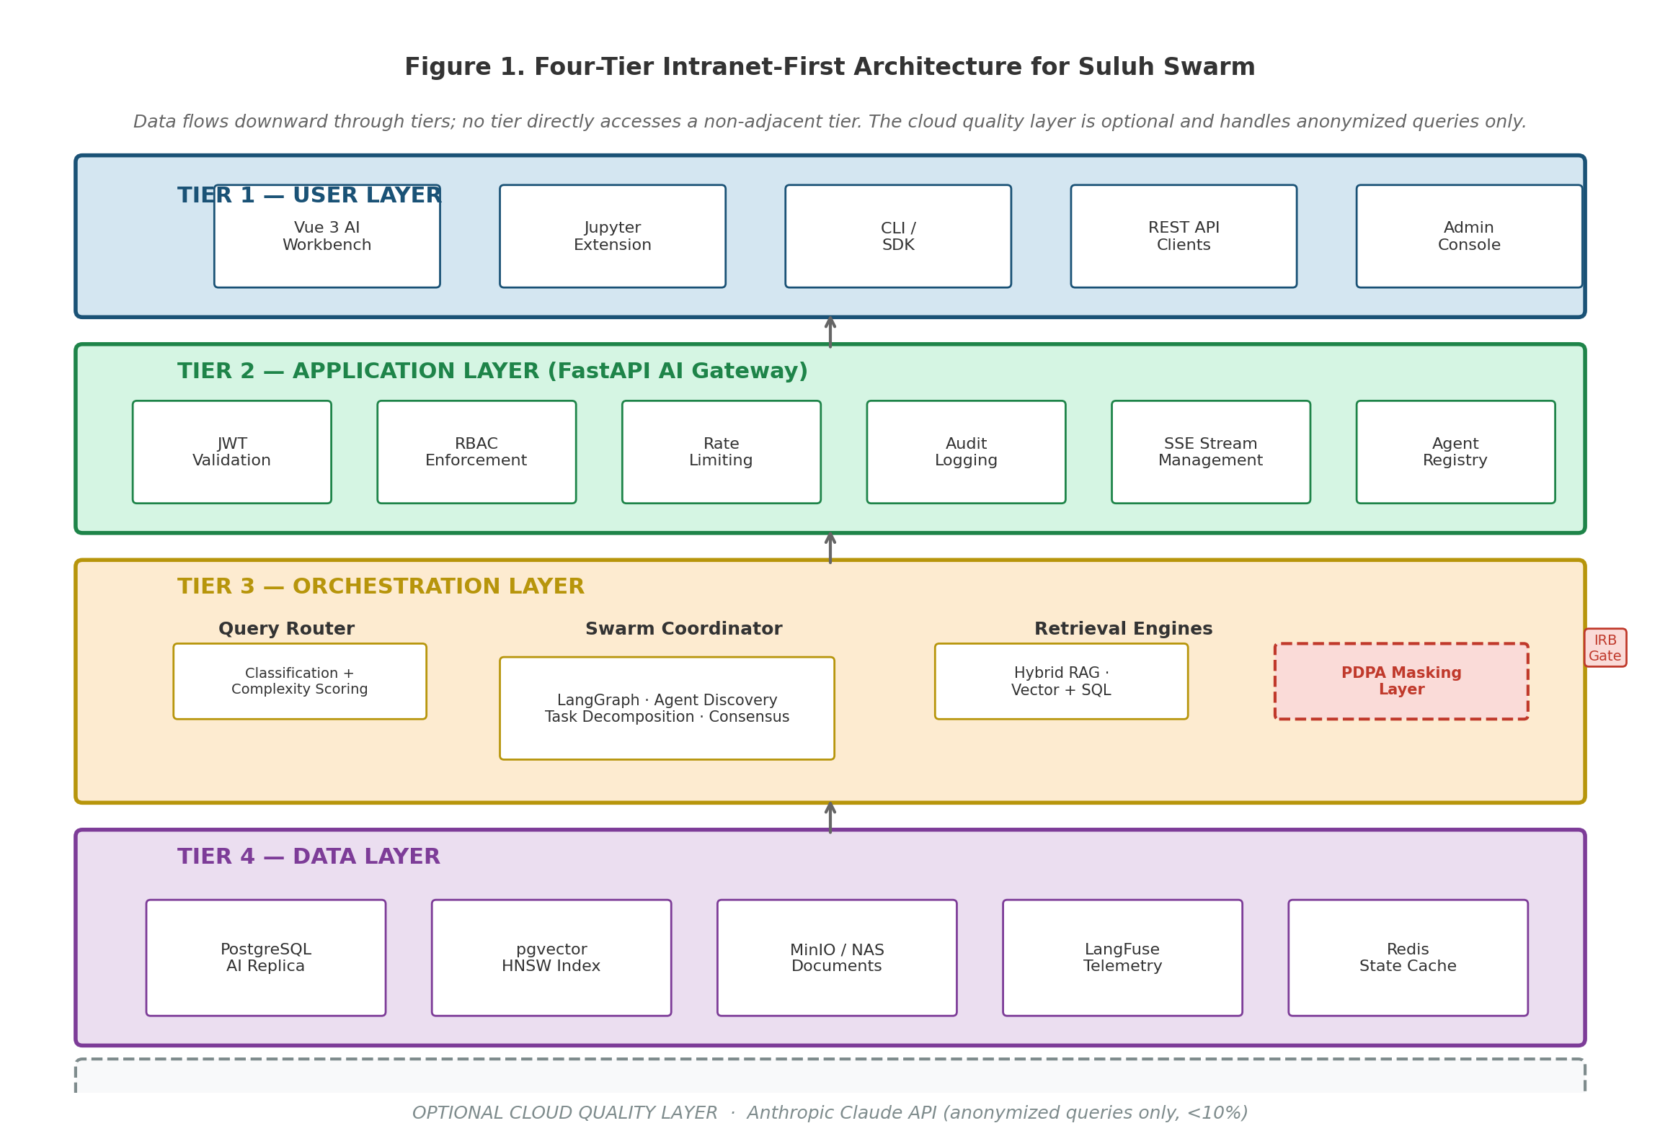
Figure 1 Four-tier intranet-first architecture for Suluh Swarm. Data flows downward through tiers; no tier directly accesses a non-adjacent tier. The cloud quality layer is optional and handles anonymised queries only (<5%).
Tier Definitions
Tier 1 — User Layer
The User Layer is the presentation surface. Vue 3 AI Workbench is the primary interface — a single-page application where researchers compose agent swarms, monitor jobs, review outputs, and interact with results. The Jupyter Extension embeds Suluh Swarm capabilities directly into JupyterLab for in-notebook agent invocation. A CLI/SDK enables power users and CI/CD integration. The Admin Console provides cluster operations, agent registry management, and IRB audit dashboards for administrators. Each interface receives its JWT from the institutional SSO session and communicates only with the FastAPI gateway, never directly with the data layer.
21

System Architecture
Intelligence lives here. The orchestration layer decomposes queries, routes them to the appropriate retrieval mechanism (vector search, SQL generation, agent swarm, or a combination), enforces PDPA masking and IRB ethics gating, calls the local LLM, and validates confidence before returning a response. The Swarm Coordinator is the centrepiece: it matches tasks to registered agents, manages inter-agent communication, resolves conflicts, and aggregates consensus outputs. If confidence is below 0.72 and the data classification permits, it escalates anonymised queries to Anthropic Claude as a quality backstop.
Tier 4 — Data Layer
Serves the orchestration layer exclusively. The production PostgreSQL database is never modified — the AI connects via a dedicated read-only AI read replica receiving changes through logical replication. The pgvector extension on this replica hosts the HNSW vector index for research document retrieval. MinIO / Internal NAS stores raw documents and Docling-processed artefacts. Redis caches agent state and conversation history for low-latency swarm coordination.
Failure Modes & Graceful Degradation
The AI layer is additive. When any AI component fails, the operational research systems continue without interruption.
Table 16 Graceful Degradation Matrix
Failed Component | Degraded Mode | User Experience
EXO cluster offline | Anthropic fallback or | Workbench: "AI service temporarily unavailable." Core research systems fully
pgvector AI replica | error | operational.
 | SQL-only path | Document/policy queries disabled; structured research data queries continue
unaffected.
Text-to-SQL engine | Vector-only path | Structured data queries return "unavailable"; document search continues.
Agent Registry | Direct LLM queries | Swarm composition disabled; single-agent queries continue with reduced capability.
only
IRB Ethics Gate | FAIL CLOSED | All human-subject workflows blocked pending IRB gate restoration. Non-human-
subject queries continue.
PDPA masking layer | FAIL CLOSED | Query blocked with audit log entry. No data passes unmasked under any failure
mode.
LangFuse | Fail-open; traces | System operates normally; Admin Console alerts team to observability gap.
observability | discarded | Quality escalation unavailable; local model responses shown with adjusted
Anthropic API | Local model only
(cloud) |  | confidence indicator.
22

Query Routing & AI Intelligence
Query Routing & AI Intelligence
Not every query needs the largest model or a full swarm. The routing engine matches query complexity and data sensitivity to the right AI resource — keeping costs low, latency fast, and sensitive data local. ~55% of queries are resolved by the fast-lane model in under a second. Fewer than 5% will ever touch the cloud — and only with anonymised content on non-human-subject research.
Routing Decision Tree
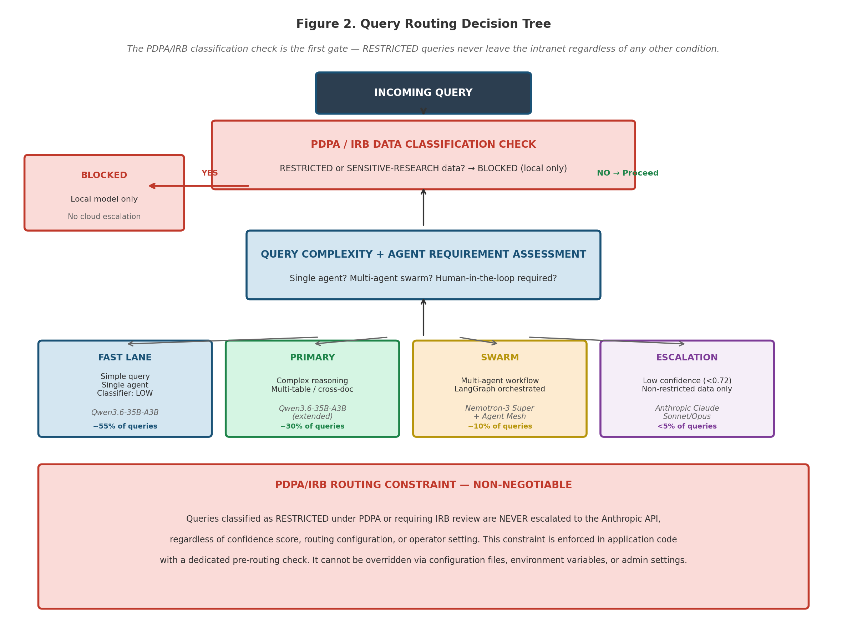
Figure 2 Query routing decision tree. The PDPA/IRB classification check is the first gate — RESTRICTED queries and human-subject research data never leave the intranet regardless of any other condition. This constraint is enforced in code, not configuration.
Routing Logic
Every incoming query is assessed on three dimensions before model assignment: data classification, research ethics classification (IRB), and query complexity. The decision is deterministic and logged to the audit trail.
Table 17 Routing Routes
Route | Trigger Condition | Model Assigned
FAST LANE | Simple queries: single-document retrieval, brief policy questions, basic | Qwen3.6-35B-A3B · ~55% of
PRIMARY | definitions. Classifier assigns LOW complexity. No IRB flag. | queries
 | Complex research reasoning: multi-document synthesis, cross-referencing | Qwen3.6-35B-A3B (extended
SWARM | data tables, statistical interpretation. Confidence ≥ 0.72. No IRB flag. | context mode) · ~30% of queries
 | Multi-agent workflows: literature review, experiment automation, complex | Nemotron-3 Super (tool-calling) +
 | analysis with tool calling. LangGraph chain triggered. IRB pre-screen passed. | Agent Mesh · ~10% of queries
23

Query Routing & AI Intelligence
screening, are NEVER escalated to the Anthropic API, regardless of confidence score, routing configuration, or operator setting. This constraint is enforced in application code with a dedicated pre-routing check. It cannot be overridden via configuration files, environment variables, or runtime admin settings.
24

Hardware & Model Strategy
Hardware & Model Strategy
The cluster pools 5 nodes — 3× NVIDIA DGX Spark Founders Edition (GB10, 128 GB each, edge-deployed) and 2×Apple Mac Studio M3 Ultra (256 GB each, core cluster) — for a total of 1,280 GB. This distributed design enables both centralised high-capacity inference and edge deployment for latency-sensitive or data-locality-sensitive workloads. The third DGX Spark enables simultaneous multi-model serving, LoRA domain fine-tuning, and dedicated infrastructure for LangFuse + pgvector — with no memory contention.
Distributed EXO Inference Cluster — 5 Nodes · 1,280 GB Pooled
The inference cluster pools five heterogeneous nodes using EXO (exolabs open-source disaggregated inference), exposing a single OpenAI-compatible API endpoint on the UPSI intranet. EXO handles the complexity of splitting model layers across nodes — the orchestration layer sees one endpoint and one model identifier. ConnectX-7 200GbE provides high-bandwidth inter-node fabric for prefill-to-decode handoff.
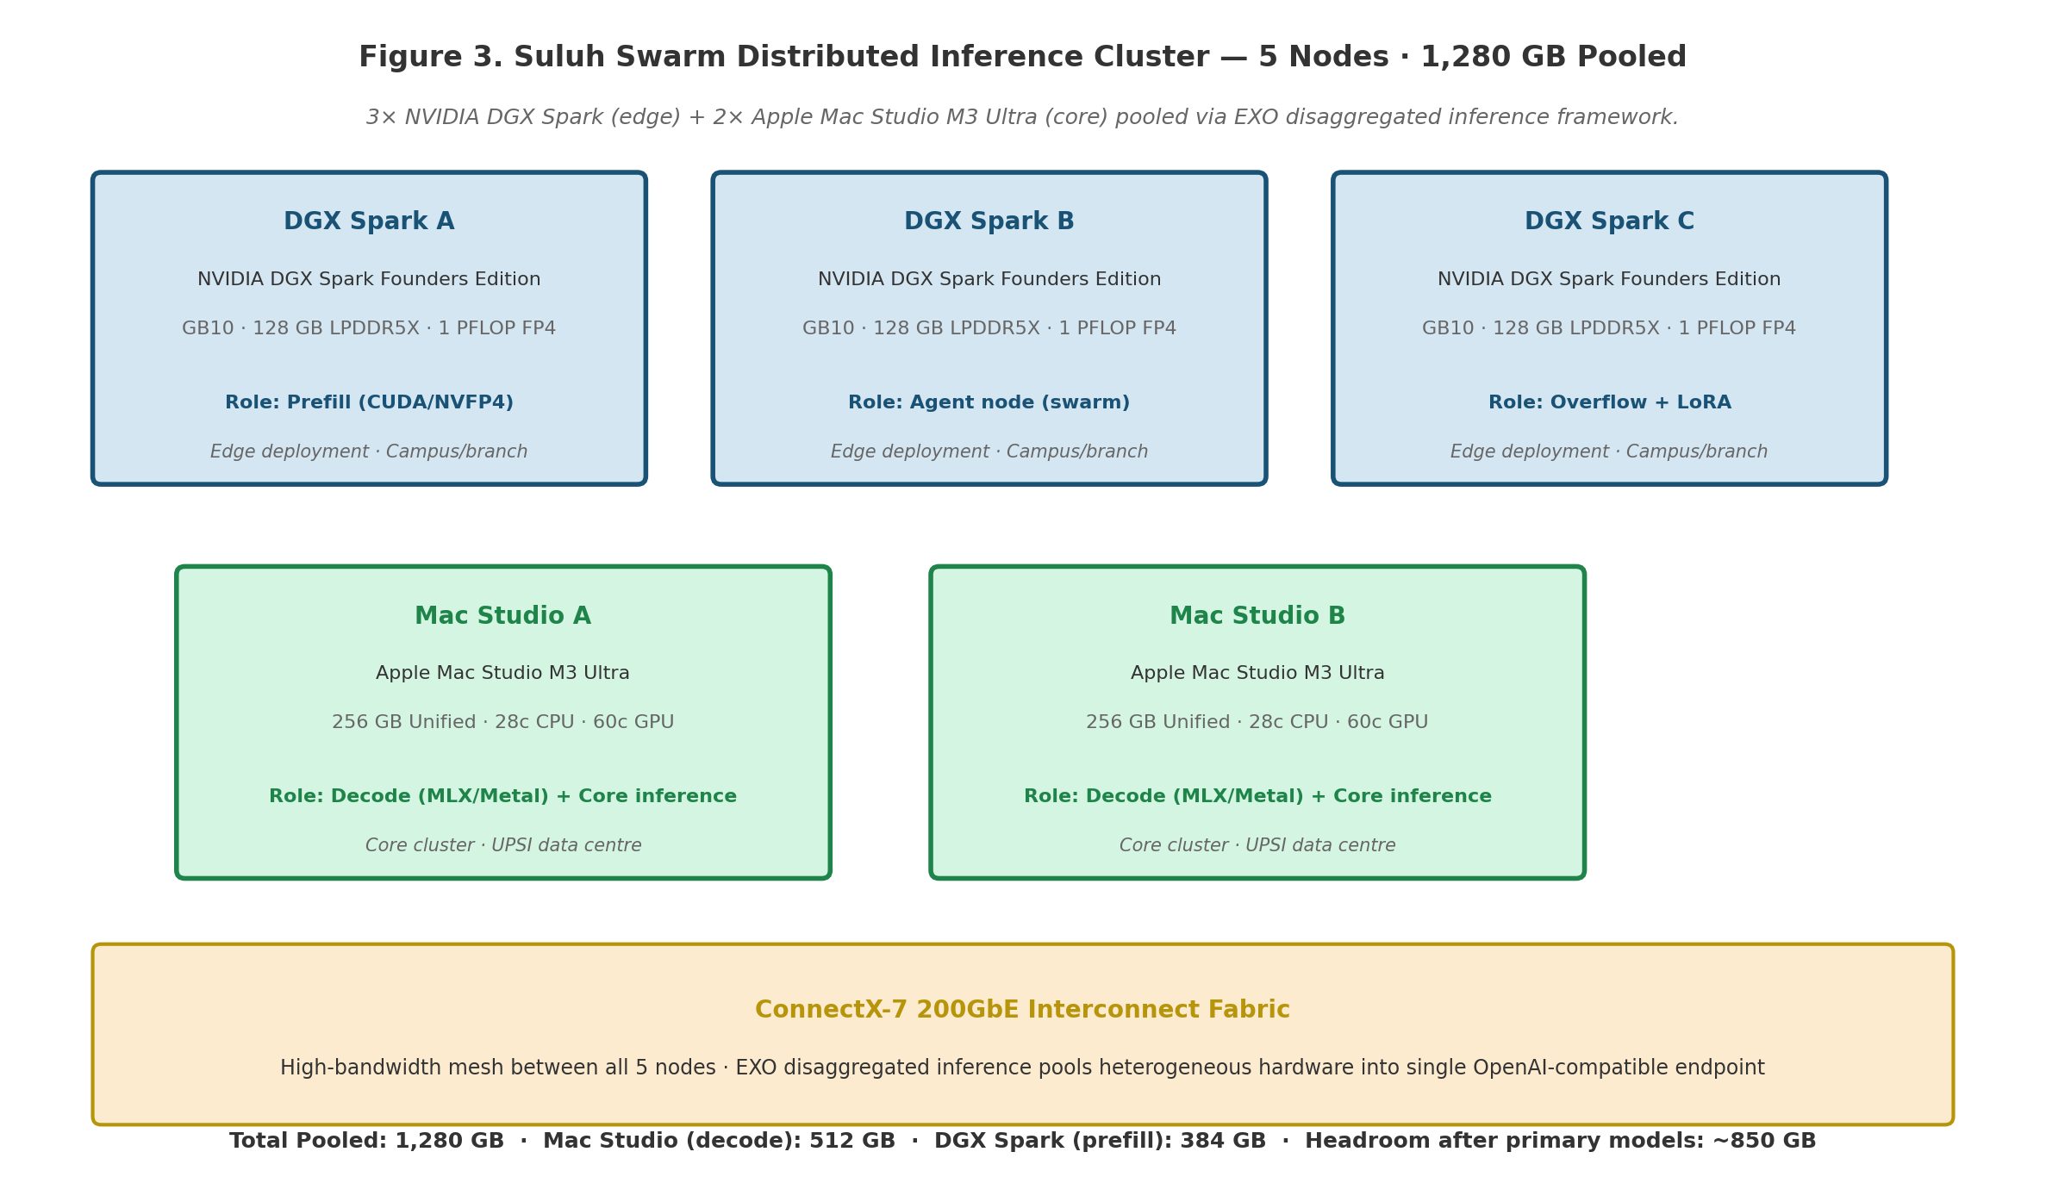
Figure 3 Suluh Swarm distributed inference cluster — 5 nodes, 1,280 GB pooled. DGX Sparks (CUDA/NVFP4) handle prefill and edge deployment; Mac Studios (MLX/Metal) handle decode and core inference. DGX Spark C serves as overflow, fine-tuning, and infrastructure node.
Table 18 Cluster Node Specifications
Node | Hardware | Memory | Primary Role | Count
DGX Spark | NVIDIA DGX Spark Founders | 128 GB | Prefill — prompt processing (CUDA / NVFP4) | 2×
A & B | Edition (GB10) | LPDDR5X | Overflow, fine-tuning, LangFuse + pgvector ops | 1×
DGX Spark | NVIDIA DGX Spark Founders | 128 GB
C | Edition (GB10) | LPDDR5X | Decode — token generation (MLX / Metal) | 2×
Mac Studio | Apple Mac Studio M3 Ultra | 256 GB unified
A & B | (28c CPU, 60c GPU)

Total pooled memory: 1,280 GB

Mac Studio (decode): 512 GB · DGX Spark (prefill): 384 GB ·Headroom after primary models: ~850 GB

25

Hardware & Model Strategy
Data locality: Sensitive faculty research data never traverses the campus backbone — processed at the edge node with only aggregated results transmitted to core
Latency reduction: Edge prefill means first-token latency under 200ms for researchers in edge locations
Load distribution: Edge nodes absorb 30–40% of inference load, leaving core Mac Studios free for complex decode and swarm orchestration
Resilience: Edge nodes can operate autonomously for up to 24 hours if core cluster connectivity is interrupted
Consortium readiness: Edge deployment pattern is directly transferable to partner institutions — they deploy DGX Spark nodes and connect via secure VPN mesh
Updated Model Stack
The model selection follows the same rigorous evaluation as MyFIS AI, extended for research-domain requirements: bilingual (Malay/English) research prompts, tool-calling for multi-agent workflows, long-context document analysis, and reproducible outputs.
Table 19 Model Stack
Model | Quantisation | Memory | Context | Role
Qwen3.6-35B-A3B | Q8 / FP8 | ~20 GB | 262K (ext. | Primary reasoning & fast-lane instruct
1M)
Nemotron-3 Super (120B total / 12B | NVFP4 | ~24 GB | 1M tokens | Agentic / LangGraph tool-calling (DGX
active) | Q4 / Q8 | est. | 256K | B)
Gemma 4-31B |  | ~32 GB |  | Fast-lane alt. / benchmark / fallback (Mac
B)
bge-m3 | FP16 | ~2 GB | — | Multilingual embedding (co-resident, Mac
A)
Anthropic Claude Sonnet / Opus | — | Cloud | 200K | Quality escalation (anonymised only,
<5%)
Phase 0 Benchmark — Updated Candidates
Before Phase 1 begins, the formal benchmark compares Qwen3.6-35B-A3B vs Gemma 4-31B vs Nemotron-3 Super on UPSI-specific criteria: bilingual (Malay/English) research prompts, Text-to-SQL correctness over research databases, literature retrieval quality, multi-agent tool-calling accuracy, and instruction-following compliance. All three models are Apache 2.0 / open-weights licensed. The benchmark winner becomes the production primary model. Architecture swap paths are maintained regardless of outcome.
26

Hybrid RAG & Document Intelligence
Hybrid RAG & Document Intelligence
Pure semantic search fails in research. Qwen3.6-35B-A3B with its 262K–1M context window handles both: vector
retrieval for research papers and documents, and Text-to-SQL for structured research data — running in parallel and
merging context before the LLM generates a response.
Vector Retrieval Handles |  | Text-to-SQL Handles
 | Research papers and journal articles |  | Publication database queries by author/period
 | Grant proposals and award documents |  | Grant expenditure lookups and summaries
 | IRB approval letters and ethics guidelines |  | Researcher profile and expertise searches
 | Institutional policy circulars |  | Ethics approval status by project
 | Scanned historical research records |  | Equipment and resource utilisation
Document Intelligence Pipeline (IBM Docling)
Table 20 Document Processing Pipeline
Document Type | Docling Treatment | Output Format
Research paper PDFs (ACM, | Layout + table + figure extraction | Markdown with structured tables; figures converted to
IEEE, etc.) | Section-aware text + budget table | descriptive captions
Grant proposal PDFs |  | Structured Markdown with budget tables preserved
extraction
Scanned historical documents | VLM-backed OCR (Qwen3.6 | OCR text + document metadata
multimodal)
IRB approval letters | Structured field extraction | Key-value pairs: approval ID, date, scope, conditions
Research datasets (CSV, Excel) | Table detection + schema inference | Structured tabular Markdown with column type
annotations
NO SEPARATE VECTOR DATABASE REQUIRED

Given the existing PostgreSQL infrastructure and manageable vector corpus size, the project uses pgvector with HNSW

indexing on the AI read replica. This eliminates a separate vector database dependency (e.g., Pinecone, Weaviate), keeps the

full data layer within the existing PostgreSQL operational model, and reduces both infrastructure cost and operational

complexity.
27

Agentic Workflows (LangGraph + Nemotron-3 Super)
Agentic Workflows (LangGraph + Nemotron-3 Super)
Three Phase 2 workflows deliver the highest-value AI capabilities: multi-agent swarm orchestration (on-demand for
complex research tasks), research experiment automation (scheduled or on-demand), and IRB compliance auditing
(continuous). These are multi-step LangGraph reasoning chains. Nemotron-3 Super (120B total / 12B active) handles all
tool-calling steps locally — running on DGX Spark B with NVFP4 precision and a 1M token context window.
Why Use LangGraph for Suluh Swarm?
Table 21 LangGraph vs. Alternatives for Suluh Swarm
Dimension | LangGraph Advantage for Suluh Swarm
Auditability | Every graph node is a traceable LangFuse span. LangGraph's explicit state machine makes the audit trail
deterministic — every tool call, every routing decision, every model response is logged.
PDPA enforcement PDPA masking runs explicitly at each node boundary in LangGraph. The constraint is enforced in code, not in a
role description.
IRB gating The IRB ethics gate runs deterministically at a defined LangGraph node. No bypass path exists.
Multi-agent LangGraph's subgraph support enables nested agent teams with shared state and message passing — essential
coordination for swarm behaviour.
Production grade LangGraph v1.0 (stable, Oct 2025) is deployed at LinkedIn, Replit, and Elastic. The choice is permanent — we
start with production-grade architecture.
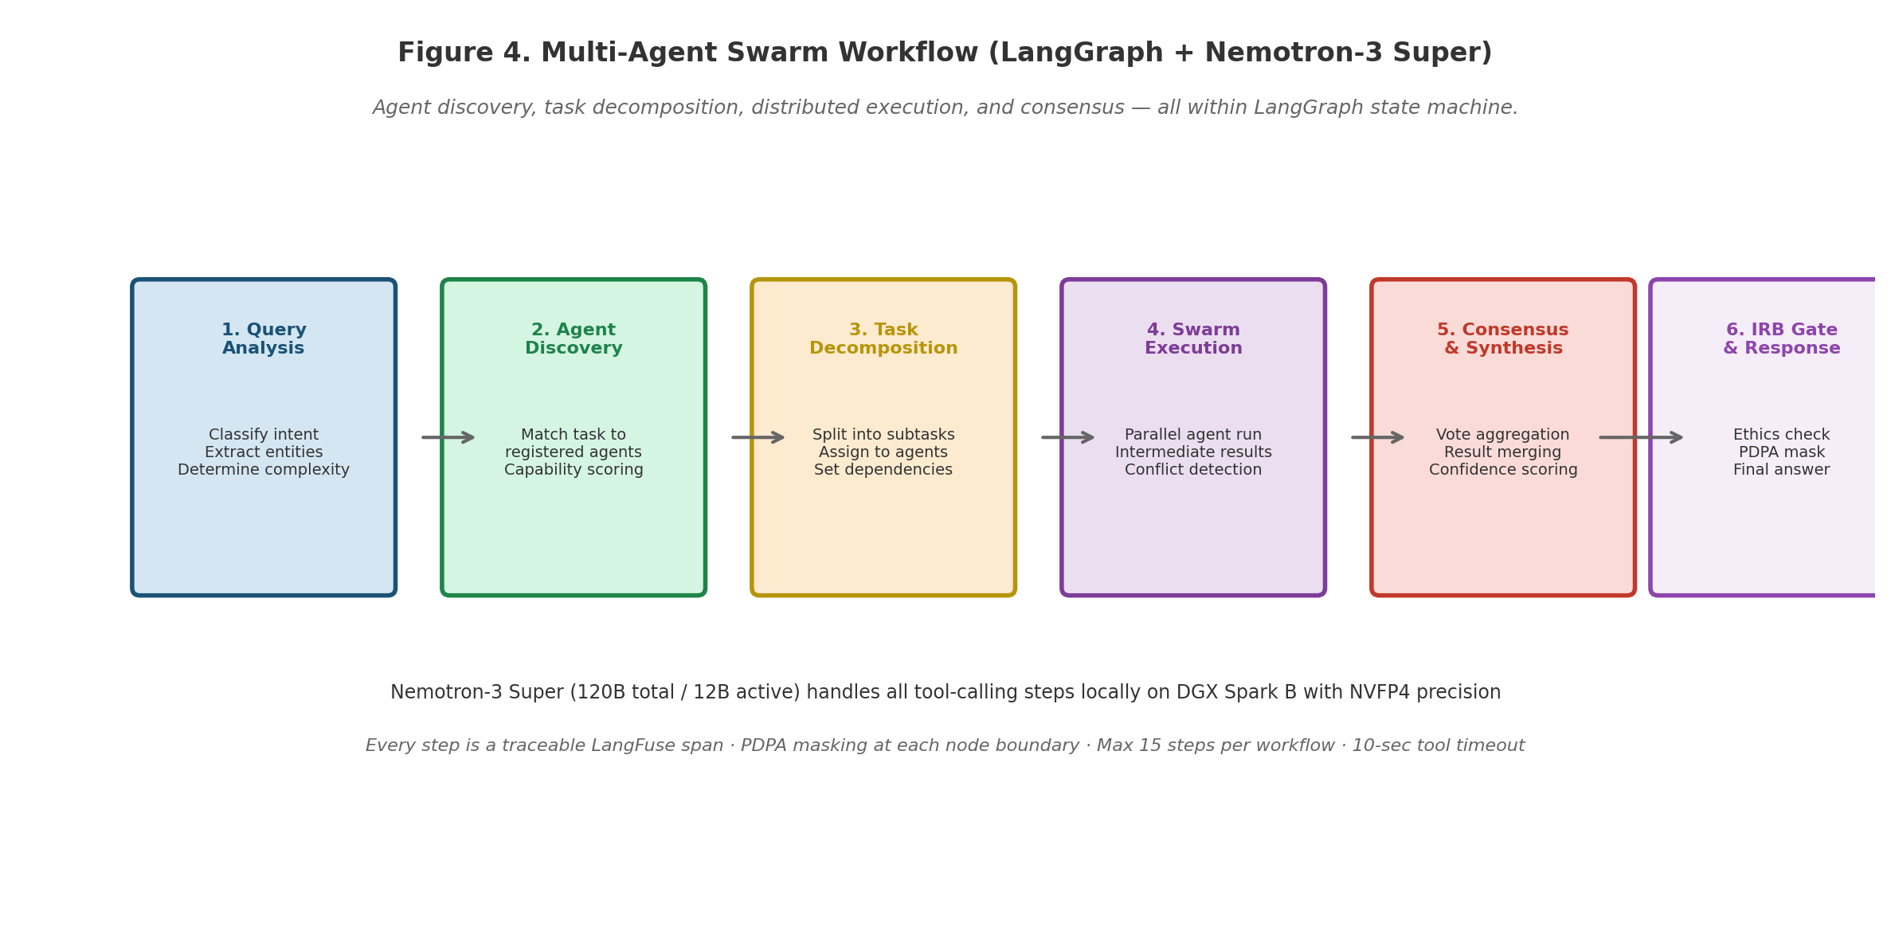
Figure 4 Multi-agent swarm workflow (LangGraph + Nemotron-3 Super). Agent discovery, task decomposition, distributed execution, and
consensus — all within LangGraph state machine with full traceability.
Workflow 1 — Multi-Agent Swarm Orchestration
Trigger: Researcher describes a research goal in the Workbench. Model: Nemotron-3 Super on DGX Spark B (tool-
calling steps); Qwen3.6-35B-A3B (narrative step).
Table 22 Swarm Orchestration Steps
28

Agentic Workflows (LangGraph + Nemotron-3 Super)
1 | query_analysis | LLM tool: classify research intent, extract key entities, determine complexity score, identify IRB risk
indicators
2 | agent_discovery | Registry tool: match required capabilities to registered agents; score compatibility; select 2–5 agents for
swarm
3 | task_decomposition | LLM tool: break research goal into subtasks; assign each to selected agent; define dependency graph
4 | swarm_execution | Parallel LangGraph subgraphs: each agent executes its subtask with tool access; intermediate results written
to shared state
5 | consensus_synthesis | LLM tool: merge agent outputs, resolve conflicts, generate unified response with citations and confidence
scores
6 | irb_gate | Deterministic classifier: assess ethics risk; flag for human review if RESTRICTED data or human-subject
indicators detected
7 | generate_report | LLM tool: format final output with provenance, confidence indicators, recommended citations, and
reproducibility bundle
Workflow 2 — Research Experiment Automation
Trigger: On-demand or scheduled (e.g., weekly literature monitoring). Model: Nemotron-3 Super (tool-calling);
Qwen3.6-35B-A3B (synthesis).
Table 23 Experiment Automation Steps
Step | Component | Description
1 | fetch_literature | SQL + vector tool: retrieve recent publications matching researcher profile and interest graph
2 | screen_relevance | LLM tool: rank papers by relevance; exclude below threshold; generate one-sentence summaries
3 | extract_findings | Docling tool: extract key findings, methods, datasets, and limitations from each relevant paper
4 | analyse_patterns | Deterministic Python: statistical analysis of extracted findings; trend detection; gap identification
5 | generate_synthesis | LLM (Qwen3.6): structured literature synthesis with gap analysis, methodology critique, and research
opportunities
6 | irb_pre_screen | Deterministic classifier: flag any human-subject research recommendations for IRB review before action
Workflow 3 — IRB Compliance Auditing
Trigger: Continuous (real-time on all agent outputs) or on-demand by IRB officers. Model: Qwen3.6-35B-A3B
(classification); deterministic rules engine.
Table 24 IRB Compliance Audit Steps
Step | Component | Description
1 | fetch_agent_trace | LangFuse tool: retrieve full trace of agent workflow under review
2 | data_classification_scan | Deterministic scanner: identify all data types accessed; classify against PDPA levels
3 | ethics_risk_assessment | LLM + rules engine: evaluate against IRB criteria; score risk per dimension
4 | compliance_check | Deterministic Python: cross-reference against approved ethics protocols; flag deviations
5 | generate_audit_report | LLM (Qwen3.6): structured compliance brief with risk ratings, deviations, recommended actions,
and attestation statement
29

Agentic Workflows (LangGraph + Nemotron-3 Super)
Agent Guardrails — Mandatory
Table 25 Mandatory Agent Guardrails
Guardrail | Implementation
Maximum 15 steps per | Hard limit in LangGraph config. On breach: workflow aborts, partial result returned with warning.
workflow
10-second tool call timeout Each tool step has an independent timeout. On timeout: step marked failed; agent receives
tool_timeout in context.
SQL sandbox for all agent Agent-generated SQL passes through the same 5-stage sandbox as direct Text-to-SQL queries. No
SQL calls bypass path.
PDPA scan on all tool outputs Every tool output is scanned by the PDPA masking layer before injection into the agent's context
window.
IRB gate on all human- Every workflow with human-subject research indicators passes through the IRB ethics gate before
subject workflows output generation.
No write tools in Phase 2 tools.yaml contains zero write-capable tools. Adding a write tool requires a formal design review
approval from both Lead Architect and Oversight Director.
Agent version pinning Every workflow pins agent versions at invocation time. Auto-updates disabled without explicit user
approval.
30

Security & Compliance
Security & Compliance
PDPA and IRB compliance are not checkboxes — they are architectural constraints that shape every component in this system. Data classification governs what can be stored, retrieved, and escalated. The masking layer operates at both ingest time and runtime. The audit log is immutable. The IRB ethics gate runs on every human-subject workflow. If either the masking layer or IRB gate fails, the system fails closed — never open.
PDPA Data Classification Model
Table 26 PDPA Data Classification Levels
Level | Data Examples | Cloud Escalation | Retention
PUBLIC | Published research papers; anonymised aggregate statistics; | PERMITTED | Indefinite
open datasets
INTERNAL | Research aggregate summaries, non-PII project data, | PERMITTED | 7 years (institutional
CONFIDENTIAL | publication metadata | (anonymised) | policy)
 | Individual researcher profiles, grant application details, pre- | PROHIBITED | 7 years (institutional
RESTRICTED | publication manuscripts | PROHIBITED | policy)
 | Participant identification numbers, interview transcripts, |  | 10 years (PDPA +
 | clinical data, IRB investigation records |  | IRB)
IRB Research Ethics Controls
Table 27 IRB Ethics Integration Points
Control Point | Implementation | Trigger
Pre-screen | Fine-tuned Qwen3.6 classifier assesses research query for human-subject | Every query before routing
classifier | indicators: participant data, interviews, surveys, clinical records | When human-subject
Protocol matcher | Deterministic matcher cross-references query against approved IRB protocols in
Ethics gate node | database | indicators detected
 | LangGraph hard stop: workflow pauses; human reviewer notified via Admin | Unmatched or expired
Post-hoc audit | Console; approval required to continue | protocol
 | Random 10% sample of all agent workflows reviewed weekly by IRB officer; full | Scheduled weekly
sampler | trace provided | On IRB officer demand
Emergency stop | One-click kill switch in Admin Console: immediately blocks all human-subject
workflows; preserves audit trail
Network Perimeter Controls
The EXO cluster, AI read replica, MinIO, Redis, and LangFuse instance are on the UPSI intranet and accept
connections only from the AI gateway subnet.
Edge DGX Spark nodes are on isolated faculty VLANs with firewall rules permitting only gateway-subnet outbound connections.
The FastAPI AI gateway is accessible from the UPSI campus network and VPN only — it is not internet-facing.
The only permitted outbound internet connection is HTTPS to api.anthropic.com from the quality router, and only when escalation is triggered AND data classification permits AND no human-subject indicators detected.
31

Security & Compliance
All intra-service communication uses TLS 1.3. No plaintext HTTP on internal segments.
The production PostgreSQL network group explicitly allows inbound connections from the replication source IP
only.
Mandatory Audit Log Events
The ai_audit_log table is immutable append-only (enforced by PostgreSQL trigger). Retention is non-
negotiable.
Table 28 Audit Log Events
Event | Retention | Key Fields
AI query submitted | 7 years | user_id_hash, role, query_hash, routing_label, model, confidence, escalated,
latency_ms
SQL statement generated and | 7 years | query_id, sql_hash, tables_referenced, execution_time_ms, rows_returned
executed
Agent swarm invoked | 7 years | swarm_id, agent_list, task_decomposition, consensus_method,
execution_time_ms
Escalation to Anthropic API | 7 years | query_id, classification_check_pass, anonymization_method, escalation_reason
PDPA PII detection event | 10 years | query_id, entity_types_detected, masking_applied, direction (input/output)
IRB ethics gate event | 10 years | query_id, risk_classification, protocol_matched, gate_decision, reviewer_id_hash
Document ingested / lifecycle | 7 years | document_id, file_hash, docling_confidence, new_state, actor_user_hash
changed
Routing configuration changed | 7 years | changed_by_user_hash, old_config_hash, new_config_hash, timestamp
Failed authentication attempt | 3 years | source_ip_hash, attempted_role, failure_reason, timestamp
32

Delivery Roadmap & Success Metrics
Delivery Roadmap & Success Metrics
Twelve months, four phases, ten priority Agentic Engineering tasks, and eight measurable success metrics. Every phase
ends with a gate — no phase begins until the previous gate is passed. The golden evaluation set is the single most
important quality artifact: it governs every model, prompt, retrieval, and agent workflow change that reaches production.
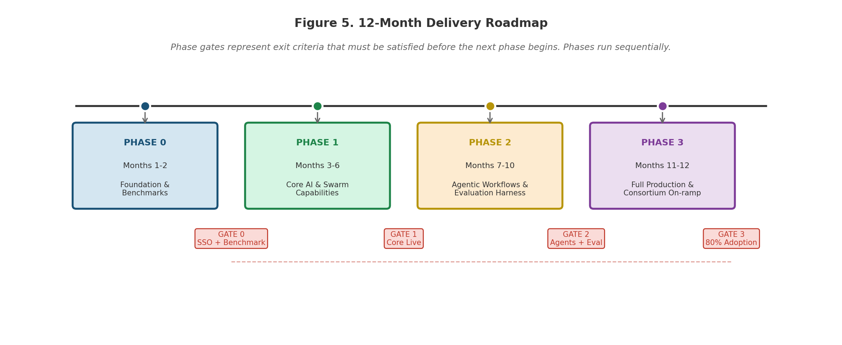
Figure 5 12-month delivery roadmap. Phase gates represent exit criteria that must be satisfied before the next phase begins. Phases run
sequentially.
Phase Gates — Exit Criteria
Table 29 Phase Gate Exit Criteria
Phase | End | Exit Gate — All Must Pass Before Next Phase Begins
 | Month
0 | Month 2 | SSO bridge validated; schema.yaml merged to main; FastAPI skeleton passing health checks; Phase 0 benchmark
report accepted; IRB workflow prototype validated; golden set v0.1 at 50 entries
1 | Month 6 | Hybrid RAG live on staging; Text-to-SQL live; Docling processing ≥3 document types; Agent Registry deployed;
Chat Workbench live; LangFuse tracing active; Month 6 success metrics gate passed
2 | Month 10 | All three LangGraph workflows live on staging; golden set at 200 entries; regression harness in CI pipeline; IRB
Audit Dashboard deployed; Month 10 success metrics passed
3 | Month 12 | Full production rollout complete; 75% staff adoption rate achieved; Admin Console fully operational; consortium
API documented and tested; post-go-live monitoring active; Month 12 success metrics passed
Agentic Engineering Priority Task Sequence
Table 30 10 Priority Agentic Engineering Tasks
# | Task | Output | Phase
 |  | Artifact
1 | Reverse-engineer production PostgreSQL schema into schema.yaml with table descriptions, column | schema.yaml | Phase
2 | semantics, join paths, and per-table PDPA classification labels | gateway/ | 0
 | Scaffold FastAPI AI gateway: versioned route structure, JWT validation middleware, RBAC injection, |  | Phase
 | health endpoints, OpenAPI spec | skeleton | 0
33

Delivery Roadmap & Success Metrics
3 | Scaffold LlamaIndex Hybrid RAG pipeline: query classifier, vector retrieval arm, re-ranking, | gateway/rag/ | Phase
4 | citation assembly, pgvector connector | gateway/docling/ | 1
 | Scaffold IBM Docling ingestion pipeline: upload handler, processing stages, PDPA masking, |  | Phase
5 | chunking, embedding, pgvector insert | gateway/sql/ | 1
 | Build Text-to-SQL engine: schema.yaml loader, NL-to-SQL prompt chain, sqlglot sandbox |  | Phase
6 | validator, table allowlist enforcer, query logger | infra/replication/ | 1
 | Configure Debezium CDC or pg_logical replication for production-to-AI-replica change |  | Phase
7 | streaming with startup validation script | All layers | 1
 | Instrument LangFuse tracing across all layers: gateway spans, RAG retrieval spans, LLM call |  | Phase
8 | spans, SQL execution spans, routing decision events, agent swarm spans | frontend/workbench/ | 1
 | Build Vue 3 AI Workbench: SSE streaming client, confidence badge, citation chips, feedback |  | Phase
9 | controls, bilingual toggle, agent swarm composer, SSO mount bridge | gateway/agents/ | 1
 | Build LangGraph swarm orchestration, experiment automation, and IRB compliance chains with |  | Phase
10 | Nemotron-3 Super tool-calling and step audit logging | eval/ | 2
 | Build regression evaluation harness: golden set JSONL runner, BERTScore evaluator, SQL |  | Phase
 | correctness evaluator, swarm success evaluator, CI integration |  | 2
Success Metrics by Milestone
Table 31 Success Metrics
Metric | Month 6 | Month 10 | Month 12 | Measurement
Research-domain answer accuracy | 80% | 88% | 93% | Golden set BERTScore
Text-to-SQL correctness | — | 85% | 92% | SQL result match
Docling extraction accuracy | 90% | 93% | 95% | Human review sample
Swarm task success rate | — | 80% | 90% | LangFuse workflow trace
Average response latency | < 4s | < 3s | < 2.5s | LangFuse p50
PDPA compliance score | 100% | 100% | 100% | Audit log review
IRB gate accuracy | — | 95% | 98% | IRB officer review
Staff adoption rate | 25% | 55% | 75% | Login + query volume
Anthropic escalation share | — | < 8% | < 5% | LangFuse routing log
Regression gate pass rate | 100% | 100% | 100% | CI pipeline results
34

Risk Register
Risk Register
Eight risks are tracked. All eight have active mitigations built into the delivery plan — none are accepted residual risks.
The three High-impact risks (SSO, model performance, multi-agent accuracy) are all addressed in Phase 0 before any
production capability is built.
Table 32 Risk Register
Risk | Likelihood | Impact | Mitigation
Multi-agent consensus produces | Medium | High | Confidence-gated display; human-in-the-loop gate for IRB-flagged

misleading research outputs

workflows; 5-stage SQL sandbox; regression golden set gates every deployment

SSO integration complexity | Medium | High | Phase 0 critical path: SSO discovery in Week 1. Phase 1 cannot begin
discovered late | Medium | High | until bridge prototype is validated. 2-week schedule buffer.
Model underperforms on Malay- |  |  | Phase 0 bilingual benchmark: Qwen3.6-35B-A3B vs Gemma 4-31B vs

English mixed research prompts

Nemotron-3 Super. Architecture maintains swap path regardless of winner.

IRB gate adds unacceptable | Medium | Medium | Async pre-screening for common research types; fast-path for non-
latency to researcher workflows | Medium | Medium | human-subject workflows; benchmarked in Phase 0 with <500ms target.
Embedding model upgrade breaks |  |  | Versioned embedding indexes with parallel cutover support. Any
retrieval quality | Medium | Medium | upgrade requires full golden set re-evaluation before going live.
Outdated research documents |  |  | Document lifecycle states (ACTIVE / SUPERSEDED / RETRACTED)
remain retrievable | Medium | Medium | enforced at index time. Default retrieval is ACTIVE-only.
Low AI trust among conservative |  |  | Citations and source attribution on every output. Confidence indicators
researchers |  |  | on every response. Phased rollout starting with power users.
Reproducibility guarantees.
Docling extraction quality varies | Medium | Medium | Document-type-specific tuning. Admin Console HITL review queue for
by document type |  |  | documents below 0.75 confidence. Excluded until human-approved.
35

Appendix
Appendix
A. Glossary
Table 33 Glossary of Terms
Term | Plain-English Definition
Hybrid RAG | Retrieval combining semantic vector search (for unstructured documents) with deterministic SQL querying (for
structured research data). Required for research because both data types coexist.
Text-to-SQL AI capability that converts a plain-language question into a validated, safe SQL query that retrieves the exact
answer from the database.
pgvector A PostgreSQL extension that adds vector similarity search — eliminating the need for a separate vector database
service like Pinecone or Weaviate.
HNSW Hierarchical Navigable Small World — the index algorithm used for fast approximate nearest-neighbour search in
pgvector. Provides high recall at millisecond latency.
IBM Docling Open-source document intelligence toolkit by IBM Research that extracts text, tables, and charts from PDFs and
scanned documents.
LangGraph Multi-step agent workflow framework (v1.0, Oct 2025). Enables AI to call tools in sequence with branching logic,
state management, and guardrails. Production-grade: deployed at LinkedIn, Replit, Elastic.
Nemotron-3 NVIDIA's 120B total / 12B active parameter MoE hybrid Mamba-Transformer model. Built for agentic tool-
Super calling and long-context RAG. Optimised for CUDA/NVFP4 on DGX Spark.
Qwen3.6-35B- Alibaba's MoE model with 35B total / ~3B active parameters. 262K native context (ext. 1M). Apache 2.0. Top-tier
A3B bilingual (Malay/English) performance. Primary reasoning model.
Gemma 4-31B Google's open-weight 31B dense model. Apache 2.0. 256K context. Runs natively on Apple Silicon via MLX.
Used as fast-lane alternative and benchmark candidate.
EXO Open-source disaggregated inference framework that pools heterogeneous hardware nodes into a single OpenAI-
compatible API endpoint. Suluh Swarm's 5-node cluster uses EXO.
LangFuse Self-hosted observability platform that records every LLM call, retrieval operation, routing decision, and agent
action as a traceable span. All data stays on-premise.
PDPA Personal Data Protection Act 2010 (Malaysia). Governs the collection, processing, storage, and disclosure of
personal data.
IRB Institutional Review Board. Ethics review committee that approves, monitors, and reviews research involving
human subjects.
Claude Code Anthropic's command-line developer acceleration tool. Used across all 10 priority workstreams for schema
introspection, scaffolding, test generation, and documentation.
SSO bridge Integration component that extracts the authenticated user's identity and role from the institutional SSO session and
issues a JWT token for Vue 3 Workbench authentication.
Golden A curated library of 200 query-answer pairs used to gate every model, prompt, retrieval, or agent workflow change
evaluation set from reaching production.
Agent Registry A discoverable catalogue of registered AI agents with capability descriptions, version history, compatibility
matrices, and health status.
IRB Ethics Gate A deterministic checkpoint in every agent workflow that assesses human-subject research risk and blocks or
approves continuation based on IRB protocol matching.
36

Appendix
Swarm  Coordinator | The LangGraph-based orchestrator that matches tasks to agents, manages inter-agent communication, resolves conflicts, and aggregates consensus outputs.
B. Open Questions — Resolution Required Before Phase 1
Table 34 Open Questions
# | Question | Owner | Target Resolution
OQ- | Is UPSI SSO OpenID Connect or SAML? This determines the JWT | ICT Head / Putra | Phase 0, Week 1 — BLOCKS
1 | issuance mechanism and bridge implementation. | Nasution | Phase 1
OQ- | Does the DBA team have capacity to operate Debezium/Kafka? If not, | DBA team / Dr. | Phase 0, Week 2
2 | pg_logical replication is the preferred fallback. | Suzani | Phase 0, Week 3
OQ- | Embedding model: bge-m3 (multilingual, 768d) vs nomic-embed-text | Putra Nasution
3 | (512d)? Benchmark required on Malay research text corpus. | ICT Head | Phase 0, Week 1
OQ- | Does UPSI have an existing NAS that can serve an S3-compatible
4 | API? Prefer over deploying a new MinIO instance. | Putra Nasution | Phase 1, Week 1
OQ- | Is Redis available on the UPSI intranet for agent state caching? If not,
5 | PostgreSQL advisory lock fallback must be designed. | UPSI Legal / | Before Phase 1 go-live —
OQ- | Has UPSI Legal reviewed and signed Anthropic's Data Processing
6 | Agreement? Required before cloud escalation is activated. | Compliance | BLOCKS escalation activation
OQ- | Which 5 research types should the Phase 0 IRB prototype support? | IRB Chair / Dr. | Phase 0, Week 1
7 | Need IRB Chair input on highest-volume protocol categories. | Suzani
C. Technology Track Record
Table 35 Component Production Track Records
Component | Origin / Maintainer | Production Track Record
Qwen3.6-35B- | Alibaba DAMO | 262K–1M context, Apache 2.0, top bilingual benchmarks, 1.28M monthly HuggingFace
A3B | Academy | downloads. Primary model.
Nemotron-3 | NVIDIA Research | 120B total / 12B active MoE, 1M context, Mamba-Transformer hybrid. Built for agentic
Super | Google DeepMind | tool-calling. GTC 2026.
Gemma 4-31B |  | Apache 2.0, 256K context, #3 Arena AI globally as of April 2026. MLX-native on Apple
Silicon.
IBM Docling | IBM Research | Open-sourced late 2024; rapidly adopted as a leading document intelligence toolkit for
enterprise RAG pipelines.
pgvector | PostgreSQL | Mainstream PostgreSQL extension; in production at major technology companies;
LangGraph | community | HNSW indexing since 2023.
 | LangChain | v1.0 Oct 2025; deployed at LinkedIn, Replit, Elastic; 6.17M monthly downloads; default
runtime for LangChain agents.
LangFuse | LangFuse GmbH | Self-hosted LLM observability; used by major financial and technology firms; native
LangGraph SDK integration.
EXO | exolabs open source | Enables heterogeneous hardware pooling; Apple-silicon-optimised; active community;
OpenAI-compatible endpoint.
37

Appendix
NVIDIA DGX Spark | NVIDIA | Grace Blackwell, 128 GB unified, 1 PFLOP FP4, ConnectX-7 200GbE. Reviewed and
(GB10) | Apple | benchmarked by Tom's Hardware Oct 2025.
Apple Mac Studio M3 |  | 256 GB unified, 28-core CPU, 60-core GPU. Highest memory bandwidth for token
Ultra | Open-source | generation in its class.
FastAPI + |  | Industry-standard Python web framework and database tooling; used across mission-
SQLAlchemy | Python | critical systems globally.
Claude Code | Anthropic | Command-line developer acceleration tool; enables dramatic productivity gains on
(acceleration) |  | schema work, scaffolding, and test generation.
D. Why This Approach vs Alternatives
Table 36 Alternative Analysis
Alternative | Why Not Chosen | Risks Incurred
Do nothing (status | Productivity opportunity lost; researcher experience degrades vs peer | Competitive erosion; talent risk; no
quo) | institutions; institutional knowledge trapped in scattered documents | position when sector-wide AI direction
Full cloud AI | and individual workflows | is set by others
 | Sensitive research data and participant records transit to foreign cloud | Data sovereignty risk; regulatory
(OpenAI / Gemini | providers; PDPA posture weakens; IRB compliance becomes | exposure; vendor lock-in; subscription
SaaS) | impossible for human-subject research; recurring vendor cost grows | cost at scale
with usage
Vendor-managed | Proprietary stacks limit customisation for UPSI research workflows; | Vendor roadmap dependency; limited
solution | IRB integration is vendor-dependent; domain integration is slower; | access to underlying reasoning; contract
Suluh Swarm | TCO typically exceeds build cost | lock-in
 | On-premise, open-source, integrated into existing UPSI infrastructure | Execution risk — mitigated by phased
(chosen) | by the existing team. PDPA and IRB-compliant by architecture. RM 0 | approach, gate reviews, and Phase 0
 | software licensing. Builds internal AI capability. Architected for SEA | validation of three highest-impact
 | consortium expansion. | unknowns
INTERNAL · CONFIDENTIAL · UNIVERSITI PENDIDIKAN SULTAN IDRIS Suluh Swarm — PRD + Technical Architecture v1.0 · July 2026
UPSI · CAI · ICT & AI Division
Page 38 of 38
38

