

Diploma in
Electronics and Computer Engineering

Full Time Semestral Project Report

Title:
Study of Action Recognition in Surveillance Videos

Written by:
Putri Elisha

Report Template

Acknowledgement

Table of Contents

1. Introduction
* Background / System Overview

2. Objective(s)

3. Scope
* Key Specifications & Features
* Major Deliverables

4. Implementation
* Hardware Development
* Software Development
* Integration and Testing
* Key Technical Issues and Solutions

5. Conclusion
* Accomplishment / Outcome
* Future Enhancement

6. References

Introduction

With the rapid advancement of artificial intelligence (AI) and computer vision technologies, automated video analysis has become an increasingly important area of research. In particular, the application of action recognition in surveillance cameras has gained attention due to its potential to enhance security and reduce the reliance on human-computer monitoring (Herath, Harandi, & Porikli, 2017; Wang et al., 2016). This project explores the feasibility of using deep-learning frameworks to detect suspicious actions such as shoplifting or concealment in CCTV footage. This report represents the background of surveillance systems, the existing challenges in action recognition, and the implementation of MMACTION2 as a foundation for further study in surveillance-based action recognition (MMAction2 Contributors, 2020).

Background

1. Introduction to Video Surveillance Systems

In the recent decades, video surveillance systems have become increasingly prevalent in both public and private spaces as a means of enhancing security and safety. CCTV (Closed-Circuit Television) surveillance has globally expanded as a key technology for monitoring the security and safety of public and private spaces. CCTV coverage has been increased to boost public safety, including large scale installations in cities like Delhi and London as part of expanding safety strategies (Khan et al., 2020). CCTVs are not only used inside spaces such as shopping malls and office spaces where they are commonly seen, but also in transportation hubs, streets, and residential areas.

CCTV footage is often reviewed manually with little to no help from modern technology. However, manual surveillance is prone to fatigue, cognitive overload, and attentional lapses. This causes many critical events to be missed or detected far too late (Khan et al., 2020). Studies have shown that most CCTV footage is unwatched in real time, leading to slow or reactive responses rather than proactive threat detection. This is why there has been increasing interest in the shift towards automation and AI integration in surveillance systems. Automated analysis of video feeds supports real-time detection of relevant events and reduces the reliance on human monitoring (Herath, Harandi, & Porikli, 2017). Detection of threats on surveillance footages are important as they serve as both preventative measures and analytical tools in post-incident investigations (Herath, Harandi, & Porikli, 2017).

2. Computer Vision in Surveillance

Automation and AI integration in surveillance systems allows computers to automatically process and interpret visual data to extract meaningful information. The core computer vision (CV) tasks which are relevant to surveillance are as follows: Object detection which helps to identify people and objects in frame (Ren, He, Girshick, & Sun, 2015). Tracking allows the computer to follow object movements in real time. Lastly, behavior and action analysis interprets what those objects or people are doing (Szeliski, 2011).

Furthermore, computer vision can be used to automate video analytics to reduce dependency on human monitoring and improve detection of security threats. AI-enabled surveillance systems can detect suspicious activity, unusual motion, and abnormal events in real-time (Khan et al., 2020). With the advancement of technology, we can begin to reduce the reliability of human monitoring in surveillance systems as we integrate computer vision into security systems. Some examples of how to integrate it into security systems are using deep-learning to analyze patterns such as loitering, crowd crowding, abandoned objects, and unsafe behavior. Additionally, real-time detection systems can use deep neural networks to classify actions and flag abnormal events (Feichtenhofer, Fan, Malik, & He, 2019).

Still, challenges in using computer vision in surveillance systems exist. The variability in video quality and lighting makes detection and tracking difficult in real-world environments. This significantly reduces the accuracy and reliability in such environments. Even advanced models may struggle due to the lack of diverse and well-annotated training datasets. Delays in data transmission may cause the system to be unable to trigger timely alerts, which could potentially miss critical events. Research and development in human action recognition for surveillance continues to be an active area, with deep learning significantly advancing state-of-the-art performance (Herath, Harandi, & Porikli, 2017). Despite these advancements, challenges remain in achieving high accuracy and robustness, particularly in complex and real-world video scenarios. Numerous studies focus on improving algorithms capable of detecting and understanding actions over time, aiming to handle variations in environment, camera angles, and occlusions.

3. Action Recognition and Action Detection
Human action analysis in video can be approached through image-based or video-based methods. Image-based approaches only provide static information, which prevents the system from capturing motion or temporal patterns, making them unsuitable for understanding dynamic actions. Video-based analysis, on the other hand, captures temporal dynamics over multiple frames, allowing systems to model motion and better understand human behavior over time (Simonyan & Zisserman, 2014).
Action recognition focuses on classifying the overall action in a video clip. For example, it can determine whether a person is walking, running, or lifting an object. Action detection goes a step further by not only identifying what action is taking place, but also where and when it occurs in the video (Escorcia, Niebles, Ghanem, & Soto, 2016; Wang et al., 2016). This localization is particularly important in surveillance, where knowing the position and timing of actions is critical for monitoring and intervention.
Modern deep learning approaches play a significant role in action recognition and detection. Methods such as 2D CNNs, 3D CNNs, two-stream networks, and SlowFast networks have been developed to capture spatial and temporal information effectively (Simonyan & Zisserman, 2014; Feichtenhofer, Fan, Malik, & He, 2019). Temporal modeling is especially crucial because motion over time conveys essential cues that static images cannot provide. In surveillance applications, these methods enable automated monitoring to detect suspicious behaviors, abnormal events, or potential theft-related actions.
4. Theft-Related Behavior in Surveillance
Theft-related behaviors in surveillance can be broadly categorized into shoplifting, pickpocketing, and concealment. Shoplifting refers to taking items without paying, while pickpocketing involves stealing from pockets or bags. Concealment, on the other hand, involves hiding items in personal belongings to evade detection. Detecting these behaviors is inherently challenging due to their subtlety. Small hand movements, occlusions from other people, and crowded environments make accurate recognition difficult. Many of these actions closely resemble normal behavior, further complicating automated detection (Herath, Harandi, & Porikli, 2017).

The real-world significance of monitoring theft-related actions is considerable. Retail theft results in substantial financial losses worldwide, and early detection of suspicious behaviors can help mitigate these losses while enhancing safety in public spaces (Khan et al., 2020). Effective surveillance systems that can identify potentially suspicious actions have the potential to support security personnel by highlighting high-risk events in real time.

5. Existing Limitations in Current Systems

Current surveillance systems face several limitations. One major constraint is the lack of large-scale, annotated datasets specific to theft or pickpocketing behaviors. Most available datasets focus on general actions, such as sports or daily activities, which reduces the accuracy of models when applied to real-world theft detection scenarios. Additionally, existing action recognition models are often trained on these general datasets which limit their ability to detect subtle or complex suspicious behaviors accurately (Lin et al., 2014; Gu et al., 2018).

Environmental factors further increase the difficulty of surveillance-based action detection. Variations in lighting, occlusions, crowd density, camera angles, and video quality can impact the performance of automated systems. This often causes misclassifications or missed detections (Szeliski, 2011). Finally, implementing real-time action detection remains challenging due to high computational costs. This makes it difficult to deploy such systems on standard hardware without significant optimization (Feichtenhofer, Fan, Malik, & He, 2019; Wang et al., 2016).

6. Motivation for the Study

This study was motivated by the need to evaluate existing action recognition frameworks in the context of surveillance applications. By assessing the performance, limitations, and applicability of these frameworks, the study aims to identify gaps in accuracy when applied to theft-related behaviors. This evaluation can give further insights which can inform future improvements in automated detection systems. This includes better handling of subtle actions, improved dataset coverage, and enhanced computational efficiency.

1.2 System Overview

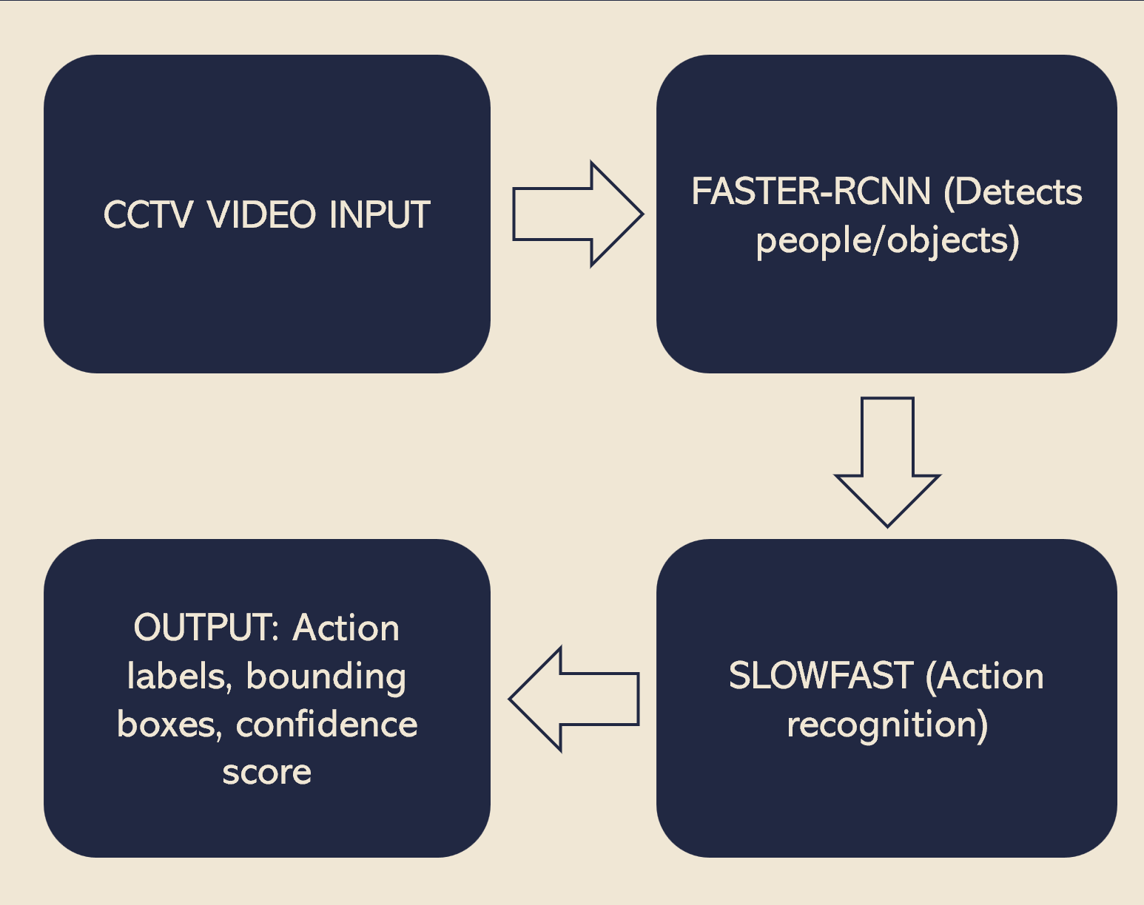
Figure 1
The proposed surveillance action recognition system is designed to process video input from CCTV cameras and automatically detect and classify human actions in real-time. As illustrated in Figure 1, the system workflow begins with raw video streams captured by surveillance cameras, which serve as the primary input for the detection pipeline. These video streams are first processed by an object detection module based on the Faster R-CNN model, implemented using the MMDetection framework. Faster R-CNN was chosen due to its two-stage detection architecture, which provides a strong balance between detection accuracy and robustness, ensuring reliable identification of objects and individuals within complex surveillance scenes. Although single-stage detectors such as YOLO offer faster processing speeds, practical considerations, including hardware limitations and time constraints necessitated the use of Faster R-CNN, which emphasizes precision and reliable bounding box generation over raw speed.
Once objects and individuals are detected, the system generates bounding boxes around each identified entity. These bounding boxes define the regions of interest that are subsequently analyzed by the action recognition module. The SlowFast model is employed at this stage to classify actions occurring within the identified regions. SlowFast is particularly suitable for surveillance applications because it captures both slow and fast temporal dynamics in video sequences, enabling the detection of subtle movements that might otherwise go unnoticed. This temporal sensitivity is essential for security-related monitoring as it allows for the identification of nuanced behaviors such as pickpocketing, item concealment, or other suspicious activities. For each detected action, the system produces a label along with a confidence score, providing a quantitative measure of the reliability of the prediction.
Finally, the processed output consists of an annotated video in which each detected individual is highlighted with a bounding box, accompanied by the predicted action label and its corresponding confidence score. This output not only facilitates intuitive monitoring by security personnel but also serves as a traceable record of all detected activities for review and analysis. By integrating high-accuracy object detection with temporally aware action recognition, the system achieves a comprehensive framework for automated surveillance, balancing precision, responsiveness, and practical deployment considerations, as summarized in Figure 1.

Objectives

The main objective of this project is to explore how action recognition can be implemented in surveillance systems to detect potential threats, such as shoplifting, pickpocketing, or the concealment of items. The goal is to create a system that can assist security personnel by automatically identifying suspicious behaviors in real-time and providing reliable, actionable information.
To achieve this, the project began by learning the fundamentals of object detection using the MMDetection framework. The Faster R-CNN model was selected for its accuracy and robustness, and a custom dataset was created, annotated, and augmented to train the model. This initial phase allowed hands-on experience with model configuration, dataset preparation, and training processes. Testing the trained model on sample images confirmed that objects could be accurately detected, providing a solid foundation for integrating action recognition.
The project then moved on to using the MMACTION2 framework to implement action recognition. The focus here was on integrating the object detection results with the action recognition pipeline and evaluating the system’s feasibility. Pretrained datasets, such as the AVA SlowFast model, were used to speed up experimentation while still maintaining effective detection of both subtle and fast actions. Throughout the project, the methodology, results, and observations were carefully documented to provide a clear record of the development process.
The overall objective is not only to implement a working system but also to understand its capabilities and limitations, and to explore its potential for future improvements. By achieving this, the project demonstrates a practical approach to automating threat detection in surveillance environments while balancing accuracy, efficiency, and real-world constraints.

Scope

Key Specifications and Features

The scope of this project is limited to the development and evaluation of an action recognition system using prerecorded surveillance footage. Due to certain hardware constraints, real-time CCTV processing was not implemented. All training and inference processes were conducted on a laptop without a dedicated NVIDIA GPU. This means that computation was performed with only using a CPU. As a result, the system can only operate in an offline setting where prerecorded footage is analyzed rather than live camera streams.

From a technical perspective, the system integrates two deep learning frameworks which are MMDetection for object detection and MMACTION2 for action recognition. The object detection component is based on the Fater R-CNN model which is trained on the COCO dataset. COCO dataset stands for common objects in context, and is a large-scale dataset containing images of everyday scenes with annotated objects across multiple categories.

For action recognition, the SlowFast model from the MMACTION2 framework is used with pretrained weights from the AVA dataset. The AVA dataset is designed for spatiotemporal action detection which consists of annotated video clips where individuals are labeled with specific actions over time. This makes it suitable for surveillance applications as it supports the identification of human behaviors within bounding boxes. With pretrained models, the project focuses on system integration rather than large-scale video training.

This system is capable of detecting individuals within video frames, generating bounding boxes, and classifying actions occurring within those boxes. The final output is an annotated video where bounding boxes, action labels, and confidence scores are displayed. Additionally, the existing demo script provided by MMACTION2 was modified with custom logic for identifying potential suspicious actions.

Overall, the scope of this project is limited to offline action recognition using established datasets and frameworks under CPU-based computational constraints.

Major Deliverables

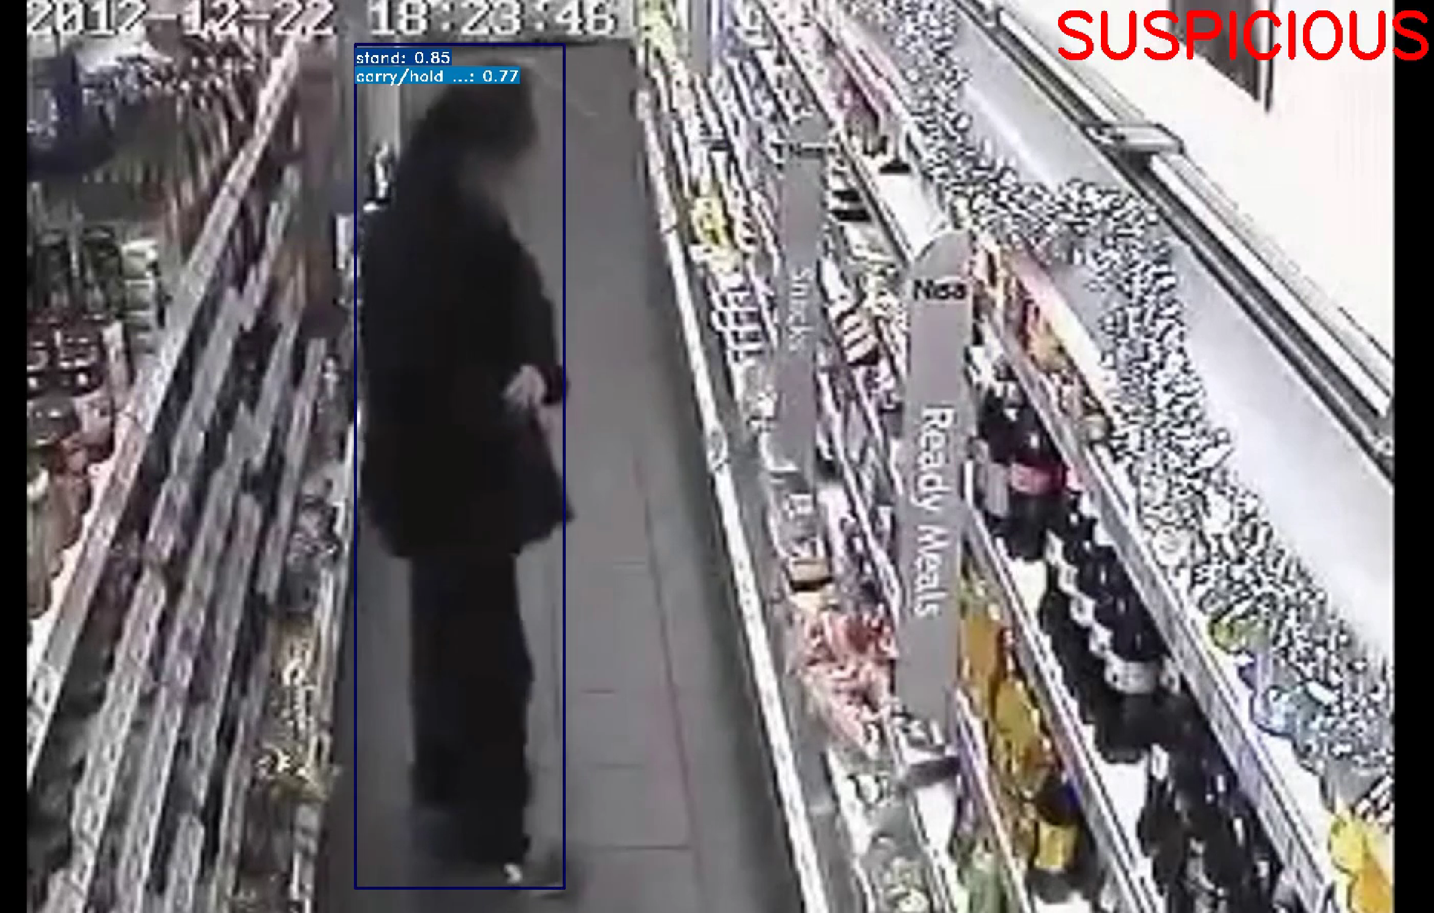
Figure 2

A sample output frame is shown in Figure 2. The figure illustrates a detected person enclosed within a bounding box generated by the object detection model, Faster R-CNN. Two action labels, including “carry/hold” are displayed together with the confidence score. Since “carry” and “hold” were defined as suspicious actions in the modified logic as shown in Figure 3, the system automatically generates an additional “Suspicious” indicator in the top right corner of the frame. This demonstrates the successful integration of object detection, action recognition, and customized filtering within a single output.

Implementation

Hardware Development

The hardware setup for this project was defined primarily by the computational resources available during development. All model inference processes were conducted on a personal laptop without a proper NVIDIA GPU. As a result, the system relied on CPU- based processing. This limitation significantly influenced the development approach, particularly in terms of model selection and testing methodology.
With the absence of GPU acceleration, real-time processing of live surveillance streams was not feasible. Instead, prerecorded surveillance-style video clips were used as input to the system. This approach allowed for controlled experimentation and evaluation without the burden associated with live video streaming. Although CPU-based processing resulted in longer processing times, it still provided a stable environment for understanding the behavior of the object detection and action recognition models.
The hardware limitations also influenced decisions related to dataset usage and mode configuration. Large-scale model training was avoided for the action recognition segment due to the high computational cost of video-based deep learning. Instead, pretrained weights were utilized for the SlowFast model which reduced training beforehand. For object detection, smaller datasets were used to ensure manageable training times within CPU limitations.
Although the system was developed under limited hardware conditions, it successfully demonstrates the feasibility of integrating object detection and action recognition within a surveillance framework. The constraints encountered also provided insight into the computational requirements for future real-time deployment.

Software Development

The software development stage focused on building and understanding both the object detection and action recognition components before integrating them into a single pipeline. Development was carried out using Python within Visual Studio Code, with PyTorch serving as the underlying deep learning framework for both MMDetection and MMACTION2.
The initial stage of development involved experimenting with MMDetection to understand the fundamentals of object detection. Faster R-CNN was selected due to its well-established two-stage detectors which separate region proposal and classifications for improved accuracy. To gain practical experience, a custom dataset was prepared and used for training. This required manual annotation where bounding boxes were assigned to target objects. Data augmentation techniques were applied to increase dataset variability and improve generalization. A configuration file was then written and adjusted to define dataset paths, training schedules, and model parameters. The model was then trained over several hours under CPU constraints and evaluation was conducted using test images to verify the detection performance. This stage provided a foundational understanding of how MMDetection is structures, allowing for easier integration with MMACTION2.
Following this, the project transitioned to action recognition using the MMACTION2 framework. Unlike static image detection, action recognition requires temporal analysis of video frames. The SlowFast model was selected for this purpose because it processes video frames using two pathways operating at different temporal resolutions. Pretrained weights based on the AVA dataset were utilized to allow the focus to remain on system integration and functional testing rather than large-scale model training. The system was configured such that detected bounding boxes from Faster R-CNN served as regions of interest for SlowFast. This ensured that the action classification was performed specifically on detected individuals rather than the entire frame itself.
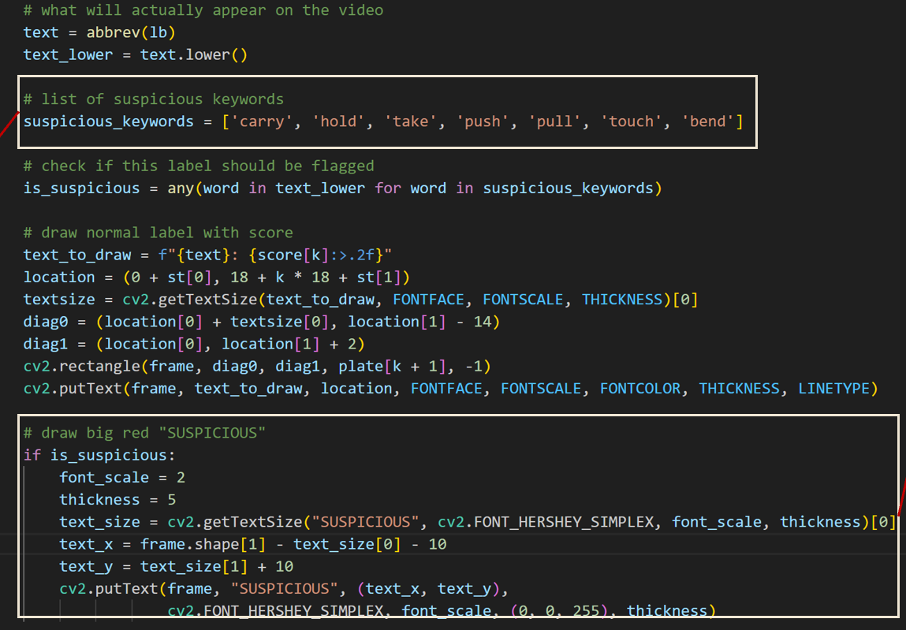
Figure 3
In addition to integration, modifications were made to the default demo_spatiotemporal_det.py script which was provided by MMACTION2. Custom logic was added to define a list of actions considered suspicious within the surveillance context. When the prediction label matched any entry in this predefined list, an additional “Suspicious” indicator was overlaid on the output frame. This addition extended the functionality of the original demo script by incorporating rule-based filtering. The modified section of the script is shown in Figure 3. This customization demonstrates the ability to adapt existing open-source frameworks to meet specific application requirements.

Integration and Testing
The primary focus of integration and testing was to demonstrate that the system could combine object detection and action recognition to identify frames containing potentially suspicious actions. Rather than creating a full surveillance system, the project aimed to show that the system could narrow down footage to specific segments flagged for review. This allows human reviewers to focus their attention of the flagged frames rather than manually scanning entire videos which reduces the manpower needed while also improving efficiency.
To evaluate the capability, prerecorded video clips were processed through an integrated pipeline. Detected individuals were analyzed by the SlowFast model, and action predictions were compared against a predefined list of suspicious actions. When a detected action matched any action from the list, a “Suspicious” indicator was displayed in the output frame. The resulting annotated videos clearly highlight frames of interest with bounding boxes, action labels, confidence scores, and triggered alerts. These flagged frames provide a clear and actionable reference for security personnel and can serve as input for further investigation if necessary.
Testing also involved verifying that bounding boxes generated by Faster R-CNN were accurately aligned with detected individuals, ensuring that action recognition was applied only to relevant regions. The system’s performance was observed under CPU constraints, with processing times recorded for different video lengths. These observations provided insight into the practical limitations of the pipeline and highlighted areas for potential future enhancement, such as GPU acceleration for real-time deployment.

4.4 Key Technical Issues and Solutions
During the development of the surveillance action recognition system, several
technical issues were encountered that required careful analysis and problem-
solving skills. These challenges highlight both the limitations of the chosen
frameworks and the practical considerations involved in integrating object
detection with action recognition.
The first challenge arose during experimentation with the Temporal Segment
Networks (TSN) model for action recognition. TSN is designed to classify a
single action over an entire video clip rather than detecting actions frame by
frame. As a result, attempts to generate annotated video outputs with
bounding boxes, action labels, and confidence scores returned empty or
incomplete videos. To address this problem, the approach was revised to
combine Faster R-CNN object detection model with the SlowFast action
recognition mode. Faster R-CNN provided accurate bounding boxes while
SlowFast generated the action labels with its confidence scores. This
demonstrates that the system could detect and localize human actions over
time while overcoming the constraints of TSN.
The second major challenge involved implementing the custom suspicious
logic. Initially, a separate Python script using OpenCV and VideoWriter was
attempted to generate annotated videos with the suspicious indicator tag.
However, due to environmental limitations in the Windows Subsystem for
Linux (WSL), VideoWriter failed to produce usable output. To overcome this,
the workflow was adjusted to leverage the existing MMACTION2 demo script,
demo_spatiotemporal_det.py, which already provided annotated video output
via the command line. The suspicious action logic was then incorporated
directly into this script, allowing the system to overlay a “Suspicious” indicator
on frames where predefined actions such as “carry”, “hold”, and “bend”, were
detected. The modified script maintained all existing annotation functionality
while successfully implementing the rule-based alert system.
A third significant challenge was the limitation imposed by hardware. Although
the development laptop included a GPU, it was not an NVIDIA GPU.
Therefore, it could not take advantage of CUDA acceleration. As a result,
real-time processing of the video streams and training of deep learning
models, particularly the SlowFast action recognition model, was not feasible.
Even the initial Faster R-CNN training on static images was computationally
intensive and required multiple days of CPU-based training. Video-based
model training on a CPY would have been impractical, potentially taking
several months to complete. To mitigate this constraint, pretrained weights
were used for the SlowFast model which was sufficient for evaluating system
integration. Additionally, the action recognition model had a limited set of
about 80 action classes which further reduced computational demands while
still supporting the detection of relevant behaviors in surveillance footage.
Together, these challenges highlight the practical considerations of developing action recognition systems under limited computational resources. By combining Faster R-CNN and SlowFast, the project was able to produce reliable annotated video outputs with integrated suspicious action detection. Figure 3 illustrates the modified script section where the suspicious logic was implemented while Figure 2 shows the resulting annotated video with triggered alerts.

Conclusion

5.1 Accomplishments and Outcome
The primary accomplishment of this project is the successful development and demonstration of an offline surveillance action recognition system that integrates object detection and action recognition. The system effectively processes prerecorded video footage, detects individuals using Faster R-CNN, classifies their actions with the SlowFast model, and highlights frames containing suspicious behaviors according to the predefined list. Through this process, the project confirmed that combining object detection with action recognition enables the narrowing down of video content to actionable segments. This significantly reduced the time and manpower required for human reviewers to monitor surveillance footage. Annotated video outputs, complete with bounding boxes, action labels, confidence scores, and triggered alerts demonstrate the practical value and functionality of the pipeline.

This project also reinforced foundational skills in working with open-source frameworks such as MMDetection and MMACTION2. Challenges encountered during development were successfully addressed through iterative problem-solving. The integration of pretrained models and modification of existing scripts not only validated the system’s feasibility but also illustrated the potential for customization and adaptation in real-world applications.

Overall, while the system was developed under computational constraints and limited to a predefined set of actions, it achieves the intended objective of demonstrating a practical workflow for automated detection of potentially suspicious behaviors in surveillance footage. The outcome provides a strong foundation for further development and experimentation in more complex and real-time enviromnents.

Future Enhancements
For practical deployment, the system could be further improved by focusing on pre-crime behaviors, subtle actions that may indicate potential theft before it occurs. Examples include loitering, unusual crowding, or bending and reaching in suspicious ways. Detecting these behaviors would allow security personnel to intervene proactively rather than reactively, which could enhance the overall effectiveness of surveillance monitoring.
Upgrading hardware would also enable the use of more complex models and support real-time video processing. A high-end NVIDIA GPU such as an RTC 4080 or 4090, paired with a powerful workstation would significantly increase inference speed and allow the system to scale to larger datasets and better models. Real-time processing could facilitate immediate alerts and continuous monitoring across multiple camera feeds, moving the system closer to practical and operational use.
Additionally, enhancements could include the integration of timestamps for flagged suspicious actions. This feature would allow human reviewers to quickly locate and assess events within recorded footage which can simplify the review process for investigations or incident documentation. Furthermore, the sequence of actions such as taking an item and immediately running off, triggers alerts. This approach would capture more complex behaviors and patterns that single-action detection may miss, providing for a more robust framework for automated surveillance analysis.
By implementing these enhancements, the system could transition from a proof-of-concept pipeline to a more comprehensive and practical surveillance solution capable of supporting proactive security measures and improving situational awareness in real-world environments.

References

Ren, S., He, K., Girshick, R., & Sun, J. (2015). Faster R-CNN: Towards Real-Time Object Detection with Region Proposal Networks. IEEE Transactions on Pattern Analysis and Machine Intelligence.
Lin, T.-Y., Maire, M., Belongie, S., Hays, J., Perona, P., Ramanan, D., Dollár, P., & Zitnick, C. L. (2014). Microsoft COCO: Common Objects in Context. European Conference on Computer Vision (ECCV).
Gu, C., Sun, C., Ross, D., Vondrick, C., Pantofaru, C., Li, Y., Vijaya Kumar, B. V., & Malik, J. (2018). AVA: A Video Dataset of Spatio-Temporally Localized Atomic Visual Actions. IEEE Conference on Computer Vision and Pattern Recognition (CVPR).
Feichtenhofer, C., Fan, H., Malik, J., & He, K. (2019). SlowFast Networks for Video Recognition. IEEE International Conference on Computer Vision (ICCV).
Escorcia, V., Niebles, J., Ghanem, B., & Soto, J. (2016). Daps: Deep Action Proposals for Action Understanding. European Conference on Computer Vision (ECCV).
Wang, L., Xiong, Y., Wang, Z., Qiao, Y., Lin, D., Tang, X., & Van Gool, L. (2016). Temporal Segment Networks: Towards Good Practices for Deep Action Recognition. European Conference on Computer Vision (ECCV).
Simonyan, K., & Zisserman, A. (2014). Two-Stream Convolutional Networks for Action Recognition in Videos. arXiv.
Szeliski, R. (2011). Computer Vision: Algorithms and Applications. Springer.
Sreenu, G., Saleem Durai, M.A. (2019). Intelligent video surveillance: a review through deep learning techniques for crowd analysis. J Big Data 6, 48
Khan, M. A., et al. (2020). Deep Learning for Video Surveillance. ACM Computing Surveys.
Herath, S., Harandi, M. T., & Porikli, F. (2017). Going deeper into action recognition: A survey. Image and Vision Computing, 60, 4–21.
Sigurdsson, G. A., Varol, G., Wang, X., Farhadi, A., Laptev, I., & Schmid, C. (2017). Hollywood2 Human Actions: Large Dataset and Benchmark for Action Detection. ECCV Workshops.
MMDetection Contributors. (2019). MMDetection: Open MMLab Detection Toolbox and Benchmark. https://github.com/open-mmlab/mmdetection
MMAction2 Contributors. (2020). MMAction2: OpenMMLab Video Understanding Toolbox and Benchmark. https://github.com/open-mmlab/mmaction2

