<https://beril.id/pengertian-dari-docker-serta-cara-penggunaannya/>

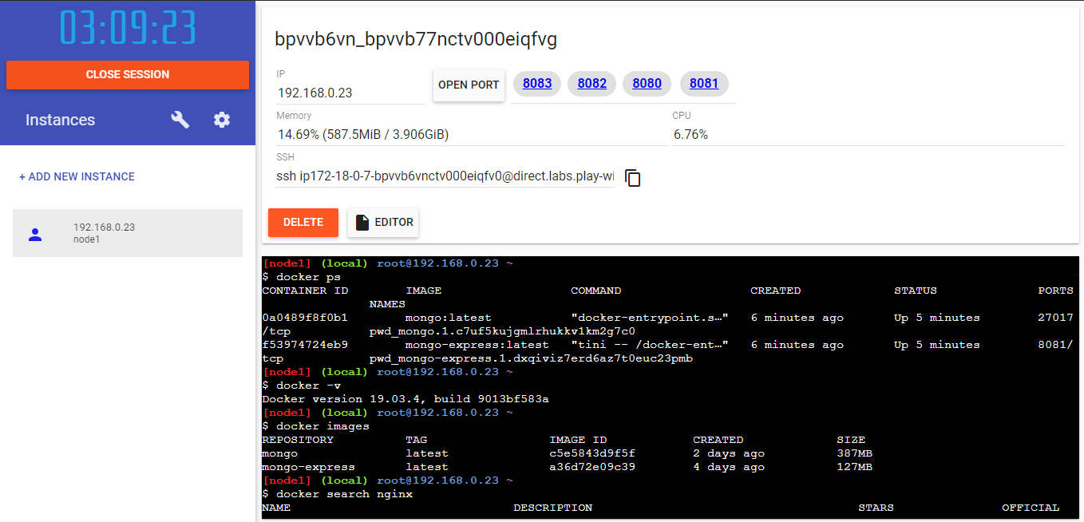

###############################################################

# WARNING!!!! #

# This is a sandbox environment. Using personal credentials #

# is HIGHLY! discouraged. Any consequences of doing so are #

# completely the user's responsibilites. #

# #

# The PWD team. #

###############################################################

[node1] (local) root@192.168.0.23 ~

**$ docker pull mongo:latest**

latest: Pulling from library/mongo

Digest: sha256:1e33093260855e83baee0237e29947e243818c58a1d37b1022909e227f624d7a

Status: Image is up to date for mongo:latest

docker.io/library/mongo:latest

[node1] (local) root@192.168.0.23 ~

**$ docker run -v "$(pwd)":/dta --name mongo -d mongo mongod --smallfiles**

547ca4df4b6b731d16c9dadf3a55f57ff8613b9685e248ee2c1ebf9f3cc88f47

[node1] (local) root@192.168.0.23 ~

**$ docker ps**

CONTAINER ID IMAGE COMMAND CREATED STATUS PORTS NAMES

0a0489f8f0b1 mongo:latest "docker-entrypoint.s…" 6 minutes ago Up 5 minutes 27017/tcp pwd_mongo.1.c7uf5kujgmlrhukkv1km2g7c0

f53974724eb9 mongo-express:latest "tini -- /docker-ent…" 6 minutes ago Up 5 minutes 8081/tcp pwd_mongo-express.1.dxqiviz7erd6az7t0euc23pmb

[node1] (local) root@192.168.0.23 ~

**$ docker -v**

Docker version 19.03.4, build 9013bf583a

[node1] (local) root@192.168.0.23 ~

**$ docker images**

REPOSITORY TAG IMAGE ID CREATED SIZE

mongo latest c5e5843d9f5f 2 days ago 387MB

mongo-express latest a36d72e09c39 4 days ago 127MB

[node1] (local) root@192.168.0.23 ~

**$ docker search nginx**

NAME DESCRIPTION STARS OFFICIAL AUTOMATED

nginx Official build of Nginx. 12893 [OK]

jwilder/nginx-proxy Automated Nginx reverse proxy for docker con… 1758 [OK]

richarvey/nginx-php-fpm Container running Nginx + PHP-FPM capable of… 760 [OK]

linuxserver/nginx An Nginx container, brought to you by LinuxS… 101

bitnami/nginx Bitnami nginx Docker Image 80 [OK]

tiangolo/nginx-rtmp Docker image with Nginx using the nginx-rtmp… 66 [OK]

jc21/nginx-proxy-manager Docker container for managing Nginx proxy ho… 46

nginxdemos/hello NGINX webserver that serves a simple page co… 44 [OK]

jlesage/nginx-proxy-manager Docker container for Nginx Proxy Manager 36 [OK]

nginx/unit NGINX Unit is a dynamic web and application … 36

nginx/nginx-ingress NGINX Ingress Controller for Kubernetes 28

privatebin/nginx-fpm-alpine PrivateBin running on an Nginx, php-fpm & Al… 23 [OK]

schmunk42/nginx-redirect A very simple container to redirect HTTP tra… 18 [OK]

blacklabelops/nginx Dockerized Nginx Reverse Proxy Server. 13 [OK]

centos/nginx-18-centos7 Platform for running nginx 1.8 or building n… 13

nginxinc/nginx-unprivileged Unprivileged NGINX Dockerfiles 13

raulr/nginx-wordpress Nginx front-end for the official wordpress:f… 12 [OK]

centos/nginx-112-centos7 Platform for running nginx 1.12 or building … 12

nginx/nginx-prometheus-exporter NGINX Prometheus Exporter 10

sophos/nginx-vts-exporter Simple server that scrapes Nginx vts stats a… 7 [OK]

mailu/nginx Mailu nginx frontend 6 [OK]

bitnami/nginx-ingress-controller Bitnami Docker Image for NGINX Ingress Contr… 4 [OK]

ansibleplaybookbundle/nginx-apb An APB to deploy NGINX 1 [OK]

wodby/nginx Generic nginx 0 [OK]

centos/nginx-110-centos7 Platform for running nginx 1.10 or building … 0

[node1] (local) root@192.168.0.23 ~

**$ docker pull nginx**

Using default tag: latest

latest: Pulling from library/nginx

68ced04f60ab: Pull complete

28252775b295: Pull complete

a616aa3b0bf2: Pull complete

Digest: sha256:2539d4344dd18e1df02be842ffc435f8e1f699cfc55516e2cf2cb16b7a9aea0b

Status: Downloaded newer image for nginx:latest

docker.io/library/nginx:latest

[node1] (local) root@192.168.0.23 ~

**$ docker rmi nama_image -f**

Error: No such image: nama_image

[node1] (local) root@192.168.0.23 ~

**$ docker ps -l**

CONTAINER ID IMAGE COMMAND CREATED STATUS PORTS NAMES

547ca4df4b6b mongo "docker-entrypoint.s…" 33 minutes ago Exited (2) 33 minutes ago mongo

[node1] (local) root@192.168.0.23 ~

**$ docker run -d -p 8080:80 --name nginx-1 nginx**

7e84ca9b4cda80508cbe47f41ea0012b8426276cdd24d3b5ede173b71311565e

[node1] (local) root@192.168.0.23 ~

**$ netstat -lnpt**

Active Internet connections (only servers)

Proto Recv-Q Send-Q Local Address Foreign Address State PID/Program name

tcp 0 0 127.0.0.11:42280 0.0.0.0:* LISTEN -

tcp 0 0 0.0.0.0:22 0.0.0.0:* LISTEN 32/sshd

tcp 0 0 :::2375 :::* LISTEN 16/dockerd

tcp 0 0 :::2377 :::* LISTEN 16/dockerd

tcp 0 0 :::7946 :::* LISTEN 16/dockerd

tcp 0 0 :::8080 :::* LISTEN 56604/docker-proxy

tcp 0 0 :::8081 :::* LISTEN 16/dockerd

tcp 0 0 :::22 :::* LISTEN 32/sshd

[node1] (local) root@192.168.0.23 ~

**$ http://localhost:8080**

bash: http://localhost:8080: No such file or directory

[node1] (local) root@192.168.0.23 ~

**$ docker run -d -p 8082:80 --name nginx-2 nginx**

9d02103165d29a4e6ac58c05ee978344996acd94931216ba66929332d95899f4

[node1] (local) root@192.168.0.23 ~

**$ docker run -d -p 8083:80 --name nginx-3 nginx**

90957925955c6d7d0de0ea9d341f49aa332716047dba35d6ccbee98b959a1815

[node1] (local) root@192.168.0.23 ~

**$ http://localhost:8082**

bash: http://localhost:8082: No such file or directory

[node1] (local) root@192.168.0.23 ~

**$ http://localhost:8083**

bash: http://localhost:8083: No such file or directory

[node1] (local) root@192.168.0.23 ~

**$ docker extc -it nginx-1 /bin/bash**

unknown shorthand flag: 'i' in -it

See 'docker --help'.

Usage: docker [OPTIONS] COMMAND

A self-sufficient runtime for containers

Options:

--config string Location of client config files (default

"/root/.docker")

-c, --context string Name of the context to use to connect to the

daemon (overrides DOCKER_HOST env var and default

context set with "docker context use")

-D, --debug Enable debug mode

-H, --host list Daemon socket(s) to connect to

-l, --log-level string Set the logging level

("debug"|"info"|"warn"|"error"|"fatal") (default

"info")

--tls Use TLS; implied by --tlsverify

--tlscacert string Trust certs signed only by this CA (default

"/root/.docker/ca.pem")

--tlscert string Path to TLS certificate file (default

"/root/.docker/cert.pem")

--tlskey string Path to TLS key file (default "/root/.docker/key.pem")

--tlsverify Use TLS and verify the remote

-v, --version Print version information and quit

Management Commands:

app* Docker Application (Docker Inc., v0.8.0)

builder Manage builds

checkpoint Manage checkpoints

config Manage Docker configs

container Manage containers

context Manage contexts

engine Manage the docker engine

image Manage images

manifest Manage Docker image manifests and manifest lists

network Manage networks

node Manage Swarm nodes

plugin Manage plugins

secret Manage Docker secrets

service Manage services

stack Manage Docker stacks

swarm Manage Swarm

system Manage Docker

trust Manage trust on Docker images

volume Manage volumes

Commands:

attach Attach local standard input, output, and error streams to a running container

build Build an image from a Dockerfile

commit Create a new image from a container's changes

cp Copy files/folders between a container and the local filesystem

create Create a new container

deploy Deploy a new stack or update an existing stack

diff Inspect changes to files or directories on a container's filesystem

events Get real time events from the server

exec Run a command in a running container

export Export a container's filesystem as a tar archive

history Show the history of an image

images List images

import Import the contents from a tarball to create a filesystem image

info Display system-wide information

inspect Return low-level information on Docker objects

kill Kill one or more running containers

load Load an image from a tar archive or STDIN

login Log in to a Docker registry

logout Log out from a Docker registry

logs Fetch the logs of a container

pause Pause all processes within one or more containers

port List port mappings or a specific mapping for the container

ps List containers

pull Pull an image or a repository from a registry

push Push an image or a repository to a registry

rename Rename a container

restart Restart one or more containers

rm Remove one or more containers

rmi Remove one or more images

run Run a command in a new container

save Save one or more images to a tar archive (streamed to STDOUT by default)

search Search the Docker Hub for images

start Start one or more stopped containers

stats Display a live stream of container(s) resource usage statistics

stop Stop one or more running containers

tag Create a tag TARGET_IMAGE that refers to SOURCE_IMAGE

top Display the running processes of a container

unpause Unpause all processes within one or more containers

update Update configuration of one or more containers

version Show the Docker version information

wait Block until one or more containers stop, then print their exit codes

Run 'docker COMMAND --help' for more information on a command.