## EN813701

### Exercise 5 Comment Web Design

Item 1: This website should keep things simple and clean interface by make it easy to interact with. You’ll see that this website has all category and all sub category in one page so that make users confuse in using this website.

Item 2: This website should use color properly based on user experience by using heat color to manage focus on category and attract attention with higher contrast. This will make the website more dimensional.

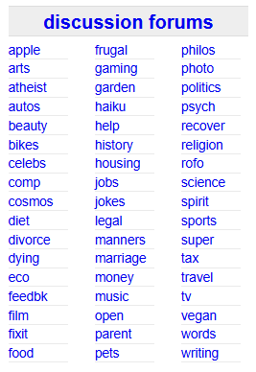

Item 3: Font size should be bigger than current because this site is used to view and post local ads for various categories, such as jobs, housing, for sale, services and all of these is for adult so that it’s hard for adult user to use this website with small font size.