## EN813701

### Exercise 5 Comment Web Design

### **Problem2 Learning from websites with good design (5 points)**

Website: <https://www.jobthai.com/>

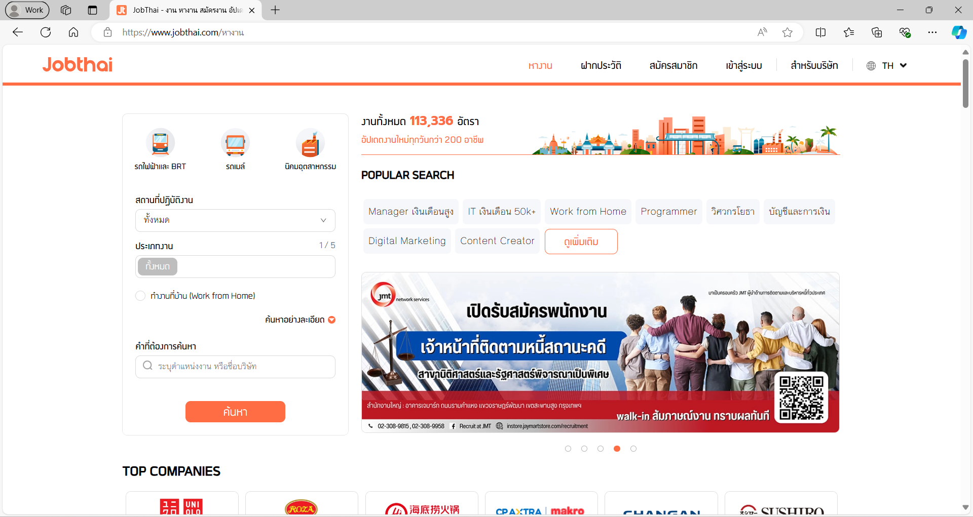

Item 1: This website has an effective UI because this website has navigation bar to lead user where to go or where to do on website and they know their audience because there is two types of user on this website: companies and job seekers so it’s easy for these two types of user to communicate with each other.



Item 2: This website is good at typography because the font size is perfect to read and the color of background and color of font is well contrast to each other.

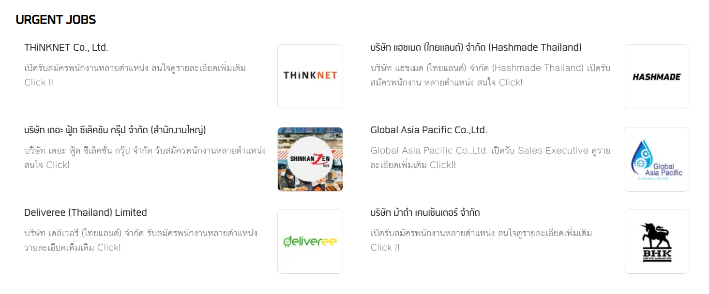

Item 3: This website implement a visual hierarchy so that make users easy to understand and interact with because they use image to describe important element in order to make users focus on them.

