* GET request - [**http://127.0.0.1:5000/info**](http://127.0.0.1:5000/info)

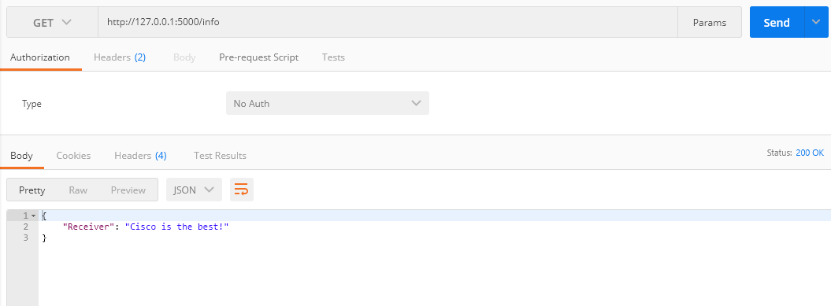

* POST request - [**http://127.0.0.1:5000/ping**](http://127.0.0.1:5000/ping)
  + Sample1 - **{"url": "http://api.plos.org/search?q=title:DNA"}**
  + Sample2 - **{"url": "http://ergast.com/api/f1/2004/1/results.json"}**

