Do pretraining corpora differ enough to matter?
Stage A results and what they imply for the rest of the project
Gabriel Dupuis and Léonard Mauvernay, 6.3930, 8 November 2026
____________________________________________________________

1. What this report establishes
The project asks whether the choice of pretraining corpus changes what a molecular property model learns, with CheMeleon's architecture, objective and budget held fixed. Before running a single pretraining job, Stage A asks the prior question: do the candidate corpora actually differ? If they do not, the experiment has no treatment and there is nothing to measure.
They differ, and by a wide margin. Five findings:
- The corpora are chemically distinct, not variations on a theme. The largest property gap reaches 2.15 standard deviations, with histograms overlapping only 28 percent.
- Natural-product-likeness is entangled with ordinary properties. Selecting on it also selects on saturation, aromaticity, size and stereochemistry. A corpus effect found later cannot be attributed to "naturalness" without this caveat.
- COCONUT is the most internally redundant corpus, despite looking diverse by average pairwise similarity. In a 10,000-molecule sample, one COCONUT molecule in five has a near twin elsewhere in the sample, against one in twenty for PubChem and fewer than one in two hundred for either ZINC arm, and COCONUT needs about 40 percent fewer coarse-grained spheres than ZINC to cover the same number of molecules. Nominal corpus size and effective corpus size are not the same quantity, which bears directly on the size curve.
- The benchmarks sit much closer to PubChem than to either ZINC arm, and PubChem already contains 73 percent of BBBP and 93 percent of ESOL by exact structure match. That corpus, CheMeleon's own, is not a uniform random draw from PubChem whatever its paper says: it is enriched roughly a hundredfold for well-known compounds. Corpus identity, benchmark proximity and benchmark exposure are three confounded variables, not one.
- The effect we are hunting is smaller than the noise reported in the published benchmarks. That is the central design constraint, and it governs every choice in sections 7 and 8.
A clear null result remains a valid outcome. What Stage A guarantees is that a null would mean something: the corpora were genuinely different and the model was indifferent to the difference.
____________________________________________________________

2. What was run
One Slurm job on a CPU node, 8 cores, 8 minutes 19 seconds wall clock, 2.96 GB peak memory. Every step is independent and skips work already on disk, so the job is safe to rerun and safe to preempt. The report tables and the splits were regenerated the same day, after an independent recomputation and a statistical review of the script (commit d6069a8, 4.5 minutes); the changes they forced are listed in section 10.
Step | Output
Build caches | one canonicalised, deduplicated table per corpus
Prepare conditions | four size-matched 20,000-molecule samples, seed 0
Corpus report | 8 tables, 2 figures
Benchmark splits | BBBP and ESOL, scaffold split, 5 seeds each
Stage A analysis | the original comparison, including the t-SNE map
Descriptors | Mordred store for the pilot pretraining condition
Provenance is recorded in manifest.json next to each output: commit a0525b4, clean working tree, and the exact version of RDKit, Mordred, NumPy, scikit-learn and Zarr used. Results are at runs/analysis/stage_a_corpora/; data products are on scratch under natural-compounds-data/processed/.

The four corpora
corpus | raw rows | parsed | unique | multi-fragment | over 150 characters
pubchem | 944,296 | 944,296 | 944,286 | 0 | 3
coconut | 738,793 | 738,789 | 738,767 | 4,247 | 65,148
zinc_general | 499,998 | 499,998 | 499,998 | 0 | 40
zinc_nplike | derived from zinc_general: the decile with the highest natural-product-likeness
PubChem and ZINC arrive clean. COCONUT does not, and the difference is chemical rather than sloppy: natural products are larger and are more often reported as mixtures. CheMeleon's 150-character rule discards 8.8 percent of COCONUT and three molecules of PubChem, so the cleaning rule is itself a compositional choice. We apply it to every corpus anyway, because cleaning the corpora differently would introduce a second variable.
____________________________________________________________

3. How the corpora differ

3.1 Natural-product-likeness
Scored with Ertl's fragment model as shipped in RDKit, on the 20,000-molecule samples. The score measures structural resemblance to natural-product chemistry, not biological origin.
corpus | mean | median | share above 0 | share above +1
coconut | +1.09 | +1.11 | 74.6% | 52.2%
zinc_nplike | +0.63 | +0.52 | 100.0% | 17.4%
pubchem | −0.70 | −0.82 | 22.4% | 7.3%
zinc_general | −0.93 | −1.01 | 12.3% | 1.8%
The ordering is the one the project assumes, and the gap between COCONUT and the two general libraries is about two units. The contrast Stage D needs is real.
Two caveats that must travel with these numbers:
- COCONUT is heterogeneous. A quarter of it scores below zero, and named
synthetics such as losartan and clonidine are present. We do not filter, because Ertl's own score misclassifies caffeine at −1.09, and removing molecules on a rule that gets caffeine wrong would damage the corpus in an unknown direction. A documented impurity is better than an unknown one.
- zinc_nplike is not natural-product-like in Ertl's sense. Its decile starts
at +0.14 and its mean is +0.63, below Ertl's +1.0 threshold. It is the most natural-product-like tenth of a synthetic library. The write-ups should say exactly that, because the arm's name promises more than the chemistry delivers.

3.2 Physicochemical properties
Thirteen descriptors per molecule. Seven of them are the ones Ertl's "simple properties" classifier used, the model he showed performs only slightly worse than the fragment score (Ertl et al. 2008, p. 4): SlogP, polar surface area, heavy-atom count, nitrogen plus oxygen count, aromatic content, potential stereocentres and rotatable bonds. We count aromatic rings where he counted aromatic atoms. Stereocentres include unassigned centres, so a molecule drawn without stereo marks still contributes its potential centres; on the assigned-only definition the PubChem mean falls from 0.93 to 0.44 and the COCONUT mean from 3.93 to 3.34. Means on the 20,000-molecule samples:
property | pubchem | coconut | zinc_general | zinc_nplike
molecular weight | 322 | 455 | 343 | 273
logP | 3.12 | 4.28 | 2.49 | 2.44
TPSA | 63.3 | 95.4 | 67.9 | 46.5
heavy atoms | 22.3 | 32.4 | 23.8 | 19.0
aromatic rings | 1.79 | 1.27 | 1.35 | 0.29
fraction sp3 | 0.36 | 0.56 | 0.58 | 0.84
stereocentres | 0.93 | 3.93 | 1.64 | 3.02
rotatable bonds | 4.48 | 9.08 | 5.36 | 4.48
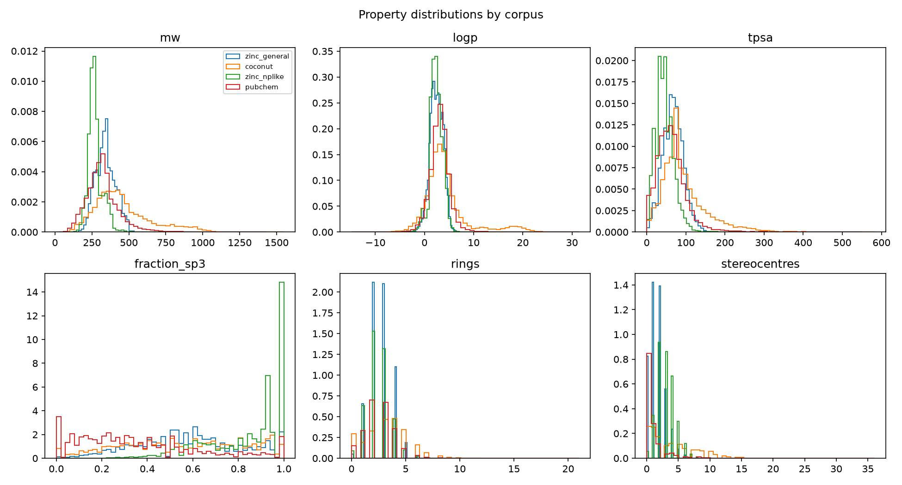
Property distributions across the four corpora. COCONUT's long tails in molecular weight, logP and TPSA are visible, as is the pile-up of fully saturated molecules in the natural-product-like ZINC decile.
The separations are large. Reported as Cohen's d, with the overlap of the two histograms alongside it:
comparison | property | d | histogram overlap
zinc_nplike vs pubchem | fraction sp3 | 2.15 | 28%
zinc_nplike vs pubchem | aromatic rings | −1.64 | 42%
zinc_general vs zinc_nplike | aromatic rings | 1.38 | 45%
coconut vs zinc_nplike | heavy atoms | 1.34 | 31%
zinc_nplike vs pubchem | stereocentres | 1.27 | 30%
coconut vs pubchem | stereocentres | 1.01 | 54%
coconut vs pubchem | molecular weight | 0.84 | 62%
coconut vs pubchem | logP | 0.33 | 81%
Cohen's d is the difference in means over the pooled standard deviation (n − 1 weights). The overlap is the histogram intersection, Σ min(p_a, p_b) over 64 bins shared by the two samples, so 1.0 means identical distributions and it does not depend on a normality assumption. For scale, a d of 0.8 is conventionally "large". Of the 78 corpus-pair comparisons (13 properties, 6 pairs), 24 exceed 0.8 and 16 exceed 1.0. The table shows the eight most informative.
One reading note. The COCONUT logP row has d = 0.33 although the means differ by 1.2 units, because COCONUT's standard deviation is 4.6 against PubChem's 2.0: a tail of lipids and polyketides with logP between 10 and 25, visible in the figure, inflates the denominator. The medians, 3.36 against 3.13, confirm that the bulk of the two distributions sits close together. Where COCONUT has heavy tails, d understates the shift of the bulk and the overlap column is the more robust companion.
This is the confound that matters most. Ertl showed that a surrogate built only from simple properties nearly reproduces the fragment score. Our numbers show the same thing from the other direction: a corpus selected on natural-product-likeness is simultaneously a corpus selected for saturation, against aromaticity, and for stereochemistry. If Stage D finds a COCONUT effect, "natural products help" and "saturated, heavy, stereochemically rich molecules help" are the same claim until an experiment separates them.

3.3 Scaffolds
Bemis-Murcko scaffolds on the same samples. Acyclic molecules have an empty scaffold; they are reported as their own share and kept out of the concentration statistics, because counting the empty string as one scaffold makes every acyclic molecule in a corpus fall into a single bucket and inflates the concentration of exactly the corpus with the most acyclic molecules. The first version of this table made that mistake and ranked COCONUT among the most concentrated corpora; it is not. Shannon entropy is in natural-log units, normalised by ln(number of scaffolds), which is Pielou's evenness. Singletons are scaffolds that occur once, given both as a share of scaffolds and as a share of molecules.
corpus | ring molecules | scaffolds | per ring molecule | evenness | top-100 share | singletons (scaffolds / molecules) | acyclic
zinc_general | 19,841 | 15,798 | 0.796 | 0.954 | 13.3% | 93.4% / 74.4% | 0.8%
coconut | 17,535 | 10,561 | 0.602 | 0.931 | 18.8% | 81.6% / 49.1% | 12.3%
zinc_nplike | 19,579 | 12,282 | 0.627 | 0.908 | 23.4% | 88.3% / 55.4% | 2.1%
pubchem | 18,713 | 10,348 | 0.553 | 0.894 | 24.0% | 81.6% / 45.2% | 6.4%
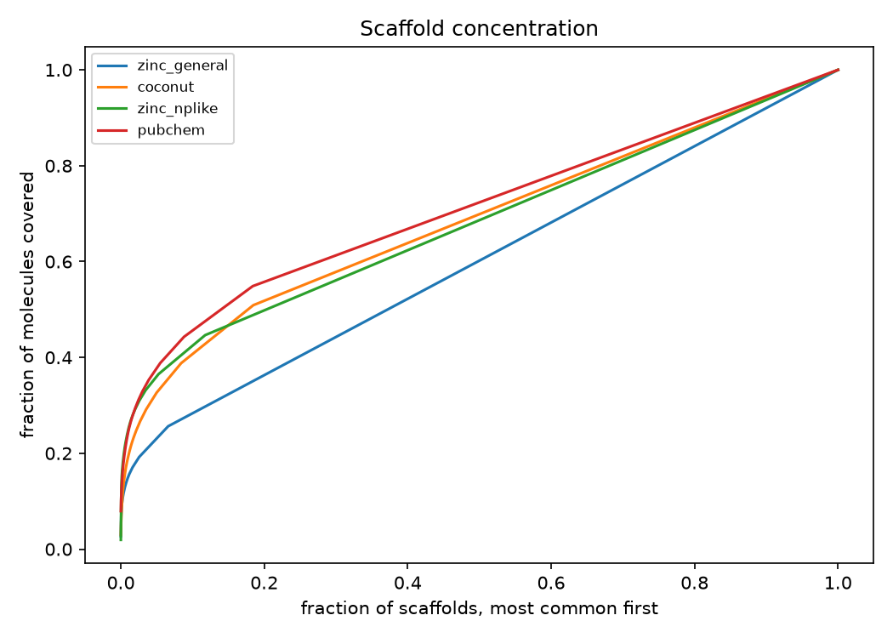
Scaffold concentration over ring-containing molecules. The further a curve bows toward the top-left, the more of the corpus sits on a few repeated frameworks. ZINC is closest to the diagonal; PubChem is the most concentrated, with COCONUT and the natural-product-like decile between.
Three observations. First, the random ZINC sample is by far the most scaffold-diverse corpus: 93 percent of its scaffolds occur once and its hundred commonest scaffolds cover 13 percent of molecules, against 24 percent for PubChem. Part of that is the library and part is our sampling, which spread 250 draws across the whole tranche-ordered upload (section 10). Second, PubChem is the most scaffold-concentrated corpus, not COCONUT: a quarter of PubChem's ring-containing molecules sit on a hundred frameworks, benzene and the common heteroaromatics among them. Third, 12.3 percent of COCONUT has no ring system at all: fatty acids, sugars, terpene chains. This matters downstream as well as upstream. In ESOL, 317 of 1,128 molecules (28 percent) are acyclic and therefore share one scaffold group; in BBBP, 99 of 2,039 (5 percent). A scaffold split moves such a group as a block, so ESOL's scaffold split is a far coarser instrument than its size suggests.

3.4 Diversity and redundancy
All similarity in this report is Tanimoto on Morgan fingerprints, radius 2, 2,048 bits, the field's default. Average pairwise similarity on 4,000-molecule samples says all four corpora are diverse and nearly identical to one another, between 0.10 and 0.12. That measure is close to useless here: a mean over eight million pairs cannot see a few thousand near-duplicates.
Sphere-exclusion coverage can. Draw a sample, walk it, keep a molecule as a new sphere centre unless it is within a set similarity of a centre already kept, and divide the number of centres by the sample size. We use two radii, because they answer different questions. At similarity 0.65 two molecules in one sphere are close analogues, the scale at which analogue series and re-reported compounds live. At similarity 0.35, the sphere ChemFM's SEDiv statistic uses through MolScore, coverage measures how many coarse regions of chemical space the sample occupies. The 2,000-molecule sample is the first 2,000 rows of the 10,000-molecule one, so the change between them is a within-sample quantity.
corpus | mean pairwise | pairs above 0.4 | near twins at 2,000 | near twins at 10,000 | coarse coverage at 2,000 | coarse coverage at 10,000
zinc_general | 0.119 | 0.009% | 0.0% | 0.1% | 0.854 | 0.640
zinc_nplike | 0.111 | 0.011% | 0.0% | 0.4% | 0.814 | 0.549
pubchem | 0.101 | 0.034% | 1.0% | 4.9% | 0.702 | 0.456
coconut | 0.105 | 0.77% | 11.8% | 20.5% | 0.593 | 0.366
"Near twins" is one minus the close-analogue coverage: the share of molecules that fall inside another sample molecule's 0.65 sphere. Two independent statistics agree. The share of molecule pairs above Tanimoto 0.4 is 0.77 percent for COCONUT and 0.009 percent for random ZINC, an eighty-fold difference, while COCONUT's mean similarity is the second lowest of the four: a heavy tail of close pairs on an otherwise diverse body, which is what analogue series look like. And at the coarse radius COCONUT needs 3,663 spheres to cover 10,000 molecules where ZINC needs 6,398 and PubChem 4,557. The decline of coarse coverage between 2,000 and 10,000 is similar for all four corpora (0.21 to 0.27), so the corpora differ in level, not in the rate at which new regions appear with size.
An earlier version of this section reported only the 0.65 radius, at which three corpora saturate at coverage 1.0, and compared decays measured from that ceiling; the resulting ratios were counts of a dozen molecules and have been withdrawn. The sphere-exclusion implementation is covered by tests: 2,000 unrelated fingerprints give 2,000 spheres, 100 analogue series of 20 give exactly 100, and the count does not depend on how the sample is blocked.
This is the expected signature of a natural-product database: congeneric series, the same terpene skeleton decorated many ways, duplicate reports of the same compound family from different organisms.
Consequence: nominal size and effective size diverge by corpus. At a fixed count of molecules, COCONUT carries fewer distinct coarse regions and five times PubChem's share of near twins. One million COCONUT molecules do not carry a million molecules' worth of distinct chemistry. Any size-matched comparison matches the wrong quantity unless this is stated.

3.5 How much the corpora overlap
Mean nearest-neighbour Tanimoto similarity from a 4,000-molecule sample of each corpus to a 4,000-molecule sample of each other, measured in both directions because the relation is not symmetric. Nearest-neighbour similarity rises with the size of the reference set, so the values are comparable across rows of this table, which all use the same sample size, but not with numbers computed against a full corpus. The original Stage A script computes the same quantity on an independent sample and reproduces every ordering below within ±0.025.
from → to | mean | share above 0.4
coconut → pubchem | 0.354 | 27.8%
pubchem → coconut | 0.323 | 14.8%
zinc_general → pubchem | 0.291 | 5.0%
zinc_nplike → zinc_general | 0.312 | 8.0%
coconut → zinc_general | 0.244 | 1.4%
zinc_general → coconut | 0.262 | 1.1%
The asymmetry between the first two rows is the useful result: COCONUT sits inside PubChem's coverage considerably more than PubChem sits inside COCONUT's. Nearly 28 percent of COCONUT molecules find a close neighbour in PubChem, against 15 percent the other way. PubChem, aggregated from several hundred depositors including vendors, the literature and natural-product databases, already contains much natural-product chemistry; COCONUT is closer to a dense subregion of PubChem than to an independent region of chemical space. ZINC, by contrast, is genuinely elsewhere: around 1 percent mutual coverage with COCONUT.
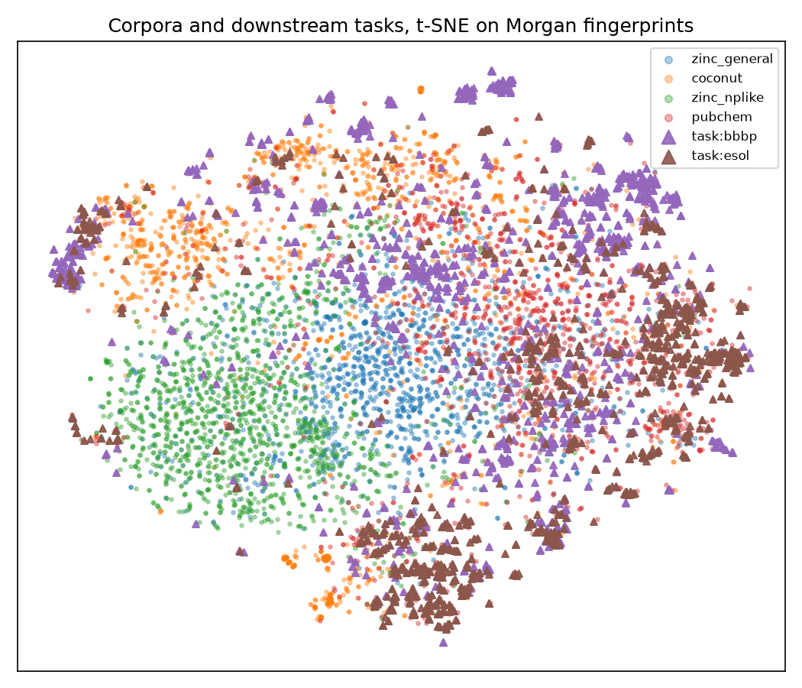
t-SNE of Morgan fingerprints, corpora and benchmark molecules together. The arrangement is consistent with the tables: the ZINC arms occupy their own region, COCONUT and PubChem interleave, and the benchmark molecules fall mostly where PubChem and COCONUT are, not where ZINC is.
____________________________________________________________

4. How the corpora relate to the benchmarks

4.1 Exposure
How much of each benchmark already sits inside each full corpus, by exact canonical SMILES match. Shares are over unique canonical structures: 1,975 for BBBP (2,050 rows, 11 unparseable, 64 duplicates) and 1,117 for ESOL (1,128 rows).
corpus | pool | contains BBBP | contains ESOL
pubchem | 944,286 | 73.1% | 93.2%
coconut | 738,767 | 36.1% | 55.6%
zinc_general | 499,998 sampled | 0.0% | 0.0%
An earlier count over the full 11.7-million-molecule ZINC upload found 0.3 and 0.1 percent, so ZINC's exposure is not exactly zero, only negligible.
The PubChem figure says something about the corpus itself. CheMeleon's paper describes the pretraining set as "randomly selecting 1 million molecules from PubChem" (Burns et al. 2026, p. 12). PubChem holds about 119 million compounds, so a uniform draw of 944,286 would contain 0.8 percent of any benchmark, not 73 or 93 percent. A direct probe confirms the enrichment: of twenty textbook molecules we checked (water, methane, ethanol, acetic acid, benzene, toluene, phenol, glucose, urea, glycine, aspirin, caffeine, ibuprofen, paracetamol, nicotine, cholesterol, penicillin G, DDT, atrazine, morphine), nineteen are in the corpus; a uniform draw would contain 0.2 of them on average. Whatever the selection procedure was, the released corpus is the well-characterised core of PubChem, enriched roughly a hundredfold for compounds that appear in textbooks, assays and benchmarks. That is a property of the released CheMeleon checkpoint as well, and it is the most likely reason its pretraining corpus sits so close to every public benchmark in section 4.2.
In the 20,000-molecule conditions actually used here, exact exposure falls to 1.7 and 2.1 percent of unique BBBP and ESOL structures for PubChem and 1.0 and 1.3 percent for COCONUT, with ZINC at zero. Near duplicates, benchmark molecules within Tanimoto 0.9 of some condition molecule, are more common and nearly equal for the two: 3.8 and 7.3 percent of BBBP and ESOL for PubChem, 3.5 and 7.4 percent for COCONUT, zero for ZINC. Scaled to a 50,000-molecule pretraining condition, about 130 PubChem structures and 85 COCONUT structures would be molecules the benchmarks also contain exactly, counting train, validation and test together; roughly a tenth of those, 14 and 8, would fall in a given test split. ZINC would carry none.
No labels leak: pretraining is unsupervised descriptor regression, and the property labels never enter it. But the arms would differ systematically in how many benchmark structures the encoder has already seen, which makes exposure a component of the treatment rather than a nuisance beside it. These counts are lower bounds, since a benchmark molecule recorded as a salt or with different stereo marks will not match its parent.

4.2 Proximity
Similarity from each benchmark molecule to its nearest neighbour in the whole 20,000-molecule condition, which is what a pretraining run of that size would see. The reference size matters: against a 4,000-molecule subsample the means are 0.08 to 0.12 lower and the "remote" shares 20 to 25 points higher, so these figures hold for conditions of this size and would rise further for the full corpora.
task | corpus | mean | share below 0.3 | share above 0.4
esol | pubchem | 0.542 | 4.6% | 81.1%
esol | coconut | 0.463 | 19.9% | 54.5%
esol | zinc_general | 0.297 | 53.7% | 11.8%
esol | zinc_nplike | 0.295 | 56.7% | 11.9%
bbbp | pubchem | 0.504 | 7.0% | 70.8%
bbbp | coconut | 0.422 | 24.1% | 41.2%
bbbp | zinc_general | 0.317 | 45.4% | 13.7%
bbbp | zinc_nplike | 0.293 | 61.5% | 9.1%
PubChem is nearest to both benchmarks on every statistic, COCONUT second, and the two ZINC arms far behind: about half of each benchmark has no neighbour above Tanimoto 0.3 in a 20,000-molecule ZINC condition, against one molecule in twenty for PubChem. This single table is the x-axis for Stage B and the binning variable for Stage E, and it also predicts the ordering we should expect downstream if transfer is driven by coverage rather than by anything specific to natural products.
____________________________________________________________

5. What this means for the experiment
The treatment is real. Four corpora, well separated on properties, scaffolds, redundancy and benchmark proximity. Stage A has done its job.
Three variables move together across the Stage D arms, and no size-matched design separates them:
 | NP-likeness | property profile | benchmark exposure | benchmark proximity
pubchem | low | aromatic, flat | very high | nearest
coconut | high | heavy, saturated, stereo-rich | moderate | middle
zinc_general | lowest | drug-like, synthetic | none | far
zinc_nplike | middle | small, saturated, stereo-rich | none | farthest
Reading a Stage D difference as "natural products help" requires ruling out the other three columns. Two controls make that possible, and both are cheap relative to the pretraining runs themselves:
- A property-matched control arm. Sample PubChem to match COCONUT's joint
distribution of molecular weight, fraction sp3, stereocentres and aromatic rings. If the COCONUT effect survives against this arm, it is not a property effect. This is the single most valuable addition to the plan.
- A deduplicated-benchmark arm. Rerun one condition with every exact and
near-duplicate benchmark structure removed from the corpus. The machinery already exists: prepare_corpus.py --exclude-benchmarks, and the counts are recorded in each condition's stats file either way.
Effective size is not nominal size. The Stage C size curve sweeps PubChem from 500 to 100,000 molecules. Because the corpora differ in near-twin share and in coarse coverage at the same count, the same curve run on COCONUT would not be the same experiment. Either report the curve against sphere coverage as well as against raw count, or keep the size curve on a single corpus and let Stage D handle composition at one fixed size. We propose the latter, which is what the plan already does.
____________________________________________________________

6. What the published benchmarks say we can detect
The 1 October lecture presented a benchmarking study whose numbers bound what any result of ours can claim. Four of them matter here. They were read off the charts on slides 20, 55, 56 and 57 (the statistics live in the figures, not the slide text) and cross-checked: the two critical differences equal the Nemenyi value for six methods on 22 and 10 datasets to two decimals, and the six mean ranks in each diagram sum to 21, as mean ranks must.
- Methods are mostly indistinguishable. The critical difference is 1.61 mean-rank points across 22 ADMET endpoints and 2.38 across 10 MoleculeNet datasets under the deck's harder scaffold variant, where the Friedman test gives p = 0.194. Six methods, five pretrained models and Chemprop trained from scratch, could not be separated at all on those ten datasets.
- Foundation-model advantages are small. CheMeleon beat Chemprop by 1.20 mean-rank points on ADMET, inside the critical difference. On four pharmaceutical assays under a temporal split, the best-to-worst spread ran from 0.009 AUROC on the tightest assay, against confidence intervals of ±0.02, to 0.058 on the widest, against ±0.08. In no assay did the spread clear the uncertainty.
- The split dominates the method. The deck's illustration of splitting shows AUROC 0.78 under a random split against 0.54 under a scaffold split: 0.24 points from the evaluation protocol alone, roughly an order of magnitude more than any corpus effect we could plausibly find.
- Gains live in the low-data regime and shrink with labels. On BACE, the best foundation model led Chemprop by about +0.07 AUROC at 60 training molecules and by about +0.04 at 847: the advantage roughly halves, it does not vanish. On ESOL at 45 molecules, three pretrained models were worse than training from scratch (RMSE 2.09, 2.04 and 1.55 against 1.26).
A fifth number is the most pointed one for us: adding computed descriptors to Chemprop improved it by roughly 0.09 AUROC on BACE at n = 60 and 0.13 RMSE on ESOL at n = 45, which is the size of the entire foundation-model effect. By 847 BACE molecules the descriptor advantage had reversed to −0.02, so it has the same lifetime as the foundation-model effect as well as the same size. CheMeleon's pretraining target is computed descriptors. Without a descriptors-only baseline, a corpus effect and a descriptor effect are indistinguishable.
The published ranks also say something about corpus size, though less than one would like: CheMeleon, pretrained on 1 million PubChem molecules, ranked best on ADMET at 2.14; MolCLR on 10 million ranked worst at 5.36; MoLFormer on 1.1 billion ranked 3.27. The ordering is not monotone in size, and on MoleculeNet it changes: MoLFormer 2.90 ahead of CheMeleon 3.10, MolCLR last on both. What survives is that the largest corpus wins on neither benchmark. Those comparisons confound corpus with objective and backbone, which is exactly what our design holds fixed, so our size curve is a clean test of a question the literature can only hint at.

What follows for our protocol
- Freeze the splits. Done: five scaffold-split seeds per benchmark are
written to disk and every later run must read them. Never compare corpora across different splits.
- Pair everything. Compare corpora on identical splits and seeds, and report
paired differences with confidence intervals rather than independent means.
- Run the baselines. Chemprop from scratch, Chemprop with descriptors, and
the released CheMeleon checkpoint. Without the descriptor baseline the experiment cannot attribute its own effect.
- Cross corpus with labelled-set size. The literature says the effect is
largest below a few hundred labelled molecules and about half as large by several hundred. BBBP at 1,631 training molecules and ESOL at 902 may both be where it is smallest. Subsample the training sets to 50, 100, 250 and full, and look for the effect where it is reported to exist.
- Expect to need more than two benchmarks. Two tasks cannot separate four
arms. If the budget allows, add endpoints from the same benchmark suite rather than more seeds on the same two.
____________________________________________________________

7. Decisions to settle
- Does zinc_nplike stay? It is the cleanest test of "move a synthetic library toward natural-product chemistry", and it has zero benchmark exposure, which makes it a useful control. It is also the arm whose name is most misleading. We recommend keeping it and renaming it in all write-ups to "the most natural-product-like decile of ZINC".
- Add the property-matched PubChem arm? We recommend yes. It converts the headline claim from "a corpus effect exists" into "a corpus effect exists that properties do not explain".
- Remove benchmark structures from pretraining corpora? We recommend running one arm both ways rather than deciding in advance, since the difference between the two is itself a measurement worth reporting.
- How many pretraining conditions can we afford? This is the question the pilot run answers, and it is the gate on everything in section 8.
____________________________________________________________

8. Plan for the rest of the project
Immediately. Submit the pilot pretraining job: PubChem, 500 molecules, seed 0, on one GPU. Its descriptor store is already built, 1,613 Mordred features over 500 molecules with 9.9 percent missing values and 70 features missing entirely. The point of the pilot is not its result; it is the measurement of seconds per epoch, which converts the plan into a budget, and the surfacing of queue and dependency problems while they are still cheap.
Then, in order.
- Finish the fine-tuning loop. It currently raises NotImplementedError, which means no endpoint can be scored today. Nothing downstream of it can run until this exists. This is the critical path, and it is the one piece of the pipeline with no fallback.
- Stage B, using the released checkpoint. Fine-tune CheMeleon on BBBP and ESOL, bin the test molecules by their distance to PubChem using the table in section 4.2, and ask whether the released model helps more on the near bins. This needs no pretraining at all and produces the project's first transfer result, so it is the highest value per GPU-hour available to us.
- Baselines. Chemprop from scratch and Chemprop with descriptors, on the frozen splits, at full and subsampled training-set sizes.
- Stage C, the size curve. PubChem at 500 to 100,000 molecules, two seeds, reported against both nominal size and sphere coverage.
- Stage D, composition at fixed size. The three or four arms, same budget, same splits, paired reporting.
- Stage E, where gains live. Bin test molecules by similarity to the pretraining corpus and report the effect per bin rather than only in aggregate.
Reporting discipline, decided now rather than later. Every claim gets a paired difference with a confidence interval. Any difference smaller than the split-induced variation gets reported as "not separable" rather than as a ranking. A null result is written up as a null result, with the Stage A separation numbers as evidence that the treatment was real.
____________________________________________________________

9. Reproducing this
source slurm/session.sh
sbatch slurm/stage-a.sbatch
The job skips any step whose output already exists, so it is safe to rerun. On a clean checkout it fetches about 300 MB, builds four caches from 2.2 million molecules, and produces everything in this report in roughly 25 minutes; with the data already present it takes 8.
Output | Location
property tables and effect sizes | runs/analysis/stage_a_corpora/report/properties.csv, property_effects.csv
scaffolds, diversity, neighbours | scaffolds.csv, diversity.csv, nearest_neighbour.csv
benchmark exposure and proximity | task_exposure.csv, full_corpus_exposure.csv, task_proximity.csv
figures | properties.png, scaffold_concentration.png, tsne_corpora.png
corpus caches and conditions | natural-compounds-data/processed/ on scratch
frozen benchmark splits | processed/splits/bbbp (1,631 / 203 / 205, 11 unparseable rows in no subset), processed/splits/esol (902 / 112 / 114)
Each directory carries a manifest.json recording the commit, whether the working tree was clean, and the versions of every package that touched the numbers.
____________________________________________________________

10. Honest limitations
- All tables except benchmark exposure are computed on 20,000-molecule samples,
not on the full corpora. Sampling error on the effect sizes is small at that size, but the scaffold and sphere counts would change with sample size by construction, which is why the decay between two sample sizes is reported rather than a single absolute count.
- Exposure is counted by exact canonical SMILES. Salts, tautomers and
stereochemical variants are missed, so all exposure figures are lower bounds.
- Similarity throughout is Morgan fingerprint Tanimoto (radius 2, 2,048
bits), one choice among many, known to compress differences among large molecules. COCONUT contains the largest molecules in the study, so its distances are the ones most likely to be affected. Nearest-neighbour and pairwise statistics use 4,000-molecule samples and are comparable within a table, not across studies.
- The ZINC sample was drawn to be spread: 250 shards chosen across the whole
tranche-ordered upload, two row groups each. That design maximises the diversity of the sample by construction, so part of ZINC's lead on scaffold and sphere diversity reflects how we sampled it, not only what the library is. A tranche-local sample would look less diverse.
- Stereocentres are counted with unassigned centres included. Half of
PubChem's counted centres are unassigned; 15 percent of COCONUT's are.
- Morgan fingerprints as used here ignore stereochemistry, so every similarity,
diversity and proximity figure is blind to one of the four properties that most distinguish the natural-product corpora. Two epimers are one molecule to the sphere-exclusion count.
- Cohen's d assumes comparable spreads, and COCONUT's variance on rotatable
bonds, logP and stereocentres is many times another corpus's. The effect-size table therefore also carries a rank-based measure (probability of superiority, Cliff's delta) and medians; 20 of the 78 comparisons are large on Cliff's scale, 16 on Cohen's, and no conclusion in this report depends on which is used.
- What the review changed. The first version of this report counted the empty
scaffold as a scaffold, reported sphere decay from a saturated ceiling, measured proximity against a 4,000-molecule subsample, divided exact benchmark matches by raw row counts, quoted entropy in bits, and said "six" where sixteen comparisons exceed d = 1.0. Each is corrected above, and the statistics that drove the corrections are now covered by tests.
- Natural-product-likeness is Ertl's 2008 model as shipped in RDKit, trained on
a 2007 snapshot of chemical space. It is the field standard and it misclassifies caffeine.
- No pretraining has been run. Nothing here measures model behaviour; it
measures the data the models will see.

