ML Module 6
Q1.Explain Generative Adversial Network
A Generative Adversarial Network (GAN) is a type of deep learning model used for generating new data that resembles the training data — such as creating realistic images, videos, or sounds.
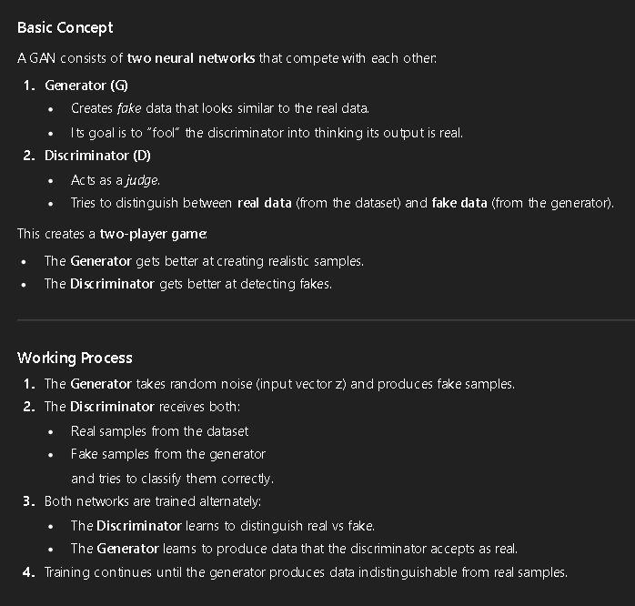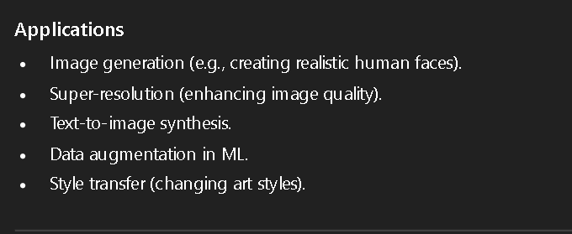

Q2. Explain the concept of reinforcement Learning .Describe the following elements of reinforcement learning
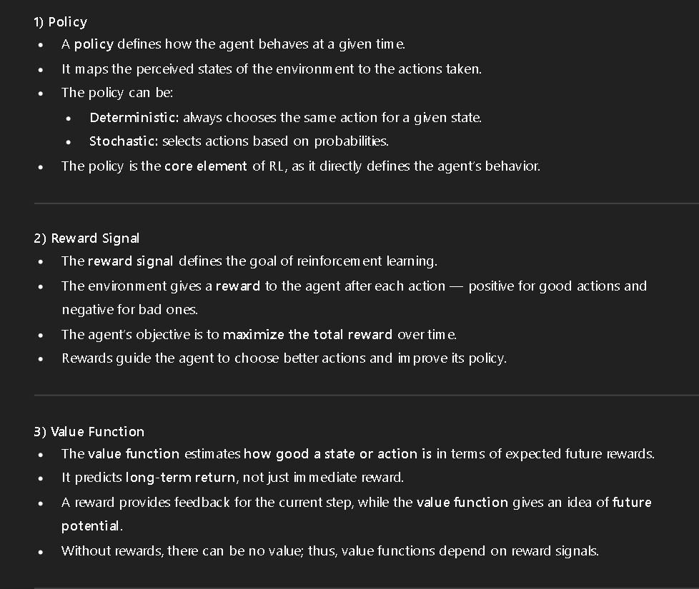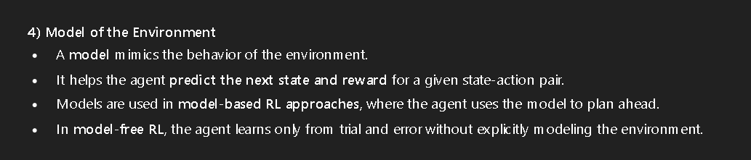

Q3.With the help of basic framework explain how reinforcement learning can be used in self driving cars (Autonomous Driving System)
Reinforcement Learning (RL) is widely used in Autonomous Driving Systems (ADS) because it enables a vehicle (agent) to learn optimal driving behavior by interacting with the environment — just like a human learns driving through experience.
The RL agent continuously observes, acts, and learns from feedback in the form of rewards or penalties.
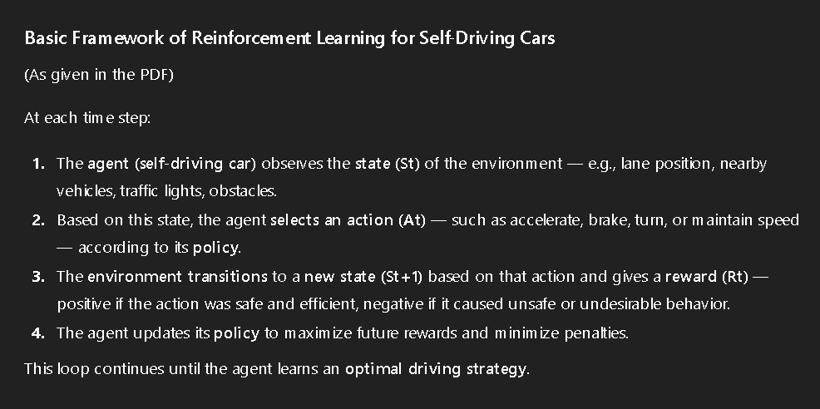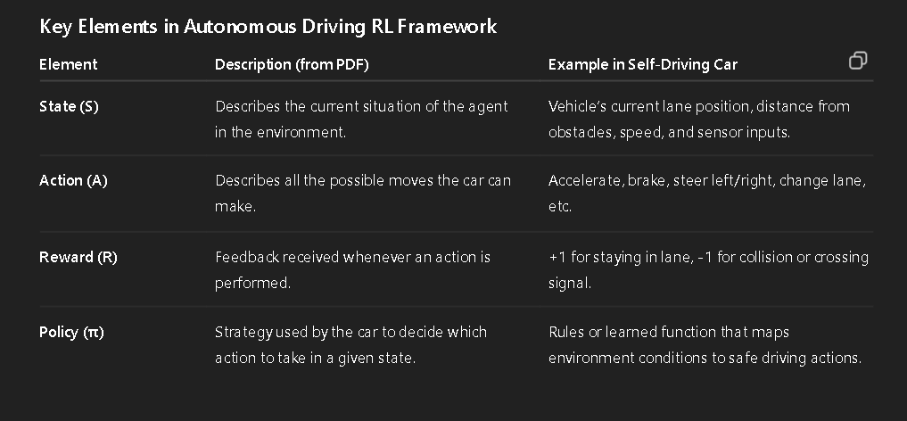
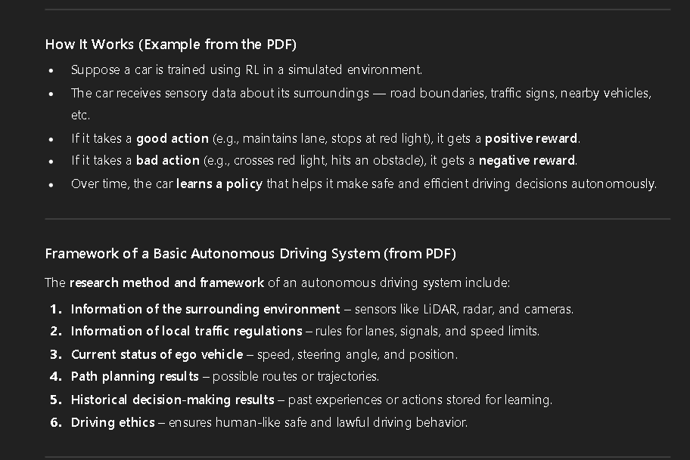
Q4. Illustrate any one application of Natural Language Processing
Natural Language Processing (NLP) is a branch of Artificial Intelligence (AI) that focuses on enabling computers to understand, interpret, and generate human language in a way that is both meaningful and useful.
It combines techniques from linguistics, computer science, and machine learning to process text and speech data
Applications of NLP
Some of the key applications include:
- Machine Translation (e.g., Google Translate)
- Chatbots and Virtual Assistants
- Sentiment Analysis
- Text Summarization
- Speech Recognition
- Document Classification

Example Application: Chatbots / Virtual Assistants

- A Chatbot (or virtual assistant) uses NLP to interact with humans through natural language, either through text or voice.
Examples include Siri, Alexa, Google Assistant, and ChatGPT itself.
- These systems understand user queries, process them, and respond intelligently — simulating a human-like conversation.
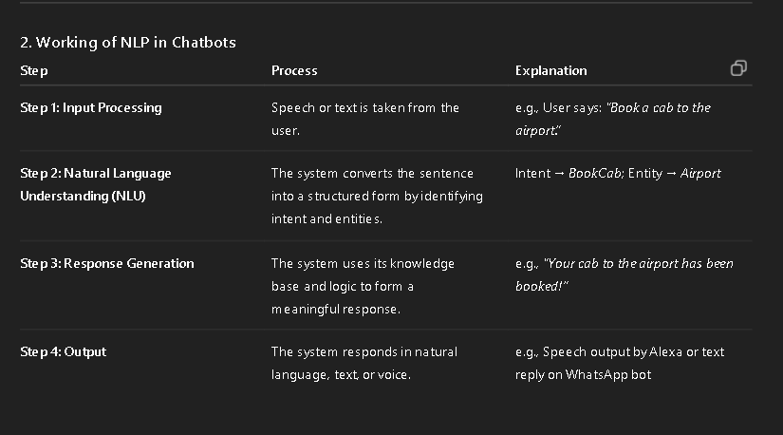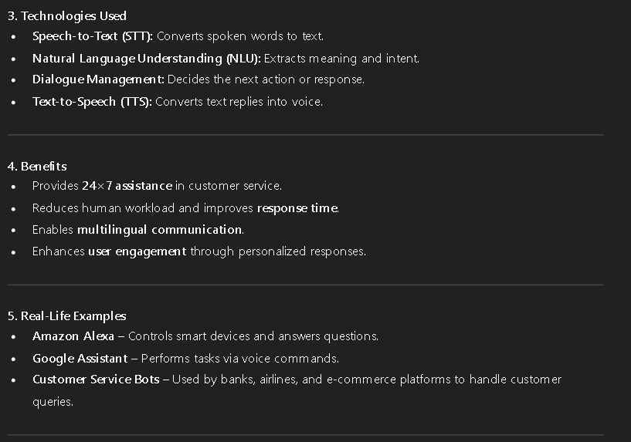

Q5.Describe any one real life example where Machine learning algorithm can create disaster if not used properly
