CMPUT656 Exercise 1 Report

Puyuan Liu

1. First Task

A Bose 700 headphone is placed on the table to record every audio data directly through the training data collection portal in the teachable machine web page. Three different audio sources are involved in this experiment: background noise from my house, saying “Audio” and saying “Table”.

* 1. Resulting Classification Accuracy and Analysis

We average each class’s classification accuracy for one minute after recording the training data. As observed, no matter how many classes we are using, the classification accuracy of the background noise is roughly unchanged with the increase of the training samples, while that of the words “Audio” and “Table” does increase with more training samples. We believe this result from the stability of the background noise and the instability of human voice. Namely, background noise usually has a low variance and therefore requires few training examples, while human voice usually has larger variance and therefore requires more. Furthermore, comparing to having only two classes (background noise and “Audio”), adding the third class (“Table”) leads to a drop in the accuracy. We believe this results from the similarity of the “Audio” and “Table” in terms of the audio wave; it also results from and the large difference between human voice and background noise. Therefore, ambiguity appears when we try to distinguish speaking words, which leads to a drop in the classification accuracy.

1. Second Task

We used code from the provided tutorial. Then we trained the SVM and MLP with random sampling and least confidence sampling to perform an active learning.

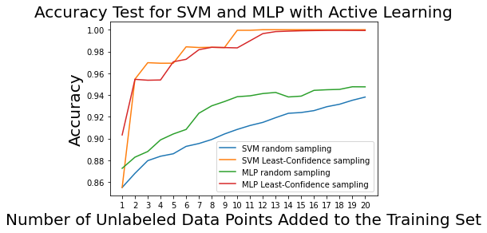

Accuracies in the plots above were all averaged over 100 runs. For random sampling, after every run, we randomly sampled a data point from the unlabeled data set and enter it into the training dataset. For least-confidence sampling, we choose the closed data point to the classification line for SVM, and the data point with the most uniform predicted distribution for MLP.

We can observe that both the accuracy for SVM and MLP converges to one when having the least-confidence sampling. The random sampling, on the other hand, converges not only slow but to a worse point than least-confidence sampling, for both SVM and MLP. Since data points from least-confidence sampling is the most ambiguous one to the classifier, telling its true label to the classifier helps most for its classification.

Though MLP is especially useful for complicated problem, according to the figure above, it’s performing worse than SVM when dealing with simple classification problem where a line classifier is enough. It is not very hard to tune the MLP, we get a converged result by using a hidden layer size of (50, 50, 50), “tanh”.