Publishing BiteWise AI at a Public Web Address

Pu Zeng
[Institution]
AIML 505: [Course name]
[Instructor name]
October 18, 2026

Publishing BiteWise AI at a Public Web Address
BiteWise AI, the second application, is public at https://bitewise-ai.ai.studio. Figure 1 shows that address on October 18, 2026, at 8:11 a.m. UTC. The clock in the corner is the desktop clock. The page is the BiteWise home screen, including the notice that the app does not place orders. The same morning, /api/health returned ok true, service bitewise-ai, demoMode false, and rankingModel gemini-3.8-flash. demoMode false means the published process has a Gemini key. That key is not in the GitHub repository.

Live Address
The live address is https://bitewise-ai.ai.studio. There is no https://example.awsapprunner.com address for this app. AWS no longer opens App Runner to new customers and points new container apps to Amazon ECS Express Mode. The classmate site used as the pattern, https://clearpath-claims-knowledge-assistant.ai.studio/, is an Express app behind Google Frontend. BiteWise was published the same way: the live response headers name Google Frontend, and Express serves the pages. No App Runner console shows a first service and a second service both Running. That screenshot is omitted, because a stand-in image would misstate where the app is hosted.

Deployment Steps
npm run build writes the React client. npm start serves that build and the Express API from one process, listening on PORT, which this host sets to 8080. Routes such as /explore return index.html. Routes under /api stay JSON. A Dockerfile runs the install, the build, and npm start. Figure 2 shows https://github.com/puzeng/AIML505_BiteWise at 8:10 a.m. UTC. Main is commit ec7a9a8, “Serve the built web app from the API for Cloud Run.” Publish rebuilds the client, so the live script name is not the hash of a local build made before publish. The assistant ran the API tests, 12 passed, then requested the live health check.

Comparison With the First App
StudyCite, the first app, is the React and Vite prototype at https://github.com/puzeng/AIML515_StudyCite. Its README describes a client-side retrieve, rerank, and cited answer or abstention. The header switches study TL-301 or TL-204, and a site coordinator is limited to TL-301. The file apprunner.yaml builds with npm ci and npm run build, then starts the Vite preview server on port 8080. That README lists no public App Runner address, so this paper does not invent one and does not claim which deployment used less clock time. BiteWise was simpler in shape: one process and one URL serve the pages and the API. StudyCite’s preview command serves only the front end. Recommendations, favorites, and menu filters stay on the BiteWise server, so production could not be a second dev server.

Challenges
The requested App Runner service could not be created for a new account. The path that worked was the ClearPath publish step, which produced https://bitewise-ai.ai.studio. The API content-security policy, default-src none, would have blocked the app’s scripts and font stylesheet. Page responses now allow the site’s own scripts and styles plus the Google font hosts, and /api stays locked down. An earlier GitHub sign-in code expired before the serving commit could upload. After a new approval, main matched ec7a9a8, the tree in Figure 2. The assistant did not invent an App Runner URL, a console screenshot, or a duration for the StudyCite deployment.
Figure 1
BiteWise AI Open at the Public Address
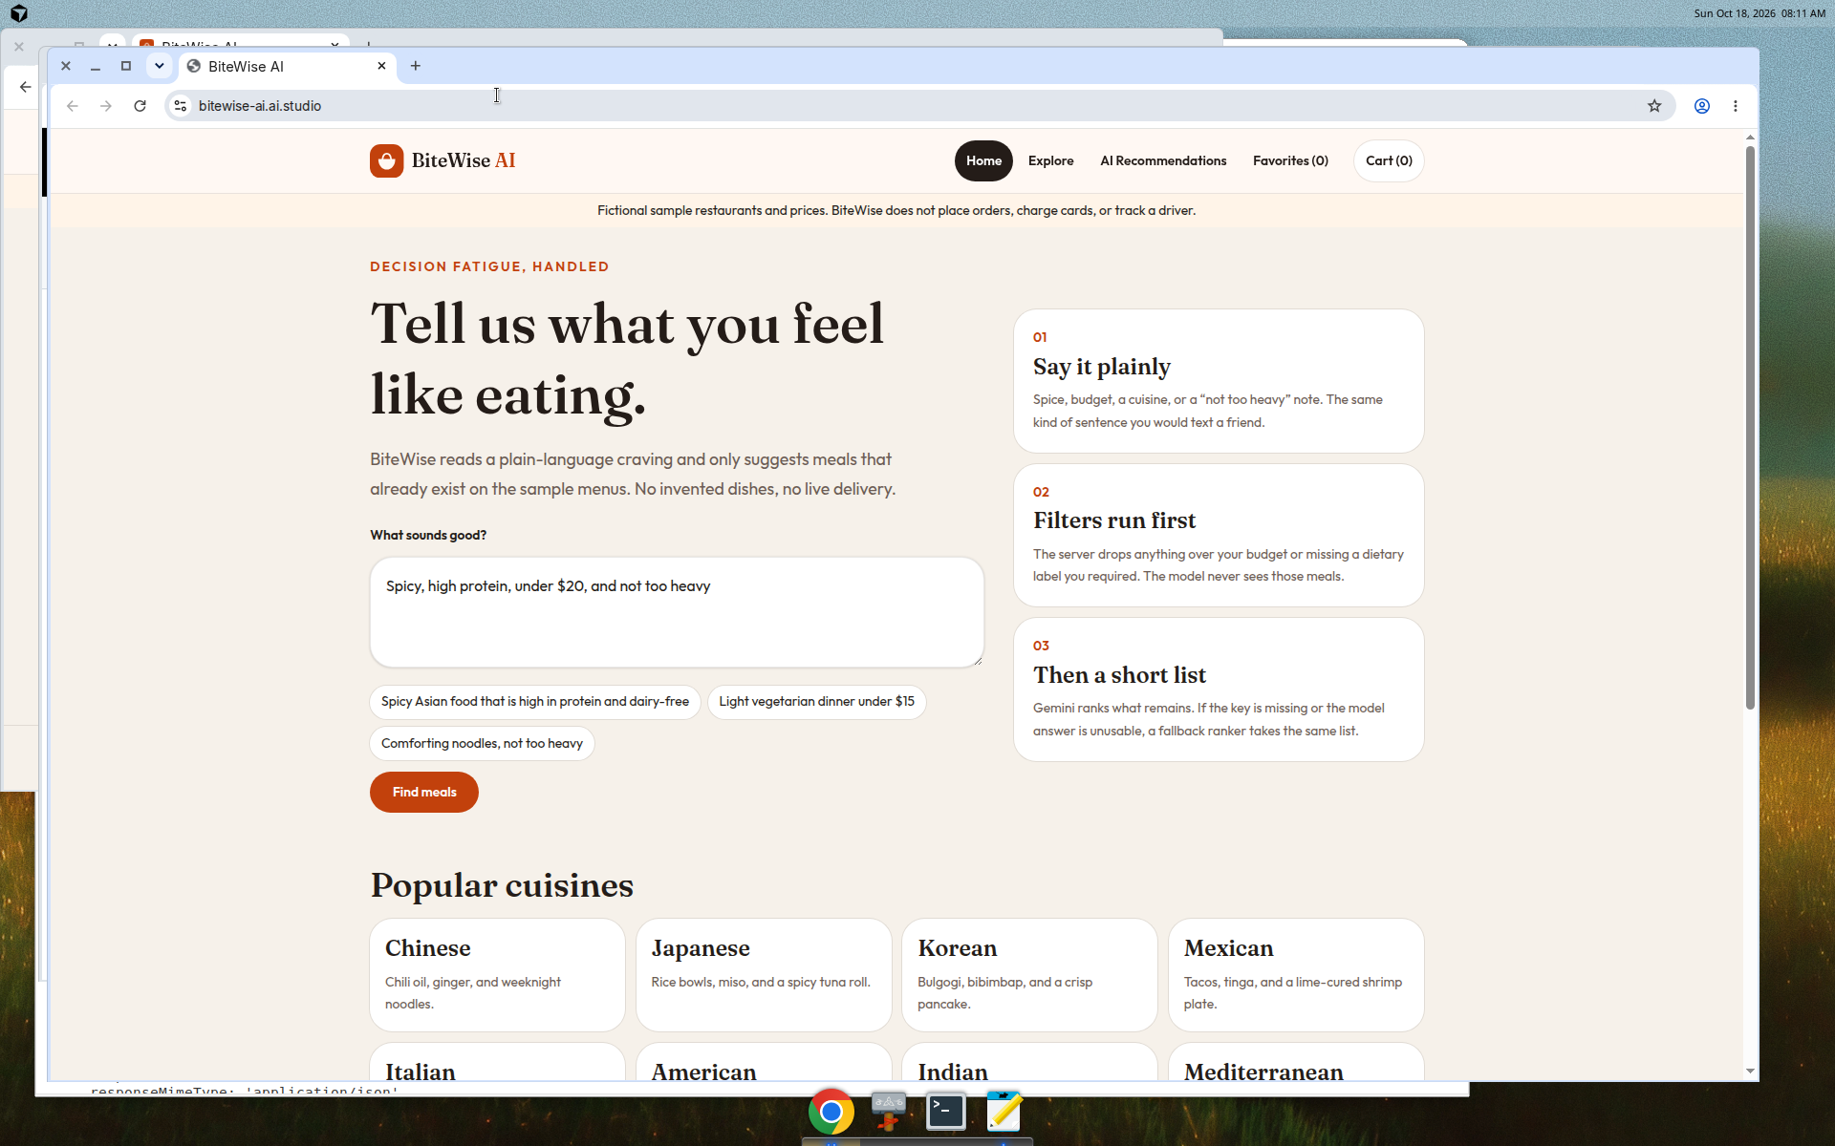
Note. The desktop clock reads 8:11 a.m. on October 18, 2026, UTC. The browser address is https://bitewise-ai.ai.studio, and the page is the BiteWise home screen.
Figure 2
GitHub Repository for the Second App
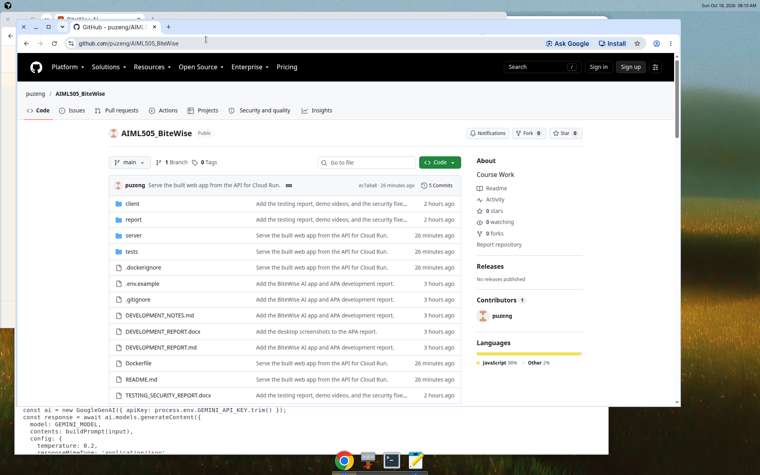
Note. The desktop clock reads 8:10 a.m. on October 18, 2026, UTC. The browser is https://github.com/puzeng/AIML505_BiteWise on main, showing client, server, tests, and the Dockerfile. A local editor is also open on the desktop.

