Building BiteWise AI: Development of a Grounded Food-Discovery Prototype

Pu Zeng
[Institution]
AIML 515: [Course name]
[Instructor name]
October 18, 2026

Building BiteWise AI: Development of a Grounded Food-Discovery Prototype
BiteWise AI is the second capstone application. A person describes a craving, and the server returns up to three dishes from a fictional sample menu. This paper records the assistant, the prompts, the features, the problems, and the clock times from October 18, 2026. LineWise AI is not in this workspace, so it is not described here.

AI Assistant and Prompts
The assistant was Cursor’s coding agent, using the model Grok 4.7. The most helpful prompt was the original build request. It named React, Vite, Tailwind, Express, and SQLite, and it kept Gemini on the server. The server must check the sentence, enforce budget and dietary labels in code, send the model only the remaining meals, require JSON menu ids, and rank with ordinary code if the key is missing or the JSON is invalid. A missing key is labeled demo mode.
Two later prompts were operational. “The local app can not be running” stopped Vite and Express, and “help me run” started them again on localhost ports 5173 and 3001. This report and the clock-visible screenshots were requested after that.

How the Approach Differed
LineWise AI’s source was not available, so this paper does not claim how that first app was written. BiteWise does not ask a model to invent dinners. It returns only SQLite rows, already filtered by price and dietary labels. Gemini, model gemini-3.8-flash, may only rank that set (Google, n.d.). With no key, the fallback ranker runs and the page says so.

Key Features and the Assistant’s Role
From the first prompt, the assistant built eight fictional restaurants and 40 menu items; Home, Explore, AI Recommendations, Favorites, and meal detail; and a sample cart that does not take payment. A meal can be saved only once. The last test run was 11 tests and 11 passes. An explanation must use menu fields, and a bad model payload must not become a new dish.

Challenges and Fixes
Three problems appeared only after the app ran. Explore filters could erase one another when two controls wrote the address from a stale render; each change now merges into the latest draft. At 375 pixels wide, the heading “AI recommendations” overflowed, so it is smaller on a narrow viewport. Vite listens on localhost, which is IPv6 here, so 127.0.0.1 on port 5173 does not connect.

Comparison of the Two Apps
This session cannot say which app was faster. There is no LineWise code here, and a guess would be false. Inside BiteWise, failure behavior was easier, because the prompt already required a labeled list when the key is missing and tests can simulate a broken model. The extra passes were filter state, the overflowing heading, and the localhost address.

Time Spent
No separate time log was kept. These clocks are coordinated universal time on October 18, 2026. The build request arrived at 1:43 a.m. The package file was written at 2:00 a.m., the recommendation module at 2:02 a.m., the README at 2:11 a.m., and the servers first started at 2:12 a.m. The recommendations page was last edited at 2:54 a.m. and the notes at 2:57 a.m., 1 hour and 14 minutes after the request. Servers were stopped near 3:29 a.m. and restarted near 3:31 a.m.
Figure 1 shows the completed code open on the desktop at 3:38 a.m. Figure 2 shows BiteWise AI running in the browser at localhost port 5173 at 3:37 a.m. Both clocks are the system clock.
Figure 1
Project Code Open on the Desktop
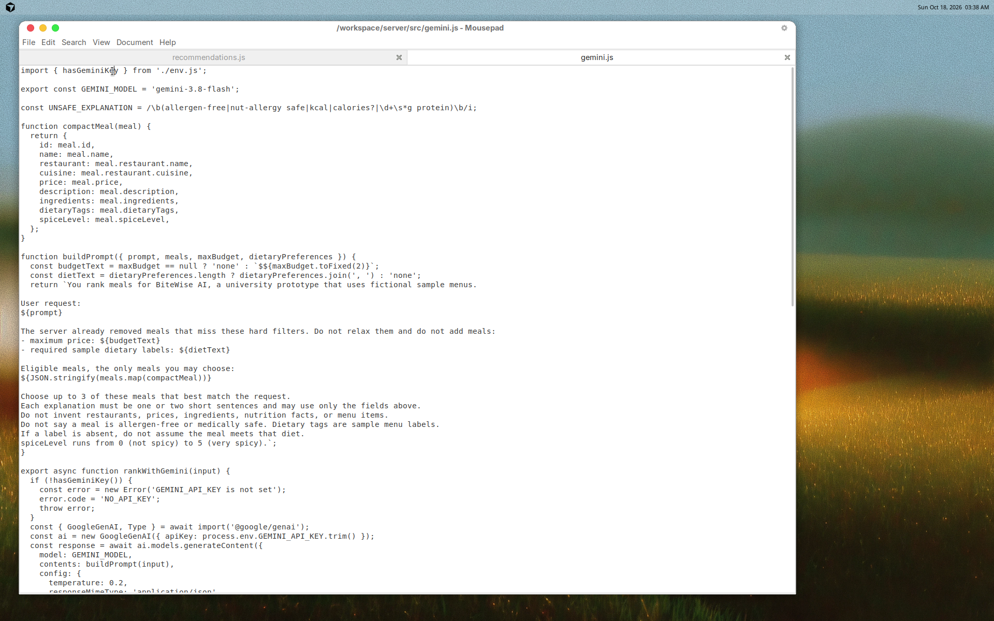
Note. The system clock reads 3:38 a.m. on October 18, 2026. The open file is server/src/gemini.js.
Figure 2
BiteWise AI Running on Localhost
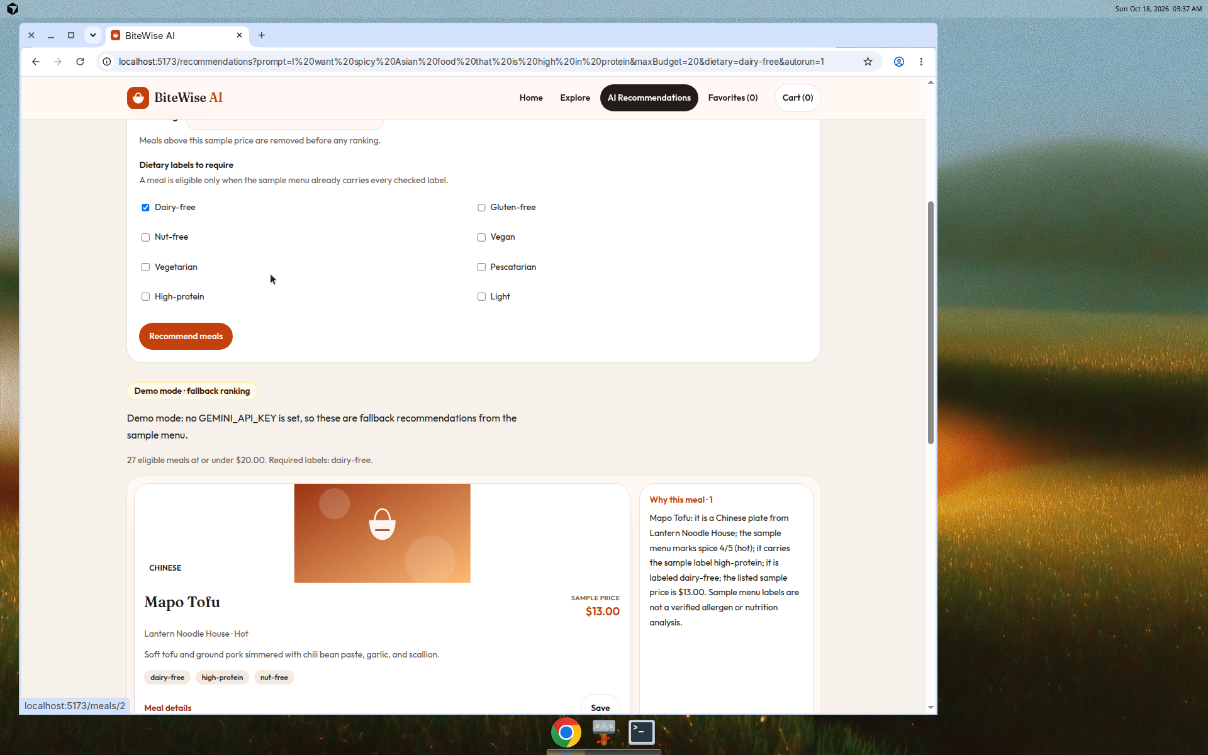
Note. The system clock reads 3:37 a.m. on October 18, 2026. The browser is at localhost port 5173 and shows demo mode because no Gemini API key is set.

References
Google. (n.d.). Gemini deprecations. Google AI for Developers. https://ai.google.dev/gemini-api/docs/deprecations

