Why cluster?
Overall goal: put them together into clusters of events
Subgoal: be able to visualise the results
Clustering subjective, especially with 'regular' datasets.
Variable selection
Sometimes objective, like with word vectors. But usually the columns you choose to go in the clustering have the greatest impact on the results.
Intuitive: each axis in your clustering is another dimension in the data. 2 columns (lat/lon) → 2 dimensional data. 50 columns –> 50 dimensional space. Curse of dimensionality: everything gets further from each other, stuff isn't close together any longer, harder to cluster.
Clustering is entirely dependent on what columns to use. What columns to use depends on what you want to use the clustering for.
Rolling out a new petrol grade? See how it does at 'similar sites'. Renovating a store? Again, see how similar sites do. Or try out a promotion at some sites and use others as a control.
Clustering together petrol stations.
Examples: geographically, the usual way it's done. Just use a map and eyeball. Usually either done informally with one metric: state, region, splits like metro/country. Can do it yourself with features: lat/lon, distance to nearest supermarket/shopping centre/bunnings, coastal or not, avg rainfall, population of SA1/2/3/4 region ),
Customer behaviour with fuel (petrol/diesel types sales per site, time of day, weekend/weekday, type of road, traffic, competitors, probably no stuff to do with the shop)
Customer behaviour with shop (sales per site of different categories; beverages, confectionery, cigarettes, time of day sales, FRESH sales, coffee sales, weekend weekday).
Nuclear explosions
What do we want to show? Depends what you're using it for.
some kind of geopolitical analysis? factors like country (USA/UK/France vs Soviet vs China/India/Pakistan), region, time period (year), lat/lon
environmental viewpoint? type of explosion (underground vs atmospheric), purpose, other factors from region (other datasets)
scientific? mb, Ms, depth, yield type, country, year
put it all together and see what you find? Results weighted by how many of each column you have.
Preprocessing
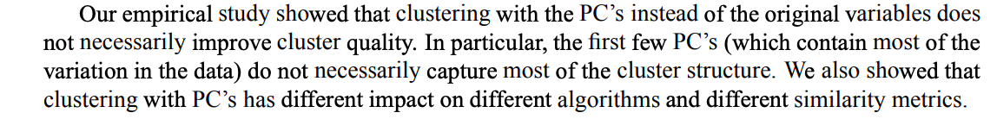
normalisation, centering usually done
categorical variables are tricky
- onehot encoding. Tradeoff between number of dimensions, can quickly spiral
- encode each level with a number. Not ideal. You'd want to maybe put “like levels” close to each other if you did this
- category binning when you have a few
Dim reduction before clustering
PCA:
- throw away some information, reduce dimensions (euclidean distance becomes useful)
- try with and without
- consider instead/as well dropping some columns, or compressing some columns together.
- Yeung & Russo (2000) shown that clustering with PC's doesn't necessarily improve cluster quality (https://stats.stackexchange.com/questions/157621/how-would-pca-help-with-a-k-means-clustering-analysis)
- linear
UMAP / TSNE
- nonlinear
- “updated” version of TSNE
UMAP vs TSNE
TSNE:
- perplexity parameter makes a big difference
- distances aren't meaningful
- pinched shapes mean that algorithm isn't finished. You'll see blobs
- cluster sizes don't mean anything
- random noise can have “shapes”
- slow
UMAP:
- parameters are n_neighbours, min_dist, metric
- much faster than TSNE
- clusters usually aren't spherical: k-means will fail here
Links:
https://observablehq.com/@fil/hello-umap-js
https://observablehq.com/@fil/mnist-umap-js
http://www.terrapattern.com/
https://twitter.com/leland_mcinnes/status/1138632202105872385
Algorithm
Personal opinion: pick something good, stick with it.
Default: k-means. Simple, but number of problems
- assumes circular clusters.
- specify number of clusters
- different results based on starting points of the algorithm
- assign everything to a cluster
One I like better: HDBSCAN, density based clustering algorithm
- can 'refuse' to cluster a point if it doesn't fit anywhere
- clusters can take any shape
- set “min number of points in cluster” as parameter
Distance metric
Usually euclidean/manhattan (L2 / L1 distance)
Another option is gower: manhattan for cts, “dice” for discrete.
Finding the number of clusters
Gridsearch over metrics of your clustering algorithm. For HDBSCAN it's a metric like “silhouette distance” with different parameters “min number of clusters” and “min_samples”
Min_samples is basically a metric for “how much noise do we want”.

Visualisation
https://projector.tensorflow.org/

Your stars cluster in evil signs
Many businesses use clustering techniques on their data. But how are they explaining their results to stakeholders? What techniques are they using? What's the whole point of clustering? And what's this “evil signs” business?
`In this talk we go through a clustering workflow, from data preparation to final output. We look at some of the latest tools available, like UMAP and HDBSCAN, and how they compare against the competition. Finally, I give my answers to these important questions.

Why cluster? Use cases
Clustering: variable selection
Clustering: categorical variables
PCA vs UMAP vs TSNE
HDBSCAN vs K-means
end-to-end demo on nuclear data
Tensorflow projector demo

Notes from PyData talk:
- what does latent data really mean? “core features that are important”
  - e.g. mnist 784 vector, you don't really need all 784 dimensions to get the essence of the data, to distinguish items from each other, they aren't all important
- 2 ways to do dim reduction: 1) matrix factorisation, 2) neighbour graphs
- PCA:
  - “generalised low rank models” - paper on dim reduction by matrix factorisation
  - “old workhorse”, been around a while
  - reconstruct data with a linear combination (adding subtracting) of some small number of prototypes
  - Like sticking a linear plane through your data, then projecting onto that.
  - PCA about minimising this reconstruction error.
    - Xij is each point in the matrix
    - U is low dimensional embedding. Basically, it's “how many of the V basis vectors do I add together to get a point”
    - V is “matrix prototypes”, what we are building linear combinations of. The directions of maximal variance
    - UV is shorthand for “linear combinations of V”
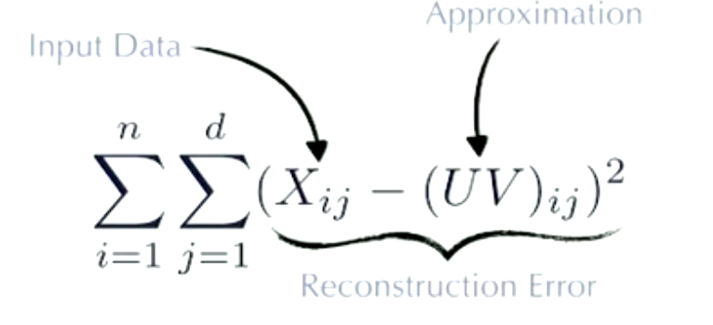

  - This algorithm has a solution you could find with an optimiser.
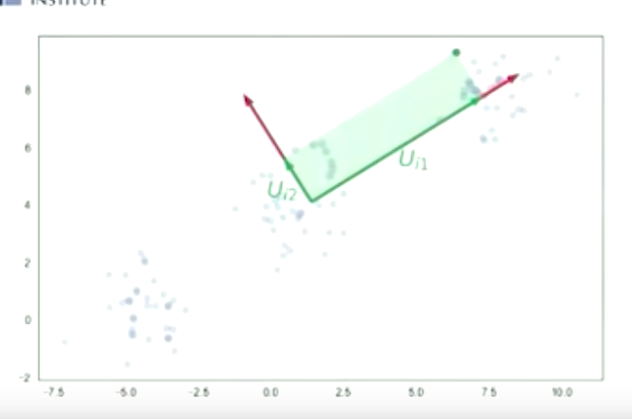Illustration 1: V1 is direction of maximum variance, V2 next direction of maximum variance that is orthogonal to that. Then U tells you how far to go in each of these directions to get to a point.
- TSNE:
  - Graph based algorithm
  - Each point is a point in the graph, or a vertex. Draw directed lines from each point to every other point. Then weight the points: closer points have thicker lines than further away points. (RBF kernel, or radial basis function kernel, is used for this). Then normalise the weights so they add to 1.
How do you choose the radius of the RBF kernel? Gist of it is that it is related to how many points are around a given point. Another way of looking at it is that it is proportional to the distance to the kth nearest neighbour, or the sum of the weighted outgoing directed lines.
Each pair of points has an arrow going to and from each one. They have different weights, since the RBF kernel bandwidth is different for each one, and also normalisation plays a part. So we next convert to undirected graph by averaging the two lines for each of them.
Normalise all weights so sum of weights of the whole graph is 1. That's the graph
  - Intuition: We want to build a graph in low dimensions, that has as close a graph to the high dimensions as possible. This is according to some error function, called the reconstitution error
    - The reconstitution error has kind of an attractive force term and a repulsive force term to it. This stops you just putting all the points on top of each other.
    - Basically, it's a force directed graph layout.
  - When you build the lower dimensional graph, you don't build it in the same way as the higher dimensional one. You use a t-distributed kernel instead of a radially distributed kernel. You have one kernel bandwidth for all points, rather than have it per-point like for the higher dimensional one. This means that the edge weights are equal for each pair of edges, so you don't have to make it a directed graph, but rather you can have it undirected.
  - Focuses more on local structure, rather than global structure
    - Here's how I interpret this. Global structure is more like “let's look at the big patterns of the overall dataset.” PCA did this, when it looked at the direction of the most variance. Local structure is more like “lets look at the points around each point”. T-SNE is like that, when it draws its graph of vetices. There's no mention of the overall look of the data: points that are far away just have real low weight lines between them.
- UMAP:
  - Captures both global and local structure.
  - Has an interesting quirk where the notion of “distance” is different at each point. This is because it relies on the assumption that the data is uniformly distributed, when it obviously isn't. So we take the non-uniformly distributed data, and we put on this distance function that makes it uniformly distributed.
  - Needs to find nearest neighbours very quickly. Random prediction trees, nearest neighbour descent are two algorithms out there that can do this.
  - Uses python + numba. Numba:
    - High performance, code looks like python,
  - You can use labelled data.
    - I don't think you can with T-SNE or PCA.
    - You can use a test set and see

