**Today’s Objectives:**

1. How to use Google Colab and How to view Jupyter files available in your local system
2. Quick review on Yesterday’s session
3. Strings and String Built-in methods
4. For Loop
5. User defined functions and its parameters
6. Recursive Functions
7. Data Structures - List

**Topics:**

1. **How to use Google Colab and How to view Jupyter files available in your local system**
2. **Quick review on Yesterday’s session**
3. **Strings and String Built-in methods**

we can create strings simply by enclosing characters in quotes. Python treats single quotes the same as double quotes.

**Ex**: var1=’hello’

Var2=”python”

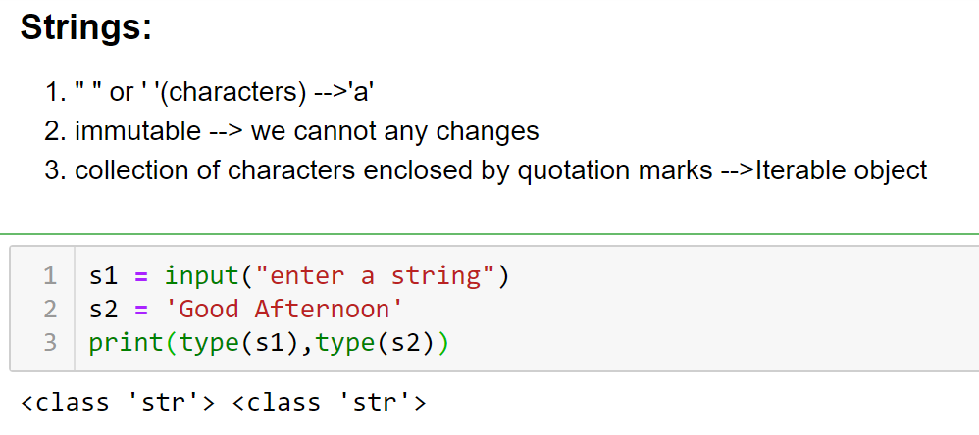

**String Special Operators**: +,*,[],[:],in,not in

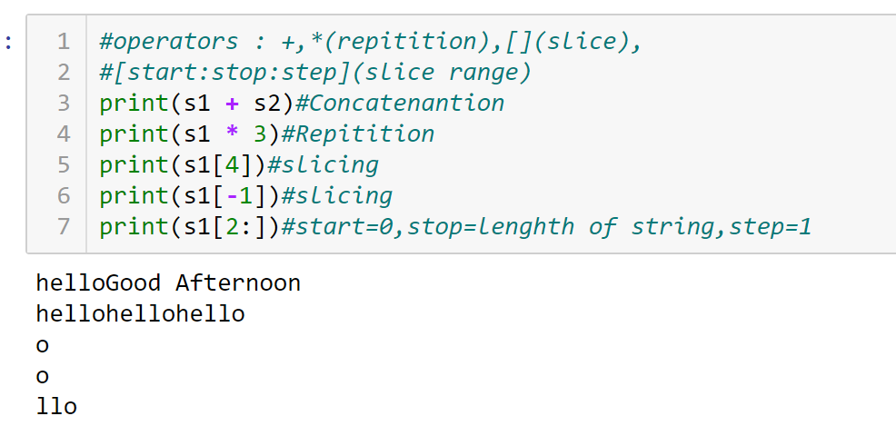

**Accept a string from the user and check whether it is palindrome or not?**

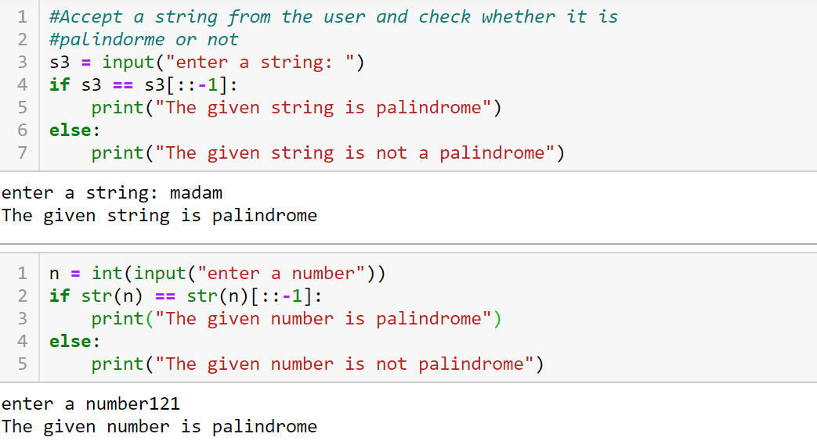

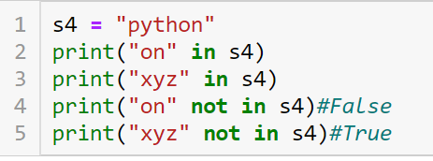

String Built-in Functions: len(),min(),max(),str()

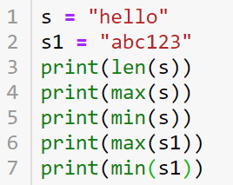

String Built-in Methods : capitalize(),index(),isalpha(),isdigit(),isalnum(),isupper(),islower(),upper(),lower(),startswith(),find(),count(),replace()

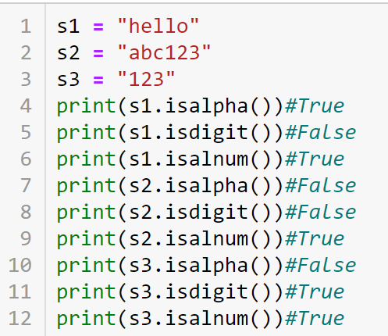

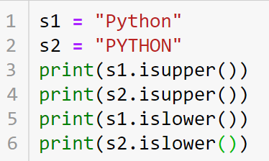

**Questions:**

**1.**Read a string from the user and Count the frequency of a character ‘a’

2. Remove nth character from the string

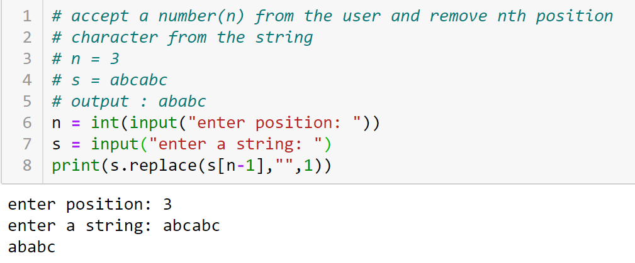

Documentation on String Built-in Methods: [click here](https://docs.python.org/3/library/stdtypes.html#text-sequence-type-str)

1. **For Loop**

**We can use for loop in 2 different ways**

1. **using range()**
2. **using iterable object**

**Syntax:**

**for variable in range(start,stop,step):**

**Statements**

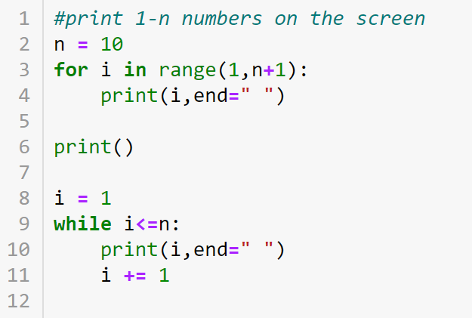

1. **for variable in iterable-obj:**

**statements**

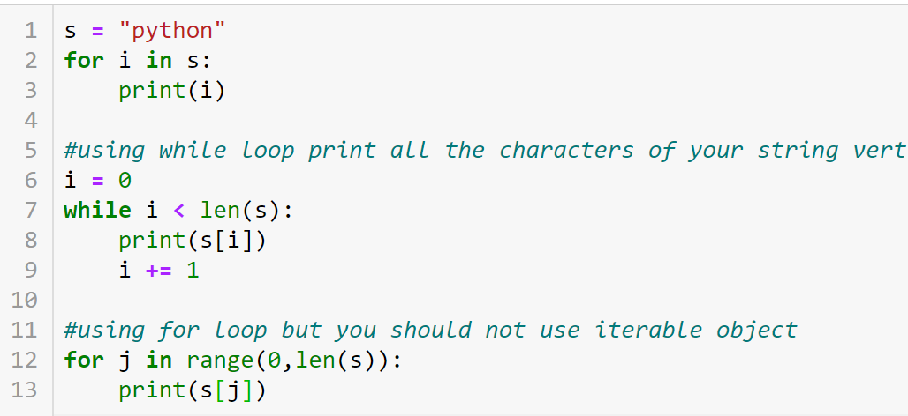

**Questions on strings:**

1. Accept a string from the user and count no.of vowels,consonants and special characters

2. count the no.of pairs of a in the given string(Infosys InfyTQ)

string → "abbaaccbbaaa"

output → 2

3.

Test case1:

string → "((((()()()))))()"

output → 8

Test case2:

string → "((()))()"

Output → 4