The Personal Trainer
Background:
- Enjoys working out
- Bachelors Degree in Sports Psychology
- Worked as a fitness instructor
Demographics:
- Male, 30 years old
- Income of $125,000
Identifiers:
- Compassionate and loves animals
- Talkative
- Comfortable with cleaning and cooking



The Newbie
Background:
- English School Teacher
- Bachelors Degree in Education
- Married with three children, 20, 22, 30
Demographics:
- Male, 65 years old
- Dual family income of $130,000
- Lives in a small quiet house in Florida
Identifiers:
- English book writer
- Loves listening to music
- Tech savy

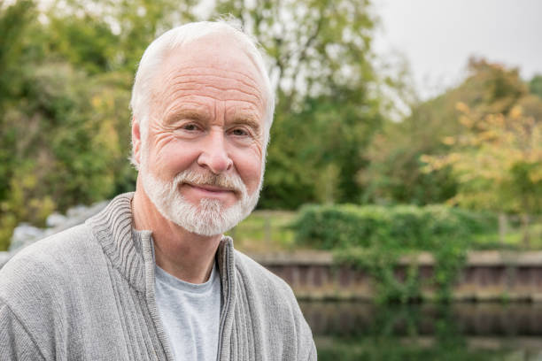

The Business Owner
Background:
- President of Sylvan Learning Center
- Bachelors Degree in English
- Recently retired
Demographics:
- Women, 65 years old
- Dual family income of $500,000
- Lives in the suburbs of Boca Raton
Identifiers:
- Good at sales and marketing
- Tech savvy
- Teaches professional development

