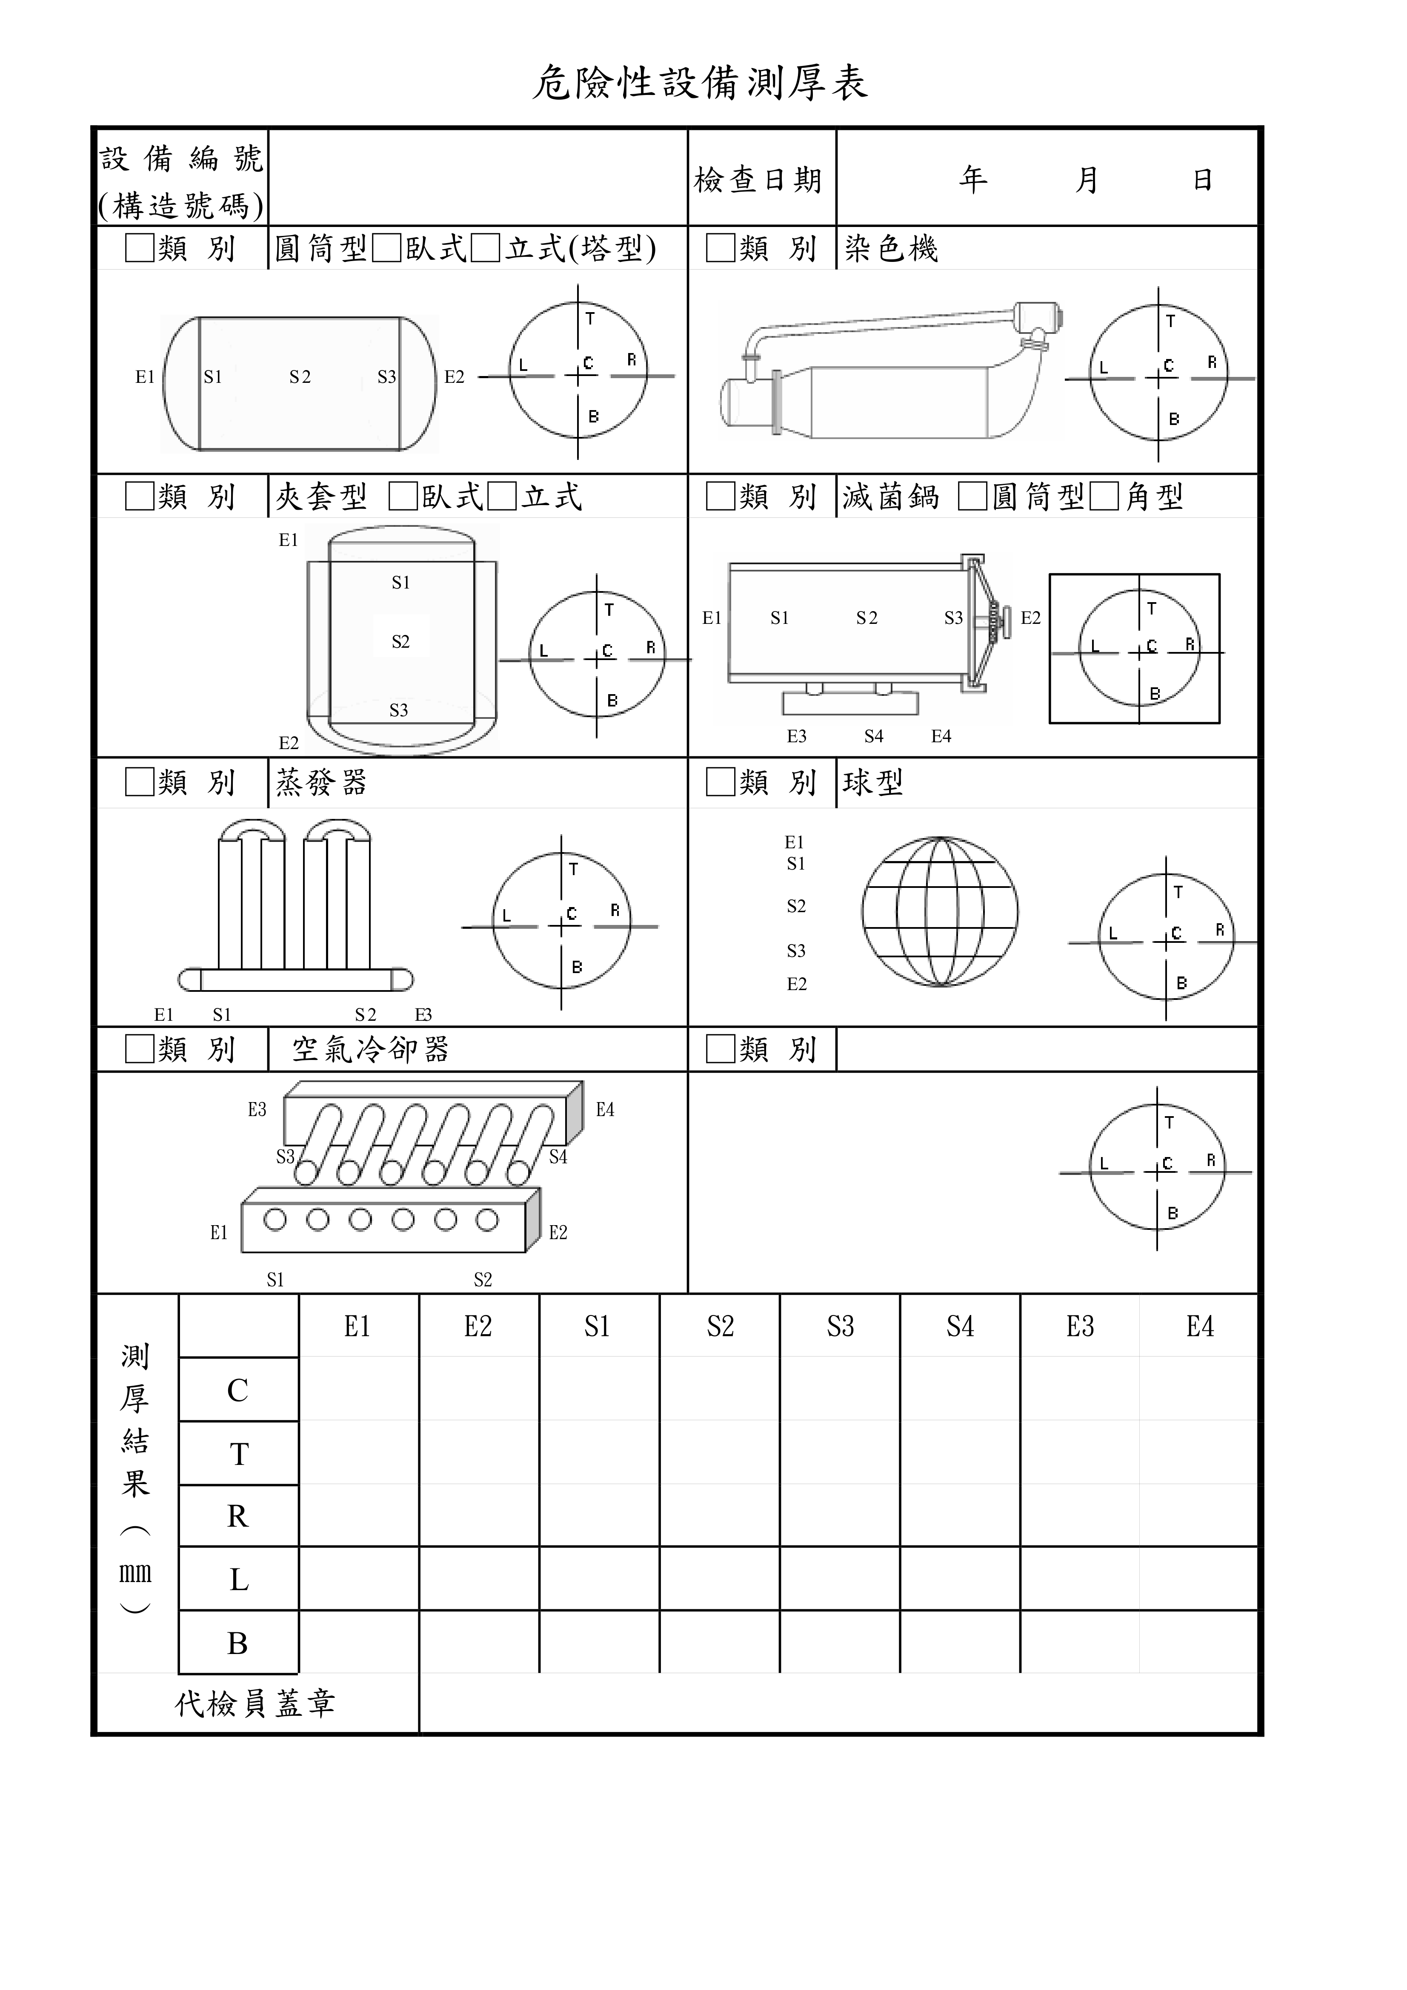
{{EQNO}}
{{CKY}}
{{CKM}}
{{CKD}}

