## Problem 1

### 1.a.

Transition probability matrix:

[[ 0.5 0.5 0. ]

[ 0.25 0.5 0.25]

[ 0. 0.5 0.5 ]]

Transition probabilities after 2 steps

[[ 0.375 0.5 0.125]

[ 0.25 0.5 0.25 ]

[ 0.125 0.5 0.375]]

Transition probabilities after 5 steps

[[ 0.26562 0.5 0.23438]

[ 0.25 0.5 0.25 ]

[ 0.23438 0.5 0.26562]]

Transition probabilities after 10 steps

[[ 0.25049 0.5 0.24951]

[ 0.25 0.5 0.25 ]

[ 0.24951 0.5 0.25049]]

Transition probabilities after 25 steps

[[ 0.25 0.5 0.25]

[ 0.25 0.5 0.25]

[ 0.25 0.5 0.25]]

### 1.b.

Transition probability matrix with absorbing states:

[[ 1. 0. 0. ]

[ 0.25 0.5 0.25]

[ 0. 0. 1. ]]

Transition probabilities after 2 steps

[[ 1. 0. 0. ]

[ 0.375 0.25 0.375]

[ 0. 0. 1. ]]

Transition probabilities after 5 steps

[[ 1. 0. 0. ]

[ 0.48438 0.03125 0.48438]

[ 0. 0. 1. ]]

Transition probabilities after 10 steps

[[ 1. 0. 0. ]

[ 0.49951 0.00098 0.49951]

[ 0. 0. 1. ]]

Transition probabilities after 25 steps

[[ 1. 0. 0. ]

[ 0.5 0. 0.5]

[ 0. 0. 1. ]]

### 1.c.

Transition probability matrix:

[[ 1. 0. 0. 0. 0. ]

[ 0.25 0.5 0.25 0. 0. ]

[ 0. 0.25 0.5 0.25 0. ]

[ 0. 0. 0.25 0.5 0.25]

[ 0. 0. 0. 0.5 0.5 ]]

Transition probabilities after 84 iterations:

[[ 1. 0. 0. 0. 0. ]

[ 0.98153 0.00281 0.0052 0.00679 0.00367]

[ 0.96587 0.0052 0.0096 0.01255 0.00679]

[ 0.9554 0.00679 0.01255 0.01639 0.00887]

[ 0.95173 0.00735 0.01358 0.01774 0.0096 ]]

Transition probabilities after 125 iterations:

[[ 1. 0. 0. 0. 0. ]

[ 0.99624 0.00057 0.00106 0.00138 0.00075]

[ 0.99305 0.00106 0.00196 0.00256 0.00138]

[ 0.99091 0.00138 0.00256 0.00334 0.00181]

[ 0.99017 0.0015 0.00277 0.00361 0.00196]]

## Problem 3.

### 3.a.

The three plots below are of random normal vectors with variances 4, 2, and 1.

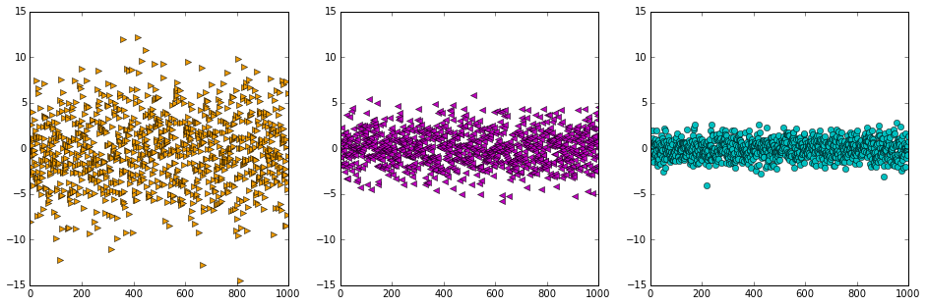

### 3.b.

For this exercise I thought it would be fun to get a very low P-value, so I did not set seed and ran the code until I got the OLS with a P-value below 0.05. Naturally, it occurs about 5% of the time, so it didn’t take long.

OLS Regression Results

==============================================================================

Dep. Variable: y R-squared: 0.008

Model: OLS Adj. R-squared: 0.007

Method: Least Squares F-statistic: 8.435

Date: Sat, 25 Oct 2014 Prob (F-statistic): 0.00376

Time: 18:33:53 Log-Likelihood: -1460.1

No. Observations: 1000 AIC: 2924.

Df Residuals: 998 BIC: 2934.

Df Model: 1

==============================================================================

coef std err t P>|t| [95.0% Conf. Int.]

------------------------------------------------------------------------------

const -0.0014 0.033 -0.042 0.967 -0.066 0.063

x1 0.0960 0.033 2.904 0.004 0.031 0.161

==============================================================================

Omnibus: 2.243 Durbin-Watson: 2.051

Prob(Omnibus): 0.326 Jarque-Bera (JB): 2.315

Skew: 0.105 Prob(JB): 0.314

Kurtosis: 2.894 Cond. No. 1.02

==============================================================================

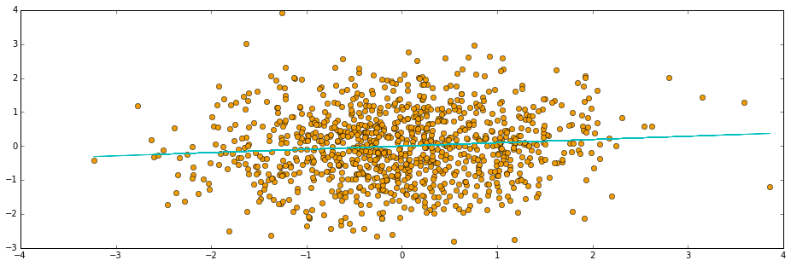

### 3.c.

Since all of the OLS conditions are met, the slope coefficients have a t-distribution. The histogram is consistent with a t-distribution.

