## Problem 1

In this problem I generate three AR(1) models with $ρ=0.5, -0.5, 1$ and estimate $ρ$ using linear regression. In each case the 95% confidence interval included the true DGP value of $ρ$. The plots and regression outputs are presented below.

#### 1.a. $ρ=0.5$

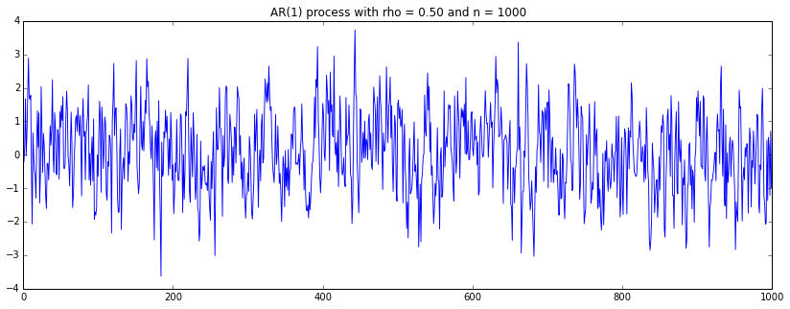

**OLS Regression Results with rho = 0.5**

==============================================================================

Dep. Variable: y R-squared: 0.261

Model: OLS Adj. R-squared: 0.260

Method: Least Squares F-statistic: 352.5

Date: Mon, 03 Nov 2014 Prob (F-statistic): 1.43e-67

Time: 19:47:55 Log-Likelihood: -1424.5

No. Observations: 999 AIC: 2853.

Df Residuals: 997 BIC: 2863.

Df Model: 1

==============================================================================

coef std err t P>|t| [95.0% Conf. Int.]

------------------------------------------------------------------------------

const 0.0336 0.032 1.053 0.293 -0.029 0.096

x1 0.5109 0.027 18.774 0.000 0.457 0.564

==============================================================================

Omnibus: 0.342 Durbin-Watson: 1.979

Prob(Omnibus): 0.843 Jarque-Bera (JB): 0.408

Skew: -0.038 Prob(JB): 0.815

Kurtosis: 2.937 Cond. No. 1.19

==============================================================================

#### 1.b. $ρ=-0.5$

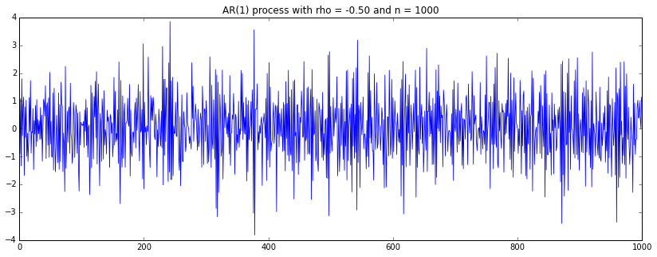

**OLS Regression Results with rho = -0.5**

==============================================================================

Dep. Variable: y R-squared: 0.284

Model: OLS Adj. R-squared: 0.283

Method: Least Squares F-statistic: 394.9

Date: Mon, 03 Nov 2014 Prob (F-statistic): 2.77e-74

Time: 19:53:19 Log-Likelihood: -1431.2

No. Observations: 999 AIC: 2866.

Df Residuals: 997 BIC: 2876.

Df Model: 1

==============================================================================

coef std err t P>|t| [95.0% Conf. Int.]

------------------------------------------------------------------------------

const 0.0229 0.032 0.713 0.476 -0.040 0.086

x1 -0.5326 0.027 -19.871 0.000 -0.585 -0.480

==============================================================================

Omnibus: 1.516 Durbin-Watson: 1.954

Prob(Omnibus): 0.469 Jarque-Bera (JB): 1.592

Skew: 0.079 Prob(JB): 0.451

Kurtosis: 2.886 Cond. No. 1.20

==============================================================================

#### 1.c. $ρ=1$ (Random Walk)

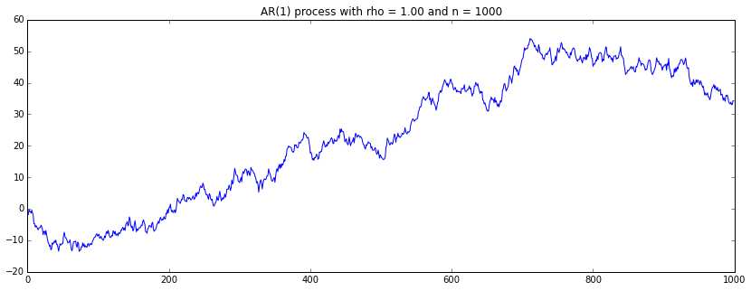

**OLS Regression Results with rho = 1**

==============================================================================

Dep. Variable: y R-squared: 0.989

Model: OLS Adj. R-squared: 0.989

Method: Least Squares F-statistic: 9.106e+04

Date: Mon, 03 Nov 2014 Prob (F-statistic): 0.00

Time: 19:53:19 Log-Likelihood: -1401.6

No. Observations: 999 AIC: 2807.

Df Residuals: 997 BIC: 2817.

Df Model: 1

==============================================================================

coef std err t P>|t| [95.0% Conf. Int.]

------------------------------------------------------------------------------

const -0.0618 0.043 -1.426 0.154 -0.147 0.023

x1 0.9941 0.003 301.761 0.000 0.988 1.001

==============================================================================

Omnibus: 1.123 Durbin-Watson: 1.968

Prob(Omnibus): 0.570 Jarque-Bera (JB): 1.202

Skew: 0.071 Prob(JB): 0.548

Kurtosis: 2.906 Cond. No. 18.4

==============================================================================

## Problem 2.

The plots and regression results for two independently generated random walks.

**OLS Regression Results of Walk1 ~ Walk2**

==============================================================================

Dep. Variable: y R-squared: 0.544

Model: OLS Adj. R-squared: 0.543

Method: Least Squares F-statistic: 1190.

Date: Mon, 03 Nov 2014 Prob (F-statistic): 2.52e-172

Time: 20:10:14 Log-Likelihood: -3688.6

No. Observations: 1000 AIC: 7381.

Df Residuals: 998 BIC: 7391.

Df Model: 1

==============================================================================

coef std err t P>|t| [95.0% Conf. Int.]

------------------------------------------------------------------------------

const -18.1120 0.632 -28.642 0.000 -19.353 -16.871

x1 0.5278 0.015 34.499 0.000 0.498 0.558

==============================================================================

Omnibus: 53.852 Durbin-Watson: 0.013

Prob(Omnibus): 0.000 Jarque-Bera (JB): 28.245

Skew: 0.237 Prob(JB): 7.36e-07

Kurtosis: 2.326 Cond. No. 85.4

==============================================================================

