## Problem 1

The descriptive statistics for the three random vectors drawn from standard normal distribution are given in the table below.

|  |  |  |  |
| --- | --- | --- | --- |
|  | x (10) | y (10,000) | z (1,000,000) |
| Mean | -0.1329441 | -0.0006762757 | 0.0004501281 |
| Standard deviation | 0.8136554 | 0.9997931 | 1.001349 |
| Variance | 0.6620352 | 0.9995862 | 1.0027 |

As the sample size increased, the sample mean approached the population mean of 0. Sample variance for larger samples is closer to 1. The variance of sample variance decreases as sample size increases, although we cannot conclude this from data.

## Problem 2

The raw generated series are given below together with a plot and a frequency table.

5,2,5,9,7,1,6,7,7,5,5,4,2,7,2,6,4,0,7,3,3,6,1,8,0,2,3,6,2,4,9,2,3,3,9,9,8,7,2,8,2,3,1,9,8,9,1,9,5,4,6,9,9,1,6,8,3,1,1,3,2,5,7,7,7,3,7,0,8,9,6,2,1,3,1,6,4,9,8,8,8,7,3,6,7,4,4,1,4,2,1,5,9,6,0,6,9,9,5,8,8,4,8,9,4,6,9,9,4,8,4,6,5,5,1,5,2,8,8,0,4,9,4,5,8,1,6,4,2,2,7,0,1,8,8,3,0,7,8,9,0,1,8,1,4,6,6,9,3,8,7,1,1,5,5,9,8,9,0,5,6,2,5,3,5,3,9,4,4,1,8,3,1,0,3,3,7,2,7,7,9,2,6,7,6,2,6,2,4,5,2,8,0,2,5,2,1,1,9,4,0,7,5,9,2,9,5,5,0,5,1,6,2,2,6,3,6,2,2,8,0,6,4,6,1,3,3,7,1,6,9,3,7,3,0,8,3,6,1,6,4,1,8,3,9,2,7,2,3,0,1,4,1,8,9,2,9,5,9,9,4,7,6,4,7,3,9,7,8,2,1,0,1,3,5,6,4,4,3,9,5,1,5,5,6,7,7,6,8,6,6,5,2,7,2,6,2,1,5,5,2,2,4,3,3,1,5,7,0,7,8,9,5,1,3,4,2,1,0,3,9,1,8,0,8,7,3,7,9,8,1,1,8,0,1,8,9,3,0,7,5,5,0,7,3,8,8,3,8,6,3,4,4,3,8,8,8,6,6,3,0,2,9,8,6,1,6,4,6,4,6,6,5,0,5,8,1,4,8,7,5,7,4,8,6,4,0,0,7,1,8,5,4,8,3,0,3,1,4,3,2,0,1,9,3,8,8,2,6,8,1,5,6,7,9,4,9,4,1,0,5,3,9,9,9,7,8,6,3,8,7,2,0,6,4,4,1,2,5,7,0,6,1,2,6,4,9,2,1,3,3,0,3,0,0,4,4,1,4,1,6,3,7,5,7,1,9,0,5,9,7,5,0,7,0,1,2,3,3,6,5,0,0,9,1,6,6,6,8,0,7,0,0,5,5,3,0,9,1,8,5,7,7,7,4,3,4,0,8,7,1,6,5,4,9,8,8,4,9,2,2,9,5,3,5,9,7,2,1,2,9,9,6,3,7,5,0,6,1,8,1,6,9,6,2,2,5,8,5,9,0,8,6,2,7,6,9,5,0,0,0,5,0,9,0,1,1,3,9,3,3,6,9,8,4,8,5,4,3,9,8,7,0,1,2,3,4,2,4,2,3,4,5,7,4,9,9,4,0,5,0,7,7,9,9,2,3,0,2,4,7,1,8,2,9,4,2,4,0,3,1,9,8,8,9,0,7,2,5,2,5,4,6,6,4,7,5,9,5,6,7,9,0,2,3,3,0,9,2,2,6,5,3,7,4,8,0,8,5,0,6,0,4,6,5,1,3,2,6,1,3,1,3,0,7,6,4,3,3,0,2,7,4,6,3,9,0,0,2,8,7,4,0,9,9,7,1,3,5,3,7,0,6,9,2,1,6,5,9,0,9,4,3,3,7,1,9,9,1,2,6,4,8,8,3,7,0,6,5,9,8,7,3,1,7,6,7,9,8,2,1,7,3,9,2,2,5,4,3,1,7,7,9,8,3,3,4,0,2,1,2,8,0,0,0,5,9,6,8,8,0,9,1,2,5,8,1,1,1,1,6,5,3,6,7,3,1,4,0,0,5,6,2,1,8,5,5,6,7,0,6,7,5,0,7,1,5,8,2,0,2,7,8,9,2,3,3,7,1,6,8,7,9,1,3,4,1,6,5,5,3,7,9,9,2,9,6,2,9,3,5,5,8,2,8,4,7,7,9,5,7,4,9,9,9,5,0,8,2,6,4,9,1,2,9,7,0,3,7,4,3,7,0,0,2,1,1,5,0,4,6,3,5,2,4,5,5,9,6,7,4,8,9,7,4,7,0,5,9,2,1,2,6,9,3,3,0,0,7,2,0,9,8,5,7,4,2,9,8,4,5,1,1,8,0,5,5,9,9,3,0,6,0,0,9,4,5,6,3,6,5,7,0,7,7,5,7,2,9,6,6,6,3,7,1,8,2,5,4,4,6,6,8,1,1,5,0,2,0,5,2,2,5,6,0,5,5,7,4,8,7,0,2,8,5,3,8,4,0,4,0,2,6,4,2,3,0,6,9,9

2,5,2,4,2,8,3,8,7,3,6,5,0,2,0,3,2,8,7,5,9,0,2,1,3,6,5,5,8,2,9,6,1,6,8,8,4,8,2,8,4,2,3,7,2,2,1,5,5,6,9,8,3,3,5,2,6,1,5,7,4,7,7,2,7,9,7,7,6,3,5,9,6,7,1,9,6,1,0,8,3,6,3,5,7,0,6,8,3,5,5,5,5,2,1,1,0,8,5,6,2,7,4,9,8,1,8,2,7,6,5,9,2,3,0,8,2,8,6,2,1,2,0,0,3,0,4,9,7,2,4,0,2,2,8,3,4,7,6,3,3,4,2,3,4,4,3,2,9,6,1,4,6,7,6,6,8,3,5,0,7,0,1,6,1,4,3,4,6,8,7,1,0,3,1,7,8,9,4,0,5,4,8,3,6,6,0,3,9,6,8,1,6,5,5,6,8,8,5,1,5,0,6,9,3,5,1,6,5,0,9,2,4,7,0,8,5,4,3,2,3,9,5,0,3,9,9,8,8,1,3,3,0,4,2,5,2,2,6,6,9,6,2,6,9,8,7,6,7,6,4,5,6,8,1,2,0,1,1,1,9,5,0,5,3,9,0,2,8,3,1,3,7,5,4,9,9,2,6,7,7,0,7,6,8,8,1,7,9,5,8,1,2,6,9,5,6,9,5,7,2,5,6,1,1,2,5,5,6,8,6,4,4,1,5,6,8,4,7,3,5,7,1,2,4,2,1,0,9,7,7,2,7,3,6,8,9,0,1,6,7,4,3,1,0,4,2,1,4,6,1,4,2,9,5,3,8,1,4,4,1,5,7,8,0,2,4,2,6,8,1,1,0,1,1,8,3,1,6,8,8,0,0,4,4,2,9,8,3,8,5,9,4,3,7,8,2,1,3,9,3,4,6,9,9,1,1,5,7,4,7,1,0,9,1,8,0,0,1,7,8,8,0,6,6,8,8,3,0,5,4,8,6,1,7,9,9,1,8,0,8,3,4,4,9,4,1,8,7,0,4,2,3,7,2,1,2,4,7,3,3,8,5,9,7,9,8,4,7,0,4,1,6,1,9,9,8,8,7,5,8,6,5,6,3,3,0,7,6,9,7,2,3,8,5,8,5,9,9,9,9,3,1,6,3,0,5,2,4,6,1,2,4,3,6,3,3,8,4,2,4,9,8,4,8,4,0,9,7,0,0,3,2,1,7,5,2,1,8,4,0,4,1,3,4,0,3,3,8,3,2,5,8,6,0,1,9,2,8,6,0,6,5,6,0,8,1,2,4,6,4,2,1,1,0,2,5,1,8,7,3,0,8,5,4,4,4,1,9,1,7,2,9,1,5,8,8,6,7,1,4,8,5,9,7,4,8,5,4,9,0,0,5,7,0,4,2,3,6,3,1,3,8,6,2,4,5,4,3,7,5,1,9,7,9,4,4,8,2,2,5,0,6,2,9,2,4,0,8,6,2,8,3,2,7,3,3,5,7,8,8,4,6,2,8,1,3,2,9,1,8,8,9,9,8,1,9,7,3,5,9,9,3,4,8,8,2,1,4,6,5,9,2,3,5,3,9,7,3,8,9,4,4,9,0,7,3,5,1,9,6,4,7,2,5,9,6,9,9,5,9,3,1,9,1,4,2,6,4,6,9,7,9,6,6,1,2,4,4,7,5,2,0,8,0,4,5,6,2,4,0,5,0,0,8,9,4,9,3,6,7,1,4,6,0,5,5,1,3,2,0,6,9,1,2,3,8,1,8,1,1,9,6,2,0,3,6,8,9,8,5,2,3,4,7,0,0,1,6,7,3,1,6,1,4,8,8,5,3,8,6,2,6,2,2,8,2,9,3,8,6,8,1,6,5,7,9,4,4,9,0,1,2,3,0,6,7,1,1,4,1,0,5,0,0,6,1,2,3,1,3,2,3,2,8,4,7,7,6,5,1,3,0,2,4,7,3,0,8,6,5,3,3,6,8,3,5,7,7,4,3,5,7,4,7,2,9,5,2,1,0,8,6,8,6,1,1,8,1,8,7,8,5,6,3,8,1,1,8,2,8,9,6,6,7,1,2,7,2,1,0,2,4,1,8,7,5,9,2,5,4,1,1,1,4,3,5,6,4,2,2,8,4,1,5,6,5,9,8,5,7,8,0,0,5,6,6,6,0,7,8,7,6,8,3,1,0,9,0,4,0,9,6,8,6,2,1,6,1,6,5,1,3,7,2,5,8,6,2,7,1,7,3,9,3,0,9,5,1,2

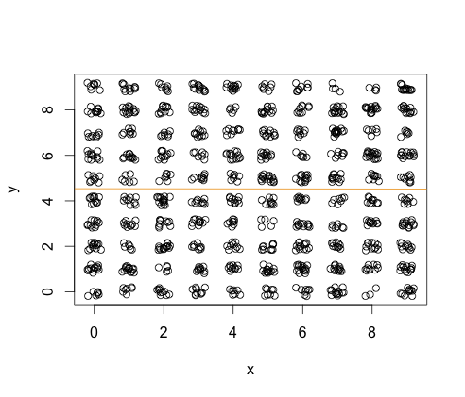

x

y 0 1 2 3 4 5 6 7 8 9

0 7 7 10 10 7 8 8 13 3 11

1 13 14 5 10 10 13 15 12 9 13

2 13 6 14 8 9 10 13 10 11 10

3 11 10 10 11 8 5 12 7 11 14

4 11 9 15 9 10 9 9 7 10 8

5 8 6 7 9 7 16 12 12 9 9

6 12 11 11 7 13 12 6 8 17 13

7 8 8 7 10 9 11 8 14 6 6

8 11 14 11 13 5 13 9 15 15 13

9 8 11 8 13 12 7 9 4 4 15

The regression coefficient in the linear model of y~x has t-statistic value -0.062, much less than 2 in absolute value. Based on the t-statistic I would reject the hypothesis that there is a linear relationship between the two series. We cannot reject the hypothesis that there is any relationship between the two series. An example of two series that are related, but with a low t value for the regression coefficient is given in graph below.

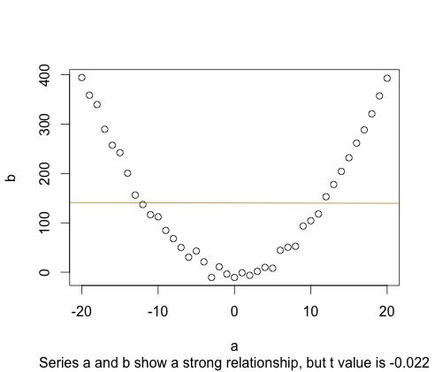

## Problem 3

b.

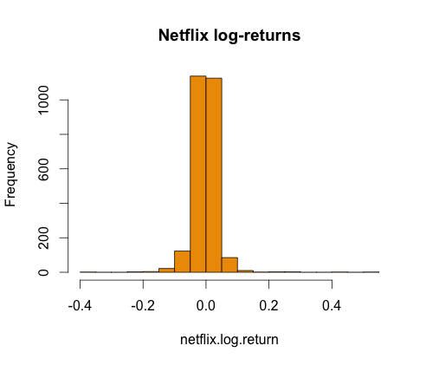

c.

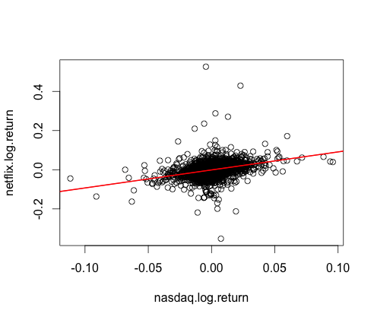 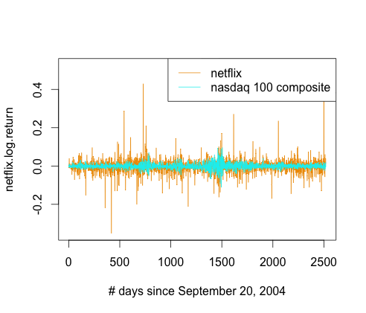

d. The linear fit is

With 95% confidence intervals

so the 95% CIs for and include 0 and 1 respectively.

## Problem 4

#### b.

**Summary statistics:**

d x1

Min. :0.000 Min. :0.0002863

1st Qu.:0.000 1st Qu.:0.2493821

Median :0.000 Median :0.4846455

Mean :0.477 Mean :0.4873756

3rd Qu.:1.000 3rd Qu.:0.7324941

Max. :1.000 Max. :0.9990059

**Standard deviation:**

d x1

0.4997206 0.2833453

#### c.

d.

Predictions   and , so with the threshold of 1, neither will be classified as spam.

## Problem 5

#### b.