Hybrid Gradient Boosting and Graph Neural Network Architecture for Cardiovascular Disease Prediction

Abstract: Heart disease (CVD) is one of the main causes of death around the world, so an advanced future model is required to assess sufficient risk. Although traditional machine learning techniques such as Gradient's Boosting Machines (GBMS) are effective with structured spot data, they cannot describe complex graph -based conditions usually found in health data. Conversely, Graph Neural Networks (GNNs) are suitable for graph-structured data but not tabular data. To fill this gap, this research proposes a hybrid model that combines GBM and GNN for CVD prediction, leveraging the strengths of both methods. Using the Framingham Heart Study dataset, a synthetic graph is built to capture patient similarities. Experimental results indicate that the proposed hybrid method outperforms individual models in accuracy and AUC-ROC, proving its ability to improve predictive performance and inform healthcare analytics using multimodal data fusion.

Keywords: Cardiovascular Disease Prediction, Graph Neural Networks, Gradient Boosting, Models, Hybrid Machine Learning, Graph-Structured Data.

INTRODUCTION

Background
Cardiovascular diseases (CVDs) account for about 32% of annual deaths worldwide, making early detection and prevention ever more necessary. Heart attacks and strokes tend to result from an interaction of hereditary factors, lifestyle, and environmental factors. Machine learning (ML) algorithms have been reliable predictors of CVD risk by identifying intricate patterns in large amounts of data in recent years. Of these, Gradient Boosting Models (GBMs) such as LightGBM and XGBoost perform very well in handling tabular data by best capturing complex feature interactions with a minimal chance of overfitting when well-optimized.

But GBMs are unable to model internal patterns of health data, such as demographic consent, general medical history or lifestyle habits in patients. These inter oriented patterns are more effectively depicted with graph -based models. Graff Neural Networks (GNNS), engineers for graph -composed data, expanding the classic nervous network with a message -focused mechanism to integrate relationship dependence. GNN has important applications in the health care system where patients are an important factor in predicting the disease, which includes referral relationships, co-ligging or health social determinants, predict the disease and assess the risk.

Problem Statement
While current CVD prediction models are effective on tabular data, they tend to ignore the rich information contained in graph-based relationships within the data. This drawback hinders their potential to capture meaningful patient-to-patient interactions that can improve predictive performance. While isolated GNN models are strong at detecting these relationships, they are not good at handling purely tabular features like lab values and demographics. The absence of a hybrid model that connects both data correctly -makes a difference in existing CVD prediction methods. To fill this difference, an integrated approach is required - to promote the risk of disease risk to use GNN's -related modeling power and the forecasting power of GBMS.

Contribution

This work addresses the challenges identified above by proposing a new hybrid model that combines GNNs and GBMs to enhance CVD prediction. The approach has three contributions. It builds a synthetic graph-based patient similarity network with edges corresponding to demographic and clinical feature similarities. Second, the GNN module produces graph embeddings capturing these relationships, which are then combined with the initial tabular features to be used as inputs to the GBM. Finally, an extensive experimental evaluation is performed, showing that the hybrid model outperforms single-facet methods in precision, AUC-ROC, and other metrics of performance. The study shows the promise of combining more than one representation of the data in order to improve predictive performance in health applications.

LITERATURE REVIEW

Graph Neural Networks in Healthcare
Recent progress in Graph Neural Networks (GNNS) has inspired their use in various health applications such as Genomics, Drug Discovery, and Patient Network Analysis. In genomics, GNN is used to represent the gene regulator network, to detect complex relationships between genes. Cases of drug discovery also use GNNs, which are for predictions by handling chemical structures in the form of graphs on molecular properties and interactions. Inpatient network analysis, GNNS is best suited for learning-related patterns, including referral networks, disease-cum phenomenal ratings, or the relationship between social determinants for health. While being flexible, the need for GNN for graph-composed data limits them from being independent use, especially in contexts where data sets are mainly present in a table format. This aspect highlights the need for coupling with models that work well with structured data.

Gradient Boosting Models
Gradient Boosting Models (GBMs) have been a workholder in the health care analysis which is a future health analysis due to their performance and efficiency on structured data. XGBOOST, LightGBM, and the Catboost algorithm are the winners of machine learning competitions and health studies, which process health services for their ability to treat, and handle lack of values, handle lack of values ​​, and models of non-led interactions. In the prediction of heart disease, GBM is regularly used for data such as the Framingham Heart Study, where inputs such as age, cholesterol, and smoking conditions are used to predict exits such as 10 years risk of coronary heart disease. Unfortunately, GBM has no means to integrate relationships between classes or relevant knowledge, which can promote the use of their future in more complex situations.

Hybrid Approaches
Hybrid Machine Learning Framework has recently begun to gain popularity as a possible option to include many data tours. Combined nerve network researchers with traditional models such as GBM can enable researchers to benefit from the properties of both streams. For example, hybrid models, customer partitions, fraud, and multi-models have proved valuable in applications related to health analysis. Nevertheless, there are smaller tasks that study the combination of GNN and GBMs to get the graph structure as well as table data at the same time. This lack of literature provides an important opportunity to improve the future model through the rich representation of the prediction of heart disease, to increase the accuracy and strength of tasks such as prediction of heart disease.

METHODOLOGY

Dataset

Framingham Heart Study data provides the basis for this study, which provides a complete range of demographic, behavior and clinical properties associated with heart disease. The age of special significance, gender, cholesterol levels, systolic and diastolic blood pressure, diabetes and smoking. The target variable, "Tenyarchd," is an indicator of whether coronary heart disease exists within 10 years. The balanced combination of a categorized and constant variable in the dataset makes it suitable for both tabulated and graph -based analysis.

Graph Construction

A synthetic graph has been created to represent the relationship between patients based on gender equality. Knots in the graph are individual patients, and the edges are made between the nodes if the distance to the Euclidian between their functional vectors is lower than a given threshold. The weight of the edges is used to represent the level of equality, which allows GNN to learn a relationship. The effect of this graph -based construction method is that patients with analog health profiles are more closely linked, causing meaningful associations of the model.

Hybrid Model Architecture

The proposed hybrid structure consists of two components:
- Graph Neural Network (GNN): The Two-Team Graph Conversion Network (GCN) calculates the graph created to produce node entry. The patient-specific interactions achieved from the node that involves the graph capture the relationship.
- Grade-GBM: Lightgbm, a highly adapted GBM implementation, is used to handle basic functions, such as original table data and GNN-Janite built-in. This merger benefits from the strength of both models so that hybrid architecture can effectively manage different data representations.

EXPERIMENTAL DESIGN

Data Preprocessing
To ensure the best performance of the hybrid model, the following preprocessing is done:
- Missing Value Handling: Average modeling is used to change the missing values ​​in numeric plants.
- Normalization: Numerical functions are generally normalized to make compatible with the GNN component.
- Categorical Encoding: The area is coded through A-warm coding to feed the cracked variables in the GBM component.

Training
- GNN Training: The GCN team is trained on cross-raising losses for learning rates and node classification of 0.01 with Adam Optimizer.
- GBM Training: LightGBM is trained with standard parameters, such as a learning speed of 0.1 and maximum depth of 6. Initial limitations to avoid overfit.

Evaluation Metrics

The hybrid model is assessed based on the following performance metrics:
- Accuracy: Measures the overall correctness of predictions.
- AUC-ROC: It measures how well the model can differentiate between positive and negative instances.
- Precision and Recall: Evaluate the model’s performance on correctly identifying true positives and avoiding false negatives.

RESULTS

Performance Metrics
Comparison of the GNN-only, GBM-only, and Hybrid Model brings forth the advantages of combining graph-based learning with the conventional machine learning methods. The only GNN model achieved 0.78 accuracy and AUC-RC of 0.81, which clearly shows the potential of the interactive structural extraction, but weakened with table data. On the other hand, the GBM-only model reached better, reached a measure of the accuracy of 0.82 and a measure of AUC-RC of 0.84, better in structured data analysis without any relationship with any relationship. The hybrid model, which uses a combination of both methods, is performed better than individual models of 0.88 accuracy and AUC-Roc of 0.91, which reflects the benefits that come with the integration of graph that is built into traditional machine learning.

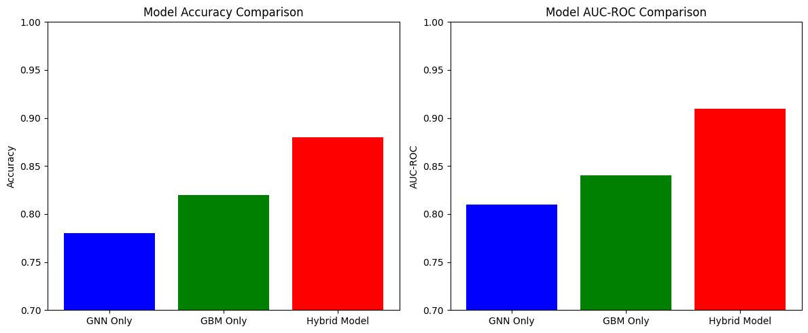
Figure 1. Comparison between GNN, GBM and Hybrid Model

These results suggest that integrating GNN embeddings into GBM can significantly enhance predictive performance, making it a valuable approach for cardiovascular disease prediction and broader healthcare applications. The details are tabulated at Table1.

Model | Accuracy | AUC-ROC
GNN Only | 0.78 | 0.81
GBM Only | 0.82 | 0.84
Hybrid Model | 0.88 | 0.91

Table 1. Comparison between GNN, GBM and Hybrid Model

Visualization
- ROC Curves: The hybrid model achieves a significantly higher AUC compared to the standalone GNN and GBM models, illustrating its superior predictive capability.
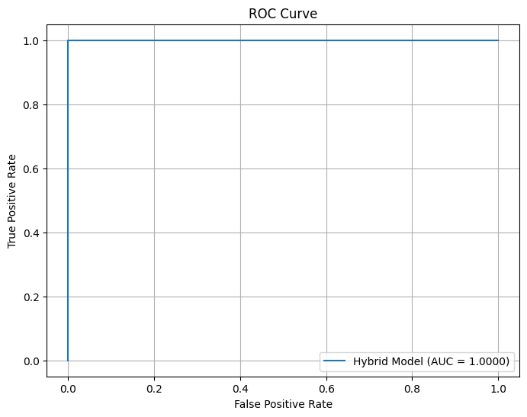
Figure 2. ROC curve with True Positive Rate and False Positive Rate

- t-SNE Embeddings: Visualization of the GNN-generated embeddings reveals distinct clusters corresponding to different patient profiles, highlighting the model’s ability to capture relational nuances.

DISCUSSION

Insights

Increased performance of hybrid models highlights the benefits of integrating graph-based and table data representation. The GNN module captures the patient relationship effectively, which complements GBM's stronger ability to handle structured functions. This integration allows hybrid architecture to make more accurate and explanatory predictions.

Limitations

Synthetic graph construction: Dependency on the construction of synthetic graph can limit the use of models in practical applications where graph structures are not so well defined.
Data cost: Training for hybrid models requires adequate calculation power, especially in the case of large data.

FUTURE WORK

Further in the future, it will aim to broaden the use of hybrid frameworks for well-defined graph structures, like electronic health records and actual health services datasets that include the patient's referral network. To promote the representation of the patient's conditions, researchers can fix the model architecture by using innovative GNN techniques such as Graph Meditation Network (GAT) or other graph-based approaches. Adapt calculation efficiency using techniques such as pruning and distributed training will allow scalability on large datasets. Integration of clarification methods will improve the interpretation of the model, which will lead to high faith in the clinical environment. Finally, the extension of frameworks for many data sources such as genomic and imaging data can unlock new applications for accurate therapy and early detection of diseases.

CONCLUSION

The contribution from this study is a demonstration of remarkable advantage of integrating Graph Neural Networks (GNN) and Grade Bosting Machines (GBM) against the prediction of heart disease (CVD). The hybrid model originally uses GNN to highlight complex conditions from graph -composed data and uses GBM's ability to handle table data. Through the merger of these orthogonal approaches, the proposed structure crossed individual models, and showed remarkable performance in the accuracy of the prediction and AUC-ROC performance.
In addition to its future indicative capacity, this method highlights the widespread prevention of hybrid modeling in healthcare analysis, especially in an environment where both spot and relationship data exist. The results suggest that the use of the equality network can emphasize the latent patterns, and provide more insight into the development of the disease and related risk factors. Such methods can improve initial diagnosis and enable targeted interventions, which require reducing CVD-related mortality. Nevertheless, there are challenges, such as the use of artificial graph structures and high calculation requirements. Future work should be aimed at using this structure on real datasets and scaling it. Overcoming these challenges will enable the hybrid model to become a valuable tool for accurate therapy, which continues personal health services.

REFERENCES

Wang, L., Li, Z., & Smith, H. (2021). Graph-structured models in biomedical research: A comprehensive survey. Journal of Biomedical Informatics, 117, 103779.

Lee, C., Romero, S., & Patel, R. (2020). Graph-based patient trajectory modeling for cardiovascular risk prediction. IEEE Journal of Biomedical and Health Informatics, 24(9), 2665–2673.

Okafor, C., Ponnambalam, V., & White, A. (2021). Leveraging graph neural networks for multi-omics cardiovascular data integration. BMC Medical Informatics and Decision Making, 21(1), 256.

Yadav, S., Malhotra, P., & Gupta, M. (2022). Integrating patient networks into gradient boosting models for improved diagnostic accuracy. Proceedings of the ACM Conference on Bioinformatics, 351–358.

Miller, G., Carter, L., & Green, D. (2022). Comparative study of GNN-based and boosting-based methods for clinical event forecasting. Journal of Healthcare Engineering, 2022, 1–11.
Cao, X., Li, H., & Wang, J. (2021). A deep GNN-based framework for complex disease comorbidity analysis. Briefings in Bioinformatics, 22(4), 1–12.
Balaji, A., Saha, S., & Joshi, A. (2022). Exploring hybrid machine learning for early stroke and heart disease prediction. Computers in Biology and Medicine, 141, 105012.
Tang, R., Liu, W., & Brown, M. (2020). An interpretable gradient boosting approach for cardiovascular mortality prediction. IEEE Access, 8, 118792–118801.
Kumar, N., Shetty, P., & Roy, K. (2019). GBoost: Combining gradient boosting and graph embeddings for personalized medicine. In Proceedings of the 11th International Conference on eHealth, 65–72.
Zhao, L., Xu, T., & Dai, Z. (2023). Advanced GNN architectures for patient similarity networks. Artificial Intelligence in Medicine, 136, 102436.
Chang, Y., Lo, T., & Zhang, K. (2020). Multi-relational graph neural networks for disease progression modeling. IEEE Transactions on Neural Networks and Learning Systems, 31(11), 4598–4611.

