

The LNM Institute of Information Technology, Jaipur Software Development Laboratory
Course Code: CS314 Lab Assignment 1: Solution
- Project Identification
Item | Details
Project Name | Company Engagement Portal
Project Type | Web-based institutional company and industry engagement management system
Team ID | T066
Team Members | Hitesh Jain, Anand Patidar, Pranav Vashisth, Avesh Khan
Roll Numbers | 24UCS123, 24UCS125, 24UCS126, 24UCS127
Development Model | Agile + Incremental Development
Primary Users | Institutional users involved in company engagement and recruitment activities
Development Team | Student software development team
Course | Software Engineering
Project Objective | To develop a centralized portal for managing institutional interactions with recruiting companies and industry organizations, including company profiles, contacts, visits, recruitment activities, and engagement history.
Expected Outcome | A centralized and organized system for recording, managing, and tracking company profiles, contacts, visits, recruitment activities, and  institutional engagement history.

Project Background Current Problem
Managing company profiles, contact details, visits, recruitment activities, and engagement history through scattered or manual records can be difficult. It can also make tracking previous company interactions less efficient.

Proposed Solution
The Company Engagement Portal will centralize company-related information and institutional interactions in a single system. It will help authorized users efficiently manage company profiles, contacts, visits, recruitment activities, and engagement history.

Project Vision
The Company Engagement Portal aims to provide a centralized and organized platform for managing institutional interactions with companies and industry organizations. It will simplify the management of company information, recruitment activities, visits, contacts, and engagement history.

Problem Statement
Institutions need to manage interactions with recruiting companies and industry organizations, including company profiles, contacts, visits, recruitment activities, and engagement history. Managing this information through scattered or manual records can make it difficult to track interactions and maintain up-to-date information. Therefore, a centralized Company Engagement Portal is needed to organize and efficiently manage these activities.

Project Objectives
The initial objectives should be:
- To maintain centralized profiles of recruiting companies and industry organizations.
- To manage and update company contact details.
- To record and track company visits to the institution.
- To manage recruitment-related activities and their details.
- To maintain the history of institutional engagement with companies.
- To provide easy access to company-related information for authorized users.
- To improve the organization and tracking of company interactions.
- To reduce dependency on scattered or manual records.

Stakeholders
Stakeholder | Interest / Role
Training & Placement Cell | Manage company profiles, recruitment activities, visits, and engagement records.
Company Representatives | Provide company information and participate in recruitment and engagement activities.
Faculty/Institute Authorities | Monitor and support institutional interactions with companies.
Students | Benefit from company recruitment activities and placement opportunities.
System Administrator | Manage users, access control, and overall system operations.
Development Team | Design, develop, test, and maintain the Company Engagement Portal.

Initial Scope
- Company profile and contact management.
- Recording company visits and recruitment activities.
- Maintaining company engagement and interaction history.
- Searching and viewing company-related information.
- Role-based access for authorized users.

Initially Out of Scope
- Payment processing
- Complete ERP or academic management
- Advanced AI-based company recommendations
- Integration with external hiring systems
- Automated recruitment decision-making

Initial Assumptions

- Users will have access to the internet
- Authorized users will have valid login credentials
- Company information will be provided by authorized users
- Company visits and recruitment activities will be recorded by authorized users
- The system will initially be developed as a web application
- The system will use a centralized database for storing company and engagement information

Initial Constraints

- Limited development time
- Limited team size and resources
- Limited access to real company data
- Limited infrastructure during development
- Limited testing with real users
- Requirement changes during development
- Need to protect company and user information
- Limited integration with external company systems

Initial Success Criteria

- Different user roles can access the appropriate system features
- Authorized users can create and manage company profiles
- Company contact details can be added and updated
- Company visits and recruitment activities can be recorded
- Company engagement history can be viewed and tracked

- Users can search and access relevant company information
- Important system functions are tested successfully
- Major defects are identified and resolved
- The project is maintained in a controlled GitHub repository

The LNM Institute of Information Technology, Jaipur Software Development Laboratory
Course Code: CS314 Lab Assignment 2: Solution

- User Classes
  - Training & Placement (T&P) Coordinator
The T&P Coordinator is the primary operator of the system, responsible for maintaining company-related information.
They shall be able to:
    - authenticate;
    - create and manage company profiles;
    - add and update company contacts;
    - record and view company visits;
    - create, edit and submit recruitment activities for approval;
    - view engagement history;
    - access reports.

Company Representative
Company representatives are the external point of contact for a company and provide information used by the institution.
They shall be able to:
    - share company and contact information with the T&P Coordinator (offline/through the Coordinator, not direct system login in the initial version);
    - participate in recorded visits and recruitment activities.

Approving Authority (Faculty/Institute Authority)
The approving authority reviews recruitment activities submitted by coordinators. The approver shall be able to:
    - review submitted recruitment activities;
    - approve recruitment activities;
    - reject recruitment activities;
    - provide comments/reasons;
    - view approval history.

Administrator
The administrator shall:
    - manage users;
    - assign roles;
    - manage system-level configuration;
    - monitor system activity;

    - access administrative reports.

Institute Management
Management users shall have access to appropriate aggregated reports and dashboards for monitoring company engagement and recruitment activity across the institution.

System Context
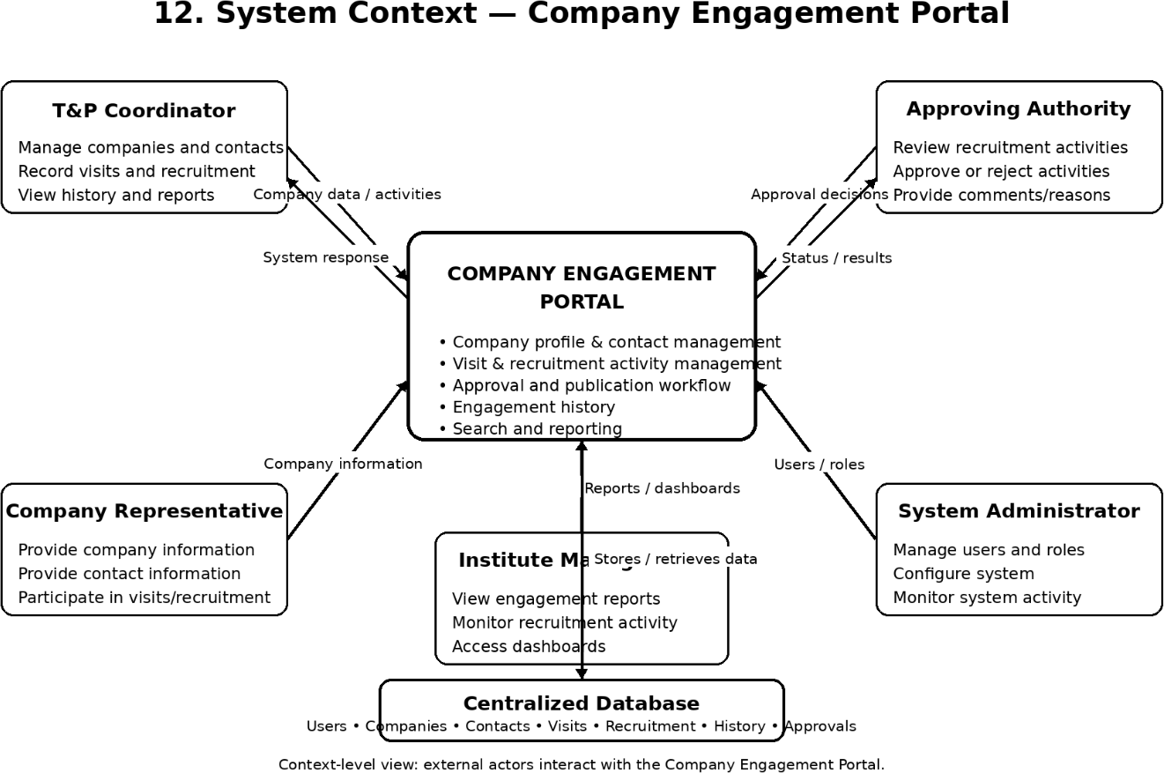

Functional Requirements
  - Authentication and Account Management
    - FR-001 — User Login: The system shall allow a registered user to authenticate using valid credentials.
    - FR-002 — Authentication Failure: The system shall notify the user when authentication fails without unnecessarily revealing sensitive authentication information.
    - FR-003 — Logout: The system shall allow authenticated users to terminate their session.

    - FR-004 — Role Assignment: The system shall allow authorized administrators to assign roles to users.
    - FR-005 — Role-Based Access: The system shall restrict system functions according to the user's assigned role.

Company Profile Management
    - FR-006 — Create Company Profile: The system shall allow an authorized coordinator to create a company profile.
    - FR-007 — Company Profile Information: The system shall allow a coordinator to specify: company name; industry/sector; address; website; primary contact; status; notes.
    - FR-008 — Edit Company Profile: The system shall allow an authorized coordinator to modify an existing company profile.
    - FR-009 — Deactivate Company Profile: The system shall allow an authorized coordinator to deactivate/archive a company profile.
    - FR-010 — View Company Profile: The system shall allow authorized users to view complete company profile details.

Company Contact Management
    - FR-011 — Add Company Contact: The system shall allow an authorized coordinator to add a contact person for a company.
    - FR-012 — Contact Information: The system shall allow a coordinator to specify: name; designation; email; phone; department.
    - FR-013 — Edit Company Contact: The system shall allow an authorized coordinator to update contact details.
    - FR-014 — Remove Company Contact: The system shall allow an authorized coordinator to remove an outdated contact.
    - FR-015 — View Company Contacts: The system shall allow authorized users to view all contacts associated with a company.

Company Visit Management
    - FR-016 — Record Company Visit: The system shall allow an authorized coordinator to record a company visit.
    - FR-017 — Visit Information: The system shall allow a coordinator to specify: visit date; purpose; attendees; outcome; notes.
    - FR-018 — Edit Visit Record: The system shall allow an authorized coordinator to modify a visit record.
    - FR-019 — View Visit History: The system shall allow authorized users to view the visit history of a company.

Recruitment Activity Management
    - FR-020 — Create Recruitment Activity: The system shall allow an authorized coordinator to create a recruitment activity.
    - FR-021 — Recruitment Activity Information: The system shall allow a coordinator to specify: title; company; type; date; eligibility criteria; positions offered; status.

    - FR-022 — Save Draft: The system shall allow an incomplete recruitment activity to be saved as a draft.
    - FR-023 — Edit Recruitment Activity: The system shall allow an authorized coordinator to modify a recruitment activity subject to its current status.
    - FR-024 — Submit for Approval: The system shall allow a coordinator to submit a recruitment activity for approval.
    - FR-025 — Approve Recruitment Activity: The system shall allow an authorized approver to approve a recruitment activity.
    - FR-026 — Reject Recruitment Activity: The system shall allow an authorized approver to reject a recruitment activity.
    - FR-027 — Rejection Reason: The system shall allow an approver to provide a reason when rejecting a recruitment activity.
    - FR-028 — Publish Recruitment Activity: The system shall mark an approved recruitment activity as published according to defined rules.
    - FR-029 — Cancel Recruitment Activity: The system shall allow an authorized user to cancel a recruitment activity.

Engagement History
    - FR-030 — Log Engagement Record: The system shall automatically log an engagement record whenever a visit, contact update, or recruitment activity occurs.
    - FR-031 — View Engagement History: The system shall allow authorized users to view the complete engagement history of a company.
    - FR-032 — Engagement Timeline: The system shall present engagement history in chronological order.

Search and Access
    - FR-033 — Company Search: The system shall allow authorized users to search for companies.
    - FR-034 — Company Filtering: The system shall allow authorized users to filter companies by relevant attributes (industry, status, etc.).
    - FR-035 — View Company Details: The system shall display complete relevant information for a selected company.

Reporting
    - FR-036 — Engagement Report: The system shall generate company engagement reports for authorized users.
    - FR-037 — Recruitment Activity Report: The system shall generate recruitment activity summaries.
    - FR-038 — Visit Report: The system shall generate company visit reports.
    - FR-039 — Administrative Dashboard: The system shall provide appropriate summary information to authorized administrators.

Business Rules

ID | BUSINESS RULE
BR-001 | Only authorized coordinators/administrators can create company profiles.
BR-002 | A recruitment activity must be approved before it is published.
BR-003 | Only approved recruitment activities can be scheduled/executed.
BR-004 | A company profile cannot be duplicated for the same company.
BR-005 | Only authorized users can record company visits.
BR-006 | Only authorized users can access administrative reports.
BR-007 | Cancelled recruitment activities cannot be further edited.
BR-008 | Engagement history entries cannot be deleted, only archived.
BR-009 | Each company contact must be linked to an existing company profile.
BR-010 | Every approval decision must record the approver's identity and decision date

Non-Functional Requirements
  - Performance
    - NFR-001: The system should provide acceptable response times for normal user operations.
    - NFR-002: Search and filtering operations should return results within an acceptable time under expected load.
    - NFR-003: The system should support concurrent users appropriate to expected institutional usage.

Security
    - NFR-004: Protected functionality shall require authentication.

    - NFR-005: Access to functionality shall be controlled by user roles.
    - NFR-006: Sensitive company/contact information shall not be exposed to unauthorized users.
    - NFR-007: Administrative operations should be auditable.

Usability
    - NFR-008: The interface shall use consistent navigation.
    - NFR-009: Error messages shall be understandable to users.
    - NFR-010: Common activities such as recording a visit or searching a company should require minimal unnecessary interaction.

Reliability
    - NFR-011: Company and contact records shall be maintained reliably.
    - NFR-012: Visit and recruitment activity records shall not be lost during normal system operation.

Availability
    - NFR-013: The system should be available during normal institutional operating periods, except during planned maintenance.

Maintainability
    - NFR-014: The software shall follow a modular architecture.
    - NFR-015: Source code shall be maintained using version control.
    - NFR-016: Software documentation shall be maintained alongside relevant system changes.

Scalability
    - NFR-017: The architecture should allow the system to support an increasing number of companies, contacts and engagement records.

Compatibility
    - NFR-018: The system should operate correctly on commonly used modern web browsers.

Privacy
    - NFR-019: Company and contact information shall be accessible only to authorized users.

Auditability

    - NFR-020: Significant administrative actions should be recorded to support accountability and troubleshooting.

Data Requirements
The initial logical information requirements include the following entities.

User
Possible attributes:
- User ID
- Name
- Email
- Contact information
- Role
- Account status

Company
Possible attributes:
- Company ID
- Name
- Industry
- Address
- Website
- Status
- Notes

Contact
Possible attributes:
- Contact ID
- Company ID
- Name
- Designation
- Email
- Phone
- Department

Visit
Possible attributes:
- Visit ID
- Company ID
- Date

- Purpose
- Attendees
- Outcome
- Notes

Recruitment Activity
Possible attributes:
- Activity ID
- Company ID
- Title
- Type
- Date
- Eligibility criteria
- Positions offered
- Status

Engagement History
Possible attributes:
- Record ID
- Company ID
- Type (visit/contact/activity)
- Description
- Date
- Recorded by

Approval
Possible attributes:
- Approval ID
- Activity ID
- Approver
- Decision
- Comments
- Decision date

Recruitment Activity Lifecycle
The recruitment activity entity may pass through the following states:

Draft
↓
Submitted
↓

Under Review
↓
┌───────┴───────┐
↓ ↓
Approved Rejected
↓ ↓
Scheduled Revision
↓ ↓
Ongoing Resubmission
↓
Completed
↓
Engagement History

Major Use Cases
ID | Use Case | Primary Actor
UC-001 | Login | All users
UC-002 | Manage Users | Administrator
UC-003 | Create Company Profile | Coordinator
UC-004 | Edit Company Profile | Coordinator
UC-005 | Add Company Contact | Coordinator
UC-006 | Record Company Visit | Coordinator
UC-007 | Create Recruitment  Activity | Coordinator
UC-008 | Submit Recruitment  Activity | Coordinator
UC-009 | Approve Recruitment  Activity | Approver
UC-010 | Reject Recruitment Activity | Approver
UC-011 | Publish Recruitment Activity | System/Coordinator
UC-012 | Cancel Recruitment Activity | Coordinator
UC-013 | Search Companies | Authorized User
UC-014 | View Engagement History | Authorized User
UC-015 | Generate Reports | Authorized User

Detailed Use Case Example

UC-006 — Record Company Visit Primary Actor: T&P Coordinator Preconditions:
- Coordinator is authenticated.
- Company profile exists. Main Flow:
- Coordinator selects a company.
- System displays company details.
- Coordinator selects "Record Visit."
- Coordinator enters visit date, purpose, attendees and outcome.
- System validates the entered information.
- System creates the visit record.
- System updates the engagement history.
- System displays confirmation. Alternative Flows:
  - If the company does not exist → coordinator is prompted to create the profile first.
  - If mandatory fields are missing → system displays a validation error.
Postcondition: A valid visit record exists and is linked to the company's engagement history.

User Stories
The requirements will also be represented in Agile form.
- US-001: As a coordinator, I want to log in so that I can securely access the Company Engagement Portal.
- US-002: As a coordinator, I want to create a company profile so that the institution has a record of the company.
- US-003: As a coordinator, I want to add company contacts so that I can reach the right person when needed.
- US-004: As a coordinator, I want to record a company visit so that the interaction is documented.
- US-005: As a coordinator, I want to create a recruitment activity so that it can be reviewed for approval.
- US-006: As an approver, I want to approve or reject recruitment activities so that only valid activities proceed.
- US-007: As a coordinator, I want to view a company's engagement history so that I understand past interactions.
- US-008: As an administrator, I want to manage user roles so that access to the system is controlled.

- US-009: As institute management, I want to view engagement reports so that I can monitor company relationships.
- US-010: As a coordinator, I want to search for companies so that I can quickly find relevant information.

Acceptance Criteria Example US-004 — Record Company Visit
ID | Acceptance Criterion
AC-01 | Coordinator must be authenticated
AC-02 | Company profile must exist
AC-03 | Mandatory visit fields must be provided
AC-04 | A successful save must create a visit record
AC-05 | Engagement history must be updated
AC-06 | Coordinator must receive confirmation

Requirements Prioritization Must Have
- Authentication
- Role-based access
- Company profile management
- Contact management
- Visit recording
- Recruitment activity creation and approval
- Company search

Should Have
- Engagement history timeline
- Draft saving
- Reports

Could Have
- Advanced dashboards
- Advanced analytics

Won't Have in Initial Release
- Payment processing
- Complete ERP/academic management
- Advanced AI-based company recommendations
- Integration with external hiring systems
- Automated recruitment decision-making

Requirements Traceability
Requirements Traceability Matrix (RTM). An initial version:

Requirement | User Story | Use Case | Test
FR-006 | US-002 | UC-003 | TBD
FR-016 | US-004 | UC-006 | TBD
FR-024 | US-005 | UC-008 | TBD
FR-025 | US-006 | UC-009 | TBD
FR-036 | US-009 | UC-015 | TBD
Note: The TBD entries will be filled later in the testing phase.

Requirements Validation
- Correctness — Does it represent a genuine stakeholder need?
- Unambiguity — Can it have only one reasonable interpretation?
- Completeness — Does it contain sufficient information?
- Consistency — Does it conflict with another requirement?
- Verifiability — Can we test whether it has been satisfied?
- Feasibility — Can it realistically be implemented?
- Traceability — Can we identify its origin and follow it through development?
- Prioritization — Do we know how important it is?
- Modifiability — Can it be changed without unnecessarily affecting the entire SRS?

Example of Requirement Quality Poor
"The system should be fast and user-friendly." This is ambiguous and difficult to verify.

Better
"The system shall provide consistent navigation across major user interfaces." and
"The system should provide acceptable response times for company search under expected workload."

Requirement Change Management

Because the Company Engagement Portal uses Agile development, requirements can change. For example:
Change Request: Add a company feedback/rating feature after each recruitment activity. The team should follow: Change Request → Impact Analysis → Requirement Update →
Backlog Update → Prioritization → Sprint Planning → Design Change → Implementation → Testing → Release
The change should also update relevant documentation and traceability.

Future Requirements
Potential future requirements include:
- integration with external hiring systems;
- automated recruitment decision-making;
- advanced AI-based company recommendations;
- mobile application;
- advanced analytics;
- integration with institutional authentication;
- integration with institutional ERP;
- automated engagement summary generation.

SRS Baseline and Versioning
- Initial baseline: SRS v1.0
- Version Control Information:
SRS v1.0 defines the initial baseline requirements for the Company Engagement Portal, covering user roles, system context, functional and non-functional requirements, data requirements, major use cases, and acceptance criteria.
This version also establishes the initial scope, business rules, recruitment activity lifecycle, requirements traceability, and change management process for the project. Future requirement changes will be managed through impact analysis, requirement updates, prioritization, implementation, testing, and controlled versioning.

Individual Contribution
Hitesh Jain — Prepared user classes and functional requirements. Anand Patidar — Prepared use cases and user stories.
Pranav Vashisth — Prepared system context and requirements traceability.
Avesh Khan — Prepared non-functional requirements and requirements validation.

AI USAGE POLICY – STUDENT DECLARATION
AI tools may be used as supporting tools for this assignment. The team is responsible for the correctness, consistency and understanding of all submitted requirements.

- We have disclosed the use of AI tools, if any.
- AI-generated suggestions have been reviewed, verified and adapted by the team.
- We understand and can explain the submitted requirements, use cases and user stories.
- We have verified that the requirements are consistent with our project's scope.
- The final SRS represents our team's understanding and decisions.

AI Tool(s) Used: ChatGPT, Claude Code

Purpose of AI Use:
AI was used as a supporting tool for reviewing and organizing the Software Requirements Specification (SRS), drafting the System Context section and context-level diagram description, and improving the clarity and consistency of the documented requirements.
Team ID: T066
Team Representative: Pranav Vashish
Date: 07/09/2026


The LNM Institute of Information Technology, Jaipur
Software Development Laboratory Course Code: CS314

Lab Assignment 3: Solution
Scenario, Use Case and Activity Modelling
Project: Company Engagement Portal Team ID: T066
Team Members: Hitesh Jain, Anand Patidar, Pranav Vashisth, Avesh Khan
Purpose: This assignment extends the requirements specification from Assignment 2 into scenarios and UML models, while keeping the existing scope and terminology unchanged.

Scenarios
The following three use cases are carried forward from the Assignment 2 use-case catalogue for detailed modelling: UC-006 Record Company Visit, UC-008 Submit Recruitment Activity, and UC-009 Approve Recruitment Activity.
  - UC-006 — Record Company Visit
Actor(s) involved | T&P Coordinator.
Starting condition | The coordinator is authenticated and the company profile exists.
Main sequence | - Coordinator selects a company.  - System displays company details.  - Coordinator selects “Record Visit.”  - Coordinator enters visit date, purpose, attendees and outcome.  - System validates the entered information.  - System creates the visit record.  - System updates the engagement history.  - System displays confirmation.
Alternative / exception | If the company does not exist, the coordinator is prompted to create the profile first. If mandatory fields are missing, the system displays a validation error.
Expected outcome | A valid visit record exists and is linked to the company’s engagement history.
  - UC-008 — Submit Recruitment Activity
Actor(s) involved | T&P Coordinator.
Starting condition | The coordinator is authenticated and a recruitment activity exists in a status that permits submission (normally a draft).
Main sequence | - Coordinator selects the recruitment activity draft.  - System displays the activity details.  - Coordinator reviews the recruitment activity details.  - Coordinator selects “Submit for Approval.”  - System validates the required information and current status.  - System marks the activity as Submitted.  - The submitted activity becomes available for the approval process.
Alternative / exception | If required information is incomplete or the activity status does not permit submission, the system displays a validation error and the coordinator corrects/edits the activity before retrying.
Expected outcome | The recruitment activity is in Submitted status and is ready for review by the Approving Authority.

19

The LNM Institute of Information Technology, Jaipur
Software Development Laboratory Course Code: CS314

  - UC-009 — Approve Recruitment Activity
Actor(s) involved | Approving Authority (Faculty/Institute Authority).
Starting condition | The approver is authenticated and a recruitment activity has been submitted for approval / is under review.
Main sequence | - Approver opens the submitted recruitment activity.  - System displays the activity details.  - Approver reviews the recruitment activity.  - Approver makes an approval decision.  - System records the approval decision, approver identity and decision date.  - System sets the recruitment activity status to Approved.
Alternative / exception | If the approver does not approve the activity, the alternative rejection flow is handled through UC-010 Reject Recruitment Activity, where the approver can provide comments/reasons.
Expected outcome | The recruitment activity is approved and can proceed to the next lifecycle state according to the Assignment 2 recruitment activity lifecycle.

20

The LNM Institute of Information Technology, Jaipur
Software Development Laboratory Course Code: CS314

Use Case Diagram
The complete system use-case model is shown below. The three detailed Assignment 3 use cases are highlighted with double borders and the label [DETAILED].
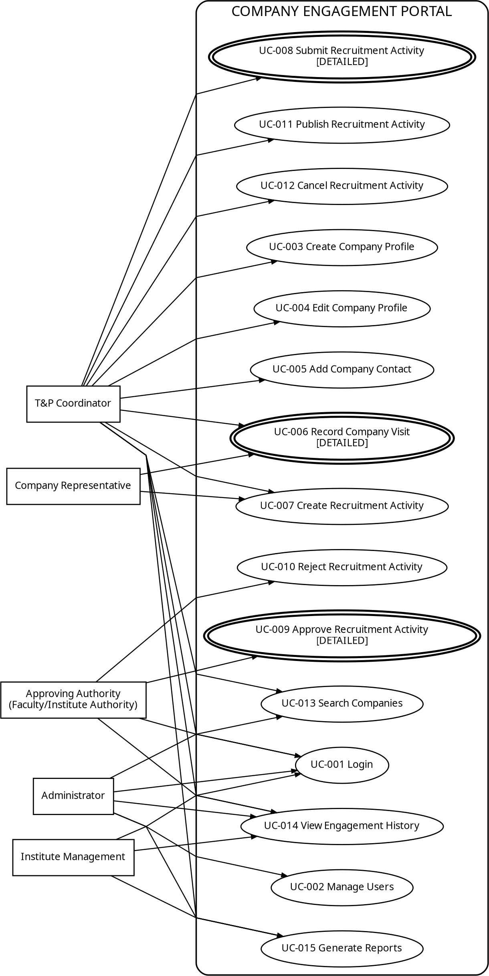
Relationship note: No new functionality is introduced. No &lt;&lt;include&gt;&gt;, &lt;&lt;extend&gt;&gt;, or actor-generalization relationship is asserted because Assignment 2 does not establish a mandatory reusable subflow or actor inheritance hierarchy for these use cases.

21

The LNM Institute of Information Technology, Jaipur
Software Development Laboratory Course Code: CS314

Activity Diagram — UC-006 Record Company Visit
The workflow follows the Assignment 2 main flow and its two stated alternatives: a missing company profile and missing mandatory fields.
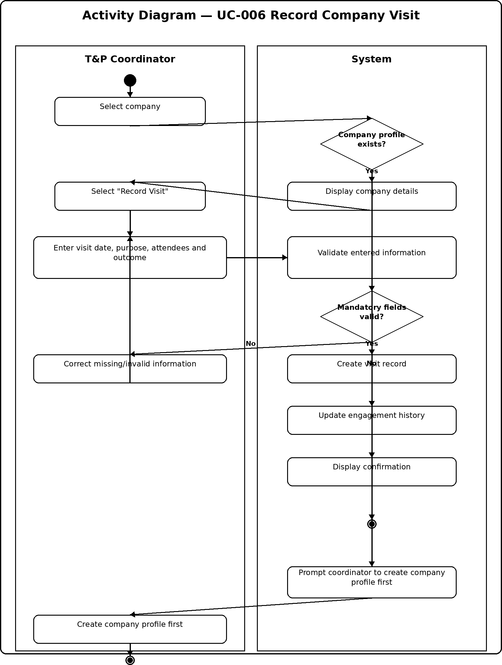

22

The LNM Institute of Information Technology, Jaipur
Software Development Laboratory Course Code: CS314

Activity Diagram — UC-008 Submit Recruitment Activity
The workflow models submission validation and the alternative path when required information or the current status prevents submission.
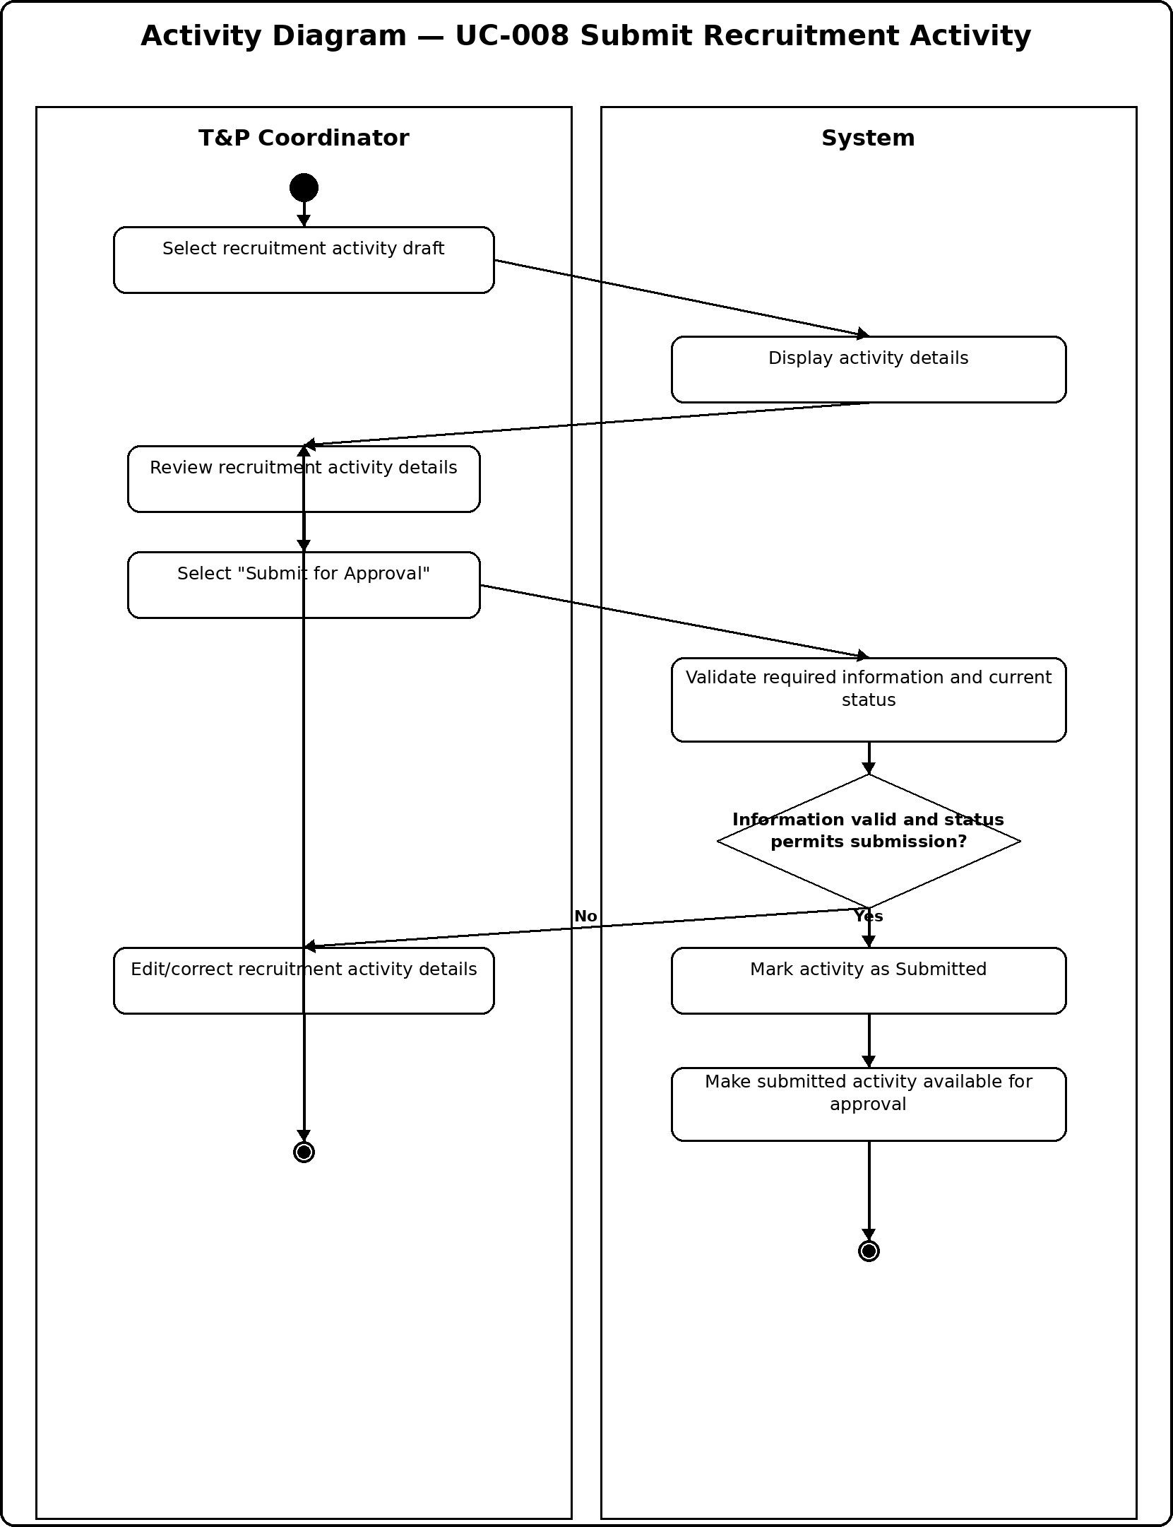

23

The LNM Institute of Information Technology, Jaipur
Software Development Laboratory Course Code: CS314

Activity Diagram — UC-009 Approve Recruitment Activity
The workflow records the approval decision, approver identity and decision date. The non-approval branch proceeds to the existing UC-010 rejection use case.
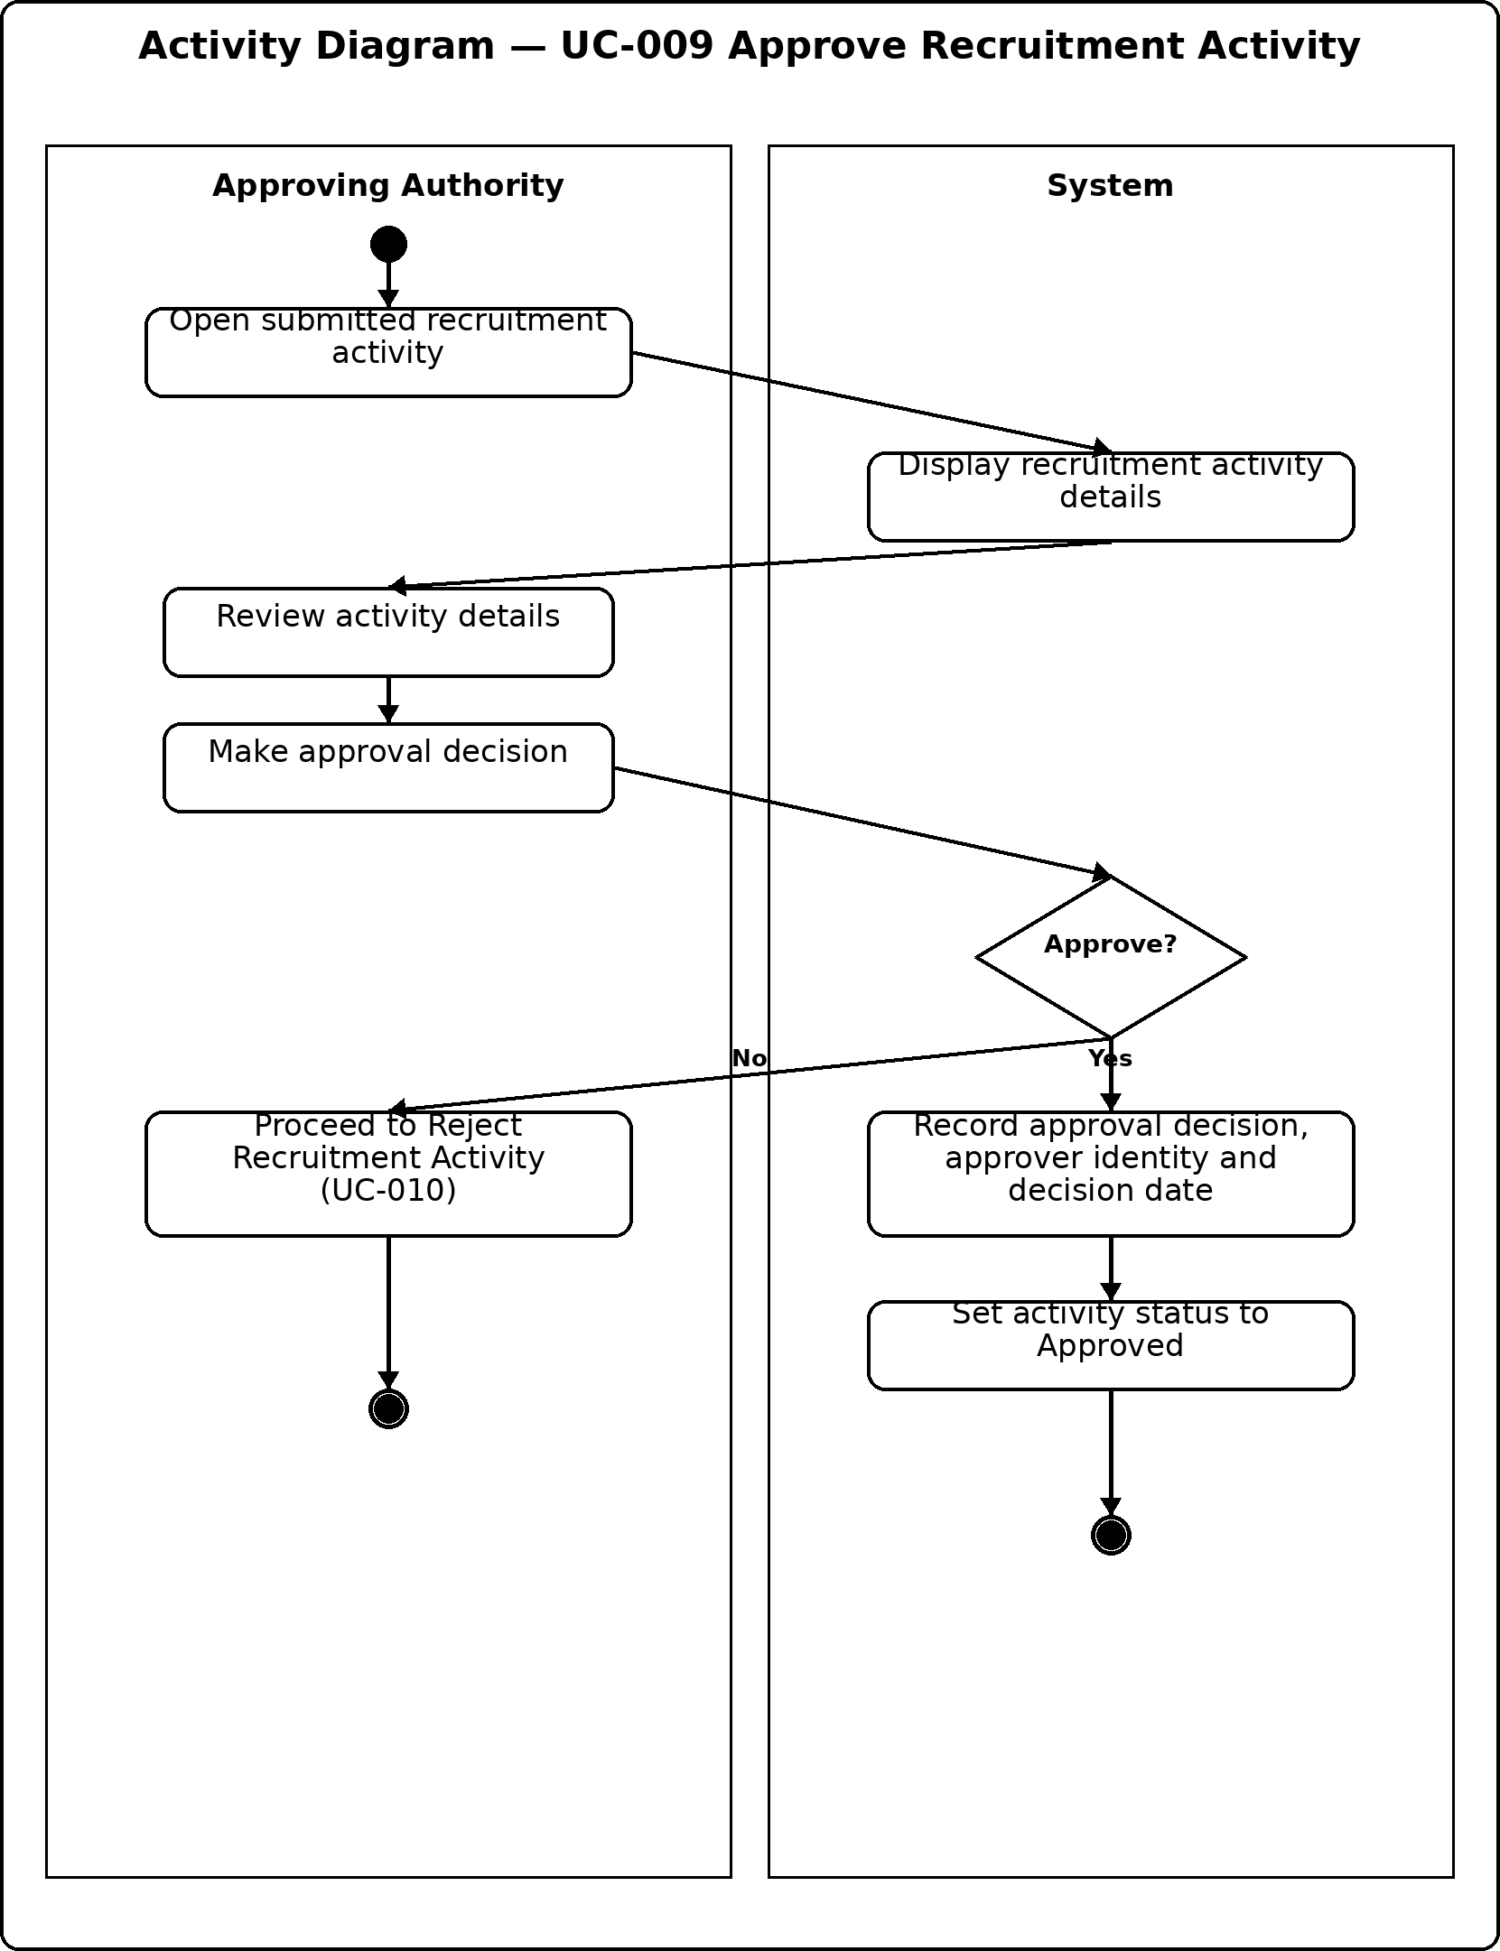

24

The LNM Institute of Information Technology, Jaipur
Software Development Laboratory Course Code: CS314

Consistency and Traceability
- UC-006 remains consistent with FR-016 to FR-019, the Record Company Visit user story/acceptance criteria, and the Engagement History requirements from Assignment 2.
- UC-008 remains consistent with FR-020 to FR-024 and the recruitment activity lifecycle Draft → Submitted → Under Review.
- UC-009 remains consistent with FR-025 to FR-027 and Business Rule BR-010, which requires the approver identity and decision date to be recorded.
- No new project functionality, scope item, or requirement is introduced. The models only represent workflows already specified in Assignment 2.

GitHub Submission Structure
docs/uml/assignment-3/
- Scenarios.md
- Use-Case-Model.md
- diagrams/Use-Case-Diagram.png
- diagrams/Activity-Diagram-UC01.png
- diagrams/Activity-Diagram-UC02.png
- diagrams/Activity-Diagram-UC03.png

Individual Contribution

Team Member | Contribution
Hitesh Jain | Prepared and reviewed the three scenario descriptions for consistency with Assignment 2.
Anand Patidar | Prepared the complete-system Use Case Diagram and verified actor/use-case associations.
Pranav Vashisth | Prepared Activity Diagrams for UC-006 and UC-008 and checked requirements traceability.
Avesh Khan | Prepared the Activity Diagram for UC-009 and performed consistency/documentation review.

AI USAGE POLICY – STUDENT DECLARATION
- We have disclosed the use of AI tools, if any.
- AI-generated suggestions have been reviewed, verified and adapted by the team.
- We understand and can explain the submitted scenarios, use case diagram and activity diagrams.
- We have verified that the UML models are consistent with our project's requirements, use cases and scope.
- The final submission represents our team's understanding and modelling decisions.
AI Tool(s) Used | ChatGPT
Purpose of AI Use | AI was used as a supporting tool for drafting scenario wording, structuring UML model layouts and checking consistency against the Assignment 2 requirements. The team is responsible for reviewing and adapting the final submission.
Team ID | T066
Team Representative | Pranav Vashisth
Date | 13/09/2026

25

The LNM Institute of Information Technology, Jaipur Software Development Laboratory
Course Code: CS314 Lab Assignment 4: Solution
Project: Company Engagement Portal Team ID: T066

Classes
The following classes extend the requirements and the three detailed use cases carried forward from Assignment 3: UC-006 Record Company Visit, UC-008 Submit Recruitment Activity, and UC-009 Approve Recruitment Activity. The model keeps the terminology and scope of the Company Engagement Portal unchanged. Classes are selected to represent the principal domain entities, role specializations and responsibilities needed to realize the three workflows.
  - Class Identification

Class | Important Attributes | Important Operations / Responsibilities | Traceability
User | userId, name, email, role, accountStatus | authenticate(), logout(), hasRole() | All three; authentication precondition
TPCoordinator | employeeId | createCompanyProfile(), recordVisit(), createRecruitmentActivity(), submitForApproval() | UC-006, UC-008
ApprovingAuthority | authorityId | reviewActivity(), approveActivity(), rejectActivity() | UC-009
Company | companyId, name, industry, address, website, status | viewProfile(), updateProfile(), addContact() | UC-006; existing company precondition
Contact | contactId, name, designation, email, phone, department | updateDetails() | UC-006;  company/contact data
Visit | visitId, date, purpose, attendees, outcome, notes | validate(), save(), update() | UC-006
RecruitmentActivity | activityId, title, type, date, eligibilityCriteria, positionsOffered, status | saveDraft(), validateSubmission(), submit(), changeStatus() | UC-008, UC-009
Approval | approvalId, decision, comments, decisionDate | recordDecision(), isApproved() | UC-009

The LNM Institute of Information Technology, Jaipur Software Development Laboratory
Course Code: CS314

  - Supporting Classes

Class | Important Attributes | Important Operations / Responsibilities | Traceability
EngagementHistory | companyId | addRecord(), getTimeline() | UC-006; FR-030 to FR-032
EngagementRecord | recordId, type, description, date, recordedBy | create(), archive() | UC-006; visit creates record
CompanyService | — | createProfile(), updateProfile(), findCompany() | Supports company lookup in UC-006
VisitService | — | recordVisit(), validateVisit(), updateVisit() | Supports UC-006
RecruitmentActivityService | — | createActivity(), validateSubmission(), submitActivity() | Supports UC-008
ApprovalService | — | reviewActivity(), approve(), reject() | Supports UC-009
EngagementHistoryService | — | logVisit(), viewHistory(), appendRecord() | Supports UC-006
ValidationService | — | validateRequiredFields(), validateStatus(), validateCompanyExists() | Validation steps in UC-006/UC-008

  - Class-Modeling Notes
- The role classes TPCoordinator and ApprovingAuthority specialize User because the requirements distinguish their responsibilities and permissions.
- Company, Contact, Visit, RecruitmentActivity, Approval, EngagementHistory and EngagementRecord are domain classes grounded directly in the Assignment 2 data requirements and business rules.
- The service classes represent system responsibilities needed to validate, create, submit, approve and log the actions already described in the three Assignment 3 workflows; they do not introduce new functionality.
- The classes are deliberately limited to responsibilities required by the selected use cases and their stated preconditions, main flows, alternatives and postconditions.

The LNM Institute of Information Technology, Jaipur Software Development Laboratory
Course Code: CS314

Object Diagram
  - Snapshot Scenario — UC-006 Record Company Visit
The object diagram represents the system immediately after a T&P; Coordinator has recorded a valid visit for an existing company. The coordinator object is associated with the selected company and the newly created Visit instance. The visit is linked to the company's EngagementHistory through a newly created EngagementRecord. A company contact is also shown to represent the existing contact information associated with the company at this point in the scenario.
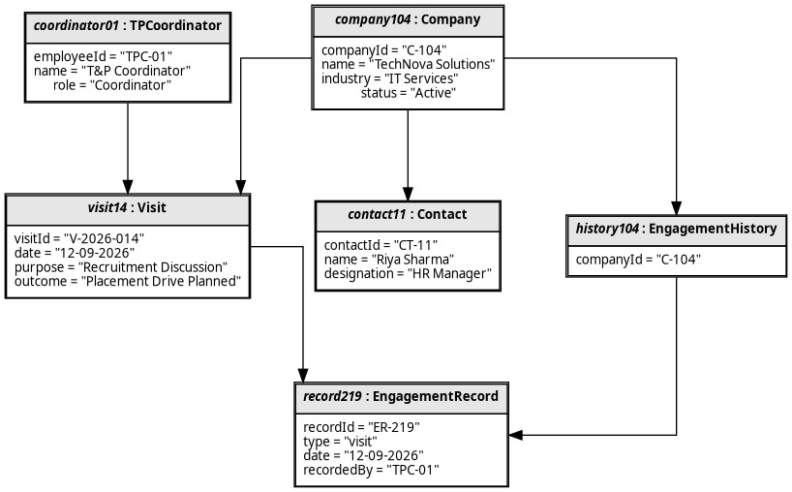
The object instances shown above are all instances of classes identified in Section 38: coordinator01 : TPCoordinator, company104 : Company, contact11 : Contact, visit14 : Visit, history104 : EngagementHistory, and record219 : EngagementRecord. The representative values correspond to a meaningful runtime snapshot rather than additional requirements.

The LNM Institute of Information Technology, Jaipur Software Development Laboratory
Course Code: CS314

Relationships
The relationships below are derived from the requirements, data requirements, business rules and the three detailed Assignment 3 scenarios. Multiplicities express the expected number of related instances; aggregation/composition is used only where the model indicates a meaningful whole-part relationship.

Relationship | Type / Multiplicity | Justification
User — TPCoordinator | Generalization | A coordinator is a role-specific User and inherits authentication/account responsibilities.
User — ApprovingAuthority | Generalization | An approving authority is a role-specific User and must authenticate before UC-009.
Company — Contact | Association: 1 to 0..* | BR-009 requires every contact to be linked to an existing company; a company may have multiple contacts.
Company — Visit | Association: 1 to 0..* | FR-016 to FR-019 record and retrieve visit history for a company.
Company — RecruitmentActivity | Association: 1 to 0..* | FR-020/FR-021 associate a recruitment activity with a company.
Company — EngagementHistory | Association: 1 to 1 | Engagement history is maintained for a company and records its institutional interactions.
EngagementHistory — EngagementRecord | Composition: 1 to 0..* | A history is made up of its engagement records; FR-030 logs a record when a visit occurs.
RecruitmentActivity — Approval | Composition: 1 to 0..* | Approval decisions belong to the recruitment activity and support approval history.
ApprovingAuthority — Approval | Association: 1 to 0..* | BR-010 requires each approval decision to record the approver identity and decision date.
TPCoordinator — Visit | Association: 1 to 0..* | UC-006 explicitly assigns the coordinator to record visits.
TPCoordinator — RecruitmentActivity | Association: 1 to 0..* | UC-008 uses the coordinator to select and submit a recruitment activity.
Service classes → domain classes | Dependency | Services invoke the responsibilities of domain objects for lookup, validation, visit recording, submission, approval and engagement logging.

The LNM Institute of Information Technology, Jaipur Software Development Laboratory
Course Code: CS314

  - UML Class Diagram
The following UML 1.x class diagram consolidates the classes and relationships identified above. Generalization is shown with hollow-triangle arrows, aggregation/composition with diamonds, associations with solid lines and multiplicities, and dependencies with dashed arrows.
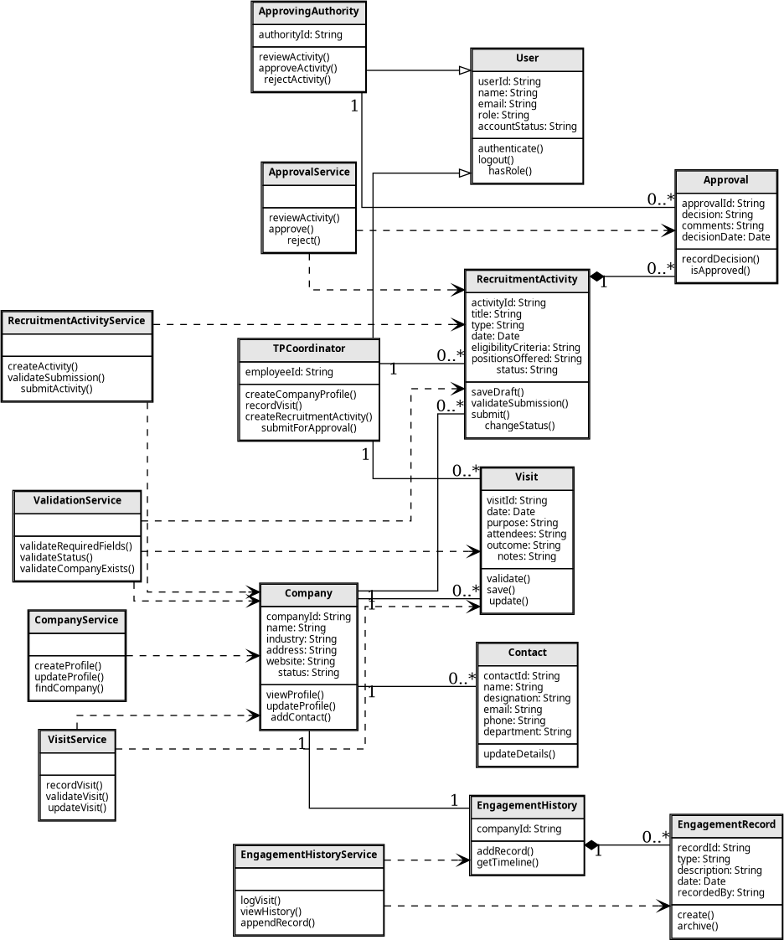

The LNM Institute of Information Technology, Jaipur Software Development Laboratory
Course Code: CS314

Consistency and Traceability
The model maintains the required chain: Assignment 2 Requirements → 3 Use Cases → Assignment 3 Activities → Classes → Objects → Relationships.
  - Use-Case to Class Traceability

Assignment 3 Use Case | Relevant classes | Consistency evidence
UC-006 Record Company Visit | TPCoordinator, Company, Contact, Visit, EngagementHistory, EngagementRecord, VisitService, ValidationService, EngagementHistoryService | The scenario selects an existing company, records visit data, validates it, creates the Visit and updates engagement history. These responsibilities are represented without changing the flow.
UC-008 Submit Recruitment Activity | TPCoordinator, RecruitmentActivity, Company, RecruitmentActivityService, ValidationService | The scenario selects a draft activity, reviews details, validates required information/status, and changes the activity to Submitted.
UC-009 Approve Recruitment Activity | ApprovingAuthority, RecruitmentActivity, Approval, ApprovalService, ValidationService | The scenario opens a submitted activity, reviews it, records the decision and approver/date, and sets the activity to Approved; rejection remains the existing UC-010 alternative.

  - Consistency Checks
- The three detailed use cases remain exactly the Assignment 3 use cases: UC-006, UC-008 and UC-009.
- UC-006 remains aligned with FR-016 to FR-019 and the stated postcondition that a valid visit record is linked to the company's engagement history.
- UC-008 remains aligned with FR-020 to FR-024 and the lifecycle transition Draft → Submitted → Under Review.
- UC-009 remains aligned with FR-025 to FR-027 and BR-010, which requires the approver identity and decision date to be recorded.
- The object diagram contains only instances of classes present in the class model, satisfying the consistency requirement.

The LNM Institute of Information Technology, Jaipur Software Development Laboratory
Course Code: CS314

GitHub Submission Structure
The completed Assignment 4 artifacts should be committed under the following structure specified in the assignment instructions:
docs/uml/assignment-04/
■■■ Classes.md
■■■ Relationships.md
■■■ Object-Model.md
■■■ diagrams/
■■■ Class-Diagram.png
■■■ Object-Diagram.png

Individual Contribution

Team Member | Contribution
Hitesh Jain | Prepared and reviewed class identification and verified that the selected classes remain consistent with the Company Engagement Portal requirements.
Anand Patidar | Prepared and reviewed the UML Class Diagram and checked class relationships and multiplicities.
Pranav Vashisth | Prepared the Object Diagram for UC-006 and verified the requirements-to-use-case-to-class-to-object traceability.
Avesh Khan | Prepared and reviewed the Relationships section and performed final consistency/documentation review.
AI USAGE POLICY – STUDENT DECLARATION
- We have disclosed the use of AI tools, if any.
- AI-generated suggestions have been reviewed, verified and adapted by the team.
- We understand and can explain the submitted classes, object diagram and relationships.
- We have verified that the UML models are consistent with our project's requirements, use cases and scope.
- The final submission represents our team's understanding and modeling decisions.

AI Tool(s) Used: ChatGPT
Purpose of AI Use: AI was used as a supporting tool for drafting class/relationship descriptions, structuring UML model layouts and checking consistency against the Assignment 2 and Assignment 3 material. The team is responsible for reviewing and adapting the final submission.
Team ID: T066
Team Representative: Pranav Vashisth
Date: 19/09/2026

Expected Outcome: The model demonstrates consistency between the requirements, the three detailed
Expected Outcome: The resulting model demonstrates consistency between the requirements, the three
detailed use cases, their Assignment 3 activity models, the identified classes, a concrete object snapshot, and
use cases, Assignment 3 activity models, identified classes, a concrete object snapshot, and class relationships.

The LNM Institute of Information Technology, Jaipur Software Development Laboratory
Course Code: CS314

Objective: Extend the structural models from Assignment 4 by modelling object interactions, object states and major software components. The same three detailed use cases are used throughout this assignment: UC-006 Record Company Visit, UC-008 Submit Recruitment Activity, and UC-009 Approve Recruitment Activity.
42. Collaboration Modelling
The collaboration models extend the three detailed use cases carried forward from Assignment 2 and Assignment 3. The participating objects and their responsibilities are based on the classes and relationships identified in Assignment 4.
42.1 Collaboration Diagram — UC-006 Record Company Visit
Purpose: This diagram represents the interaction between the T&P Coordinator and the objects responsible for selecting a company, validating visit information, creating the visit record, and updating engagement history.
Participating Objects:
- coordinator01 : TPCoordinator
- companyService : CompanyService
- company104 : Company
- visitService : VisitService
- validationService : ValidationService
- visit14 : Visit
- engagementHistoryService : EngagementHistoryService
- history104 : EngagementHistory
- record219 : EngagementRecord
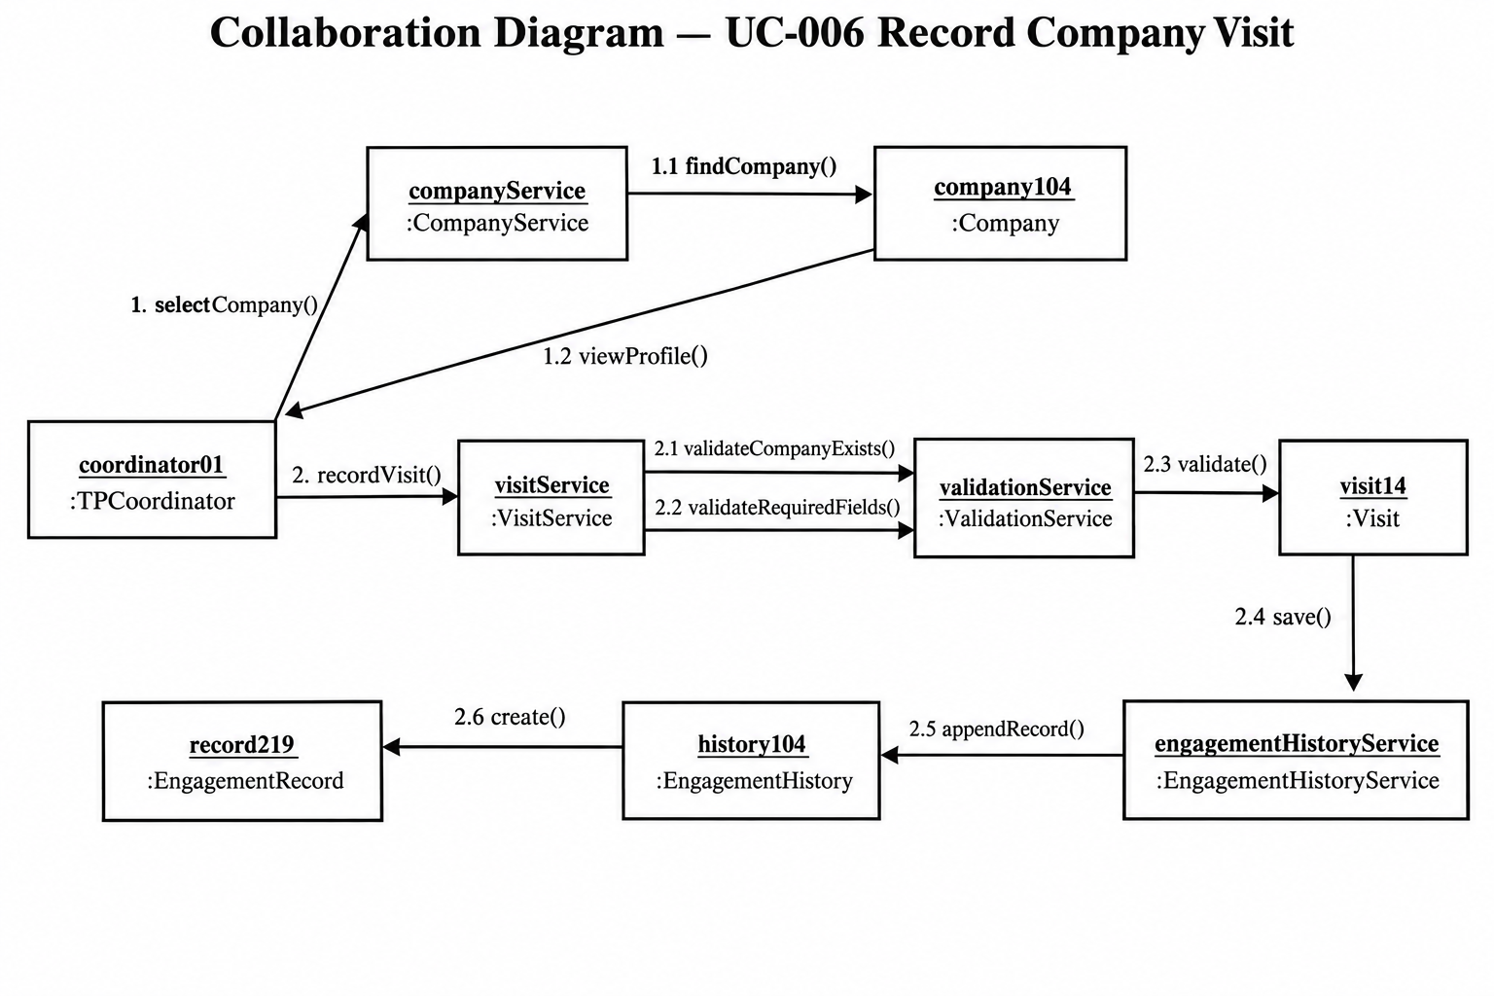
The LNM Institute of Information Technology, Jaipur Software Development Laboratory
Course Code: CS314

Message Sequence
Message | From | To | Message
1 | TPCoordinator | CompanyService | selectCompany(companyId)
1.1 | CompanyService | Company | findCompany(companyId)
1.2 | Company | TPCoordinator | viewProfile()
2 | TPCoordinator | VisitService | recordVisit(visitData)
2.1 | VisitService | ValidationService | validateCompanyExists()
2.2 | VisitService | ValidationService | validateRequiredFields()
2.3 | VisitService | Visit | validate()
2.4 | VisitService | Visit | save()
2.5 | VisitService | EngagementHistoryService | appendRecord()
2.6 | EngagementHistoryService | EngagementHistory | createRecord()

Responsibility: The TPCoordinator initiates the operation. CompanyService handles company lookup, VisitService coordinates the visit recording process, ValidationService performs validation, Visit represents the visit record, and EngagementHistoryService updates the company's engagement history.

42.2 Collaboration Diagram — UC-008 Submit Recruitment Activity
Purpose: This diagram represents how the T&P Coordinator submits an existing recruitment activity draft for approval.
Participating Objects:
- coordinator01 : TPCoordinator
- recruitmentActivityService : RecruitmentActivityService
- activity15 : RecruitmentActivity
- validationService : ValidationService
- company104 : Company

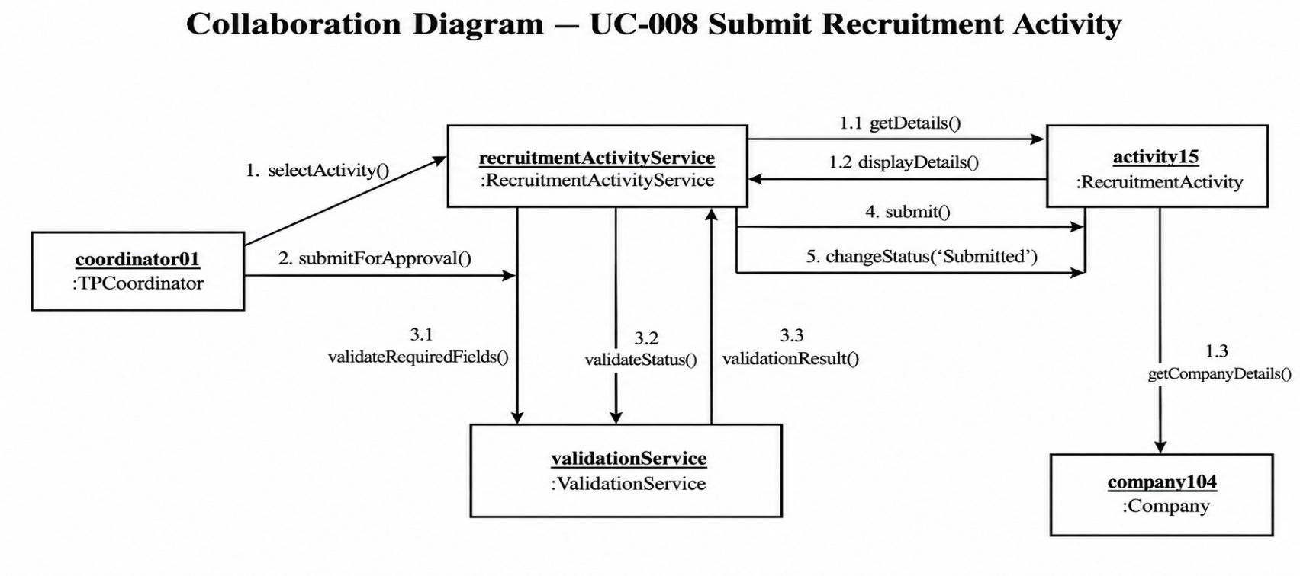

The LNM Institute of Information Technology, Jaipur Software Development Laboratory
Course Code: CS314

Message Sequence
Message | From | To | Message
1 | TPCoordinator | RecruitmentActivityService | selectActivity(activityId)
1.1 | RecruitmentActivityService | RecruitmentActivity | get/display activity()
1.2 | RecruitmentActivity | TPCoordinator | displayDetails()
2 | TPCoordinator | RecruitmentActivity | reviewActivity()
3 | TPCoordinator | RecruitmentActivityService | submitForApproval()
3.1 | RecruitmentActivityService | ValidationService | validateRequiredFields()
3.2 | RecruitmentActivityService | ValidationService | validateStatus()
3.3 | ValidationService | RecruitmentActivityService | validationResult()
4 | RecruitmentActivityService | RecruitmentActivity | submit()
5 | RecruitmentActivityService | RecruitmentActivity | changeStatus('Submitted')
Responsibility: TPCoordinator selects and reviews the recruitment activity. RecruitmentActivityService coordinates submission, ValidationService verifies required information and status, and RecruitmentActivity changes to the Submitted state after successful validation.
42.3 Collaboration Diagram — UC-009 Approve Recruitment Activity
Purpose: This diagram represents the interaction between the Approving Authority and the objects involved in reviewing and approving a submitted recruitment activity.
Participating Objects:
- approver01 : ApprovingAuthority
- approvalService : ApprovalService
- activity15 : RecruitmentActivity
- approval21 : Approval

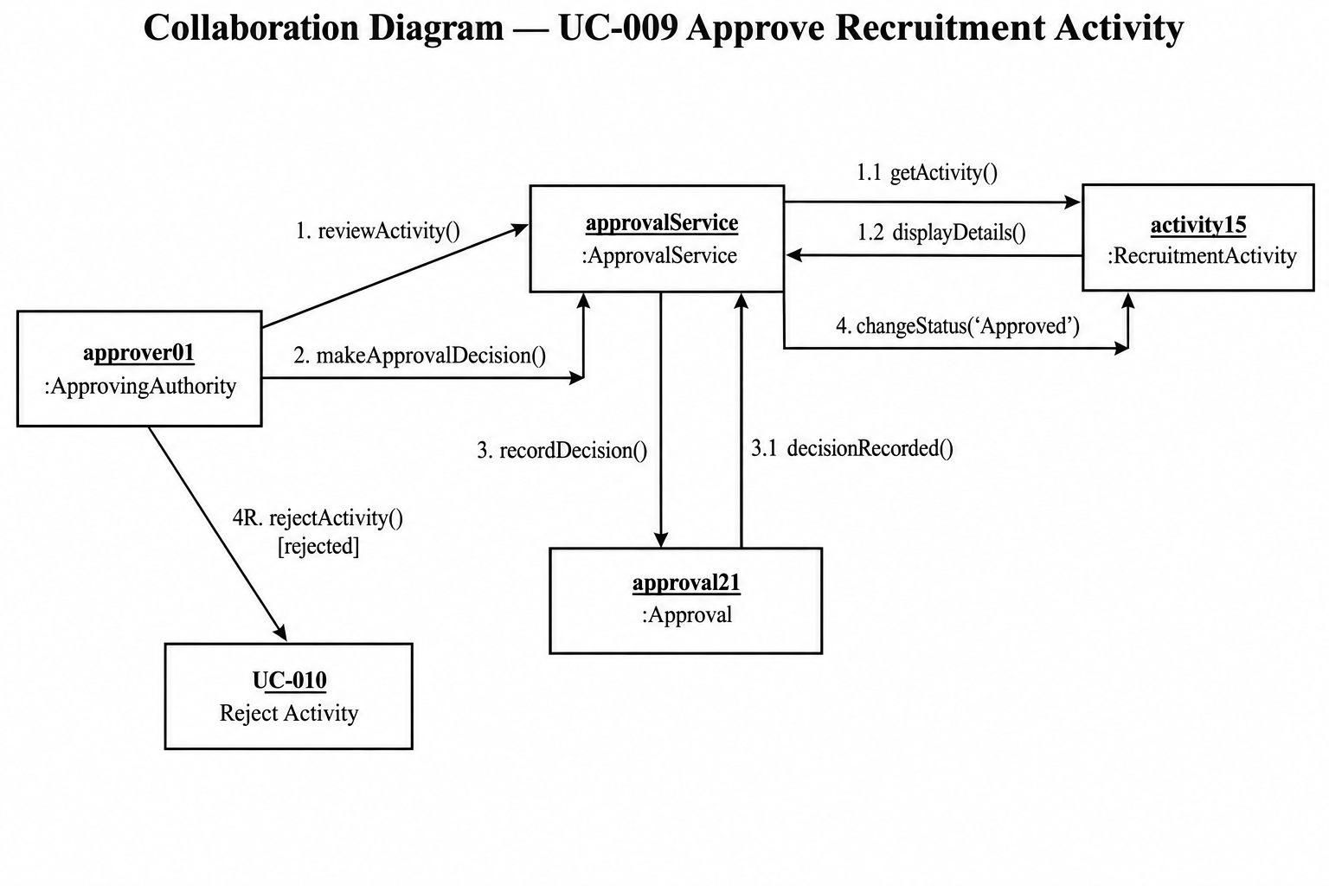

The LNM Institute of Information Technology, Jaipur Software Development Laboratory
Course Code: CS314

Message Sequence
Message | From | To | Message
1 | ApprovingAuthority | ApprovalService | reviewActivity(activityId)
1.1 | ApprovalService | RecruitmentActivity | getActivity()
1.2 | RecruitmentActivity | ApprovingAuthority | displayDetails()
2 | ApprovingAuthority | ApprovalService | makeApprovalDecision()
3 | ApprovalService | Approval | recordDecision()
3.1 | Approval | ApprovalService | recordDecision()
4 | ApprovalService | RecruitmentActivity | changeStatus('Approved')
4R | ApprovalService | UC-010 | rejectActivity()

Responsibility: ApprovingAuthority reviews the submitted activity and makes the approval decision. ApprovalService coordinates the process, while Approval records the decision. If approved, RecruitmentActivity changes to Approved; otherwise the existing UC-010 rejection flow is followed.

43. State Modelling
Two important objects whose states change during the selected use cases are RecruitmentActivity and Visit. The RecruitmentActivity lifecycle follows the lifecycle already established in the requirements and Assignment 2.

43.1 State Diagram — RecruitmentActivity
State | Description
Draft | Recruitment activity is being created or edited.
Submitted | Coordinator has successfully submitted the activity for approval.
Under Review | Activity is being reviewed by the Approving Authority.
Approved | Activity has been approved.
Rejected | Activity has been rejected.
Revision | Rejected activity requires modification.
Resubmission | Revised activity is submitted again.
Scheduled | Approved activity is scheduled.
Ongoing | Recruitment activity is currently being conducted.
Completed | Recruitment activity has finished.
Engagement History | Activity has contributed to the company's engagement history.
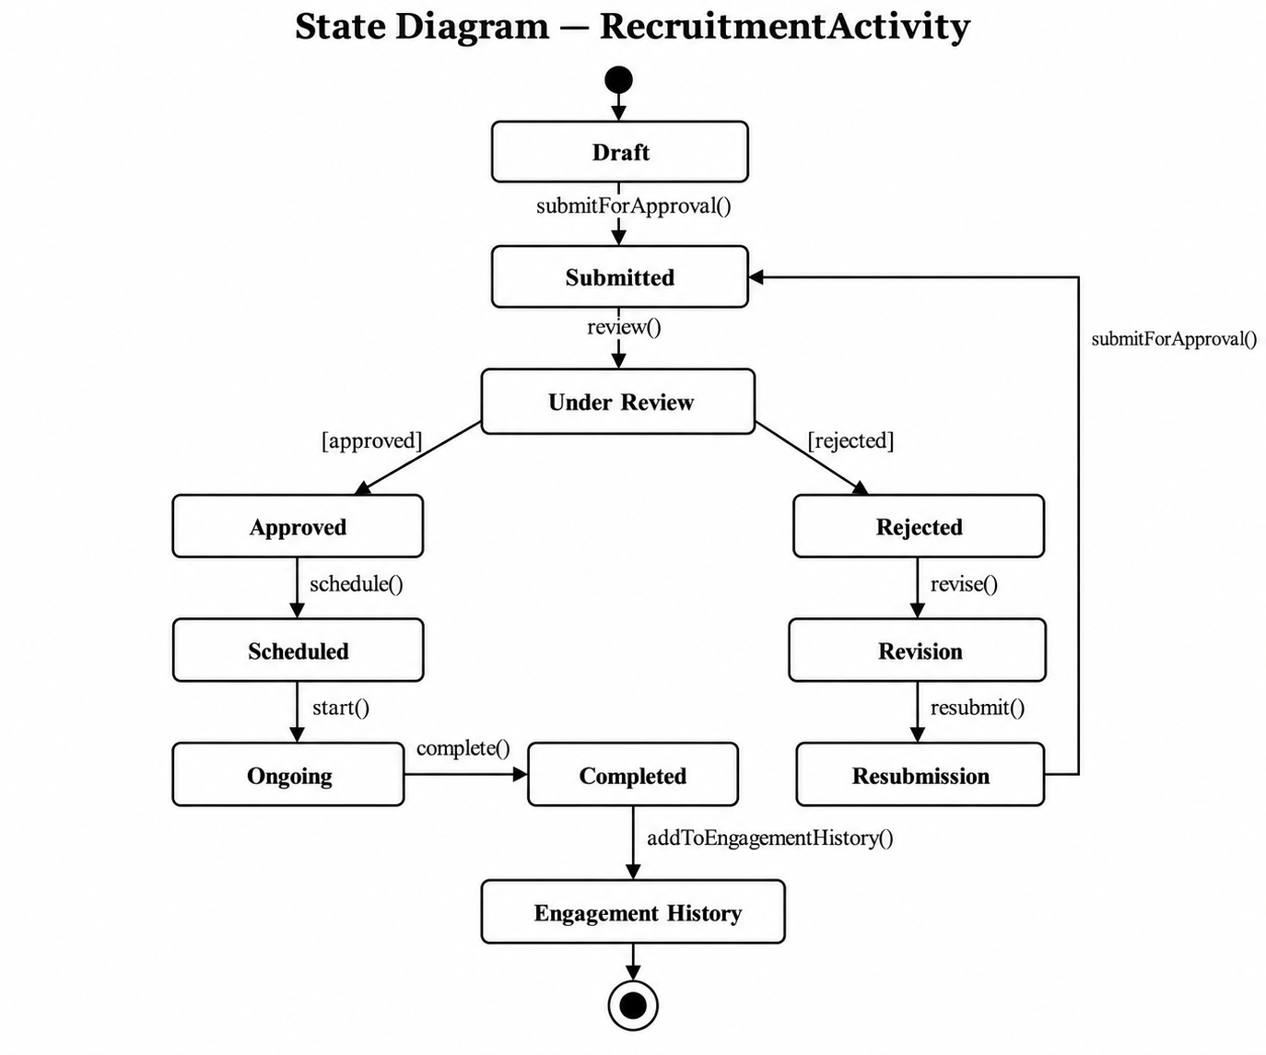
Events and guards: submitForApproval() moves Draft to Submitted; review() moves Submitted to Under Review; [approved] moves to Approved; [rejected] moves to Rejected; revise() moves to Revision; resubmit() returns the activity to the approval process; schedule() moves an approved activity to Scheduled; start() moves it to Ongoing; and complete() moves it to Completed.
43.2 State Diagram — Visit
State | Description
Initial | No visit record exists yet.
Information Entered | Coordinator has entered visit details.
Validating | System validates company and mandatory visit information.
Recorded | Valid visit record has been created.
Validation Error | Entered information is incomplete or invalid.
Engagement Logged | The visit has been added to the company's engagement history.

The LNM Institute of Information Technology, Jaipur Software Development Laboratory
Course Code: CS314

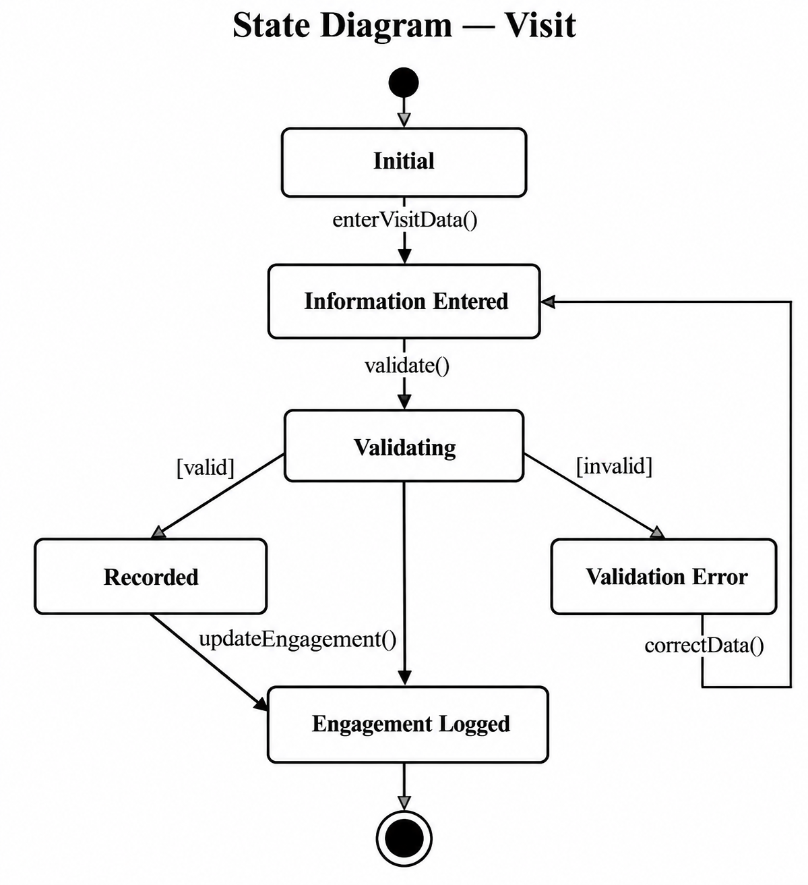
Events and guards: enterVisitData() creates visit information; validate() starts validation; [valid] permits the Recorded state; [invalid] produces a validation error; correctData() allows correction; and updateEngagement() adds the visit to engagement history.
44. Component Modelling
The component model provides the implementation-level structure required to support the same three use cases. It is based on the service responsibilities identified in Assignment 4, including CompanyService, VisitService, RecruitmentActivityService, ApprovalService, EngagementHistoryService and ValidationService.
44.1 Component Diagram
Major components:
- Web User Interface
- Authentication & Access Control
- Company Management
- Visit Management
- Recruitment Activity Management
- Approval Management
- Validation Service
- Engagement History Management
- Company Engagement Database

The LNM Institute of Information Technology, Jaipur Software Development Laboratory
Course Code: CS314

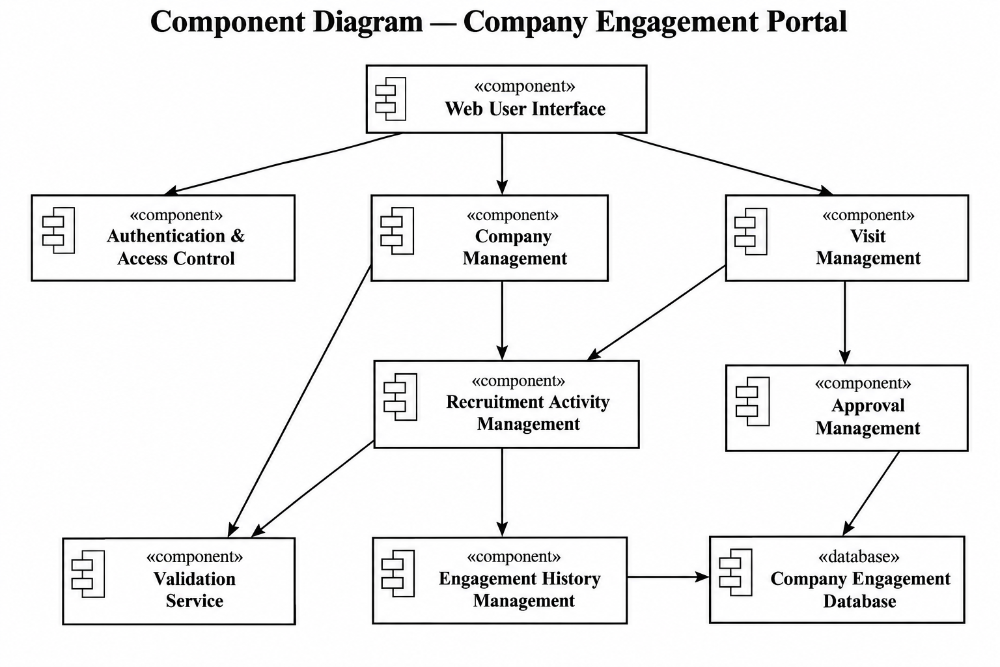

Component Responsibilities
Component | Responsibility
Web User Interface | Provides interfaces through which authorized users interact with the system.
Authentication & Access Control | Authenticates users and applies role-based access.
Company Management | Creates, updates and searches company profiles.
Visit Management | Records and manages company visits.
Recruitment Activity Management | Creates, validates and submits recruitment activities.
Approval Management | Reviews and approves/rejects recruitment activities.
Validation Service | Validates required information, company existence and activity status.
Engagement History Management | Records and retrieves company engagement history.
Company Engagement Database | Stores users, companies, contacts, visits, recruitment activities, approvals and engagement records.
Component Dependencies
Web User Interface depends on Authentication & Access Control, Company Management, Visit Management and Recruitment Activity Management. Company Management, Visit Management and Recruitment Activity Management use the Validation Service where required. Recruitment Activity Management interacts with Approval Management. Visit Management and relevant recruitment workflows interact with Engagement History Management. The management components persist their information in the Company Engagement Database.
45. Consistency and Traceability
The LNM Institute of Information Technology, Jaipur Software Development Laboratory
Course Code: CS314

The Assignment 5 models maintain the following modelling chain:
Requirements → 3 Detailed Use Cases → Scenarios → Activities → Classes → Objects & Relationships → Collaboration → States → Components
45.1 UC-006 — Record Company Visit
The collaboration model uses TPCoordinator, Company, CompanyService, Visit, VisitService, ValidationService, EngagementHistory, EngagementHistoryService and EngagementRecord. The state model represents the transition of a visit from entering information through validation, recording and engagement-history logging. The component model provides the Visit Management, Validation Service and Engagement History Management components required to implement the workflow.
45.2 UC-008 — Submit Recruitment Activity
The collaboration model uses TPCoordinator, RecruitmentActivity, RecruitmentActivityService and ValidationService. The workflow remains consistent with the previously defined process in which the coordinator selects a draft activity, reviews it, validates it and submits it for approval. The RecruitmentActivity state model represents the Draft → Submitted → Under Review progression and subsequent lifecycle.
45.3 UC-009 — Approve Recruitment Activity
The collaboration model uses ApprovingAuthority, ApprovalService, RecruitmentActivity and Approval. The model represents the approval decision and recording of the approver and decision date, followed by the transition of RecruitmentActivity to Approved or the existing rejection flow.
45.4 Overall Consistency
No new functional requirements or use cases are introduced in Assignment 5. The collaboration diagrams explain how existing objects interact, the state diagrams explain how important objects change state, and the component diagram explains how the system can be organized into implementation components.
46. Individual Contribution
Team Member | Contribution
Hitesh Jain | Prepared and reviewed collaboration diagrams for UC-006 and verified consistency with the previous scenarios.
Anand Patidar | Prepared collaboration diagram for UC-008 and reviewed object-message interactions.
Pranav Vashisth | Prepared state diagrams for RecruitmentActivity and Visit and verified lifecycle consistency.
Avesh Khan | Prepared the component diagram and performed overall consistency and documentation review.
47. AI Usage Policy – Student Declaration
- We have disclosed the use of AI tools, if any.
- AI-generated suggestions have been reviewed, verified and adapted by the team.
- We understand and can explain the submitted collaboration diagrams, state diagrams and component diagram.
- We have verified that the UML models are consistent with our project's requirements, use cases, classes, objects and scope.
- The final submission represents our team's understanding and modelling decisions.
Field | Details
AI Tool(s) Used | ChatGPT
Purpose of AI Use | AI was used as a supporting tool for structuring collaboration diagrams, state transition descriptions, component relationships and checking consistency with the UML models developed in previous assignments.
Team ID | T066
Team Representative | Pranav Vashisth
Date | 27/09/2026

The LNM Institute of Information Technology, Jaipur
Software Development Laboratory
Course Code: CS314
Lab Assignment 6: Solution
Software Design Modelling — Data/Class Design and Architectural Design
Project: Company Engagement Portal Team ID: T066
Team Members: Hitesh Jain, Anand Patidar, Pranav Vashisth, Avesh Khan
Purpose: This assignment transforms the analysis models of Assignments 4 and 5 into a design model for the Company Engagement Portal. The same three detailed use cases are used throughout: UC-006 Record Company Visit, UC-008 Submit Recruitment Activity and UC-009 Approve Recruitment Activity. No new functionality beyond the SRS (v1.0) is introduced.
1. Data/Class Design
1.1 Refinements made over the Assignment 4 analysis model
Analysis model (Assignment 4) | Design model (this assignment) | Reason
Attributes had names only | Every attribute has a data type and visibility (all private, "-") | Needed for implementation
Operations had names only | Operations have parameters, return types and visibility ("+") | Needed to code the interfaces
Status was a plain attribute | Enumerations: UserRole, ActivityStatus, Decision, VisitState, EngagementType, CompanyStatus, AccountStatus | Prevents invalid values; matches the lifecycle in SRS and Assignment 5 state diagram
Services had no data access | Repository<T> interface + concrete repositories added; services depend on repositories | Separates business logic from database access
Services directly shown as dependencies only | Services hold a private reference to their repository; ValidationService returns a ValidationResult | Testable, loosely coupled design
Approval history and archive not explicit | Approval.decisionDate / approver recorded (BR-010); EngagementRecord.archived flag (BR-008) | Business rules enforced in the data design
Role classes only | User made abstract; TPCoordinator and ApprovingAuthority concrete subclasses | Role-specific behaviour, shared login logic

1.2 Design Class Diagram
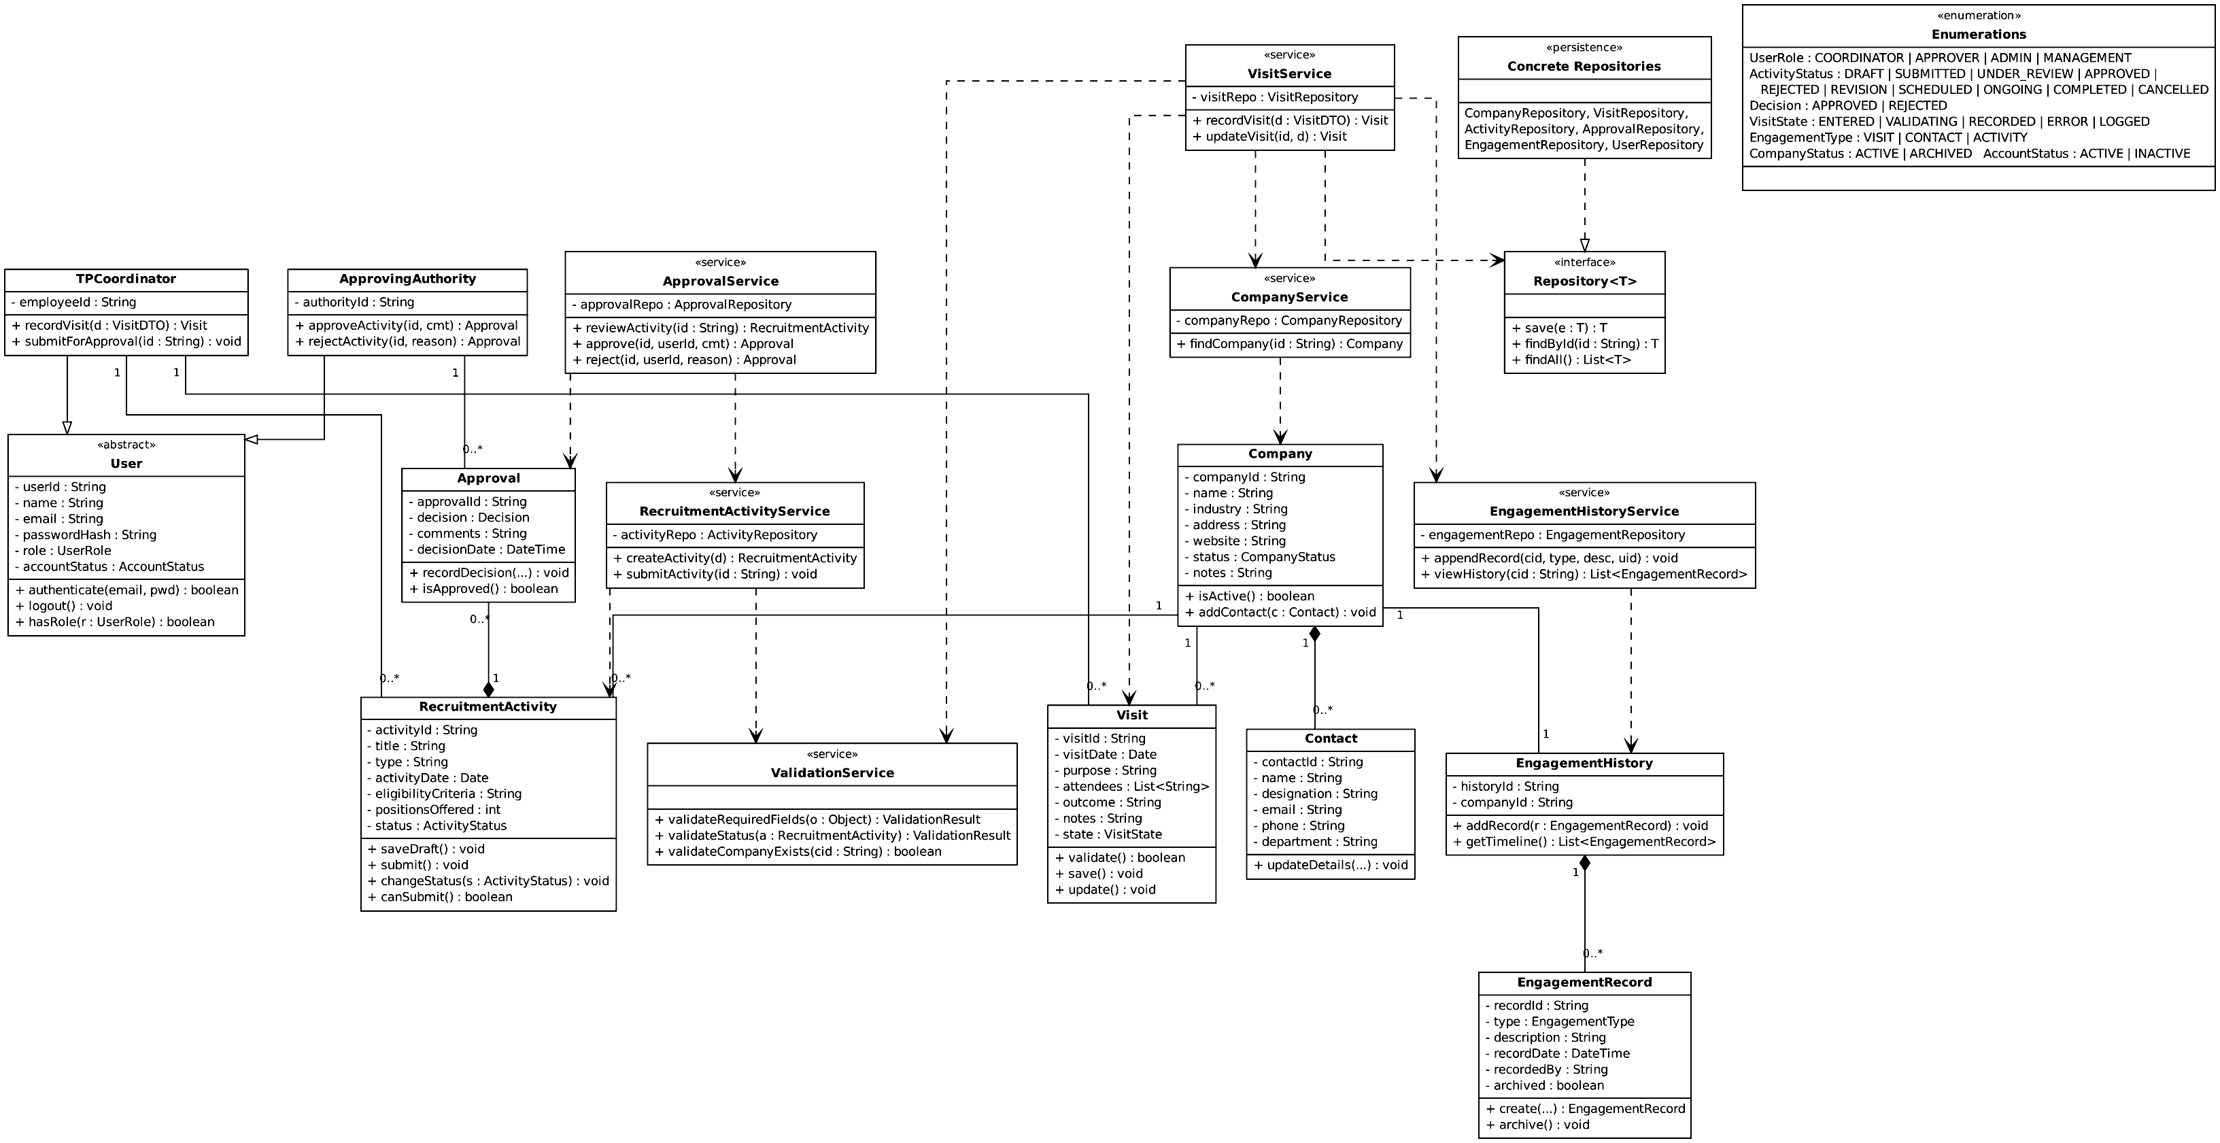
Figure 1: Design Class Diagram (Design-Class-Diagram.png). Domain classes, «service» classes, «persistence» classes and enumerations are marked by stereotypes. "-" private, "+" public.
1.3 Relationships (design level)
Relationship | Type | Multiplicity | Note
TPCoordinator, ApprovingAuthority → User | Generalization | — | Inherit authenticate(), logout(), hasRole()
Company — Contact | Composition | 1 : 0..* | Contact cannot exist without Company (BR-009)
Company — Visit | Association | 1 : 0..* | FR-016 to FR-019
Company — RecruitmentActivity | Association | 1 : 0..* | FR-020, FR-021
Company — EngagementHistory | Association | 1 : 1 | One timeline per company
EngagementHistory — EngagementRecord | Composition | 1 : 0..* | Records are archived, never deleted (BR-008)
RecruitmentActivity — Approval | Composition | 1 : 0..* | Approval history (BR-010)
ApprovingAuthority — Approval | Association | 1 : 0..* | Records who decided
TPCoordinator — Visit / RecruitmentActivity | Association | 1 : 0..* | Who recorded / created
Service → Domain class | Dependency | — | Services create and update domain objects
VisitService → CompanyService, ValidationService, EngagementHistoryService | Dependency | — | Collaboration from Assignment 5
Concrete repositories → Repository<T> | Realization | — | Data access abstraction

1.3a Visibility and data structures
- Attributes are private (-); operations used by other classes are public (+). Internal helper methods are private.
- Attendees in Visit is a List<String> (stored in a separate VisitAttendee table, one row per attendee).
- EngagementHistory.getTimeline() returns a List<EngagementRecord> sorted by recordDate descending (FR-032).
- ValidationResult is a small value object: isValid : boolean, errors : List<String>.
1.4 Persistent data (database tables)
Table | Columns (PK = primary key, FK = foreign key) | Source class
users | user_id PK, name, email (unique), password_hash, role, account_status | User
companies | company_id PK, name (unique, BR-004), industry, address, website, status, notes | Company
contacts | contact_id PK, company_id FK, name, designation, email, phone, department | Contact
visits | visit_id PK, company_id FK, recorded_by FK(users), visit_date, purpose, outcome, notes | Visit
visit_attendees | visit_id FK, attendee_name | Visit.attendees
recruitment_activities | activity_id PK, company_id FK, created_by FK(users), title, type, activity_date, eligibility_criteria, positions_offered, status | RecruitmentActivity
approvals | approval_id PK, activity_id FK, approver_id FK(users), decision, comments, decision_date | Approval
engagement_records | record_id PK, company_id FK, type, description, record_date, recorded_by FK(users), archived | EngagementHistory / EngagementRecord

1.5 Responsibilities of important classes
Class | Responsibility
User | Holds account data; authenticates user and checks role (FR-001 to FR-005).
TPCoordinator | Initiates company, visit and recruitment activity actions (UC-006, UC-008).
ApprovingAuthority | Reviews and decides on submitted activities (UC-009).
Company / Contact | Stores company profile and contact data; knows if profile is active.
Visit | Holds visit data and its own state; validates itself and saves.
RecruitmentActivity | Holds activity data and status; knows whether it can be submitted; changes status along the lifecycle.
Approval | Stores decision, comments, approver and decision date.
EngagementHistory / EngagementRecord | Keeps chronological history of visits, contact updates and activities.
VisitService | Coordinates UC-006: lookup, validate, save visit, log engagement.
RecruitmentActivityService | Coordinates UC-008: validate and submit activity.
ApprovalService | Coordinates UC-009: review, approve/reject, record decision.
ValidationService | Central validation of required fields, status and company existence.
EngagementHistoryService | Appends and reads engagement records.
Repositories | CRUD operations on the database; no business logic.

2. Architectural Design
2.1 Architectural style
Selected style: Layered (N-tier) architecture, combined with a client-server model (web browser = client, server application + database = server) and object-oriented design inside the layers.
2.2 Justification
- The system is a web application with a centralized database (SRS assumptions) — this fits client-server and layered styles directly.
- NFR-014 requires modular architecture and NFR-017 requires scalability; layers can be changed or scaled independently.
- The Assignment 4/5 classes already separate domain, service and data responsibilities, so they map naturally onto layers.
- Security (NFR-004 to NFR-006) is easy to enforce at one controller/security layer instead of on every screen.
- Easy for a small student team to divide work and test layer by layer.
2.3 Architectural diagram
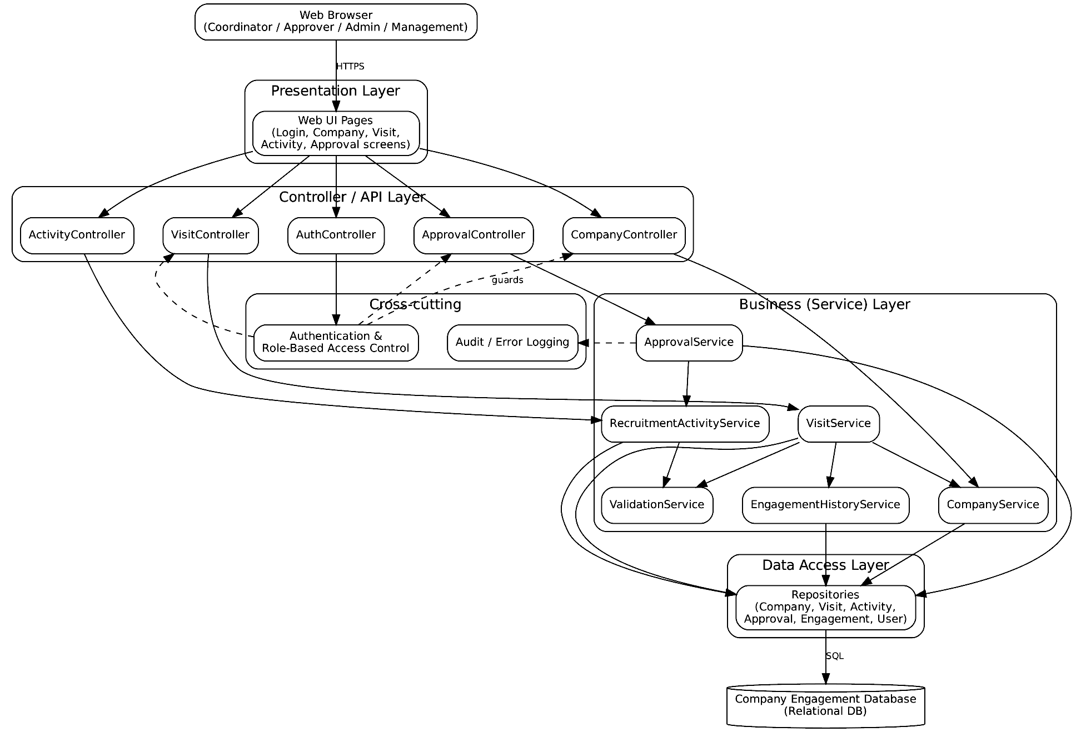
Figure 2: Layered architecture of the Company Engagement Portal (Architectural-Diagram.png).
2.4 Subsystems and responsibilities
Layer / Subsystem | Responsibility | Depends on
Presentation Layer (Web UI) | Screens, forms, validation messages, navigation | Controller layer
Controller / API Layer | Receives requests, checks access, calls services, returns results | Business layer, Security
Business (Service) Layer | Use-case logic: company, visit, activity, approval, validation, engagement history | Data Access layer
Data Access Layer | Repositories that read/write database records | Database
Company Engagement Database | Persistent storage of all entities (Section 1.4) | —
Authentication & Access Control (cross-cutting) | Login, session handling, role-based access (BR-001, BR-005, BR-006) | User data
Audit / Error Logging (cross-cutting) | Logs administrative and approval actions (NFR-007, NFR-020) | Database / log file

2.4a Communication rules
- Calls go downward only: UI → Controller → Service → Repository → Database. A lower layer never calls a higher layer.
- Services may call other services (VisitService → ValidationService, CompanyService, EngagementHistoryService).
- Browser and UI communicate over HTTPS; repositories communicate with the database using SQL.
2.5 External systems
Only the end-user web browser and the relational database are external to the application. As per SRS (Initially Out of Scope and Future Requirements), no integration with external hiring systems, institutional authentication, ERP or payment services is part of this version, so none is shown.
2.6 Support for the three use cases
Use case | Presentation | Controller | Service | Data
UC-006 Record Company Visit | S2 Company Details, S3 Record Visit | CompanyController, VisitController | CompanyService, VisitService, ValidationService, EngagementHistoryService | companies, visits, visit_attendees, engagement_records
UC-008 Submit Recruitment Activity | S4 Activity Details | ActivityController | RecruitmentActivityService, ValidationService | recruitment_activities
UC-009 Approve Recruitment Activity | S5 Approval Review | ApprovalController | ApprovalService, RecruitmentActivityService | approvals, recruitment_activities

Individual Contribution
Team Member | Contribution
Hitesh Jain | Prepared Data/Class Design tables and refined attributes and operations.
Anand Patidar | Prepared the Design Class Diagram and relationship table.
Pranav Vashisth | Prepared the Architectural Design and justification.
Avesh Khan | Prepared persistent data design, consistency review and documentation.

The LNM Institute of Information Technology, Jaipur
Software Development Laboratory
Course Code: CS314
Lab Assignment 7: Solution
Software Design Modelling — Interface, Component-Level Design and Traceability
Project: Company Engagement Portal Team ID: T066
Team Members: Hitesh Jain, Anand Patidar, Pranav Vashisth, Avesh Khan
3. Interface Design
3.1 User Interface Design
The project is a web application, so the user interacts through browser screens. Screens needed for the three use cases:
ID | Screen | Used in | Main inputs / outputs | Wireframe
S1 | Login | All (precondition) | Email, password, Login button; error message | UI-Wireframe-01.png
S2 | Company Details | UC-006 | Company data, Record Visit button, recent engagement | UI-Wireframe-02.png
S3 | Record Visit | UC-006 | Date, purpose, attendees, outcome, notes; Save / Cancel | UI-Wireframe-03.png
S4 | Recruitment Activity Details | UC-008 | Activity data, status, Save Draft / Submit for Approval | UI-Wireframe-04.png
S5 | Approval Review | UC-009 | Activity data, comments, Approve / Reject | UI-Wireframe-05.png

Navigation flow
S1 Login --(success)--> Dashboard
Coordinator: Dashboard -> Company Search -> S2 Company Details -> S3 Record Visit -> (saved) -> S2
Coordinator: Dashboard -> Activities -> S4 Activity Details -> (submitted) -> Activities list
Approver: Dashboard -> Review Queue -> S5 Approval Review -> (decision saved) -> Review Queue
Wireframes
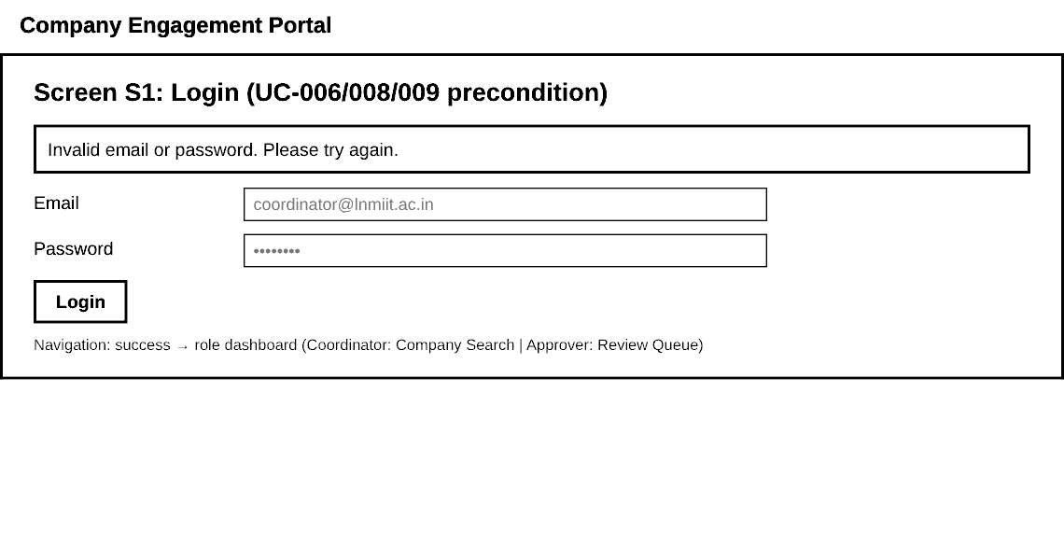
Figure 3: UI-Wireframe-01.png — S1 Login with authentication-failure message (FR-002).
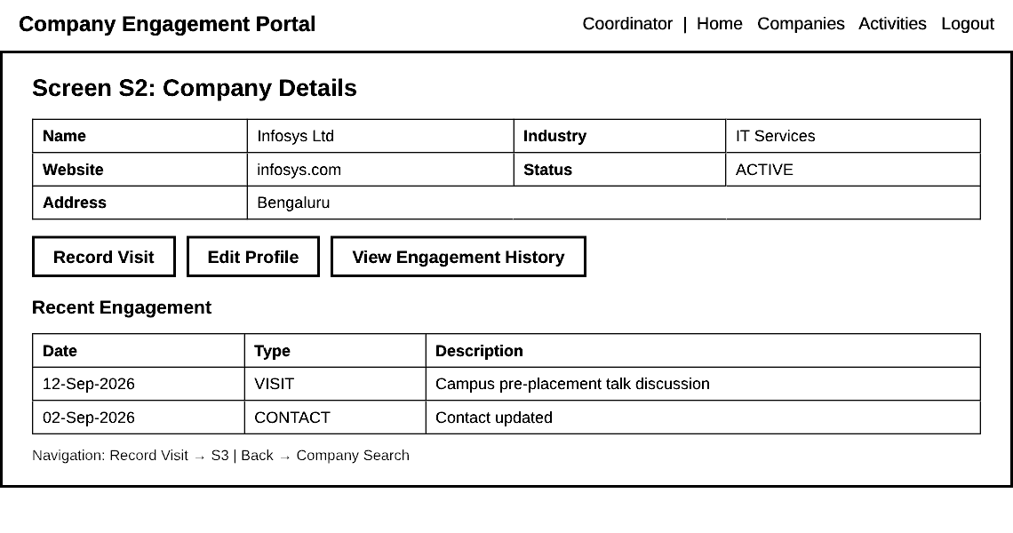
Figure 4: UI-Wireframe-02.png — S2 Company Details — start of UC-006.
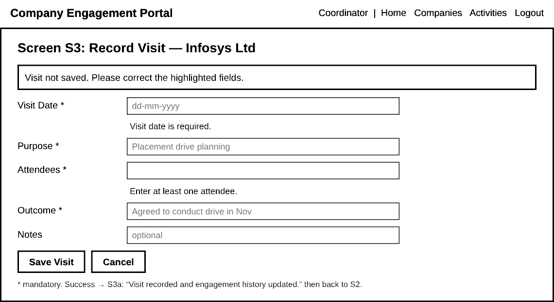
Figure 5: UI-Wireframe-03.png — S3 Record Visit showing validation errors for missing mandatory fields.
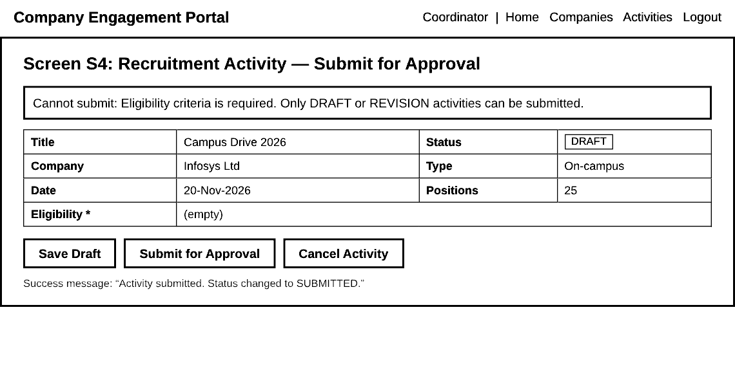
Figure 6: UI-Wireframe-04.png — S4 Recruitment Activity — submit blocked because eligibility is missing.
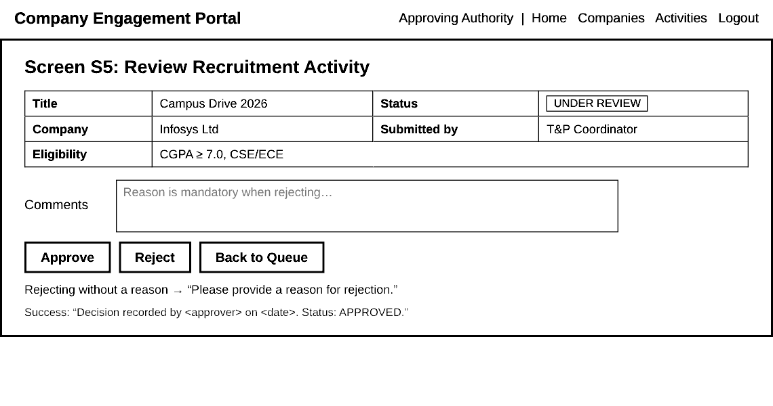
Figure 7: UI-Wireframe-05.png — S5 Approval Review — approve/reject with comments.
Validation and error messages
Screen | Condition | Message shown
S1 | Wrong email/password | Invalid email or password. Please try again. (no detail about which one is wrong)
S1 | Inactive account | Your account is not active. Contact the administrator.
S2 | Company not found (UC-006 alt. flow) | Company profile does not exist. Please create the profile first.
S3 | Visit date empty | Visit date is required.
S3 | Attendees / purpose / outcome empty | <Field> is required.
S3 | Visit date invalid format | Enter date as dd-mm-yyyy.
S3 | Saved successfully | Visit recorded and engagement history updated.
S4 | Required field missing | Cannot submit: <field> is required.
S4 | Status is not DRAFT/REVISION | Only DRAFT or REVISION activities can be submitted.
S4 | Submitted successfully | Activity submitted. Status changed to SUBMITTED.
S5 | Reject without reason | Please provide a reason for rejection.
S5 | Activity not in reviewable state | This activity is not available for review.
All | No permission for role | You are not authorized to perform this action.

3.2 Software Interface Design
Each major component exposes one interface. Errors are returned as an error code with a message (ValidationException, NotFoundException, UnauthorizedException, InvalidStateException).
Interface | Operation | Input | Output | Error responses
IAuthService | login(email, password) | email, password | Session token + role | AUTH_FAILED, ACCOUNT_INACTIVE
IAuthService | checkAccess(token, action) | token, action name | boolean | UNAUTHORIZED
ICompanyService | findCompany(companyId) | companyId | Company | NOT_FOUND
IVisitService | recordVisit(VisitDTO) | companyId, date, purpose, attendees, outcome, notes, userId | Visit (state RECORDED) | NOT_FOUND (company), VALIDATION_ERROR (list of fields)
IVisitService | updateVisit(visitId, VisitDTO) | visitId, new data | Visit | NOT_FOUND, VALIDATION_ERROR
IRecruitmentService | createActivity(ActivityDTO) | company, title, type, date, eligibility, positions | Activity (DRAFT) | VALIDATION_ERROR
IRecruitmentService | submitActivity(activityId, userId) | activityId, userId | Activity (SUBMITTED) | NOT_FOUND, VALIDATION_ERROR, INVALID_STATE
IRecruitmentService | changeStatus(activityId, status) | activityId, new status | Activity | INVALID_STATE
IApprovalService | reviewActivity(activityId) | activityId | Activity (UNDER_REVIEW) | NOT_FOUND, INVALID_STATE
IApprovalService | approve(activityId, approverId, comments) | ids, comments | Approval + status APPROVED | UNAUTHORIZED, INVALID_STATE
IApprovalService | reject(activityId, approverId, reason) | ids, reason | Approval + status REJECTED | VALIDATION_ERROR (reason empty), INVALID_STATE
IValidationService | validateRequiredFields(object) | DTO | ValidationResult | —
IValidationService | validateStatus(activity) | activity | ValidationResult | —
IValidationService | validateCompanyExists(companyId) | companyId | boolean | —
IEngagementService | appendRecord(companyId, type, description, userId) | values | EngagementRecord | NOT_FOUND
IEngagementService | viewHistory(companyId) | companyId | List<EngagementRecord> (chronological) | NOT_FOUND
IRepository<T> | save / findById / findAll | entity or id | entity / list | DB_ERROR

How the interfaces support the workflows
- UC-006: UI → IVisitService.recordVisit → ICompanyService.findCompany, IValidationService, IRepository.save, IEngagementService.appendRecord.
- UC-008: UI → IRecruitmentService.submitActivity → IValidationService → IRepository.save.
- UC-009: UI → IApprovalService.approve → IRecruitmentService.changeStatus, IRepository.save (Approval).
4. Component-Level Design
4.1 Refined component diagram
The Assignment 5 component diagram is refined by showing the provided interfaces and by connecting Approval Management to Recruitment Activity Management and Engagement History Management through interfaces.
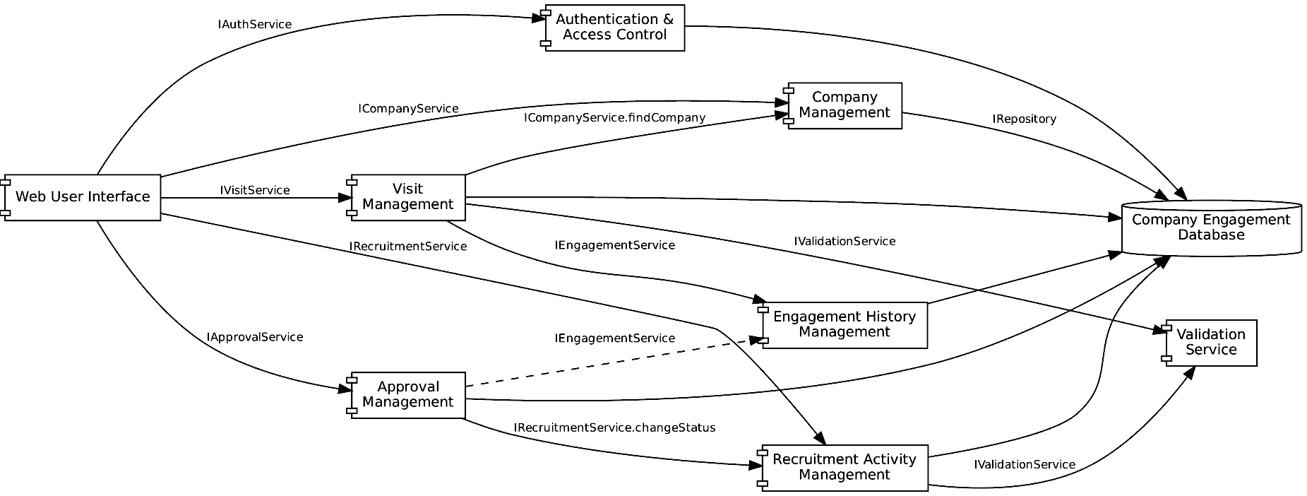
Figure 8: Refined Component Diagram (Component-Design-Diagram.png).
4.2 Components, responsibilities and class mapping
Component | Responsibility | Classes / operations (from design class model)
Web User Interface | Screens S1–S5, shows messages | —
Authentication & Access Control | Login, role check | User.authenticate(), hasRole(), logout()
Company Management | Find/view company | CompanyService.findCompany(); Company, Contact
Visit Management | Record and update visits | VisitService.recordVisit(), updateVisit(); Visit.validate(), save()
Recruitment Activity Management | Create, validate, submit activities | RecruitmentActivityService.submitActivity(); RecruitmentActivity.canSubmit(), submit(), changeStatus()
Approval Management | Review, approve/reject | ApprovalService.reviewActivity(), approve(), reject(); Approval.recordDecision()
Validation Service | Rule checks | ValidationService.validateRequiredFields(), validateStatus(), validateCompanyExists()
Engagement History Management | Log and read history | EngagementHistoryService.appendRecord(); EngagementHistory.addRecord(); EngagementRecord.create()
Company Engagement Database | Storage | Repositories; tables in Section 1.4

4.3 Component specification — UC-006: VisitService.recordVisit()
Item | Details
Component | Visit Management
Input | companyId, visitDate, purpose, attendees, outcome, notes, userId
Output | Visit (state RECORDED) or error
Pre-condition | User is authenticated as Coordinator
Post-condition | Visit saved and linked to company; EngagementRecord of type VISIT added (FR-030)
Uses | CompanyService, ValidationService, VisitRepository, EngagementHistoryService

FUNCTION recordVisit(data, userId)
IF NOT validationService.validateCompanyExists(data.companyId) THEN
THROW NotFoundException("Company profile does not exist. Please create the profile first.")
result = validationService.validateRequiredFields(data) // date, purpose, attendees, outcome
IF result.isValid = false THEN
visit.state = ERROR
THROW ValidationException(result.errors) // shown on S3
visit = NEW Visit(data) // state = ENTERED
visit.state = VALIDATING
IF visit.validate() = false THEN THROW ValidationException
BEGIN TRANSACTION
visit.state = RECORDED
visitRepo.save(visit)
engagementHistoryService.appendRecord(data.companyId, VISIT, data.purpose, userId)
visit.state = LOGGED
COMMIT
ON ERROR in transaction: ROLLBACK, log error, THROW "Visit could not be saved. Please try again."
RETURN visit
Decisions and exceptions: company missing → NotFoundException; mandatory field missing → ValidationException; database failure → rollback so a visit is never saved without its engagement record (NFR-012).
4.4 Component specification — UC-008: RecruitmentActivityService.submitActivity()
Item | Details
Component | Recruitment Activity Management
Input | activityId, userId
Output | RecruitmentActivity with status SUBMITTED or error
Pre-condition | Coordinator authenticated; activity exists in DRAFT (or REVISION) status
Post-condition | Status = SUBMITTED, available to approver (FR-024)
Uses | ValidationService, ActivityRepository

FUNCTION submitActivity(activityId, userId)
activity = activityRepo.findById(activityId)
IF activity = NULL THEN THROW NotFoundException
IF activity.createdBy != userId THEN THROW UnauthorizedException
r1 = validationService.validateRequiredFields(activity) // title, company, type, date,
// eligibility, positions
r2 = validationService.validateStatus(activity) // must be DRAFT or REVISION
IF r1.isValid = false OR r2.isValid = false THEN
THROW ValidationException(r1.errors + r2.errors) // shown on S4
IF activity.status = CANCELLED THEN THROW InvalidStateException // BR-007
activity.submit() // sets status = SUBMITTED
activityRepo.save(activity)
RETURN activity
Decisions and exceptions: missing field → "Cannot submit: <field> is required."; wrong status → "Only DRAFT or REVISION activities can be submitted."; cancelled activity cannot be edited or submitted (BR-007).
4.5 Component specification — UC-009: ApprovalService.approve()
Item | Details
Component | Approval Management
Input | activityId, approverId, comments
Output | Approval record; activity status APPROVED
Pre-condition | User is authenticated as Approving Authority; activity is SUBMITTED / UNDER_REVIEW
Post-condition | Approval stored with approver identity and decision date (BR-010); status = APPROVED (FR-025)
Uses | RecruitmentActivityService, ApprovalRepository, EngagementHistoryService

FUNCTION approve(activityId, approverId, comments)
IF NOT user(approverId).hasRole(APPROVER) THEN THROW UnauthorizedException
activity = activityRepo.findById(activityId)
IF activity = NULL THEN THROW NotFoundException
IF activity.status NOT IN (SUBMITTED, UNDER_REVIEW) THEN
THROW InvalidStateException("This activity is not available for review.")
IF activity.status = SUBMITTED THEN activity.changeStatus(UNDER_REVIEW)
BEGIN TRANSACTION
approval = NEW Approval(activityId, approverId, APPROVED, comments, NOW())
approvalRepo.save(approval) // approver + decision date stored
activity.changeStatus(APPROVED)
activityRepo.save(activity)
engagementHistoryService.appendRecord(activity.companyId, ACTIVITY, "Activity approved", approverId)
COMMIT
RETURN approval
FUNCTION reject(activityId, approverId, reason) // alternative flow UC-010
IF reason is empty THEN THROW ValidationException("Please provide a reason for rejection.")
... same steps with decision = REJECTED and status = REJECTED
Decisions and exceptions: not an approver → UnauthorizedException; activity in another state → InvalidStateException; database failure → rollback so status and approval record stay consistent.
4.6 Component dependencies
Component | Depends on (interface used)
Web User Interface | Auth, Company, Visit, Recruitment, Approval interfaces
Visit Management | ICompanyService, IValidationService, IEngagementService, IRepository
Recruitment Activity Management | IValidationService, IRepository
Approval Management | IRecruitmentService, IEngagementService, IRepository
Engagement History Management | IRepository
Validation Service | None (pure rule checks)

5. Design Consistency and Traceability
5.1 Traceability chain
SRS → Use Cases → Scenarios and Activity Diagrams → Analysis Classes and Relationships → Collaboration and State Models → Design Class Model → Architectural Design → Interface Design → Component-Level Design
Use case | SRS (FR / BR) | Assignment 3 activity | Assignment 4 classes | Assignment 5 collaboration / state | Design class model | Architecture | Interface | Component spec
UC-006 | FR-016–019, FR-030, BR-005, BR-009 | Activity UC-006 | TPCoordinator, Company, Visit, EngagementHistory, EngagementRecord | Collab 42.1; Visit state | VisitService, Visit, ValidationService | Visit/Company controllers + services | S2, S3; IVisitService | 4.3 recordVisit()
UC-008 | FR-020–024, BR-007 | Activity UC-008 | TPCoordinator, RecruitmentActivity | Collab 42.2; Activity state | RecruitmentActivityService, RecruitmentActivity | ActivityController + service | S4; IRecruitmentService | 4.4 submitActivity()
UC-009 | FR-025–027, BR-002, BR-010 | Activity UC-009 | ApprovingAuthority, Approval, RecruitmentActivity | Collab 42.3; Activity state | ApprovalService, Approval | ApprovalController + service | S5; IApprovalService | 4.5 approve()

5.2 Consistency checks
- The three use cases are exactly UC-006, UC-008 and UC-009 from Assignments 2–5.
- All design classes come from Assignment 4 classes; new elements (enumerations, repositories, DTOs, ValidationResult) are implementation details, not new functionality.
- Business rules are enforced: BR-002/BR-003 (approval before publish), BR-007 (cancelled not editable), BR-008 (archive only), BR-009 (contact linked to company), BR-010 (approver and date recorded).
- The status values in ActivityStatus match the lifecycle in the SRS and the Assignment 5 state diagram.
- Every interface operation is used by at least one screen or one component specification.
- The refined component diagram uses the same nine components as Assignment 5, with interfaces added.
GitHub Submission Structure
docs/design/assignment-06/
Data-Class-Design.md
Architectural-Design.md
Interface-Design.md
Component-Level-Design.md
Design-Traceability.md
diagrams/
Design-Class-Diagram.png
Architectural-Diagram.png
Component-Design-Diagram.png
interfaces/UI-Wireframe-01.png ... UI-Wireframe-05.png
Individual Contribution
Team Member | Contribution
Hitesh Jain | Prepared Interface Design (wireframes and validation messages).
Anand Patidar | Prepared Software Interface specification.
Pranav Vashisth | Prepared Component-Level Design for UC-006 and UC-008.
Avesh Khan | Prepared Component-Level Design for UC-009, traceability matrix and final review.

AI Usage Policy – Student Declaration
- We have disclosed the use of AI tools, if any.
- AI-generated suggestions have been reviewed, verified and adapted by the team.
- We understand and can explain the submitted design models.
- We have verified that the designs are consistent with our project requirements, use cases and scope.
- The final submission represents our team's understanding and design decisions.
Field | Details
AI Tool(s) Used | Claude and ChatGPT
Purpose of AI Use | AI was used as a supporting tool for drafting design content and diagrams, checked against Assignments 1–5.
Team ID | T066
Team Representative | Pranav Vashisth
Date | 22/10/2026

