Lab2: Body Fat Prediction Dataset
For this lab, we use the Body Fat Prediction dataset, which contains anthropometric measurements collected from subjects (e.g., age, weight, height, and several body circumferences). The objective is to build a regression model that can predict BodyFat (%), because body fat percentage is not always directly measurable in typical settings without specialized equipment.
The dataset also includes a Density attribute. However, Density is strongly related to body fat percentage because it is typically connected through established formulas, meaning it can behave like a “shortcut” feature that makes the prediction task unrealistically easy. In our use case, we assume that Density is not available (e.g., we do not have the appropriate sensor or measurement process in our lab). Therefore, in this lab we intentionally remove the Density column and focus on predicting BodyFat (%) using only the measurements we can realistically obtain.
Dataset Description
The BodyFat dataset contains 252 adult male subjects. Each row is one subject. The goal is to predict BodyFat (%) from body measurements.
Target Variable
BodyFat: Body fat percentage (%) — this is the target to be predicted.
Features:
Age: Age (years)
Weight: Body weight (lbs)
Height: Height (inches)
Neck: Neck circumference (cm)
Chest: Chest circumference (cm)
Abdomen: Abdomen/waist circumference (cm)
Hip: Hip circumference (cm)
Thigh: Thigh circumference (cm)
Knee: Knee circumference (cm)
Ankle: Ankle circumference (cm)
Biceps: Biceps circumference (cm)
Forearm: Forearm circumference (cm)
Wrist: Wrist circumference (cm)
Density: Body density estimate (typically in g/cm³).
Lab note: We remove Density to simulate a realistic scenario where this measurement is not available.

KNIME Instructions
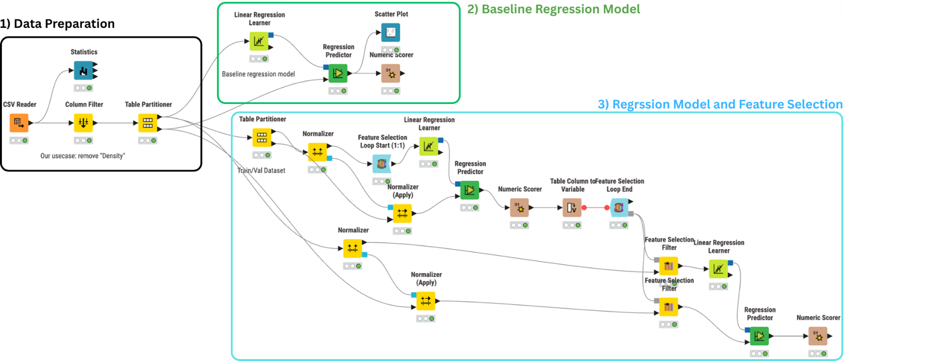
- Data Preparation
  - CSV Reader
Load the BodyFat CSV file.
  - Statistics (optional)
Inspect distributions/summary statistics.
  - Column Filter
Remove Density (simulate a realistic setting where Density is not available).
Keep BodyFat and all other measurement columns.
  - Table Partitioner (Dev/Test split)
Partitioning method: Random
Split ratio: 80% / 20%
Set your own fixed random seed for reproducibility.
Output 1 = Dev (Train+Validation), Output 2 = Test

- Baseline Regression Model (Linear Regression)
2.1 Linear Regression Learner
Input: Dev (80%) from Table Partitioner
Target/Response column: BodyFat
2.2 Regression Predictor
Model input: from Linear Regression Learner
Data input: Test (20%)
2.3 Numeric Scorer
Report at least RMSE (optionally R²).
2.4 Scatter Plot (optional)
Plot predicted vs actual BodyFat.

- Regression Model + Feature Selection (Wrapper)
3.1 Table Partitioner (Train/Validation)
Input: Dev (80%)
Output: 75% Train / 25% Validation
3.2 Normalizer (fit on Train only)
Input: Train
Method: standardization (z-score) is typical.
3.3 Normalizer (Apply)
Apply the same normalization model to: Validation set
3.4 Feature Selection Loop Start (1:1)
Input: normalized Train
Ensure BodyFat is the target, and BodyFat is NOT treated as a selectable feature.
Double-clck the node to open configure view.
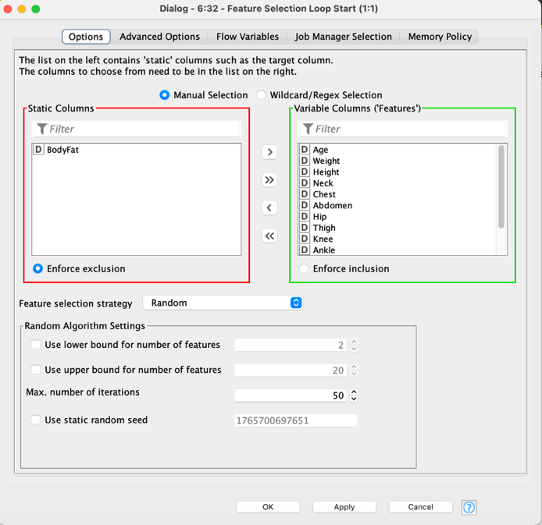
3.5 Linear Regression Learner (inside loop)
Target: BodyFat
3.6 Regression Predictor (inside loop)
Data input: normalized Validation
3.7 Numeric Scorer (inside loop)
Metric: RMSE
3.8 Table Column to Variable
Convert the RMSE output into a Double flow variable.
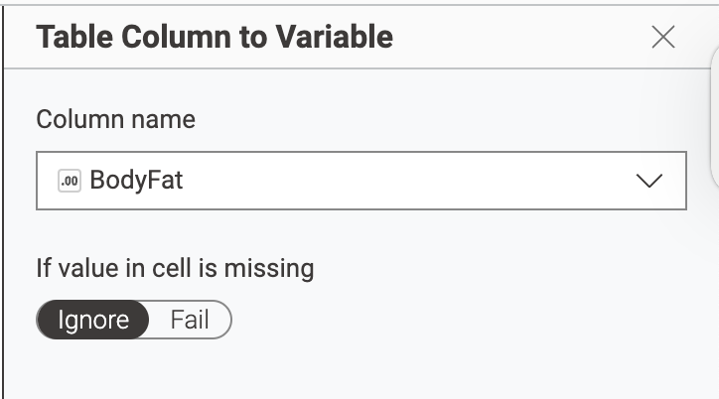
3.9 Feature Selection Loop End
Optimization: minimize RMSE
This selects the best feature subset based on Validation performance.
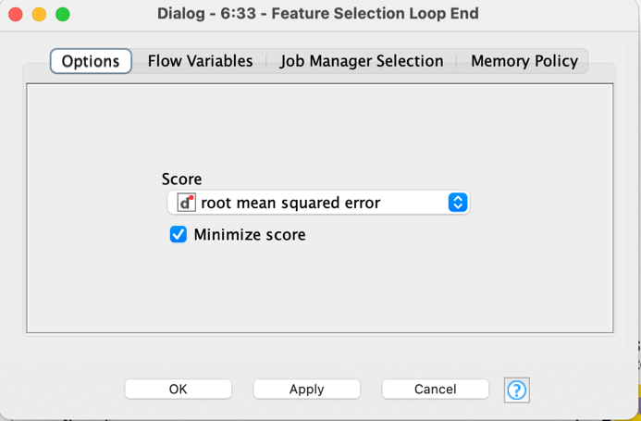
3.10 Normalizer (fit on Train + Validation)
Input: Train + Validation (From the first table partitioner) (80%)
Method: standardization (z-score)
3.11 Normalizer (Apply)
Apply the same normalization model to: Test set (20%)
3.12 Feature Selection Filter (Dev)
Model input: from Feature Selection Loop End
Data input: normalized Train + Validation (80%)
Enable Include static columns so BodyFat remains available for training.
3.13 Linear Regression Learner (final)
Train on filtered Train + Validation set
Target: BodyFat
3.14 Feature Selection Filter (Test)
Model input: from Feature Selection Loop End
Data input: normalized Test (20%)
(Recommended to guarantee the test schema matches the selected feature set.)
3.15 Regression Predictor (final)
Model input: final learner output
Data input: filtered Test
3.16 Numeric Scorer (final)
Report final Test RMSE

