Lab1: Pima Indians Diabetes Database
This lab uses the classic Pima Indians Diabetes dataset, which contains medical measurements collected from female patients of Pima Indian heritage.
Dataset description
The Pima Indians Diabetes dataset contains 768 records, each representing one female patient of Pima Indian heritage aged 21 years or older. For each patient, the following variables are recorded:
- Pregnancies
Number of times the patient has been pregnant (integer count).
- Glucose
2-hour plasma glucose concentration (mg/dL) from an oral glucose tolerance test.
- BloodPressure
Diastolic blood pressure (mm Hg).
- SkinThickness
Triceps skinfold thickness (mm), a proxy for body fat.
- Insulin
2-hour serum insulin (µU/mL).
- BMI
Body Mass Index, defined as weight in kg divided by the square of height in meters (kg/m²).
- DiabetesPedigreeFunction
A derived score that estimates the patient’s hereditary risk of diabetes, based on family history.
- Age
Age of the patient in years.
- Outcome
Binary target variable:
  - 1 = patient is diagnosed with diabetes
  - 0 = patient is not diagnosed with diabetes
Your task is to build and analyse binary classification models that predict Outcome from these clinical features. You will first clean and prepare the data in KNIME, then train a decision tree model, evaluate its performance, and explore global feature importance to understand which variables contribute most to the diabetes prediction.

KNIME Instructions
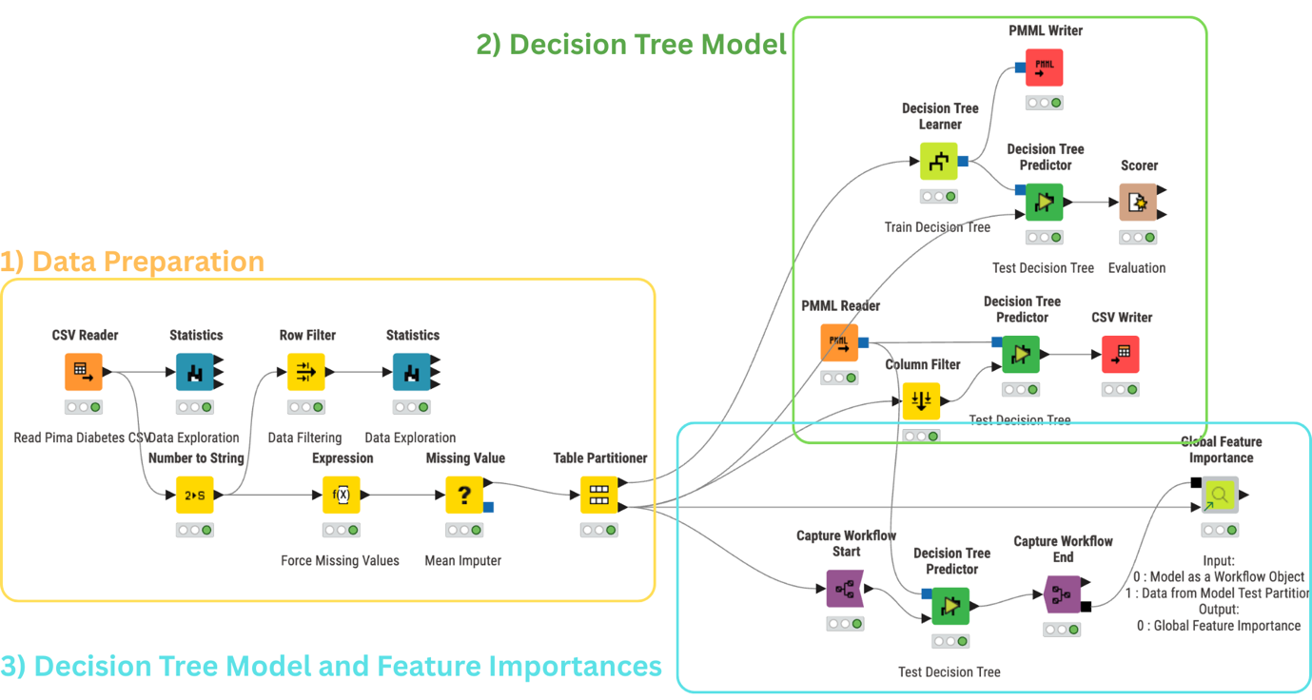
1) Data Preparation block
1.1 CSV Reader – Drag CSV Reader, connect nothing to it, double-click, and set the path to diabetes.csv so KNIME can read the Pima Diabetes data.
1.2 Statistics (raw) – Drag Statistics, connect it to the CSV Reader output; execute and open the view to quickly inspect distributions and spot weird values (0’s, outliers, class balance).
1.3 Number to String (Outcome) – Drag Number to String, connect from CSV Reader, configure it so Outcome is converted from integer to string; this gives KNIME a proper nominal class column for classification nodes.
1.4 Row Filter (drop-0s demo)
Drag a Row Filter node, connect it after CSV Reader, and set criteria such as BMI > 0, Glucose > 0, BloodPressure > 0, SkinThickness > 0, and Insulin > 0 with “Match row if matched by: All criteria” so KNIME keeps only records with non-zero medical values, demonstrating a naïve “drop rows with 0s” cleaning approach.
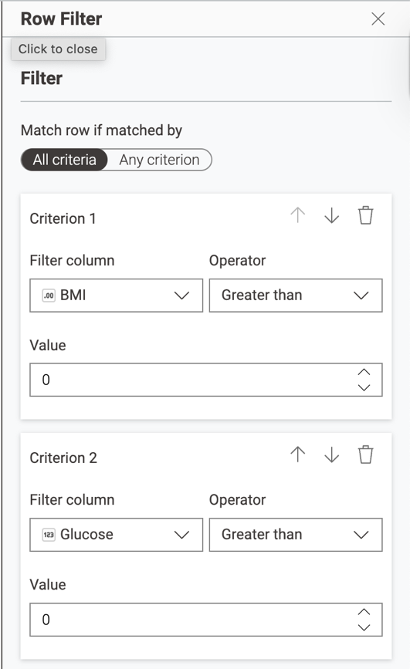
1.5 Statistics (show data loss from drop-0s)
Drag a Statistics node, connect it after this Row Filter, execute, and open the view to see that the row count falls from 768 to only ~400 rows, illustrating that this hard filtering discards many patients and motivating the other branch, where we convert 0s to missing values and impute them instead.
1.6 Expression (force 0 values to missing)
Drag an Expression node, connect it after Number to String, and for each clinical column (Glucose, BloodPressure, SkinThickness, Insulin, BMI) add an expression like if($Glucose$ == 0, MISSING, $Glucose$) (set “Output replaces ‘Glucose’”) so that any impossible 0 is turned into a missing value that can later be filled by the Missing Value (mean imputation) node instead of dropping whole rows.
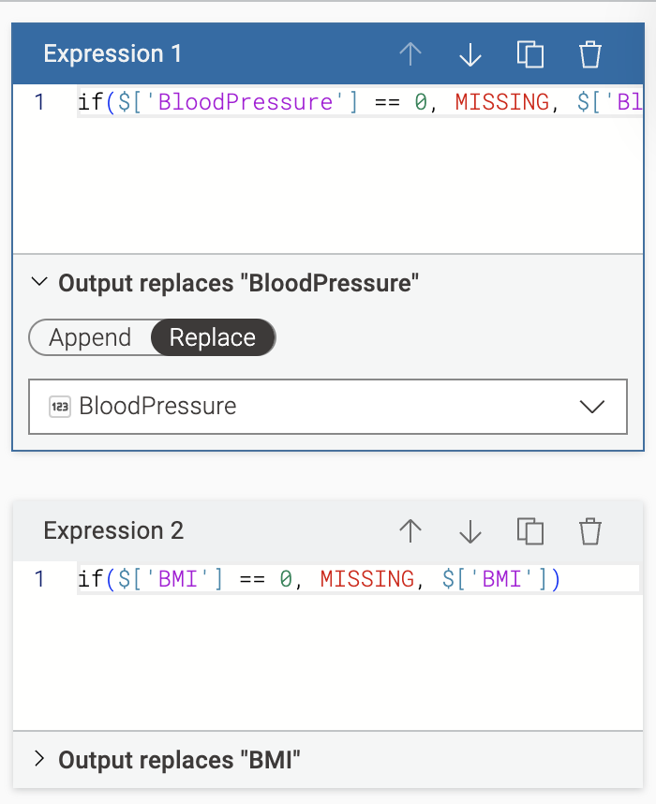
1.7 Missing Value (mean imputation for numeric columns)
Drag a Missing Value node, connect it after Expression, then double-click to open its configuration and on the Default tab set Number (Integer), Number (Long Integer) and Number (Float) to Mean (leave String as “Most Frequent Value”); this fills all the new missing values in the medical numeric columns with their column means so the next nodes receive a complete table with no missing entries.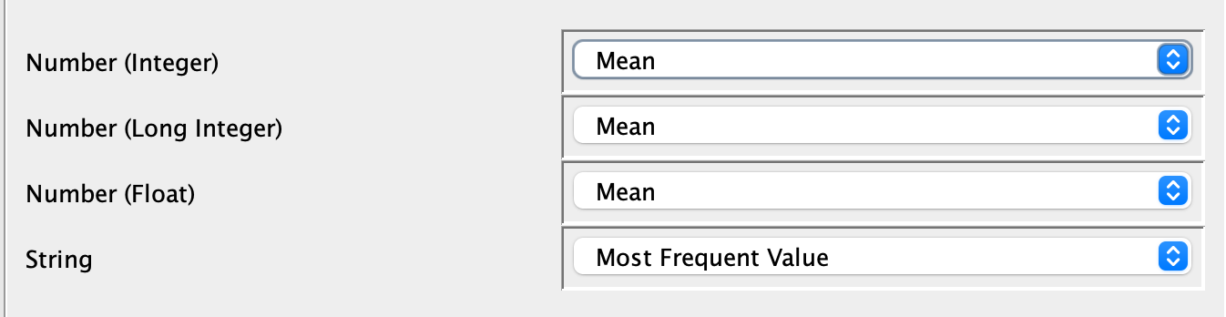
1.8 Table Partitioner – Drag Table Partitioner, connect from Missing Value, choose a train/test split (e.g. 70/30) and tick “Stratified” by Outcome; this creates a fair split with similar class balance in both partitions. To make your results reproducible, enable Fixed random seed and set its value to 2026.

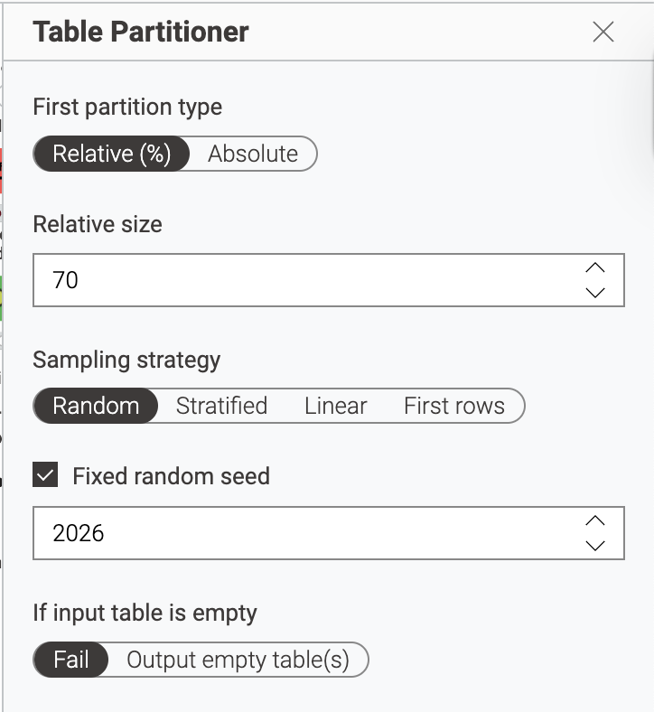

2) Decision Tree Model block
2.1 Decision Tree Learner – Drag Decision Tree Learner, connect its data input to the output port of Table Partitioner (training data), configure Outcome as class column, and other settings (Gini, pruning, etc.), and execute to train the baseline tree.
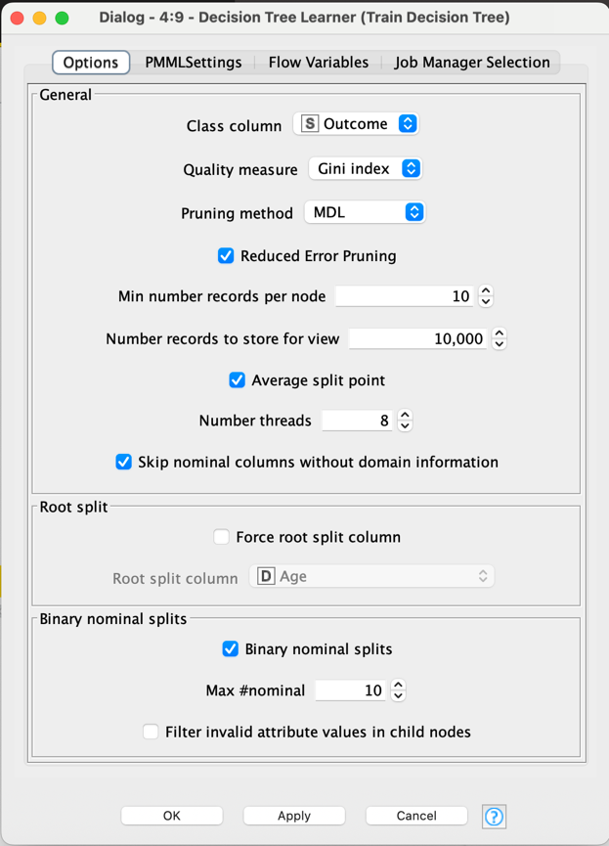
You can inspect the learned Decision Tree by right-clicking the Decision Tree Learner node → Open view. This opens a window showing the full tree structure, including each split (feature and threshold) and the class distribution at every node
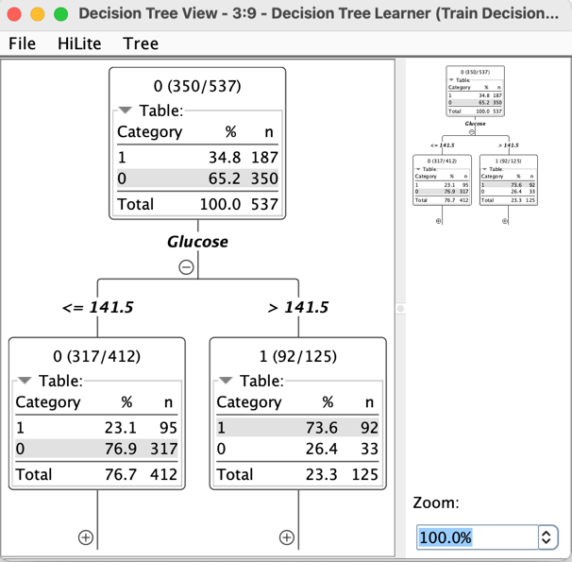
2.2 Decision Tree Predictor (direct KNIME evaluation) – Drag Decision Tree Predictor, connect its model input to the Decision Tree Learner and its data input to the output port of Table Partitioner (test data); execute to get predictions.
2.3 Scorer – Drag Scorer, connect from Decision Tree Predictor output and configure Outcome as true class; execute to view accuracy, confusion matrix, ROC etc. – this is the KNIME-side evaluation of the baseline.
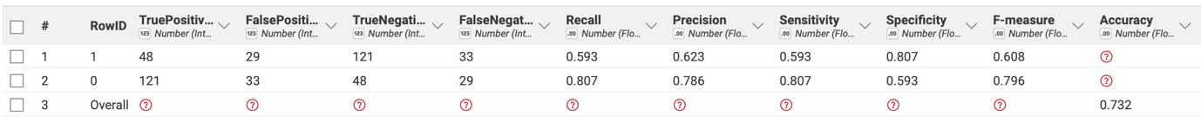
See How to Interpret the KNIME Scorer Results (Decision Tree Baseline) section later for more details.
2.4 PMML Writer (export tree to Python) – Drag PMML Writer, connect the model port from Decision Tree Learner, and configure it to write d-tree.pmml into the destination folder; this file will later be loaded and evaluated in Python.
2.5 Column Filter (simulate unlabeled deployment data)
Drag a Column Filter node, connect it from the Table Partitioner (test dataset), and deselect the Outcome column so only the predictor features remain; this simulates a real deployment situation where you want to score new patients but do not know their diagnosis yet.
2.6 PMML Reader + Decision Tree Predictor (deployment branch)
Use PMML Reader to load the saved d-tree.pmml, then drag a second Decision Tree Predictor and connect its model input to the PMML Reader and its data input to the Column Filter output; this shows how a trained tree model, stored as PMML, can be reloaded and applied to feature-only data in a separate workflow or at deployment time.
2.7 CSV Writer (prediction.csv for external use)
Drag a CSV Writer, connect it to the second Decision Tree Predictor, and configure it to write prediction.csv into the destination folder; this exports the predicted class and probabilities for each patient, which can be used as the final deployment output.

3) Decision Tree Model & Global Feature Importances block
3.1 Capture Workflow Start / End (wrap LR workflow as object) – Drag Capture Workflow Start before the Decision Tree Predictor and Capture Workflow End after them; this turns the whole Decision Tree scoring workflow into a workflow object that the Global Feature Importance component can call internally.
3.2 Decision Tree (2) Predictor – Drag Decision Tree (2) Predictor, connect the model input from the PMML Reader and the data input from the output of Capture Workflow Start, then connect its output to Capture Workflow End.
3.3 Global Feature Importance (download component from KNIME Hub and connect it)
At the top-right of KNIME, click ‘(?) button’→ KNIME Hub,

then in the Hub search box type “Global Feature Importance” and open the component page;
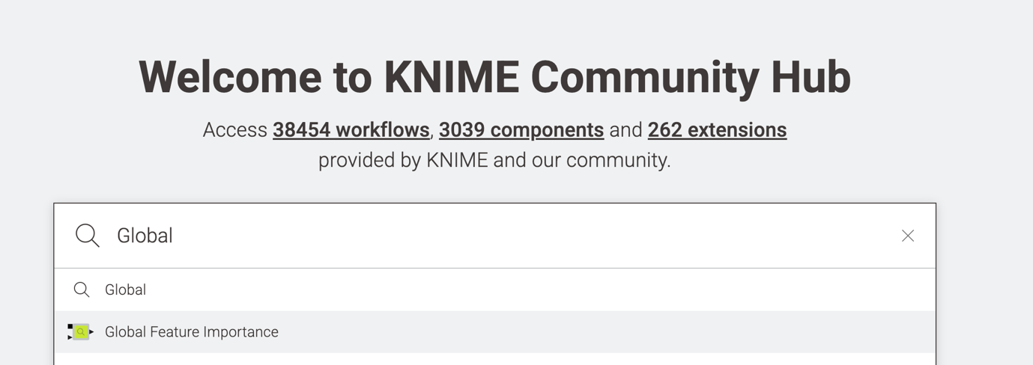
on that page, grab the small green Drag & drop icon and drag it straight into your workflow editor, 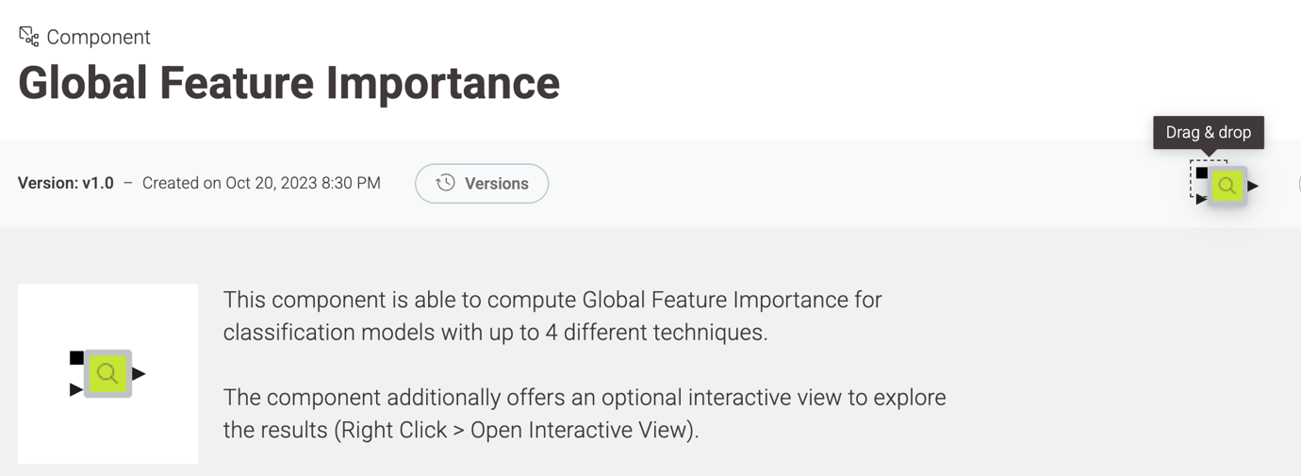
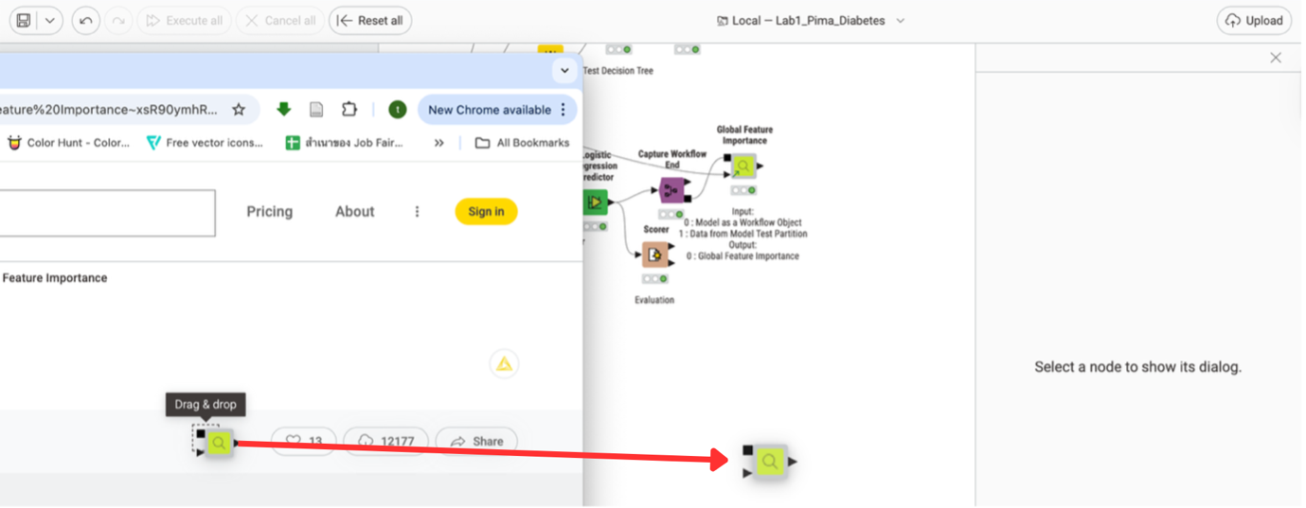
then connect its model workflow input port 0: Model as a Workflow Object to Capture Workflow End, its data input port 1: Data from Model Test Partition to the second output of Table Partitioner (test data), execute the node, and finally right-click → Open Interactive View to explore how each feature contributes to the Decision Tree model.
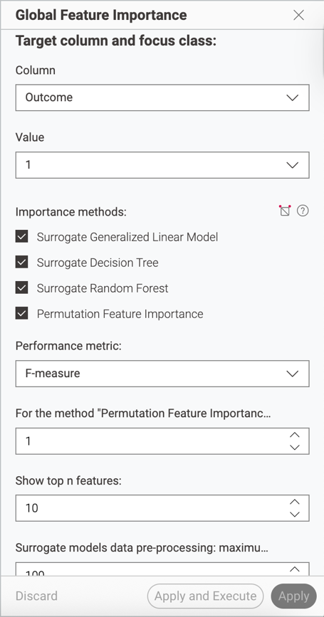
Below is an example of the Global Feature Importance output. To view it in KNIME, right-click the Global Feature Importance node and choose Open View.
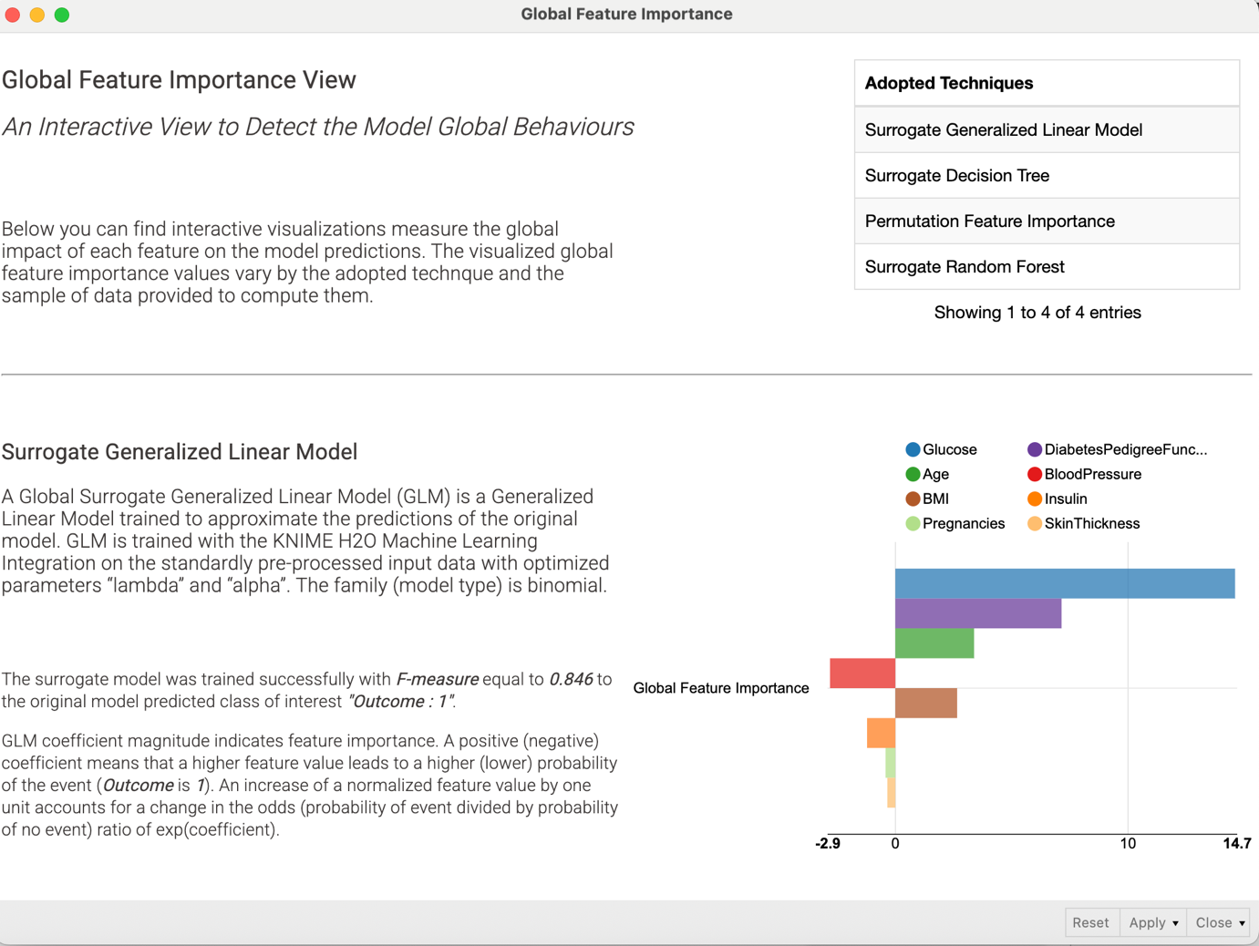

How to Interpret the KNIME Scorer Results (Decision Tree Baseline)
1) Confusion Matrix (core of everything)
- True Positive (TP): predicted Diabetes (1) and actually Diabetes (1)
- False Positive (FP): predicted Diabetes (1) but actually No Diabetes (0)
- True Negative (TN): predicted No Diabetes (0) and actually No Diabetes (0)
- False Negative (FN): predicted No Diabetes (0) but actually Diabetes (1)
Key idea: FN is often the most critical error in medical screening (missed diabetes cases).
2) Metrics (what they mean and what “better” looks like)
- Accuracy: overall % correct = (TP + TN) / all
  - Good for a quick check, but can be misleading if classes are imbalanced.
- Recall / Sensitivity (for class 1): TP / (TP + FN)
  - “Out of all real diabetes cases, how many did we catch?”
  - Higher = fewer missed cases (lower FN).
- Precision (for class 1): TP / (TP + FP)
  - “When we predict diabetes, how often are we right?”
  - Higher = fewer false alarms (lower FP).
- Specificity (for class 0): TN / (TN + FP)
  - “Out of all non-diabetes cases, how many did we correctly reject as non-diabetes?”
  - Higher = fewer false positives.
- F1-score (F-measure): balances Precision and Recall
  - Useful when you want a single number that penalizes both FP and FN.
3) How to read the Scorer table in KNIME
- The row for class “0” reports metrics treating class 0 as the “positive” class.
- The row for class “1” reports metrics treating diabetes (1) as the “positive” class.
- The “Overall” row summarizes total performance (e.g., accuracy).
4) What to focus on in this lab
- Because Outcome = 1 (diabetes) is the critical class, prioritize:
  - Recall/Sensitivity for class 1 (avoid missing diabetes cases), then
  - Precision for class 1 (avoid too many false alarms), and
  - F1 for class 1 as a balanced summary.

