Lab2: Body Fat Prediction Dataset
For this lab, we use the Body Fat Prediction dataset, which contains anthropometric measurements collected from subjects (e.g., age, weight, height, and several body circumferences). The objective is to build a regression model that can predict BodyFat (%), because body fat percentage is not always directly measurable in typical settings without specialized equipment.
The dataset also includes a Density attribute. However, Density is strongly related to body fat percentage because it is typically connected through established formulas, meaning it can behave like a “shortcut” feature that makes the prediction task unrealistically easy. In our use case, we assume that Density is not available (e.g., we do not have the appropriate sensor or measurement process in our lab). Therefore, in this lab we intentionally remove the Density column and focus on predicting BodyFat (%) using only the measurements we can realistically obtain.
Dataset Description
The BodyFat dataset contains 252 adult male subjects. Each row is one subject. The goal is to predict BodyFat (%) from body measurements.
Target Variable
BodyFat: Body fat percentage (%) — this is the target to be predicted.
Features:
Age: Age (years)
Weight: Body weight (lbs)
Height: Height (inches)
Neck: Neck circumference (cm)
Chest: Chest circumference (cm)
Abdomen: Abdomen/waist circumference (cm)
Hip: Hip circumference (cm)
Thigh: Thigh circumference (cm)
Knee: Knee circumference (cm)
Ankle: Ankle circumference (cm)
Biceps: Biceps circumference (cm)
Forearm: Forearm circumference (cm)
Wrist: Wrist circumference (cm)
Density: Body density estimate (typically in g/cm³).
Lab note: We remove Density to simulate a realistic scenario where this measurement is not available.

KNIME Instructions
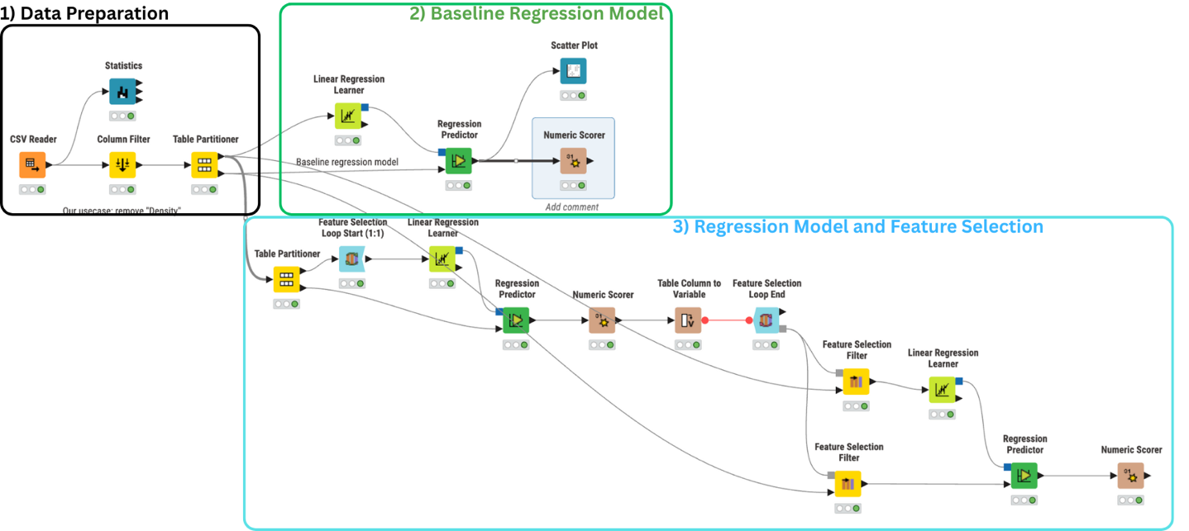
- Data Preparation
  - CSV Reader
Load the BodyFat CSV file.
  - Statistics (optional)
Inspect distributions/summary statistics.
  - Column Filter
Remove Density (simulate a realistic setting where Density is not available).
Keep BodyFat and all other measurement columns.
  - Table Partitioner (Dev/Test split)
Partitioning method: Random
Split ratio: 80% / 20%
Set your own fixed random seed for reproducibility.
Output 1 = Dev (Train+Validation), Output 2 = Test
Also set its Fixed random seed = 2026.

- Baseline Regression Model (Linear Regression)
2.1 Linear Regression Learner
Input: Dev (80%) from Table Partitioner
Target/Response column: BodyFat
You can view the output of the learner by right-clicking then open view.

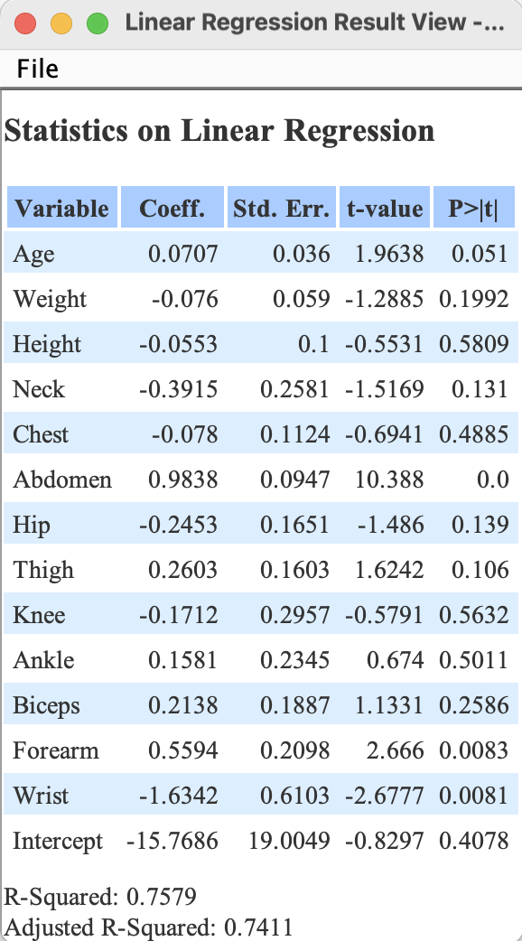
2.2 Regression Predictor
Model input: from Linear Regression Learner
Data input: Test (20%)
2.3 Numeric Scorer
Report at least RMSE (optionally R²).
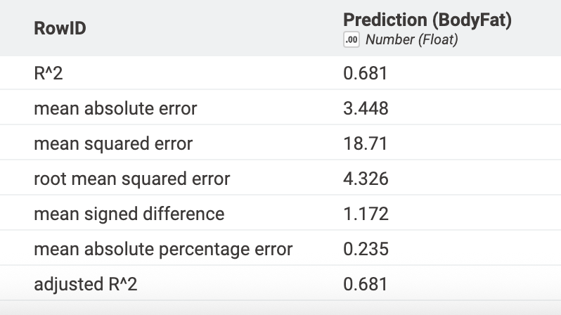
2.4 Scatter Plot (optional)
Plot predicted vs actual BodyFat.

- Regression Model + Feature Selection (Wrapper)
3.1 Table Partitioner (Train/Validation)
Input: Dev (80%)
Output: 75% Train / 25% Validation
Also set its Fixed random seed = 2026.
3.2 Feature Selection Loop Start (1:1)
Input: Train dataset
Ensure BodyFat is the target, and BodyFat is NOT treated as a selectable feature.
Double-clck the node to open configure view.
Also set static random seed = 2026
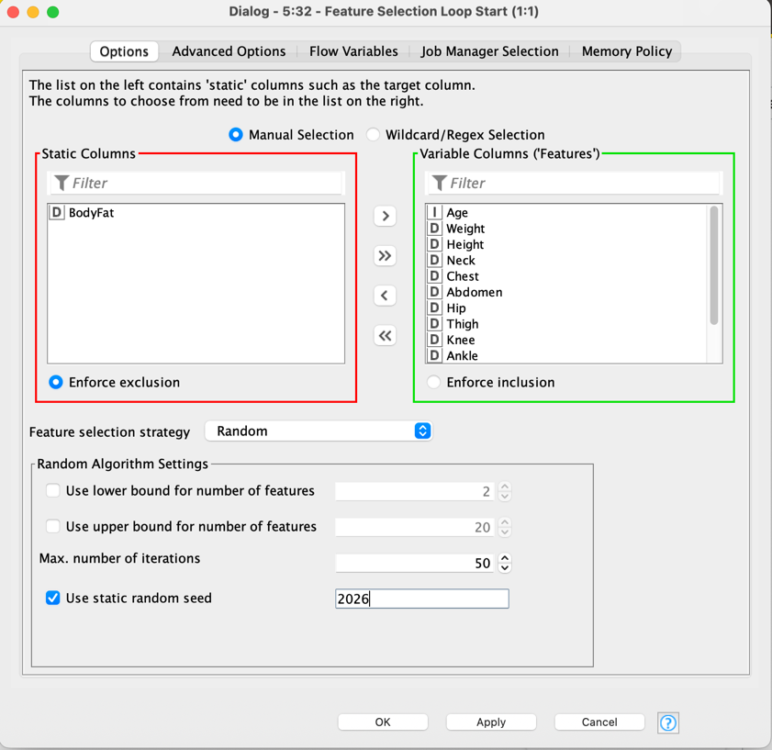
3.3 Linear Regression Learner (inside loop)
Target: BodyFat
3.4 Regression Predictor (inside loop)
Data input: Validation Dataset
3.5 Numeric Scorer (inside loop)
Output: A table of regression evaluation metrics (e.g., RMSE, MAE, and/or R²) computed on the Validation predictions.
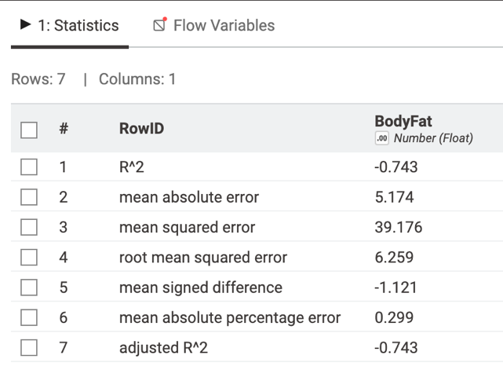
3.6 Table Column to Variable
Purpose: Convert the selected metric from the Numeric Scorer output (e.g., RMSE) into a Double flow variable.
Use: This flow variable is passed to Feature Selection Loop End so the loop can compare feature subsets and select the best one (e.g., minimize RMSE or maximize R²).

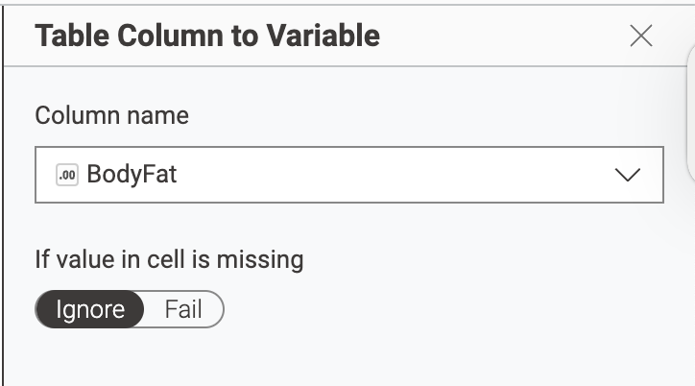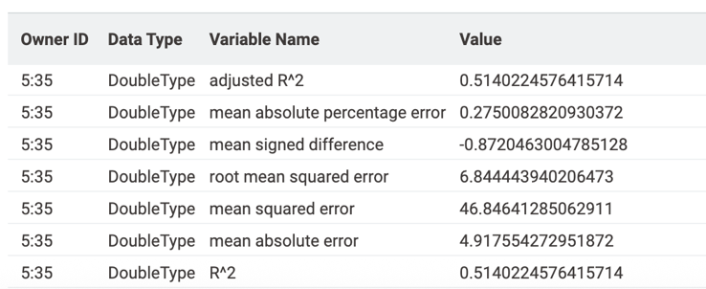
3.7 Feature Selection Loop End
Optimization: minimize RMSE
This selects the best feature subset based on Validation performance.
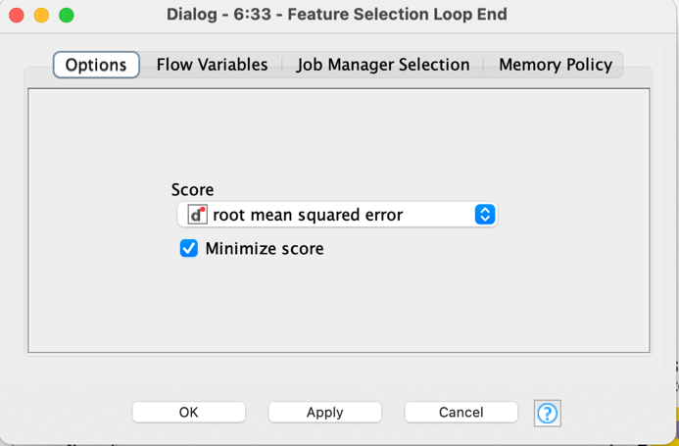
3.8 Feature Selection Filter (Dev)
Model input: from Feature Selection Loop End
Data input: Dev + Validation (80%)
Enable Include static columns so BodyFat remains available for training.
3.9 Linear Regression Learner (final)
Train on filtered Train + Validation set
Target: BodyFat
3.10 Feature Selection Filter (Test)
Model input: from Feature Selection Loop End
Data input: Test (20%)
(Recommended to guarantee the test schema matches the selected feature set.)
3.11 Regression Predictor (final)
Model input: final learner output
Data input: filtered Test
3.12 Numeric Scorer (final)
Report final Test metrics
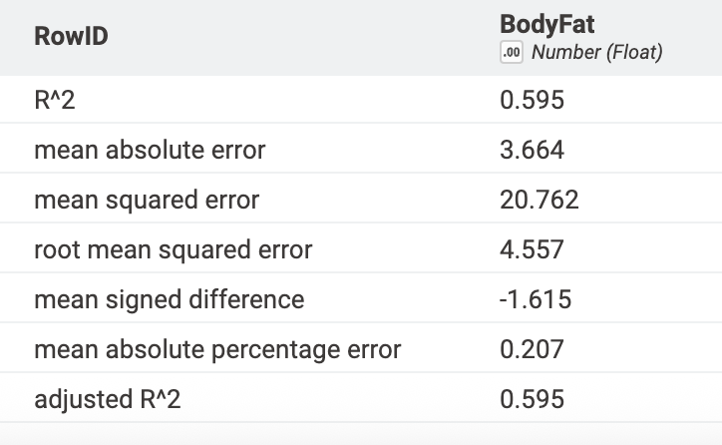
How to Interpret Regression Performance (BodyFat %)
What each metric means (and what “better” looks like):
- R² / Adjusted R² (0 to 1): how much variance in BodyFat the model explains. Higher is better.
- MAE (Mean Absolute Error): average absolute prediction error in percentage points.
Example: MAE = 3.45 means the prediction is off by ~3.45 BodyFat% on average. Lower is better.
- RMSE (Root Mean Squared Error): like MAE but penalizes large errors more. Lower is better.
- MSE: squared version of error; mainly used because RMSE is derived from it. Lower is better.
- Mean Signed Difference (Bias): shows whether the model systematically over/under-predicts.
Closer to 0 is better (positive = overpredict; negative = underpredict).
- MAPE: average percentage error (relative error). Lower is better, but can be sensitive when true values are small.
Comparing Your Two Results (Baseline vs Feature-Selected)
- Baseline performs better on the main accuracy metrics:
  - R²: 0.681 (better than 0.595)
  - MAE: 3.448 (better than 3.664)
  - RMSE: 4.326 (better than 4.557)
- Feature-selected model has a slightly better MAPE (0.207 vs 0.235), but overall it does not improve the model on R²/MAE/RMSE.

