ARC-1 Setup for SAP BTP ABAP Environment
BAS, Local VS Code, GitHub, MCP, OAuth, Troubleshooting, and Validation
Prepared for future reference from the completed working setup

Tutorial references
Primary ARC-1 tutorial/repository: ARC-1 GitHub tutorial and repository
SAP BAS Toolkit reference used for connecting local VS Code to BAS: SAP Business Application Studio Toolkit README
The ARC-1 repository provided the Agent Plugin/MCP package, BTP ABAP setup guidance, tool definitions, and safe defaults. The SAP BAS Toolkit reference provided the BAS landscape and dev-space connection context.

Contents

Architecture flow diagram
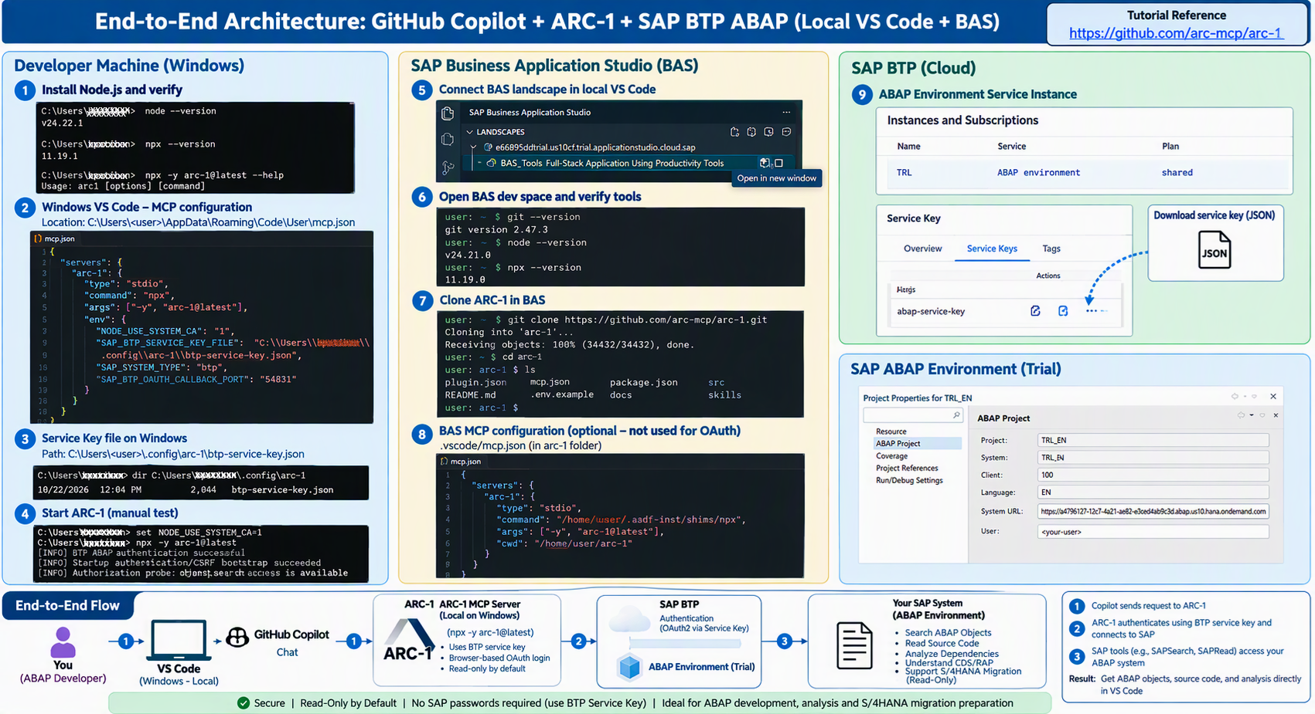

Figure A. End-to-end architecture and setup flow for local Windows VS Code, BAS, ARC-1, OAuth, and SAP BTP ABAP Environment.
- Connect local VS Code to the BAS dev space
  - You connected your Windows VS Code to the SAP Business Application Studio landscape.
  - You opened the BAS_Tools dev space remotely.
  - This gave you the BAS Linux development environment with Git, Node.js, and npx.
- Set up ARC-1 as an MCP server
  - You cloned the ARC-1 GitHub repository.
  - You configured mcp.json.
  - VS Code/Copilot became the MCP client and ARC-1 became the MCP server.
  - ARC-1 exposed SAP tools such as SAPSearch and SAPRead.
- Authenticate ARC-1 to the SAP BTP ABAP Environment
  - Slight correction to your wording: ARC-1 doesn't really connect to BTP Cockpit.
  - BTP Cockpit is where you obtained the ABAP Environment service key.
  - ARC-1 uses that ABAP service key plus browser OAuth authentication to connect to the SAP BTP ABAP Environment.
  - We eventually moved ARC-1 execution to local Windows VS Code because the OAuth localhost callback timed out when ARC-1 ran remotely inside BAS.
- Use Copilot + ARC-1 to work with the ABAP repository
  - Copilot calls ARC-1 tools.
  - ARC-1 calls the SAP ADT APIs.
  - SAPSearch found your package ZBPA_WORKFLOW and enumerated repository objects.
  - SAPRead can then retrieve individual ABAP object/source information for analysis.
  - We deliberately kept the setup read-only.

So, the final architecture is:
Developer → GitHub Copilot in local VS Code → MCP → ARC-1 → BTP OAuth/service key → SAP BTP ABAP Environment → ADT APIs → ABAP repository
And BAS sits alongside this primarily as your cloud development environment:
Local VS Code → BAS remote connection → BAS dev space → Git/GitHub/ARC-1 development files

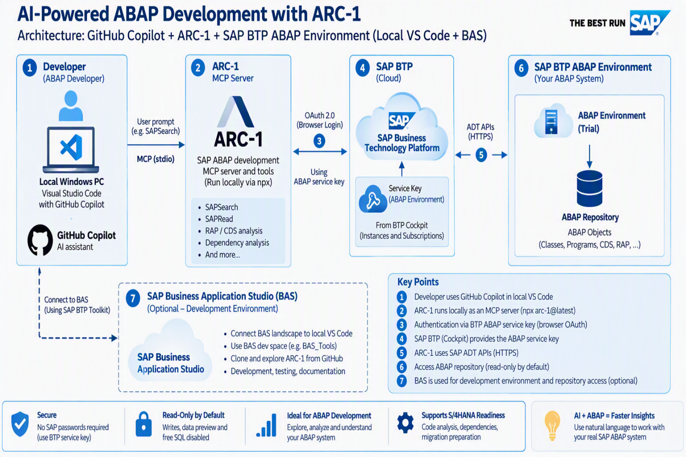

A one-line explanation for the above:
I integrated GitHub Copilot in VS Code with an SAP BTP ABAP Environment through the ARC-1 MCP server, using a BTP ABAP service key and OAuth authentication, enabling AI-assisted discovery and read-only analysis of ABAP repository objects through SAP ADT APIs.

1. Purpose and architecture
This guide records the complete setup used to connect Visual Studio Code, SAP Business Application Studio (BAS), GitHub, ARC-1, and an SAP BTP ABAP Environment. It describes both the working solution and the failed approaches that were corrected.
Layer | Working component | Purpose
User interface | Local Windows VS Code + Copilot Chat | Active chat and MCP client.
MCP adapter | ARC-1 1.7.0 over stdio | Provides SAPSearch, SAPRead, and other SAP tools.
Authentication | BTP service key + browser OAuth/PKCE | Authenticates the interactive SAP user.
Backend | SAP BTP ABAP Environment | ADT APIs and ABAP repository.
Development environment | BAS_Tools dev space | Git/source access and diagnostics; not the final OAuth host.
Final topology: Local Windows VS Code -> ARC-1 via npx -> browser OAuth callback on Windows localhost -> SAP BTP ABAP Environment. BAS remains optional for development.

2. Prerequisites
- SAP BTP Trial subaccount with BAS subscription.
- Running BAS Full-Stack Application dev space (BAS_Tools).
- SAP BTP ABAP Environment instance and service key.
- Working Eclipse ADT connection to the ABAP environment.
- Windows VS Code with GitHub Copilot Chat and MCP support.
- Node.js 22.19+ and npx. Completed Windows versions: Node.js v24.22.1, npx 11.19.1.
- Network access to GitHub, npm, BTP authentication, and the ABAP API host.

3. Connect local VS Code to BAS
Install the SAP Business Application Studio Toolkit/Remote Access extension.
In the BAS activity view choose Connect Landscape and enter the BAS application URL opened from BTP Cockpit.
Note: Do not enter the Cloud Foundry API endpoint.
- Sign in to the BAS landscape through the browser.
- Start BAS_Tool dev space
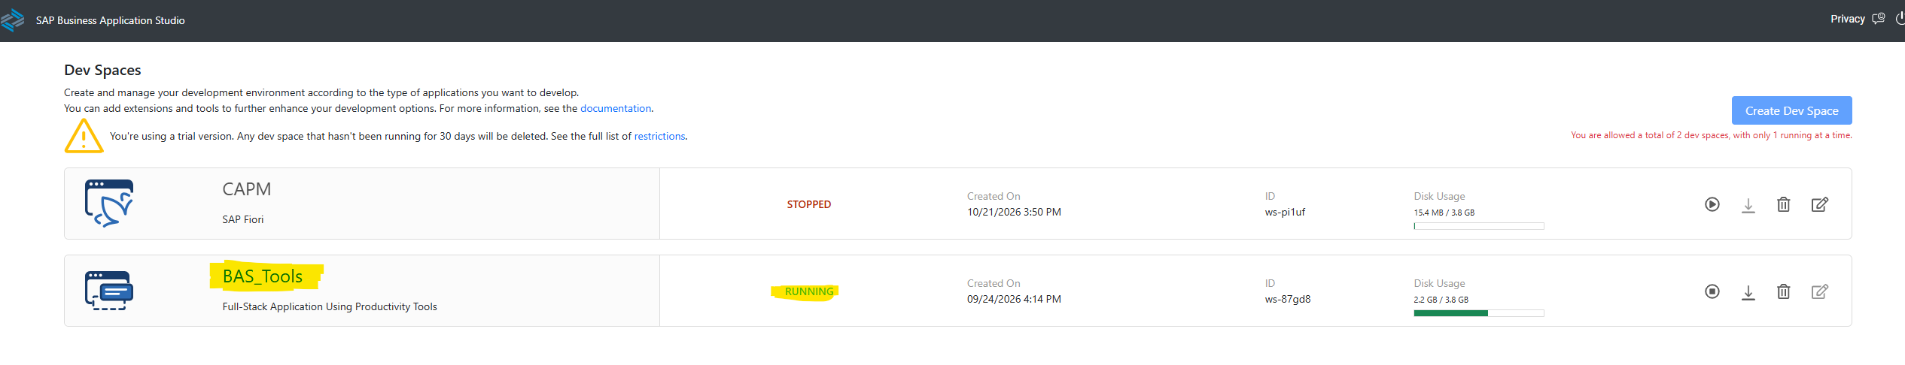
- Click Open in new window. Selecting the dev space alone does not switch the terminal into BAS.
- Open a new terminal. BAS shows a Linux prompt such as user: ~ $. A prompt such as PS C:\Users\bpatiban> is local Windows.
BAS terminal verification
git --version

Observed: git version 2.47.3.

4. Clone ARC-1 in BAS
GitHub connectivity and clone
git ls-remote https://github.com/arc-mcp/arc-1.git
git clone https://github.com/arc-mcp/arc-1.git
cd arc-1
ls
pwd

Expected path: /home/user/arc-1. The root contains plugin.json, mcp.json, package.json, skills/, src/, and README.md.

5. Validate ARC-1 in BAS
BAS runtime tests
node --version
npx --version
npx arc-1@latest --help
which npx
/home/user/.asdf-inst/shims/npx -y arc-1@latest

Observed BAS versions: Node.js v24.21.0, npx 11.19.0. The direct server test reached ARC-1 MCP server running on stdio. Missing SAP configuration was expected at this stage.

6. Configure MCP
Agent Plugin discovery from the remote checkout did not consistently expose ARC-1, so a direct MCP definition was used.
BAS workspace: /home/user/arc-1/.vscode/mcp.json
{
"servers": {
"arc-1": {
"type": "stdio",
"command": "/home/user/.asdf-inst/shims/npx",
"args": ["-y", "arc-1@latest"],
"cwd": "/home/user/arc-1"
}
}
}

After a Copilot message created the session runtime, MCP: List Servers -> arc-1 -> Start Server produced Running and Discovered 9 tools.
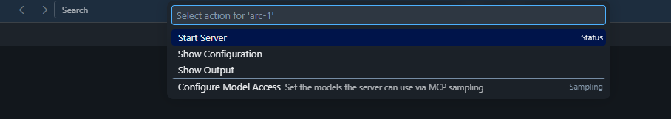
You can see the Output Tab with Discovered 9 tools…
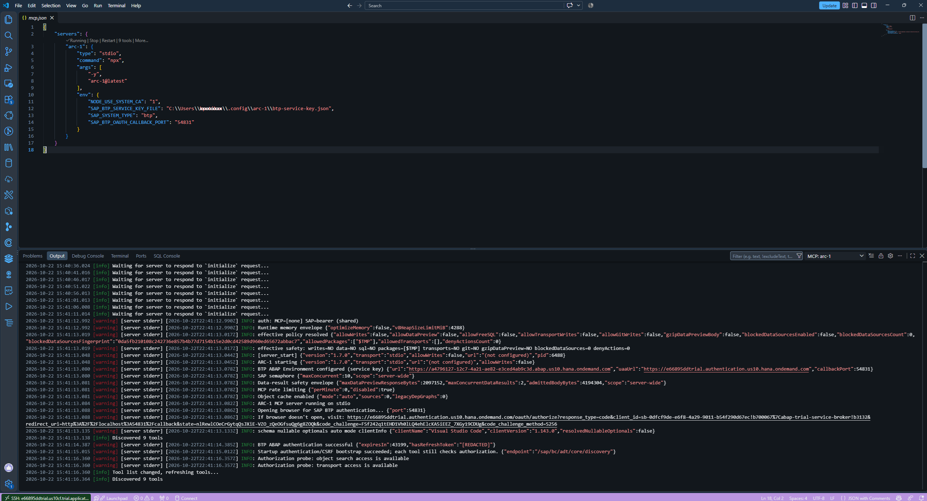

7. Prepare the BTP ABAP service key
Keep the key outside every Git repository.
Download the ABAP Service Key Instance and rename the file to btp-service-key.json
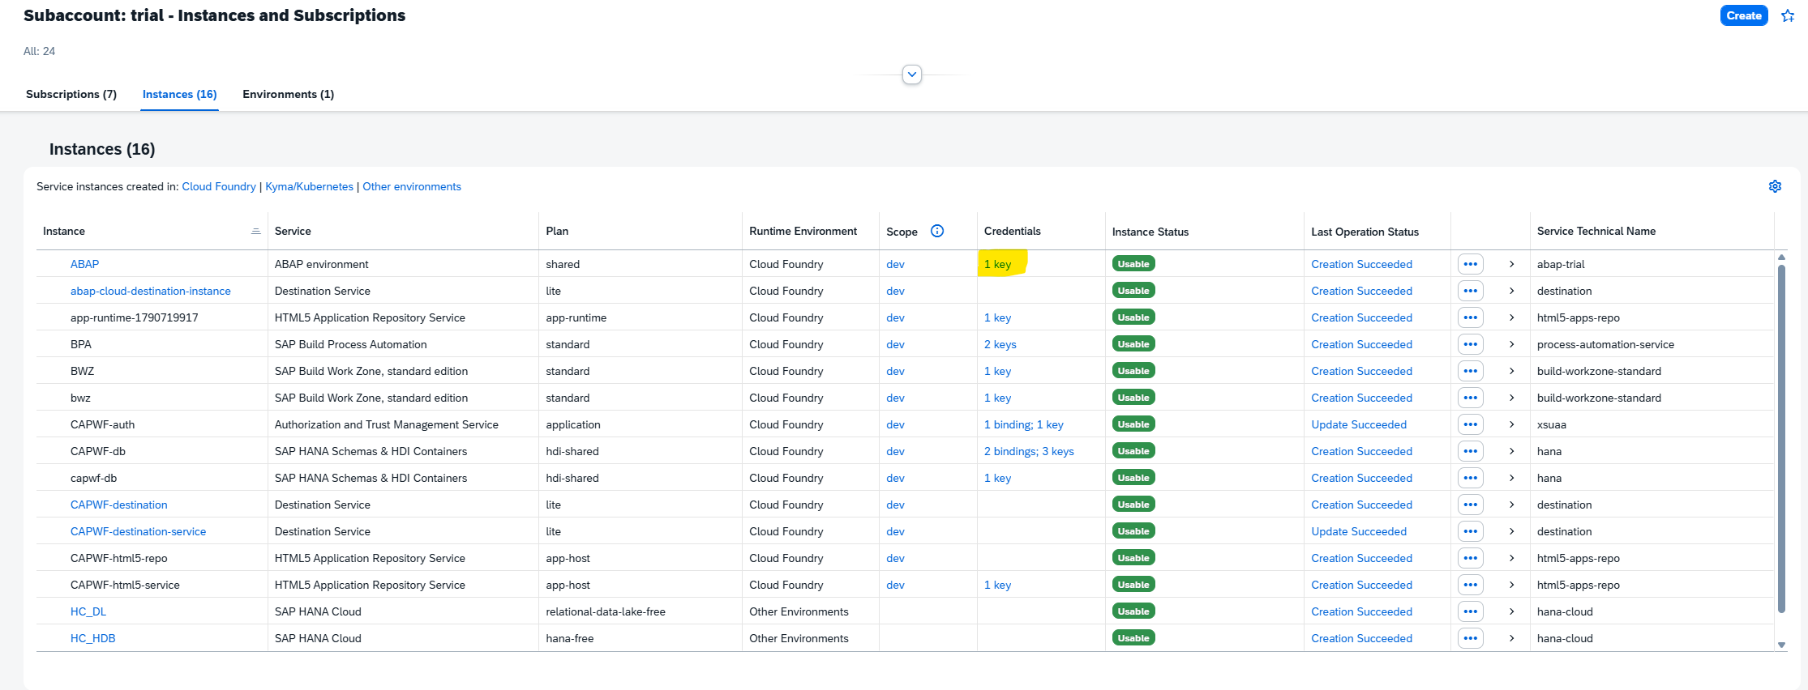
BAS protected location
mkdir -p /home/user/.config/arc-1
chmod 600 /home/user/.config/arc-1/btp-service-key.json
ls -l /home/user/.config/arc-1/btp-service-key.json

BAS MCP environment
"env": {
"SAP_BTP_SERVICE_KEY_FILE": "/home/user/.config/arc-1/btp-service-key.json",
"SAP_SYSTEM_TYPE": "btp"
}

Do not: Do not commit, print, chat, email, or document the service-key contents. Do not place the key under /home/user/arc-1.

8. Resolve BAS OAuth callback timeout
ARC-1 started in BAS, but SAP OAuth timed out because the callback listener was on remote BAS localhost while the interactive browser was on Windows. The solution was to run ARC-1 locally on Windows for the browser OAuth flow.

9. Configure local Windows runtime
Windows CMD verification
node --version
npx --version

Observed: Node.js v24.22.1 and npx 11.19.1.
Enterprise certificate-chain fix
set NODE_USE_SYSTEM_CA=1
npx -y arc-1@latest --help

This fixed SELF_SIGNED_CERT_IN_CHAIN without disabling TLS verification.
Copy the service key to C:\Users\bpatiban\.config\arc-1\btp-service-key.json. Verify the extension because Windows initially created btp-service-key.json.json.
Filename verification/fix
dir "%USERPROFILE%\.config\arc-1"
ren "%USERPROFILE%\.config\arc-1\btp-service-key.json.json" "btp-service-key.json"

Manual Windows validation
set NODE_USE_SYSTEM_CA=1
set SAP_BTP_SERVICE_KEY_FILE=C:\Users\bpatiban\.config\arc-1\btp-service-key.json
set SAP_SYSTEM_TYPE=btp
npx -y arc-1@latest

Successful logs included BTP ABAP authentication successful, CSRF bootstrap succeeded, object search access is available, and transport access is available. Stop the manual process with Ctrl+C and answer Y to Terminate batch job.
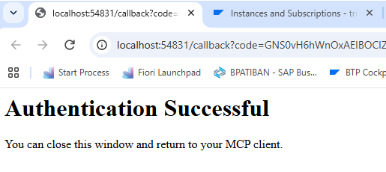

10. Final local VS Code MCP configuration
Use MCP: Open User Configuration in local Windows VS Code. This opens the Windows user-level mcp.json, not the BAS workspace file.
C:\Users\bpatiban\AppData\Roaming\Code\User\mcp.json
{
"servers": {
"arc-1": {
"type": "stdio",
"command": "npx",
"args": ["-y", "arc-1@latest"],
"env": {
"NODE_USE_SYSTEM_CA": "1",
"SAP_BTP_SERVICE_KEY_FILE": "C:\\Users\\bpatiban\\.config\\arc-1\\btp-service-key.json",
"SAP_SYSTEM_TYPE": "btp",
"SAP_BTP_OAUTH_CALLBACK_PORT": "54831"
}
}
}
}

- Close duplicate VS Code windows.
- Use one local Windows VS Code window.
- Create a new Copilot chat and send Hello to create the session runtime.
- Run MCP: List Servers, select arc-1, and Start Server.
- Complete browser authentication.
- Confirm arc-1 Running and Discovered 9 tools.

11. Complete OAuth and validate SAP tools
The broad Z* prompt was not a reliable first test. Use an exact SAP package and explicitly name the SAP tool.
Successful SAPSearch prompt
Using the SAPSearch tool from arc-1, search the connected SAP system for package ZBPA_WORKFLOW and list the ABAP objects in that package. Do not search the local workspace.

The response found package ZBPA_WORKFLOW and listed SAP-side ABAP objects. For source analysis:
Read-only SAPRead prompt
Using arc-1 SAPRead, read the complete source of class <CLASS_NAME> from package ZBPA_WORKFLOW. Explain its purpose, methods, dependencies, referenced CDS views, and processing flow. Do not modify anything in SAP.

12. Issues and fixes
Issue / symptom | Cause | Resolution | Validation
PowerShell blocked copilot.ps1 | Execution policy disabled scripts. | Used CMD; later used direct VS Code MCP configuration. | No policy error in CMD.
winget error 0x8a15000f | WinGet source metadata missing; admin reset unavailable. | Used Node.js and npx instead. | ARC-1 help executed.
git not recognized | Command ran locally, not in BAS. | Opened BAS dev space in a new remote window. | git version 2.47.3.
gh command not found | GitHub CLI absent in BAS. | Used Git directly; gh not required. | Clone completed.
spawn npx ENOENT | MCP host could not resolve npx. | Used absolute BAS npx path; local Windows used npx. | Running; 9 tools discovered.
Session runtime not created | MCP started before Chat session. | New chat -> Hello -> start arc-1. | Server started.
SAP_URL not configured | No SAP auth configuration yet. | Used BTP service key and SAP_SYSTEM_TYPE=btp. | Service key recognized.
OAuth callback timed out in BAS | Callback was on remote localhost. | Moved interactive MCP process to Windows. | Authentication Successful.
SELF_SIGNED_CERT_IN_CHAIN | Enterprise TLS CA not trusted by Node/npm. | NODE_USE_SYSTEM_CA=1. | npx registry access worked.
Service key ENOENT | Double .json extension. | Renamed to btp-service-key.json. | ARC-1 opened OAuth.
No SAP tools in chat | Different VS Code windows/sessions, or old chat. | One local window; new chat after discovery. | SAPSearch worked.
Z* search ambiguous | Too broad; could route to local search. | Exact package + SAPSearch + no local workspace. | ZBPA_WORKFLOW results returned.

13. Final inventory and safe operation
- Windows user MCP file: C:\Users\bpatiban\AppData\Roaming\Code\User\mcp.json
- Windows key: C:\Users\bpatiban\.config\arc-1\btp-service-key.json
- BAS checkout: /home/user/arc-1
- BAS key copy: /home/user/.config/arc-1/btp-service-key.json
- Final active server: arc-1, Global in Code, Running
- Successful validation package: ZBPA_WORKFLOW
Avoid duplicates: Do not run the BAS workspace ARC-1 server and the Windows user-level ARC-1 server for the same chat.
- Keep writes disabled until a dedicated test package and governance are approved.
- Keep data preview and free SQL disabled unless explicitly approved.
- Use exact package/object names.
- Never share service keys, secrets, tokens, or OAuth URLs.
- Rotate any token exposed in chat or screenshots.
- Review each ARC-1 tool call before approval.

Appendix A. Consolidated commands
# BAS
git --version
git ls-remote https://github.com/arc-mcp/arc-1.git
git clone https://github.com/arc-mcp/arc-1.git
cd arc-1
node --version
npx --version
which npx
/home/user/.asdf-inst/shims/npx -y arc-1@latest
mkdir -p /home/user/.config/arc-1
chmod 600 /home/user/.config/arc-1/btp-service-key.json
# Windows CMD
set NODE_USE_SYSTEM_CA=1
set SAP_BTP_SERVICE_KEY_FILE=C:\Users\bpatiban\.config\arc-1\btp-service-key.json
set SAP_SYSTEM_TYPE=btp
npx -y arc-1@latest --help
npx -y arc-1@latest

Appendix B. Screenshot evidence
The available final screenshot below shows local VS Code, ARC-1 MCP output, successful BTP authentication, discovered tools, and Copilot Chat results for ZBPA_WORKFLOW.
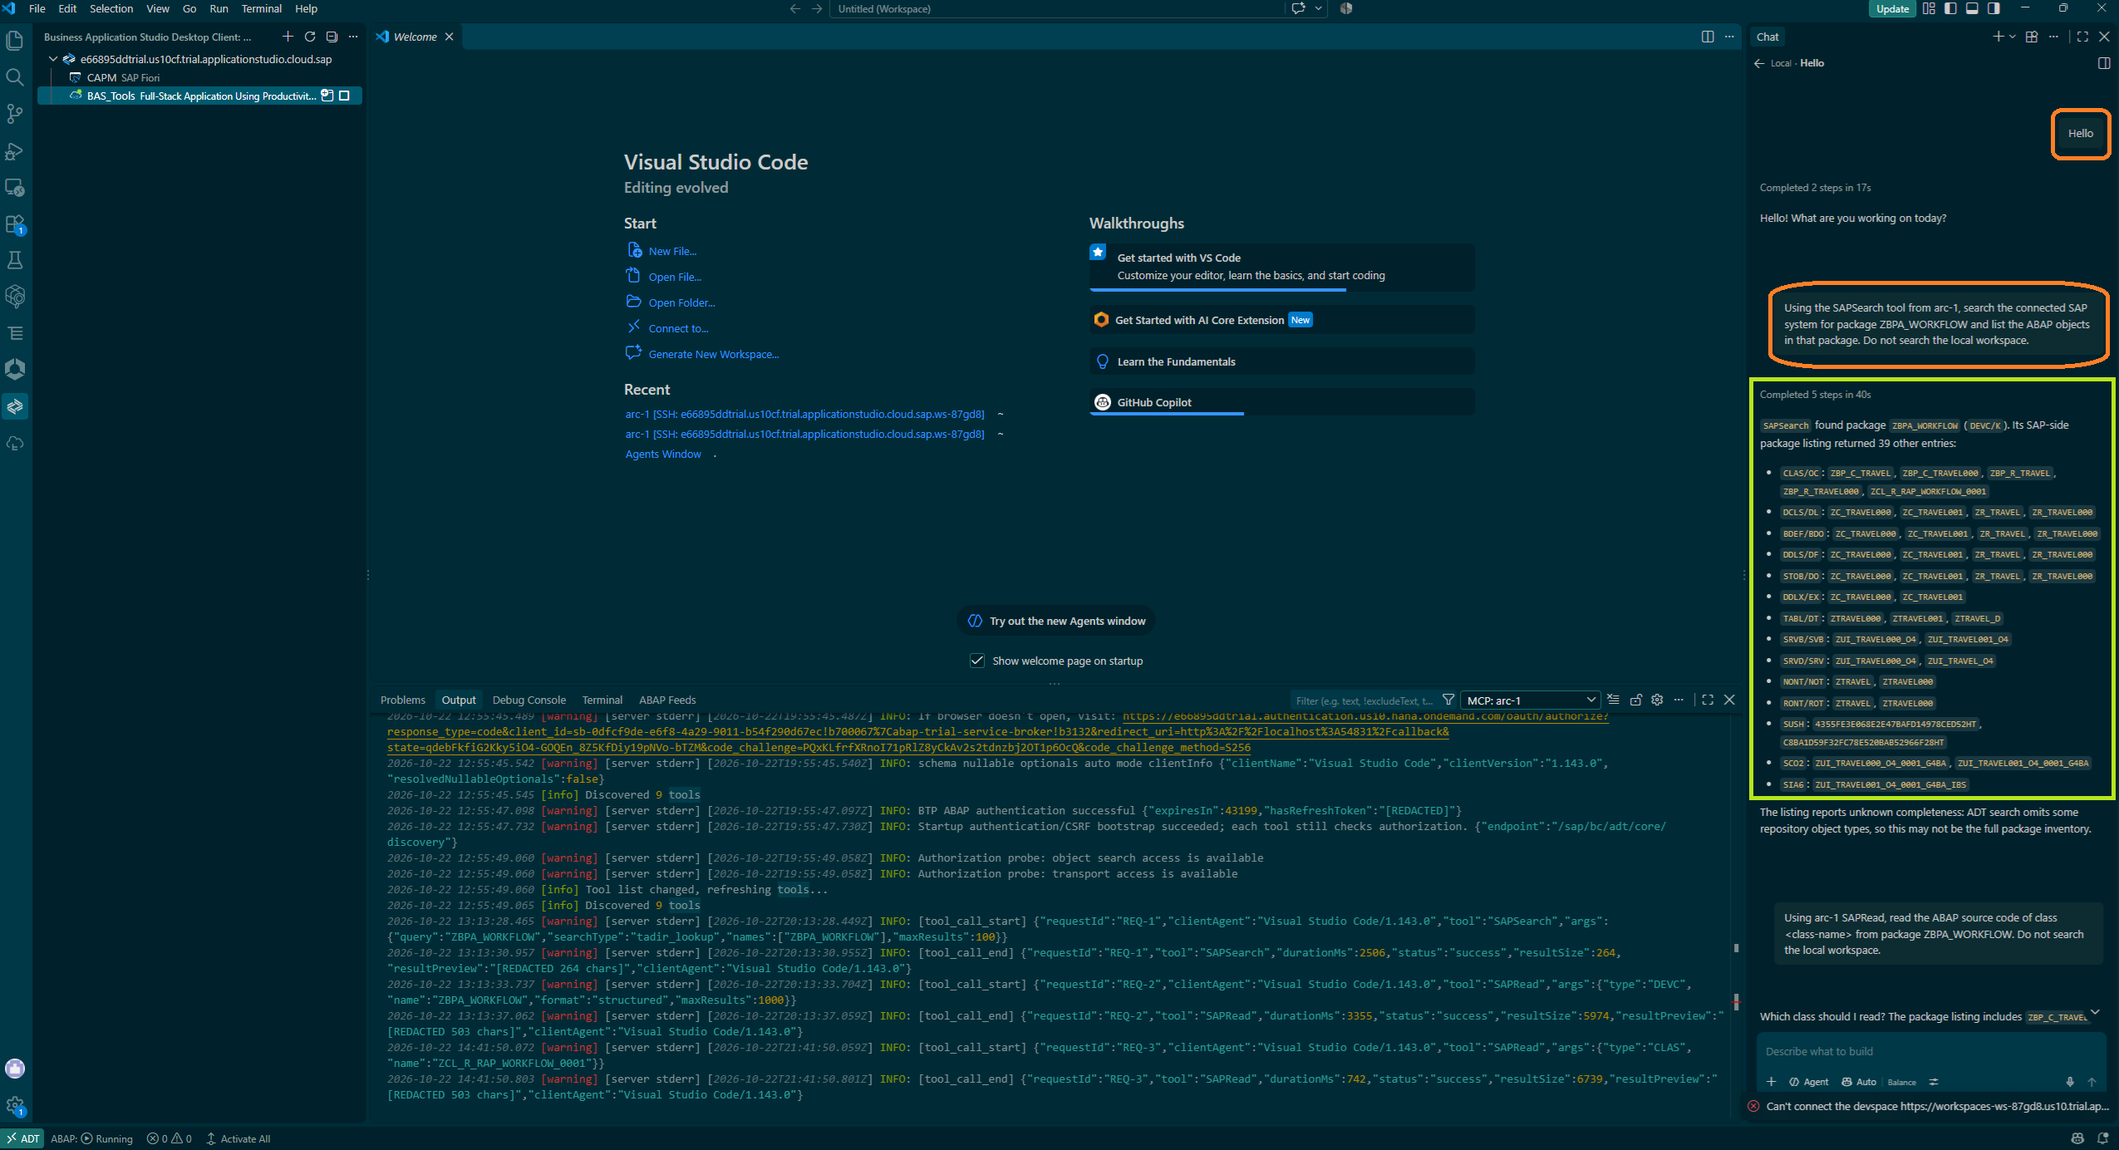
Figure 1. Final working validation for ARC-1 and ZBPA_WORKFLOW.

References
- ARC-1 Agent Plugin documentation.
- ARC-1 BTP ABAP Environment documentation.
- ARC-1 Configuration Reference.
- Visual Studio Code MCP configuration documentation.
- Node.js Enterprise Network Configuration documentation.

