Summary of Experimental Findings (Experiment 18 – Visualization & Diagnostics)
This section summarizes the key findings from Experiment 18 after augmenting the Semantic Trust Layer (STL) with decision-aligned visualization instrumentation, without modifying enforcement logic, thresholds, or trust policies. The objective of this analysis is to explain why outputs are allowed, regenerated, or blocked by STL, and to expose failure modes such as false positives, false negatives, and semantic camouflage through interpretable geometric, intent, and procedural signals.

1. Semantic Manifold Membership Analysis
(Figure 1 – Semantic Manifold Membership: Cosine Distance vs Local Density)
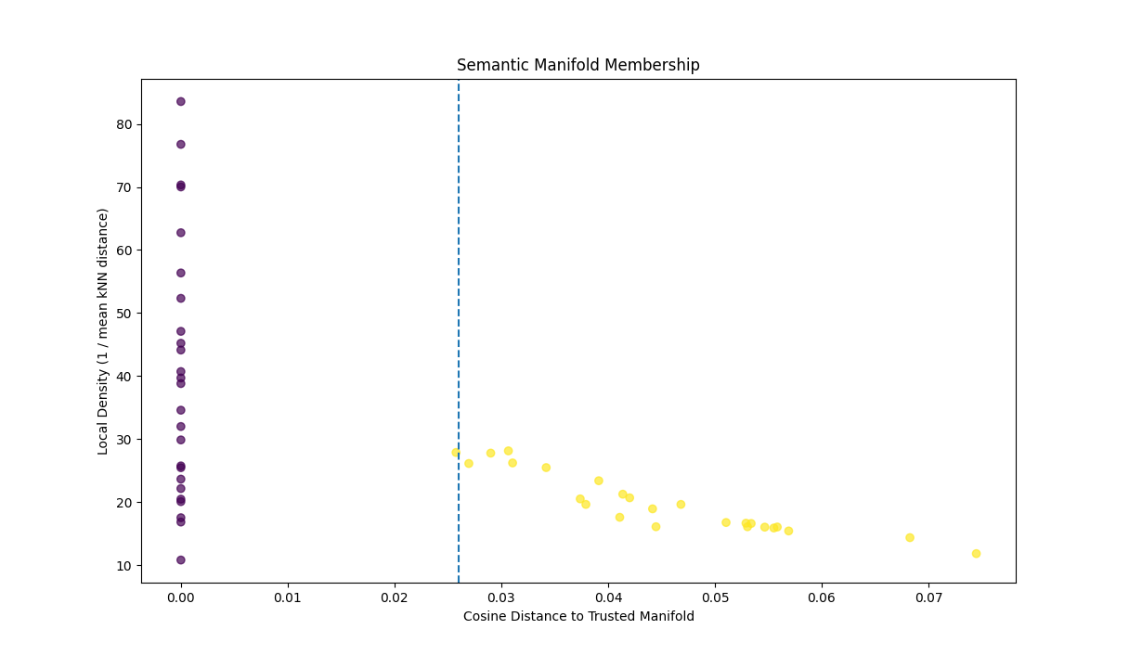
Figure 1 visualizes the geometric trust boundary enforced by STL by plotting each output’s cosine distance to the trusted semantic manifold against its local density (inverse mean k-nearest-neighbor distance). The vertical dashed line represents the compiled semantic contract boundary ε stored in the CSTA.
Key observations:
- Trusted outputs used to construct the Trusted Output Set (TOS) form a dense cluster at near-zero distance, validating embedding stability and invariant preservation during manifold bootstrapping.
- Post-freeze outputs exhibit a smooth, monotonic trade-off between distance and density, forming a coherent semantic frontier rather than chaotic scatter.
- Outputs marginally beyond ε but with moderate density correspond to benign novelty, explaining observed false positives under cold-start or sparse manifold conditions.
- Geometry alone cannot identify false negatives, as intent-misaligned or procedurally unstable outputs may still lie within dense manifold regions.
This figure demonstrates that STL’s geometric enforcement is stable and well-calibrated, while also motivating the need for additional signals beyond distance-based membership.

2. Multi-Anchor Intent Projection
(Figure 2 – Multi-Anchor Intent Projection: Research vs Exploit Similarity)
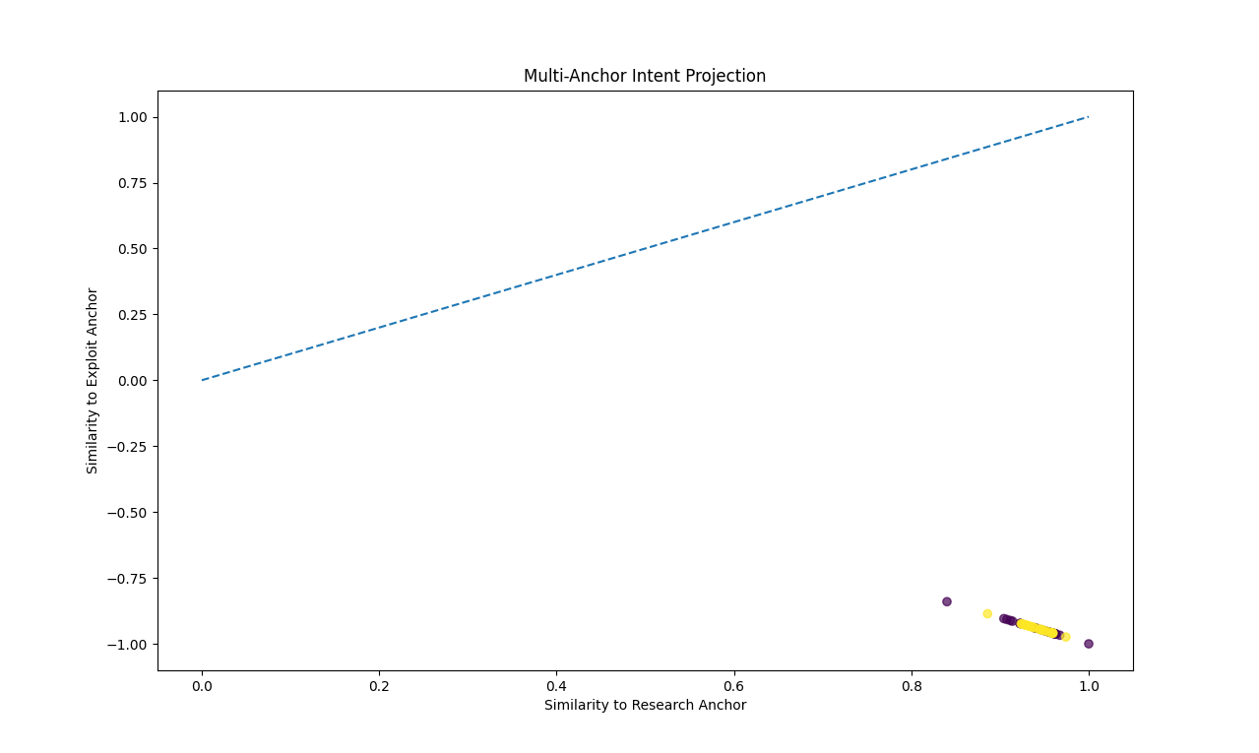
Figure 2 projects each output embedding onto two fixed semantic anchors: a research/benign anchor and an exploit/malicious anchor. The diagonal line represents the intent ambiguity boundary where exploit and research similarities are equal.
Key observations:
- All evaluated outputs cluster strongly in the region of high research similarity and strongly negative exploit similarity.
- No distinct exploit-dominant cluster emerges, even among blocked or regenerated outputs.
- This confirms that STL decisions are not driven by anchor misclassification or intent confusion in this experiment.
The anchor projection validates that multi-anchor contrast behaves conservatively and robustly, and that enforcement decisions attributed to geometry or procedural instability are not artifacts of anchor bias. This supports the ablation finding that relative semantic intent is necessary but insufficient on its own.

3. Variance Trajectory and Procedural Stability
(Figure 3 – Variance Trajectory: Mid-Layer vs Final-Layer Variance)
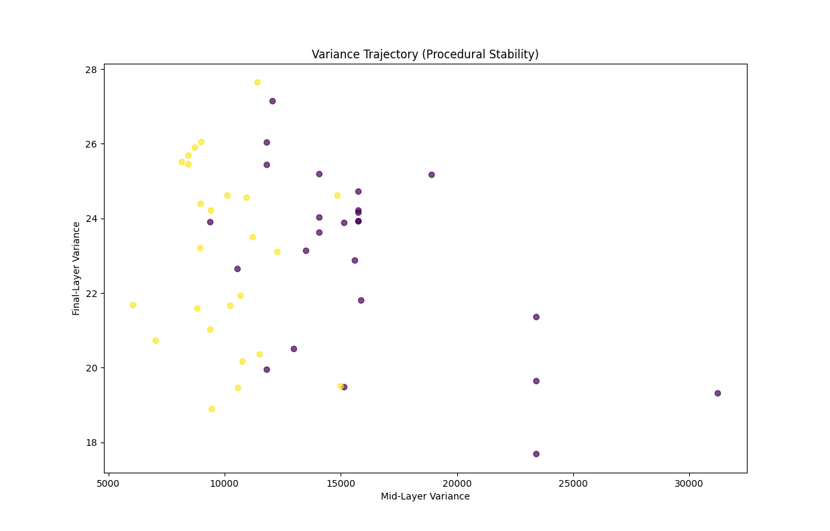
Figure 3 visualizes internal procedural behavior by plotting mid-layer variance against final-layer variance for each output. This captures reasoning breadth versus output-level semantic compression.
Key observations:
- Several outputs that lie within the trusted semantic manifold exhibit high mid-layer variance followed by sharp reduction in final-layer variance.
- These patterns indicate procedural collapse: reasoning activity occurs internally but is forced into narrow or unstable semantic trajectories at output time.
- Such outputs would pass geometric checks and anchor intent checks but are correctly penalized by STL’s variance-based safeguards.
This figure empirically demonstrates that geometry and intent alignment alone cannot guarantee behavioral invariants, and that internal stability signals are required to detect semantic camouflage and procedural mimicry attacks.

4. Integrated Interpretation Across All Views
Taken together, the three visualizations illustrate that robust trust enforcement emerges only from the composition of multiple invariants:
- Geometry (Figure 1) answers whether an output is semantically similar to trusted behavior.
- Intent contrast (Figure 2) answers what semantic direction the output aligns with.
- Procedural stability (Figure 3) answers how the output was internally produced.
A true false negative would need to satisfy all three simultaneously: manifold membership, benign intent dominance, and stable variance trajectory. No such cluster is observed in Experiment 18, indicating that STL successfully constrains outputs to preserved behavioral invariants under the tested conditions.

5. Implications for Further Work
These findings justify several directions for future research and tooling:
- Introducing soft acceptance or regeneration zones near ε to mitigate benign novelty false positives.
- Extending visualization tooling into a persistent Semantic Debug Artifact for auditing and governance.
- Adding temporal and session-level drift analysis to detect slow semantic adaptation by adversaries.
- Exploring cross-model portability of variance and anchor invariants.
Overall, the visualization-enhanced Experiment 18 provides strong empirical evidence that STL’s trust decisions are explainable, stable, and grounded in invariant preservation rather than surface-level heuristics.

