

Vaccine Storage Refrigerator

DOC161W DOC162G DOC21W DOC22G DOC31W DOC32G DOC51W DOC52G DOC1011W DOC1012G DOC1321W DOC1322G DOC1601W DOC1602G
DOC161WNSF456 DOC162GNSF456 DOC21WNSF456 DOC22GNSF456 DOC31WNSF456 DOC32GNSF456 DOC51WNSF456 DOC52GNSF456 DOC1011WNSF456 DOC1012GNSF456 DOC1321WNSF456 DOC1322GNSF456 DOC1601WNSF456 DOC1602GNSF456

USER MANUAL
Read the instructions carefully and keep them for future reference

ACMED Division of ACME Inc.
Write Model and Serial Numbers here:
Model: Serial No.:
Non-Explosive Medical Appliance Division
2 ACME Way
Metropolis, MD 19958
www.acme.co/acmed

APPLIANCE SAFETY

Your safety and the safety of others are very important.
We have included many important safety messages in this manual and on your appliance. Always read and obey all safety messages.


This is the Safety Alert Symbol. The symbol alerts you to potential hazards that can kill or injure you and others. All safety messages will follow the Safety Alert Symbol and either the word DANGER or WARNING.

DANGER means that failure to heed this safety statement may result in severe personal injury or death.


WARNING means that failure to heed this safety statement may result in extensive product damage, serious personal injury, or death.
All safety messages will alert you about the potential hazard, tell you how to reduce the chance of injury, and let you know what can happen if the instructions are not followed.

IMPORTANT SAFEGUARDS

Before the appliance is used, it must be properly positioned and installed as described in this manual, so read the manual carefully. To reduce the risk of fire, electrical shock, or injury when using the appliance, follow basic precautions, including the following:
Plug into a grounded 3-prong outlet, do not remove the grounding prong, do not use an adapter, and do not use an extension cord.
Replace all panels before operating.
It is recommended that a separate circuit serving only your appliance be provided. Use receptacles that cannot be turned off by a switch or pull chain.
Never clean appliance parts with flammable fluids. These fumes can create a fire hazard or explosion. And do not store or use gasoline or other flammable vapors and liquids in the vicinity of this or any other appliance. The fumes can create a fire hazard or explosion.
Do not connect or disconnect the electric plug when your hands are wet.
Unplug the appliance or disconnect the power before cleaning or servicing. Failure to do so can result in electrical shock or death.
Do not attempt to repair or replace any part of your appliance unless it is specifically recommended in this manual. All other servicing should be referred to a qualified technician.
This appliance is CFC- and HFC-free and contains small quantities of Isobutane (R600a) which is environmentally friendly, but flammable. It does not damage the ozone layer, nor does it increase the greenhouse effect. Care must be taken during transportation and setting up of the appliance so that no parts of the cooling system are damaged. Leaking coolant can ignite and may damage the eyes.

In the event of any damage:
- Avoid open flames and anything that can create a spark.
- Disconnect from the power supply.
- Air the room in which the appliance is located for several minutes, and contact the Service Department for advice
The more coolant there is in an appliance, the larger the room it should be installed in. In the event of a leakage, if the appliance is in a small room, there is the danger of combustible gases building up. For every ounce of coolant, at least 325 cubic feet of room space is required. The amount of coolant in the appliance is stated on the data plate inside the appliance. It is hazardous for anyone other than an Authorized Service Person to carry out servicing or repairs to this appliance.
Take serious care when handling, moving, and using the appliance to avoid either damaging the refrigerant tubing or increasing the risk of a leak.
Replacing component parts and servicing shall be done by factory authorized service personnel, so as to minimize the risk of possible ignition due to incorrect parts or improper service.

FOLLOW WARNING CALLOUTS BELOW ONLY WHEN APPLICABLE TO YOUR MODEL
Use two or more people to move and install the appliance. Failure to do so can result in back or other injuries. To ensure proper ventilation for your appliance, the front of the unit must be completely unobstructed.
Choose a well-ventilated area with temperatures above 60°F (16°C) and below 90°F (32°C).
The appliance should not be located next to ovens, grills, or other sources of high heat. For optimal performance, install the unit where the ambient temperature is between72º and 78ºF (23º-26ºC).
The appliance must be installed with all electrical, water, and drain connections in accordance with state and local codes. A standard electrical supply (115 V AC only, 60 Hz), properly grounded in accordance with the National Electrical Code and local codes and ordinances, is required.
Do not kink or pinch the power supply cord of the appliance. The size of the fuse (or circuit breaker) should be 15 amperes.
It is important that the appliance be leveled in order to work properly. You may need to make several adjustments to level it.
All installations must be in accordance with local plumbing code requirements. Make certain that the pipes are not pinched, kinked, or damaged during installation. Check for leaks after connection.
Never allow children to operate, play with or crawl inside the appliance.
Do not use solvent-based cleaning agents or abrasives on the interior. These cleaners may damage or discolor the interior.
Use this appliance only for its intended purpose as described in this Instruction Manual.
Keep fingers out of the “pinch point” areas. Clearances between the door and cabinet are necessarily small. Be careful closing the door when children are in the area.

 Risk of child entrapment!
Child entrapment and suffocation are not problems of the past. Junked or abandoned appliances are still dangerous, even if they will “just sit for a few days.”
Before discarding your old refrigerator: Take off the doors
Leave the shelves in place so that children may not easily climb inside.
- SAVE THESE INSTRUCTIONS -

LOCATION OF PARTS

Security Lock Light switch
Digital Control Panel
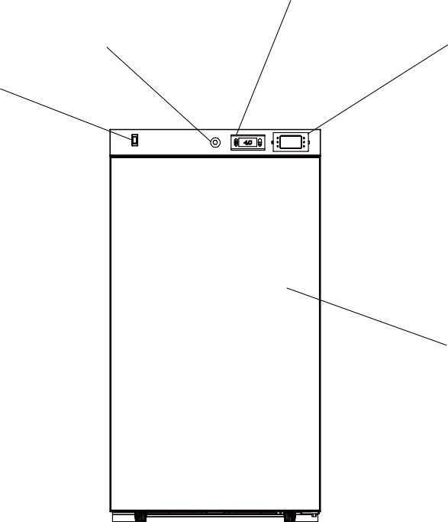
Thermometer/Alarm

Door

Security Lock Light switch
Digital Control Panel
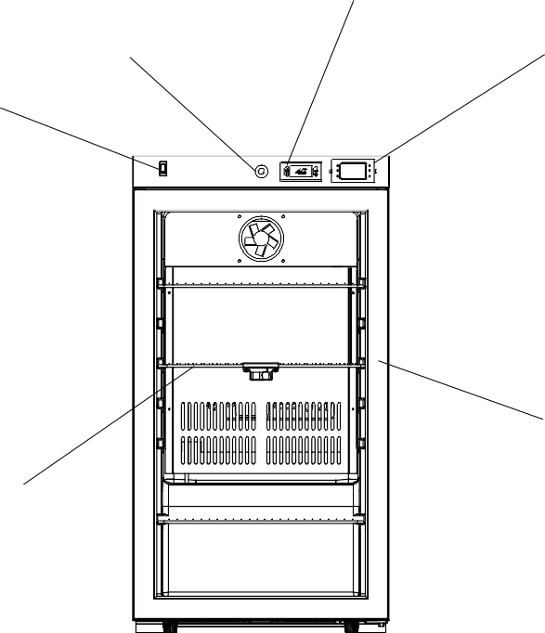
Thermometer/Alarm

Door

Shelves

TECHNICAL INFORMATION

Model Number | DOC161W | DOC21W | DOC31W | DOC51W | DOC1011W | DOC1321W | DOC1601W
Net usable interior capacity, ft³ | 1.58 | 1.94 | 3.17 | 3.88 | 9.88 | 12.71 | 15.53
Electrical Input | 61W | 66W | 88W | 100W | 150W | 163W | 167W
Rated Current | 0.6A | 0.9A | 0.9A | 2.0A | 2.0A | 2.0A | 2.0A
Temperature Setpoint | 4°C | 4°C | 4°C | 4°C | 4°C | 4°C | 4°C
Temperature Range | 2-8 ºC | 2-8 ºC | 2-8 ºC | 2-8 ºC | 2-8 ºC | 2-8 ºC | 2-8 ºC
Refrigerant | R600a | R600a | R600a | R600a | R600a | R600a | R600a
Installation | Freestanding | Freestanding | Freestanding | Built-in and freestanding | Freestanding | Freestanding | Freestanding

Model Number | DOC162G | DOC22G | DOC32G | DOC52G | DOC1012G | DOC1322G | DOC1602G
Net usable interior capacity, ft³ | 1.58 | 1.94 | 3.17 | 3.88 | 9.88 | 12.71 | 15.53
Electrical Input | 61W | 66W | 88W | 100W | 150W | 163W | 167W
Rated Current | 0.6A | 0.9A | 0.9A | 2.0A | 2.0A | 2.0A | 2.0A
Temperature Setpoint | 4°C | 4°C | 4°C | 4°C | 4°C | 4°C | 4°C
Temperature Range | 2-8 ºC | 2-8 ºC | 2-8 ºC | 2-8 ºC | 2-8 ºC | 2-8 ºC | 2-8 ºC
Refrigerant | R600a | R600a | R600a | R600a | R600a | R600a | R600a
Installation | Freestanding | Freestanding | Freestanding | Built-in and freestanding | Freestanding | Freestanding | Freestanding

NOTES:
Specifications are subject to change without notice

INSTALLATION INSTRUCTIONS

Before Using your Appliance
Remove the exterior and interior packing.
Before connecting the appliance to the power source, let it stand upright for approximately 2 hours. This will reduce the possibility of a malfunction in the cooling system from handling during transportation.
Clean the interior surface with lukewarm water using a soft cloth.

Installation of your Appliance
This appliance is designed for free-standing installation for indoor use only.
NOTE: Models DOC51W/NSF456 and DOC52G/NSF456 are the only models approved for built-in use. Place your appliance on a floor that is strong enough to support it when it is fully loaded. To level the unit, adjust the front leveling legs.
For a freestanding installation, allow a clearance of 5” (127mm) from the back and sides of the unit and 4” (102mm) from the top of the unit to allow proper air circulation to cool the compressor and condenser.
If the unit is going to be built into an enclosure, you must still allow at least 1/4” of clear space on both sides and at the top, and 2” at the back. Take care that the air vents at the front are never covered or blocked in any way.

NOTE: It is recommended that you do not install the appliance near an oven, radiator, or other heating sources. Direct sunlight may affect the acrylic coating and heat sources may increase electrical consumption. Do not install in a location where the temperature will fall below 60°F (16°C). For best performance, do not install the appliance behind a cabinet door or block the base grille.
Avoid locating the unit in moist areas.
Plug the appliance into an exclusive, properly grounded wall outlet.

Stabilization Period
Prior to use, the unit shall be allowed to stabilize for at least twenty-four hours.

Electrical Connection

WARNING
Improper use of the grounded plug can result in the risk of electrical shock. If the power cord is damaged, have it replaced by a qualified electrician or an authorized service center.
This appliance should be properly grounded for your safety. The power cord of this appliance is equipped with a three-prong plug which should be used with standard three-prong wall outlets to minimize the possibility of electrical shock.

Do not under any circumstances cut or remove the third (grounding) prong from the power cord supplied. For personal safety, this appliance must be properly grounded. Any questions concerning power and/or grounding should be directed toward a certified electrician or an authorized service center.
This appliance requires a standard 115/120 Volt AC ~60Hz three-prong grounded electrical outlet. Have the wall outlet and circuit checked by a qualified electrician to make sure the outlet is properly grounded. When a standard 2-prong wall outlet is encountered, it is your responsibility and obligation to have it replaced with a properly grounded 3-prong wall outlet.

To prevent accidental injuries, the cord should be secured behind the appliance and not left exposed or dangling.

The appliance should always be plugged into its own individual electrical outlet which has a voltage rating that matches the rating label on the appliance. This provides the best performance and prevents overloading house wiring circuits that could cause a fire hazard from overheating.
Never unplug the appliance by pulling on the power cord. Always grip the plug firmly and pull it straight out from the receptacle. Repair or replace immediately all power cords that have become frayed or otherwise damaged. Do not use a cord that shows cracks or abrasion damage along its length or at either end. When moving the appliance, be careful not to damage the power cord.

Extension Cord
Because of potential safety hazards under certain conditions, it is strongly recommended that you do not use an extension cord with this appliance. However, if you must use an extension cord, it is necessary that it be a UL/CUL-Listed, 3-wire grounding type appliance extension cord having a grounding type plug and outlet and that the electrical rating of the cord is 115 volts and at least 10 amperes.

Reversing the Door Swing of your Appliance
This unit has the capability of having the door open from either the left or right side. The unit is delivered with the door opening from the left side. Should you desire to reverse the opening direction, please follow the reversal instructions shown below.
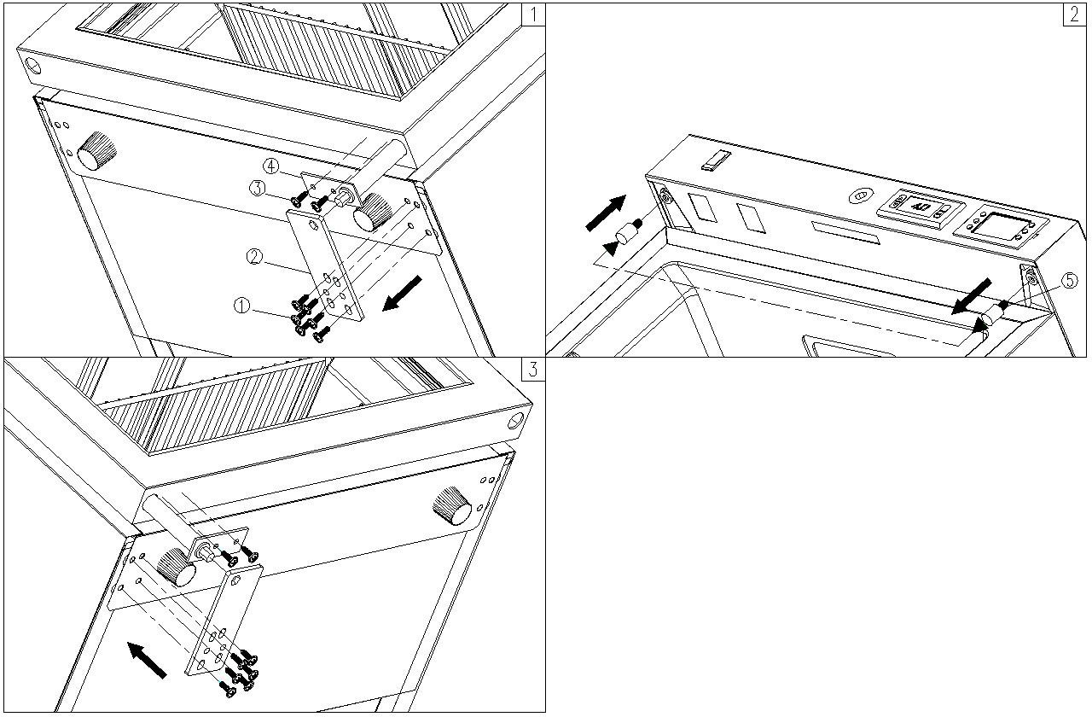

NOTE: All models are shipped with self-closing doors by default, should you choose to reverse the door swing of the appliance, the door will no longer be self-closing.

NOTES:
All parts removed must be saved to allow the door swing to be reversed. Some models may not be reversible in the field
- Remove the bottom hinge ② by unscrewing the six screws①, and firmly hold the door when removing the screws (Pic 1)
- Gently pull the door down and remove it from the top hinge and place it on a padded surface to avoid damage. Then unscrewing the screw③, move the door closer ④ to the other side. (Pic 1, 3)
- Unscrew the top hinge pin ⑤ from the unit and reinstall it on the other side. (Pic 2)
- Relocate the door to the designated position, then screw the bottom hinge on the left, and tighten it after the door is leveled. (Pic 3)

OPERATING YOUR APPLIANCE
Temperature Controller

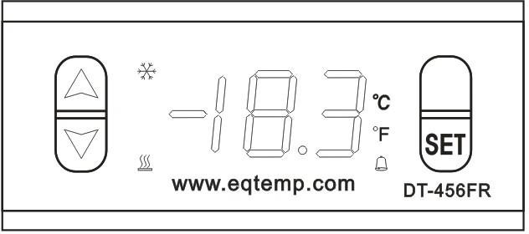
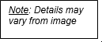
Each refrigerator has a factory preset temperature controller (thermostat). The default setpoint for your unit is 4°C (39°F). To confirm or change the temperature setting, follow the steps below:

TO SEE THE SET POINT
The default display for your temperature controller is the internal cabinet temperature. To view the unit’s set point, push and immediately release the SET key. The display will flash, showing the set point value. If no other actions are taken in 6 seconds, the display will revert to the internal air temperature.

Please note the temperature displayed on the temperature controller is the internal air temperature. Your temperature measurement device/alarm/thermometer (installed on the left in the control panel) provides a temperature readout based on the buffered probe to better simulate the temperature of what is stored inside the unit (as opposed to the air temperature itself). As a result, these readings may not always display the same temperature reading.


Changes to the settings are not recommended; any changes may compromise the unit’s ability to perform in compliance with the NSF/ANSI 456 Standard.
If you find it necessary to change the temperature setting for your temperature controller, follow the instructions below:

To change the SET POINT
- To prevent accidental adjustment, the temperature controller is locked. To unlock it, press the DOWN arrow and hold for six seconds and ON will be displayed.
- To change the set point, push and immediately release the SET key. The display will flash, while the current set point value is blinking, press the UP or DOWN arrow to change the set point to your desired temperature. Press the SET button again to exit the adjustment. The display will revert to the internal air temperature. To lock the thermostat, press the down arrow and hold for six seconds and OFF will be displayed.

NOTE: The temperature controller displays the set point after the unit stabilizes to the set temperature. It only reads the air temperature during the stabilization period.

Temperature Measurement Device (TMD-02)
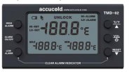
Your appliance is equipped with a temperature measurement device (TMD) also referred to Thermometer/Alarm that simultaneously displays minimum, maximum, and current interior temperatures and provides a visual and audible signal when the temperature inside the unit falls outside the set temperature range.

NOTE: When you first receive your appliance, the TMD-02 is powered off. It will need to be turned on before use. To turn the TMD on, press and hold the button for five seconds.

NOTE ABOUT CALIBRATION: Models with NSF456 suffix are equipped with a NIST-calibrated TMD-02. A two-year certificate of calibration is included in the alarm/thermometer box that comes inside your unit. Keep this certificate stored safely for your records. EQTemp® offers re-calibration services through our ISO 17025:2017 certified calibration laboratory. It is recommended to have your TMD re-calibrated every two years (or one year, depending on your state’s health department guidelines). For more information on how to have your device re-calibrated or to replace a valid certificate, contact us at calibration@summitappliance.com.

The temperature sensor, or probe, is enclosed in a glycol or glass bead-filled bottle that is stored inside your unit in a special shelving compartment.

Function of Controls
MODE/RESET Key: Press ONCE to reset Max/Min temperature record. When the unit is sounding an alarm, press ONCE to turn off the beeping sound.
HI/LO Key: Press ONCE to display high alarm setting. Press TWICE to display low alarm setting. Press THREE TIMES to display current temperature reading.

ºF/ºC Key: Press this button to change the temperature display scale from Fahrenheit (ºF) to Celsius (ºC).

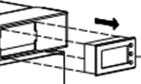
Battery Installation: Gently pull out your TMD from the housing. Remove battery compartment cover located on the rear of the unit and remove insulation strip from battery compartment. Following the polarity (+/-) diagram in the battery compartment, install the battery. Replace the battery cover. The unit will beep, and all segments of the LCD will be activated.

Programming the Alarms
By default, the high alarm temperature setting is 8°C (46.4°F) and the low alarm temperature setting is 2°C (35.6°F). To reset these limits, follow these instructions:
NOTE: When the alarm feature is ON, the alarm icon 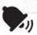 will be displayed, and the user can receive visual and audible alarm notifications. Long press the ALARM ON/OFF to turn the alarm feature ON/OFF.
High Alarm Temperature Setting: Press the High Alarm button once to enter the High Alarm temperature setting mode. HI-SET will display on the LCD screen. Use the Up and Down arrows to adjust the temperature accordingly. Then press the LOW ALARM button to confirm. The LCD screen will return to the current temperature.

Low Alarm Temperature Setting: Press the Low Alarm button once to enter the Low Alarm temperature setting mode. LO-SET will display on the LCD screen. Use the Up and Down arrows to adjust the temperature accordingly. Then press the LOW ALARM button to confirm. The LCD screen will return to the current temperature.

NOTE: The TMD can be locked to avoid accidental adjustments. By default, the TMD is unlocked.
Long press ºC/ºF and keys simultaneously for 6 seconds to lock all the alarm features. LOCK will display on the screen when the unit is successfully locked. When the TMD is locked, the alarm features and functions are inaccessible, except for silencing beeping sound.
If the temperature rises above or falls below the set temperature range, the alarm will emit a beeping sound, and the HI-ALARM/LO-ALARM indicator on the display will blink until the temperature is back in range. To silence the alarm, press any button. The beeping sound lasts for 60 seconds, but the high and low indicators will remain on display even when the unit gets back in range. Press the LOW ALARM and RESET keys simultaneously to clear the LO-ALARM/HI-ALARM display indicators. The alarm will beep every 30 minutes if the same alarm event exists, even if the user has silenced the alarm. The alarm will NOT clear if an alarm event still exists.

More details about the features and usage of the TMD can be found in the User Manual accompanying the unit.
This appliance is equipped with a 3/8” probe port and plug, which can accept additional monitoring devices. It is recommended that you position the additional temperature monitoring device on the middle shelf close to the TMD sensor.

Door Alarm
If the door has been left open for more than 60 seconds, the alarm will sound. Pressing the POWER key once or closing the door can switch off the audible alarm.

Door Lock
Your unit is provided with a lock and key combination. The keys are located inside the plastic bag that contains this User Manual. Insert the key into the lock and turn it counterclockwise to unlock the door. To lock the door, follow the directions in reverse, making sure the metal pin is engaged completely.
Remove the key and put it in a secure place for safekeeping.

Shelves
To prevent damaging the door gasket, make sure to have the door all the way open when pulling the shelves out of the rail compartment.
  - The top and bottom shelves can be removed to store larger items.
  - When removing a shelf from the rail compartment, make sure to remove all stored items first. Then move the shelf to the position where the notch of the shelf is exactly under the plastic post and lift the shelf. To replace the shelf, repeat the steps described above in reverse.
  - The center shelf is fixed in place and cannot be removed. This is because the glass bead-filled bottle that contains the temperature sensor for your TMD-02 Thermometer/Alarm is best stored in this location. The center of your refrigerator or freezer will provide the most accurate temperature readings.
NOTE: For proper temperature monitoring, keep the bottle in place and do not remove this shelf.

Energy-Saving Tips
  - The appliance should be located in the coolest area of the room or outdoor location, away from heat- producing appliances and out of direct sunlight.
  - Ensure that the unit is adequately ventilated. Never cover air vents.
  - Do not keep the door open any longer than necessary. Remove as many items as needed at one time and close the door as soon as possible. Organize and label food to reduce door openings and extended searches.
  - Let hot items cool to room temperature before placing them in the unit. Overloading the unit with hot items forces the compressor to run longer.
  - Be sure to wrap foods properly, and wipe containers dry before placing them in the unit. This cuts down on frost build-up inside the unit.
  - Unit shelves and storage bins should not be lined with aluminum foil, wax paper, or paper toweling. Liners interfere with cold air circulation, making the unit less efficient.

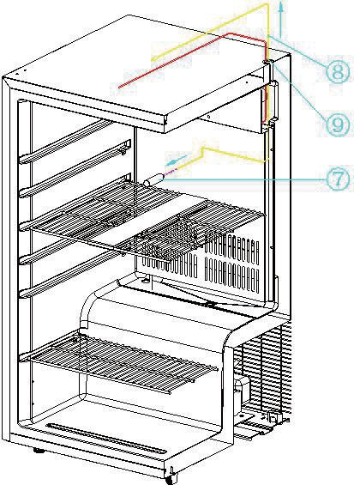
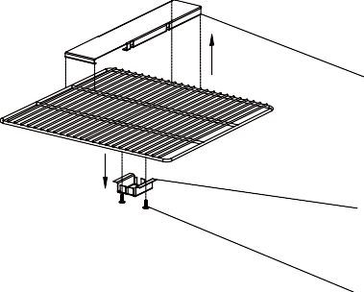
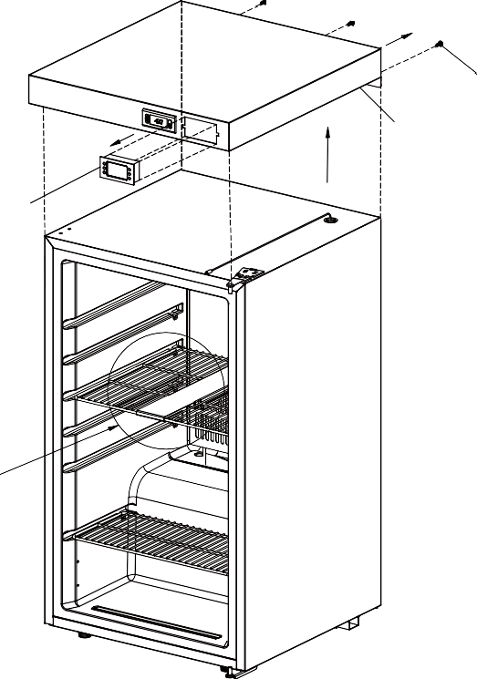
How to Remove the Thermometer/Alarm for Recalibration

A

- Remove the three screws (1) that affix the top cover to the unit.
- Gently pull out the TMD-02 (2) following the direction of the arrow in the picture and then disconnect it from the temperature sensor cable
- Remove the top cover (3)
- Unscrew the 2 screws (4), and be careful to hold the glass bottle holder (5)
- Remove the glass bottle holder (5) and take out the glass bottle
- Remove the shelf cover (6)
- Gently pull the temperature sensor head out of the glass bottle (7)
- Pull out the temperature sensor cable (8) (yellow color)

CARE AND MAINTENANCE

Cleaning your Appliance
  - Turn off the power, unplug the appliance, and remove all items, including shelves.
  - Wash the inside surfaces with a solution of warm water and baking soda (about 2 tablespoons of baking soda to a quart of water).
  - Wash the shelves with a mild detergent solution.
  - Wring excess water out of the sponge or cloth when cleaning the area where the controls are located, or any electrical parts.
  - Wash the outside cabinet with warm water and mild liquid detergent. Rinse well and wipe dry with a clean, soft cloth.

CAUTION: Failure to unplug the appliance during cleaning could result in electrical shock or other personal injuries.

Power Failure
Most power failures are corrected within a few hours and should not affect the temperature of your appliance if you minimize the number of times the door is opened. If the power is going to be off for a longer period, you need to take the proper steps to protect the contents.

Vacations
  - Short vacations: Leave the appliance operating during vacations of less than three weeks.
  - Long vacations: If the appliance will not be used for several months, remove all items, and turn off the appliance. Clean and dry the interior thoroughly. To prevent odor and mold growth, leave the door open slightly, propping it open if necessary.

MOVING YOUR APPLIANCE
- Remove all items.
- Securely tape down all the loose items (i.e., shelves) inside your appliance.
- Turn the adjustable legs up to the base to avoid damage.
- Tape the door shut.
- Be sure the appliance stays secure in an upright position during transportation. Also, protect the outside of the appliance with a blanket or similar item.

TROUBLESHOOTING
You can solve many common problems easily, saving you the cost of a possible service call. Try the suggestions below to see if you can solve the problem before calling the servicer.

PROBLEM | POSSIBLE CAUSE | FIX
The appliance does not operate. | Appliance is not connected to a power source.  The appliance is turned off.  Tripped circuit breaker or a blown fuse. | Connect the appliance. Switch on the appliance.  Switch on circuit breaker or replace fuse.
The appliance is not cold enough. | The temperature is not set correctly.  The ambient temperature could require a lower temperature setting.  The door was opened too often.  The door was not closed completely. The door is not hermetically sealed. The condenser is too dirty.  The ventilation opening is blocked or too dusty. | Check the set temperature. Set a lower temperature.  Do not open the door more often than necessary.  Close the door properly.  Check the door seal and clean or replace it.  Clean the condenser when necessary.  Clear the obstructions and clean the dust.
The appliance turns itself on and off frequently. | The room temperature is higher than average.  A large amount of food has been added to the unit.  The door is opened too often.  The door is not closed completely.  The door gasket does not seal properly. | Put the appliance in a cooler place. Leave the appliance to work for a while until the set temperature has been reached.  Do not open the door more often than necessary.  Close the door properly.  Check the door seal and clean or replace it.
The light does not work. | Appliance is not connected to a power supply.  Tripped circuit breaker or a blown fuse. The light was switched off on the control panel. | Connect the appliance.  Switch on the circuit breaker or replace the fuse.  Switch on the light.
Vibrations | The appliance is not properly leveled. | Level the appliance with adjustable feet.
The appliance seems to make too much noise. | The rattling noise may come from the flow of the refrigerant, which is normal. As each cycle ends, you may hear gurgling sounds caused by the flow of refrigerant in your appliance.  If temperature fluctuations occur, the contraction and expansion of the inner walls may cause popping and crackling noises.
The appliance seems to make too much noise. | The appliance is not properly leveled. | Level the appliance with adjustable feet.
The door will not close properly. | The appliance is not properly leveled. The door was reversed and not properly installed.  The gasket is dirty.  The shelves are out of position. | Level the appliance with adjustable feet.  Check the door hinge and reassemble correctly.  Clean the door gasket.  Check the shelves and refit correctly.

The alarm sounds and the temperature display flashes. | Has the appliance door been open for longer than 60 seconds? If not, then the temperature has risen higher or fallen lower than the temperature that has been set. This could be due to: | If yes, close the door.  Do not open the door more often than necessary.  Clear the obstructions and clean the dust.  Leave the appliance to work for a while until the set temperature has been reached.
The alarm sounds and the temperature display flashes. | The appliance door is opened too often.  The ventilation opening is covered or too dusty.  A lengthy interruption in the power supply.  A large amount of content has been added to the unit.

If you have checked the table above and find that you still need help with your appliance, call our Customer Service facility at 302-555-1938 between 9:00 AM and 5:00 PM ET or visit http://acme.co/support. We will do our best to answer your questions.

This product uses eco-friendly hydrocarbon refrigerant and fully complies with California CARB regulations.
However, we are required by California Law to provide the following disclosure statement in every product sold in California.

"This equipment is prohibited from use in California with any refrigerants on the 'List of Prohibited Substances' for that specific end-use, in accordance with California Code of Regulations, title 17, section 95374. This disclosure statement has been reviewed and approved by Felix Storch, Inc. and Felix Storch, Inc. attests, under penalty of perjury, that these statements are true and accurate."
This product does not use any refrigerants on the 'List of Prohibited Substances'"

LIMITED WARRANTY

ONE-YEAR LIMITED WARRANTY
Within the 48 contiguous United States, for one year from the date of purchase, when this appliance is operated and maintained according to instructions attached to or furnished with the product, warrantor will pay for factory-specified parts and repair labor to correct defects in materials or workmanship. Service must be provided by a designated service company. Outside the 48 states, all parts are warranted for one year from manufacturing defects. Plastic parts, shelves and cabinets are warranted to be manufactured to commercially acceptable standards, and are not covered from damage during handling or breakage.

FIVE-YEAR COMPRESSOR WARRANTY
- The compressor is covered for five years.
- Replacement does not include labor.

ITEMS WARRANTOR WILL NOT PAY FOR:
- Service calls to correct the installation of your appliance, to instruct you how to use your appliance, to replace or repair fuses or to correct wiring or plumbing.
- Service calls to repair or replace appliance light bulbs or broken shelves. Consumable parts (such as filters) are excluded from warranty coverage.
- Damage resulting from accident, alteration, misuse, abuse, fire, flood, acts of God, improper installation, installation not in accordance with electrical or plumbing codes, or use of products not approved by warrantor.
- Replacement parts or repair labor costs for units operated outside the United States.
- Repairs to parts or systems resulting from unauthorized modifications made to the appliance.
- The removal and reinstallation of your appliance if it is installed in an inaccessible location or is not installed in accordance with published installation instructions.

DISCLAIMER OF IMPLIED WARRANTIES; LIMITATION OF REMEDIES
CUSTOMER'S SOLE AND EXCLUSIVE REMEDY UNDER THIS LIMITED WARRANTY SHALL BE PRODUCT REPAIR AS PROVIDED HEREIN. IMPLIED WARRANTIES, INCLUDING WARRANTIES OF MERCHANTABILITY OR FITNESS FOR A PARTICULAR PURPOSE, ARE LIMITED TO ONE YEAR. WARRANTOR SHALL NOT BE LIABLE FOR INCIDENTAL OR CONSEQUENTIAL DAMAGES. SOME STATES DO NOT ALLOW THE EXCLUSION OR LIMITATION OF INCIDENTAL OR CONSEQUENTIAL DAMAGES, OR LIMITATIONS ON THE DURATION OF IMPLIED WARRANTIES OF MERCHANTABILITY OR FITNESS, SO THESE EXCLUSIONS OR LIMITATIONS MAY NOT APPLY TO YOU. THIS WARRANTY GIVES YOU SPECIFIC LEGAL RIGHTS AND YOU MAY ALSO HAVE OTHER RIGHTS, WHICH VARY FROM STATE TO STATE.

WARNING: This product can expose you to chemicals including Nickel (Metallic) which is known to the State of California to cause cancer.
For more information go to www.P65Warnings.ca.gov
Note: Nickel is a component in all stainless steel and some other metallic compositions.

For parts and accessory ordering, troubleshooting, and helpful hints, visit:
www.acme.co/support
ACMED Division of ACME, Inc.
Non-Explosive Medical Appliance Division
2 ACME Way
Metropolis, MD 19958
www.acme.co

