DELOITTE | SALESFORCE ENGINEERING
AI Agent-Augmented
Salesforce Delivery Pipeline
Troubleshooting & Operations Guide
Automated pre-flight checks, recovery from failure, the full issue log, notifications, and running the pipeline day to day
Version | 8.0 — 10 new issues (C15, G16, E11, D1–D3, F1–F4), 93 in total; new section 5.12, deploy notifications (6.7), and Part 12 Operating v8 (live progress, step timings, Salesforce deploy tracking with Done after a successful deploy). Previous: 7.0 — closes G11 and adds the continuous multi-ticket flow: 9 new issues (G12–G15, E9, E10, J3–J5), 83 in total; new section 5.11, PR and queue notifications (6.6), and Part 11 Operating the Continuous Flow. Previous: 6.0 — adds 9 issues from the second and third end-to-end runs (C13, C14, E7, E8, S11–S13, G10, G11), 74 in total; closes C12 (real AI credits from the usage file), G9 (PR 422) and R8 (deploy approval gate); adds the live pipeline dashboard (Part 8.6) and how to verify a seeded bug safely (Part 4.5). Previous: 5.0 — adds 8 issues found in the first full end-to-end run (C9–C12, S9, S10, G9, R8), 65 in total: prompt via stdin, auto-tier model routing, deploy validate for Apex tests, the AuraHandledException message fix, and the merge-gate gap. Previous: 4.0 — adds Phase 0 guardrails (budget, ceiling, run lock, production-org guard, redaction, security checks) and Phase 1 code intelligence (plain-language ticket matching, model routing); 21 new issues (R1–R7, L1–L14), 57 in total. Previous: 3.0 — split from the combined v2 guide; adds automated pre-flight checks (preflight.py), configurable multi-recipient notifications (recipients.json), and 4 new issues (P1–P4) found while building the automation
Companion document | Pipeline-Implementation-Guide-v8.docx (software installation, account setup, new-project setup, Salesforce deployment)
Date | October 2026
Author | Pavan Vellure, Senior Consultant, Deloitte
Audience | Anyone operating this pipeline day to day, or called in when a run fails
Classification | Deloitte Internal

How to Use This Guide
This is the second of two documents. The companion Implementation Guide covers installing software and setting up a new project. This guide covers everything from the moment you first run watch_queue.py onward: what it checks automatically before it will even start, how to read what's happening while it runs, how to recover when something fails, and a complete log of every real issue encountered while building and testing this pipeline.
If you want to… | Go to
Understand what the watcher checks automatically before it starts | Part 1 — Automated Pre-Flight Checks ★ read this first
See the full manual checklist the automation is based on | Part 2 — Pre-Flight Checklist Reference
Know what you will see on screen while it runs | Part 3 — Running the Watcher Service
Get going again after the watcher stops halfway | Part 4 — Recovery Playbook
Fix a specific error message | Part 5 — Issue Log (93 real issues)
Get notified when something fails, and control who | Part 6 — Failure Notifications
Run this day to day: housekeeping, safety switches, security | Part 7 — Operating the Pipeline
Look up a validation check or use a sign-off checklist | Appendices E–G
Understand the budget, ceiling, lock and security checks while it runs | Part 8 — Cost and Safety Guardrails in Operation (new in v4)
Understand how tickets are matched to code and which AI model is used | Part 9 — Code Intelligence in Operation (new in v4)
See what is planned next (dashboard, cloud, pilot) | Part 10 — Roadmap for Operators (new in v4)
Run several tickets in one session, follow PRs and batches | Part 11 — Operating the Continuous Flow (new in v7)
Follow progress, step times and deploys to Done | Part 12 — Operating v8 (new in v8)

Conventions used
- monospace text is something you type or a file name. <KEY> is a Jira ticket key; <alias> is a Salesforce CLI org alias.
- Screen captures show real output recorded during our implementation. Your paths and ticket numbers will differ.
IMPORTANT — Read Part 1 before every first run on a new project
Most failures we hit could have been caught in under two minutes by the automated pre-flight checks described in Part 1. As of v3, these run automatically every time you start the watcher — you no longer need to remember to check manually.

Contents

Right-click the table above and choose Update Field (or press F9) if page numbers do not appear.

Part 1 — Automated Pre-Flight Checks
This is the single most important change in v3. Previously, a human had to remember to run a 27-item manual checklist (reproduced for reference in Part 2) before starting the watcher. As of v3, watch_queue.py runs these checks automatically, every time, via agent/preflight.py — and refuses to start polling at all if anything fails.

1.1 What happens automatically at startup
The moment you run python watch_queue.py, before it polls Jira even once, it calls preflight.run_all(), which checks four groups in order:
Group | What it checks | Why
A — Repository state | Working tree is clean; you're on the base branch (main); the local repo is fast-forwarded to the absolute latest `origin/main` | Guarantees the agent only ever fixes the current, correct version of the code — never a stale local copy
B — Copilot CLI | Copilot is logged in; this exact folder is trusted for shell commands and file writes | The #1 and #2 most common causes of a silently-failed run in v2
C — Credentials and config | Jira and GitHub are reachable; GITHUB_REPO matches the actual git remote; SF_TARGET_ORG is set; the kill switch is on | Catches token/config mismatches before they waste a Copilot run
D — Salesforce | The target org is authenticated and reachable | Confirms validation and deployment will actually be able to run tests
S — Security (v4) | The org is a sandbox or Developer Edition (and in ALLOWED_ORG_IDS if set); main requires a pull request; the GitHub token is fine-grained and reaches only this repository | Makes the "AI can never reach production or merge" guarantee something that is checked every start, not assumed

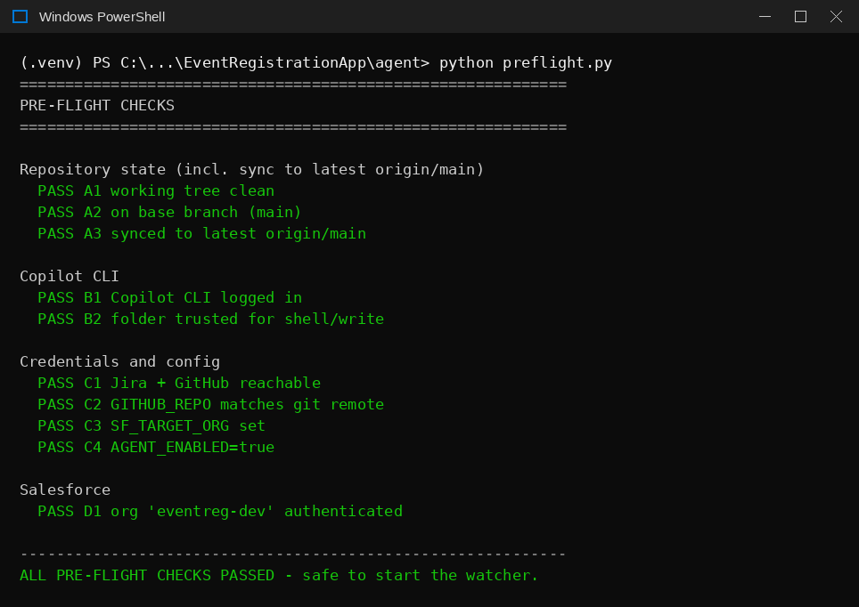
Figure 1. A healthy pre-flight run — all four groups pass, and the watcher is told it's safe to start.
If any check fails, the watcher prints exactly which one, why, and what to do — then exits immediately without polling Jira at all. A notification also fires (Part 6).

1.2 The repository sync behaviour — why it's conservative by design
The sync check in Group A does more than confirm you're on the right branch. It runs git fetch origin and compares your local main to origin/main. Three outcomes are possible:
Situation | What preflight.py does
Local already matches origin exactly | Nothing to do — passes immediately
Local is behind origin, with no local-only commits | Automatically fast-forwards (git pull --ff-only) — safe, since nothing local would be lost
Local and origin have genuinely diverged (local has commits origin doesn't) | Refuses to auto-merge, rebase, or reset. Fails the check and tells you to reconcile manually with git log --graph --all and git merge or git cherry-pick

IMPORTANT — Why it will not just “fix” a divergence for you
An earlier real incident (Issue G3) involved git reset --hard origin/main silently discarding a real, uncommitted-to-remote fix. preflight.py is deliberately written to never perform any operation that could discard local work — a fast-forward is the only automatic action it will ever take. Anything riskier is left for a human to decide, every time.

1.3 The second gate: re-checking before every single ticket
The full pre-flight check in 1.1 only runs once, at startup. But the watcher may run unattended for hours or days — someone could merge a PR to main while it's idle between polls. To handle this, watch_queue.py runs a lighter re-check (just the Group A repository checks) immediately before branching for every individual ticket, not just at startup.
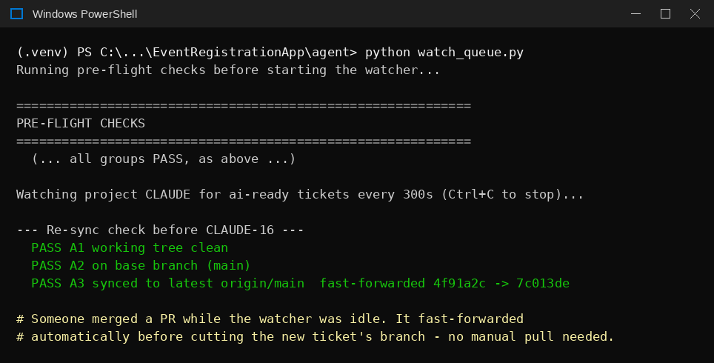
Figure 2. The watcher automatically fast-forwards to a newly-merged commit before cutting the next ticket's branch — no manual git pull needed.
If this per-ticket re-check fails (for example, a genuine divergence happened while the watcher was idle), only that one ticket is skipped — with a notification — and the watcher goes back to polling. It does not shut down entirely, since the next ticket may well be fine.

1.4 Running it standalone
You can run the full pre-flight report at any time, independent of starting the watcher — useful for a quick health check, or for debugging:
cd agent
python preflight.py

Exit code 0 means every check passed; a non-zero exit code means at least one failed. This is the same function watch_queue.py calls automatically — running it by hand just lets you see the report without committing to starting a full watcher session.

1.5 New in v4: security checks and spending gates
At startup the watcher now runs security_checks.run_all() straight after preflight.run_all(). Both must pass. Before every Jira poll it also checks the monthly budget and the daily ticket cap; if either is reached it claims nothing, leaves tickets as ai-ready, and sends one alert per day. Before every ticket it re-runs the git checks and the production-org guard. It also rebuilds the code index (Part 9) at startup, every poll cycle and after each ticket — an indexing problem prints a warning and never blocks the watcher.
WHAT A HEALTHY v4 START LOOKS LIKE
Running pre-flight and security checks...
... all Group A-D checks PASS ...
Security checks:
PASS Salesforce org is non-production - Developer Edition 'Agentforce_CICD' (00Dau00000COSx7EAH)
WARN Base branch requires a reviewed PR - main is protected, but review rules could not be read ...
WARN GitHub token is least-privilege - account has admin on pvellure-hash/EventRegistrationDemo ...
[index] refreshed (startup): 10 files, 0 re-parsed
Watching CLAUDE for ai-ready tickets every 300s (Ctrl+C to stop)...
Limits: budget $25/month, 10 tickets/day, 60 credits/ticket

The two WARN lines are expected for a solo owner with a correctly scoped token (Issues R3 and R5). Any FAIL stops the watcher.

Part 2 — Pre-Flight Checklist Reference
This is the original, detailed manual checklist that preflight.py (Part 1) now automates. It's kept here for two reasons: it explains the *reasoning* behind each automated check in more depth than the terse pass/fail output does, and it covers a few project-level and ticket-level items (Groups E and F) that are deliberately not automated, since they depend on judgement calls a script shouldn't make silently.

2.1 Group A — Repository state (now automated, Part 1.1–1.3)
# | Check | Command | Expected | If it fails
A1 | Working tree is clean | git status | “nothing to commit, working tree clean” | Commit, stash or remove the files
A2 | You are on main | git branch --show-current | main | git checkout main
A3 | main matches GitHub | git fetch origin then git status | “up to date with 'origin/main'” | Now auto-resolved if a simple fast-forward; see Part 1.2 if diverged

2.2 Group B — Copilot CLI (now automated, Part 1.1)
# | Check | Command | Expected | If it fails
B1 | Logged in | copilot -p "say hello" -s --no-ask-user | A short reply | copilot login --device-code
B2 | Folder trusted for shell | copilot -p "run: git status --short --branch" -s --no-ask-user | Real git output | See Issue C1/C2
B3 | Enough Copilot credits | github.com → Settings → Copilot | Requests remaining | Upgrade or wait for reset (Issue C8)

2.3 Group C — Credentials and configuration (now automated, Part 1.1)
# | Check | Command / where | Expected | If it fails
C-1 | Jira and GitHub reachable | python check_connections.py | All lines OK | 404 → token for wrong repo (Issue G6)
C-2 | Correct Salesforce org | .env vs sf org list | SF_TARGET_ORG is this project's org | Fix the alias (Issue S8)
C-3 | Correct GitHub repo | .env vs git remote -v | Same owner/repo | Fix GITHUB_REPO
C-4 | Jira status names match | .env vs a Jira ticket | Exact spelling and case | Correct the values

2.4 Group D — Salesforce (now automated, Part 1.1)
# | Check | Command | Expected | If it fails
D1 | Org authenticated | sf org display --target-org <alias> | Connected status | sf org login web --alias <alias>
D2 | Your user can see the objects | Run the test class once | All tests pass on main | Assign the permission set (Issue S2)

2.5 Group E — The Jira ticket (not automated — judgement calls)
# | Check | Expected | If it fails
E-1 | All four headings are in the Description field | Steps to Reproduce, Expected Result, Actual Result, Acceptance Criteria — as plain text | Ticket is labelled ai-needs-info (Issue J1)
E-2 | Label applied | ai-ready | Watcher ignores the ticket
E-3 | If re-running a ticket | ai-locked, ai-needs-info, ai-blocked removed; ai-ready re-added | Issue J2
E-4 | No instructions to the AI in the text | Plain description of the problem | Labelled ai-blocked
E-5 | One clear problem per ticket | Fits within 5 files / 200 lines | Validation size checks fail

2.6 Group F — Only when testing with a seed bug (not automated)
# | Check | Expected | If it fails
F1 | Seed bug merged through a normal PR on main | Merged; local main pulled | The agent may fix code that is not in main
F2 | Seed bug actually deployed to the org | Deployed with --test-level NoTestRun | With RunLocalTests the deploy rolls back (Issue S4)
F3 | Bug is visible in the UI | Bad input is accepted | Browser validation is hiding it (Issue S5)

TIP — First run on a new project
Run once with AGENT_DRY_RUN=true. Copilot still edits files locally so you can see the review gate, but nothing is written to Jira or GitHub. Then set it to false, reset the ticket labels (Issue J2), and run for real.

Part 3 — Running the Watcher Service

3.1 Start it
cd agent
python watch_queue.py

Leave the window open. It runs the automated pre-flight checks from Part 1 first; if they pass, it checks Jira every WATCH_POLL_INTERVAL_SECONDS (default 300). When a ticket is claimed you will see this:
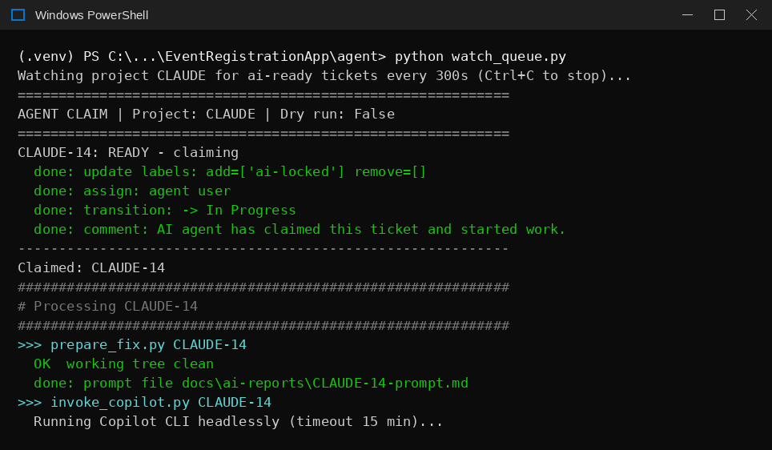
Figure 3. The watcher claims CLAUDE-14, prepares the branch and prompt, then starts Copilot.

3.2 While Copilot is working, the screen looks frozen
Copilot runs in silent mode, so nothing prints until it finishes. v8: a live progress line now shows the step, elapsed time against the usual time, and files edited / commits made (Part 12). A normal fix takes 1–5 minutes; the limit is COPILOT_CLI_TIMEOUT_MINUTES (15). Do not press Ctrl+C. If you want to watch progress, open another terminal and check git status.

3.3 The review gate: how to decide
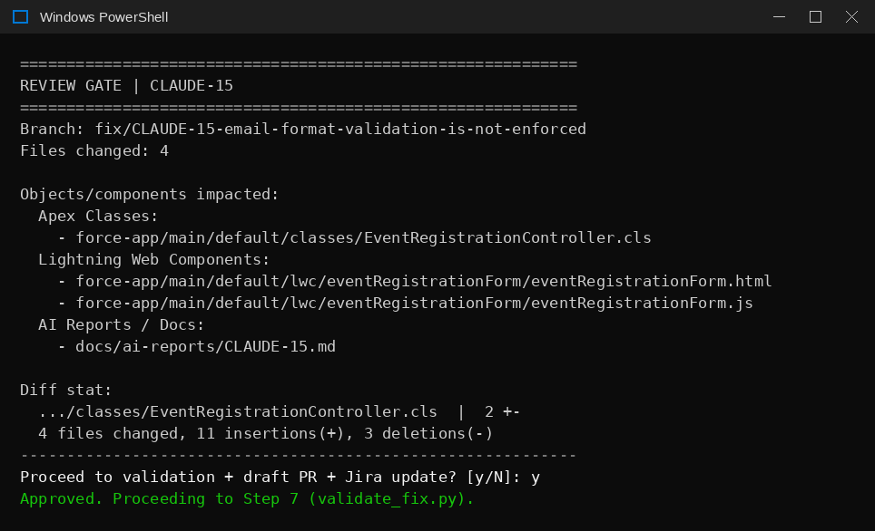
Figure 4. The review gate for CLAUDE-15, listing every file and Salesforce component changed.
Approve (type y) when… | Reject (type n or press Enter) when…
Files changed match what the ticket describes  Only expected Salesforce components are listed  A test file or the existing tests cover the change  The root cause in the Solution Report excerpt makes sense | Files changed: 0 — Copilot did nothing (Issue C7)  Files unrelated to the ticket appear  Anything under agent/, .github/, profiles or permission sets (auto-rejected anyway)  The change is much larger than the ticket warrants

WATCH OUT — We once approved a run with 0 files changed
The review gate does not block an empty change by itself. Approving it simply moves the failure to validation. Always read the file count first.

3.4 Validation, Pull Request and Jira update
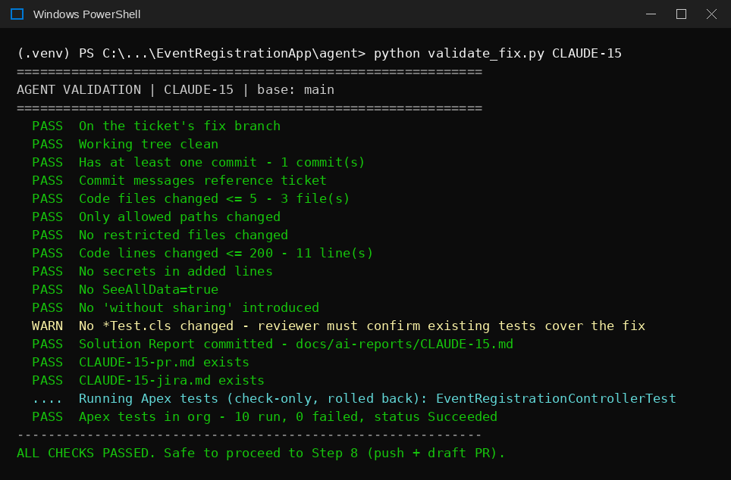
Figure 5. All checks passed, including the real Apex tests in the org.
After approval, the pipeline continues on its own: validation, push, draft PR, and Jira update. The ticket gets a comment with the PR link and the Solution Report attached, the label ai-pr-created, and the status In Review.

3.5 Finish the ticket (human steps)
- Review the draft PR on GitHub, mark it ready, approve and merge.
- GitHub → Actions: confirm the Salesforce Deploy run Succeeded. Merged does not mean deployed.
- Re-test the original problem in the live app (hard refresh with Ctrl+F5).
- Move the Jira ticket to Done.
- Delete the branch: git checkout main; git pull; git branch -d <branch>; git push origin --delete <branch>

3.6 How the watcher handles several tickets
The watcher processes one ticket at a time, start to finish. While it is waiting at your review gate, it is not polling Jira. v7: it no longer waits for merges — once a draft PR is open it returns to main and polls again after 5 seconds, so the queue keeps moving while PRs wait for review. Tickets that change the same files as an open PR wait as ai-waiting; related ready bugs are fixed together in one batch (Part 11, and Implementation Guide Part 13). Do not run two watchers on the same repository.

3.7 Stopping it
Press Ctrl+C. Nothing is lost: every script is safe to re-run, and prepare_fix.py resumes an existing branch instead of creating a new one.

3.8 New lines you will see on screen in v4
Line | Meaning
[phase1] localisation confidence=0.55 complexity=moderate | How sure the code index is about which files the ticket affects (threshold 0.35), and how big the change looks
7.0 ...Email__c.field-meta.xml <- mentions 'email' (summary) ... | The top candidate files and why each scored. Tags: (summary) counted double, (area) inherited from parent object, (common)/(generic) low-value words
[phase1] plan: {'action': 'run', 'tier': 'standard', ...} | Decision: run at a tier, or ask_for_info (stop, no AI), or hand_to_person
[phase1] context pack: 2515 tokens, 5 files included | How much code is placed directly in the prompt
[phase1] routed to standard tier -> model gpt-4.1 (saved to logs/routing/...) | The model invoke_copilot.py will use
budget : budget ok: $0.42 of $25.00 (2%) / ceiling: / org : / mcp : | Gates checked inside invoke_copilot.py before any AI spend
cost: 12.50 AI credits (~$0.12) | Credits Copilot reported for this run (written to run-events.jsonl)
[dashboard] refreshed (after agent): 4 tickets, $0.72 | The cost dashboard was rebuilt
[index] refreshed (poll cycle): 10 files, 0 re-parsed | Incremental code-index rebuild (no AI); 0 re-parsed means nothing changed
Not claiming: monthly budget reached | Spending gate closed; nothing is claimed until next month or the budget is raised

Part 4 — Recovery Playbook: When the Watcher Stops Halfway
When a step fails, the watcher logs it, sends a notification (Part 6), and goes back to polling. The ticket stays labelled ai-locked and the fix branch stays in place. You do not need to start from the beginning. Find the step that stopped below, fix the cause, then run the remaining scripts by hand.
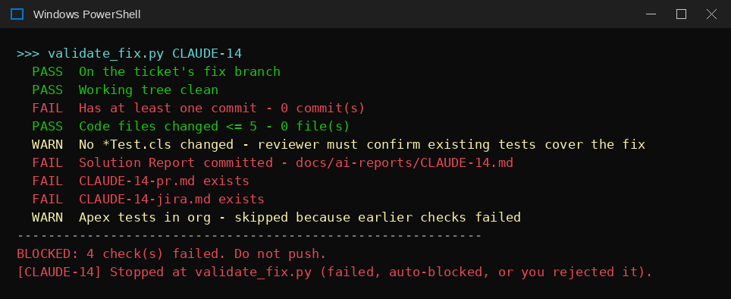
Figure 6. A run stopped at validation: Copilot made no commits, so four checks failed.

4.1 Where did it stop?
Stopped at | Most likely cause | First thing to run | Then resume with
pre-flight (startup) | Any Group A–D check failed — see Part 1 | python preflight.py | Fix the item shown, then restart watch_queue.py
pre-flight (per-ticket) | Repo diverged while watcher was idle | git log --oneline --graph --all | Reconcile manually, then let the watcher retry next poll
claim_ticket.py | Missing headings or suspicious text | python read_queue.py | Fix the ticket, reset labels (Issue J2); the watcher picks it up
prepare_fix.py | Dirty working tree or diverged main | git status | Fix (Issue G1/G2), then run prepare_fix.py <KEY>
invoke_copilot.py | Folder trust, token leak, timeout | type logs\<KEY>-copilot-cli.log | Fix (Issue C1–C3), then invoke_copilot.py <KEY>
review_gate.py | You rejected, or restricted path touched | Read the printed summary | Fix or redo the change, then review_gate.py <KEY>
validate_fix.py | No commit, missing report files, test failure | Read which checks say FAIL | Fix (Issue C5/C6), then validate_fix.py <KEY>
create_pr.py | Token scoped to wrong repo | python check_connections.py | New token (Issue G6), then create_pr.py <KEY>
update_jira.py | Jira token or status name | Compare .env with Jira | update_jira.py <KEY>
prepare_fix.py — STOP: localisation confidence too low | Ticket gives no usable signal about which feature it affects (labelled ai-needs-info, no AI used) | Read the ticket; add the screen/field/behaviour or an error message | Remove ai-needs-info (keep ai-locked), run prepare_fix.py <KEY> (Issue L13)
prepare_fix.py — STOP: suspicious content detected | A code file the fix would read contains instruction-like text (labelled ai-blocked) | logs/run-events.jsonl detail shows the file and pattern | Human review of that file; fix or allow, then relabel
invoke_copilot.py — STOP: monthly budget / ceiling | Spending limit reached | Get-Content ..\logs\run-events.jsonl | Raise the limit deliberately or hand the ticket to a developer (Part 8)
invoke_copilot.py — STOP: already being processed | Another run holds logs\locks\<KEY>.lock | Check the other terminal / watcher | Wait; a crashed run's lock expires after timeout + 10 min
invoke_copilot.py — STOP: REFUSED ... PRODUCTION org | SF_TARGET_ORG points at a production org | python security_checks.py | Point at a sandbox / Developer Edition alias

4.2 Resume the rest by hand
Make sure you are on the ticket's fix branch, then run only the steps that have not completed yet:
MANUAL RESUME
git checkout fix/<KEY>-<slug>
cd agent
python invoke_copilot.py <KEY> # only if Copilot has not produced the fix
python review_gate.py <KEY>
python validate_fix.py <KEY>
python create_pr.py <KEY> # re-validates, pushes, opens draft PR
python update_jira.py <KEY> # safe to run more than once

4.3 Copilot made the fix but did not commit
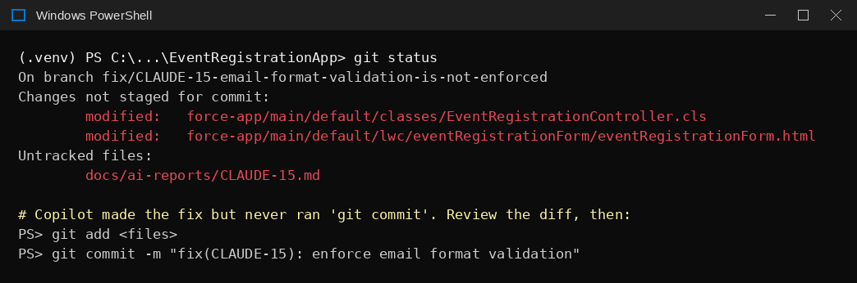
Figure 7. Changes and the Solution Report exist but are not committed.
- Review the change: git diff (and git status for untracked files).
- If it is correct and in scope, commit it yourself: git add <files> then git commit -m "fix(<KEY>): <summary>".
- If report files are missing, resume the session (the ID is at the end of the Copilot log) with copilot --resume=<id> and ask it to create only the missing docs/ai-reports files and commit, without pushing or using gh.
- Run python validate_fix.py <KEY>, then create_pr.py and update_jira.py.

4.4 Start a ticket completely over
- git checkout main and delete the fix branch locally (and on GitHub if it was pushed).
- In Jira remove ai-locked (and any ai-needs-info or ai-blocked), add ai-ready.
- Restart the watcher — the automated pre-flight check (Part 1) runs again before anything else.

4.5 Verifying a seeded bug before a demo run — new in v6
A seeded bug that breaks an existing Apex test can never be deployed through salesforce-deploy.yml: RunLocalTests rolls the whole deploy back (Issue S4). In v6 we kept it that way on purpose — the bug lives in the source on main for the agent to find, while the live org keeps the correct code. Prove the bug from the test results instead of the UI:
Evidence | Where | What it shows (CLAUDE-16 example)
PR Validate check fails | GitHub → the seed PR → Salesforce Validate | testZeroGuestsIsRejected and testNegativeGuestsIsRejected fail — the regression is real and covered by tests
Real deploy fails with test failures | Setup → Deployment Status | “Deploy: Failed — 2 Test Failures” (same-day seed: 1 Test Failure)
Org tests still pass | sf apex run test --class-names <Test> | 11/11 pass — the org still runs the old, correct code (expected)

WATCH OUT — Do not leave a manual fix in place
If you fix the seed by hand to check your understanding, restore it with git checkout -- <file> and confirm git status is clean before starting the watcher — otherwise the agent has nothing to fix and pre-flight A1 stops the run.

Part 5 — Issue Log: Every Hurdle We Hit and How to Fix It
Each issue below is a real problem hit while building and testing this pipeline, not a hypothetical. They are grouped by area and numbered in roughly the order first encountered. Use Ctrl+F in Word to jump straight to an issue code if you recognize a symptom.
Area | Issues | Most common
P — Pre-flight automation (new in v3) | P1–P4 | P1 npm .cmd shims; P2 token leak in preflight's own checks
E — Environment and tooling | E1–E6 | E3 pasting text as commands; E4 watcher looks frozen
S — Salesforce | S1–S10 (S9–S10 in 5.9) | S4 seed bug rolled back; S5 browser validation hides bug; S9 use deploy validate for Apex tests
C — Copilot CLI | C1–C12 (C9–C12 in 5.9) | C1/C2 folder trust; C5 no commit
J — Jira | J1–J2 | J1 headings in the wrong field
G — Git and GitHub | G1–G9 (G9 in 5.9) | G6 token scoped to the wrong repository
R — Run guardrails (Phase 0, new in v4) | R1–R8 (R8 in 5.9) | R1 inline .env comment; R2 private repo cannot be protected on GitHub Free; R8 0-approval ruleset lets a PR merge with no review
L — Code intelligence (Phase 1, new in v4) | L1–L14 | L4 plain-language tickets scored 0.0; L8 routed model lost between processes; L10 wrong file ranked first
D — Dashboard and progress (v8) | D1–D3 | D1 UTC dates hid evening spend
F — Salesforce deploy tracking (v8) | F1–F4 | F1 token needs Actions: Read; F2 Done waits for deploy

5.1 Pre-flight automation (preflight.py) — new in v3
These four issues were found while building the automated pre-flight checks themselves (Part 1) — all are already fixed in the current preflight.py, documented here so the same class of problem is recognized instantly if it resurfaces in a future script.
P1 preflight.py's Copilot/Salesforce checks fail with [WinError 2]
What you see | Running python preflight.py reports FAIL for the Copilot CLI and Salesforce checks with a detail of [WinError 2] The system cannot find the file specified — even though typing the same copilot or sf command directly into PowerShell works fine.
Why it happens | On Windows, npm installs copilot and sf as .cmd wrapper scripts, not .exe files. Python's subprocess.run() cannot launch a .cmd file directly without shell interpretation. PowerShell resolves .cmd shims automatically when you type a command; Python's subprocess module does not.
How to fix it | Route the command through cmd /c on Windows only (macOS/Linux are unaffected, since those platforms install plain executables): subprocess.run(["cmd", "/c"] + cmd, ...) when platform.system() == "Windows". This fix is built into the current preflight.py's _run_cli() helper.

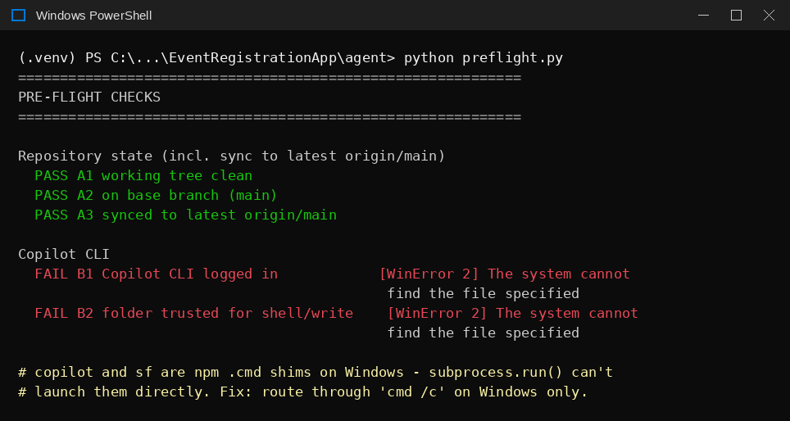
Figure 8. The WinError 2 failure before the cmd /c fix was applied.
P2 preflight.py's own Copilot checks fail with “Authentication failed”
What you see | After fixing P1, the Copilot checks still fail — now with “Error: Authentication failed... Your GitHub token may be invalid”, even though copilot -p "say hello" works fine when run directly.
Why it happens | The exact same root cause as Issue C3, but in a different script: .env's GITHUB_TOKEN (a fine-grained PAT meant only for the pipeline's own GitHub REST API calls) was leaking into the copilot subprocess that preflight.py itself launches to verify the CLI. Copilot tried to authenticate with that token instead of its own stored login, and failed because the PAT has no “Copilot Requests” permission.
How to fix it | Strip GITHUB_TOKEN / GH_TOKEN / COPILOT_GITHUB_TOKEN from the subprocess environment before launching copilot, exactly as invoke_copilot.py already did — preflight.py's own CLI checks needed the identical treatment, via a strip_github_token=True option on its _run_cli() helper.

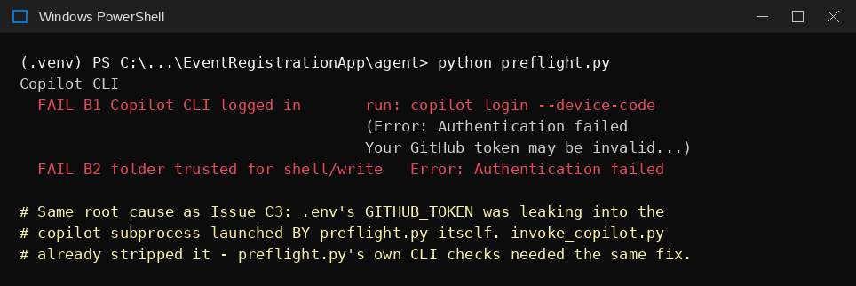
Figure 9. The authentication failure, caused by GITHUB_TOKEN leaking into preflight.py's own copilot subprocess.
P3 `check_connections.py` check in preflight.py shows FAIL with a blank detail
What you see | Group C's “Jira + GitHub reachable” check fails with no error text at all, even though running python check_connections.py directly in the same terminal shows everything is OK.
Why it happens | The check was launched with the literal string "python" rather than the exact interpreter currently running. On a machine with multiple Python installs (common after working around winget restrictions), "python" on PATH can silently resolve to a different installation than the one running inside the project's .venv — one that lacks the requests / python-dotenv packages, failing immediately with no captured output.
How to fix it | Use sys.executable instead of the literal string "python" when launching check_connections.py as a subprocess — this guarantees the exact same interpreter (and therefore the exact same virtual environment) is reused.

P4 The Salesforce org-authentication check times out
What you see | Group D's org check fails with “timed out after 30s”, even though sf org display responds quickly when typed directly.
Why it happens | Routing the command through cmd /c (the P1 fix) adds a small but real amount of overhead on the first invocation in a session, which occasionally pushed a previously-tight 30-second timeout over the edge.
How to fix it | Raise the timeout for Salesforce CLI calls specifically to 60 seconds. This does not meaningfully slow down a healthy pre-flight run — it only matters when something is already wrong.

5.2 Environment and tooling
E1 Software installs fail: winget or Microsoft Store blocked
What you see | winget install ... fails with a Group Policy message, or the Store will not open.
Why it happens | Deloitte-managed laptops block winget, the Store, and some admin installs by policy.
How to fix it | 1. Download the official .exe or .msi installers for Python, Node.js and Salesforce CLI (see Implementation Guide, Part 3), or use Company Portal.  2. Install Copilot CLI through npm (npm install -g @github/copilot), which does not need winget.  3. If python opens the Store, turn off the python App execution aliases in Windows Settings.
Prevent it | Use vendor installers from the start on managed machines.

E2 TLS or certificate warnings when tools call Jira or GitHub
What you see | CRYPT_E_NO_REVOCATION_CHECK errors, or every sf / copilot command prints “Setting the NODE_TLS_REJECT_UNAUTHORIZED environment variable to '0' makes TLS connections… insecure”.
Why it happens | The corporate proxy inspects HTTPS traffic, so certificate revocation checks fail. A workaround that turns off Node certificate checking was applied, which produces the warning.
How to fix it | 1. For one-off curl tests use curl.exe --ssl-no-revoke.  2. The warning itself is harmless for running the pipeline.  3. Permanent fix (recommended): export the corporate root certificate and set NODE_EXTRA_CA_CERTS to its path, then remove NODE_TLS_REJECT_UNAUTHORIZED.
Prevent it | Ask the desktop team for the corporate root CA file and configure NODE_EXTRA_CA_CERTS once per machine.

E3 PowerShell error: “'one-time' is not recognized as a cmdlet”
What you see | A command fails with “The term '<word>' is not recognized” for a word that is part of an instruction, not a command.
Why it happens | Instruction text such as “then” or “(one-time)” was pasted into PowerShell together with the commands.
How to fix it | 1. Run each command on its own line exactly as shown in a code block.  2. Example: run npm install -g @github/copilot, wait for it to finish, then run copilot login --device-code.
Prevent it | Copy only from the code blocks in this guide.

E4 The watcher looks frozen after “Running Copilot CLI headlessly”
What you see | No output for several minutes.
Why it happens | Copilot runs in silent mode (-s) so it prints nothing until it finishes. It is reading code, editing and testing.
How to fix it | 1. Wait. Most runs finish in 1–5 minutes; the limit is COPILOT_CLI_TIMEOUT_MINUTES (default 15).  2. In another terminal, git status shows files changing while it works.  3. If it reaches the timeout, the log at logs/<KEY>-copilot-cli.log shows how far it got.

E5 An unexpected Jira “Review Approval Process” form appears in an interactive Copilot session
What you see | While using copilot interactively, a form asking for a Jira ticket summary appears instead of the conversation.
Why it happens | An Atlassian MCP server connection is configured in this environment and intercepted the input. Its source has not yet been identified.
How to fix it | 1. Press Esc to cancel the form. Do not fill it in — it may create an unwanted Jira ticket.  2. Start a fresh session with copilot and retype your request.
Prevent it | Before a live demo, find and review MCP configurations (for example .vscode/mcp.json) so nothing unexpected can write to Jira.

E6 Sharing code for help breaks files or leaks secrets
What you see | A repository shared as a renamed zip or .txt shows **name** instead of __name__, or truncated files. In one case the export contained .env with live tokens.
Why it happens | Converting archives to text mangles some characters, and zipping the folder includes untracked secret files.
How to fix it | 1. If secrets were included, revoke and regenerate the Jira and GitHub tokens immediately.  2. Export only tracked files: git archive --format=zip -o ..\export.zip HEAD.  3. Delete any export file from the repository folder so it does not block the clean working tree check (Issue G1).
Prevent it | Always use git archive and never commit or share .env.

5.3 Salesforce
S1 Deploy fails: “You cannot deploy to a required field”
What you see | sf project deploy start reports a PermissionSet component failure naming a field, for example Event_Registration__c.Status__c.
Why it happens | Salesforce automatically grants access to fields marked required=true, and rejects any permission set that lists them. The error names only the first such field; the others fail the same way afterwards.
How to fix it | 1. Open the .permissionset-meta.xml.  2. Remove every fieldPermissions block for a field whose .field-meta.xml has <required>true</required>.  3. Keep entries only for optional fields, then redeploy.
Prevent it | When creating permission sets, list only optional fields.

S2 Tests fail: “Insufficient permissions: secure query included inaccessible field”
What you see | Metadata deploys 100% but one test fails at a WITH SECURITY_ENFORCED query.
Why it happens | On the very first deploy of a new object, your user has no field access yet because the permission set is assigned only after the deploy — but RunLocalTests runs the tests inside the same deploy.
How to fix it | 1. sf project deploy start --target-org <alias> --test-level NoTestRun  2. sf org assign permset --name <PermissionSet> --target-org <alias>  3. sf apex run test --target-org <alias> --test-level RunLocalTests --result-format human --synchronous
Prevent it | Use this order the first time any new object is deployed (Implementation Guide, Part 7.1).

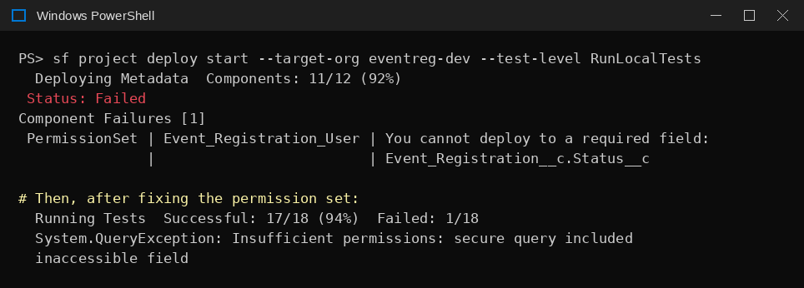
Figure 10. The two failures from our first deployment: a required-field permission error, then a security error in tests.
S3 A test passes sometimes and fails sometimes: “Expected: Second Person, Actual: First Person”
What you see | A test checking that the newest record comes first fails unpredictably.
Why it happens | Records inserted in the same test get the same CreatedDate, so ORDER BY CreatedDate DESC alone does not define their order.
How to fix it | 1. Add a tie-breaker: ORDER BY CreatedDate DESC, Id DESC.
Prevent it | Always add Id as a secondary sort when ordering by a timestamp.

S4 Seed bug is not live: deploy shows “Status: Failed”
What you see | After introducing a deliberate bug and deploying with RunLocalTests, one test fails, the deploy fails, and the org still has the correct code.
Why it happens | Deploys with tests are all-or-nothing. A realistic seed bug breaks an existing test, so the whole deploy is rolled back.
How to fix it | 1. Deploy only the changed file without tests: sf project deploy start --target-org <alias> --source-dir <path-to-file> --test-level NoTestRun.  2. Confirm in the browser that the bug is now visible.
Prevent it | Use NoTestRun only for intentional seed bugs, never for real changes.

S5 Seed bug deployed, but the page still rejects the bad input
What you see | Entering 500 guests shows “The number is too high”, or an invalid email shows “Enter a valid email address”, even though the Apex bug is live.
Why it happens | The browser enforces max="10" or type="email" on the Lightning input before the form ever reaches Apex.
How to fix it | 1. For the demo only, remove the browser-side constraint (delete max, or change type="email" to type="text").  2. Commit it through a reviewed seed PR, deploy the component with NoTestRun, then hard-refresh with Ctrl+F5.  3. Decide afterwards whether to restore the browser-side check.
Prevent it | Check whether a rule is enforced in the browser, the server, or both before choosing a seed bug.

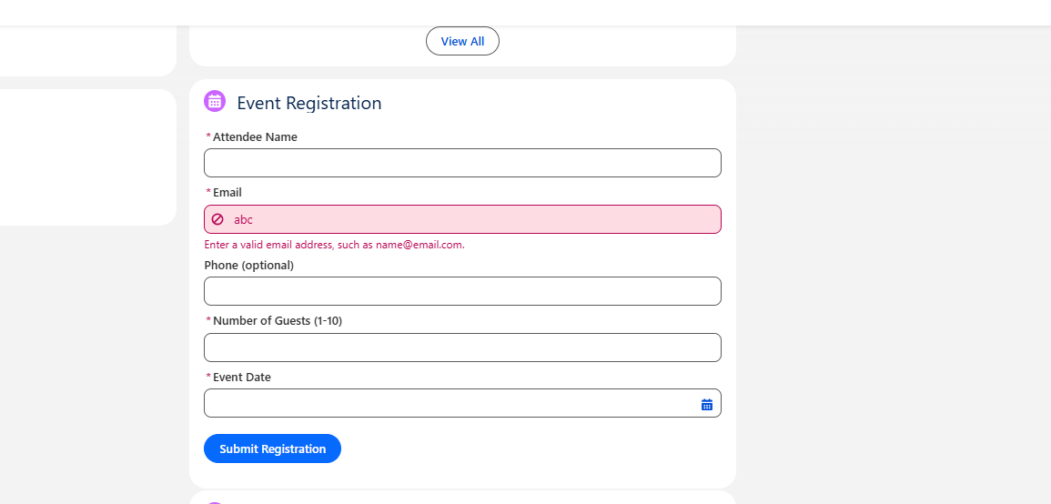
Figure 11. Browser-side validation blocking an invalid email before it reaches Apex.
S6 The Lightning component does not appear after deploying
What you see | Deploy succeeds but the form is nowhere in the org.
Why it happens | Components are not shown until placed on a Lightning page and the page is activated. Lightning App Builder may also list several near-identical page copies.
How to fix it | 1. Gear icon → Edit Page.  2. In the Pages dialog, pick the page you intend to use and click Open.  3. Search the component name in the Components box, drag it on, Save, then Activation → Assign as Org Default.  4. Go back and hard-refresh.
Prevent it | Name pages clearly and delete unused copies from Setup → Lightning App Builder.

S7 Warning: “Starting in December 2025, this command will require that the target org use source tracking”
What you see | Printed on every sf project deploy start.
Why it happens | Salesforce CLI deprecation notice for orgs without source tracking.
How to fix it | 1. No action needed today for Developer Edition orgs.  2. For production or non-tracking orgs, specify what to deploy with --source-dir, --metadata or --manifest.
Prevent it | Use --source-dir in scripts to be future-proof.

S8 Validation runs Apex tests against the wrong org
What you see | validate_fix.py prints “Running Apex tests in 'demo-dev'” while working on a different project.
Why it happens | .env was copied from the earlier project and SF_TARGET_ORG was not changed. Tests ran in an org that may not contain the new project's code.
How to fix it | 1. Set SF_TARGET_ORG to this project's alias (check with sf org list).  2. Re-run python validate_fix.py <KEY>.
Prevent it | Pre-flight check C-2 (Part 2.3) — now caught automatically at startup (Part 1.1).

5.4 GitHub Copilot CLI
C1 Copilot finishes but nothing changed: 0 commits
What you see | invoke_copilot.py prints “Copilot CLI finished”, but validation reports “Has at least one commit — 0 commit(s)”. The log contains “Permission denied and could not request permission from user... This is not an OS or sandbox error.”
Why it happens | The folder has not been trusted for this exact path. In headless mode Copilot cannot ask, so every write and shell command is denied and it exits normally.
How to fix it | 1. Check logs/<KEY>-copilot-cli.log for the “Permission denied” lines to confirm.  2. Run copilot from the repository root and choose “Yes, and remember this folder”.  3. Re-run the automated pre-flight check (Part 1) — it will now catch this before any ticket is even claimed.  4. Re-run python invoke_copilot.py <KEY>.
Prevent it | Implementation Guide, Part 6, Step 10; and the automated Group B check in Part 1.1.

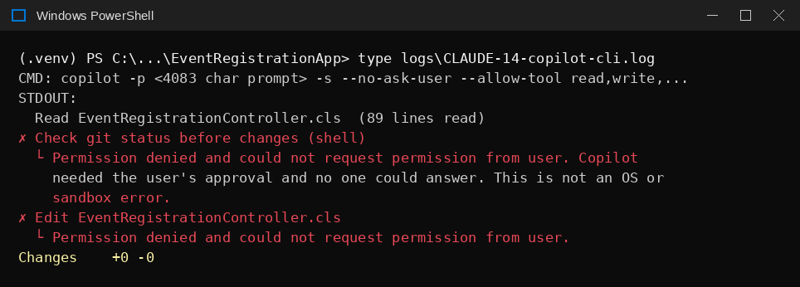
Figure 12. Copilot log showing every action denied because of missing folder approvals.
C2 Folder trusted, but Copilot is still denied
What you see | Even after accepting trust, the log shows denials for edits and for harmless commands like git status or Write-Output 'hello'.
Why it happens | Approvals are stored per folder as a list of specific actions in permissions-config.json. A new project folder may only be approved for one narrow action (e.g. sf), so everything else is denied.
How to fix it | 1. Close all copilot sessions.  2. Open notepad $env:USERPROFILE\.copilot\permissions-config.json.  3. Copy the tool_approvals list from a working project, or use the Implementation Guide's Appendix D, so this folder has write and the git commands.  4. Save and re-run the automated check.
Prevent it | Verify the file every time you set up a new project folder.

C3 Copilot: “Authentication failed… Your GitHub token may be invalid”
What you see | The CLI works on its own but fails when started by invoke_copilot.py (or by preflight.py — see Issue P2); the log mentions GITHUB_TOKEN, GH_TOKEN or COPILOT_GITHUB_TOKEN.
Why it happens | The scripts load .env, which contains a repository-only GITHUB_TOKEN. Child processes inherit it, so Copilot tried to sign in with that token (which has no Copilot permission) instead of your login.
How to fix it | 1. Use the current invoke_copilot.py and preflight.py, both of which remove those three variables before starting Copilot.  2. Confirm with findstr GITHUB_TOKEN agent\invoke_copilot.py that the removal code is present on the branch you are running.
Prevent it | Never set GH_TOKEN or COPILOT_GITHUB_TOKEN globally on the machine.

C4 Copilot tries to open its own Pull Request or push
What you see | The log shows gh pr create or git push attempts after the fix was committed.
Why it happens | The original prompt did not explicitly forbid it, so Copilot tried to be helpful.
How to fix it | 1. Use the current prepare_fix.py, whose prompt has a “Hard stops” section.  2. Use the current invoke_copilot.py, which passes --deny-tool shell(gh:*),shell(git push*),shell(sf * deploy*),shell(sf * org *).
Prevent it | Keep both layers. Do not install or log in to gh on the pipeline machine.

C5 Copilot changed the files but never committed
What you see | git status shows modified code and an untracked Solution Report; validation fails on “has at least one commit”.
Why it happens | Copilot sometimes stops before its final commit, especially after an earlier action was denied.
How to fix it | 1. Review with git diff.  2. If correct, commit it yourself with a fix(<KEY>): ... message.  3. Continue with validate_fix.py, create_pr.py, update_jira.py (Part 4.3).

Figure 13. Uncommitted fix from the CLAUDE-15 run.
C6 Validation fails: “<KEY>-pr.md exists” or “<KEY>-jira.md exists”
What you see | Code and Solution Report are committed but one or both of the other report files are missing.
Why it happens | Copilot occasionally finishes the code and stops before writing every report.
How to fix it | 1. Resume the session: copilot --resume=<id> (the ID is at the end of the CLI log).  2. Ask it to create only the missing docs/ai-reports files and commit them, without pushing or using gh.  3. Re-run validate_fix.py <KEY>.

C7 The review gate shows “Files changed: 0” and the run was approved
What you see | Approving leads straight to validation failures.
Why it happens | The gate blocks restricted paths but not an empty change; Copilot had silently been denied (Issue C1).
How to fix it | 1. Reject (n), fix the cause (usually C1 or C2), and run invoke_copilot.py <KEY> again.
Prevent it | Read the file count first at every review gate (Part 3.3).

C8 Copilot stops working part way through the month
What you see | Requests fail with quota or credit messages.
Why it happens | Free tier includes a limited monthly allowance of premium/agentic requests shared across all Copilot use, and one ticket can use several.
How to fix it | 1. Check usage on github.com → Settings → Copilot.  2. Upgrade to a paid seat, or wait for the monthly reset.
Prevent it | Budget for a paid seat before leaving the watcher running regularly — see the executive briefing deck for cost detail.

5.5 Jira
J1 Ticket is immediately labelled ai-needs-info
What you see | The watcher prints “NOT READY — asking for more information” and comments on the ticket.
Why it happens | The scripts read only the Description field. A ticket template where “Steps to Reproduce” is its own dedicated Jira field (rather than inline text in Description) will be rejected for this reason.
How to fix it | 1. Run python read_queue.py to see exactly which headings are missing.  2. Put all four headings as plain text in Description (Implementation Guide, Appendix B).  3. Remove ai-needs-info, add ai-ready.
Prevent it | Use the template for every ticket.

J2 A ticket you fixed and relabelled is not picked up again
What you see | The watcher keeps printing “Nothing claimed this cycle”.
Why it happens | The ticket still carries ai-locked, ai-needs-info or ai-blocked, or ai-ready was removed when it was claimed.
How to fix it | 1. Remove every ai-* label except ai-ready, and make sure ai-ready is present.
Prevent it | Pre-flight check E-3 (Part 2.5).

5.6 Git and GitHub
G1 “STOP: working tree has uncommitted changes”
What you see | prepare_fix.py stops and lists files, often with ?? (untracked).
Why it happens | The safety check refuses to branch from a dirty tree. In our case: new agent scripts not yet committed, and a repository export file left in the folder.
How to fix it | 1. Commit real changes on main.  2. Delete or move export files and other stray files out of the repository.  3. Confirm git status shows a clean tree.
Prevent it | Now also caught automatically by the pre-flight Group A check (Part 1.1).

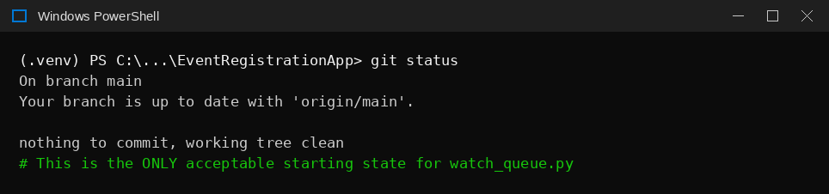
Figure 14. The only acceptable starting state for the watcher service.
G2 “Diverging branches can't be fast-forwarded”
What you see | prepare_fix.py fails at git pull --ff-only origin main.
Why it happens | Local main and GitHub main both have commits the other does not (for example, a PR merge on GitHub plus a local commit).
How to fix it | 1. git fetch origin then git log --oneline --graph --all -15 to see both histories.  2. Usually: git pull origin main (a normal merge), then git push origin main.  3. Do not use git reset --hard origin/main unless you are sure you have nothing local worth keeping (Issue G3).
Prevent it | Pre-flight Group A, Part 1.2 — the automated check will now fast-forward a simple case automatically, and refuses (rather than guessing) on a genuine divergence.

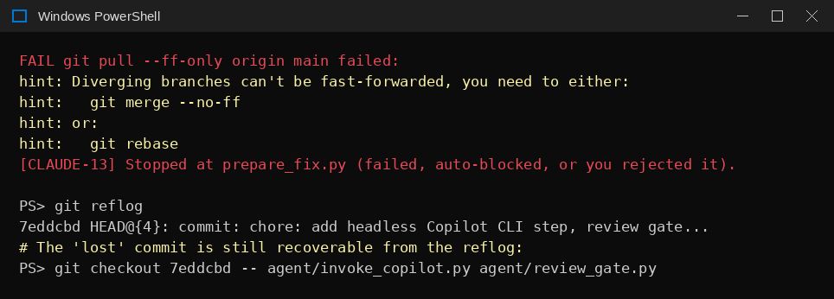
Figure 15. The divergence error and the reflog recovery used in G3.
G3 Work disappeared after `git reset --hard`
What you see | Files you had just committed are gone.
Why it happens | reset --hard discards local commits that are not on the target branch. This is exactly the risk the automated pre-flight sync (Part 1.2) was designed to never introduce.
How to fix it | 1. Run git reflog and find the commit just before the reset.  2. Restore the files: git checkout <hash> -- <file> <file>.  3. Commit and push them properly.
Prevent it | Prefer git pull or git cherry-pick to reconcile branches; never let any script run reset --hard automatically.

G4 Review gate auto-rejects `agent/...` or a fix silently disappears
What you see | The gate says “RESTRICTED PATHS TOUCHED” listing agent/invoke_copilot.py; or after resetting a fix branch an earlier tooling fix is gone again.
Why it happens | A pipeline-tooling fix was committed onto the ticket's fix branch. agent/ is restricted for ticket changes. Later, resetting that branch removed the tooling fix again.
How to fix it | 1. Move tooling commits to main: git checkout main; git cherry-pick <hash>; git push origin main.  2. Bring the fix branch up to date with main: git checkout fix/<KEY>-...; git merge main --ff-only.  3. Check git diff main...HEAD --stat shows only ticket-related files.
Prevent it | Change pipeline files only on main (Implementation Guide, Part 6, Step 12).

G5 `git push` says “Everything up-to-date” but your commit is not on GitHub
What you see | You committed and pushed, but the change is missing on GitHub.
Why it happens | The commit was made on a different branch (for example main) from the one being pushed (for example a seed branch).
How to fix it | 1. Check git branch --show-current and git log --oneline -3.  2. Push the branch that actually has the commit, for example git push origin main.
Prevent it | Always check the current branch before committing.

G6 HTTP 404 from check_connections.py, or HTTP 422 “head invalid” when creating the PR
What you see | git push works, but the PR step fails; check_connections.py reports FAIL with 404.
Why it happens | Git pushed with your Windows credentials, while the scripts use GITHUB_TOKEN from .env — which was created for a different repository and cannot see this one.
How to fix it | 1. Run python check_connections.py to confirm.  2. Create a new fine-grained PAT with this repository selected (tokens cannot be re-scoped).  3. Update GITHUB_TOKEN, re-run the check, then create_pr.py <KEY>.
Prevent it | One token per repository (Implementation Guide, Part 6, Step 5). Now also caught automatically at startup (Part 1.1, Group C).

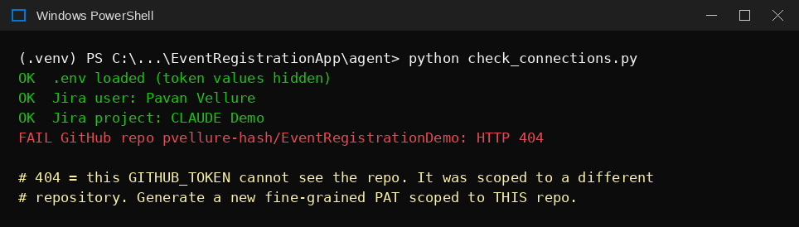
Figure 16. A token scoped to the wrong repository.
G7 No Pull Request appears after opening the link from `git push`
What you see | GitHub printed “Create a pull request… by visiting: <url>” but the PR list is empty.
Why it happens | The link only opens a pre-filled form.
How to fix it | 1. Open the link, check base and compare branches, and click Create pull request.
Prevent it | This applies to manual seed branches only; create_pr.py creates agent PRs directly.

G8 You cannot approve your own Pull Request
What you see | The Approve option is unavailable on a PR you created.
Why it happens | GitHub never counts the author as an approver.
How to fix it | 1. Add a second collaborator to review and approve.  2. For a solo proof-of-concept only, set required approvals to 0 and treat the review as informational.
Prevent it | Plan a second reviewer before a pilot.

5.7 Run guardrails (Phase 0) — new in v4
Found while installing and validating the Phase 0 security checks and spending guardrails on EventRegistrationDemo.
R1 Org check fails: "org 00D... is not in ALLOWED_ORG_IDS"
What you see | python security_checks.py reports FAIL for "Salesforce org is non-production" even though the org query worked and the org is a Developer Edition.
Why it happens | The .env line was ALLOWED_ORG_IDS= # optional: comma-separated .... With an empty value, python-dotenv can read the inline comment as the value, so the agent saw an allow-list that did not contain your org.
How to fix it | 1. Confirm: python -c "from dotenv import dotenv_values; print(repr(dotenv_values('../.env').get('ALLOWED_ORG_IDS')))".  2. Pin your org id: ALLOWED_ORG_IDS=00Dau00000COSx7EAH (safer anyway — the agent can then only use this org).  3. In security_checks.py, only accept values that start with 00D: if x.strip().startswith("00D").
Prevent it | Never put a comment on the same line as an empty .env value.

R2 "main is NOT protected" and GitHub will not let you turn rules on
What you see | security_checks.py FAILs the branch check; in GitHub, rulesets or branch protection cannot be enabled for the repository.
Why it happens | GitHub Free only supports branch protection and rulesets on public repositories. Private repositories need a paid plan.
How to fix it | 1. Scan history for secrets: git log -p --all | Select-String -Pattern "ATATT|ghp_|github_pat_|force://|AKIA|BEGIN .*PRIVATE KEY|sf_auth_url|password\s*=" and git log --all --oneline -- .env — both must return nothing (regex definitions inside validate_fix.py are fine).  2. If clean: Settings → General → Danger Zone → Make public. Create ruleset protect-main: Active, default branch, Restrict deletions, Block force pushes, Require a pull request before merging, 0 approvals (solo), empty bypass list.  3. If it must stay private: upgrade to GitHub Pro, or use the local-demo waiver ALLOW_UNPROTECTED_BRANCH=true (works only when AGENT_ENVIRONMENT=local; Implementation Guide Part 9, Step 7).
Prevent it | Decide repository visibility and plan before the first project setup. What we did: history clean, made public, ruleset created.

R3 WARN "review rules could not be read with this least-privilege token"
What you see | Branch check shows WARN rather than PASS after the ruleset is created.
Why it happens | Reading full protection details needs administration read access, which a correctly scoped token deliberately does not have.
How to fix it | 1. Confirm once by eye: Settings → Rules → Rulesets → protect-main is Active with "Require a pull request before merging".  2. Leave the WARN — it shows the token is correctly limited.

R4 WARN "token can reach 2 repos"
What you see | Token check warns it can see more than this repository.
Why it happens | One fine-grained token was being used for both demo repositories.
How to fix it | 1. GitHub → Settings → Developer settings → Fine-grained tokens → open it → Repository access → Only select repositories → this repository only. The token value does not change.  2. Create a separate token for the other repository and put it in that repository's own .env.
Prevent it | One token per repository (Implementation Guide Part 6, Step 5).

R5 WARN "account has admin on <repo>; the token itself should not grant Administration"
What you see | After scoping the token, this WARN remains.
Why it happens | You own the repository, so your account always has admin. The check really asks whether the token carries the Administration permission.
How to fix it | 1. Confirm the token's repository permissions are only Contents (RW), Pull requests (RW) and Metadata (R).  2. Leave the WARN — it will always appear for a repository you own.

R6 test_phase0.py prints "[events] WARNING: could not write event ... WinError 3"
What you see | One warning line in an otherwise passing test run.
Why it happens | Test test_never_raises deliberately points the log folder at an impossible path to prove that a logging failure can never stop the pipeline.
How to fix it | 1. Nothing to fix. The run must still end with Ran 23 tests ... OK.

R7 One run used more credits than TICKET_CREDIT_CEILING
What you see | Log shows single run used N credits, above the per-ticket ceiling and a cost_ceiling alert.
Why it happens | Copilot CLI reports AI credits only when a run ends, so the ceiling cannot stop a run part-way. Inside a run, the hard limit is COPILOT_CLI_TIMEOUT_MINUTES.
How to fix it | 1. The ticket is now blocked from further attempts (STOP before any spend).  2. Review why it was expensive (vague ticket, large exploration) and either improve the ticket or hand it to a developer.  3. If this recurs, lower COPILOT_CLI_TIMEOUT_MINUTES or the ceiling.
Prevent it | Phase 1's code intelligence reduces exploration, which is the main cost driver.

5.8 Code intelligence (Phase 1) — new in v4
Found while building and validating ticket localisation, the context pack and model routing on EventRegistrationDemo with ticket CLAUDE-15.
L1 test_phase1.py: 16 failures mentioning EventRegistrationService.cls or LegacyUtil.cls
What you see | FileNotFoundError / KeyError for files that do not exist in your project; afterwards the index counts one file too many.
Why it happens | The first version of the test file assumed a set of sample files would exist in the real repository. A crashed test also left force-app\main\default\classes\Temp.cls behind, which the index then counted (11 instead of 10).
How to fix it | 1. Use the current test_phase1.py, which builds its own temporary sample repository and deletes it afterwards.  2. Delete the stray file: Remove-Item force-app\main\default\classes\Temp.cls.  3. Rebuild the index with force=True.
Prevent it | Tests must never read or write the real repository.

L2 SyntaxError: "unexpected character after line continuation character"
What you see | A multi-line python -c "..." command fails at [:5\].
Why it happens | A stray backslash was copied from formatted instructions, and PowerShell quoting makes multi-line python -c commands fragile.
How to fix it | 1. Put the code in a small file (agent\try_localize.py) and run python try_localize.py.  2. The line must read for c in r['candidates'][:5]: — no backslash.
Prevent it | Use script files for anything longer than one line. Do not commit test helpers.

L3 try_localize.py prints the literal text ['score'] instead of a number
What you see | Output lines start with ['score'].
Why it happens | The print line was missing the c before ['score'].
How to fix it | 1. Use print(' ', c['score'], c['path'], c['reasons']).

L4 A normally written ticket scores confidence 0.0 and is labelled ai-needs-info
What you see | "Email format validation is not enforced" → confidence=0.0, plan ask_for_info, ticket labelled, no branch.
Why it happens | Design flaw in the first version: the index stored only API names and the matcher only recognised exact technical tokens (Email__c, class names). Real reporters write in business language and should never need to know class names.
How to fix it | 1. Use the current code_index.py and localizer.py: the index stores field labels, splits every name into plain words (EventRegistrationController → event, registration, controller), lets fields inherit their parent object's words, and handles plurals.  2. Rebuild the index with force=True, remove ai-needs-info from the ticket (keep ai-locked), re-run.  3. Result: the same ticket scored 0.42, then 0.55 after ranking fixes (L10).
Prevent it | Truly vague tickets ("the app is broken") still score 0.0–0.20 and are correctly refused.

L5 test_phase1_lang.py: KeyError 'force-app/main/default/objects/.../Email__c.field-meta.xml'
What you see | One test errors on Windows; the other ten pass.
Why it happens | On Windows the index stores paths with backslashes; the test looked the file up with forward slashes.
How to fix it | 1. Look the key up by normalised suffix: key = [k for k in self.idx["files"] if k.replace("\\", "/").endswith("Event_Registration__c/fields/Email__c.field-meta.xml")][0].
Prevent it | Always normalise path separators when comparing paths.

L6 AttributeError: module 'jira_client' has no attribute 'add_label'
What you see | prepare_fix.py crashes right after [phase1] plan: {'action': 'ask_for_info' ...}.
Why it happens | The new code assumed a helper name instead of checking the real module. Your jira_client.py provides update_labels(key, add=(), remove=()).
How to fix it | 1. Use jc.update_labels(key, add=["ai-needs-info"]) and jc.update_labels(key, add=["ai-blocked"]) (current prepare_fix.py).  2. To check a module's real functions: python -c "import jira_client; print([m for m in dir(jira_client) if not m.startswith('_')])" and inspect.signature(...).

L7 ValueError: Unknown format code 'd' for object of type 'float'
What you see | prepare_fix.py crashes printing the candidate list.
Why it happens | Plain-word matches add partial points, so scores became decimals, but the print used an integer format (:3d).
How to fix it | 1. Use {float(c['score']):5.1f} (current prepare_fix.py). The crash happens before any branch or Jira change, so the ticket can simply be re-run.

L8 The routed model never reaches invoke_copilot.py
What you see | prepare_fix.py says "routed to economy tier", but Copilot still runs on the default model.
Why it happens | watch_queue.py runs each step as a separate process. An environment variable set inside prepare_fix.py disappears when that process exits.
How to fix it | 1. Use routing.py: prepare_fix.py writes logs/routing/<KEY>.json, invoke_copilot.py reads it (Implementation Guide Part 10, Step 3).  2. Confirm on the next run that invoke_copilot.py prints model : <name> (<tier> tier, routed by prepare_fix.py).
Prevent it | Anything one step decides for another must be written to a file, not an environment variable.

L9 The context pack contains only the field's XML, not the code to fix
What you see | Prompt shows Email__c.field-meta.xml but not EventRegistrationController.cls.
Why it happens | A field has no code of its own; the fix lives in the Apex/LWC that uses it, which was not pulled in.
How to fix it | 1. Use the current localizer.py: when a field or object is matched, every file that references it (and its tests) is added.

L10 Wrong file ranked first, four-way tie, routed to premium with 10 files
What you see | Event_Date__c, Email__c, Number_of_Guests__c and the test class all score 9.0; complexity "complex"; premium model; 4,055-token pack.
Why it happens | Every field inherited "event" and "registration" from its parent object, so words that describe the whole app counted as strongly as the word that described the bug.
How to fix it | 1. Words found in half or more of all files count as generic (0.5); words a field only inherits score 1; words in the ticket summary count double; test classes count half.  2. Linked files (a field, its object, the class that uses it, its test) are treated as one group, not competitors, when measuring confidence.  3. Complexity and context expansion use only strong candidates (≥ half the top score). Generic-only matches are capped at 0.20 confidence.  4. Result on CLAUDE-15: Email__c first (7.0 vs 4.0), confidence 0.55, standard tier, 5 files, 2,515 tokens.

L11 Two test_phase1.py failures after the ranking update
What you see | 'moderate' != 'complex' and 0.75 not less than 0.7.
Why it happens | (1) Real bug: when candidates carried no score at all, the strong-candidate filter emptied the list. (2) Outdated expectation: a ticket naming two real API names correctly scores higher now.
How to fix it | 1. Use the current escalation.py (only filters when scores exist) and test_phase1.py (upper bound 0.9).

L12 "STOP: working tree has uncommitted changes" right after adding Phase 1
What you see | prepare_fix.py lists M agent/... and ?? agent/code_index.py etc.
Why it happens | Same safety check as Issue G1: the new files were copied but not committed.
How to fix it | 1. Commit on a feature branch, push, open a PR and merge it (branch protection blocks direct pushes to main).  2. git checkout main; git pull, rebuild the index, re-run.

L13 Retrying a ticket that was labelled ai-needs-info
What you see | The ticket is not processed again, or prepare_fix.py stops with "not claimed by the agent".
Why it happens | ai-needs-info keeps it out of the queue; prepare_fix.py also requires ai-locked to still be present.
How to fix it | 1. In Jira remove ai-needs-info; keep ai-locked if re-running prepare_fix.py by hand, or reset to ai-ready only for the watcher (Issue J2).

L14 "Branch fix/<KEY>-... already exists - resuming it"
What you see | Shown when re-running a ticket.
Why it happens | Expected: an earlier attempt already created the branch. The prompt file is rewritten with the new context pack.
How to fix it | 1. Nothing to fix. To start completely over, follow Part 4.4.

5.9 End-to-end run (CLAUDE-15) — new in v5
Found while running CLAUDE-15 from Copilot through validation, pull request, merge and deployment on EventRegistrationDemo. C9, C10 and S9 are fixed in the pipeline code (PRs #7–#9); S10 was a real application bug fixed in PR #10. v6 update: C12, G9 and R8 are now closed — see 5.10.
C9 Copilot CLI exits 1: “The command line is too long.”
What you see | invoke_copilot.py prints FAIL: Copilot CLI exited 1 and the log STDERR shows The command line is too long. The prompt was 14,272 characters.
Why it happens | The prompt was passed as a -p argument. On Windows the npm copilot command is a .cmd shim, which always runs through cmd.exe, and cmd.exe limits the whole command line to 8,191 characters. Phase 1 context packs make prompts longer than that.
How to fix it | 1. Use the v5 invoke_copilot.py: the prompt is piped on standard input (input=prompt_text in subprocess.run) and -p is removed. Copilot CLI ignores piped input if -p is also present.  2. Check the log header: it should read CMD: copilot (prompt via stdin, N chars) ....  3. Land the change through its own branch and pull request, then git merge main into the ticket branch (see C11).
Prevent it | Never pass large, generated text as a command-line argument on Windows; use stdin or a file.

C10 Copilot CLI exits 1: “Model … from --model flag is not available”
What you see | STDERR shows Error: Model "gpt-4.1" from --model flag is not available. The same happened for gpt-5.4, gpt-5.5, gpt-5.3-codex, claude-sonnet-4.6 and gpt-5.6-luna, even though they appeared in the interactive /model list.
Why it happens | Model names are renamed and retired over time, and on this account the --model flag rejected every explicit name. Copilot CLI has no non-interactive way to list valid names (open request github/copilot-cli #700). A rejected model fails fast with no AI spend.
How to fix it | 1. Use the v5 invoke_copilot.py and new model_resolve.py. The tier from escalation.py is passed as --model auto --auto-tier <preference>: economy = efficiency, standard = balance, premium = intelligence.  2. Expect the console line model : auto (--auto-tier balance, from standard tier).  3. Leave COPILOT_CLI_MODEL blank. Set it only to pin one exact model on purpose; it then overrides auto routing.  4. The COPILOT_MODEL_ECONOMY/_STANDARD/_PREMIUM variables are no longer used and can be removed from .env.
Prevent it | Do not store model names in configuration; let Copilot’s auto routing pick a currently valid model for the requested cost/capability level.

C11 Copilot run reports “Blocked: the working tree is not clean”
What you see | invoke_copilot.py finishes with exit 0, but the log says Copilot made no changes because agent/invoke_copilot.py was modified and agent/model_resolve.py was untracked.
Why it happens | The guardrail file tells Copilot to stop on a dirty tree. Pipeline files had been copied onto the ticket branch for a quick test and not committed. This is the guardrail working, not a fault (related: G1, G4, L12).
How to fix it | 1. Stash the tooling files: git add agent/model_resolve.py then git stash push -m "tooling" -- agent/invoke_copilot.py agent/model_resolve.py (untracked files must be staged before a pathspec stash).  2. git checkout main; git pull; git checkout -b fix/<tooling-change>; git stash pop, commit, push, open and merge the pull request.  3. git checkout fix/<KEY>-...; git merge main, confirm git status --short is empty, then re-run invoke_copilot.py <KEY>.
Prevent it | Test tooling changes from a tooling branch, never from a ticket branch.

C12 “AI Credits line not found in CLI output; recorded as unknown”
What you see | Every run prints cost: WARNING - 'AI Credits' line not found and run-events.jsonl has no credits. The budget shows $0.00 of $25.00 after several real runs.
Why it happens | -s (silent) suppresses Copilot’s usage statistics, so the regex in parse_ai_credits() never finds a credits line. Because credits are not recorded, the monthly budget and per-ticket ceiling cannot fire on real spend.
How to fix it | 1. Open item. Add --usage-output-file ..\logs\<KEY>-usage.json to the Copilot command (documented in copilot --help).  2. Run once, inspect the JSON, then read credits from it in record_run(); keep the regex as a fallback. Do not guess field names.  3. Optionally add --max-ai-credits <TICKET_CREDIT_CEILING> for a live in-run cap (partly addresses R7).
Prevent it | Treat an unknown cost as a defect: the guardrails depend on it.

S9 Validation: Apex tests “0 run”, “Fatal Error” or 0% coverage, but the tests pass on their own
What you see | validate_fix.py reports Apex tests in org - 10 run, 1 failed or 0 run, and Setup → Deployment Status shows Run Apex Tests: Fatal Error, while sf apex run test --class-names <Test> passes 10/10.
Why it happens | sf project deploy start --dry-run --test-level RunSpecifiedTests --tests ... has known Salesforce CLI problems: the --tests values can be ignored (forcedotcom/cli #2117) and runs can end in a bare Fatal Error with no tests executed (#2648). Separately, sf apex run test tests the code already deployed in the org, not your local source.
How to fix it | 1. Use the v5 validate_fix.py, which runs sf project deploy validate --source-dir force-app --target-org <alias> --test-level RunSpecifiedTests --tests <Test> --wait 30 --json (no --dry-run; validate is always validate-only).  2. If it fails, run the same command by hand: the top-level message in the JSON names the failing test and the expected/actual values.  3. Developer Edition orgs run tests on validate. On a sandbox, check that tests actually ran (numberTestsTotal > 0).
Prevent it | Trust deploy validate for the fix branch; use sf apex run test only to check what is already in the org.

S10 Apex test: “Expected: A valid email address is required., Actual: Script-thrown exception”
What you see | deploy validate fails testInvalidEmailIsRejected with that message, although the controller adds exactly the expected text to its error list.
Why it happens | AuraHandledException.getMessage() returns “Script-thrown exception” unless setMessage() is called. The controller used throw new AuraHandledException(String.join(errors, ' ')). Copilot’s stronger regression test (exact message for notanemail) exposed this real, pre-existing application bug.
How to fix it | 1. Build the exception, call ex.setMessage(msg), then throw it: AuraHandledException ex = new AuraHandledException(msg); ex.setMessage(msg); throw ex;.  2. Commit with a fix(<KEY>): ... message on the ticket branch and re-run validate_fix.py <KEY> (CLAUDE-15: 10 run, 0 failed).  3. Update the Solution Report so it states the real root cause.
Prevent it | Whenever Apex throws AuraHandledException with a message the UI or a test relies on, also call setMessage().

G9 create_pr.py: “HTTP 422 … No commits between main and fix/…”, but the PR exists
What you see | create_pr.py re-validates, pushes, then prints FAIL GitHub PR: HTTP 422 - Validation Failed ... No commits between main and fix/<KEY>-.... A few minutes later origin/main already contains Merge pull request #10 from .../fix/CLAUDE-15-....
Why it happens | The pull request was created (or already existed) and the 422 came from GitHub’s comparison of branches immediately after the push. Because protect-main needs no approval, the PR then merged (see R8).
How to fix it | 1. Check GitHub before re-running: open the repository’s pull request list for the branch.  2. git fetch origin; git log --oneline origin/main -5 shows whether the branch is already merged.  3. Open item: make create_pr.py look up an existing PR for the head branch on 422 (and retry once) instead of printing FAIL.
Prevent it | A failure message from the PR step is not proof that no PR exists.

R8 A pipeline PR merged with no review and deployed to the org
What you see | PR #10 (CLAUDE-15) shows Merged, “No reviews”, 1 check passed. GitHub Actions then ran “Salesforce Deploy (real deploy on merge to main)” on commit 98e02d7, and Setup → Deployment Status shows the deploy Succeeded. Nobody clicked Merge on purpose.
Why it happens | The protect-main ruleset requires a pull request but 0 approvals (used because GitHub does not let the author approve their own PR). With 0 approvals nothing stops a PR from merging, and salesforce-deploy.yml deploys every push to main that touches force-app/**. Human Checkpoint #2 was therefore not enforced.
How to fix it | 1. Settings → General: turn off “Allow auto-merge”.  2. Settings → Rules → protect-main: required approvals = 1, dismiss stale approvals, require review from Code Owners.  3. Add .github/CODEOWNERS through a PR, and add a second GitHub account as collaborator to approve pipeline PRs.  4. Re-test: a new pipeline PR must stay open until the second account approves it.  5. Record how PR #10 merged (its timeline) in the run notes.
Prevent it | Before any pilot: the pipeline’s token must never be able to satisfy the merge rule on its own.

5.10 Second and third end-to-end runs — new in v6
Found while closing the v5 open items and running two more tickets end to end through watch_queue.py on EventRegistrationDemo: CLAUDE-16 (guest count of zero or negative accepted) and a pair of tickets for a same-day event-date bug and a new “edit registration” feature. Three v5 issues are now closed (C12, G9, R8) and nine new ones are documented. G11 is open and must be fixed before the watcher is left to run several tickets unattended.
Issue | v5 status | v6 resolution
C12 AI credits unknown | Open | Fixed (PRs #12 and #14): --usage-output-file logs/<KEY>-usage.json; credits = totalNanoAiu / 1e9. CLAUDE-16 logged 1.6703 credits (~$0.0167), source usage_file.
G9 PR 422 but PR exists | Open | Fixed (PR #13): create_pr.py looks up PRs in all states (state=all) and, on a 422, waits 2 s and re-checks before failing.
R8 PR merged with no review | Open — highest priority | Root cause confirmed: PR #10 was merged by a manual click (timeline: merged by pvellure-hash, auto_merge empty; no merge call anywhere in agent/). Fixed for a solo owner with a deploy approval gate (PR #11); see R8 update below.

R8 UPDATE — How the merge gate is enforced with one GitHub account
GitHub never lets an author approve their own PR, so “1 required approval + CODEOWNERS” locks a solo owner out. The control that works with one account is to gate the dangerous step — the real Salesforce deploy — instead of the merge.
Done: environment: salesforce-deploy-gate added to the deploy job in salesforce-deploy.yml (PR #11); environment created with Required reviewers = pvellure-hash (available because the repository is public); “Allow auto-merge” confirmed off. Proven: the deploy run sat in Queued/Waiting until “pvellure-hash approved” was recorded under Deployment protection rules.
For a team or client pilot: also set the ruleset to 1 required approval with CODEOWNERS and a second account, so both the merge and the deploy need a person.

C13 Usage file has no field called “credit”
What you see | The first C12 patch searched the usage JSON for any numeric key containing “credit”. A test call (copilot -s --no-ask-user --usage-output-file ..\logs\test-usage.json -p "say hello") showed the real keys: totalPremiumRequestCost, totalNanoAiu, tokenDetails, modelMetrics, currentModel — none contains “credit”, so every run would still have been logged as unknown.
Why it happens | Field names were guessed instead of read from a real file. totalPremiumRequestCost is a flat request counter (1 for any call); totalNanoAiu scales with input, output and cached tokens.
How to fix it | 1. Use the v6 invoke_copilot.py (PR #14): credits = totalNanoAiu / 1,000,000,000; falls back to totalPremiumRequestCost, then to the old regex.  2. Each run prints the raw JSON, totalNanoAiu, totalPremiumRequestCost and currentModel so the mapping stays visible.  3. The /1e9 conversion is a best fit (the trivial call gave 0.226 credits; CLAUDE-16 gave 1.67). It has not been reconciled with a GitHub invoice — see C14.
Prevent it | Run the tool once and read its real output before writing any parser.

C14 GitHub “AI usage” page shows “No usage” even after weeks of Copilot use
What you see | github.com/settings/billing → AI usage shows “No usage” for every month, and the Additional usage card says “your enterprise will be billed”. Copilot settings → Usage shows only percentages (e.g. Included credits 23% used, Inline suggestions 3% used).
Why it happens | The account’s Copilot seat is assigned by the Deloitte enterprise. GitHub documents the AI usage breakdown page as available only on Copilot Individual plans. For Business/Enterprise seats, credits are pooled at the billing entity; members see a cycle total only, and per-user breakdowns are visible to enterprise owners and billing managers.
How to fix it | 1. Use Copilot settings → Usage for your own cycle total.  2. To reconcile the dashboard’s cost per ticket, ask the enterprise billing manager for a usage report filtered to your user and compare it with logs/run-events.jsonl for the same days.  3. Until then, treat dashboard dollars as estimates (credits × $0.01). Relative comparisons between tickets are still valid.
Prevent it | Agree with the enterprise admin, before a pilot, who can pull per-user AI credit reports.

E7 Deploy run stuck in Queued, then fails: “job was not acquired by Runner of type hosted”
What you see | After approving the deploy gate, “Salesforce Deploy” waited for a runner for 15+ minutes and failed with “The job was not acquired by Runner of type hosted even after multiple attempts” and “Internal server error. Correlation ID …”. The PR’s Validate run failed the same way.
Why it happens | A GitHub Actions platform incident on 5 Oct 2026 (from 19:11 UTC) delayed hosted-runner assignment. Nothing in the repository was wrong.
How to fix it | 1. Check githubstatus.com before debugging. While Actions is degraded, do not re-run.  2. When it recovers, open the failed run and choose Re-run all jobs. The deploy gate asks for approval again — approve it.  3. Confirm the result in Setup → Deployment Status, not only the green tick (the job uses || true).
Prevent it | Any “not acquired by Runner” message: check GitHub status first.

E8 PowerShell: “Invalid identifier '<BOM>Id'”, “Unable to find type”, “New--Object not recognized”, “utf8NoBOM not valid”
What you see | Writing a small Apex file with Out-File -Encoding utf8 made sf apex run fail with an invalid identifier; later attempts failed on mistyped .NET type names and Set-Content -Encoding utf8NoBOM.
Why it happens | Windows PowerShell 5.1 writes a byte-order mark with -Encoding utf8, and the Apex compiler reads it as part of the first word. utf8NoBOM exists only in PowerShell 7+. Stray characters (\], --, **) were introduced while copying commands.
How to fix it | 1. Write files without a BOM: [System.IO.File]::WriteAllText("$PWD\file.apex", $code, (New-Object System.Text.UTF8Encoding($false))).  2. Copy commands from a code block only; if a command looks different from the one shown (extra *, \, --), retype it.  3. Delete scratch files afterwards (Remove-Item verify-*.apex) — otherwise pre-flight check A1 (clean tree) stops the watcher.
Prevent it | Prefer the Salesforce test classes over hand-written anonymous Apex (see S12).

S11 `sf apex run --file -` fails: “File not found at the specified path: -”
What you see | Trying to pipe anonymous Apex on standard input.
Why it happens | This Salesforce CLI version does not accept - as a file name.
How to fix it | 1. Write the Apex to a file (without a BOM, see E8) and run sf apex run --target-org <alias> --file <file>.apex.

S12 Anonymous Apex: “System.LimitException: Can only throw this exception type from VisualForce or Aura context”
What you see | Calling EventRegistrationController.submitRegistration(...) from sf apex run fails with this error for both invalid and valid input.
Why it happens | AuraHandledException can only be thrown from an LWC/Aura/Visualforce call, never from anonymous Apex. The controller throws it for permission and validation errors, so this method cannot be exercised that way at all.
How to fix it | 1. Do not use anonymous Apex to verify this controller.  2. Use the test class: sf apex run test --target-org <alias> --class-names EventRegistrationControllerTest --synchronous --result-format human, or the PR’s check-only Validate run (see Part 4.5).  3. To test in the UI, use the form itself and click Submit.

S13 Manual UI test gives the wrong answer about a fix
What you see | After the same-day fix deployed, the form still looked as if it accepted a bad date; for the guest-count bug the form said “The number is too low”.
Why it happens | Three separate causes: (1) the form was filled in but Submit was not clicked, so no server validation ran; (2) the date tried (4 Oct) was yesterday, not today (5 Oct), so it never tested the same-day rule; (3) browser-side rules such as min="1" on the input block bad values before Apex sees them (see S5).
How to fix it | 1. Hard-refresh first (Ctrl+Shift+R).  2. Enter exactly the boundary value the ticket is about (today’s date; 0 guests) and click Submit.  3. Expect the server message (for example “Event date must be in the future.”). Then try one valid value to confirm the happy path.  4. If in doubt, trust the Apex test result over the UI.

G10 Commit landed on the wrong branch; GitHub says “There isn’t anything to compare”
What you see | git checkout -b fix/capture-ai-credits printed “a branch named … already exists”, but the next git add/git commit ran anyway and committed onto fix/create-pr-existing-pr-check. Pushing fix/capture-ai-credits then published an empty branch. Separately, a feature branch showed “nothing to compare” because git add/git commit had never been run.
Why it happens | A failed checkout -b leaves you on the current branch; the following commands do not stop. GitHub compares what is pushed, not your local working tree.
How to fix it | 1. Before committing, always run git branch --show-current and git status.  2. If a commit went to the wrong branch: git log --oneline -3 to find it, then rename the branch (git branch -m <correct-name>) or cherry-pick the commit onto the correct branch.  3. Delete stale empty branches locally and on GitHub (git branch -D <b>; git push origin --delete <b>).  4. If GitHub shows nothing to compare, check git status for unstaged files and commit them.
Prevent it | Use a fresh branch name per change (for example -v2) and check the branch before every commit.

G11 Second ticket is blocked: “not on base branch (main)” — and may not contain the first ticket’s fix (CLOSED in v7 — see 5.11)
What you see | After the watcher finishes one ticket (draft PR + Jira update), the local repository is left on that ticket’s fix/<KEY>-… branch. On the next poll the per-ticket re-check (A2) fails because the repository is not on main, so the next ai-ready ticket is skipped. If the first PR has not been merged yet, the second ticket’s branch would also not include the first fix.
Why it happens | Nothing in the pipeline returns to main after update_jira.py: by design, merging is a human step that happens later. The per-ticket check correctly refuses to branch from another ticket’s branch (doing so would mix unmerged changes from two tickets into one PR).
How to fix it | 1. Workaround today: after each ticket finishes, run git checkout main; git pull --ff-only before the next poll.  2. Planned fix (next step): at the end of every ticket (success or failure) watch_queue.py will check out main and fast-forward it from origin, without discarding anything (it refuses if the tree is dirty). Requires reading the real prepare_fix.py and preflight.py first.  3. Tickets are independent: each branch forks from the currently merged main. Several draft PRs can be open at once and merged in any order.  4. If one ticket truly depends on another, link them in Jira (“is blocked by”) and keep the second ticket out of ai-ready until the first PR is merged; preflight then fast-forwards main automatically.
Prevent it | Merge each PR promptly after review; independent tickets only in the same batch.

5.11 Continuous multi-ticket flow — new in v7
Found while designing, installing and testing the v7 continuous flow (Implementation Guide, Part 13). G11 is now closed, and nine new issues are documented, bringing the total to 83. Several of them are not faults but behaviours an operator needs to recognise.
Issue | v6 status | v7 resolution
G11 Second ticket blocked: not on main | Open — highest priority | Closed. git_sync.sync_base() returns to main and fast-forwards at startup, before and after every ticket; new branches are always cut from the latest main. A dirty tree or a diverged main is never touched — the watcher reports it and skips the ticket.

DESIGN — Why the second ticket does not include the first, unmerged fix
This is deliberate. Each ticket branches from what is actually merged, so every PR can be approved, changed or rejected on its own. Tickets that change the same files as an open PR wait (ai-waiting) and restart from the new main once that PR merges. Related bugs that are all ready at the same time are fixed together in one batch instead.

G12 git add fails: “pathspec ’agent/git_sync.py’ did not match any files”
What you see | Run from the agent folder, git add agent/git_sync.py prints could not open directory 'agent/agent/' and the following commit says “nothing added to commit”.
Why it happens | Git paths are relative to the current folder. From inside agent, agent/git_sync.py means agent/agent/git_sync.py.
How to fix it | 1. From agent: git add git_sync.py. From the repository root: git add agent/git_sync.py.  2. Check with git status that the file now shows as staged before committing.
Prevent it | Look at the prompt (...\agent>) before typing a path; the guides now give commands for the agent folder.

E9 “can’t open file ...\agent\git_sync.py: No such file or directory” after downloading a file
What you see | A file downloaded from the chat or email cannot be found when running python git_sync.py status.
Why it happens | The browser saved it to your Downloads folder (sometimes as git_sync (1).py or with an extra .txt), not into the repository.
How to fix it | 1. Find it: Get-ChildItem $env:USERPROFILE\Downloads -Filter "git_sync*" | Sort-Object LastWriteTime -Descending.  2. Copy it in under the exact name: Copy-Item "$env:USERPROFILE\Downloads\git_sync.py" .\git_sync.py.  3. Check the size matches what you expected (Get-Item .\git_sync.py).
Prevent it | Save pipeline files straight into agent\, and check the branch is a tooling branch before copying.

E10 “warning: in the working copy of ’...’, LF will be replaced by CRLF”
What you see | Printed by git add for a new .py file.
Why it happens | The file was written with Linux line endings; Git on Windows converts them on checkout.
How to fix it | 1. Nothing to fix — the warning is harmless and the code runs the same.
Prevent it | Optional: add a .gitattributes with *.py text eol=lf in a separate tooling PR if you want consistent line endings.

G13 Second PR: “This branch is out-of-date with the base branch”
What you see | After the first PR is merged, GitHub shows the second PR as behind main, and (with the v7 ruleset) the Merge button is disabled.
Why it happens | Both PRs were created from the same older main. Requiring branches to be up to date is intentional: it re-tests the second change together with the first.
How to fix it | 1. Do nothing: with PR_AUTO_UPDATE_BRANCH=true the watcher presses Update branch on the next poll and Salesforce Validate re-runs.  2. Or click Update branch on the PR yourself.  3. Merge once Validate is green.
Prevent it | Keep Require branches to be up to date on in the protect-main ruleset.

G14 PR shows “This branch has conflicts that must be resolved”
What you see | The watcher prints [pr-tracker] CONFLICT PR #N and the ticket gets one Jira comment and a notification.
Why it happens | Another change to the same lines was merged first. The overlap guard prevents this inside one watcher session, but a hand-made PR or a ticket processed before v7 can still collide.
How to fix it | 1. Small conflict: resolve it on GitHub (Resolve conflicts), let Validate re-run, merge.  2. Otherwise: close the PR, delete the branch, set the ticket labels back to ai-ready only. The agent redoes it from the latest main (about 1.7 credits on CLAUDE-16’s evidence).
Prevent it | Leave OVERLAP_GUARD_ENABLED=true and avoid hand-made PRs on the same files while the watcher runs.

G15 Batch fails validation: “Code lines changed <= 200 - FAIL”
What you see | A batch of two or three bugs stops at validate_fix.py on the size check; the members go back to ai-ready.
Why it happens | The v6 validate_fix.py applies single-ticket limits (5 files / 200 lines) to every run. Two tickets with tests easily exceed 200 lines.
How to fix it | 1. Use the v7 validate_fix.py: limits scale to 8 / 350 for two tickets and 10 / 450 for three (capped). The line batch : CLAUDE-A + CLAUDE-B -> limits ... confirms it.  2. If even the batch limit is exceeded, the members are retried alone automatically; no action needed.
Prevent it | Keep batches at the default 3 or fewer.

J3 A ticket stays `ai-waiting` and is never picked up
What you see | The ticket has ai-waiting and a comment naming a PR or a blocking ticket, but nothing happens for a long time.
Why it happens | It is released only when every PR it waits for is merged or closed, or every blocking Jira ticket is Done. A PR left open, or a blocker never moved to Done, keeps it waiting by design.
How to fix it | 1. Run python pr_tracker.py to see which PRs are still open.  2. Check the blocking ticket’s status category is Done (not just resolved).  3. To release by hand: remove ai-waiting, add ai-ready, and delete its entry from logs\waiting.json.
Prevent it | Merge or close reviewed PRs promptly; the PR reminder (PR_REMIND_HOURS) helps.

J4 Related bugs are never batched
What you see | Two bugs that clearly change the same class run as separate tickets; the watcher prints [batch] ... - not batched (BATCH_KINDS=Bug) or skip CLAUDE-N: issue type 'Task' not in BATCH_KINDS.
Why it happens | Only issue types listed in BATCH_KINDS are batched (default Bug). Other reasons printed: low localisation confidence, a Jira blocker, the batch already full, or a previous failed batch of the same pair.
How to fix it | 1. Match BATCH_KINDS to how bugs are raised, e.g. BATCH_KINDS=Bug,Task.  2. Read the [batch] skip lines — each gives the exact reason.  3. Check BATCH_ENABLED=true.

J5 After a merge: “WARNING: no transition to ’Done’. Available: ...”
What you see | The merged ticket gets its ai-merged label and comment but stays In Review.
Why it happens | JIRA_STATUS_DONE does not match a transition available from the ticket’s current status.
How to fix it | 1. Copy the exact name from the Available: list into JIRA_STATUS_DONE in .env.  2. Move already-merged tickets to Done by hand once.
Prevent it | Check the workflow’s final status name when setting up a new project.

5.12 Agent stops, dashboard and deploy tracking — new in v8
Found while running the first feature ticket (CLAUDE-18), checking the dashboard against the budget, and adding progress and Salesforce deploy tracking (Implementation Guide, Part 14). Ten new issues bring the total to 93.
C15 Copilot finished, but validation fails: 0 commits, report files missing
What you see | 1. Validation shows Has at least one commit — 0 commit(s) and the three report checks fail. The Copilot log ends with a plan and “I can’t proceed … without written approval”. (Before v8 the review gate had also let the empty run through.)
Why it happens | The repository rules told the agent to stop. On CLAUDE-18 it counted the 3 report files toward the 5-file limit and treated a required isUpdateable() check as an authorization change. It followed the rules correctly; the rules were unclear.
How to fix it | 1. Read the reason: v8 prints it, posts it to Jira and records outcome agent_no_changes (or check logs\<KEY>-copilot-cli.log).  2. If the rules were applied too strictly, fix .github/copilot-instructions.md on a tooling branch (v8 version: code-only limits, CRUD/FLS checks allowed, AGENT-STOP: line).  3. If the ticket is genuinely too big or unclear, split or clarify it.  4. Retry: labels back to ai-ready only. v8 has already deleted the empty branch.
Prevent it | Keep the v8 rules file and invoke_copilot.py; the agent’s reason then arrives in Jira in plain language.

G16 GitHub compare page: “There isn’t anything to compare”, main and the branch are identical
What you see | A tooling branch was pushed (for example fix/agent-stop-rules, fix/dashboard-local-dates) but GitHub shows 0 changed files.
Why it happens | The branch was pushed before any commit. Usually the new files were not copied in yet, or git add ran from the wrong folder, so nothing was staged and the commit silently did not happen; git push then published an empty branch.
How to fix it | 1. git log --oneline -3 — if the top commit is still the last merge, nothing was committed.  2. git status — the files should show as modified/untracked. If not, copy them in (E9).  3. From the repository root: git add agent\<file> (or from agent\: git add <file>), git status must list them under “Changes to be committed”, then git commit and git push (no -u needed again).  4. Refresh the compare page.
Prevent it | Always run git status between git add and git commit.

E11 Select-String finds nothing for a pattern you can see in the file
What you see | Select-String -Pattern "getFullYear()+'-'" returns no match although the line is there.
Why it happens | -Pattern is a regular expression; (, ) and + are special characters.
How to fix it | 1. Add -SimpleMatch to search for the exact text: Select-String -Path <file> -SimpleMatch -Pattern "...".

D1 Dashboard: Month to date is lower than Total AI spend
What you see | Budget health shows, for example, $0.03 month to date while Total AI spend shows $0.09; the actual-spend line stays at $0.
Why it happens | Before v8 the dashboard grouped runs by UTC date. Runs after 5 p.m. Pacific counted as the next day and fell outside “this month so far”.
How to fix it | 1. Use the v8 dashboard_template.html (local dates). Rebuild: python generate_pipeline_dashboard.py.  2. The two cards can still differ legitimately: month to date counts this calendar month; Total AI spend counts the selected period (30D by default, shown on the card).

D2 Dashboard shows merged tickets as “PR open”
What you see | A PR was merged on GitHub but the ticket still says PR open.
Why it happens | Before v8 the dashboard never read GitHub. From v8 it reads logs/pr-status.json, which the watcher writes each poll.
How to fix it | 1. Wait for the next poll, or run python pr_tracker.py --snapshot then python generate_pipeline_dashboard.py.  2. PRs older than the 50 most recently updated are not in the snapshot.

D3 Progress line shows odd characters, wraps, or the review gate shows no bar
What you see | Boxes or ? instead of the bar; the line repeats instead of updating; no bar at the review gate.
Why it happens | The console font or encoding cannot show block characters, or the window is narrower than the line. The review gate deliberately has no bar because it waits for your typed answer.
How to fix it | 1. Widen the window, or set WATCH_PROGRESS=false in .env and restart the watcher for plain output.  2. “longer than usual” is not an error — the step is past its typical time. The timeout is still the hard limit.

F1 [deploy] WARNING: cannot read GitHub Actions runs (HTTP 403)
What you see | Printed once per watcher session; merged tickets stay In Review with ai-merged.
Why it happens | Deploy tracking reads workflow runs from the GitHub Actions API. The fine-grained token has no Actions permission.
How to fix it | 1. GitHub → Settings → Developer settings → Fine-grained tokens → the token → Repository permissions → Actions: Read-only → Save. The token value does not change.  2. Restart the watcher; run python deploy_tracker.py --apply to catch up at once.
Prevent it | Include Actions: Read-only when creating tokens for new projects.

F2 Ticket stays In Review after its PR is merged
What you see | Label ai-merged, comment “moves to Done automatically once the deploy succeeds”, status unchanged.
Why it happens | By design in v8: Done means live in Salesforce. The deploy is waiting for approval at salesforce-deploy-gate, still running, or tracking cannot read Actions (F1).
How to fix it | 1. Approve the deploy: GitHub → Actions → Salesforce Deploy → Review deployments.  2. python deploy_tracker.py shows the state of every tracked merge.  3. To restore the old behaviour set DEPLOY_TRACKING_ENABLED=false (Done on merge).

F3 Ticket labelled ai-deploy-failed; the deploy job is red
What you see | Jira comment “Salesforce deploy FAILED” with the run link; alert; ticket not Done.
Why it happens | The real deploy failed (component error or Apex test failure). Since v8 the workflow no longer hides this with || true. Salesforce rolled the whole deploy back, so nothing is live.
How to fix it | 1. Open the run summary: it lists component errors and failing tests; or Setup → Deployment Status.  2. Platform problem (for example E7): Re-run all jobs and approve again — a successful re-run moves the ticket to Done and removes the label.  3. Real defect: fix forward with a new ticket; the original stays out of Done until a deploy succeeds.

F4 Alert: “no deploy run found” for a merged PR
What you see | After DEPLOY_NO_RUN_HOURS (2 h) the tracker found no deploy run for the merge commit.
Why it happens | The merge changed nothing under force-app/** (the workflow does not run), the workflow file was renamed (DEPLOY_WORKFLOW), or Actions is down.
How to fix it | 1. Check GitHub → Actions for a Salesforce Deploy run on that commit.  2. If a later deploy of main succeeds, the ticket is marked deployed automatically (“included in a later successful deploy”).  3. Otherwise move the ticket to Done by hand once verified.

Part 6 — Failure Notifications
When the watcher runs unattended you need to know at once if it stops — whether that's the one-time startup pre-flight gate (Part 1) refusing to even begin, or a specific ticket failing partway through. notify.py is called automatically in both cases.

6.1 Two alert categories
Category | Fires when | Typical cause
preflight | The watcher refuses to start at all, or skips one ticket because the per-ticket re-sync check failed | Something about the environment or repo state is wrong — see Part 1
failure | A specific ticket's pipeline run fails at one of its named steps | See the Part 5 issue log for the specific step

6.2 What you get with no setup
- A Windows toast notification naming the ticket (or “-” for a pre-flight failure) and the failed step.
- A highlighted banner in the watcher window with specific guidance for that step.
- A structured record in logs/notifications.jsonl, including the category.
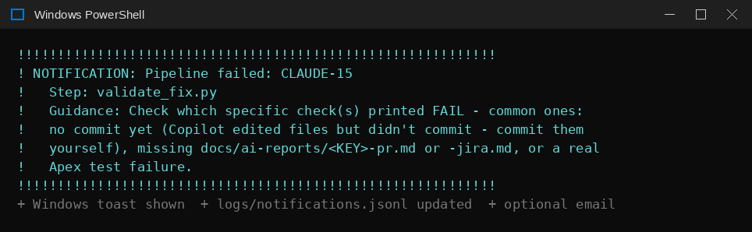
Figure 17. The failure banner printed when validation stops a run.
Enable it with NOTIFY_ENABLED=true and NOTIFY_TOAST_ENABLED=true in .env. Test it any time with python notify.py.

6.3 Configurable recipients — recipients.json
As of v3, who gets emailed (once email is enabled, see 6.4) is controlled entirely by a plain JSON file, agent/recipients.json — not hardcoded in any script. Add, remove, or re-subscribe people by editing this file directly; no code changes are needed.
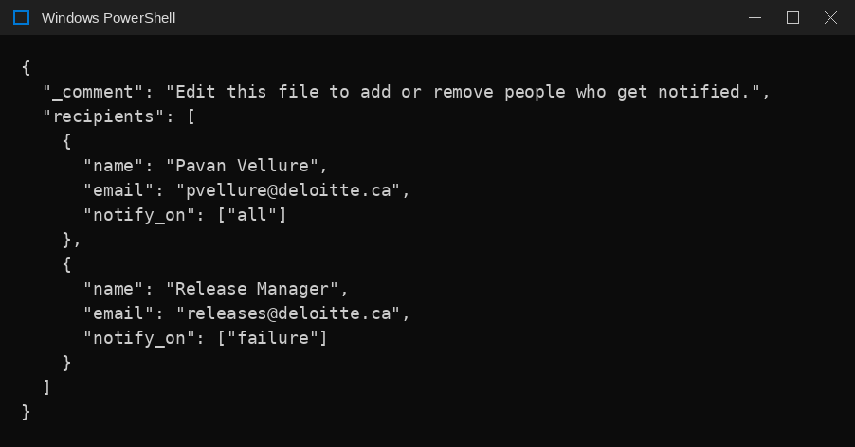
Figure 18. An example recipients.json with two people subscribed to different alert categories.
Field | Meaning
name | Display name, used only in log output
email | The address to send to
notify_on | An array containing any of "preflight", "failure", or "all"

NOTE
If recipients.json is missing, malformed, or empty, this is never treated as an error — the toast notification and logs/notifications.jsonl entry still happen exactly as normal. Email is purely additive.

6.4 Optional email alerts (Microsoft Graph)
- portal.azure.com → Microsoft Entra ID → App registrations → New registration. Single tenant; no redirect URI.
- Authentication → Advanced settings → Allow public client flows → Yes → Save.
- API permissions → Add → Microsoft Graph → Delegated → Mail.Send. Your tenant may require an administrator to grant consent.
- Copy the Application (client) ID into AZURE_CLIENT_ID in .env and set NOTIFY_EMAIL_ENABLED=true.
- pip install msal. On the first failure a sign-in code is printed once; after that the token refreshes silently.
- Add everyone who should be notified to recipients.json (6.3).

6.5 What each alert tells you
Failed step | Guidance in the alert | See
pre-flight | Run python preflight.py directly to see exactly which check failed | Part 1
claim_ticket.py | Ticket missing headings or flagged as suspicious; check its labels | J1, J2
prepare_fix.py | Dirty working tree or diverged main; run git status | G1, G2
invoke_copilot.py | Read the Copilot log; folder approvals, token leak or timeout | C1–C3, P1–P2, E4
review_gate.py | You rejected it, or a restricted path was touched | C7, G4
validate_fix.py | Read which checks failed; often no commit or a missing report | C5, C6, S8
create_pr.py | Token scope; run check_connections.py | G6
update_jira.py | Jira token or status names | Appendix A (Implementation Guide)
poll_loop | Network or Jira connectivity; see the traceback | E2
spending_guard | Monthly budget or daily cap reached; watcher paused claiming (one alert per day) | Part 8.2
budget_warning | Budget passed BUDGET_WARN_PCT (one alert per day) | Part 8.2
cost_ceiling | A single run went over TICKET_CREDIT_CEILING; ticket blocked from further attempts | R7

6.6 PR and queue updates — new in v7
v7 adds a third alert category, pr, for updates that are not failures. They use the same channels (log, toast, optional email). Subscribe people in recipients.json with "notify_on": ["pr"] (or "all").
Update | When | What to do
pr_merged | A pipeline PR was merged | Approve the Salesforce deploy in GitHub Actions when ready
pr_rejected | A pipeline PR was closed without merging | Nothing, or re-queue the ticket after updating it
pr_conflict | A PR conflicts with main | Resolve on GitHub, or close and re-queue (G14)
pr_update | A PR was behind main and was updated | Nothing unless Validate fails
pr_reminder | A PR has waited longer than PR_REMIND_HOURS | Review and merge or close it; waiting tickets depend on it
ticket_waiting | A ticket overlaps an open PR or a Jira blocker | Nothing; it is released automatically
ticket_released | A waiting ticket returned to ai-ready | Nothing; it is picked up on the next poll

A failure to sync back to main is reported as a normal failure with step git_sync, and tells you to run python git_sync.py status.

6.7 Deploy updates — new in v8
Category pr (same channels and recipients.json setting as 6.6).
Update | When | What to do
pr_merged | PR merged; deploy now awaiting approval (v8 wording) | Approve the deploy when ready
deploy_reminder | Deploy has waited for approval longer than PR_REMIND_HOURS | Approve or reject it in GitHub Actions
deploy_succeeded | Deploy succeeded; ticket moved to Done | Nothing
deploy_failed | Deploy failed / cancelled / timed out | See F3
deploy_no_run | No deploy run found for the merge | See F4

A Copilot run that changed nothing is reported as a normal failure of invoke_copilot.py with the agent’s reason in the alert (C15).

Part 7 — Operating the Pipeline

7.1 Routine housekeeping
Task | How often | How
Delete merged fix branches | After each merge | git branch -d <b>; git push origin --delete <b>
Confirm the deploy ran after merges | After each merge | GitHub → Actions → Salesforce Deploy
Move finished tickets to Done | After each merge | Jira
Review the audit log | Weekly | Get-Content logs\agent-audit.jsonl | ConvertFrom-Json | Format-Table action,ticket,result,time
Review failures | Weekly | Get-Content logs\notifications.jsonl | ConvertFrom-Json | Format-Table time,category,ticket,failed_step
Rotate Jira and GitHub tokens | Every 90 days, or immediately if exposed | Regenerate, update .env, run check_connections.py
Check Copilot usage | Monthly | github.com → Settings → Copilot
Review recipients.json | When the team changes | Add/remove entries directly; no restart required for the next run
Open the cost dashboard | Weekly | start logs\cost-dashboard.html (rebuilt automatically after every ticket)
Review run events and blocked runs | Weekly | Get-Content logs\run-events.jsonl | ConvertFrom-Json | Where-Object status -eq 'blocked' | Format-Table time,ticket,step,reason_code
Check routing decisions | Weekly | Get-ChildItem logs\routing — compare tier/confidence with how the ticket actually went
Re-run security checks | After any GitHub or org change | python security_checks.py
Check for stale locks | If a run crashed | Get-ChildItem logs\locks — locks expire on their own after timeout + 10 min

7.2 Safety switches
Setting | Effect
AGENT_ENABLED=false | Kill switch. Every script refuses to run, including preflight.py.
AGENT_DRY_RUN=true | No writes to Jira or GitHub. Copilot still edits local files.
COPILOT_CLI_ENABLED=false | Skips the headless Copilot step; use the manual VS Code flow (run_agent.py) instead.
MONTHLY_BUDGET_USD / MAX_TICKETS_PER_DAY | Stop claiming tickets once reached (v4)
TICKET_CREDIT_CEILING | No further attempts on a ticket once reached (v4)
ALLOWED_ORG_IDS | Agent refuses every org not listed (v4)
LOCALIZATION_MIN_CONFIDENCE | Below this, ask the reporter for detail; no AI used (v4)
ALLOWED_MCP_SERVERS | Any other MCP server configured for Copilot blocks the run (v4)
AGENT_DRY_RUN=true (v4 behaviour) | Copilot is no longer called in dry run, so dry runs cost nothing

7.3 Security rules
- Never commit or share .env. Use git archive for any code export (Issue E6).
- One fine-grained token per repository with only Contents, Pull requests and Metadata permissions.
- Keep gh (GitHub CLI) uninstalled or logged out on the pipeline machine — its absence is an extra safety layer (Issue C4).
- Treat SF_SFDX_AUTH_URL like a password; store it only as a GitHub secret.
- Never change .github/copilot-instructions.md, workflows or the agent/ folder on a ticket branch (Issue G4).

Part 8 — Cost and Safety Guardrails in Operation (Phase 0)
Setup is in the Implementation Guide, Part 9. This part explains how the guardrails behave day to day and where to look when one fires.

8.1 Three layers of control
Layer | Controls | Enforced by
Before any AI call | Kill switch, ticket triage, prompt-injection scan (ticket and, from Phase 1, code), localisation confidence, monthly budget, daily cap, per-ticket ceiling, run lock, production-org guard, MCP allow-list | Scripts and configuration — the run stops before spending anything
While the AI runs | Tool deny-list (no push, no gh, no deploy, no org commands), timeout, GitHub tokens stripped from Copilot's environment | Copilot CLI flags and process environment
After the AI runs | Review gate, restricted paths, size limits, secret scan, validate-only Apex tests, draft PR only, branch protection, human merge, plus a required deploy approval in the salesforce-deploy-gate environment (v6, Issue R8), redacted logs and alerts | Scripts, GitHub ruleset, people

8.2 Spending gates
Gate | Checked | When it fires
Monthly budget | Before every Jira poll, and inside invoke_copilot.py | Spend this calendar month (from run-events.jsonl) ≥ MONTHLY_BUDGET_USD. Watcher pauses claiming; alert once a day
Budget warning | Before every poll | Spend ≥ BUDGET_WARN_PCT of budget; work continues; alert once a day
Daily cap | Before every poll | Tickets started today ≥ MAX_TICKETS_PER_DAY
Per-ticket ceiling | Inside invoke_copilot.py before each attempt | Credits already spent on this ticket ≥ TICKET_CREDIT_CEILING. Also flags any single run that overshoots (R7)
Run lock | Inside invoke_copilot.py | Another process holds logs/locks/<KEY>.lock (atomic create; stale after timeout + 10 min)

8.3 The run-event log
logs/run-events.jsonl gets one line per step: event id, run id (shared by all steps of one attempt), ticket, project, environment, step, status (started / ok / failed / blocked / skipped), actor (system / agent / human), duration, model, AI credits, estimated cost, outcome and reason code. Every record is redacted before it is written, and writing can never stop the pipeline.
USEFUL QUERIES
Get-Content logs\run-events.jsonl | ConvertFrom-Json | Format-Table time,ticket,step,status,ai_credits,outcome,reason_code
Get-Content logs\run-events.jsonl | ConvertFrom-Json | Where-Object step -eq 'localise' | Format-Table ticket,reason_code,detail
Get-Content logs\run-events.jsonl | ConvertFrom-Json | Measure-Object ai_credits -Sum

8.4 The cost dashboard
generate_cost_dashboard.py rebuilds logs/cost-dashboard.html after the agent step and at the end of every ticket: tickets tracked, total credits and cost, average per ticket, timed-out and unparsed runs, a cumulative-spend trend, cost per ticket and a detail table. It is one self-contained file (no internet, works behind the corporate proxy). Data is append-only; only the HTML view is rebuilt. Costs are estimates at $0.01 per AI credit, not an invoice.
v6: the live command-center dashboard (logs/pipeline-dashboard.html) is now generated from run-events.jsonl after every ticket — see Part 8.6. The three-view Executive/Delivery/Engineering version is still sample-data only.

8.5 Redaction
Removed before writing | Examples
Credentials | Atlassian API tokens (ATATT...), GitHub tokens (ghp_, github_pat_), Salesforce auth URLs (force://) and session ids, private keys, AWS keys, Bearer tokens, user:password in URLs, password= / secret= / api_key= values
Personal data | Email addresses, phone numbers, card numbers, SIN/SSN patterns

Redaction is deliberately aggressive: a slightly less readable log line is better than a credential in an email.

8.6 The live pipeline dashboard — new in v6
generate_pipeline_dashboard.py rebuilds logs/pipeline-dashboard.html from the whole of run-events.jsonl (plus logs/<KEY>-usage.json and <KEY>-pr.json when present). watch_queue.py calls it, non-blocking, after the agent step and at the end of every ticket, next to the existing cost dashboard. Because the event log is append-only, the dashboard accumulates on its own — one ticket or fifty. Open it with start logs\pipeline-dashboard.html.
Shown | Source | Note
Ticket runs (one per run id) | run-events.jsonl | Retries of one ticket appear as separate runs (CLAUDE-15 had several)
Confidence, complexity, tier | localise event | Tier mapped from complexity (simple → Economy, moderate → Standard, complex → Premium)
AI credits and cost | agent events | credits × $0.01; estimate, not an invoice (C13, C14)
Outcome | final run event | pr_open after a draft PR. Merge and deploy are not observed yet, so “merged” is not shown
Tool calls, files/lines changed | not logged | Shown as “not logged”; the usage file has codeChanges that can be used later

POWERSHELL
cd agent
python generate_pipeline_dashboard.py # manual rebuild; prints ticket-run count
start ..\logs\pipeline-dashboard.html

How the cost number is built: totalNanoAiu from the usage file ÷ 1,000,000,000 = AI credits; credits × $0.01 = estimated USD. CLAUDE-16: 1,670,317,500 nano → 1.6703 credits → $0.0167. Totals, cost per delivered fix and wasted-spend % are sums and ratios of those per-ticket values.

Part 9 — Code Intelligence in Operation (Phase 1)
Setup is in the Implementation Guide, Part 10. In operation, Phase 1 runs inside prepare_fix.py before git or Copilot are touched.

9.1 Reading a localisation result
You see | It means | What to do
Confidence ≥ 0.35, sensible top file | Proceeds; context pack and tier chosen | Nothing
Confidence < 0.35 → ai-needs-info | No usable signal about which feature the ticket is about | Ask the reporter to name the screen, field or behaviour, or paste the error. Plain language is fine — class names are not required
Top file clearly wrong | Scoring needs tuning for this codebase | Record the ticket text and the file actually fixed; tune weights in localizer.py
Many files close together, premium tier | Genuinely broad ticket — or a scoring problem like Issue L10 | Check the reasons column for (common)/(area) tags dominating
BLOCKED: suspicious content in <file> | Planted instruction found in code | Human review of that file before the ticket proceeds

9.2 Validated results
Ticket text | Confidence | Top file | Tier
Email format validation is not enforced (CLAUDE-15, real repo) | 0.55 | Email__c | Standard
Registration accepts a negative number of guests | 0.71 | Number_of_Guests__c | Economy
Event date in the past is accepted on registration | 0.72 | Event_Date__c | Economy
The registration page is broken, please fix | 0.20 | — | Refused (no AI)
Event registration not working | 0.20 | — | Refused (no AI)

Only the first row ran on the real repository; the others ran against a copy of its layout (same classes, LWC, object and six fields).

9.3 Keeping the index fresh
The watcher rebuilds the index incrementally at startup, at the top of every poll cycle (picking up merged PRs) and after each ticket. Unchanged files are skipped by content hash; deleted files are removed. To force a full rebuild: python -c "import code_index; code_index.build_or_update('..', force=True)". Stray files in force-app (such as a leftover Temp.cls) are indexed like real code — keep the folder clean (Issue L1).

Part 10 — Roadmap for Operators
Phase | Status | What changes for operators
0 — Cost and safety foundations | Built; offline tests pass; security checks live. Deliberate guard triggers on a live ticket still to do | Budget/ceiling/lock/org guard, redaction, cost dashboard
1 — Code intelligence | Built; 35 tests pass; proven on CLAUDE-15 through prepare_fix.py. Routed model in invoke_copilot.py and retry-with-feedback still to confirm/build | Plain-language matching, context pack, model tiers
2 — Live dashboard | Built (v6) — single-view live dashboard; three-view version next | Three-view dashboard (Executive / Delivery / Engineering) generated from run-events.jsonl after every run; PDF, offline HTML and CSV downloads
3 — Cloud and agentic | Planned | GitHub Actions on Linux, Jira webhook trigger, approval in GitHub Environments, GitHub App tokens, vault secrets, no production credentials anywhere. Confirm first: Copilot CLI sign-in in an unattended runner and licence terms
4 — Enterprise | Planned | SSO-protected dashboard link, per-project budgets, Teams alerts, retention policy, client approvals for models and data
5 — Earned autonomy (optional) | Only with pilot evidence | Auto-approve the review gate for a proven low-risk class only. A person still merges
v7 — Continuous flow | Code complete; 52 offline tests pass; Step 1 merged; live five-ticket test next | Return to main after every ticket, PR tracking, ai-waiting, batching of related bugs (Part 11)
v8 — Merge to live | Code complete; 48 new offline tests; dashboard checked in a browser; live checks next | Done only after a successful deploy; progress line; step times; PR and deploy status on the dashboard (Part 12)

Part 11 — Operating the Continuous Flow (v7)
Setup is in the Implementation Guide, Part 13. This part covers what you see and do day to day once the watcher runs several tickets in one session.

11.1 What you will see on screen
Line | Meaning
[git-sync] OK (startup) On main @ 1a2b3c4, up to date with origin | The watcher started from the latest main
[git-sync] OK (end of ticket) ... (was on 'fix/CLAUDE-20-...') | Returned to main after a ticket — the G11 fix working
[git-sync] STOP (end of ticket) Working tree not clean ... | Something is uncommitted; nothing was changed. Run git status (Part 11.4)
[pr-tracker] open ticket PRs: #22, #23 | new updates: 1 | PR check at the start of every poll
[pr-tracker] MERGED PR #22 CLAUDE-20,CLAUDE-21 | Merge detected; Jira updated for every ticket in that PR
[pr-tracker] released to ai-ready: CLAUDE-24 | A waiting ticket is back in the queue
[overlap] WAIT PR #22 (fix/CLAUDE-20-...) already changes: ...Controller.cls | This ticket waits; no AI used
[batch] CLAUDE-20 + CLAUDE-21: 4 files, tier economy -> standard | Related bugs batched into one run
[batch] skip CLAUDE-23: no shared files | Why a ready ticket was not batched
[CLAUDE-24] Waiting on an open PR (ai-waiting). No AI spend. Moving on. | Outcome waiting, not a failure

11.2 Daily routine
1. Start the watcher from a clean main: python git_sync.py status must show clean : True.
2. Answer each review gate (y/n) as before. The watcher moves on as soon as the PR is open.
3. Review and merge PRs on GitHub whenever convenient; approve each deploy at the salesforce-deploy-gate.
4. Leave out-of-date PRs alone — the watcher updates them. Act only on conflicts (G14).
5. Glance at ai-waiting tickets in Jira; they release themselves when their PR merges or blocker is Done (J3).

11.3 Useful commands
POWERSHELL — FROM THE agent FOLDER
python git_sync.py status # branch, base, clean?
python git_sync.py sync # return to main safely (never discards work)
python pr_tracker.py # read-only table of pipeline PRs and the action each would get
python pr_tracker.py --apply # run one tracking cycle by hand (state file + Update branch)
python git_sync.py overlap force-app/main/default/classes/EventRegistrationController.cls
Get-Content ..\logs\pr-state.json
Get-Content ..\logs\waiting.json
Get-Content ..\logs\batch-failed.json

11.4 If the watcher did not return to main
git_sync never discards work, so a crash in the middle of an edit leaves the repository where it was. Recover by hand:
1. git status — see what is uncommitted and on which branch.
2. If it is a valid part of the ticket’s fix, commit it on that fix branch; otherwise git restore <file> or move it out of the repository.
3. python git_sync.py sync — must print OK On main @ ....
4. If it prints “Local main has N commit(s) not on origin/main”, inspect with git log --oneline origin/main..main and move those commits to a branch before resetting anything (Issue G2/G3).

11.5 Retrying or stopping batches
– To stop batching temporarily: BATCH_ENABLED=false and restart the watcher.
– To retry a pair that failed together: delete its entry from logs\batch-failed.json.
– To reject one ticket of a batch: close the PR (all tickets in it get ai-rejected), then re-queue the ones you still want with ai-ready only.

11.6 State files written by v7
File | Contents | Safe to delete?
logs/pr-state.json | Last known action per PR, reminder and update timestamps | Yes — but the next run re-baselines and will not repeat old updates
logs/waiting.json | Why each ai-waiting ticket waits (PR numbers or blockers) | Only together with removing the ai-waiting labels
logs/routing/<LEAD>.batch.json | Members, files, tier and branch of a batch run | Yes, after the batch PR is merged or closed
logs/batch-failed.json | Ticket pairs never to batch again | Yes, to allow a retry

Part 12 — Operating v8: Progress, Timings and Deploy Tracking
Setup is in the Implementation Guide, Part 14.

12.1 What you will see on screen
Line | Meaning
[2/6] agent_step ██████░░ 52% 1m 34s / ~3m 00s typical · 2 files edited, 0 commits · timeout 15m | Live status of the current step; updates in place
[2/6] agent_step done in 2m 11s (typical ~3m 00s) | Step finished; how it compares
[3/6] review - waiting for your answer | Review gate; type y or n
AI agent stopped without changing any code (0.46 AI credits). Agent's reason: ... | C15 — the agent stopped on purpose; reason also in Jira
[pr-tracker] MERGED PR #30 CLAUDE-20 | Merge seen; ticket gets ai-merged, stays In Review
[deploy] PR #30 CLAUDE-20: deploy pending -> awaiting_approval | Deploy run waiting at the gate
[deploy] PR #30 CLAUDE-20: deploy deploying -> deployed | Live in Salesforce; ticket moved to Done
[deploy] WARNING: cannot read GitHub Actions runs (HTTP 403) | Token lacks Actions: Read (F1)
[dashboard] rebuilt from 18 ticket run(s), 9 merged, 6 deployed | Dashboard refreshed after a change

12.2 Reading the dashboard
– Ticket ledger → PR / deploy column: #30 merged + deployed, awaiting approval, deploy failed, or no deploy run.
– Click a ticket: each step with start → end and duration; Pull request (merged, time after draft PR); Salesforce deploy (approval wait, deploy time, run link); Jira → Done. Totals: end-to-end, lead time to merged, lead time to live.
– Where the time goes: average per step, waiting for merge, merge → live (approval wait + deploy).
– Review queue: open PRs (ready / behind / conflict), deploys not yet live, waiting tickets.

12.3 Daily routine with deploy tracking
1. Answer review gates; merge reviewed PRs.
2. Approve deploys in GitHub Actions (Review deployments). Reminders arrive if one waits too long.
3. Check the Review queue for deploy failed — act on F3.
4. Tickets reach Done on their own when live.

12.4 Commands
POWERSHELL — FROM THE agent FOLDER
python deploy_tracker.py # tracked merges and deploy state (read-only)
python deploy_tracker.py --apply # run one deploy-tracking cycle now
python pr_tracker.py --snapshot # refresh logs/pr-status.json now
python generate_pipeline_dashboard.py; start ..\logs\pipeline-dashboard.html
Get-Content ..\logs\deploy-state.json

12.5 State files added in v8
File | Contents | Safe to delete?
logs/pr-status.json | GitHub snapshot of ticket PRs (rewritten every poll) | Yes
logs/deploy-state.json | Deploy state per merged PR, run link, approval wait and deploy times | Not while deploys are pending — tracking would stop for those merges

Appendix E — The Validation Checks Explained
# | Check | Why it exists
1 | On the ticket's fix branch | Work never happens on main
2 | Working tree clean | Everything validated is committed
3 | Has at least one commit | Catches silent Copilot failures (Issue C1, C5)
4 | Commit messages reference the ticket | Traceability from code to Jira
5 | Code files changed ≤ 5 | Keeps changes small and reviewable
6 | Only allowed paths changed | Scope control from the guardrail file
7 | No restricted files changed | Profiles, permission sets, workflows, agent/ are off-limits
8 | Code lines changed ≤ 200 | Large changes need a human-led approach
9 | No secrets in added lines | Prevents credential leaks
10 | No SeeAllData=true | Tests must create their own data
11 | No without sharing introduced | Record-level security is never weakened
12 | Apex test updated or added (warning only) | Reviewer confirms coverage if no test file changed
13 | Solution Report committed | Permanent audit record
14 | <KEY>-pr.md exists | PR description is ready
15 | <KEY>-jira.md exists | Jira comment is ready
+ | Apex tests in the org (sf project deploy validate, validate-only; v5) | Proves the fix works in real Salesforce; always rolled back

Appendix F — Setup Sign-Off Checklist
Use this once per new project (cross-references the Implementation Guide). Tick every box before the first real run.
☐ | Item | Where
☐ | Repository created, code pushed, branch protection on | Impl. Guide 6.1, 6.9
☐ | Automation files copied and committed on main | Impl. Guide 6.2, 6.12
☐ | Guardrail file reviewed for this project | Impl. Guide 6.3
☐ | Jira status names recorded | Impl. Guide 6.4
☐ | New Jira token and repo-scoped GitHub token created | Impl. Guide 6.5
☐ | .env created with this project's repo and org; not tracked | Impl. Guide 6.6
☐ | Virtual environment and packages installed | Impl. Guide 6.7
☐ | SF_SFDX_AUTH_URL secret added | Impl. Guide 6.8
☐ | Folder trusted and approvals verified | Impl. Guide 6.10
☐ | python preflight.py shows ALL CHECKS PASSED | This guide, Part 1.4
☐ | App deployed in the right order; all tests pass | Impl. Guide 7.1
☐ | Component visible on a page and tested by hand | Impl. Guide 7.2, 7.3
☐ | recipients.json set up with the right people | This guide, Part 6.3
☐ | Notifications tested with python notify.py | This guide, Part 6.2
☐ | Dry run completed through the review gate | This guide, Part 2
☐ | First real ticket merged, deployed and verified | This guide, Part 3.5
☐ | python test_phase0.py → 23 OK; python security_checks.py → no FAIL | Impl. Guide Part 9
☐ | ALLOWED_ORG_IDS pinned; main protected (ruleset); token scoped to one repo | Impl. Guide Part 9; R1–R5
☐ | Budget, ceiling, lock and org guard each triggered once on purpose | Impl. Guide Part 9, Step 9
☐ | Code index built; test_phase1.py (24) and test_phase1_lang.py (11) OK | Impl. Guide Part 10
☐ | One real ticket shows sensible [phase1] confidence, top file and tier; invoke_copilot.py prints the routed model | This guide, Part 9
☐ | v7 tests: test_step2_tracker (18), test_step2_flow (7), test_step3_batch (19), test_step3_validate (8) all pass | Impl. Guide 13.10
☐ | Ruleset: Salesforce Validate required and branches must be up to date | Impl. Guide 13.9
☐ | v7 .env values set; BATCH_KINDS matches your Jira issue type; JIRA_STATUS_DONE matches your workflow | Impl. Guide 13.9; J4, J5
☐ | Live multi-ticket session: return to main after each ticket, one batch PR, one waiting ticket released after merge | Impl. Guide 13.11
☐ | v8 tests: test_agent_stop (11), test_dashboard_v71 (18), test_deploy_v72 (19) pass | Impl. Guide 14.9
☐ | Token has Actions: Read-only; v8 .env values set | Impl. Guide 14.8; F1
☐ | One merged ticket reached Done only after its deploy succeeded | Impl. Guide 14.10

Appendix G — recipients.json Reference
Located at agent/recipients.json. Edited directly — no code changes or restart required for the watcher to pick up changes on its next notification.
agent/recipients.json
{
"recipients": [
{
"name": "Pavan Vellure",
"email": "pvellure@deloitte.ca",
"notify_on": ["all"]
},
{
"name": "Release Manager",
"email": "releases@deloitte.ca",
"notify_on": ["failure"]
}
]
}

`notify_on` value | Receives
"all" | Both pre-flight startup failures and per-ticket failures
"preflight" | Only alerts when the watcher refuses to start, or skips a ticket due to a failed re-sync
"failure" | Only alerts when a specific ticket's pipeline run fails at a named step

