1)**What is annotation?**

It is provide metadata

From java 1.5v own wards we have annotation support

It come in to the market as an alternative xml configurations.

2)**What is Spring Bean?**

The java classes managed by ioc is called spring bean

3)**How to represent java class as spring bean??**

1)using xml configuration.

<bean id=”car” class=”in.ashokit.Car” />

2)using annotation

@component,@Service, @Repository(any one)

@Componet is used in class as a utility class

@Service is used in service class

@Repository is used in Dao class

Note: All 3 annotation are class level

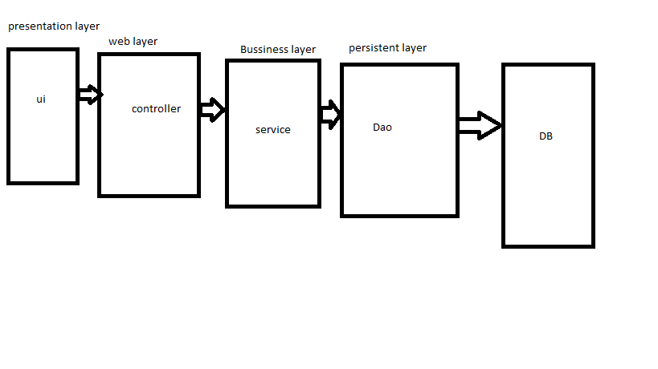

At controller level we used @contrller, @restcontroller

4) **who is responsible to perform dependency in jection in spring??**

Ioc container so we used @autowired

To inform ioc container to do dependency injection we used @autowired

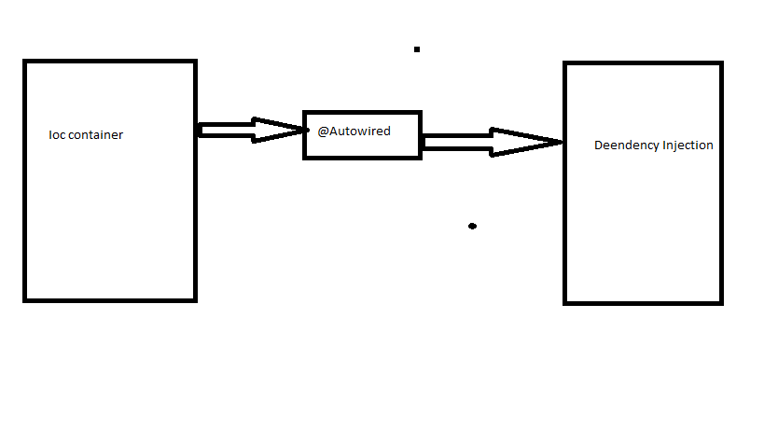

If we want to inject one class to another class we used @autowired

Ex dao inject into service class

Ex service class inject into controller

@autowiring perform in to setter level, constructor level, field level/ method level, constructor level, variable level

@restcontroler used in btob application

@controler used to btoc application

**5)@configration?**

If we want to used java class as configuration class used @Configration alternate of xml.

It is a class level annotation.

**6)@Bean?**

It is a method level annotation

Create a object of class we used as a @Bean u need to take care of object but @componet,@service,@repository,@configration create object take care of ioc container

**7)@Qualifier?**

If more then one bean qualifying for depency injection to avoid this ambiguity we use @qualifier

Resolve the problem in @autowiring

**8) @component?**

Create an object in container

**9)@component scan?**

**10) @value?**

Read data from input

**11)@propertySource?**

Access application properties

**12)@configrationProperties?**

It load all keys in to matching variable at a time by writing this only one time

13)@Autowired?

14)@Lookup?

15)@primary?

16)@Bean?

17)@Repository?

18)@Service?

19)@Controller?

20)@RestController?