Question:

13 topographic points are marked on a stereo-pair of aerial photographs.
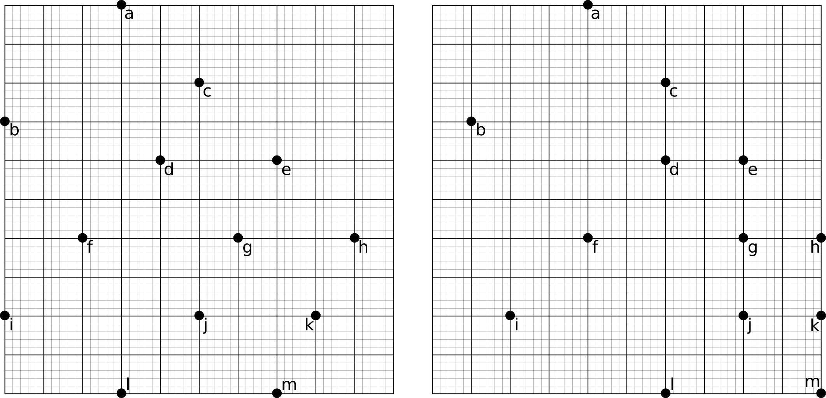
1. Connect the dots to form three contour lines (50%).
2. Estimate the contour interval assuming that the aerial photographs were taken from a position 1500m above the highest contour (50%).

Answer:

1. Connect the points of equal parallax:
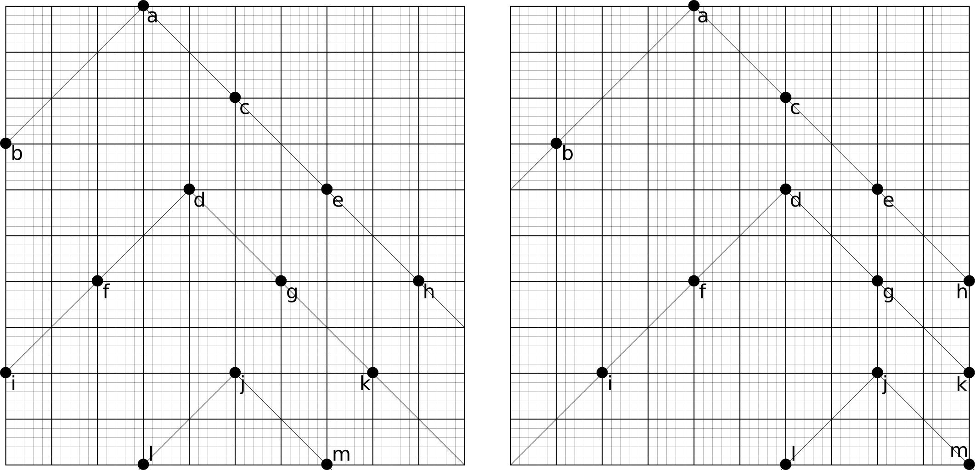
2. l-j-m has the highest parallax (=15) and is therefore the highest contour. The height difference with the second highest contour (i-f-d-g-k) is h = 1500 * (15-10)/15 = 500m.

