Question x: The stereo-imagery in Figure 1 was taken at an elevation of 4000m above point A. What is the elevation difference between points A and B?

Model answer:
1. Parallax of point A = 34-8 = 26
2. Parallax of point B = 6+32 = 38
3. Parallax difference = 38-26 = 12
4. Height difference = 4000*12/38 = 1260m

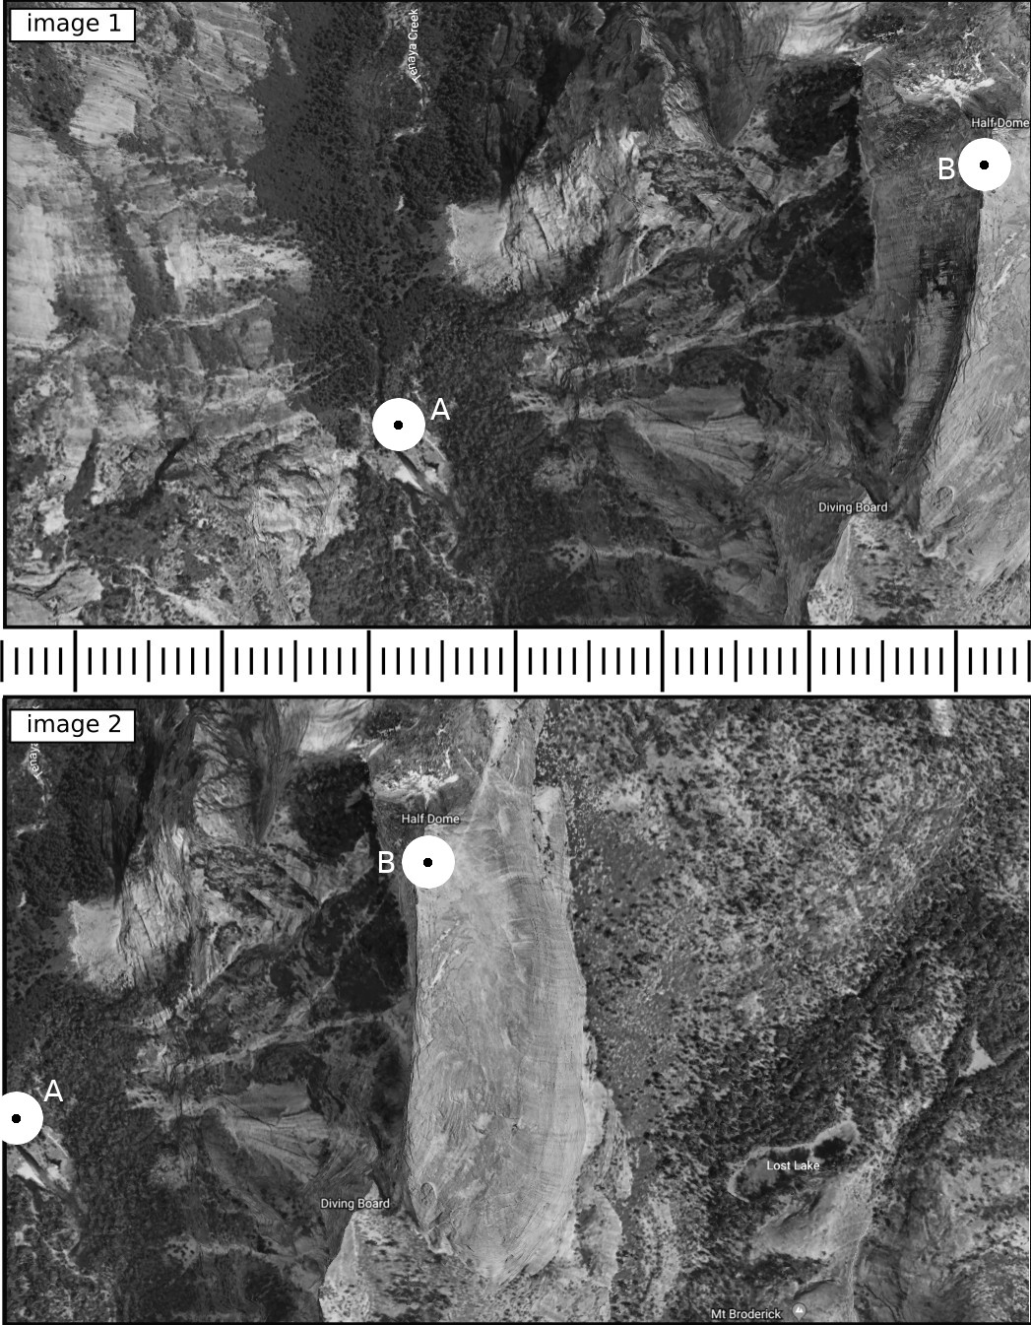Figure 1: Stereo-imagery for Question x.

