Unmixing detrital age distributions: a direct solution
Pieter Vermeesch
University College London
p.vermeesch@ucl.ac.uk
Abstract
Detrital geochronology can be used to quantify sediment budgets by estimating the proportions in which a set of known sources contribute to a sedimentary sink, such as a river downstream of a confluence. Existing ‘top-down’ unmixing algorithms solve this inverse problem by iterative search, either exhaustively testing all mixing proportions in 1% increments or sampling them at random. Their computational cost grows exponentially with the number of sources. They also rely on heuristic dissimilarity measures that lack a firm theoretical basis and can give inconsistent results depending on which measure is chosen. This paper presents a direct solution to the top-down unmixing problem. Because mixing of frequency distributions is a linear operation, the problem can be expressed in matrix form using empirical cumulative distribution functions and solved by least squares, subject to the constraint that the proportions sum to one. The solution is unique and is mathematically equivalent to minimising the Cramér–von Mises distance between the observed and predicted distributions, so no kernel smoothing or choice of objective function is needed. Its speed makes bootstrap resampling practical, which yields confidence intervals that capture sampling uncertainty in both sources and sink. Tests on simulated binary mixtures of normal distributions show that the method remains accurate even when the sources overlap strongly. Applied to a published detrital zircon U–Pb dataset from central California, the method gives confidence intervals that encompass the full range of results from the exhaustive search under five different dissimilarity functions. The Cramér–von Mises statistic also serves as a diagnostic for identifying sinks that the specified sources cannot adequately explain. As with any top-down approach, the results are only as reliable as the assumption that all relevant sources have been identified, and they describe the dated mineral phase rather than total sediment contributions. The algorithm is implemented in the R package IsoplotR.

Introduction
Consider the confluence of two rivers draining catchments with contrasting geological histories, and hence distinct detrital zircon U–Pb age distributions. Downstream of the confluence, the detrital zircon U–Pb age spectra form a mixture of the two input signals, with mixing proportions determined by the relative contributions of each branch to the zircon budget of the main river. If the zircon concentrations of both branches are known, these mixing proportions can be used to constrain the sediment budget of the river network. Solving this inverse problem is of considerable interest to sedimentary geologists, as it provides an opportunity to quantify sediment budgets using detrital geochronology. distinguish between top-down unmixing, in which the sources are known, and bottom-up unmixing, in which they are unknown. This paper focuses exclusively on the top-down problem because the bottom-up problem has no unique solution .
Existing algorithms solve the top-down problem using iterative search strategies to find the mixing proportions that minimise the misfit between the observed and predicted age distributions. These algorithms are suboptimal in two respects. First, they are computationally inefficient. exhaustively search all possible mixing proportions in 1% increments, whereas use a Monte Carlo approach without a convergence criterion. Both approaches exhibit exponential time complexity: the computational cost of estimating the mixing proportions of a $k$-component mixture scales with the $\left(k−1\right)$^{th} power of the number of possible proportions. Second, existing unmixing algorithms quantify the misfit between observed and predicted distributions using heuristic measures, such as ‘likeness’ and the ‘cross-correlation of probability density plots’. These measures lack a firm theoretical foundation and have been shown to be problematic in limiting cases such as the application to high precision data .
This paper presents a direct solution to the unmixing problem that addresses both limitations. Section 2 shows that mixing frequency distributions is a linear problem that can be expressed in matrix form and solved using least squares estimation. This approach is mathematically equivalent to minimising the Cramér–von Mises distance between the observed and predicted distributions. Section 3 applies the new algorithm to simulated and published datasets to demonstrate its effectiveness. The examples also illustrate how the results can be used to identify problematic datasets for which the underlying model assumptions are violated. The new algorithm has been added to IsoplotR for immediate use in detrital studies (Section 4).

A direct solution to the unmixing problem
The unmixing problem can be cast as a linear system of three matrices, using the following definitions:
$k$: the number of sediment sources (e.g. $k=2$ in Figure [fig:algorithm]);
$W_{j}$; the contribution of the $j$^{th} source to the sink, where $W_{k}=1−\sum_{j=1}^{k−1}{ }W_{j}$ (Figure [fig:algorithm]d);
$n$: the sample size of the sink;
$t_{i}$: the $i$^{th} sample (date) of the sink (with $1≤i≤n$);
$X_{i,j}$: the cumulative probability of $t_{i}$ under the empirical cumulative distribution function of source $j$ (Figure [fig:algorithm]e).
$Y_{i}=\left(2i−1\right)/2n$, which is essentially the empirical cumulative probability of $t_{i}$ in the sink (Figure [fig:algorithm]f).
Using these definitions, the mixing problem can be written as a linear matrix expression:
$$\left[\begin{matrix}X_{1,1} & … & X_{1,j} & … & X_{1,k} \\ ⋮ & ⋱ & ⋮ & ⋱ & ⋮ \\ X_{i,1} & … & X_{i,j} & … & X_{i,k} \\ ⋮ & ⋱ & ⋮ & ⋱ & ⋮ \\ X_{n,1} & … & X_{n,j} & … & X_{n,k} \\ \end{matrix}\right]\left[\begin{matrix}W_{1} \\ ⋮ \\ W_{j} \\ ⋮ \\ W_{k}\end{matrix}\right]=\left[\begin{matrix}Y_{1} \\ ⋮ \\ Y_{i} \\ ⋮ \\ Y_{n}\end{matrix}\right] or X W=Y$$
It is worth noting that this matrix formulation is similar to the non-negative matrix factorisation approach introduced by to solve the bottom-up unmixing problem. There are two key differences between their approach and the direct solution presented here. A first difference is that ’s $X$ and $Y$ are populated with density estimates, whereas the direct solution uses cumulative probabilities. This avoids the need for kernel smoothing. The second difference is that both $X$ and $W$ are unknown in ’s bottom-up formulation, whereas $X$ is known and only $W$ needs to be estimated in the top-down problem. Consequently, Equation [eq:unmix] has a unique solution, obtained by minimising the sum of squared residuals between $Y$ and $XW$, subject to the constraint that $\sum_{j=1}^{k}{ }W_{j}=1$. Several methods can be used to solve Equation [eq:unmix], including Lagrange multipliers and non-negative least squares algorithms . Unlike non-negative matrix factorisation, this least squares problem has a unique solution.
Both sides of Equation [eq:unmix] represent cumulative distributions. The sum of the squared differences between two such distributions is closely related to the Cramér–von Mises (CvM) criterion, a well-established statistical measure:
$$\text{CvM}=\frac{1}{12n}+∥X \hat{W}−Y∥^{2}$$
where $\hat{W}$ denotes the least squares solution. The Cramér–von Mises criterion does not satisfy the triangle inequality and is therefore not a proper metric. This limits its suitability for applications such as multidimensional scaling . For the purpose of unmixing, however, the Cramér–von Mises criterion is adequate.
The mixing proportions $W_{j}$ are constrained to lie between 0 and 1. In the vicinity of either boundary, their uncertainty distributions become skewed and strongly correlated. Because the direct solution is computationally efficient, the method is well suited to bootstrap resampling, which captures sampling uncertainties in both the sources and the sink. Section 3 demonstrates the effectiveness of this approach using a simulated example.
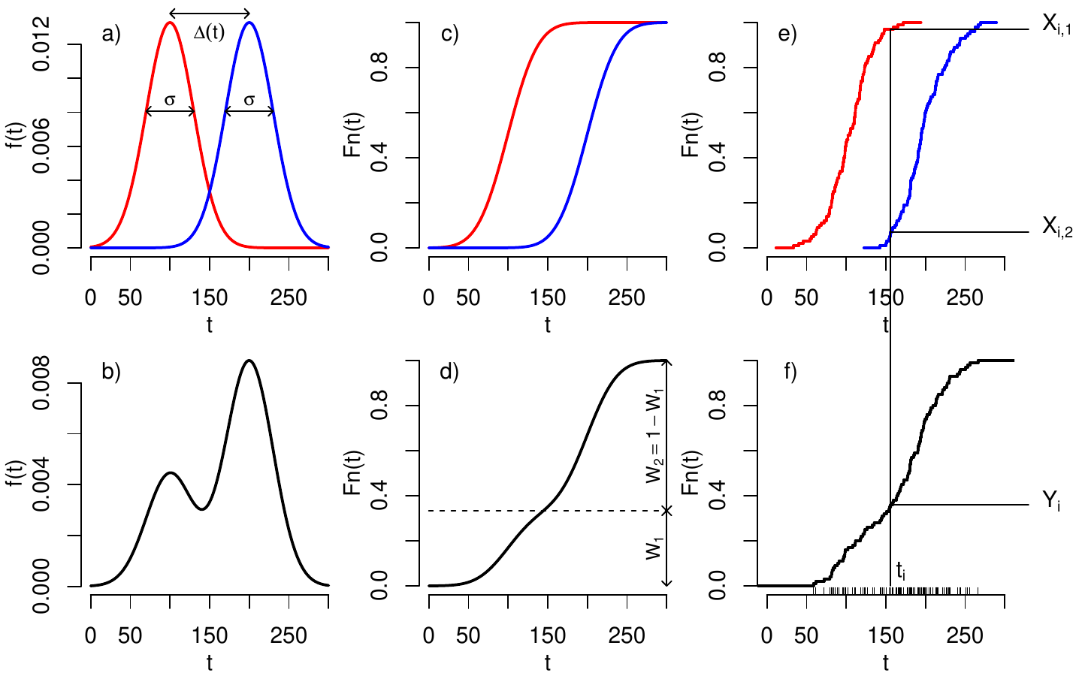

Examples
As a first example, consider a binary mixture of two normal distributions with the same standard deviation $σ$ (Figure [fig:algorithm]a). Let $Δ\left(t\right)$ denote the lateral separation between the two source distributions. When $Δ\left(t\right)$ is much larger than $σ$, the sink distribution is bimodal, making the mixing proportions easy to recover. As $Δ\left(t\right)$ decreases, the sink becomes unimodal, making the deconvolution problem more difficult. Figure [fig:bootstrap] shows the bootstrapped 95% confidence intervals for $W_{1}$ as $Δ\left(t\right)$ varies from 0 to 3 standard deviations. As expected, the uncertainties decrease with increasing separation. Nevertheless, the direct solution remains accurate even when $Δ\left(t\right)$ is small.
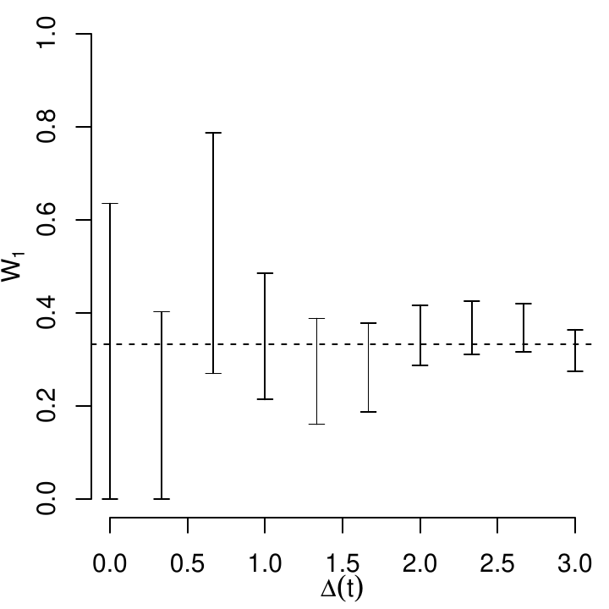

Figure [fig:Sickmann] applies the direct solution to the detrital zircon U–Pb dataset of , which was used as a case study in the unmixing study of . The dataset comprises seventeen sand samples from central California (USA): five river samples, four beach samples and eight submarine canyon samples. partitioned these data into three sources (P1, P2 and P3) and twelve sinks. We retain the same partitioning to facilitate comparison between the direct solution and the exhaustive search algorithm of .
Figure [fig:Sickmann] consists of three parts. The top panel shows the empirical cumulative distributions of the three sources. P1 and P2 have broad U–Pb age distributions, whereas P3 is more concentrated in the 80–100 Ma interval. The left-hand panels show the observed ($Y$, red) and fitted ($X\hat{W}$, blue) distributions for each of the twelve sinks. The goodness of fit is quantified using the Cramér–von Mises statistic (CvM), with higher values indicating a poorer fit. Sample GSB has the highest CvM value in Figure [fig:Sickmann]. Closer inspection reveals that its DZ dates span a much narrower range than those of any of the three sources, explaining the poor fit. Thus, the CvM statistic provides a useful diagnostic for identifying potential problems with the unmixing solution. Finally, the lower-right panel shows the estimated mixing proportions for all twelve sinks.
Before comparing the direct solution with the exhaustive search algorithm of , it is worth noting that the results of the latter depend on the objective function used for optimisation. explored five dissimilarity functions (likeness, similarity, cross-correlation, Kolmogorov–Smirnov and Kuiper), each yielding different results. They illustrate this sensitivity using sample MAN, for which the estimated mixing proportions span the following ranges across the five functions: $66\%≤W_{1}≤86\%$, $3\%≤W_{2}≤15\%$ and $0\%≤W_{3}≤31\%$. By comparison, the direct solution for MAN yields $\{W_{1}=83\%,W_{2}=5\%,W_{3}=12\%\}$, with 95% confidence intervals of $66\%≤W_{1}≤90\%$, $0\%≤W_{2}≤20\%$ and $0\%≤W_{3}≤31\%$. These confidence intervals encompass the full range of solutions obtained by , while avoiding the ambiguity introduced by the choice of dissimilarity function.
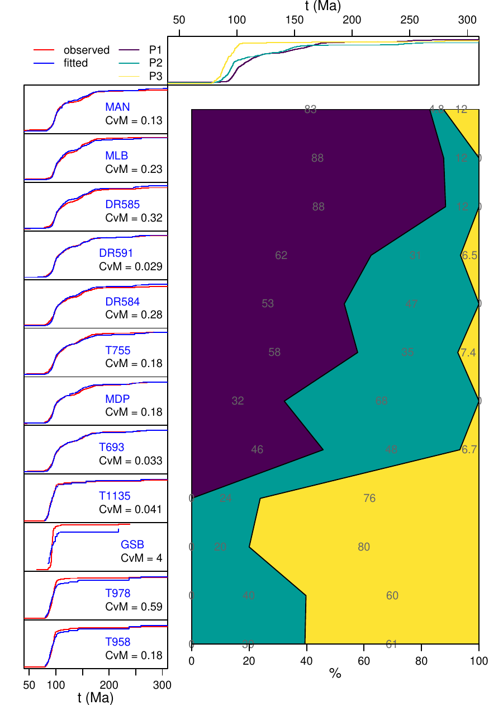

Implementation in IsoplotR
The new algorithm was implemented in the R package IsoplotR (version 7.1 and higher) via a new unmix function. It uses a modified least squares algorithm that enforces a unit sum of the mixing proportions with a Lagrange multiplier. If the solution returns any value outside the unit interval, a fallback solution uses the non-negative least squares algorithm of with a penalty applied to the final row to enforce the unit sum of the weights. The unmix function can either be called from the R console, or from IsoplotR’s graphical user interface (GUI), which is available online and offline . In the GUI, the unmixing functions can be accessed by selecting ‘detritals’ and ‘unmix’ as top-level options. At the console:
library(IsoplotR)
DZ <- read.data("Sickmann.csv",method="detritals")
unmix(DZ,source_names=c("P1","P2","P3"))
To obtain bootstrapped confidence intervals:
fit <- unmix(DZ,source_names=c("P1","P2","P3"),boot=TRUE,plot=FALSE)
which returns a list containing matrices called W, ll and ul, storing the mixing proportions and the lower and upper limits of their confidence intervals, respectively.

Conclusions
This paper introduced a direct solution to the top-down sediment unmixing problem, which had previously been addressed using exhaustive and random search algorithms. Whereas these numerical approaches become progressively slower as the number of sources increases, the direct solution can be computed almost instantaneously on any modern computer. The algorithm can accommodate any number of sources, provided that this number does not exceed the number of dates in the sink.
Beyond its obvious speed advantage, the direct solution eliminates the ambiguity associated with choosing between different objective functions in iterative approaches, some of which lack a firm statistical basis. Instead, the new algorithm uses least squares to minimise a single, well-established objective function: the Cramér–von Mises (CvM) statistic. When applied to multiple sinks, the CvM statistic can help identify problematic samples that cannot be adequately reproduced by the specified sources. In principle, it can also be used to formally test whether a sink represents a mixture of those sources. However, such tests have limited practical value because their outcomes depend strongly on sample size. Given a sufficiently large sample, no geological sink will be an exact mixture of a finite number of sources. The CvM statistic is therefore better used as a relative measure of goodness of fit than as a basis for calculating p-values .
As with any top-down unmixing model, the reliability of the results depends on the validity of the input. Whether the estimated mixing proportions reflect geological reality or an analytical artefact depends on the assumption that all relevant sources have been identified. Moreover, even if this assumption holds, the estimated weights quantify only the contributions of the datable mineral, not the total sediment. Converting these proportions into sediment budgets requires estimates of mineral fertility , which are not always available in real-world studies.

Acknowledgments
This work was initiated in response to a request from IsoplotR user Estefany Villanueva-García. Andy Carter and Guido Pastore are thanked for beta-testing the algorithm. This research was supported by the Natural Environment Research Council (grant no. NE/T001518/1).

Supplementary Information
All the code and data to generate the figures in this paper are available online at https://github.com/pvermees/supplements.

References
Lawson, C. L. and Hanson, R. J. Solving least squares problems. SIAM, 1995.
Malusà, M., Resentini, A., and Garzanti, E. Hydraulic sorting and mineral fertility bias in detrital geochronology. Gondwana Research, 31: 1–19, 2016.
Saylor, J., Sundell, K., and Sharman, G. Characterizing sediment sources by non-negative matrix factorization of detrital geochronological data. Earth and Planetary Science Letters, 512: 46–58, 2019. ISSN 0012-821X. doi: https://doi.org/10.1016/j.epsl.2019.01.044. URL https://www.sciencedirect.com/science/article/pii/S0012821X19300706.
Sharman, G. R. and Johnstone, S. A. Sediment unmixing using detrital geochronology. Earth and Planetary Science Letters, 477: 183–194, 2017.
Sickmann, Z. T., Paull, C. K., and Graham, S. A. Detrital-zircon mixing and partitioning in fluvial to deep marine systems, central California, USA. Journal of Sedimentary Research, 86 (11): 1298–1307, 2016.
Sundell, K. and Saylor, J. E. Unmixing detrital geochronology age distributions. Geochemistry, Geophysics, Geosystems, 2017.
Vermeesch, P. IsoplotR: a free and open toolbox for geochronology. Geoscience Frontiers, 9: 1479–1493, 2018a. doi: 10.1016/j.gsf.2018.04.001.
Vermeesch, P. Dissimilarity measures in detrital geochronology. Earth-Science Reviews, 178: 310–321, 2018b. doi: 10.1016/j.earscirev.2017.11.027.

