Point thèse

2024-07-01

# 1. Treatment assignment mechanism

* Binary (treated/not treated)
* Switching (i.e. on/off)

Climate and weather extreme events listed as such by the[@ipcc2023] and included in EM-DAT:

* temperature extremes (nat-met-ext);
* pluvial floods (nat-hyd-flo);
* river floods (nat-hyd-flo);
* drought (nat-cli-dro)
* storms (including tropical cyclones) (nat-met-sto);
* compound events (multivariate and concurrent extremes)

*Note: ‘Heavy precipitation’ is also considered as an climate and weather extreme events, however EM-DAT doesn’t include a specific category for it. ‘Flood’ can be considered the closest related category*.

## 1.1 Treatment status

### 1.1.1 All events

Here, three criteria defined the treatment (cf. the treatment assignment mechanism above): (1) the occurence of a disaster included in one of the EM-DAT categories defined as a climate and weather extreme event by the IPCC; (2) binary; (3) switching/on-off.

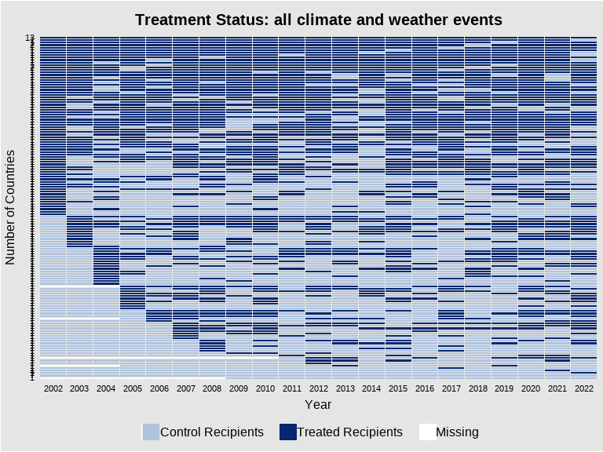

*Note: most recipient countries have been treated multiple times and over subsequent periods. This makes any attempt to define a treatment assignment mechanism for causal inference very complex*.

To limit the number of treated periods per country, I follow a two-stage approach:

### 1.1.2 Events *leading to an international assistance call (“appeal”)*

First, I restrict the sample to disasters which have led to an international assistance call (“appeal”) by the affected country’s government. We can assume that the most extreme events are more likely to push recipient governments to call for international assistance.

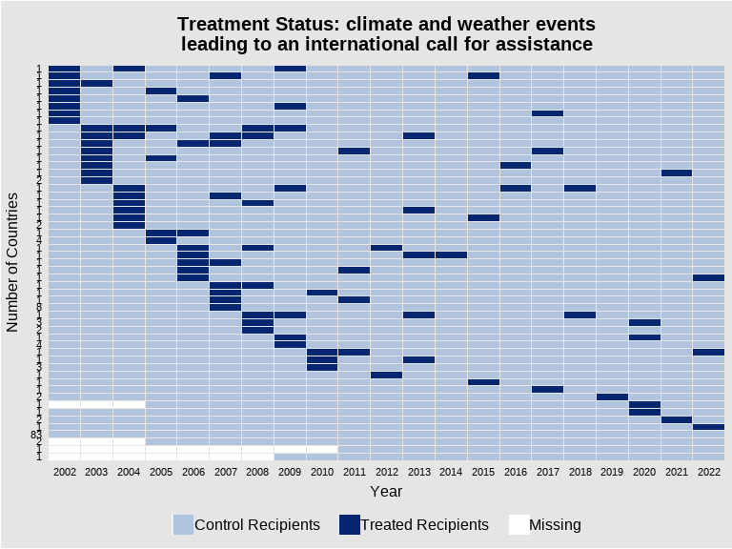

*Note: the average number of treatment periods per country has decreased drastically. However, a large sample are part of more than one treatment cohorts (i.e., the have faced more than one disaster) over the period*.

### 1.1.3 *Unique* events leading to an international assistance call (“appeal”)

Second, I restrict the sample to countries which have been affected by maximum one disaster over the period (i.e. 0 or 1).

List of the countries with only one treatment period in the sample:

[1] "Ukraine" "Burundi"   
 [3] "Cameroon" "Central African Republic"   
 [5] "Comoros" "Democratic Republic of the Congo"  
 [7] "Benin" "Ethiopia"   
 [9] "Ghana" "Kenya"   
[11] "Lesotho" "Liberia"   
[13] "Mozambique" "Zimbabwe"   
[15] "Sao Tome and Principe" "Sierra Leone"   
[17] "Djibouti" "Uganda"   
[19] "Zambia" "Haiti"   
[21] "Belize" "Mexico"   
[23] "Trinidad and Tobago" "Saint Vincent and the Grenadines"  
[25] "Chile" "Colombia"   
[27] "Paraguay" "Peru"   
[29] "Uruguay" "Bangladesh"   
[31] "Lao People's Democratic Republic" "Mongolia"   
[33] "Viet Nam" "Vanuatu"   
[35] "Micronesia" "Solomon Islands"

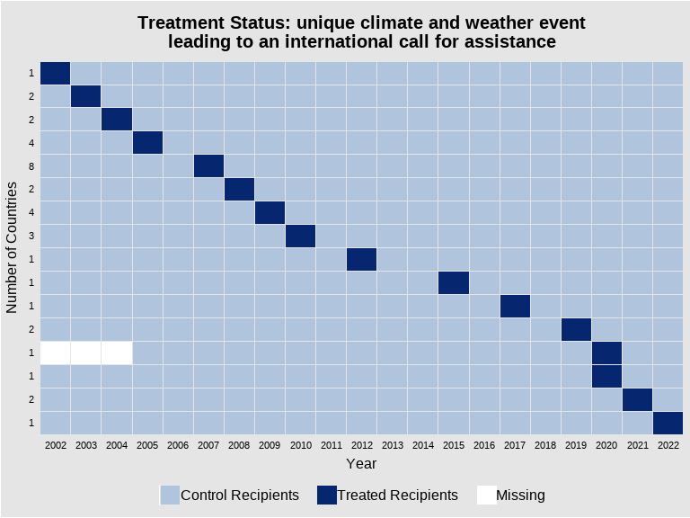

*Note: treatment cohorts include between 1 and 8 countries*.

# 2. Within-subject comparisons by period

First, I list all donors and recipients registered in the OECD CRS data base.

Second, I transform observations with negative commitments (i.e. commitment withdrawals) to zeroes.

Note: while there are 173 obs. with negative commitments, from 5 donors and 65 recipients over the period in the initial data set, both their distinct and aggregated values remain low (~ MUSD). Besides, only one observation remains with a small negative commitment once aggregated at the dyad level. Consequently, the conversion of negative values to zeroes should not bias the results.

Third, I define the main outcome variables at the level of the donor-recipient dyad.

* Total commitments, Millions, USD
  + Total commitments delivered through non-State channels, Millions, USD
    - Total commitments delivered through NGOs, Millions, USD
    - Total commitments delivered through Multilaterals, Millions, USD
* Share of commitments delivered through non-State channels, %
  + Share of commitments delivered through NGOs, %
  + Share of commitments delivered through Multilaterals, %
* Number of sectors (with positive commitments)
  + Number of sub-sectors (‘purposes’ from the OECD’s code book) (with positive commitments)
* Number of projects (with positive commitments)
  + Average size of projects (with positive commitments), Millions, USD

Fourth, I merge the list of all potential dyads by year with the outcome data set which includes total commitments aggregated at the donor-recipient dyad.

Fifth, I specify ‘real’ zeroes. When both the donor and the recipient’s cohorts (i.e. the year of the first registered projects in the OECD CRS data base) are prior to the project’s year, missing values are converted to zeroes. In other words, missing values are only applied when the cohort of at least one side of the dyad comes after the project’s year.

Lastly, I merge the outcomes data set with the treatment data set.

recipient_id year donor_id donor_name   
 Length:113703 Min. :2002 Length:113703 Length:113703   
 Class :character 1st Qu.:2007 Class :character Class :character   
 Mode :character Median :2012 Mode :character Mode :character   
 Mean :2012   
 3rd Qu.:2017   
 Max. :2022   
   
 recipient_name universe commitment commit.channel_nonstate  
 Length:113703 Min. :0.0000 Min. : 0.00 Min. : 0.00   
 Class :character 1st Qu.:0.0000 1st Qu.: 0.00 1st Qu.: 0.00   
 Mode :character Median :0.0000 Median : 0.00 Median : 0.00   
 Mean :0.4877 Mean : 16.43 Mean : 3.60   
 3rd Qu.:1.0000 3rd Qu.: 0.93 3rd Qu.: 0.01   
 Max. :1.0000 Max. :10924.86 Max. :2237.15   
 NA's :58250 NA's :58250   
 commit.channel_nonstate_ngo commit.channel_nonstate_multi n_sector   
 Min. : 0.00 Min. : 0.00 Min. : 0.0   
 1st Qu.: 0.00 1st Qu.: 0.00 1st Qu.: 1.0   
 Median : 0.00 Median : 0.00 Median : 3.0   
 Mean : 1.51 Mean : 1.39 Mean : 5.7   
 3rd Qu.: 0.00 3rd Qu.: 0.00 3rd Qu.: 8.0   
 Max. :817.85 Max. :1452.66 Max. :32.0   
 NA's :58250 NA's :58250 NA's :90765   
 n_purpose n_project size_project   
 Min. : 0.00 Min. : 0.00 Min. : 0.00   
 1st Qu.: 1.00 1st Qu.: 2.00 1st Qu.: 0.06   
 Median : 4.00 Median : 6.00 Median : 0.22   
 Mean : 9.32 Mean : 23.03 Mean : 4.03   
 3rd Qu.: 12.00 3rd Qu.: 23.00 3rd Qu.: 0.97   
 Max. :107.00 Max. :1779.00 Max. :1093.01   
 NA's :90765 NA's :90765 NA's :90765   
 sh_commit.channel_nonstate sh_commit.channel_nonstate_ngo  
 Min. : 0.00 Min. : 0.00   
 1st Qu.: 0.00 1st Qu.: 0.00   
 Median : 28.79 Median : 0.00   
 Mean : 44.75 Mean : 22.81   
 3rd Qu.:100.00 3rd Qu.: 35.05   
 Max. :100.00 Max. :100.00   
 NA's :90765 NA's :90765   
 sh_commit.channel_nonstate_multi treat_all treatment   
 Min. : 0.00 Min. :0.0000 Min. :0.00000   
 1st Qu.: 0.00 1st Qu.:0.0000 1st Qu.:0.00000   
 Median : 0.00 Median :1.0000 Median :0.00000   
 Mean : 16.91 Mean :0.6295 Mean :0.04781   
 3rd Qu.: 13.31 3rd Qu.:1.0000 3rd Qu.:0.00000   
 Max. :100.00 Max. :1.0000 Max. :1.00000   
 NA's :90765

## 2.1 Commitments

### 2.1.1 Total

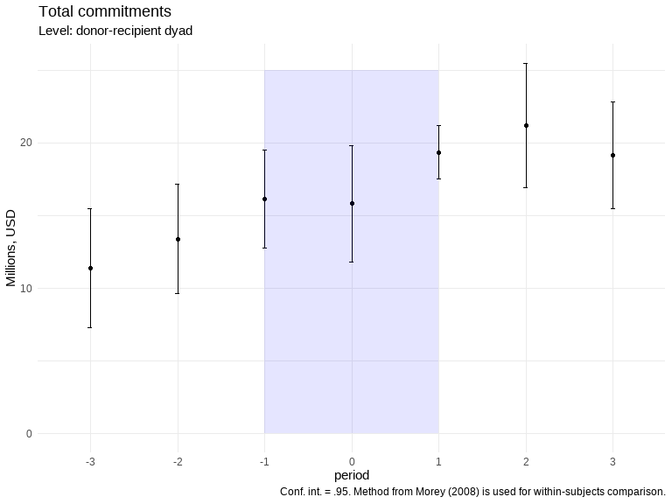

**Graph reading**: increasing trend before treatment, small break in trend in t=0, recovery in t=1 and t=2, then decline in t=3.

**Comment**: short-term effect of the treatment, where the outcome returns to the pre-treatment trend from t=1. However, the decline in t=3 raises the question whether of the post-emergency trend. Is reconstruction following the emergency phase or do we observe a recovery in “M”? Is the increasing trend before treatment due to the time trend?

### 2.1.2 Non-State

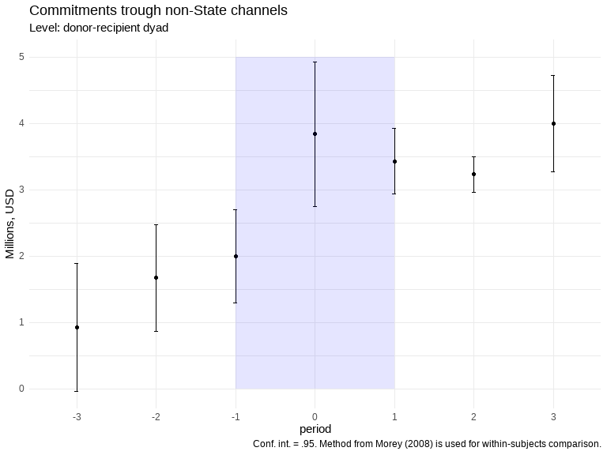

**Graph reading**: increasing trend before treatment, level of commitments increases significantly at t=0, then follows a decreasing trend until t=2, then returns to a level equivalent to that at t=0 at t=3.

**Comment**: clear observable impact of the treatment in t=0. However, the effect on the pre-treatment trend is not obvious when looking at t=3. It seems more like a short-term surge in t=0, going back to pre-treatment trend (or a slightly lower trend) in the following periods. Is the increasing trend before treatment due to the time trend?

#### 2.1.2.1 NGOs

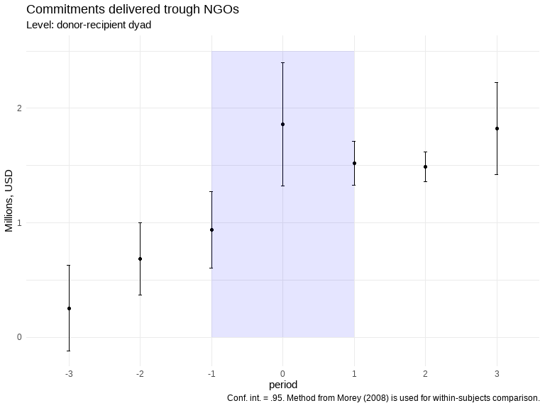

**Graph reading**: same trend than for the aggregated non-State channels above, with a significant impact of treatment in t=0.

**Comment**: It raises the question of the post-treatment trend: back to pre-treatment or stagnation? Is the increasing trend before treatment due to the time trend?

#### 2.1.2.2 Multilaterals

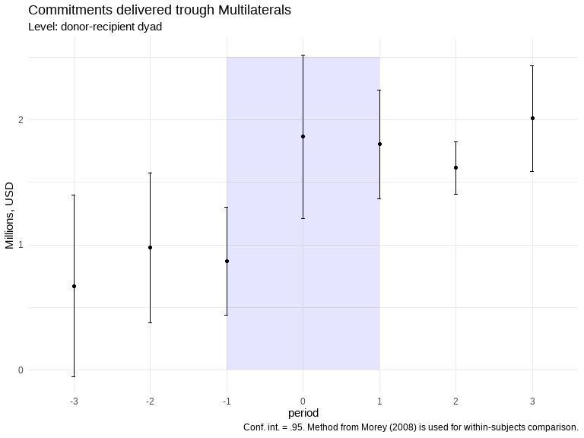

**Graph reading**: same trend than for the aggregated non-State channels and NGOs above.

**Comment**: same as above. Do we see a different between earmarked and un-earmarked funds? Between the two different types of earmarked funds (institutional sub-accounts vs. pass-through providers)?

## 2.3 Share of commitments delivered through non-State channels

### 2.3.1 Total

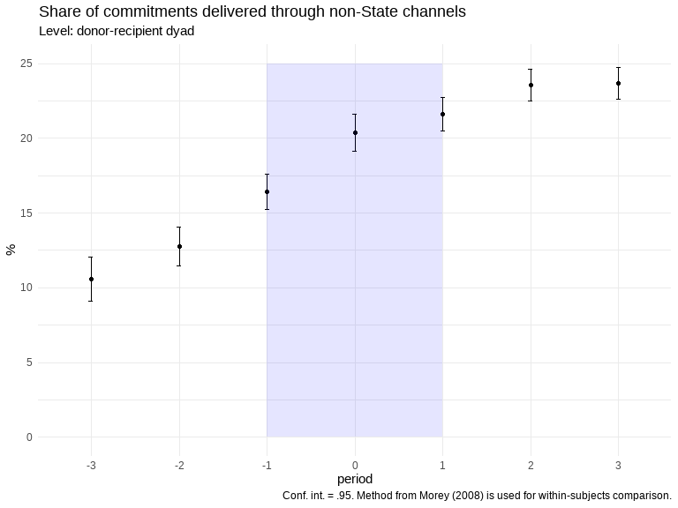

**Graph reading**: increasing pre-treatment trend (time trend). No observable impact of treatment in t=0, slowing trend in t=1, flattening trend in t=2 and t=3.

**Comment**: no clear interpretation. No impact? But if so, how to explain the lack of strong effect on overall commitments but the significant one on commitments delivered through non-State channels? Is it that the volume of and/or the effect on latter are too small?

#### 2.3.1.1 By donor type

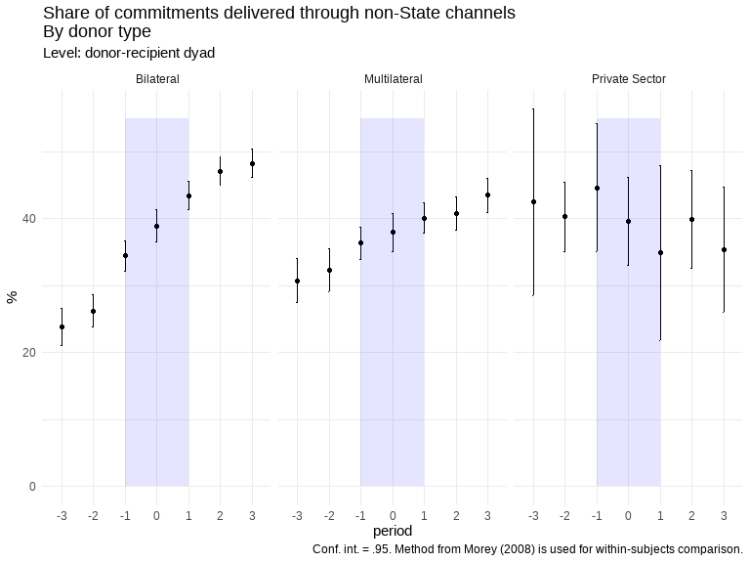

**Graph reading**: observable differences between donor type. Increasing pre-treatment trends for both bilateral and multilateral donors (no clear pre-treatment trend for private sector donors). Positive impact of treatment on the outcome in t=-1 for both bilateral and multilateral donor, even though it is clearer for the former (no clear impact for private sector donors or slightly decreasing in the short-term).

**Comment**: the impact of the treatment seems to occur as soon as t-1. Several explanations could explain this: measurement error in the year attributed to disasters, donors have started committed new funds before the recipient government declared a state of emergency (and call for external assistance), good forecasting leading to investments in preparedness, etc. This stresses the need to use a physical measure of the extreme events.

#### 2.3.1.2 By recipient income group

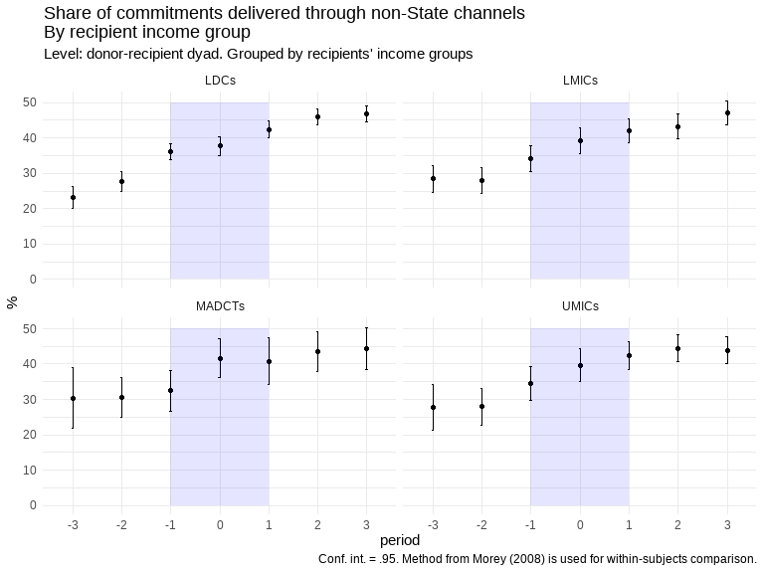

**Graph reading**: similar trend for each income group, with a flat pre-treatment trend, a small change in trend level in t=-1 or t=0, and a flat post-treatment trend.

**Comment**: the “treatment effect” seems more obvious in t=-1 for LDCs and in t=0 for MADCTs. Most MADCTs are SIDS, can it be related? Maybe is it due to different disaster types (fast-onset, such as tropical storms, in SIDS)? Or maybe (international) NGOs are more likely to be already on the ground in LDCs, so it is faster to channel funds to them before/once a disaster heats?

### 2.3.2 Channel of delivery

#### 2.3.2.1 NGOs

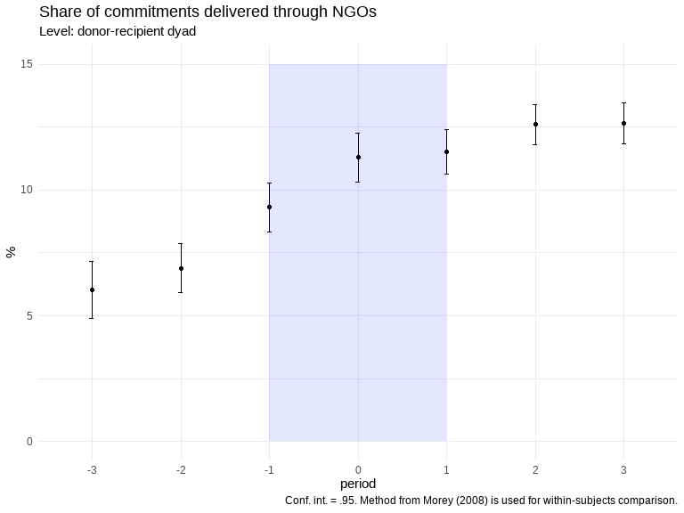

**Graph reading**: change in trend (level) in t=-1, and a flat post-treatment trend.

**Comment**: is it really a change in trend (level) in t=1 or t=0 or only a lower average level in t=-2? In any case, the pre- and post-treatment trends differ.

#### 2.3.2.2 Multilaterals

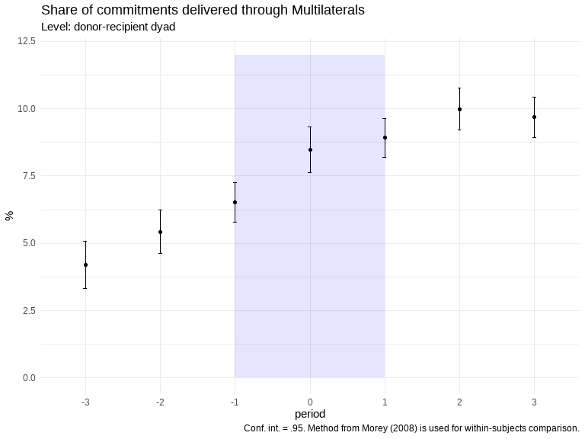

**Graph reading**: change in trend (level) in t=0, and a flat post-treatment trend.

**Comment**: it tends to reinforce the hypothesis that what we observed above in t=-1 is not an anticipation effect, but is only due to a lower level in t=-2. Here, the change in trend and trend level in t=0 is clearer. The share of commitments delivered through multilateral donors increase the same year the disaster occurs, but this share tends to stagnate in the following periods. Again, there might be differences between un/earmarked funds.

## 2.4 Projects

### 2.4.1 Number

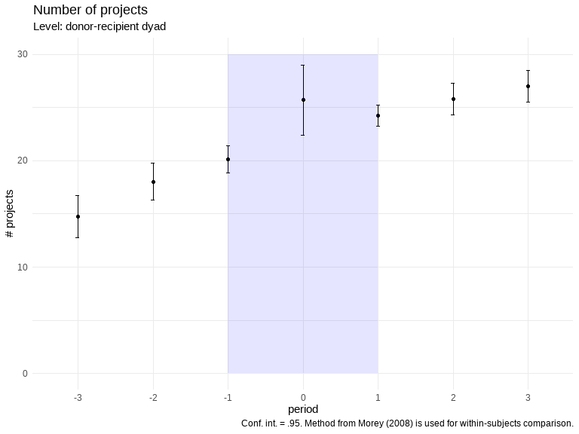

**Graph reading**: it is not clear if the observable change in level observed in t=0 is due to the treatment effect, a lower average level in t=-1, or an anticipation effect leading to the latter. However, there seems to be a difference between pre- and post-treatment trends.

**Comment**: it is not possible to say if the treatment leads to an increase in the number of projects in t=0. However, the number of project per dyad is increasing pre-treatment and seems to stagnate post-treatment. This would imply more concentration (or less fragmentation) of funds in recipient countries.

### 2.4.2 Average size

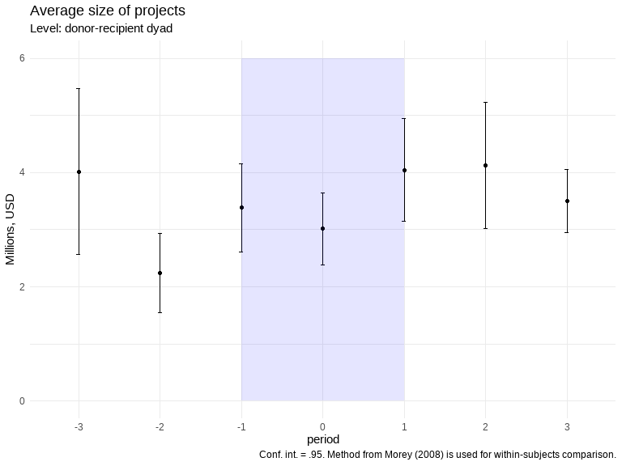

**Graph reading**: no clear trend, except maybe a small decrease in the average size of projects in t=0 and an increase in t=1 and t=2 (tbc).

**Comment**: no clear observable effect of treatment on the average size of projects.

## 2.5 Sectors

### 2.5.1 Number of sectors

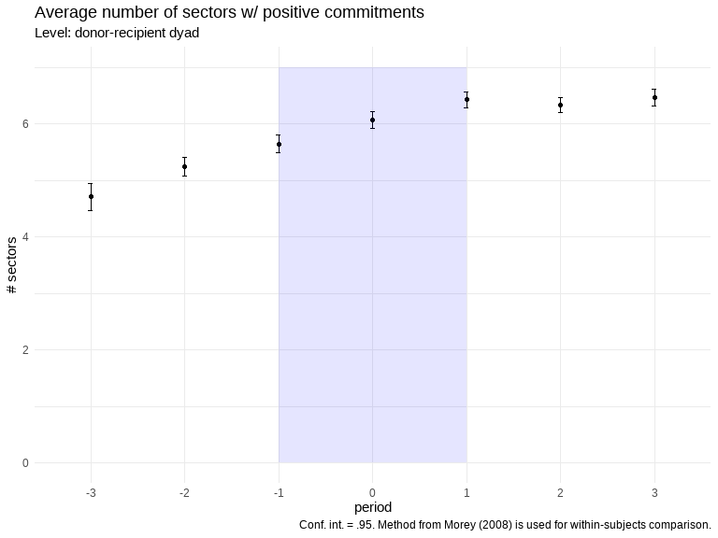

**Graph reading**: no clear trend, except maybe a flattening post-treatment trend?

**Comment**: no clear observable effect of treatment on the average number of sectors with positive commitments. This would imply that disasters have no (or a small negative) effect on the extensive margin of donors’ portfolio in affected countries.

### 2.5.2 Number of purposes

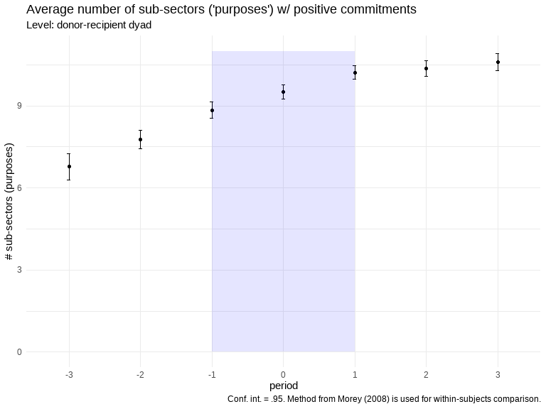

**Graph reading**: no clear trend, except maybe a flattening post-treatment trend?

**Comment**: no clear observable effect of treatment on the average number of sub-sectors (“purposes”) with positive commitments.