1. What are the two values of the Boolean data type? How do you write them?

Ans: Two values of Boolean data types are True and False.

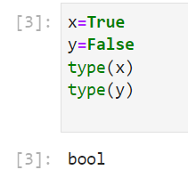

2. What are the three different types of Boolean operators?

Ans: Three different types of Boolean operators are **and ,or ,not**

3. Make a list of each Boolean operator's truth tables (i.e. every possible combination of Boolean values for the operator and what it evaluate).

Truth table for **and** is

**True, True, True**

**True, False, False**

**False, True, False**

**False, False , False**

Truth table for **or is**

**True, True, True**

**True, False, True**

**False, True, True**

**False, False, False**

**Truth table for not is**

**True is False**

**False is True.**

4. What are the values of the following expressions?

(5 > 4) and (3 == 5)

not (5 > 4)

(5 > 4) or (3 == 5)

not ((5 > 4) or (3 == 5))

(True and True) and (True == False)

(not False) or (not True)

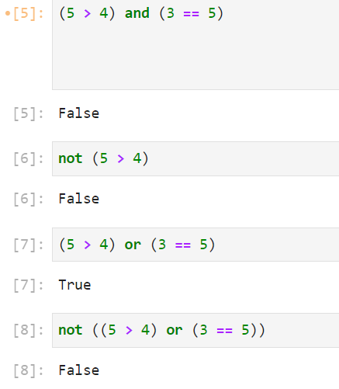

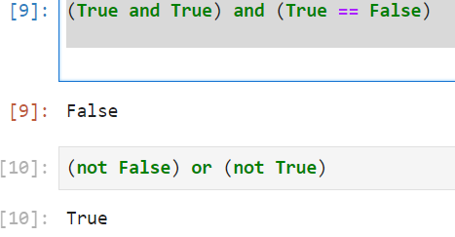

5. What are the six comparison operators?

**Ans: == , != , < , > , <= , =>**

6. How do you tell the difference between the equal to and assignment operators? Describe a condition and when you would use one.

**Ans: = is the assignment operator that stores the value in variable,**

**Where as == compares the two values.**

7. Identify the three blocks in this code:

spam = 0

if spam == 10:

print('eggs')

if spam > 5:

print('bacon')

else:

print('ham')

print('spam')

print('spam')

Ans: ‘eggs’ ‘bacon’ and ‘ham’ these are the block codes, having Indentation error.

8. Write code that prints Hello if 1 is stored in spam, prints Howdy if 2 is stored in spam, and prints Greetings! if anything else is stored in spam.

Ans: 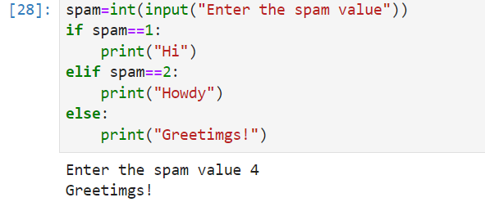

9. If your programme is stuck in an endless loop, what keys you’ll press?

Ans: **Ctrl C**

10. How can you tell the difference between break and continue?

**Ans: The break and continue are used to skip the iteration of loop.**

**Break statement ends or terminates the whole iteration of loop whereas continue skips the current iteration and brings the next iteration early.**

11. In a for loop, what is the difference between range(10), range(0, 10), and range(0, 10, 1)?

Ans: range(10)-------🡪It counts from 0 to 9

range(0, 10)------🡪It counts from 0 to 10

range(0, 10, 1)-----🡪It counts by increasing the value 1 for each iteration.

12. Write a short program that prints the numbers 1 to 10 using a for loop. Then write an equivalent program that prints the numbers 1 to 10 using a while loop.

Ans:

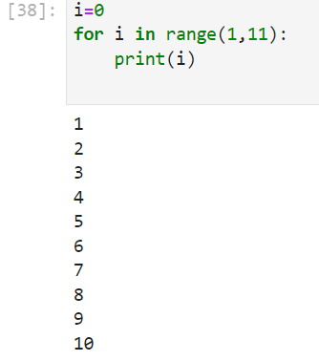

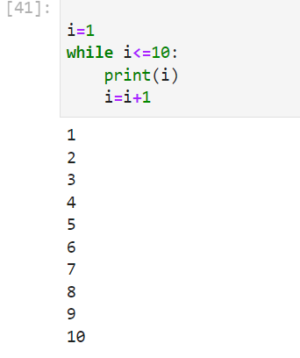

13. If you had a function named bacon() inside a module named spam, how would you call it after importing spam?

Ans: **spam.bacon()**