1. What exactly is []?

**Ans: [] is the list ,that having no items inside.**

2. In a list of values stored in a variable called spam, how would you assign the value 'hello' as the third value? (Assume [2, 4, 6, 8, 10] are in spam.)

**Ans: spam[2]=’hello’**

Let's pretend the spam includes the list ['a', 'b', 'c', 'd'] for the next three queries.

3. What is the value of spam[int(int('3' * 2) / 11)]?

**Ans: spam[3] i.e. d**

4. What is the value of spam[-1]?

Ans: spam[-1] is **d**

5. What is the value of spam[:2]?

**Ans:spam[:2] is ['a', 'b']**

Let's pretend bacon has the list [3.14, 'cat,' 11, 'cat,' True] for the next three questions.

Ans: bacon=[3.14, 'cat,' 11, 'cat,' True]

6. What is the value of bacon.index('cat')?

**Ans:bacon.index(‘cat’) is 1**

7. How does bacon.append(99) change the look of the list value in bacon?

**Ans: bacon.append(99) is [3.14, 'cat', 11, 'cat', True, 99]**

8. How does bacon.remove('cat') change the look of the list in bacon?

**Ans:bacon.remove(‘cat’) is [3.14, 11, 'cat', True]**

9. What are the list concatenation and list replication operators?

Ans: + is used for list concatenation and * is used for list replication.

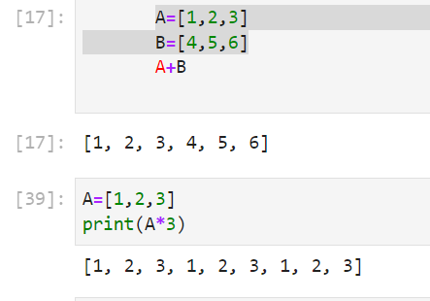

10. What is difference between the list methods append() and insert()?

Ans: Append will add the values at the end of the list , where as insert will add the values anywhere in the list based on indexing.

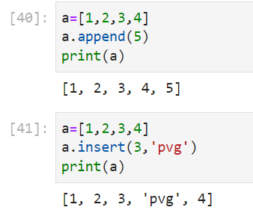

11. What are the two methods for removing items from a list?

**Ans: remove() and pop()**

12. Describe how list values and string values are identical.

**Ans: List and string both are sequences. String is a sequence of characters. List is a sequence of characters,integers.**

13. What's the difference between tuples and lists?

**Ans: We can change the values in list ,these are mutable but we cannot change the values of tuples which are immutable.**

14. How do you type a tuple value that only contains the integer 42?

**Ans: tup(42,)**

15. How do you get a list value's tuple form? How do you get a tuple value's list form?

**Ans: tuple() and list() are used to convert list and tuple values respectively.**

16. Variables that "contain" list values are not necessarily lists themselves. Instead, what do they contain?

**Ans: They contain references to list values.**

17. How do you distinguish between copy.copy() and copy.deepcopy()?

Ans: A copy of original object is stored in shallow copy .In deep copy the original object and the repetitive copies both are stored.

