

LiveCode 6.0 Reviewer’s Guide

April 2013

Contact: support@runrev.com



Copyright © 2013 Runtime Revolution
All Rights Reserved

Welcome
Welcome to the LiveCode platform reviewer’s guide. This guide highlights the core benefits of the LiveCode platform and walks you through getting started in the desktop development environment.
With this guide, you will learn how to build a simple business application, build an application for iOS (iPhone/iPad) and create a simple server script using LiveCode.
If you’re short on time, we’ve uploaded a 3-minute demonstration video of a simple game being built using LiveCode for iOS

Contents
LiveCode 6.0 Reviewer’s Guide 1
Welcome 2
Product Overview 4
LiveCode iOS Deployment Pack Overview 4
Getting Started 5
Points of Interest – Build a desktop application in LiveCode 5
The Message Box 6
Points of Interest – Building for iOS in LiveCode 7

Points of Interest – Building a server script using LiveCode Server 13
Conclusion 14
Appendix A: Handy Message Box Commands 15
Appendix B: LiveCode Feature List 16

Product Overview
LiveCode empowers developers to create applications that run in any environment, using a fast and easy compile-free workflow. This is why 89% of our customers would recommend us.
Target Customer
LiveCode has a robust feature set that makes it suitable for the development of a wide variety of commercial software, enterprise IT solutions, in-house utilities, front ends, e-learning solutions and even school projects.
Platform and Pricing
LiveCode is available as the $500 Commercial Edition, or the free Community Edition. The Commercial Edition can be used to build apps for all LiveCode supported platforms, including Mac, Windows, Linux, iOS, Android and Server. The free Community Edition is ideal for use in education, and can be used to build open source apps for all these platforms. You can learn more about the differences between them and download the free Community Edition here.
Product Highlights
- Compile-free Coding: Developers can achieve project goals in a fraction of the time using a compile-free workflow, with the ability to make changes to the interface or code while the application is running;
- English-like Programming Language: The LiveCode programming language lets users write code that makes sense using expressive, memorable syntax;
- Cross Platform Development: Flexible delivery options allow developers to reuse the same code across multiple devices and platforms–iPhone/iPad, Android, desktop, and server–from a single code base.
Live Development – It’s fast
- Changes in LiveCode happen in real time, which creates a uniquely productive workflow. Developers can make changes to the interface or code while the application is running.
- There is no compile cycle, changes are applied instantly. This workflow is fast and efficient and the iterative nature saves both time and effort in equal measure.
- There is something compelling and efficient about being able to make small changes and see the results instantly. You’ll need to try this feature for a little while to appreciate it.

LiveCode – It’s easy to write code that makes sense
- LiveCode is based on an English-like language that is designed lets you write code that makes sense, it’s expressive, readable, memorable and English-like. Symbols are a common source of time wasting errors in traditional languages, and we’ve reduced the use of obscure symbols by an order of magnitude compared with traditional languages. See our page on Text and Data Processing for some examples comparing LiveCode with other languages.
- English-like structure is a much shorter, more expressive way of describing complex programming instructions when compared to traditional languages. You’ll typically write a fraction of the number of statements or lines of code to get the same job done.
- The code you write is dramatically more readable and understandable than code written in a traditional language. This benefit comes into its own months after you’ve written your LiveCode solution, when it comes time to maintain, upgrade or hand your code to another developer.
- With LiveCode you can expect to write up to 90% less code than with traditional languages.
Ideal for Education.
- LiveCode is the Education platform of choice for thousands of schools, colleges and universities around the world for teaching students computer programming. It’s ease of use and intuitive graphical interface has a proven track record of exciting students, increasing both class sizes and students exam passes at all levels.
- The free Community Edition removes any barrier to the use of LiveCode in schools.

Flexible Delivery – It runs in any environment
- Multiple products leverage the same programming language for code reuse across all platforms.
- Users can deliver applications and solutions to multiple devices and platforms, all from a single code base and often with only minimal changes.
- LiveCode can deploy to iOS, Android, Mac, Windows, Linux and Server environments.

LiveCode iOS Deployment Pack Overview
LiveCode for iOS lets software developers create full-featured applications for deployment to the App Store. As a cross-platform development solution, LiveCode for iOS allows developers to use the same code to deploy to multiple mobile platforms, while taking advantage of the many OS-specific features on each device.
The LiveCode Deployment Pack for iOS offers tremendous productivity gains over other solutions when developing mobile apps. Specific advantages include:
- Create stunning rich-media apps for distribution to the App Store;
- Build powerful enterprise, IT and business productivity apps for in-house use;
- Create active prototypes for exploring and designing using full-functional apps;
- Use an iterative development environment to view changes in real time;
- Leverage a high-level language, for writing code that makes sense;
- Reuse code to write applications once and deploy across multiple platforms and devices.
Specific features to look for include:

UI Development
- Bitmap and vector graphic support
- Button and text field support
- iOS Navigation controllers
- Status bar configuration
- iOS inertial scrolling
- iOS pick wheels

Device Interaction
- Orientation change handling
- Multi-touch support
- Shake motion detection
- Accelerometer support
- Access Core location
- Gesture support

Rich Media
- Audio playback
- Video Playback
- Visual transition effects
- Webkit Web browser object

Business and Cloud Apps
- SQLite Database support
- HTTP, FTP & POST
- Send mail

Getting Started
Download and install LiveCode Commercial from your account, or LiveCode Community, here.

Points of Interest – Build a desktop application in LiveCode
In this example we will build an application that displays a dialog containing Hello World.
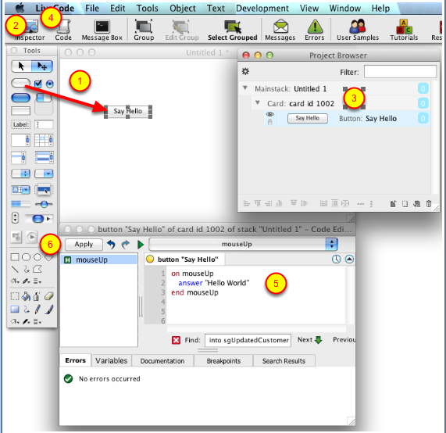
- Choose New Mainstack from the File menu. Drag out a new button onto your stack.
- Load the Project Browser.
- Name your button Say Hello.
- Open the Script Editor.
- Type: answer "Hello World"
- Press Apply.
- Choose the Run tool to switch the program to run mode. Click the Say Hello button. A dialog will display Hello World.
You can continue to make changes to the script even while the program is running. This greatly increases efficiency when making iterative improvements and additions, as the software performs regular checks to see if new code runs as expected. This feature can save a substantial amount of development time in a typical project.
You can now deploy this application to major desktop and mobile platforms and devices. Use the Standalone Builder in the File menu to build an executable.

The Message Box
Another unique feature of the LiveCode live development model is the Message Box. This utility serves as a command line that runs within your live application. Use the Message Box to call functions, test code or edit to your project as it runs. You can use this facility to generate dynamic interfaces; test code or format data while your application is running.
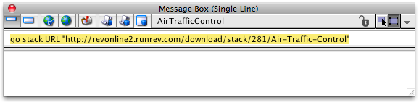
For example, you can download the HTML source from a web page into your stack just by typing in a command. Start by creating a field. Open the Message Box by clicking on it in the toolbar. Type in the following line then press return:
put URL "http://www.google.com/" into field 1
We have included some additional 1-line commands you can try out in Appendix A.

Points of Interest – Building for iOS in LiveCode
In this section, we demonstrate building an iOS application from scratch. We’ve chosen an example that demonstrates how to use the accelerometer to build a simple Shake Motion that will run on your iPhone or iPad.
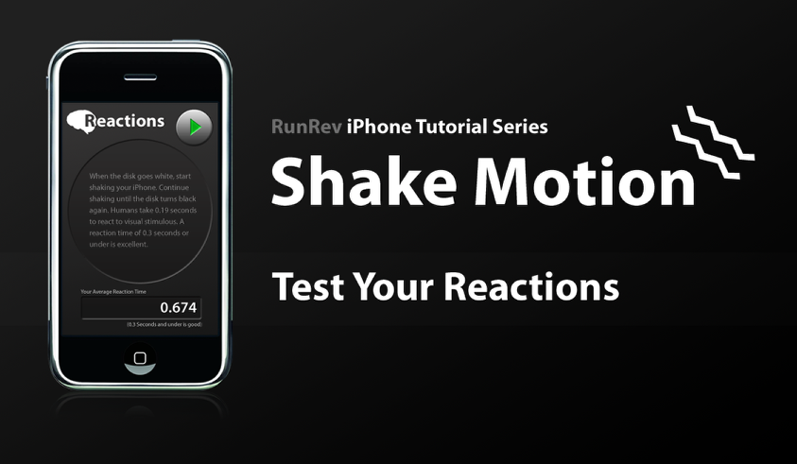
Watch the Lesson Videos at:
http://lessons.runrev.com/spaces/lessons/buckets/1004/lessons/12019-revMobile-Video-How-To-s-Shake
Or you can download the completed stack and take it apart here.
You can see additional Lessons on creating iOS applications in our Lessons Portal.
Points of Interest – Building a project in LiveCode
In this example we will build an application that downloads and displays a stock quote from a web service. The application will allow you to enter a stock symbol and display whether or not the stock price has closed up or down relative to the previous day. This application assumes you know how to build the Hello World application, as detailed above.
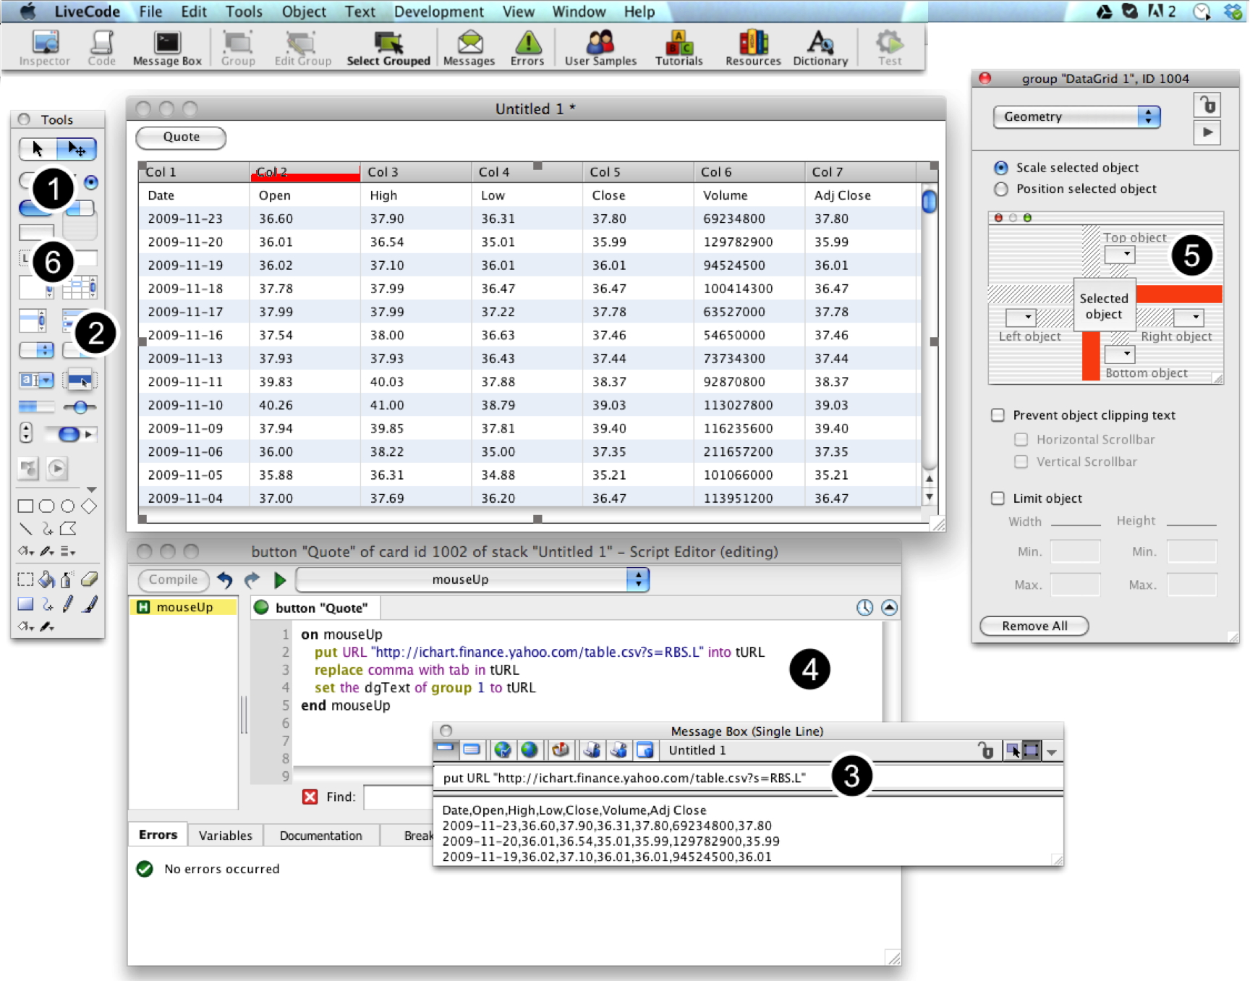
- Choose New Mainstack from the File menu. Drag out a new button onto your stack.
- Drag out a Data Grid and size it as shown in the screenshot.
- Look at the data that comes back from the web service we’re going to use. Open the Message Box from the toolbar and type in:
put URL "http://ichart.finance.yahoo.com/table.csv?s=RBS.L
You should see that data from the URL appears in the Message Box after a second or two. You’ll notice looking at the data that it is comma separated (CSV).
- Rename your button to Quote and edit its script. You will download the data from the web service and display it using the Data grid you created. The Data grid accepts data in tab delimited form, so you’ll need to replace the commas with tabs. Add the following lines to your mouseUp handler:
put URL "http://ichart.finance.yahoo.com/table.csv?s=RBS.L" into theURL
replace comma with tab in theURL
set the dgText of group 1 to theURL
Press Compile, choose the Run tool (top left of the tools palette) and click the Quote button. Note that you don’t need to close the Script Editor and you can immediately see the results of your script. If you’ve made a mistake you can correct it now before you add more code. This iterative development workflow reduces the number of times you need to use LiveCode’s debugger.
- Apply a resizing behavior to your data grid so that it automatically updates when the window is resized. Choose the pointer tool (top right of the tools palette) and double click the data grid. Choose Geometry from the Inspector menu and then click the line to attach the grid to the right of the stack (see screenshot above). Then attach it to the bottom. You’ll notice that if you resize the window the data grid is now attached to the edges.
- Now let’s add the logic that displays whether or not the stock closed up or down. Drag out a label field and place it above the top right of the data grid. Name the field Indicator and set the text font to be a little larger than the default. Open Geometry, click the Position selected object radio button and click to attach the field to the right of the stack. Now add the following logic to the Quote button script:
if the last word of line 2 of theURL > the last word of line 3 of theURL then
put "Closed Up" into field "indicator"
set the textColor of field "indicator" to darkGreen
else
put "Closed Down" into field "indicator"
set the textColor of field "indicator" to darkRed
end if

We are using LiveCode’s chunk expressions to compare today’s closing price, which is the last word on the second line, with the previous closing price (the last word of the third line). We then display whether the stock closed up or down.
Tip: If you want to watch this script run line-by-line, click in the breakpoints column to the left of the line you want to pause on in the Script Editor before you run it. You can then walk through it as it runs to see if your logic is working correctly.
Press Compile and try the script. (Remember to press the Run icon, top left of the Tools palette.)
- Finally, create a field to the right of the quote button. Name the field symbol. Add the following script to the field, to cause it to trigger the button when the user presses return after typing in a symbol:
on returnInField
send “mouseUp” to button “Quote”
end returnInField
Change the first line in the Quote button script to the following two lines, to take account of the symbol that the user types in:
put "http://ichart.finance.yahoo.com/table.csv?s=" & field "Symbol" into tStock
put URL tStock into theURL

- Create a standalone application. Save the stack then choose Standalone Application Settings from the File menu. Check the box for the platforms you want to build for then choose Save as Standalone Application… from the File menu to create double clickable executable applications for each platform and an HTML page embedded for the Web. Alternatively, use the iOS Deployment Pack (pre-release) to create an iPhone application (see below).
You can also download this completed stock quote stack from: http://www.runrev.com/offers/reviewers/stockquote.rev

Points of Interest – Building a server script using LiveCode Server
In this example we will build a simple web service that increments a poll and returns the result. To see an example of such a web service, see the section on creating a polling application using LiveCode above.
Please note that server scripting using on-Rev is currently a pre-release version. on-Rev is our hosted service that allows you to create and run LiveCode scripts online without any configuration. on-Rev includes a live visual debugger that allows you to step through server scripts line by line as they run on the server. on-Rev uses the LiveCode Server Deployment Pack, which is available for installation on your own server and contain all the core features of on-Rev, but will not include extras such as the debugger.
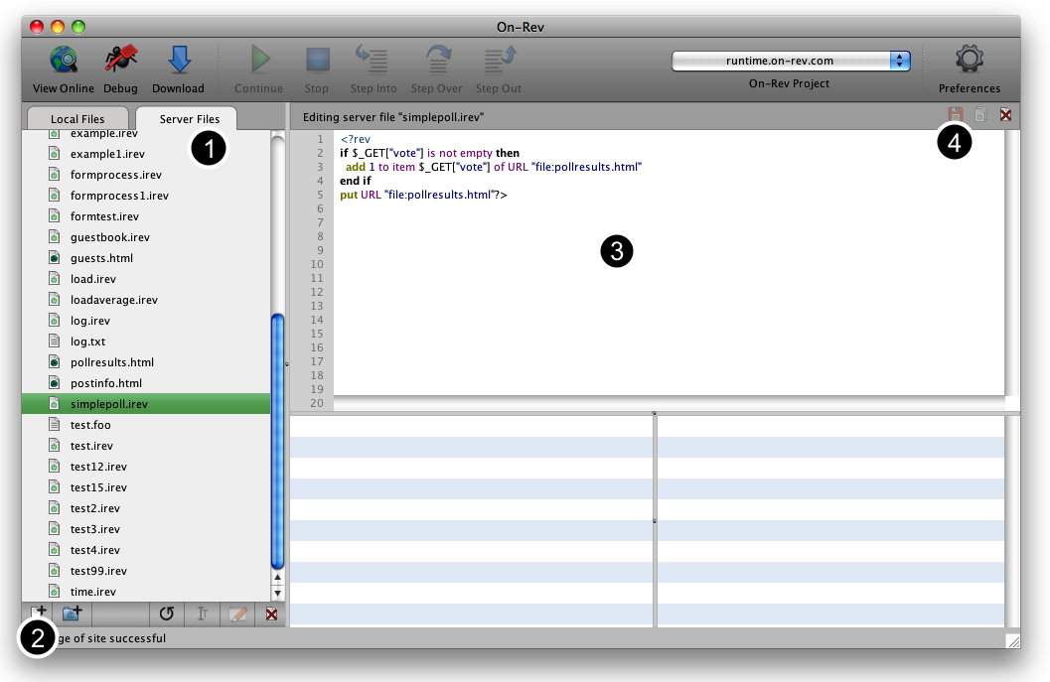
- Load the on-Rev client. (Please note this client is currently in pre-release form.) Log on using your User Name and Password then click on Server Files to work directly on the server.
- Create a new file. Name the file simplepoll.irev.
- Add the following script:
<?rev
if $_GET["vote"] is not empty then
add 1 to item $_GET["vote"] of URL "file:pollresults.html"
end if
put URL "file:pollresults.html"?>

This script reads in the $_GET[“vote”] value passed as part of the URL. (Please note that new syntax for this will be introduced before launch, the vote of the form.) If another vote has been made, it adds this vote to the appropriate item in a text file. We could have elected to use any standard SQL database (and there are several pre-installed on on-Rev) but this is a simple example, so a database is not required.
- Save the file to the server. Create another new file and call this pollresults.html. Fill this fill out with 0,0,0 and save it.
- Press the View Online button. Your browser will open and should display 0,0,0.
- Modify the URL in the browser to add ?vote=1 to the end of the URL. The result should be 1,0,0.
Tip: To debug the script, insert the word breakpoint onto a line and press Debug instead of View Online. This will allow you to step through line by line.

Conclusion
The LiveCode platform provides a powerful way to create applications that run on the desktop, mobile devices, or on the server using an intuitive and robust language. LiveCode’s workflow supports live running and editing. The combined benefits of the LiveCode platform make software development up to 10 times more productive when compared to traditional development platforms. Providing an open source free Community Edition makes LiveCode accessible to all.
If you want to learn more, we encourage you to visit the developer center on our website or visit the following pages:
- Step-by-step tutorials: http://lessons.runrev.com/
- Active user communities: http://forums.runrev.com/ and http://forums.on-rev.com/
The examples from this Guide were created using Screensteps, a commercial product from Blue Mango Learning http://www.bluemangolearning.com/screensteps/ built entirely using LiveCode.

Contacts
If you’d like help or additional information, please contact us at support@runrev.com.
If you are a member of the press, blogger or analyst community and would like more information or to speak with RunRev executives, please contact: Samantha Steinwinder, samantha@conceptpr.net, 206-760-9809.

Appendix A: Handy Message Box Commands
LiveCode’s run-and-edit-live workflow enables a fluid editing process where you can run commands as you work. Here are a few more 1-line commands you can try. The goal is for you to get an idea of the quick utilities you can create and editing operations you can perform using the Message Box.
- Start by creating a field. Open the Message Box by clicking on it in the toolbar. Type in the following line then press return:
put URL "http://www.google.com/" into field 1
- To perform a character count on the first line you retrieved:
put the number of characters in line 1 of field 1
- Export an image from the current card to a file. Note that you could just as easily upload this image to a server by replacing “binfile:” with “ftp:”:
export snapshot from this card to URL ("binfile:My Stack.png") as png
- Download and run stacks located online:
go stack URL "http://revonline2.runrev.com/download/stack/281/Air-Traffic-Control”
- Interrogate the current stack, for example count the number of objects:
the number of controls
- Send a message:
send "mouseUp" to button "Say Hello"
- Perform an editing operation. Move the mouse over an object in your stack then run:
move the mouseControl relative 100,0
- Dynamically adjust all the objects on a card:
repeat with i = 1 to the number of controls; set the width of control i to the width of control i + 10; end repeat

Appendix B: LiveCode Feature List

Core language features overview
Approximately 2000 commands, functions, messages, operators, properties and keywords | Our language dictionary is online and can be searched at docs.runrev.com
23 fully customizable interface objects | Includes buttons, check boxes, radio buttons, tabbed buttons, text fields, menus, bitmap & vector graphics and multimedia player; flexible data grid allows sophisticated presentation of data from any data source with customizable interactive cells
Object oriented behaviors | Create sophisticated reusable objects that share common behaviors
Create, delete and set object properties at runtime | Create executables that generate objects on demand, e.g. from an XML data source, create dynamic or user-editable interfaces
Nested arrays | Nested arrays allow representation and manipulation of complex data structures. Includes manipulation functions such as split, combine, add, matrix multiply, transpose and union
Automatic type conversion | Variable declaration is optional. Data in variables is automatically converted to the appropriate format on demand
Text and data processing | Comprehensive support for processing text and data. More information
Regular expression support | PERL compatible regular expression (PCRE) support
XML support | XML library supports loading, manipulating and processing XML
Unicode support | Support for rendering, editing, encoding and decoding Unicode. Some limitations apply. See the text page for more information
Timer based messaging | Send messages to be delivered in the future
Custom object properties | Attach text and binary data directly to objects, store custom property arrays, define properties as functions
Math operator functions | Full range of standard mathematical operators (IEEE double-precision arithmetic)
Bitwise operator functions | Standard operators for manipulating integers in a bitwise fashion

Networking support
Built in protocol support | Access http, https and ftp. HTTP post and get with one line of code
Socket support | Create a custom protocol starting from as little as 10 lines of code

Database support
Access standard SQL databases | MySQL, SQLite, PostgreSQL, Oracle and ODBC
Render large data sets | Flexible data grid object

Multimedia support
QuickTime player object | Play, interact with and programmatically control QuickTime movies on Mac OS and Windows
Bitmap graphics | Import, download, manipulate and export bitmap graphics in a variety of popular formats including JPEG, PNG, GIF, BMP and others
Vector graphics | Create and manipulate vector graphics
Custom skin support | Create complete multimedia skins for your application with a totally customizable look for all interface objects
Alpha blended windows | Support for irregularly shaped, alpha blended windows
Web browser object | Render web pages directly in your application (uses WebKit on Mac OS X and MSHTML (IE) on Windows)
Sound support | Playback of popular formats
Color cursors | Color and alpha blended cursors, depending on OS support
Screenshot import | Programmatic and user control over importing snapshots from the screen
Text to speech support | On Windows and Mac where supported by the OS
Video capture | On Windows and Mac using QuickTime on the Mac and DirectShow on Windows
Gradients | 7 fully customizable gradient types for graphics
Blend modes and bitmap effects | Over 20 sophisticated object blend modes, applicable to all types of object

Data security support
Encrypt and decrypt data | Industrial strength symmetric cipher support based on OpenSSL
Public key cryptography support* | RSA encryption, decryption, verification and signing based on OpenSSL
Cryptographic hashes | Includes MD5 digest, SHA-1 digest* and creation of cryptographic quality random data*
Transmit data securely using HTTPS | Support for transmitting data HTTPS

File System access
Quick access to files | Single line access to read, append or extract data from files
Work with large files | Set of file commands support reading, writing and seeking through large files
Access and convert text and binary data | Numerous functions for converting data in a variety of formats
Work with ZIP archives and GZIP data | Create, archive and unpack data in these popular formats

Printing and output
High quality printing | Print text and graphics at high resolution under full programmatic control
Programmatic control over print settings | Get save and set printer settings, page layout, number of copies and more
Generate PDF output | Create high quality PDF output including support for creating links and anchors
Output images in a variety of formats | Output JPEG, PNG, BMP and other format images with alpha channel and optional optimized palette

Extensibility and Integration
Interprocess communication | Launch and communicate with other processes
AppleScript support | Run AppleScripts and retrieve results
Simple shell support | Get output from command-line programs in one line
Create socket based protocols | Implement any existing protocol or create a custom protocol from as little as 10 lines of code
Native code externals | Augment your application by calling code libraries written in lower level languages
Serial port access | Read and write to the serial ports
Launch elevated processes* | Launch processes which request administrator privileges

Platforms supported
Windows | Create native executables for Windows 2000 SP4, Windows XP SP2 and above, Windows Server 2003, Windows Vista SP1 and above, Windows 7, Windows Server 2008
Mac OS X | Create native executables for 10.3.9 (Panther) on Intel and PowerPC, 10.4.11 (Tiger) on Intel and PowerPC, 10.5.8 and later (Leopard) on Intel and PowerPC 10.6.x (Snow Leopard) on Intel
Linux | Create native executables for 32-bit installation, or a 64-bit Linux distribution that has a 32-bit compatibility layer, 2.4.x or later kernel, X11R5 or later, glibc 2.3.2 or later, gtk/gdk/glib (optional – required for native theme support), pango/xft (optional – required for pdf printing, anti-aliased text and unicode font support), lcms (optional – required for color profile support in JPEGs and PNGs), gksu (optional – required for elevate process support)
iOS (iPhone, iPad, iPod Touch) | Create executables for 3.x and up iOS devices
Windows Mobile 8 | Coming soon
Android | Support for Android 2.2 (Froyo) or later
Raspberry Pi | Demo version available here
Server and faceless applications | Linux ,Darwin (Mac OS X) and Windows servers
Visual Development Environment
Fully integrated visual development environment | Edit your interface while running your application
Extensible development environment | Editing environment is written in LiveCode and can be customized, extended with plugins or even replaced
Point and click geometry manager | Easily create dynamic layouts that resize when a window is resized
Application browser | Locate and edit controls
Integrated developer command line | Enter commands to dynamically create your interface, make batch changes, or test your application
Professional code editor with auto formatting | Tab based code editor with automatic syntax highlighting and formatting, integrated documentation. Integrated debugger and variable watcher
Object property inspectors | Edit object properties with a point and click interface
Basic painting and drawing tools | Create or touch up bitmap and vector graphics

