**OUTPUT**

QUERY1: “We are brothers”

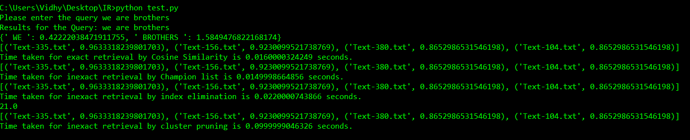

|  |  |  |
| --- | --- | --- |
| **METHODS** | **TIME TAKEN(s)** | **OUTPUT** |
| **Exact query** | 0.0160000324249 | 'Text-335.txt', 0.9633318239801703), ('Text-156.txt', 0.9230099521738769), ('Text-380.txt', 0.8652986531546198), ('Text-104.txt', 0.8652986531546198) |
| **Inexact query by Champion list** | 0.0149998664856(s) | 'Text-335.txt', 0.9633318239801703), ('Text-156.txt', 0.9230099521738769), ('Text-380.txt', 0.8652986531546198), ('Text-104.txt', 0.8652986531546198) |
| **Inexact query by Index Elimination** | 0.0220000743866(s) | ('Text-335.txt', 0.9633318239801703), ('Text-156.txt', 0.9230099521738769), ('Text-380.txt', 0.8652986531546198), ('Text-104.txt', 0.8652986531546198) |
| **Inexact query by Cluster Pruning** | 0.0999999046326(s) | [('Text-335.txt', 0.9633318239801703), ('Text-156.txt', 0.9230099521738769), ('Text-380.txt', 0.8652986531546198), ('Text-104.txt', 0.8652986531546198) |

QUERY2: “religious brothers WAR SOUTH”

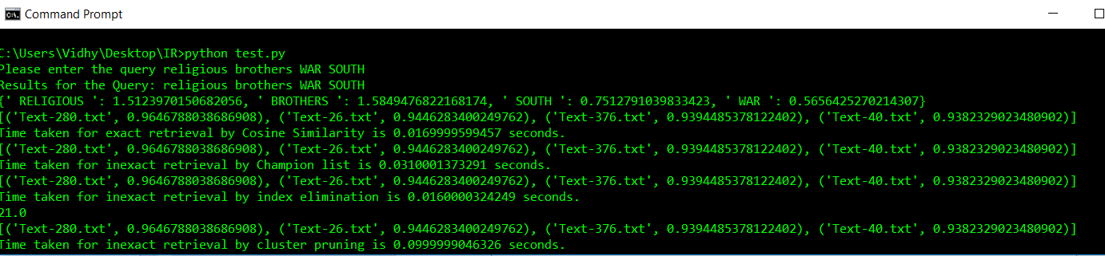

|  |  |  |
| --- | --- | --- |
| **METHODS** | **TIME TAKEN** | **OUTPUT** |
| **Exact query** | 0.0169999599457 | ('Text-280.txt', 0.9646788038686908), ('Text-26.txt', 0.9446283400249762), ('Text-376.txt', 0.9394485378122402), ('Text-40.txt', 0.9382329023480902) |
| **Inexact query by Champion list** | 0.0310001373291 | ('Text-280.txt', 0.9646788038686908), ('Text-26.txt', 0.9446283400249762), ('Text-376.txt', 0.9394485378122402), ('Text-40.txt', 0.9382329023480902) |
| **Inexact query by Index Elimination** | 0.0160000324249 | 'Text-280.txt', 0.9646788038686908), ('Text-26.txt', 0.9446283400249762), ('Text-376.txt', 0.9394485378122402), ('Text-40.txt', 0.9382329023480902) |
| **Inexact query by Cluster Pruning** | 0.0999999046326 | 'Text-280.txt', 0.9646788038686908), ('Text-26.txt', 0.9446283400249762), ('Text-376.txt', 0.9394485378122402), ('Text-40.txt', 0.9382329023480902) |

QUERY3: “religious brothers”

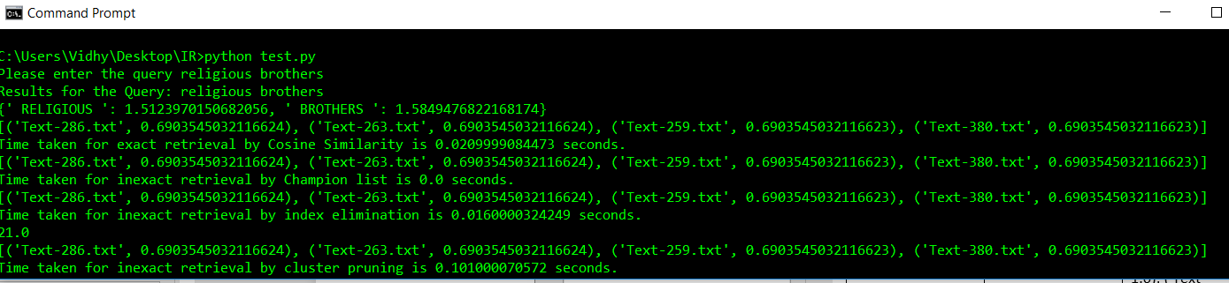

|  |  |  |
| --- | --- | --- |
| **METHODS** | **TIME TAKEN** | **OUTPUT** |
| **Exact query** | 0.0209999084473 | 'Text-280.txt', 0.9646788038686908), ('Text-26.txt', 0.9446283400249762), ('Text-376.txt', 0.9394485378122402), ('Text-40.txt', 0.9382329023480902) |
| **Inexact query by Champion list** | 0.0 | 'Text-280.txt', 0.9646788038686908), ('Text-26.txt', 0.9446283400249762), ('Text-376.txt', 0.9394485378122402), ('Text-40.txt', 0.9382329023480902) |
| **Inexact query by Index Elimination** | 0.0160000324249 | 'Text-280.txt', 0.9646788038686908), ('Text-26.txt', 0.9446283400249762), ('Text-376.txt', 0.9394485378122402), ('Text-40.txt', 0.9382329023480902) |
| **Inexact query by Cluster Pruning** | 0.0160000324249 | 'Text-280.txt', 0.9646788038686908), ('Text-26.txt', 0.9446283400249762), ('Text-376.txt', 0.9394485378122402), ('Text-40.txt', 0.9382329023480902) |

QUERY4: “government jail war amen”

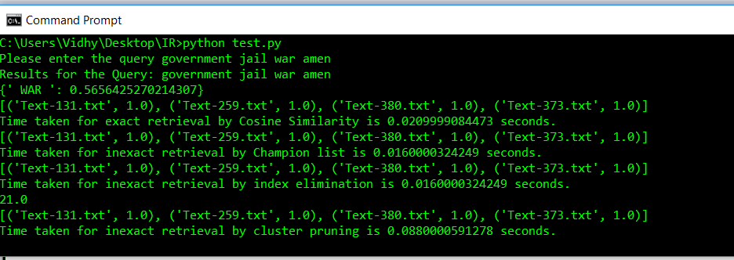

|  |  |  |
| --- | --- | --- |
| **METHODS** | **TIME TAKEN** | **OUTPUT** |
| **Exact query** | 0.0209999084473 | ('Text-131.txt', 1.0), ('Text-259.txt', 1.0), ('Text-380.txt', 1.0), ('Text-373.txt', 1.0) |
| **Inexact query by Champion list** | 0.0160000324249 | ('Text-131.txt', 1.0), ('Text-259.txt', 1.0), ('Text-380.txt', 1.0), ('Text-373.txt', 1.0) |
| **Inexact query by Index Elimination** | 0.0160000324249 | ('Text-131.txt', 1.0), ('Text-259.txt', 1.0), ('Text-380.txt', 1.0), ('Text-373.txt', 1.0) |
| **Inexact query by Cluster Pruning** | 0.0880000591278 | ('Text-131.txt', 1.0), ('Text-259.txt', 1.0), ('Text-380.txt', 1.0), ('Text-373.txt', 1.0) |

QUERY5: “amen god these lives”

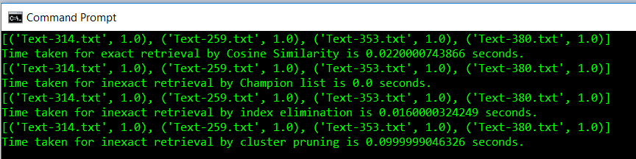

|  |  |  |
| --- | --- | --- |
| **METHODS** | **TIME TAKEN** | **OUTPUT** |
| **Exact query** | 0.0220000743866 | ('Text-314.txt', 1.0), ('Text-259.txt', 1.0), ('Text-353.txt', 1.0), ('Text-380.txt', 1.0) |
| **Inexact query by Champion list** | 0.0 | ('Text-314.txt', 1.0), ('Text-259.txt', 1.0), ('Text-353.txt', 1.0), ('Text-380.txt', 1.0) |
| **Inexact query by Index Elimination** | 0.016000032424 | ('Text-314.txt', 1.0), ('Text-259.txt', 1.0), ('Text-353.txt', 1.0), ('Text-380.txt', 1.0) |
| **Inexact query by Cluster Pruning** | 0.0999999046326 | ('Text-314.txt', 1.0), ('Text-259.txt', 1.0), ('Text-353.txt', 1.0), ('Text-380.txt', 1.0) |