Supplementary Material:

Contents:

- Formulation of biomass reaction
- Constraints for growth simulations:
  - minimal medium
  - LB medium
- Thermodynamic analysis
- Biolog results
- Statistical analysis of transposons disrupting downstream genes
- iMO1056 in excel format
- Transposon Essentiality results in excel format
- Network Map
- References

- Formulation of biomass reaction

To perform flux balance analysis (FBA) on iMO1056, it was necessary to define a biomass reaction representing both a weighted ratio of cell mass components and an energetic ATP demand accounting for growth and non-growth associated maintenance. These values have been determined for Escherichia coli and some other organisms, and for the present study it was assumed that Pseudomonas aeruginosa biomass composition would not significantly differ from an E. coli biomass reaction used in previous network reconstructions (2, 7), and originally derived from values reported in literature (5). In order to account for differences in fatty acid composition of E. coli and P. aeruginosa, average ratios of acyl side-chains in P. aeruginosa phospholipids were calculated based on values from (9). The proportions (by mass) of total biomass represented by each phospholipid and by lipopolysaccharide were assumed not to vary between E. coli and P. aeruginosa, so coefficients for these components were determined by calculating the mass of each component drained in E. coli biomass and adjusting the coefficients of P. aeruginosa biomass so that P. aeruginosa biomass would drain the same mass of each component. Mass of a component drained in biomass (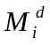) equals the product of its coefficient (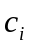) and its mass (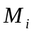):
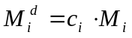.
The coefficients for phospholipids and lipopolysaccharide in P. aeruginosa (PA) biomass were thus determined from E. coli (EC) biomass as:
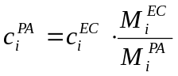.
Heme was also included in biomass at a small concentration due to its essentiality in iron uptake of P. aeruginosa (8). Lipopolysaccharide was included without O-antigen, since O-antigen is not always expressed in P. aeruginosa (1). The P. aeruginosa biomass reaction used in iMO1056 is provided in the ‘Biomass Equation’ tab of the attached excel file, ‘iMO1056 model’.

- Constraints for growth simulations:

  - minimal medium

Minimal medium was simulated in silico by allowing free exchange of some simple salts and ions, water, and O₂ (for aerobic simulations) or NO₃ (for denitrification) but restricting import of any carbon compounds except CO₂ and a single limiting carbon source. The limiting carbon source was allowed a maximum flux of 10 mmol/(g Dry Weight · h). All extracellular compounds were allowed to leave the system with no bounds on the flux. A sample minimal medium is provided in the ‘Minimal Medium Constraints’ tab of the attached excel file, ‘iMO1056 model’.

  - LB medium

Luria-Bertani (LB) medium composition was approximated in a previous study (6) based on yeast extract analysis provided by the manufacturers. LB medium was used in the present study only for determination of in silico gene essentiality, so quantitative rates of nutrient uptake were not relevant, and all such constraints were set to 10 mmol/(g Dry Weight · h). The LB medium constraints used in this study are provided in the ‘LB Medium Constraints’ tab of the attached excel file, ‘iMO1056 model’.

- Thermodynamic analysis

Although the direction that a reaction will operate in is related to the stoichiometry of the reaction, elements such as temperature, pH, and metabolite concentration can alter the energies involved and cause reaction directionality to vary by system. Due to these factors, it is not always trivial to determine the in vivo directionality of a reaction for a new organism just by knowing that a particular enzyme exists in that organism, so it is common for online reaction databases such as KEGG and EXPASY to provide reaction stoichiometries, but not to include directionality information.

Because of the difficulty of obtaining accurate reaction directionality information for many enzymes, we were concerned that some reactions might be able to run in an energy-producing manner. This was confirmed in initial simulations, as the model was capable of producing ATP energy equivalents when no metabolites were allowed in or out of the system. Some free ATP loops were trivial to fix, such as the existence of both a reversible ABC magnesium transporter and a reversible magnesium permease. In simulations, the ABC magnesium transporter could shuttle magnesium out of the cell while the permease allowed it back in, causing a net conversion of ADP to ATP. This loop was fixed simply by making the magnesium transporter irreversible. Other free ATP loops were more complicated, and would have been difficult to spot without computational analysis. The electron transport enzyme NADPH-quinone-oxidoreductase (NADPHQO, PA4975) was one such enzyme. Initially added to the model as a reversible reaction, NADPHQO was found upon analysis of free ATP production to be necessarily irreversible. Several reactions were re-annotated as obligate irreversible through this process. The process of refining reaction directionality in order to prevent violations of thermodynamics represents another type of functional re-annotation that necessitates genome-scale reconstruction, is crucial for accurately representing gene function, and is usually absent from annotations and online databases.

- Biolog results

Biolog results are shown in the excel file, ‘supplementary-biolog study.xls’. A Biolog reading of 150 or higher was considered a positive growth phenotype. The reading of 143 for L-leucine was considered borderline and was included as ‘weak growth,’ as described in the paper.

- Statistical analysis of transposons disrupting downstream genes

An analysis was performed to determine whether transposons in the in vivo essentiality set disrupt downstream genes, and thus whether some non-essential genes might have been labeled ‘essential’ in the in vivo essentials set due to disruption of essential genes downstream. A model for this process is shown in Figure S1. If transposon inserts disrupted downstream genes, we would expect that some non-essential genes that have essential genes close downstream would be labeled as false negative, due to the faulty assignment of essentiality in the in vivo set (see Figure S1, row f, and compare ‘in vivo’ versus ‘in silico’ essentiality predictions against those for rows a-e).

In order to test this hypothesis, we determined the number of next-downstream-essential-genes within 1000bp of all 85 false negative genes. For this analysis, all in vivo essential genes, including those not present in iMO1056, were included as ‘essential genes’ in the search for next-downstream-essential-genes. We then compared the number of next-downstream-essential-genes from the false negative set to the average number of next-downstream-genes within 1000bp of all genes from 100 random sets of 85 genes, picked from the PAO1 genome (Figure S2, panel a), genes in the iMO1056 model (Figure S2, panel b), genes from the full in vivo essential set from Lewenza et al. (4) (Figure S2, panel c), genes from the full in vivo essential set from Jacobs et al. (3) (Figure S2, panel d), and genes from the full combined (Jacobs/Lewenza) in vivo essential set (Figure S2, panel e). In panels a-c of Figure S2, the false negatives set differs from the mean of the random set in the number of next-downstream-essential-genes set by at least 4 standard deviations, whereas in panels d-e of Figure S2, the false negatives differ by less than a standard deviation from the mean of the random sets. Therefore, false negative genes show a clear preponderance of next-downstream-essential-genes over random genes chosen from the whole genome, from the iMO1056 model, and from the Lewenza et al. in vivo set (Figure S2, panels a-c), but not over random genes chosen from the Jacobs et al. in vivo essential gene set or the combined Jacobs/Lewenza in vivo essentials set (Figure S2, panel d-e). In the Jacobs et al. in vivo essential gene set and the combined Jacobs/Lewenza in vivo essentials set, the false negatives
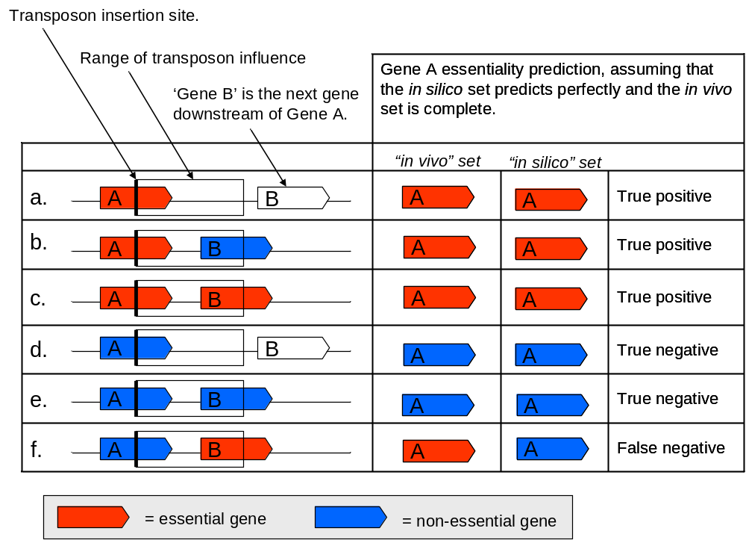
Figure S1: Model for effects of transposon inserts on downstream genes: The figure shows several different cases of transposon insertions into genes and the hypothesized effects those insertions will have on the in vivo and in silico assignments of gene essentiality, taking into account possible disruption of downstream genes by transposon inserts. (a) insertion into an essential gene, with no close downstream genes, (b) insertion into an essential gene, with a close non-essential downstream gene, (c) insertion into an essential gene, with a close essential downstream gene, (d) insertion into a non-essential gene, with no close downstream gene, (e) insertion into a non-essential gene, with no close downstream gene, and (f) insertion into a non-essential gene, with an essential gene close downstream. Only in panel (f) is there a discrepancy between the in vivo and the in silico sets.

The lack of a preponderance of next-downstream-essential-genes in the false negatives over random genes from the Jacobs et al. in vivo essential set (Figure S2, panel d) indicates that the transposon method employed by Jacobs et al. does not appreciably disrupt downstream essential genes. The fact that there is a preponderance of next-downstream-essential-genes in the false negatives versus random genes from the Lewenza et al. in vivo essential set (Figure S2, panel c), however, does not conclusively indicate that the transposon method employed by Lewenza et al. does disrupt downstream genes (although it suggests this to be the case). Since the transposon coverage of the PAO1 genome in the Lewenza et al. study is much smaller than that of Jacobs et al. (only 1284 unique ORFs were inactivated due to transposons in Lewenza et al., as opposed to 4892 ORFs in Jacobs et al.), many more genes were classified as ‘essential’ simply due to insufficient transposon coverage of the genome. Therefore, it is possible that the difference between the number of next-downstream-essential-genes from the false negative set versus the Lewenza in vivo essentials set is simply a result of the fact that the Lewenza essentials set is larger and thus has next-downstream-essential-genes statistics similar to the full genome set (Figure S2, panel a), while the false negatives are a subset of the combined in vivo essentials set, which has a characteristically high preponderance of next-downstream-essential-genes (Figure S2, panel e).

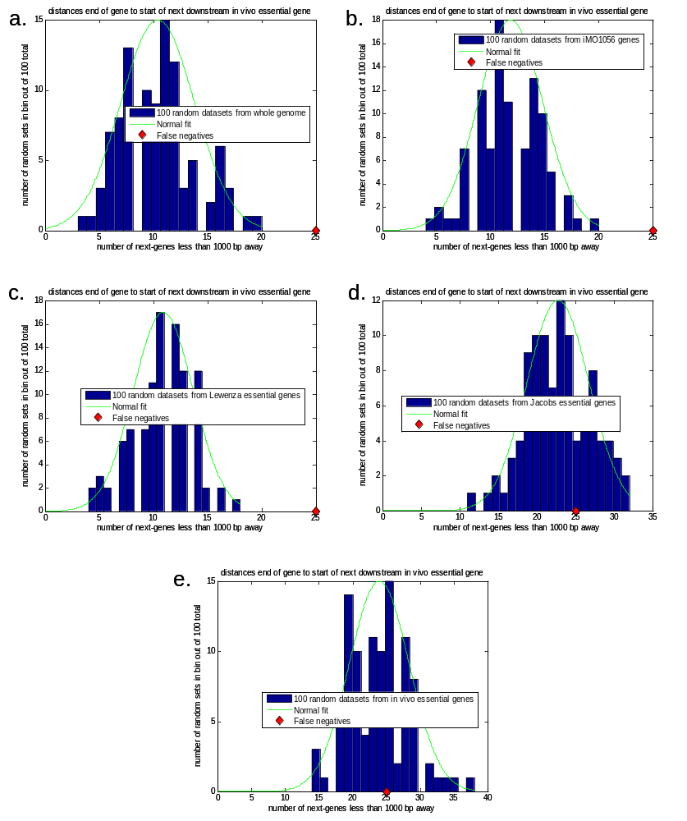
Figure S2: Results of statistical analysis of effects on downstream genes. Results of False negative analysis are overlayed on histograms of random sets from (a) the whole PAO1 genome, (b) genes in the iMO1056 model, (c) in vivo essential genes from the Lewenza et al. study, (d) in vivo essential genes from the Jacobs et al. study, and (e) the combined in vivo essential genes set from both studies. The number of next-downstream-essential-genes in the false negatives set differs significantly from the average number of next-downstream-essential-genes from random sets in panels (a-c), but not in panels (d-e).

- iMO1056 in excel format

The complete iMO1056 model is given in excel format in the ‘iMO1056 PAO1 model’ tab of the attached excel file, ‘supplementary-iMO1056 model’. References for the model are included in the ‘References’ tab.

- Transposon Essentiality results in excel format

The results of the transposon essentiality study are provided in the excel file, ‘supplementary-essentiality analysis.xls’.

- Network Map

A map of the iMO1056 metabolic network is available in the jpeg file, ‘supplementary-iMO1056 map.jpg’.

- References

1. Augustin, D. K., Y. Song, M. S. Baek, Y. Sawa, G. Singh, B. Taylor, A. Rubio-Mills, J. L. Flanagan, J. P. Wiener-Kronish, and S. V. Lynch. 2007. Presence or absence of lipopolysaccharide O antigens affects type III secretion by Pseudomonas aeruginosa. J Bacteriol 189:2203-9.
2. Edwards, J. S., and B. O. Palsson. 2000. The Escherichia coli MG1655 in silico metabolic genotype: its definition, characteristics, and capabilities. Proc Natl Acad Sci U S A 97:5528-33.
3. Jacobs, M. A., A. Alwood, I. Thaipisuttikul, D. Spencer, E. Haugen, S. Ernst, O. Will, R. Kaul, C. Raymond, R. Levy, L. Chun-Rong, D. Guenthner, D. Bovee, M. V. Olson, and C. Manoil. 2003. Comprehensive transposon mutant library of Pseudomonas aeruginosa. Proc Natl Acad Sci U S A 100:14339-44.
4. Lewenza, S., R. K. Falsafi, G. Winsor, W. J. Gooderham, J. B. McPhee, F. S. Brinkman, and R. E. Hancock. 2005. Construction of a mini-Tn5-luxCDABE mutant library in Pseudomonas aeruginosa PAO1: a tool for identifying differentially regulated genes. Genome Res 15:583-9.
5. Neidhardt, F. C. 1987. Escherichia coli and Salmonella typhimurium : cellular and molecular biology. American Society for Microbiology, Washington, D.C.
6. Oh, Y. K., B. O. Palsson, S. M. Park, C. H. Schilling, and R. Mahadevan. 2007. Genome-scale reconstruction of metabolic network in bacillus subtilis based on high-throughput phenotyping and gene essentiality data. J Biol Chem.
7. Reed, J. L., T. D. Vo, C. H. Schilling, and B. O. Palsson. 2003. An expanded genome-scale model of Escherichia coli K-12 (iJR904 GSM/GPR). Genome Biol 4:R54.
8. Wegele, R., R. Tasler, Y. Zeng, M. Rivera, and N. Frankenberg-Dinkel. 2004. The heme oxygenase(s)-phytochrome system of Pseudomonas aeruginosa. J Biol Chem 279:45791-802.
9. Zhu, K., K. H. Choi, H. P. Schweizer, C. O. Rock, and Y. M. Zhang. 2006. Two aerobic pathways for the formation of unsaturated fatty acids in Pseudomonas aeruginosa. Mol Microbiol 60:260-73.

