Reconstruction and analysis of a genome-scale metabolic model of the vitamin C producing industrial strain Ketogulonicigenium vulgare WSH-001

Additional file 1
Contents of the text:
Figure S1 (Reconstruction pipeline) 2
Figure S2 (Robustness analysis of L-sorbose consumption rate) 6
Figure S3 (Influence of amino acids uptake rates on growth rate) 7
Figure S4 (Robustness analysis of oxygen consumption rate) 8
Figure S5 (Proportions of essential genes and reactions in iWZ663) 9
Figure S6 (Distributions of essential genes in different metabolic subsystems) 10
References 11

Figure S1
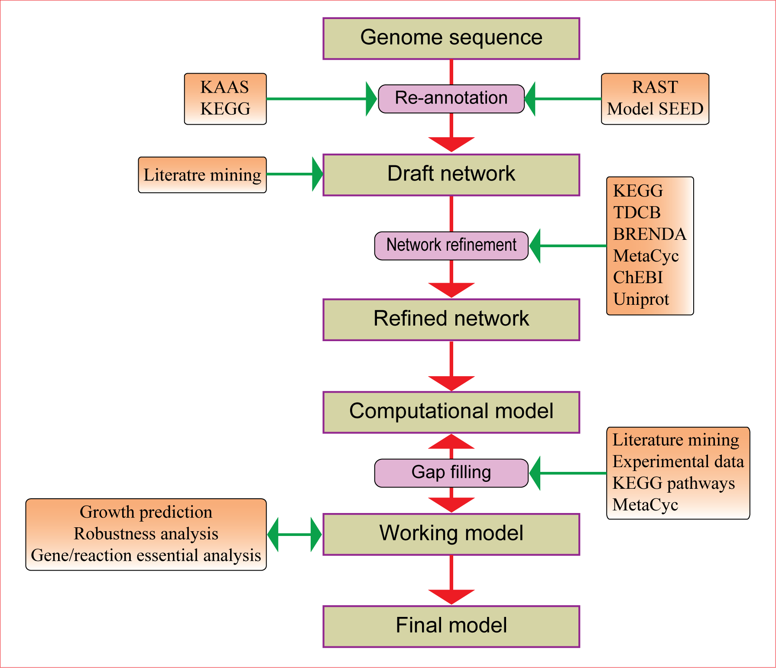
Fig. S1 Reconstruction pipeline
The main reconstruction procedure follows the published protocol (Thiele and Palsson, 2010) and the work flow is described in the above figure. The genome information for K. vulgare WSH001 was obtained from our previous sequencing study (GenBank accession no. CP002018, CP002019, and CP002020). To link the genome sequence with the metabolic reactions, first the genome was re-annotated via two routes: one was the KEGG automatic annotation server (KAAS) with amino acid sequences as input (Moriya et al., 2007); the other was the Rapid Annotation using Subsystem Technology (RAST) server with the nucleotide sequence of the whole genome as input (Aziz et al., 2008). The result of KAAS included the re-annotated functions of ORFs with KEGG Orthology (KO) assignments, partly with the Enzyme Commission number (EC number). Further, particular reactions could be selected from the KEGG database via these KO identifiers and EC numbers. Metabolic maps of KEGG pathways were automatically generated and could play important roles in assembling metabolic reactions into a network and gap filling process. Meanwhile, the result of RAST annotation was put through the Model SEED pipeline to obtain a draft network (Henry et al., 2010). Second, literature on K. vulgare was collected from PubMed and Web of Knowledge and other sources, with “Ketogulonicigenium” or “Ketogulonigenium” or “Gluconobacter oxydans DSM 4025” (this strain has now been re-named as K. vulgare DSM 4025 (Urbance et al., 2001)) as the search key words, and 27 papers had been found and download. Then, the metabolic reactions of K. vulgare were manually extracted from the literature surveys. Third, functional genes and their corresponding reactions that were acquired from previous steps were collected together to constitute a draft reconstruction for WSH001 and applied as a starting point for manual refinement.
Before the manual refinement of the draft network, genes annotated by the different approaches were uniformed. Because ORFs were re-assigned during the RAST annotation process, we compared the genes obtained from the Model SEED pipeline with the published genes of K. vulgare and treated them using different strategies. (1) ORFs such that the start points and end points were both the same as the published genes of K. vulgare in NCBI: we just replaced the new names with the old local names. (2) ORFs such that only the start or end points were the same as the published genes: firstly, we checked whether the different numbers of nucleic acids of the two ORFs were divisible by 3 to avoid frame-shift mutation. Then, a local sequence similarity search (BLASTp) with the UniProtKB/Swiss-Prot database (Jain et al., 2009) was performed, with a threshold of E value of ≤ 10⁻⁵, ≥ 30% amino acid sequence identity, to test whether the addition or loss of amino acids affects the function of the proteins. If not, we just replaced the new names with the old local names; otherwise, we kept the new names. (3) ORFs that were totally different from the known published genes of K. vulgare: we kept the new names. Further, new assigned ORFs were identified by the known physiological features of K. vulgare or a local BLASTp of the UniProtKB/Swiss-Prot database with the same threshold used above. The completely new ORFs identified can be seen in Additional File 4. Moreover, for the same gene, if the function annotations by two approaches were different, we re-annotated it by a local BLASTp of the UniProtKB/Swiss-Prot database as before, and the best result was used to check the accuracy of the two previous annotations.
Then, KEGG maps obtained from the above KAAS annotation process were applied to assemble these reactions into a network. ChEBI names (http://www.ebi.ac.uk/chebi/init.do) were used to unify the metabolite names. If the metabolite did not contain a ChEBI name, its KEGG name was used. Duplicated reactions catalyzed by the same genes were deleted. The reactions, metabolites, and gene-protein-reactions (GPR) associations were refined with the help of the biochemical information database of BRENDA (Scheer et al., 2011), KEGG (Kanehisa et al., 2010), MetaCyc (Caspi et al., 2010), TCDB (Saier et al., 2009), and Uniprot (Jain et al., 2009). For transport reactions, GPR associations for the ABC transporters were mainly identified by KEGG Modules. In addition, a biomass equation that represented all components and their fractional contributions to the overall cellular constitution was added. Finally, a refined network was obtained and transformed into the mathematical model in terms of a stoichiometric matrix, and the gap filling process was carried out. Then, KEGG maps of K. vulgare that were obtained by KAAS were manually checked and metabolic gaps in essential metabolic processes were filled by searching the KEGG database. The remaining gaps in metabolic pathways necessary for cell growth were identified and filled by reviewing published papers and experimental data and adding the necessary reactions taken from the KEGG or MetaCyc database.

Figure S2
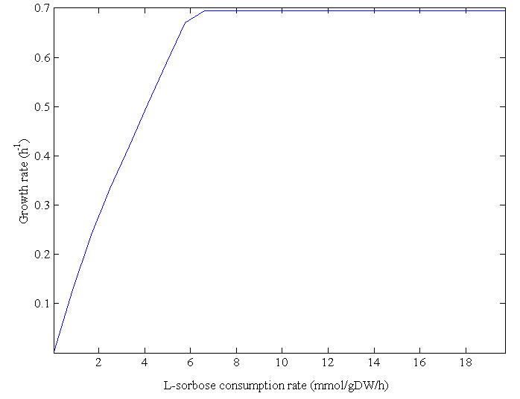
Fig. S2 Robustness analysis of L-sorbose consumption rate
The robustness analysis of L-sorbose consumption rate was performed by setting the exchange reaction of L-sorbose as the controlled reactions. The optimum value of growth rate at each controlled flux was predicted.

Figure S3
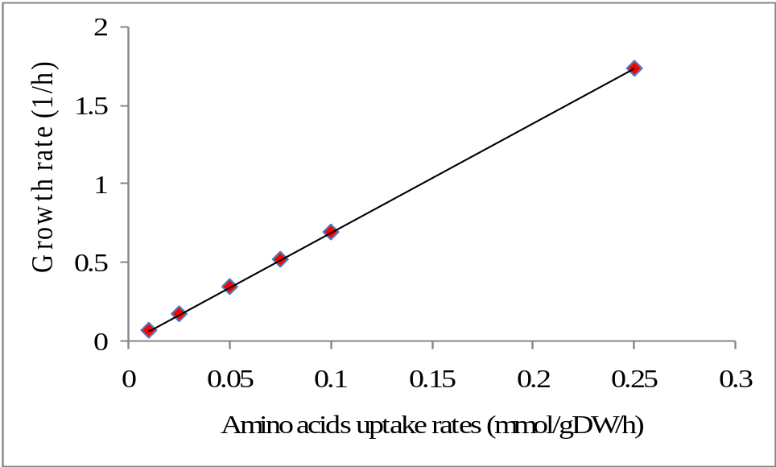
Fig. S3 Influence of amino acids uptake rates on growth rate
Cell growth rate was predicted under six consumption rates of amino acids (0.01, 0.025, 0.05, 0.75, 0.1, 0.25 mmol/gDW/h).

Figure S4
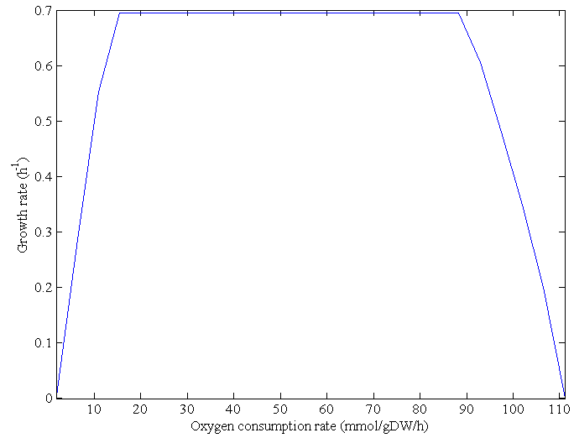
Fig. S4 Robustness analysis of oxygen consumption rate
The robustness analysis of oxygen consumption rate was performed by setting the exchange reaction of oxygen as the controlled reactions. The optimum value of growth rate at each controlled flux was predicted.

Figure S5
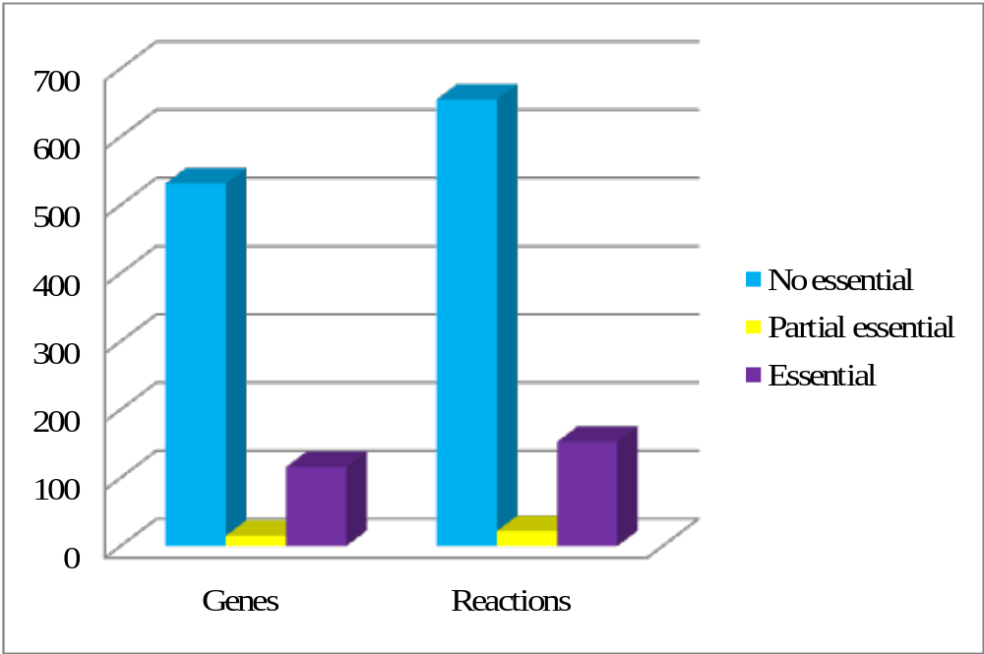
Fig. S5: Proportions of essential genes and reactions in iWZ663

Figure S6
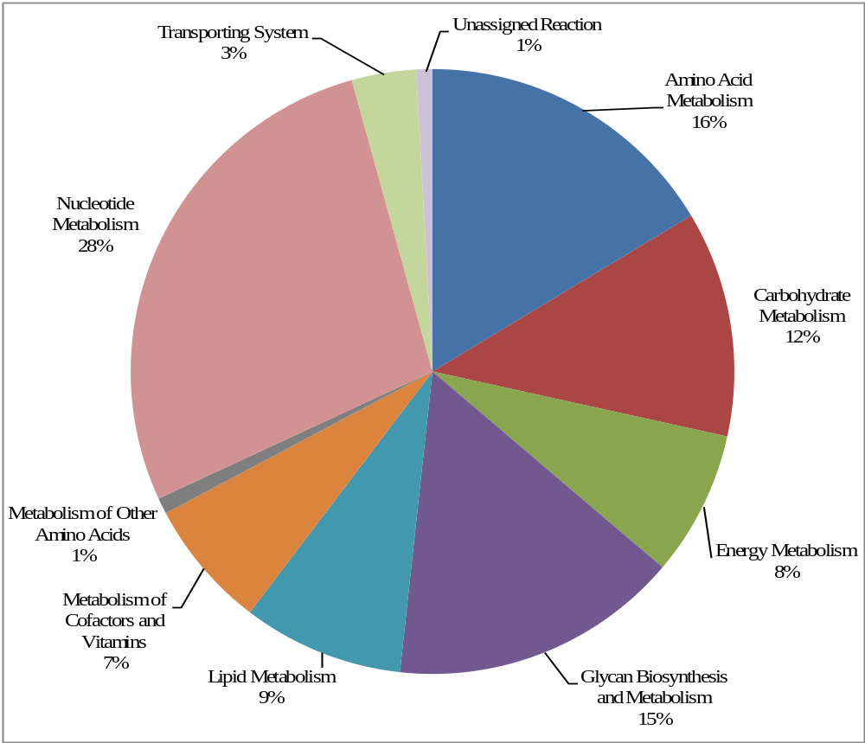
Fig. S6: Distributions of essential genes in different metabolic subsystems

References
Aziz, R.K., Bartels, D., Best, A.A., DeJongh, M., Disz, T., Edwards, R.A., Formsma, K., Gerdes, S., Glass, E.M., Kubal, M., Meyer, F., Olsen, G.J., Olson, R., Osterman, A.L., Overbeek, R.A., McNeil, L.K., Paarmann, D., Paczian, T., Parrello, B., Pusch, G.D., Reich, C., Stevens, R., Vassieva, O., Vonstein, V., Wilke, A., Zagnitko, O., 2008. The RAST Server: rapid annotations using subsystems technology. BMC Genomics 9, 75.
Caspi, R., Altman, T., Dale, J.M., Dreher, K., Fulcher, C.A., Gilham, F., Kaipa, P., Karthikeyan, A.S., Kothari, A., Krummenacker, M., Latendresse, M., Mueller, L.A., Paley, S., Popescu, L., Pujar, A., Shearer, A.G., Zhang, P., Karp, P.D., 2010. The MetaCyc database of metabolic pathways and enzymes and the BioCyc collection of pathway/genome databases. Nucleic Acids Res. 38, D473-479.
Henry, C.S., DeJongh, M., Best, A.A., Frybarger, P.M., Linsay, B., Stevens, R.L., 2010. High-throughput generation, optimization and analysis of genome-scale metabolic models. Nat. Biotechnol. 28, 977-982.
Jain, E., Bairoch, A., Duvaud, S., Phan, I., Redaschi, N., Suzek, B.E., Martin, M.J., McGarvey, P., Gasteiger, E., 2009. Infrastructure for the life sciences: design and implementation of the UniProt website. BMC Bioinformatics 10, 136.
Kanehisa, M., Goto, S., Furumichi, M., Tanabe, M., Hirakawa, M., 2010. KEGG for representation and analysis of molecular networks involving diseases and drugs. Nucleic Acids Res. 38, D355-360.
Moriya, Y., Itoh, M., Okuda, S., Yoshizawa, A.C., Kanehisa, M., 2007. KAAS: an automatic genome annotation and pathway reconstruction server. Nucleic Acids Res. 35, W182-185.
Saier, M.H., Yen, M.R., Noto, K., Tamang, D.G., Elkan, C., 2009. The Transporter Classification Database: recent advances. Nucleic Acids Res. 37, D274-D278.
Scheer, M., Grote, A., Chang, A., Schomburg, I., Munaretto, C., Rother, M., Sohngen, C., Stelzer, M., Thiele, J., Schomburg, D., 2011. BRENDA, the enzyme information system in 2011. Nucleic Acids Res. 39, D670-676.
Thiele, I., Palsson, B.O., 2010. A protocol for generating a high-quality genome-scale metabolic reconstruction. Nat. Protoc. 5, 93-121.
Urbance, J.W., Bratina, B.J., Stoddard, S.F., Schmidt, T.M., 2001. Taxonomic characterization of Ketogulonigenium vulgare gen. nov., sp. nov. and Ketogulonigenium robustum sp. nov., which oxidize L-sorbose to 2-keto-L-gulonic acid. Int. J. Syst. Evol. Microbiol. 51, 1059-1070.

