Table of Contents
Pichia pastoris biomass composition calculation 1
Overall cellular composition (Carnicer, et al., 2009) 1
Amino acid composition (Carnicer, et al., 2009) 2
Carbohydrates composition (Carnicer, et al., 2009) 2
DNA composition 3
RNA composition (Förster, et al., 2003) 3
Lipid composition 3
Growth associated ATP requirement for polymerization 5
Additional biomass components 5
Biomass composition summary 6
Carbon content of cell mass 7
Non-growth associated ATP maintenance (NGAM) requirement 8
References 9

Pichia pastoris biomass composition calculation
In the following calculations, general information such as molecular weight (MW) and chemical formula of each compound are obtain from the online PubChem database.

Overall cellular composition (Carnicer, et al., 2009)
Components | g/gDCW
Protein | 0.370
Carbohydrates | 0.369
RNA | 0.066
DNA | 0.001
Lipids | 0.062
Others | 0.132

Amino acid composition (Carnicer, et al., 2009)
The composition of aspartate cannot be distinguished from that of asparagine and this is also the same for glutamine and glutamate. Thus, we assume equal distribution of the composition within the pairs of amino acids. The molecular weight of the amino acids given in the following table excludes the weight of the water molecule that was lost during the formation of peptide bonds.
Amino acids | mol/100mol | MW (-H2O) | g/mol Protein | mmol/g Protein | mmol/gDCW
Ala | 10.68 | 71.078 | 7.59 | 0.943 | 0.349
Arg | 6.74 | 156.186 | 10.53 | 0.595 | 0.220
Asn | 4.39 | 114.103 | 5.01 | 0.388 | 0.143
Asp | 4.39 | 115.087 | 5.05 | 0.388 | 0.143
Cys | 0.15 | 103.143 | 0.15 | 0.013 | 0.005
Gln | 9.28 | 128.129 | 11.88 | 0.819 | 0.303
Glu | 9.28 | 129.114 | 11.98 | 0.819 | 0.303
Gly | 7.12 | 57.051 | 4.06 | 0.629 | 0.233
His | 1.79 | 137.139 | 2.45 | 0.158 | 0.058
Ile | 4.12 | 113.158 | 4.66 | 0.364 | 0.135
Leu | 6.99 | 113.158 | 7.91 | 0.617 | 0.228
Lys | 6.33 | 128.172 | 8.11 | 0.559 | 0.207
Met | 0.77 | 131.196 | 1.01 | 0.068 | 0.025
Orn | 1.53 | 115.154 | 1.76 | 0.135 | 0.050
Phe | 3.03 | 147.174 | 4.46 | 0.268 | 0.099
Pro | 3.67 | 97.115 | 3.56 | 0.324 | 0.120
Ser | 6.43 | 87.077 | 5.60 | 0.568 | 0.210
Thr | 5.77 | 101.104 | 5.83 | 0.510 | 0.189
Trp | 1.40 | 186.210 | 2.61 | 0.124 | 0.046
Tyr | 2.13 | 163.173 | 3.48 | 0.188 | 0.070
Val | 5.58 | 99.131 | 5.53 | 0.493 | 0.182

Carbohydrates composition (Carnicer, et al., 2009)
Carbohydrates, other than trehalose and glycogen were assumed to be glucan (13BDglcn) due to lack of detailed information.
Carbohydrates | g/100 gDCW | MW | mmol/gDCW
13BDglcn | 27.75 | 163.149 | 1.701
Glycogen | 11.26 | 666.578 | 0.1689
Trehalose | 0.33 | 342.296 | 0.0096

DNA composition
GC content of Pichia pastoris is about 41.1% (De Schutter, et al., 2009).
DNA | MW | mol/mol DNA | g/mol DNA | mmol/gDCW
dAMP | 329.21 | 0.2945 | 96.951 | 0.00118
dCMP | 305.18 | 0.2055 | 62.715 | 0.00082
dGMP | 345.21 | 0.2055 | 70.940 | 0.00082
dTMP | 320.19 | 0.2945 | 94.297 | 0.00118

RNA composition (Förster, et al., 2003)
We assume the following RNA composition since total cellular RNA content of P. pastoris is similar to that of S. cerevisiae.
RNA | mmol/gDCW
AMP | 0.051
CMP | 0.050
GMP | 0.051
UMP | 0.067

Lipid composition
The composition of lipids were calculated from data obtained from (Carnicer, et al., 2009; Wriessnegger, et al., 2009). Before we can evaluate the composition of lipids, we need to calculate the average molecular weight of a fatty acid chain based on data reported by Wriessnegger et al.:
Fatty acids (FA) | g/g FA | MW | mmol/g FA | mol % FA
Hexadecanoate (n-C16:0) | 0.155 | 255.42 | 0.607 | 0.167
Hexadecenoate (n-C16:1) | 0.055 | 253.40 | 0.22 | 0.060
Octadecanoate (n-C18:0) | 0.034 | 283.47 | 0.12 | 0.033
Octadecenoate (n-C18:1) | 0.339 | 281.45 | 1.20 | 0.331
Octadecadienoate (n-C18:2) | 0.288 | 279.44 | 1.03 | 0.283
Octadecadienoate (n-C18:3) | 0.129 | 277.42 | 0.465 | 0.128

Taking the inverse of the sum of the values in the “mmol/g FA” column gives us the average molecular weight of a fatty acid chain to be 274 g/mol. Using the data by Carnicer et al., we can evaluate the molecular weights and composition of the phospholipids by adding the weight of the respective number of fatty acid chains to the phosphate-containing core structure of the phospholipids. Although Carnicer et al. reported the lumped composition of phphatidylinositol (PI) and phosphatidylserine (PS) as 0.4% w/w, we have decomposed the two based on the relative abundance of PI:PS (i.e. 10.8:4.4) reported by Wriessnegger et al. By taking into consideration that the total cellular lipid composition is 0.062 g/gDCW, we can calculate the individual lipid composition:
Lipid | g/g Lipid | Core MW | No. of FA | Lipid MW | mmol/g Lipid | mmol/gDCW
Triglycerol | 0.572 | 173.10 | 3 | 996 | 0.574 | 0.0356
Cardiolipin | 0.003 | 508.22 | 4 | 1606 | 0.002 | 0.0001
Phosphatidic acid | 0.001 | 226.08 | 2 | 775 | 0.001 | 0.00008
Phosphatidylcholine | 0.100 | 312.23 | 2 | 861 | 0.116 | 0.00720
Phosphatidylethanolamine | 0.052 | 269.15 | 2 | 818 | 0.064 | 0.0039
Phosphatidylserine | 0.001 | 383.29 | 2 | 932 | 0.001 | 0.00008
Phosphatidylinositol | 0.003 | 388.22 | 2 | 937 | 0.003 | 0.0002
Sterols | 0.268

Sterol composition data given by Wriessnegger et al. is in µg/mg protein. These values are converted to biomass composition using the values of 0.268 g sterol/g lipid and 0.062 g lipid/gDCW given by Carnicer et al.
Sterols | µg/mg protein | g/g sterol | MW | mmol/g sterol | mmol/gDCW
Episterol | 0.3 | 0.02 | 398.66 | 0.04 | 0.0007
Ergosterol | 17.7 | 0.927 | 396.65 | 2.34 | 0.0388
Fecosterol | 0.3 | 0.02 | 398.66 | 0.04 | 0.0007
Lanosterol | 0.1 | 0.005 | 426.72 | 0.01 | 0.0002
Zymosterol | 0.7 | 0.04 | 384.64 | 0.1 | 0.002

Growth associated ATP requirement for polymerization
The ATP requirement for polymerization of each species is obtained from (Verduyn, 1991).
Polymer | g/gDCW | mmol ATP/g polymer | mmol ATP/gDCW
Protein | 0.370 | 37.7 | 13.95
Carbohydrate | 0.369 | 12.8 | 4.72
RNA | 0.066 | 26.0 | 1.7
DNA | 0.001 | 26.0 | 0.03

Total growth associated ATP requirement is 20.4 mmol ATP/gDCW.

Additional biomass components
We include some essential metabolites in the biomass composition so as to qualitative account for the essentiality of their synthesis pathways. The composition of these metabolites is summarized in the following table:
Metabolite | mmol/gDCW
Cyclic-AMP | 0.000001
Chitin | 0.000001
Coenzyme-A (CoA) | 0.000001
FAD | 0.000001
Glutathione | 0.000001
NAD | 0.000001
Protoheme | 0.000001
Ubiquinone-6 | 0.000001
Tetrahydrofolate | 0.000001
Thiamin | 0.000001

It is noted that since the contribution of these metabolites is minute, we assume that they do not contribute quantitatively to any calculations with regards to cellular biomass.

Biomass composition summary
Metabolite | mmol/gDCW | Metabolite | mmol/gDCW
Ala | 0.349 | dGMP | 0.00082
Arg | 0.220 | dTMP | 0.00118
Asn | 0.143 | 13BDglcn | 1.701
Asp | 0.143 | Glycogen | 0.1689
Cys | 0.005 | Trehalose | 0.0096
Gln | 0.303 | Episterol | 0.0007
Glu | 0.303 | Ergosterol | 0.0388
Gly | 0.233 | Fecosterol | 0.0007
His | 0.058 | Lanosterol | 0.0002
Ile | 0.135 | Zymosterol | 0.002
Leu | 0.228 | Triglycerol | 0.0356
Lys | 0.207 | Cardiolipin | 0.0001
Met | 0.025 | Phosphatidic acid | 0.00008
Orn | 0.050 | Phosphatidylcholine | 0.00720
Phe | 0.099 | Phosphatidylethanolamine | 0.0039
Pro | 0.120 | Phosphatidylserine | 0.00008
Ser | 0.210 | Phosphatidylinositol | 0.0002
Thr | 0.189 | Cyclic-AMP | 0.000001
Trp | 0.046 | Chitin | 0.000001
Tyr | 0.070 | Coenzyme-A (CoA) | 0.000001
Val | 0.182 | FAD | 0.000001
AMP | 0.051 | Glutathione | 0.000001
CMP | 0.050 | NAD | 0.000001
GMP | 0.051 | Protoheme | 0.000001
UMP | 0.067 | Ubiquinone-6 | 0.000001
dAMP | 0.00118 | Tetrahydrofolate | 0.000001
dCMP | 0.00082 | Thiamin | 0.000001

Carbon content of cell mass
The carbon content of 1 g of biomass can be evaluated based on the biomass composition and the chemical formulae of the respective biomass constituents. The carbon content of the lipids was calculated by adding the average carbon content of the fatty acids to the core structure. Consequently, the carbon content of one mole of each lipid molecules is as follows: cardiolipin, 83.2 C-mol/mol; phosphatidic acid, 40.1 C-mol/mol; phosphatidylcholine, 45.1 C-mol/mol; phosphatidylethanolamine, 42.1 C-mol/mol; phosphatidylserine, 48.1 C-mol/mol; phosphatidylinositol, 46.1 C-mol/mol; triacylglycerol 58.6 C-mol/mol. The carbon content of the other metabolites is given in the following table.
Metabolite | C-mol/mol | Metabolite | C-mol/mol | Metabolite | C-mol/mol
Ala | 3 | Orn | 5 | dAMP | 10
Arg | 6 | Phe | 9 | dCMP | 9
Asn | 4 | Pro | 5 | dGMP | 10
Asp | 4 | Ser | 3 | dTMP | 10
Cys | 3 | Thr | 4 | 13BDglcn | 6
Gln | 5 | Trp | 11 | Glycogen | 24
Glu | 5 | Tyr | 9 | Trehalose | 12
Gly | 2 | Val | 5 | Episterol | 28
His | 6 | AMP | 10 | Ergosterol | 28
Ile | 6 | CMP | 9 | Fecosterol | 28
Leu | 6 | GMP | 10 | Lanosterol | 30
Lys | 6 | UMP | 9 | Zymosterol | 27
Met | 5

By multiplying the above numbers with the corresponding biomass composition values, we can calculate the carbon content of the P. pastoris biomass to be 36.35 C-mmol/gDCW. To determine validity of the constructed biomass synthesis reaction, we compare the computed biomass carbon content with experimental values and evaluate the in silico carbon balance. The in silico biomass carbon content evaluated to be 36.4 C-mmol/gDCW compares well with the value of 36.9 C-mmol/gDCW obtained from our chemostat experiment and the value of 35.9 C-mmol/gDCW reported by (Carnicer, et al., 2009).
Non-growth associated ATP maintenance (NGAM) requirement
The NGAM refers to the amount of ATP required by the cell even when it is not growing. This energy consumed for purposes other than the production of new cell material has been extensively reviewed (van Bodegom, 2007). In this study, we determined the NGAM requirement for our chemostat experiment using a conventional method of finding the y-intercept of the plot of glucose uptake rate against dilution rate (Pirt, 1982).
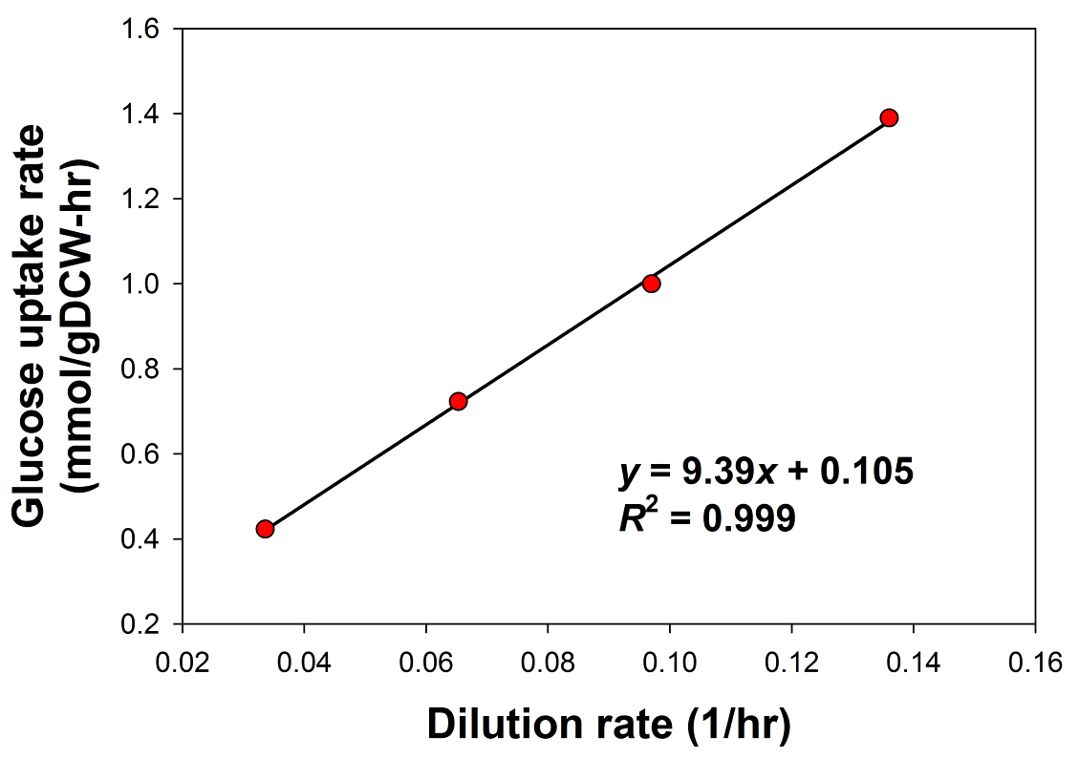
By maximizing ATP turnover under the glucose uptake constraint of 1 mmol/gDCW-hr, the ATP yield is evaluated as Y_{ATP, max} = 21.5 mol ATP/ mol glucose. Using this value and the y-intercept (0.105 mmol glucose/gDCW-hr), we can calculate the NGAM requirement to be about 2.26 mmol ATP/gDCW-hr.

References
Carnicer, M., et al. (2009) Macromolecular and elemental composition analysis and extracellular metabolite balances of Pichia pastoris growing at different oxygen levels, Microb Cell Fact., 8, 65.
Carnicer, M., et al. (2009) Macromolecular and elemental composition analysis and extracellular metabolite balances of Pichia pastoris growing at different oxygen levels, Microb Cell Fact, 8, 65.
De Schutter, K., et al. (2009) Genome sequence of the recombinant protein production host Pichia pastoris, Nat Biotechnol, 27, 561-566.
Förster, J., et al. (2003) Genome-scale reconstruction of the Saccharomyces cerevisiae metabolic network, Genome Res, 13, 244-253.
Pirt, S.J. (1982) Maintenance energy: a general model for energy-limited and energy-sufficient growth, Arch Microbiol, 133, 300-302.
van Bodegom, P. (2007) Microbial maintenance: a critical review on its quantification, Microb Ecol, 53, 513-523.
Verduyn, C. (1991) Physiology of yeasts in relation to biomass yields, Antonie Van Leeuwenhoek, 60, 325-353.
Wriessnegger, T., et al. (2009) Lipid analysis of mitochondrial membranes from the yeast Pichia pastoris, Biochim Biophys Acta, 1791, 166-172.

