Additional file 3: Figure S1. Schematic representation of in silico gene essentiality in iJN746 (iLB medium) compared experimental data of gene essentiality in P.aeruginosa [83].

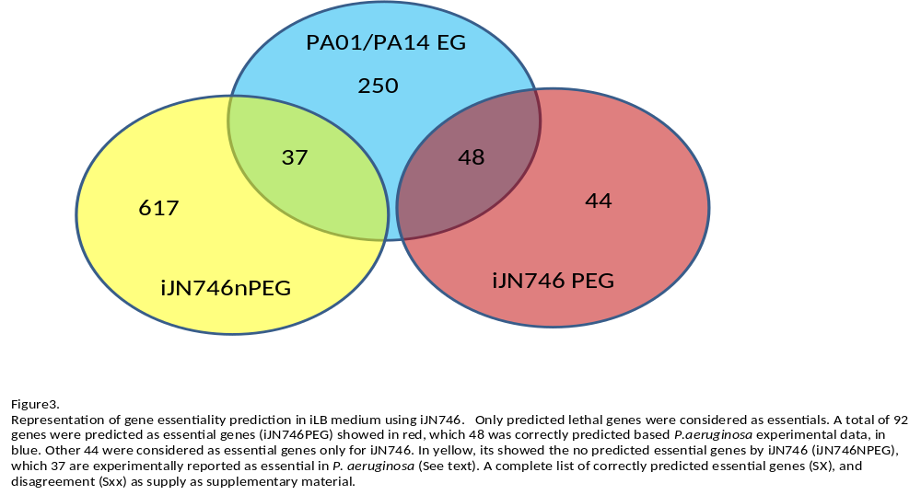

Figure S1. Schematic representation of in silico gene essentiality in iJN746 under iLB medium conditions. A total of 92 metabolic genes were predicted to be essential (iJN746PEG) in iLB mediun (red). 48 of these genes were correctly predicted when compared to the 335 essential genes found experimentally in P.aeruginosa (blue) [1]. The remaining 44 genes were only found to be essential in iJN746. Note that a significant number of these 335 essential genes found in P. aeruginosa were not metabolic. The predicted non-essential genes by iJN746 (iJN746NPEG) are shown in yellow. Only 37 of these genes were reported to be essential in P. aeruginosa (See text).

