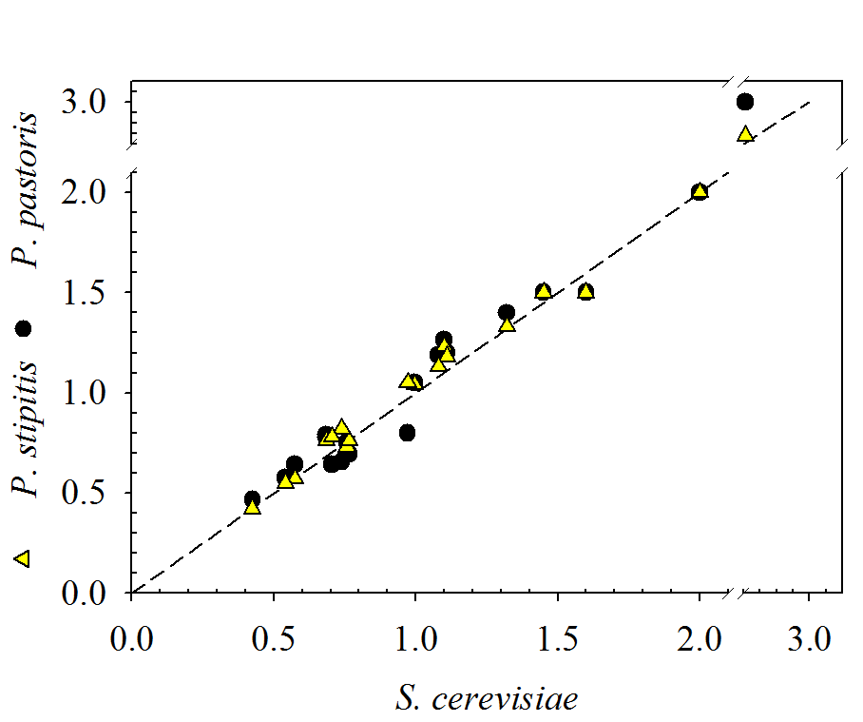
Maximum capacities for the production of amino acids among the three yeast species predicted by simulations. Reactions for the synthesis of every amino acid were maintained as objective function and simulations to compute its maximum production were performed in minimal medium with glucose as the carbon source.

