Supplementary material 12. Scale-free network and universal metabolites of Mannheimia succiniciproducens MBEL55E.
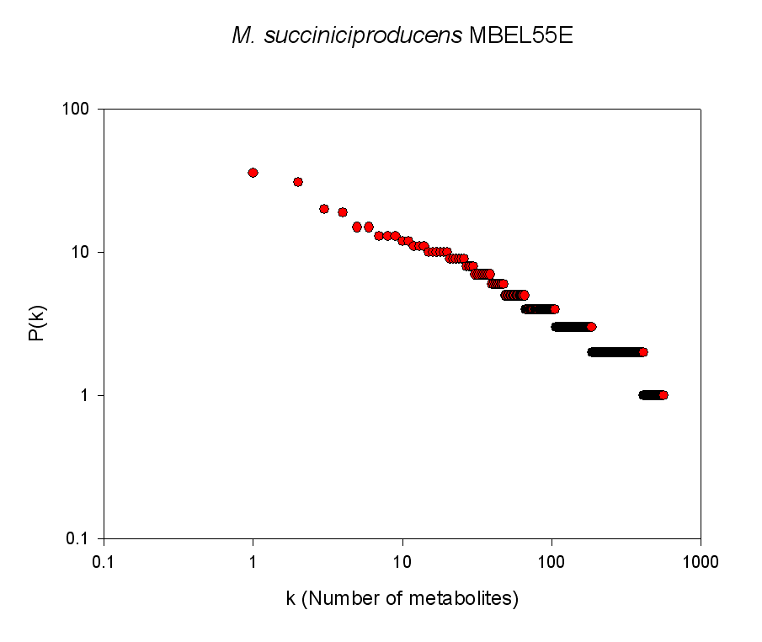

Universal metabolite
Abbreviated metabolite | Metabolite name
H2O | H₂O
CO2 | Carbon dioxide
O2 | Oxygen
H2O2 | Hydrogen peroxide
NH3 | Ammonium
NO2 | Nitrite
NO3 | Nitrate
NO | Nitric oxide
H2S | Hydrogen sulfide
H2SO3 | Sulfite
SLF | Sulfate
H | Proton
H2 | Hydrogen
PI | Orthophosphate
PPI | Pyrophosphate
COA | Coenzyme A
ATP | ATP
GTP | GTP
ADP | ADP
GDP | GDP
AMP | AMP
NAD | NAD⁺
NADP | NADP⁺
NADH | NADH
NADPH | NADPH
FAD | Flavin adenine dinucleotide
FADH2 | FADH₂
Na | Sodium

