Supplementary material 14. Results of the single gene deletion studies with M. succiniciproducens on the minimal (A) and complex medium (B). Essential reaction (gene) is the one that causes zero cell growth rate when it is deleted. Partially essential reaction (gene) causes decreased zero cell growth rate if deleted. Finally, non-essential reaction (gene) does not affect cellular phenotype at all. Reactions were categorized into essential, partially essential and non-essential, based on the global-scale single gene deletion simulations in the 8 metabolic sub-systems.
(A)
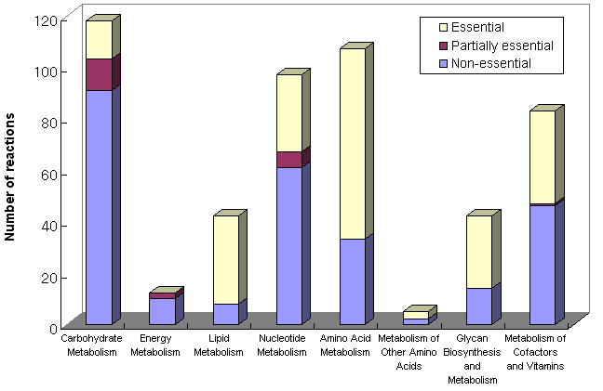
(B)
